Notes from meeting with Amber and David Thoma (1/28/25)

* PET in WB package:
  + Thornwaithe was original, functions added for other
  + Used to work with Thornwaithe -> haven’t used any but Oudin recently
    - Something off with snow partitioning in Thornwaithe
  + Other PET equations work but we don’t have the correct input data
  + Need to look at all the other PET functions other than Oudin and test them
* Package better in scripts
* Probably multiple scripts/packages: one for WB, one for calibration
  + Standalone and not dependent on CCRP WB package
* Calibrate water balance AET to openET
* Ensure reproducibility – work on making this more transparent/accurate from Joseph’s code
  + Frog rock? Only WB variables
  + Joseph’s code does comparisons at Wet Beaver Creek with daily NSE of streamflow
  + Xy scatterplot of both models to make sure r2 is one
* Good documentation of code: switches
* Brecken
* Frog Rock as “test” case: make tutorial, ensure output is correct + play around with switches
  + Buddy boulder, Douglas fir, impact of shade coefficient on AET/D

Questions:

* Calculated WB is temporally offset from gridded WB (this is a single year but trend is consistent across years – double check this):
  + Watershed area (grid) vs single point (calc)
  + Gridded model is not calibrated to RWC specifically (parameter values are obtained from other places for RWC watershed i.e. soil moisture, DEM models)
  + Plot soil moisture to get WH capacity + compare to SWC max from calibration
  + Figure out how to pull gridded model automatically [CCRP-Adaptation/Gridded_WB_extraction](https://github.com/CCRP-Adaptation/Gridded_WB_extraction)

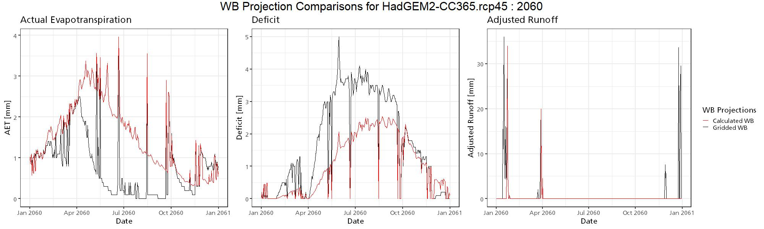

* Optimization questions
  + Changed optim() to ga() for WB
  + WB optimization
    - Do the temperatures really need to be whole numbers?
    - How precise should the optimized values be?
    - Possible to specify step increment for individual variables?
  + Visualization: HBV version in R that plots parameters in clear ways
  + Look into random forest models for parameter importance
* Wrapper script: what is the use case for the wrapper script? Should it include optimization capabilities?
  + Run multiple streams in one go: add optimization
  + Run with user input parameters
  + Or manual parameter evaluation
* Other ET functions?
  + Check ET functions with excel: ask amber? Check against excel
* Other plots that would be useful for visualization?
* Make code well-organized/usable? What is the end goal? Package?
* Janelle code
* Other priorities: parameter importance, variable optimization, plot of local maxima vs global maxima
  + Test on relevant watershed (ask Dave Lawrence)
* Look at janelle’s code, try running it. What are ways to give hydrologic overview of watershed?
* What do I want to be the end result of the R model?
  + Climate analyzer, near term forecasts with Mike Tercek?

Optimization functions for IHACRES flow:

* GA function produces accuracy of 0.6031631 without initial values
  + Also produces thorough evaluation of parameter space
* Optim() function produces accuracy of 0.6209558 with initial values close to final values; accuracy of 0.59 with initial values not close to final values (but parameters were not consistent)
  + Only evaluates close to parameters: does not assess complete parameter space
* Combination of GA for exploration of parameter space + determination of initial values, then optim() for final tuning? If that level of specificity is even required

GA results:

Iterations = 100

Fitness function value = 0.6068097

Solution =

l_qa l_qb l_sa l_sb l_va

[1,] 0.598966 0.07933573 0.6243437 0.1494174 0.9792371

IHACRES optimization:

* Initial code:
* Elapsed time: 1.049762 days
* Optimized coeffs: qa=0.7, qb=0.35, sa=0.85, sb=0.05, va=1, vb=0