Snake Basin Natural-Origin Steelhead Kelt Analysis

26 February, 2025

Table of Contents

| spawn_yr | spawner_above | kelt_LGR | kelt_below |
| --- | --- | --- | --- |
| 2010 | 598 | 1 | 53 |
| 2011 | 1091 | 39 | 126 |
| 2012 | 1060 | 32 | 186 |
| 2013 | 1131 | 19 | 146 |
| 2014 | 1174 | 47 | 221 |
| 2015 | 1233 | 25 | 164 |
| 2016 | 1263 | 51 | 222 |
| 2017 | 975 | 34 | 130 |
| 2018 | 920 | 47 | 172 |
| 2019 | 831 | 59 | 171 |
| 2020 | 1035 | 184 | 139 |
| 2021 | 1543 | 284 | 165 |
| 2022 | 845 | 191 | 107 |
| 2023 | 1139 | 254 | 128 |
| 2024 | 1173 | 168 | 131 |

|  | model | npar | AIC | DeltaAIC | weight | neg2lnl |
| --- | --- | --- | --- | --- | --- | --- |
| 24 | Phi(~year + pop + time)p(~year * time) | 67 | 21095.38 | 0.00000 | 0.9994436 | 20961.38 |
| 9 | Phi(~pop + time)p(~year * time) | 53 | 21110.47 | 15.08963 | 0.0005286 | 21004.47 |
| 12 | Phi(~pop * time)p(~year * time) | 74 | 21116.44 | 21.05480 | 0.0000268 | 20968.44 |
| 23 | Phi(~year + pop + time)p(~year + time) | 53 | 21122.80 | 27.41807 | 0.0000011 | 21016.80 |
| 21 | Phi(~year + mpg + time)p(~year * time) | 50 | 21150.22 | 54.83984 | 0.0000000 | 21050.22 |
| 6 | Phi(~mpg * time)p(~year * time) | 40 | 21172.94 | 77.56013 | 0.0000000 | 21092.94 |
| 3 | Phi(~mpg + time)p(~year * time) | 36 | 21178.01 | 82.62293 | 0.0000000 | 21106.01 |
| 20 | Phi(~year + mpg + time)p(~year + time) | 36 | 21180.77 | 85.39053 | 0.0000000 | 21108.77 |
| 11 | Phi(~pop * time)p(~year + time) | 60 | 21206.64 | 111.25509 | 0.0000000 | 21086.64 |
| 8 | Phi(~pop + time)p(~year + time) | 39 | 21222.56 | 127.17848 | 0.0000000 | 21144.56 |
| 5 | Phi(~mpg * time)p(~year + time) | 26 | 21266.34 | 170.96019 | 0.0000000 | 21214.34 |
| 2 | Phi(~mpg + time)p(~year + time) | 22 | 21290.30 | 194.91864 | 0.0000000 | 21246.30 |
| 17 | Phi(~year + time)p(~year + time) | 32 | 21336.50 | 241.12016 | 0.0000000 | 21272.50 |
| 18 | Phi(~year + time)p(~year * time) | 46 | 21337.82 | 242.44042 | 0.0000000 | 21245.82 |
| 15 | Phi(time)p(year * time) | 32 | 21346.47 | 251.08782 | 0.0000000 | 21282.47 |
| 26 | Phi(~year * time)p(~year + time) | 46 | 21358.32 | 262.93791 | 0.0000000 | 21266.32 |
| 27 | Phi(~year * time)p(~year * time) | 60 | 21365.55 | 270.16776 | 0.0000000 | 21245.55 |
| 14 | Phi(time)p(year + time) | 18 | 21441.86 | 346.47525 | 0.0000000 | 21405.86 |
| 25 | Phi(~year * time)p(~time) | 32 | 21720.55 | 625.16756 | 0.0000000 | 21656.55 |
| 22 | Phi(~year + pop + time)p(~time) | 39 | 22140.65 | 1045.26386 | 0.0000000 | 22062.65 |
| 19 | Phi(~year + mpg + time)p(~time) | 22 | 22204.34 | 1108.95973 | 0.0000000 | 22160.34 |
| 10 | Phi(~pop * time)p(~time) | 46 | 22341.00 | 1245.62091 | 0.0000000 | 22249.00 |
| 16 | Phi(~year + time)p(~time) | 18 | 22358.41 | 1263.02866 | 0.0000000 | 22322.41 |
| 7 | Phi(~pop + time)p(~time) | 25 | 22401.77 | 1306.38721 | 0.0000000 | 22351.77 |
| 4 | Phi(~mpg * time)p(~time) | 12 | 22436.18 | 1340.79276 | 0.0000000 | 22412.18 |
| 1 | Phi(~mpg + time)p(~time) | 8 | 22448.98 | 1353.59489 | 0.0000000 | 22432.98 |
| 13 | Phi(time)p(time) | 4 | 22627.91 | 1532.52821 | 0.0000000 | 22619.91 |

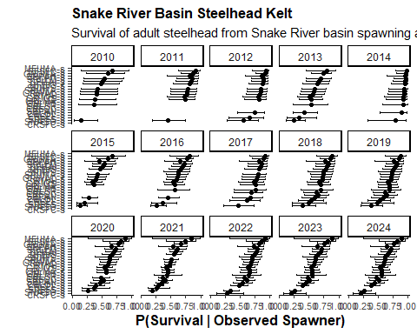

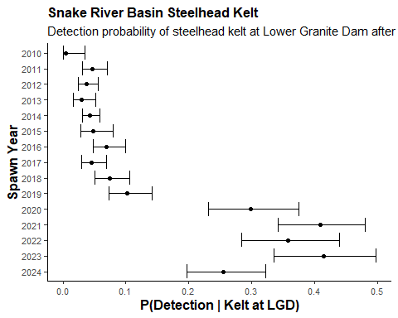

| pop | time | avg_Phi | se_Phi | lower_CI | upper_CI |
| --- | --- | --- | --- | --- | --- |
| CRLMA-s | 1 | 0.6129283 | 0.0207073 | 0.5723420 | 0.6535146 |
| CRLOC-s | 1 | 0.4786577 | 0.0251223 | 0.4294180 | 0.5278975 |
| CRLOL-s | 1 | 0.4739123 | 0.0232904 | 0.4282631 | 0.5195614 |
| CRSEL-s | 1 | 0.3822864 | 0.0237964 | 0.3356454 | 0.4289274 |
| CRSFC-s | 1 | 0.2233723 | 0.0600653 | 0.1056443 | 0.3411003 |
| GRJOS-s | 1 | 0.5688856 | 0.0199570 | 0.5297699 | 0.6080014 |
| GRLMT-s | 1 | 0.5604086 | 0.0296822 | 0.5022315 | 0.6185858 |
| GRUMA-s | 1 | 0.8470534 | 0.0144552 | 0.8187213 | 0.8753855 |
| GRWAL-s | 1 | 0.6549557 | 0.0193653 | 0.6169997 | 0.6929117 |
| IRMAI-s | 1 | 0.6349105 | 0.0188625 | 0.5979400 | 0.6718810 |
| MFBIG-s | 1 | 0.7464923 | 0.0203966 | 0.7065149 | 0.7864697 |
| MFUMA-s | 1 | 0.9015562 | 0.0661449 | 0.7719121 | 1.0000000 |
| SFMAI-s | 1 | 0.7743297 | 0.0178964 | 0.7392527 | 0.8094067 |
| SFSEC-s | 1 | 0.9260103 | 0.0176635 | 0.8913898 | 0.9606307 |
| SNASO-s | 1 | 0.2442136 | 0.0167329 | 0.2114172 | 0.2770101 |
| SREFS-s | 1 | 0.3402174 | 0.0433864 | 0.2551802 | 0.4252547 |
| SRLEM-s | 1 | 0.8194711 | 0.0187419 | 0.7827371 | 0.8562052 |
| SRLSR-s | 1 | 0.6817351 | 0.0394028 | 0.6045055 | 0.7589646 |
| SRNFS-s | 1 | 0.6743346 | 0.0422737 | 0.5914781 | 0.7571911 |
| SRPAH-s | 1 | 0.7851714 | 0.0299211 | 0.7265261 | 0.8438166 |
| SRPAN-s | 1 | 0.5228165 | 0.0309588 | 0.4621373 | 0.5834958 |
| SRUMA-s | 1 | 0.6972233 | 0.0219636 | 0.6541746 | 0.7402719 |

