1.

(1)select A

from R;

(2)select B

from R

where B=13;

(3)select R.A,R.B

from R join S

on R.C=S.D;

2.

（1）

"Kasper";"Spreadsheet";"Admin"

"Mohan";"Spreadsheet";"Admin"

"Lin";"Forecast";"Admin"

"Lin";"Spreadsheet";"Admin"

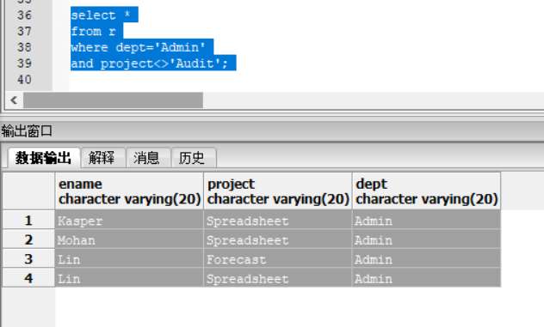

(2)

查询失败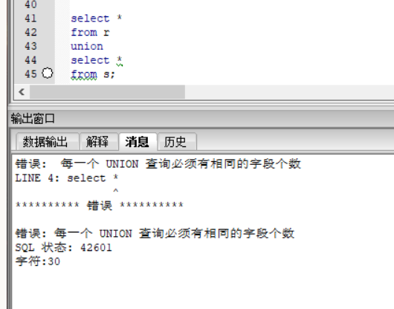

做并集应该两个数据表的列数相等，而r有三列，s只有两列，所以不能做并集。

1. 查询结果为空

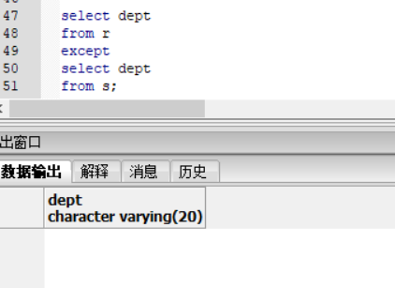

因为两个数据表的dept属性一样。

3.

创建表

create table customer(

CId INT NOT NULL UNIQUE,

Name VARCHAR(20),

Address VARCHAR(20),

Zip INT,

PRIMARY KEY(CId)

);

create table part(

PNo INT NOT NULL UNIQUE,

Pname VARCHAR(20),

UnitPrice decimal(14,2),

PRIMARY KEY(PNo)

);

create table orders(

Ono INT NOT NULL UNIQUE,

CId INT NOT NULL,

Received date NOT NULL,

Shipped date,

Primary Key(Ono),

Foreign Key(CId) References customer(CId)

);

create table invoice(

Ono INT NOT NULL,

Pno INT NOT NULL,

Qty INT NOT NULL,

BilledPrice decimal(14,2),

Foreign Key(Ono) References orders(Ono),

Foreign Key(Pno) References part(Pno)

);

（1）

select pno

from part

where unitprice>=10

and unitprice<=25;

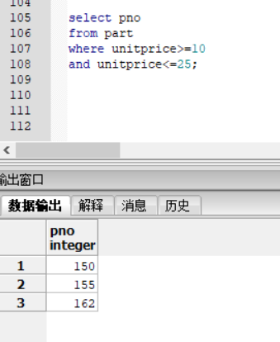

（2）

select Pno, sum(Qty) as TotalQuantity, sum(BilledPrice) as TotalBilledPrice

from invoice

where ono in (

select Ono

from orders

where extract (year from Received) = 1998)

group by Pno

order by sum(BilledPrice) ASC;

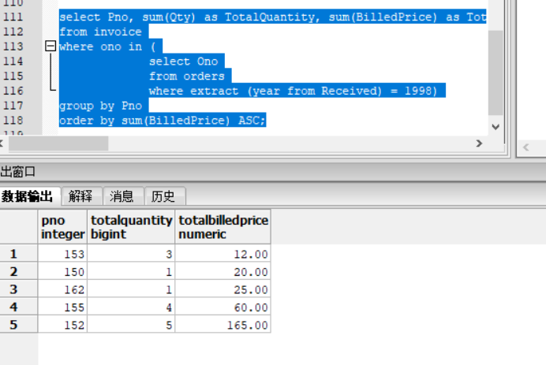

(3)

题目意思不是很理解，写了两种情况

第一种，不是98年卖出的

select pno

from invoice

where ono not in (

select ono

from orders

where extract(year from Received)=1998)；

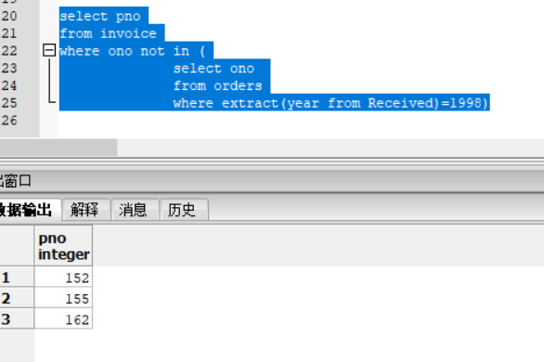

第二种，98年没有卖出去的

select pno

from part

except

select pno

from invoice

where ono in (

select ono

from orders

where extract(year from Received)=1998);

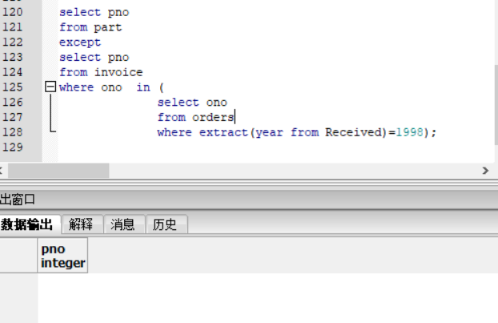

4.

create table EMPLOYEE(

id_dom INT NOT NULL,

name_dom VARCHAR(20) NOT NULL,

salary decimal(14,2) NOT NULL,

dept_name_dom VARCHAR(20) NOT NULL

);

alter table EMPLOYEE ADD primary key(id_dom);

create table DEPARTMENT(

dept_name_dom VARCHAR(20) NOT NULL,

id_dom INT NOT NULL,

budget_dom VARCHAR(20) NOT NULL

);

alter table DEPARTMENT ADD primary key(dept_name_dom);

alter table DEPARTMENT ADD foreign key(id_dom) references EMPLOYEE(id_dom);

或者

create table EMPLOYEE(

id_dom INT NOT NULL,

name_dom VARCHAR(20) NOT NULL,

salary_dom decimal(14,2) NOT NULL,

dept_name_dom VARCHAR(20) NOT NULL,

PRIMARY KEY (id_dom)

);

create table DEPARTMENT(

dept_name_dom VARCHAR(20) NOT NULL,

id_dom INT NOT NULL,

budget_dom VARCHAR(20) NOT NULL,

PRIMARY KEY (dept_name_dom),

FOREIGN KEY ( id_dom ) REFERENCES EMPLOYEE ( id_dom )

);