实验1：HTTP
班级14012008 学号 2020302995 姓名 陈靖
- 实验内容。
- Is your browser running HTTP version 1.0 or 1.1? What version of HTTP is the server running?
- What languages (if any) does your browser indicate that it can accept to the server?
- What is the IP address of your computer? Of the gaia.cs.umass.edu server?
- What is the status code returned from the server to your browser?
- When was the HTML file that you are retrieving last modified at the server?
- How many bytes of content are being returned to your browser?
- By inspecting the raw data in the packet content window, do you see any headers within the data that are not displayed in the packet-listing window? If so, name one.
- Inspect the contents of the first HTTP GET request from your browser to the server. Do you see an “IF-MODIFIED-SINCE” line in the HTTP GET?
- Inspect the contents of the server response. Did the server explicitly return the contents of the file? How can you tell?
- Now inspect the contents of the second HTTP GET request from your browser to the server. Do you see an “IF-MODIFIED-SINCE:” line in the HTTP GET? If so, what information follows the “IF-MODIFIED-SINCE:” header?
- What is the HTTP status code and phrase returned from the server in response to this second HTTP GET? Did the server explicitly return the contents of the file? Explain.
- How many HTTP GET request messages did your browser send? Which packet number in the trace contains the GET message for the Bill or Rights?
- Which packet number in the trace contains the status code and phrase associated with the response to the HTTP GET request?
- What is the status code and phrase in the response?
- How many data-containing TCP segments were needed to carry the single HTTP response and the text of the Bill of Rights?
- How many HTTP GET request messages did your browser send? To which Internet addresses were these GET requests sent?
- Can you tell whether your browser downloaded the two images serially, or whether they were downloaded from the two web sites in parallel? Explain.

- 实验操作步骤及结果。
操作步骤
1.Start up your web browser.
2.Start up the Wireshark packet sniffer, as described in the Introductory lab (but don’t yet begin packet capture). Enter “http” (just the letters, not the quotation marks) in the display-filter-specification window, so that only captured HTTP messages will be displayed later in the packet-listing window. (We’re only interested in the HTTP protocol here, and don’t want to see the clutter of all captured packets).
3.Wait a bit more than one minute (we’ll see why shortly), and then begin Wireshark packet capture.
4.Enter the following to your browser
http://gaia.cs.umass.edu/wireshark-labs/HTTP-wireshark-file1.html
Your browser should display the very simple, one-line HTML file.

第一个问题
浏览器运行的http版本为1.1，服务器运行的http版本也为1.1。
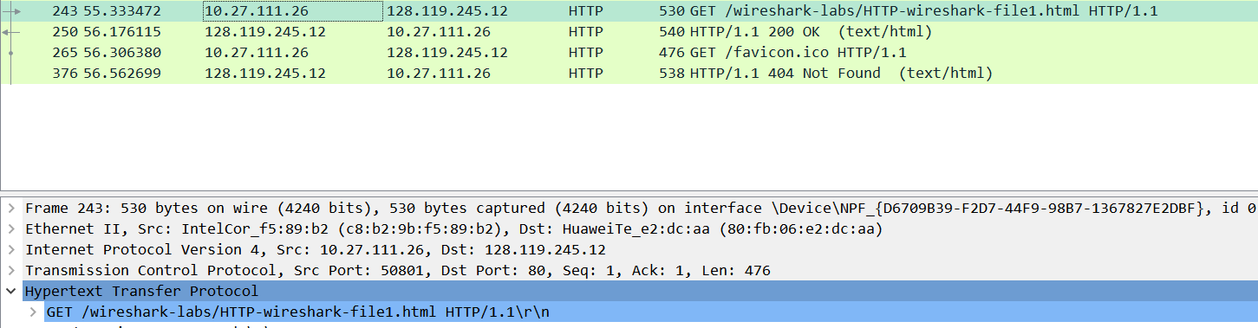

第二个问题
可接受的服务器语言
第三个问题
我的计算机的IP地址为10.27.111.26，gaia.cs.umass.edu服务器的IP地址为128.119.245.12第四个问题
服务器返回的浏览器状态码为200OK和404NOT FOUND
第五个问题
上次在服务器上检索的HTML文件的修改时间：2022年5月5日星期四 05：59：01
第六个问题
向浏览器分别返回了128字节和209字节的内容

第七个问题
没有
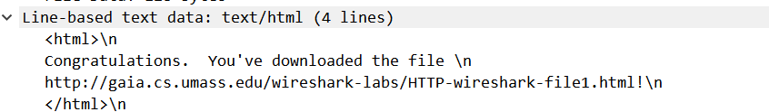
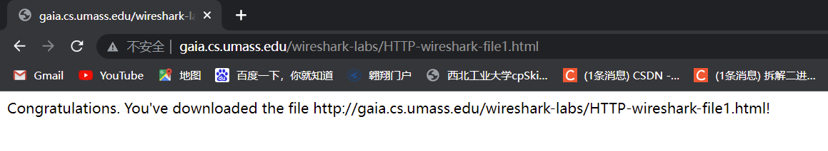

操作步骤
•Start up your web browser, and make sure your browser’s cache is cleared, as discussed above.
•Start up the Wireshark packet sniffer
•Enter the following URL into your browser
http://gaia.cs.umass.edu/wireshark-labs/HTTP-wireshark-file2.html
Your browser should display a very simple five-line HTML file.
•Quickly enter the same URL into your browser again (or simply select the refresh button on your browser)
•Stop Wireshark packet capture, and enter “http” in the display-filter-specification window, so that only captured HTTP messages will be displayed later in the packet-listing window.
•(Note: If you are unable to run Wireshark on a live network connection, you can use the http-ethereal-trace-2 packet trace to answer the questions below; see footnote 1. This trace file was gathered while performing the steps above on one of the author’s computers.)

回答第八个问题
没有看到修改
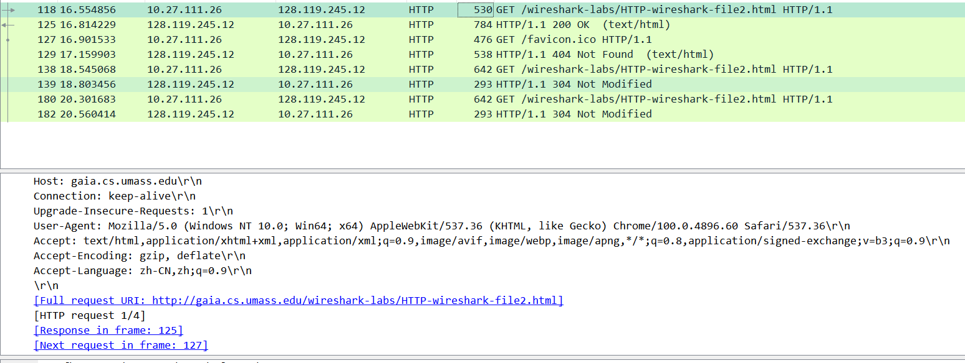

回答第九个问题
返回了文件内容
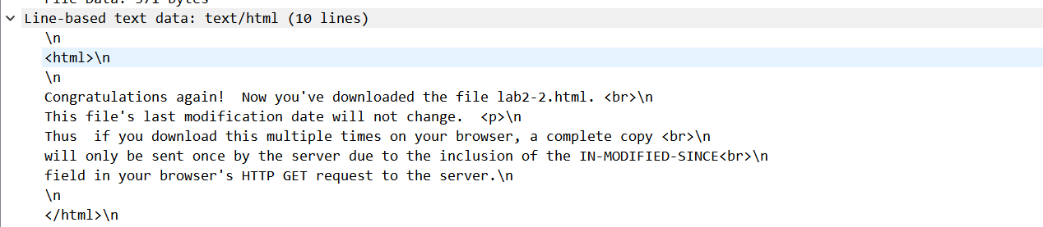
回答第十个问题
看到了if修改行：Thu，05 May 2022 05:29:01 GMT\r\n
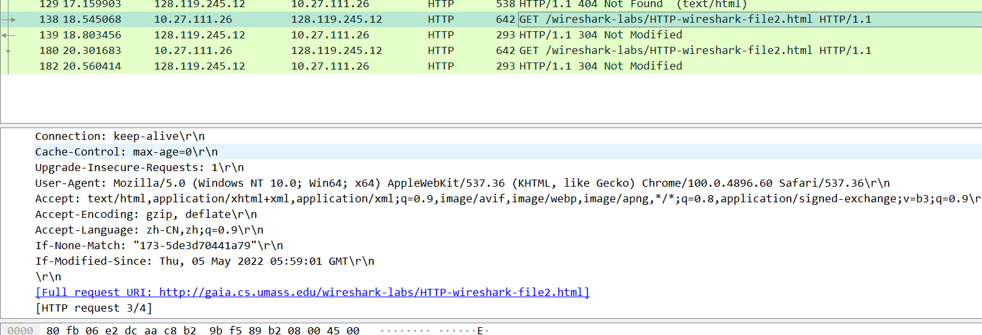

回答第十一个问题
http状态码和状态短语：304 Not Modified
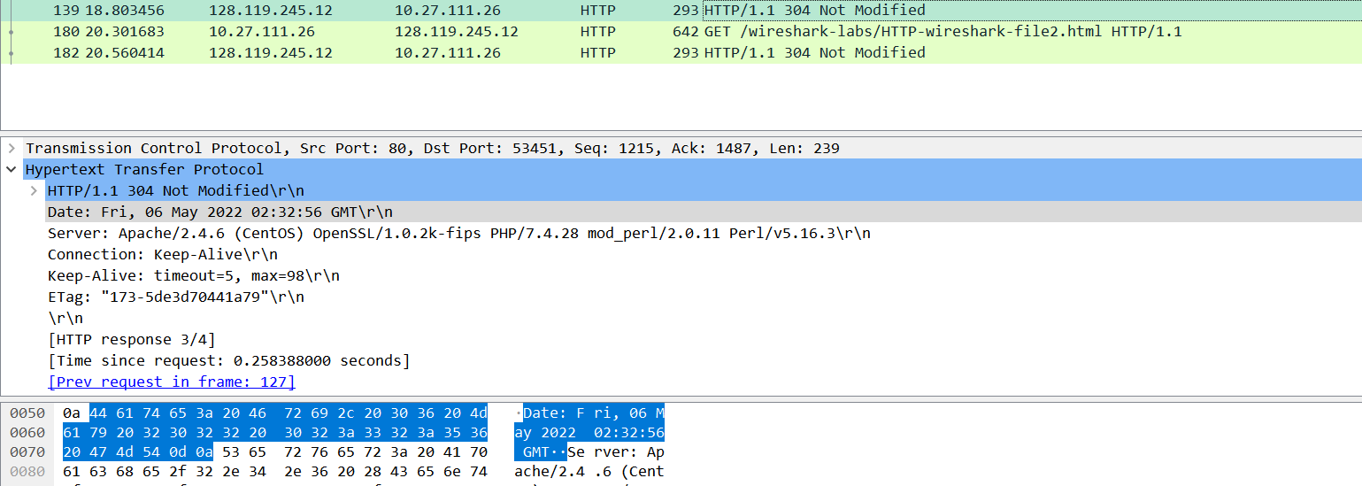
没有返回文件内容，因为浏览器在第一次请求的时候保存了网页内容到缓存去了，所以可以直接从本地缓存获得网页内容。
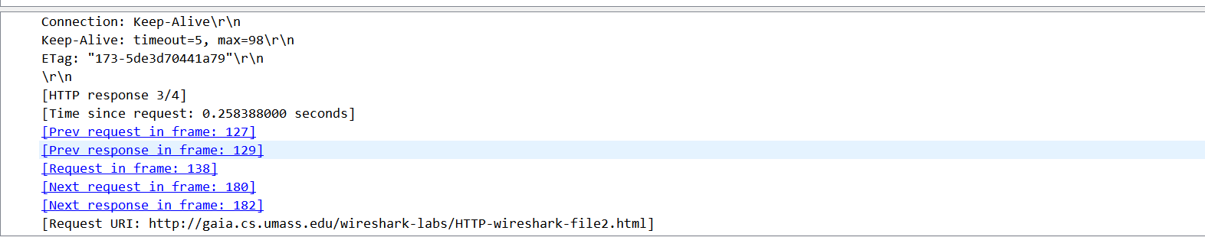

操作步骤
•Start up your web browser, and make sure your browser’s cache is cleared, as discussed above.
•Start up the Wireshark packet sniffer
•Enter the following URL into your browser
http://gaia.cs.umass.edu/wireshark-labs/HTTP-wireshark-file3.html
Your browser should display the rather lengthy US Bill of Rights.
•Stop Wireshark packet capture, and enter “http” in the display-filter-specification window, so that only captured HTTP messages will be displayed.
•(Note: If you are unable to run Wireshark on a live network connection, you can use the http-ethereal-trace-3 packet trace to answer the questions below; see footnote 1. This trace file was gathered while performing the steps above on one of the author’s computers.)

回答第十二个问题
两个HTTP请求报文 包含Bill and Right的数据包的编号为126
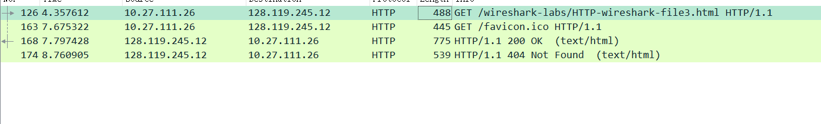

回答第十三个问题
包号：168
包号：174

回答第十四个问题
状态码和短语：200 OK
状态码和短语：404 Not Found

回答第十五个问题
需要四个包
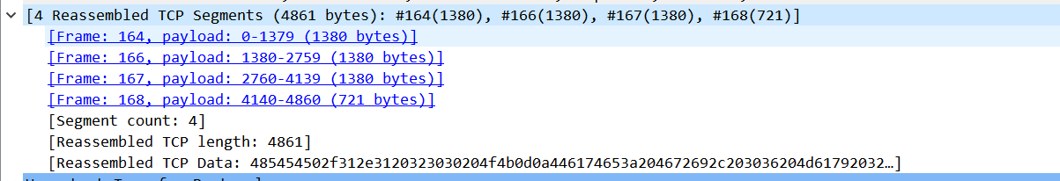

操作步骤
•Start up your web browser, and make sure your browser’s cache is cleared, as discussed above.
•Start up the Wireshark packet sniffer
•Enter the following URL into your browser
http://gaia.cs.umass.edu/wireshark-labs/HTTP-wireshark-file4.html
Your browser should display a short HTML file with two images. These two images are referenced in the base HTML file. That is, the images themselves are not contained in the HTML; instead the URLs for the images are contained in the downloaded HTML file. As discussed in the textbook, your browser will have to retrieve these logos from the indicated web sites. Our publisher’s logo is retrieved from the www.aw-bc.com web site. The image of the cover for our 5th edition (one of our favorite covers) is stored at the manic.cs.umass.edu server.
•Stop Wireshark packet capture, and enter “http” in the display-filter-specification window, so that only captured HTTP messages will be displayed.
•(Note: If you are unable to run Wireshark on a live network connection, you can use the http-ethereal-trace-4 packet trace to answer the questions below; see
footnote 1. This trace file was gathered while performing the steps above on one
of the author’s computers.)

回答第十六个问题
四个HTTP请求
第一个：128.119.245.12
第二个：128.129.245.12
第三个：178.79.137.164
第四个：128.119.245.12
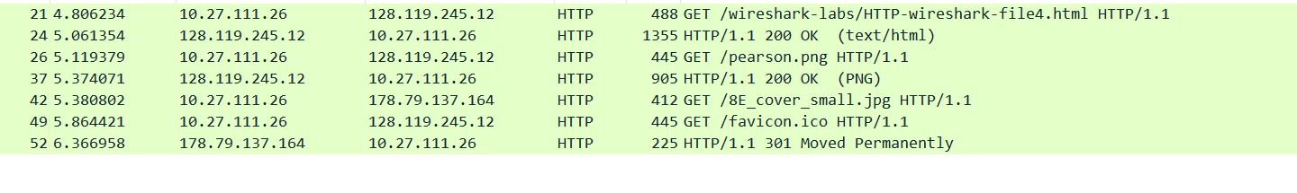
回答第十七个问题
连续下载，因为下载第一个图片时间是5.119s，完成时间是5.374s。下载第二个图片时间是5.380s，完成时间是6.366s。
三、实验中存在问题及分析。
实验过程中发现会出现很多干扰选项，经过排查之后，发现是QQ和WPS也会获取网络资源，干扰了实验结果。

实验2：TCP
班级 14012008 学号 2020302995 姓名 陈靖
- 实验内容。
- What is the IP address and TCP port number used by the client computer (source) that is transferring the file to gaia.cs.umass.edu? To answer this question, it’s probably easiest to select an HTTP message and explore the details of the TCP packet used to carry this HTTP message, using the “details of the selected packet header window” (refer to Figure 2 in the “Getting Started with Wireshark” Lab if you’re uncertain about the Wireshark windows.
- What is the IP address of gaia.cs.umass.edu? On what port number is it sending and receiving TCP segments for this connection?
If you have been able to create your own trace, answer the following question:
- What is the IP address and TCP port number used by your client computer (source) to transfer the file to gaia.cs.umass.edu?
- What is the sequence number of the TCP SYN segment that is used to initiate the TCP connection between the client computer and gaia.cs.umass.edu? What is it in the segment that identifies the segment as a SYN segment?
- What is the sequence number of the SYNACK segment sent by gaia.cs.umass.edu to the client computer in reply to the SYN? What is the value of the Acknowledgement field in the SYNACK segment? How did gaia.cs.umass.edu determine that value? What is it in the segment that identifies the segment as a SYNACK segment?
- What is the sequence number of the TCP segment containing the HTTP POST command? Note that in order to find the POST command, you’ll need to dig into the packet content field at the bottom of the Wireshark window, looking for a segment with a “POST” within its DATA field.
- Consider the TCP segment containing the HTTP POST as the first segment in the TCP connection. What are the sequence numbers of the first six segments in the
- What is the length of each of the first six TCP segments?4
- What is the minimum amount of available buffer space advertised at the received for the entire trace? Does the lack of receiver buffer space ever throttle the sender?
- Are there any retransmitted segments in the trace file? What did you check for (in the trace) in order to answer this question?
- How much data does the receiver typically acknowledge in an ACK? Can you identify cases where the receiver is ACKing every other received segment (see Table 3.2 on page 247 in the text).
- What is the throughput (bytes transferred per unit time) for the TCP connection? Explain how you calculated this value.
Use the Time-Sequence-Graph(Stevens) plotting tool to view the sequence number versus time plot of segments being sent from the client to the gaia.cs.umass.edu server. Can you identify where TCP’s slowstart phase begins and ends, and where congestion avoidance takes over? Comment on ways in which the measured data differs from the idealized behavior of TCP that we’ve studied in the text.
Answer each of two questions above for the trace that you have gathered when you transferred a file from your computer to gaia.cs.umass.edu

- 实验操作步骤及结果。
操作步骤
•Start up your web browser. Go the http://gaia.cs.umass.edu/wireshark-labs/alice.txt and retrieve an ASCII copy of Alice in Wonderland. Store this file somewhere on your computer.
•Next go to http://gaia.cs.umass.edu/wireshark-labs/TCP-wireshark-file1.html.
•You should see a screen that looks like:
•Use the Browse button in this form to enter the name of the file (full path name) on your computer containing Alice in Wonderland (or do so manually). Don’t yet press the “Upload alice.txt file” button.
•Now start up Wireshark and begin packet capture (Capture->Start) and then press OK on the Wireshark Packet Capture Options screen (we’ll not need to select any options here).
•Returning to your browser, press the “Upload alice.txt file” button to upload the file to the gaia.cs.umass.edu server. Once the file has been uploaded, a short congratulations message will be displayed in your browser window.
•Stop Wireshark packet capture. Your Wireshark window should look similar to the window shown below.

回答第一个问题
Ip地址：192.168.3.16 端口号：60545
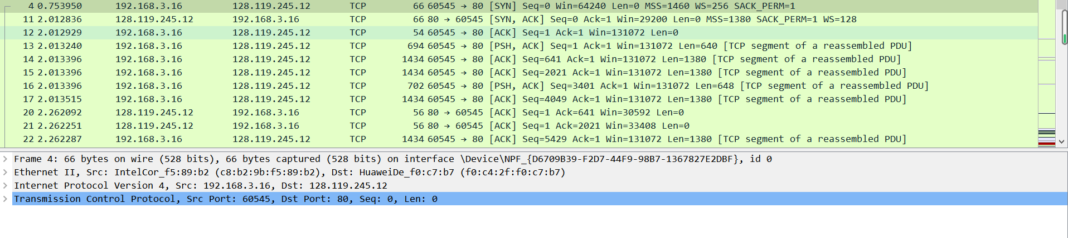

回答第二个问题
IP地址128.119.245.12 端口号：80
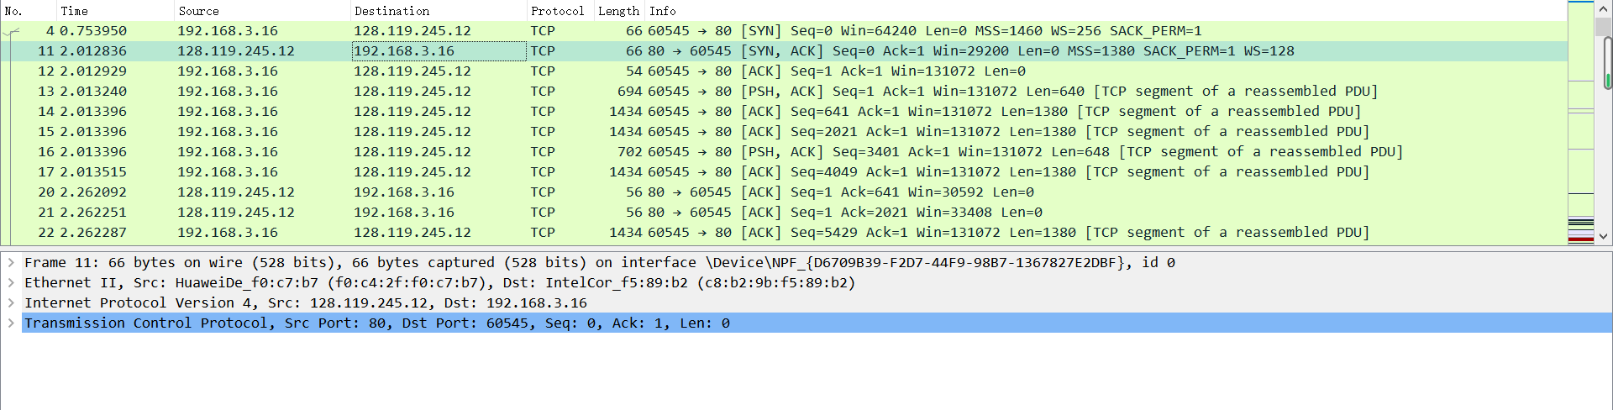
回答第三个问题
IP地址：10.27.111.26 端口号：58744
回答第四个问题
Sequence number是0 SYN是1，当SYN为1时表示这是一条TCP建立请求报文段。
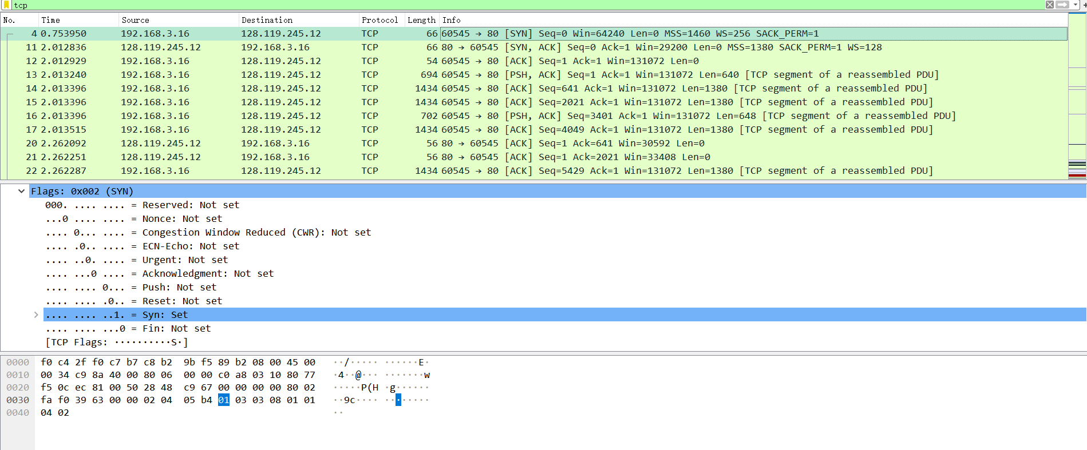回答第五个问题
Sequence number是0
Acknowledgement是1
服务器可以决定是否相应ACK
SYN和ACK表示服务器对客户端链接请求响应。报文通过设置SYN字段和Acknowledgment number字段为1，来标识这是一个SYNACK报文。
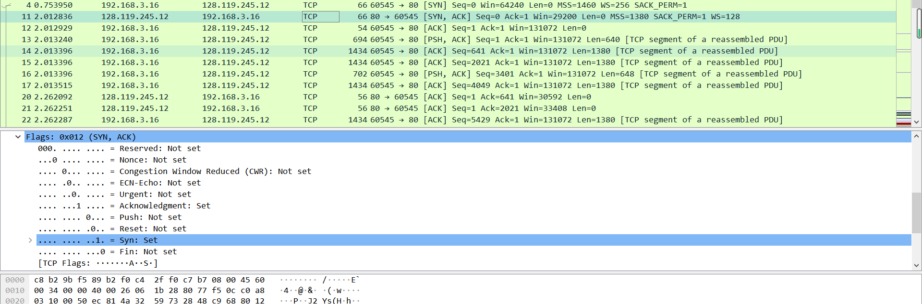
回答第六个问题
Sequence number是1
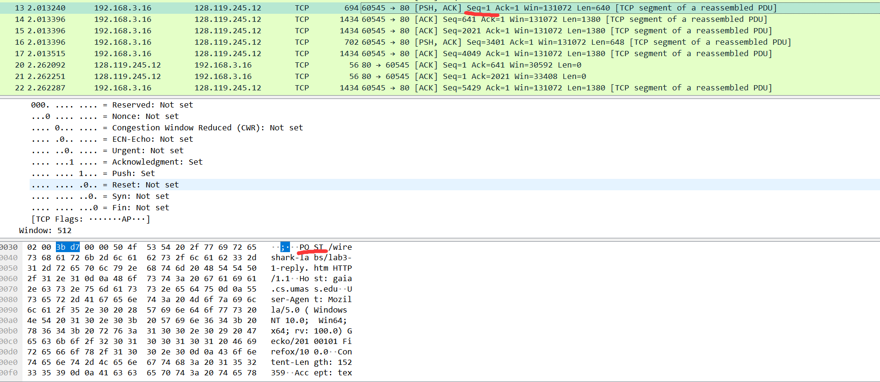
回答第七个问题
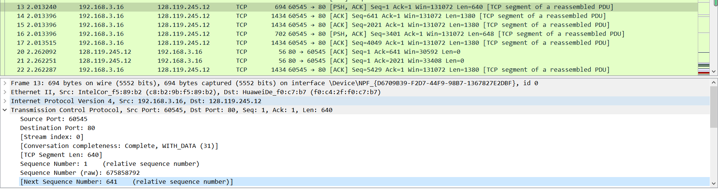
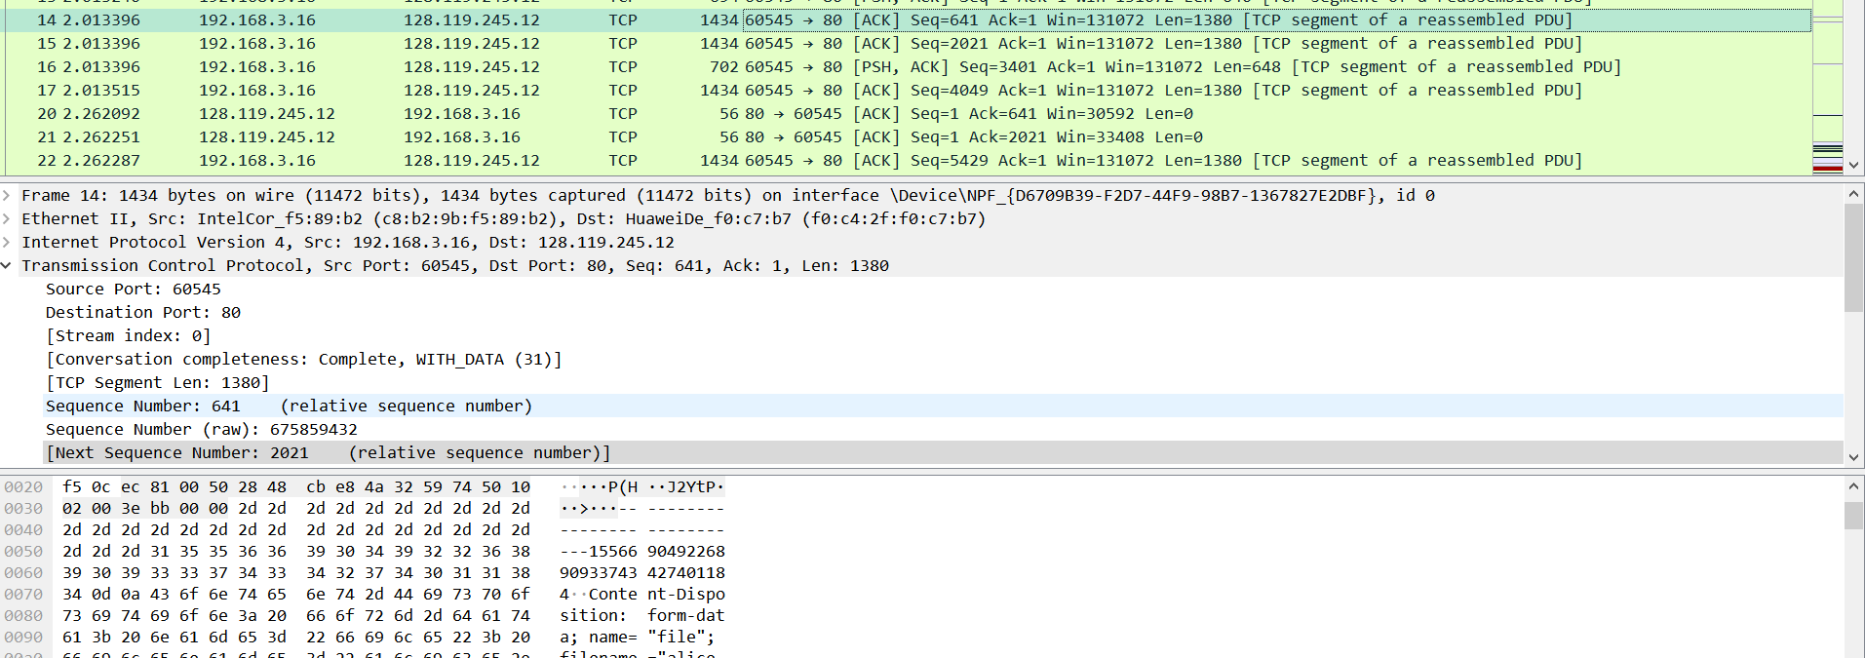

报文序列号：
segments1:1 segments2:641 segments3:2021
segments4:3401 segments5:4049 segments6:5429

报文段发送时间：
segments1:2.013240 segments2:2.013396 segments3:2.013396
segments4:2.013396 segments5:2.013515 segments6:2.262287

ACK收到的时间：
segments1:2.262092 segments2:2.262251 segments3:2.266396
segments4:2.277083 segments5:2.282293 segments6:2.509477

RTT时间（秒）：
segments1:0.248852 segments2:0.248855 segments3:0.253
segments4:0.263687 segments5:0.268778 segments6:0.24719

EstimatedRTT = 0.875 * EstimatedRTT + 0.125 * SampleRTT
EstimatedRTT:
Segments1=0.248852
Segments2=0.875*0.248852+0.125*0.248855=0.248852
Segments3=0.875*0.248852+0.125*0.253=0.249371
Segments4=0.875*0.249371+0.125*0.263687=0.289957
Segments5=0.875*0.289957+0.125*0.268778=0.287325
Segments6=0.875*0.287325+0.125*0.24719=0.282308
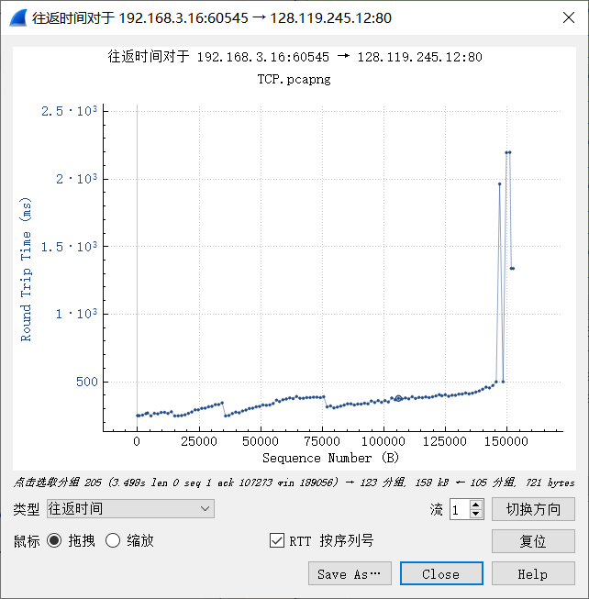
回答第八个问题
由上一问可知：
Segments1=640bits segments2=1380bits segments3=1380bits
Segments4=648bits segments5=1380bits segments6=1380bits

回答第九个问题
最小窗口为29200。不会阻碍，接收方的窗口在不断的变大，始终大于发送的量，最终增长到288256
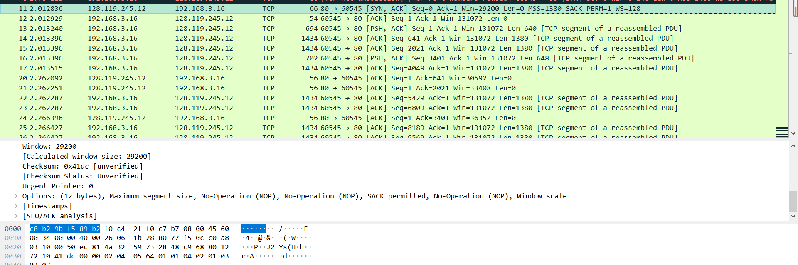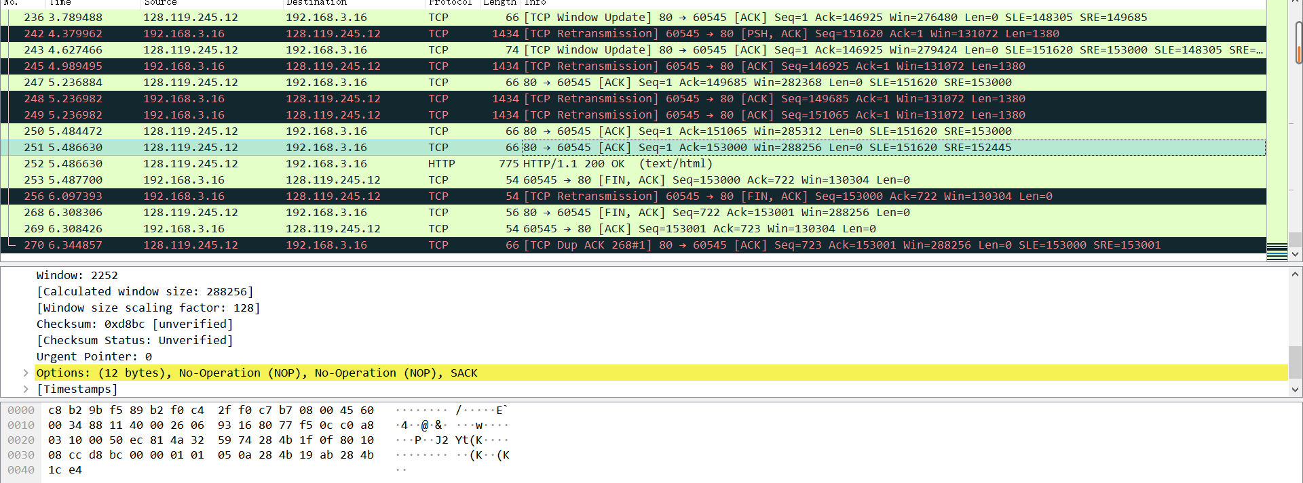
回答第十个问题
有重传现象，图中黑色的那些行，都是重传行。从sequence number和retransmission中可以得知发生了重传的现象。
回答第十一个问题
除了ACK1数据大小为640和ACK4数据大小为648以外，其他ACK数据大小都为1380。
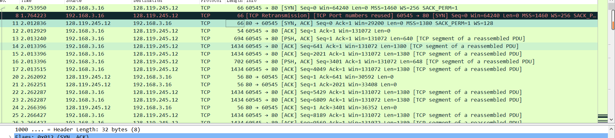
回答第十二个问题
最后一个TCP段的序列号，减去第一个TCP段的序列号，除以第一个 ACk的时间和最后的 ACK的时间的差值。（153001-1）/（6.344857-2.262092）=37474.6b/s=37.47Kb/s
回答第十三个问题
由图可知，慢启动大约在1.s处开始，在1.6s结束。拥塞避免大约在2.6秒处开始。
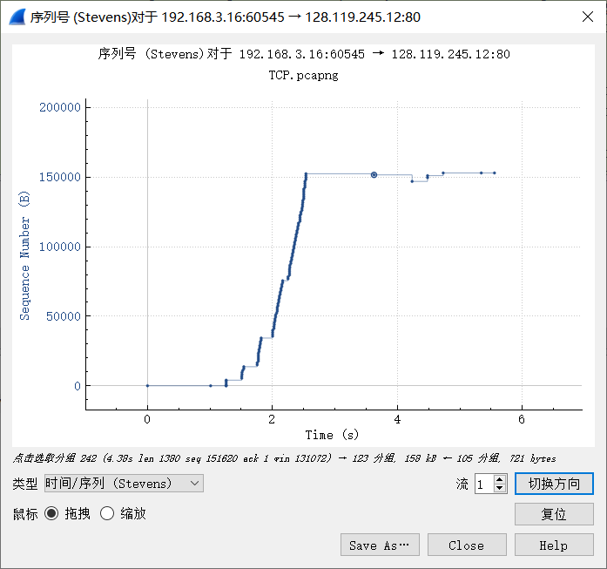
回答第十四个问题
Answer each of two questions above for the trace that you have gathered when you transferred a file from your computer to gaia.cs.umass.edu

三、实验中存在问题及分析。
本次实验难度很大，获取报文失败了好几次才成功。对于三次握手和拥塞控制不是很熟悉，所以做起来很吃力。

实验3：ICMP
班级 14012008 学号 2020302995 姓名 陈靖
- 实验内容。
- What is the IP address of your host? What is the IP address of the destination host?
- Why is it that an ICMP packet does not have source and destination port numbers?
- Examine one of the ping request packets sent by your host. What are the ICMP type and code numbers? What other fields does this ICMP packet have? How many bytes are the checksum, sequence number and identifier fields?
- Examine the corresponding ping reply packet. What are the ICMP type and code numbers? What other fields does this ICMP packet have? How many bytes are the checksum, sequence number and identifier fields?
- What is the IP address of your host? What is the IP address of the target destination host?
- If ICMP sent UDP packets instead (as in Unix/Linux), would the IP protocol number still be 01 for the probe packets? If not, what would it be?
- Examine the ICMP echo packet in your screenshot. Is this different from the ICMP ping query packets in the first half of this lab? If yes, how so?
- Examine the ICMP error packet in your screenshot. It has more fields than the ICMP echo packet. What is included in those fields?
- Examine the last three ICMP packets received by the source host. How are these packets different from the ICMP error packets? Why are they different?
- Within the tracert measurements, is there a link whose delay is significantly longer than others? Refer to the screenshot in Figure 4, is there a link whose delay is significantly longer than others? On the basis of the router names, can you guess the location of the two routers on the end of this link?

- 实验操作步骤及结果。
操作步骤：
- Let’s begin this adventure by opening the Windows Command Prompt application (which can be found in your Accessories folder).
- Start up the Wireshark packet sniffer, and begin Wireshark packet capture.
- The ping command is in c:\windows\system32, so type either “ping –n 10 hostname” or “c:\windows\system32\ping –n 10 hostname” in the MS-DOS command line (without quotation marks), where hostname is a host on another continent. If you’re outside of Asia, you may want to enter www.ust.hk for the Web server at Hong Kong University of Science and Technology. The argument “-n 10” indicates that 10 ping messages should be sent. Then run the Ping program by typing return.
- When the Ping program terminates, stop the packet capture in Wireshark.
Ping的结果
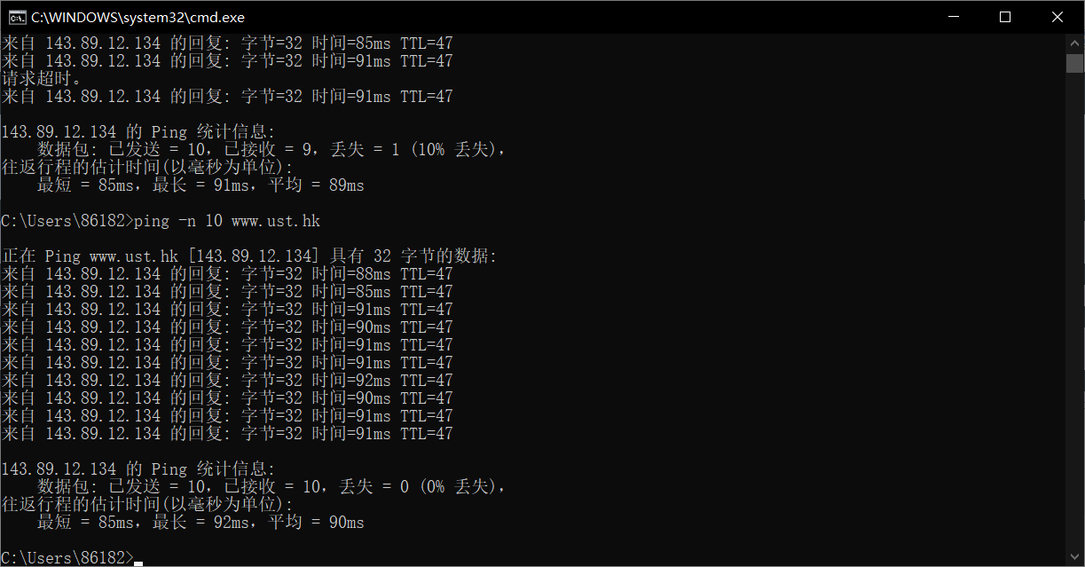
抓包的结果（一共有二十行）
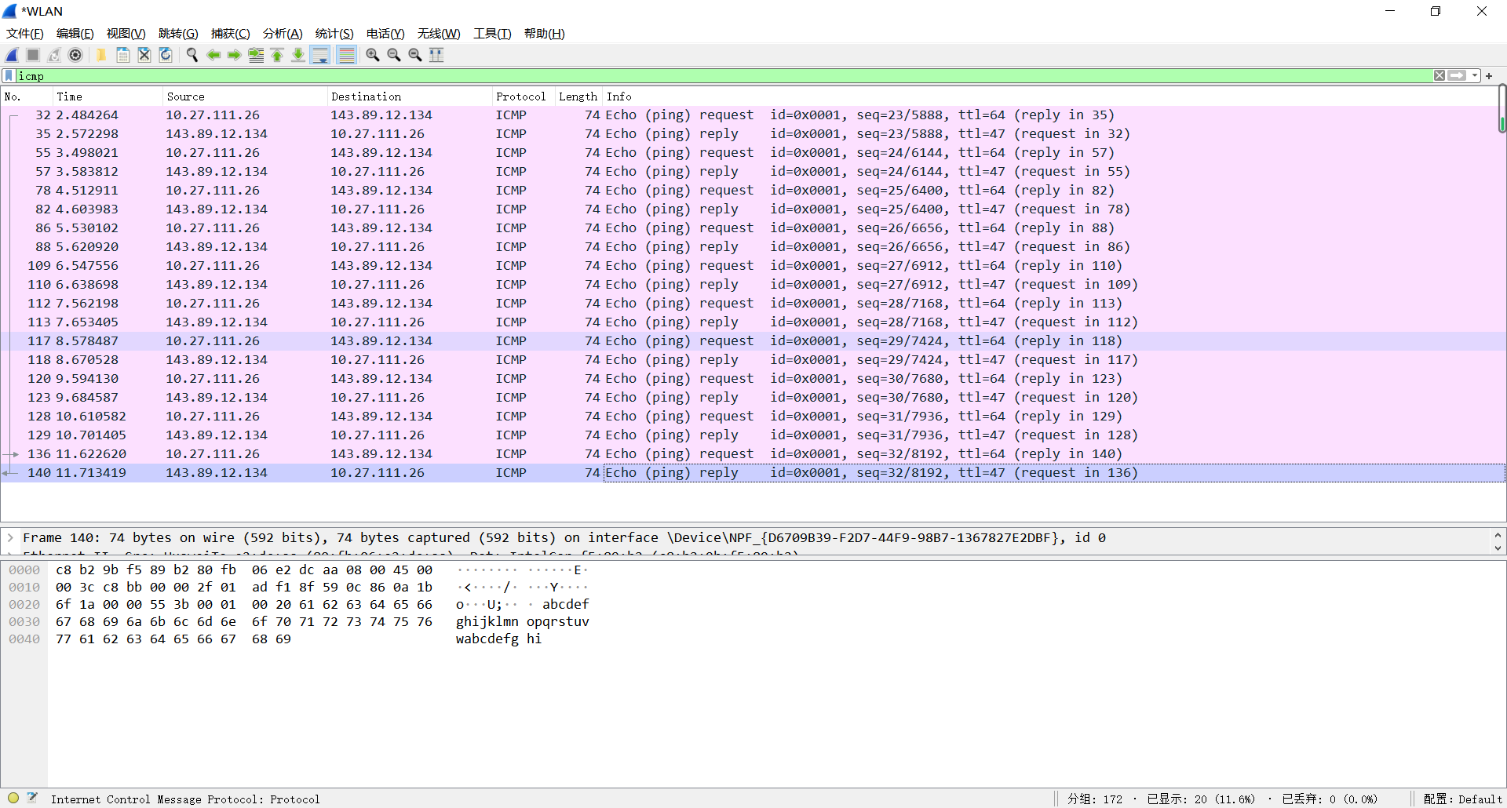

回答第一个问题
主机IP地址：10.27.111.26
目的IP地址：143.89.12.134
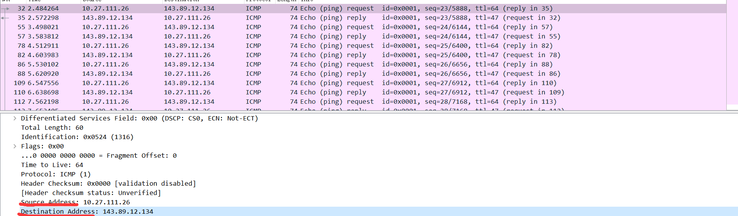

回答第二个问题
因为端口号是运输层的内容，而ICMP协议是封装在IP数据包中的，属于网络层，所以ICMP没有端口号

回答第三个问题
the ICMP type:8
code numbers:0
此数据包中还有Checksum（2字节）、Identifier（2字节）、Sequence number（2字节）字段
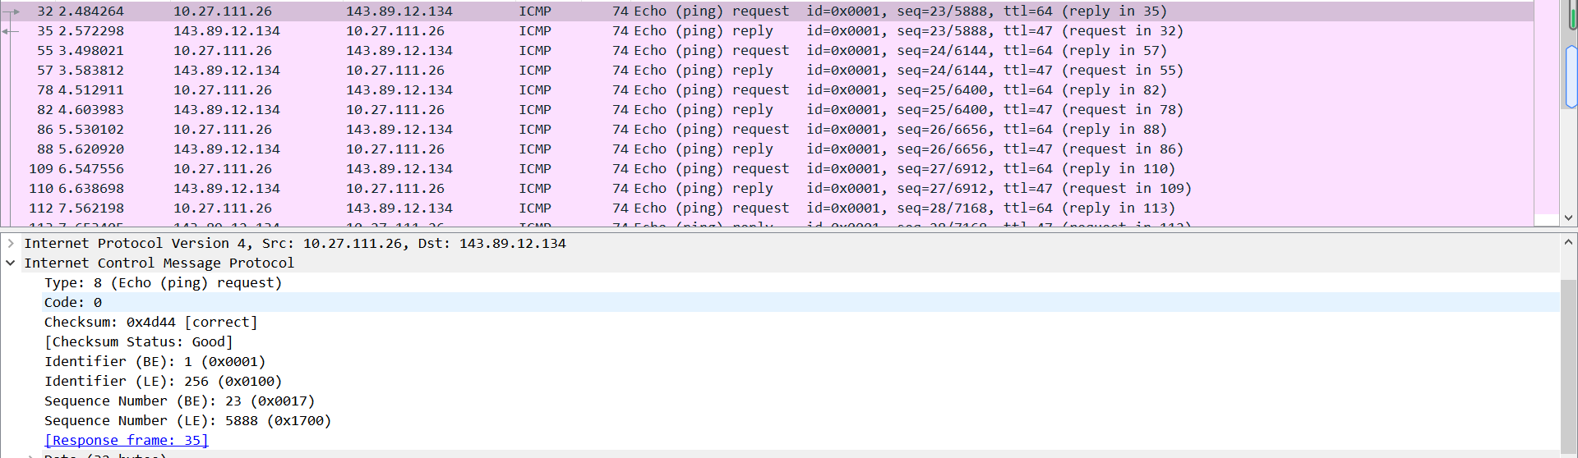

回答第四个问题
the ICMP type:0
code numbers:0
此数据包中还有Checksum（2字节）、Identifier（2字节）、Sequence number（2字节）字段

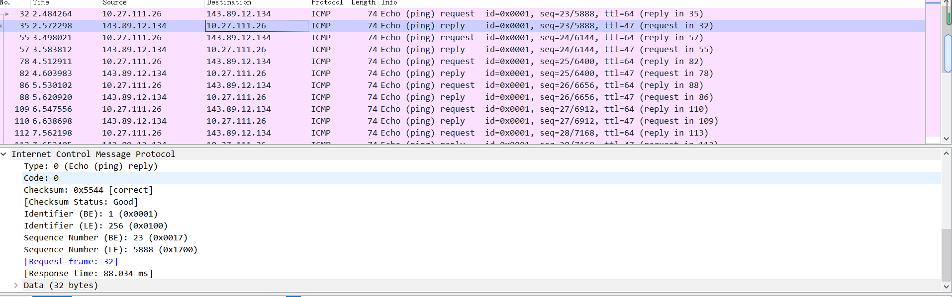

操作步骤
- Let’s begin by opening the Windows Command Prompt application (which can be found in your Accessories folder).
- Start up the Wireshark packet sniffer, and begin Wireshark packet capture.
- The tracert command is in c:\windows\system32, so type either “tracert hostname” or “c:\windows\system32\tracert hostname” in the MS-DOS command line (without quotation marks), where hostname is a host on another continent.
(Note that on a Windows machine, the command is “tracert” and not “traceroute”.) If you’re outside of Europe, you may want to enter www.inria.fr for the Web server at INRIA, a computer science research institute in France. Then run the Traceroute program by typing return.
- When the Traceroute program terminates, stop packet capture in Wireshark.
Traceroute结果
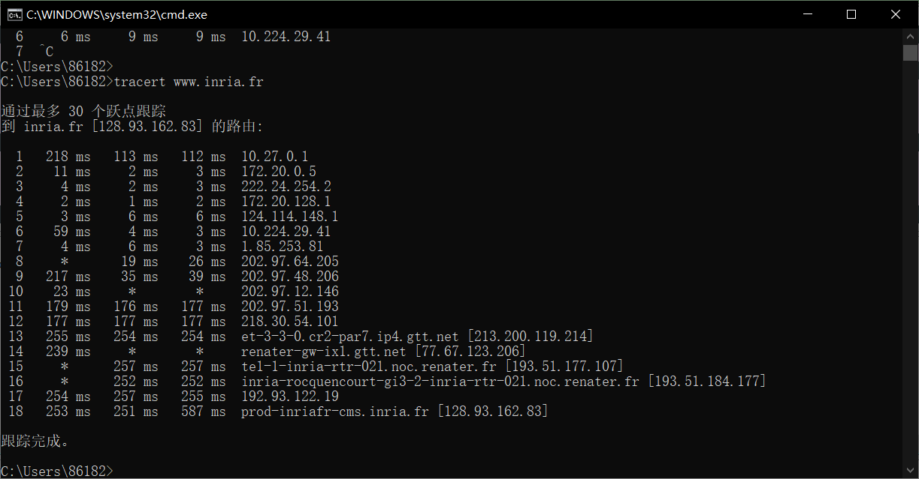
抓取报文结果
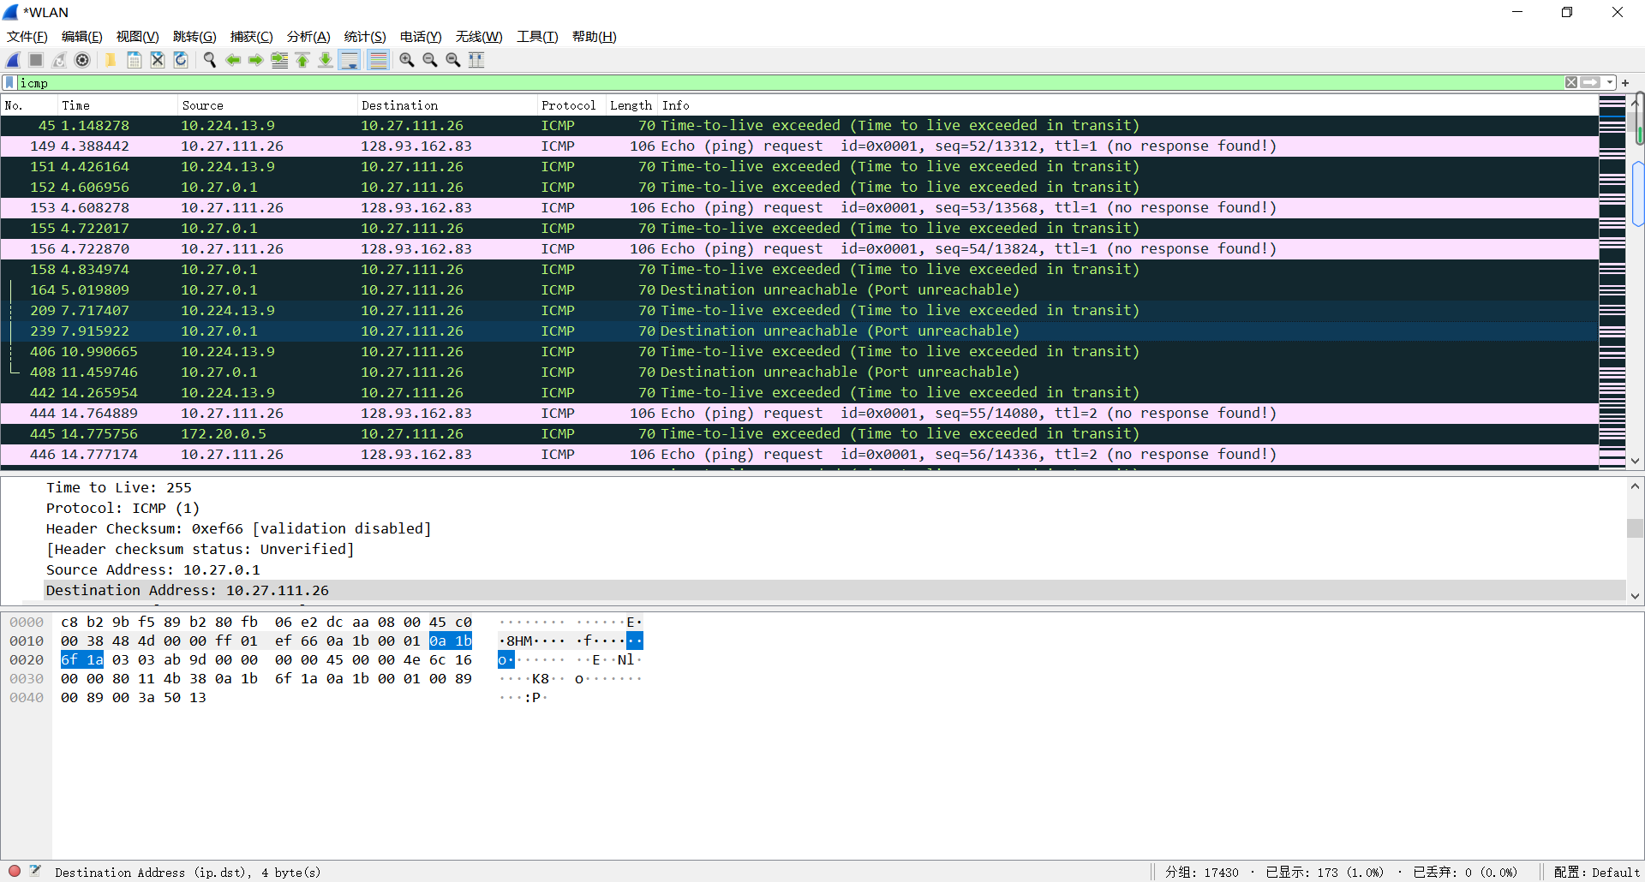

回答第五个问题
主机IP地址：10.27.111.26
目的IP地址：128.93.162.83
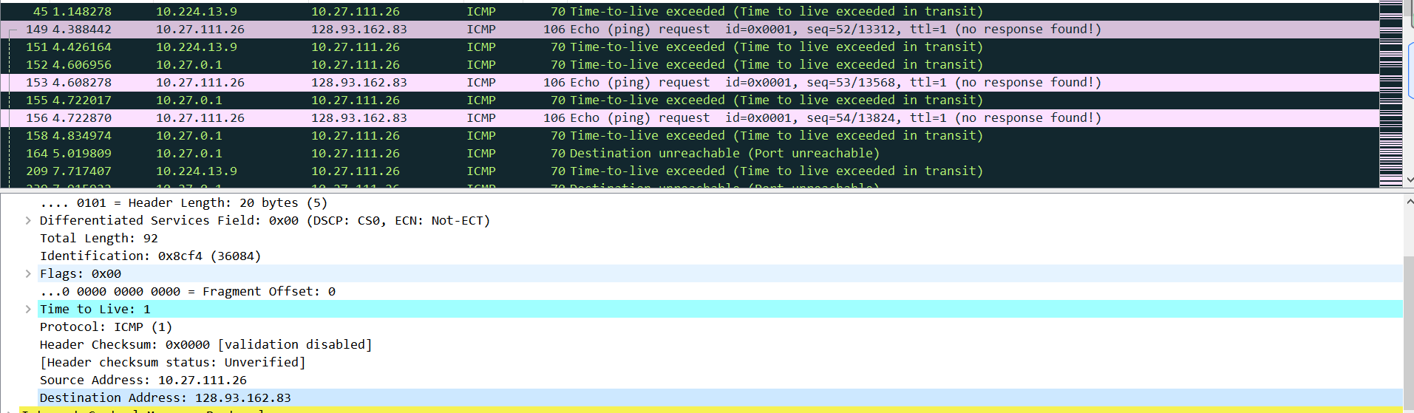

回答第六个问题
不会，协议号不会为零，应为UDP的协议号：17，十六进制表示为0x11，该协议好表明交给UDP处理。

回答第七个问题
Traceroute
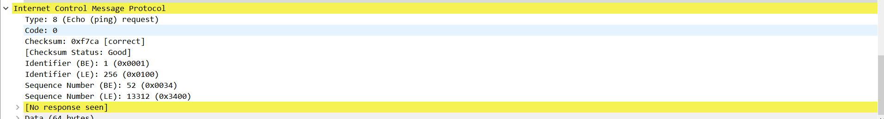
Ping
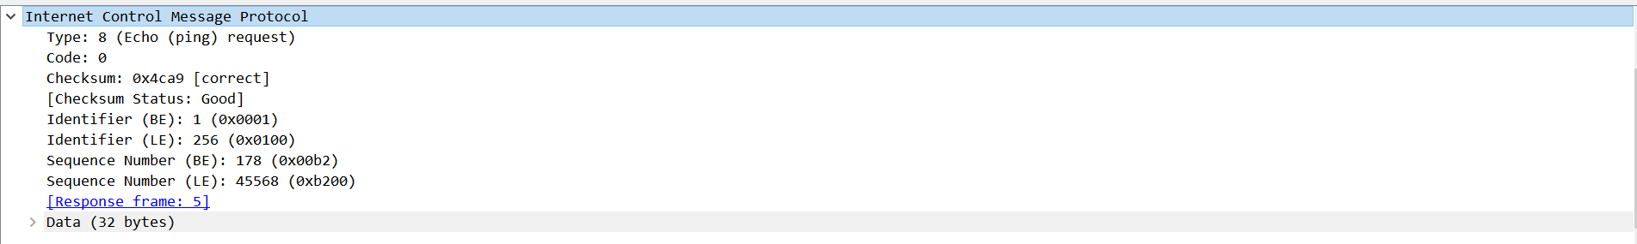
两者没有区别
回答第八个问题
Error包比echo包多了IP数据包的首部信息，还有错误所对应的原始ICMP数据包的前八个字节。
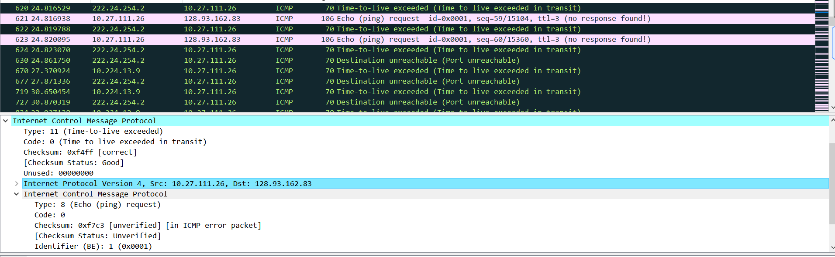

回答第九个问题
最后三个数据包的Type为0（回答）而不是11（超时）。
不同是因为数据包一直到达目的主机，没有超时。
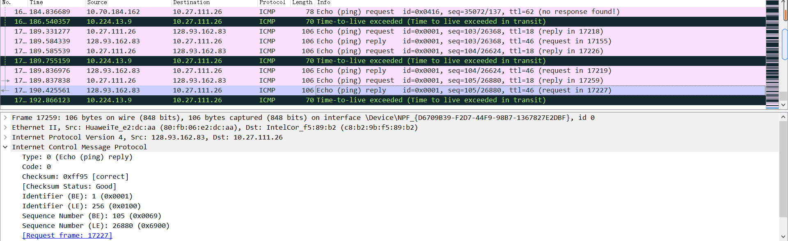

回答第十个问题
第十一步至第十八步的延迟明显长于其他步。猜测这些链接是在中国境外。

三、实验中存在问题及分析。
1.ping操作的时候，会出现请求超时的状况，需要反复ping几次，才可以实现十次ping操作全部成功。
分析：可能当时网络拥塞，发送的请求包被丢弃了。

实验4：ARP
班级 14012008 学号 2020302995 姓名 陈靖
- 实验内容。
- What is the 48-bit Ethernet address of your computer?
- What is the 48-bit destination address in the Ethernet frame? Is this the Ethernet address of gaia.cs.umass.edu? (Hint: the answer is no). What device has this as its Ethernet address? [Note: this is an important question, and one that students sometimes get wrong. Re-read pages 468-469 in the text and make sure you understand the answer here.]
- Give the hexadecimal value for the two-byte Frame type field. What upper layer protocol does this correspond to?
- How many bytes from the very start of the Ethernet frame does the ASCII “G” in “GET” appear in the Ethernet frame?
- What is the value of the Ethernet source address? Is this the address of your computer, or of gaia.cs.umass.edu (Hint: the answer is no). What device has this as its Ethernet address?
- What is the destination address in the Ethernet frame? Is this the Ethernet address of your computer?
- Give the hexadecimal value for the two-byte Frame type field. What upper layer protocol does this correspond to?
- How many bytes from the very start of the Ethernet frame does the ASCII “O” in “OK” (i.e., the HTTP response code) appear in the Ethernet frame?
- Write down the contents of your computer’s ARP cache. What is the meaning of each column value?
- What are the hexadecimal values for the source and destination addresses in the Ethernet frame containing the ARP request message?
- Give the hexadecimal value for the two-byte Ethernet Frame type field. What upper layer protocol does this correspond to?
- Download the ARP specification from ftp://ftp.rfc-editor.org/in-notes/std/std37.txt. A readable, detailed discussion of ARP is also at http://www.erg.abdn.ac.uk/users/gorry/course/inet-pages/arp.html.
- How many bytes from the very beginning of the Ethernet frame does the ARP opcode field begin?
- What is the value of the opcode field within the ARP-payload part of the Ethernet frame in which an ARP request is made?
- Does the ARP message contain the IP address of the sender?
d)Where in the ARP request does the “question” appear – the Ethernet address of the machine whose corresponding IP address is being queried?

13. Now find the ARP reply that was sent in response to the ARP request.
a)How many bytes from the very beginning of the Ethernet frame does the ARP opcode field begin?
b)What is the value of the opcode field within the ARP-payload part of the Ethernet frame in which an ARP response is made?
c)Where in the ARP message does the “answer” to the earlier ARP request appear – the IP address of the machine having the Ethernet address whose corresponding IP address is being queried?

14. What are the hexadecimal values for the source and destination addresses in the Ethernet frame containing the ARP reply message?

- Open the ethernet-ethereal-trace-1 trace file in http://gaia.cs.umass.edu/wireshark-labs/wireshark-traces.zip. The first and second ARP packets in this trace correspond to an ARP request sent by the computer running Wireshark, and the ARP reply sent to the computer running Wireshark by the computer with the ARP-requested Ethernet address. But there is yet another computer on this network, as indicated by packet 6 – another ARP request. Why is there no ARP reply (sent in response to the ARP request in packet 6) in the packet trace?

八、实验操作步骤及结果
操作步骤
- First, make sure your browser’s cache is empty. To do this under Mozilla Firefox V3, select Tools->Clear Recent History and check the box for Cache. For Internet Explorer, select Tools->Internet Options->Delete Files. Start up the Wireshark packet sniffer
- Enter the following URL into your browser http://gaia.cs.umass.edu/wireshark-labs/HTTP-ethereal-lab-file3.html Your browser should display the rather lengthy US Bill of Rights.
Stop Wireshark packet capture. First, find the packet numbers (the leftmost column in the upper Wireshark window) of the HTTP GET message that was sent from your computer to gaia.cs.umass.edu, as well as the beginning of the HTTP response message sent to your computer by gaia.cs.umass.edu. You should see a screen that looks something like this (where packet 4 in the screen shot below contains the HTTP GET message)

回答第一个问题
主机地址：c8:b2:9b:f5:89:b2

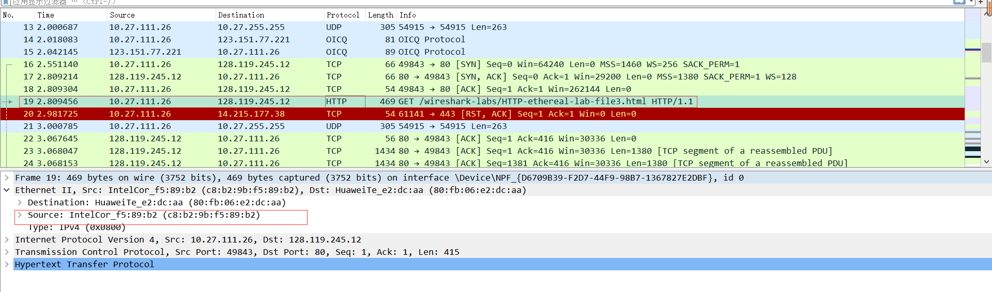

回答第二个问题
目的地址：80:fb:06:e2:dc:aa
这不是gaia.cs.umass.edu的以太网地址，而是华为路由器的地址
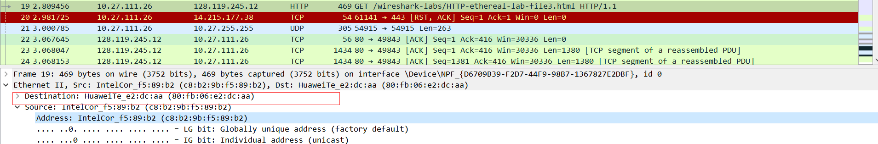

回答第三个问题
0x0800，对应于IPv4
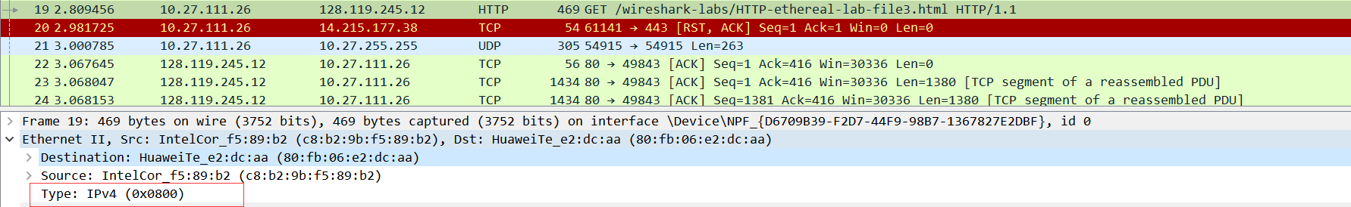

回答第四个问题
前面一共有54个字节，其中有14个字节的以太网帧，20个字节的IP首部和20个字节的TCP首部

回答第五个问题
源地址：80:fb:06:e2:dc:aa
不是我的主机地址，也不是网站地址。这个是华为路由器的地址
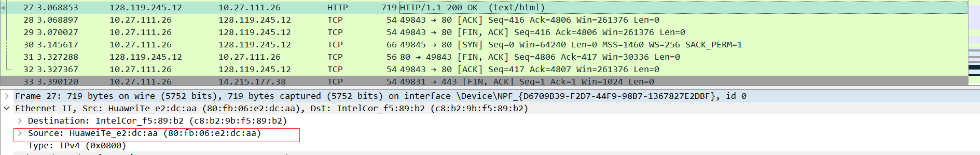

回答第六个问题
目的地址：c8:b2:9b:f5:89:b2
这个是我的主机地址。
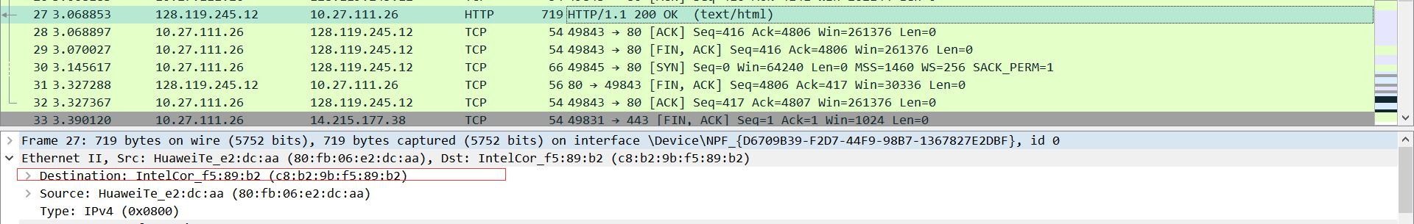

回答第七个问题
0x0800，对应于IP协议
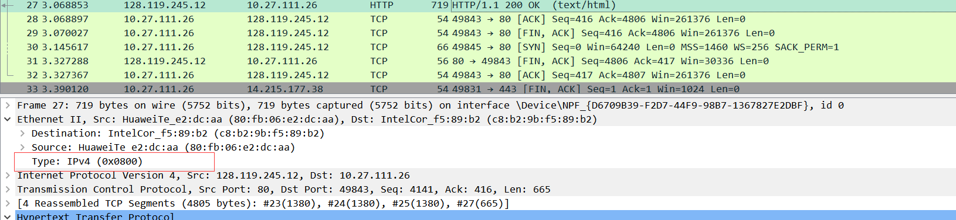

回答第八个问题
前面一共有54个字节，其中有14个字节的以太网帧，20个字节的IP首部和20个字节的TCP首部

回答第九个问题
第一列是Internet地址，即IP地址
第二列是物理地址，即MAC地址
第三列是协议类型
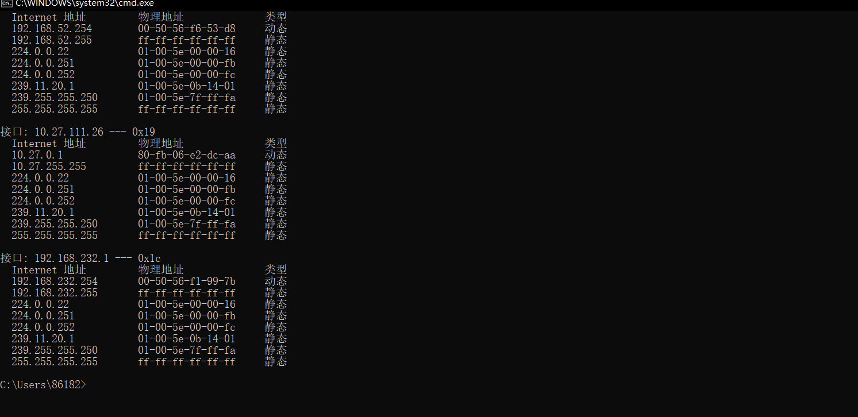

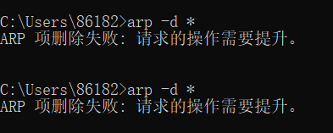

由于使用自己的电脑一直抓取报文失败，所以接下来的实验我选择使用了官方提供的。
回答第十个问题
源地址是：00:d0:59:a9:3d:68
目的地址：ff:ff:ff:ff:ff:ff
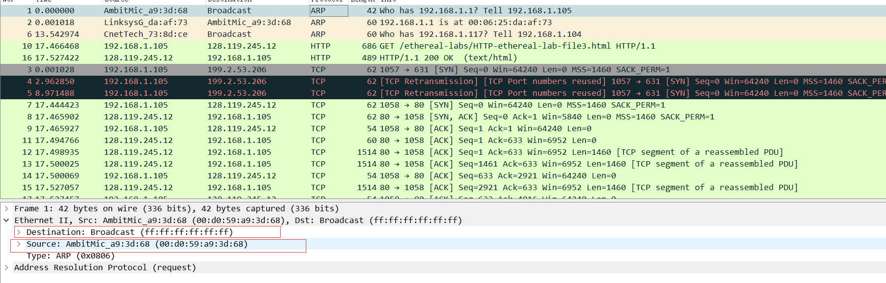

回答第十一个问题
0x0806，对应于ARP协议
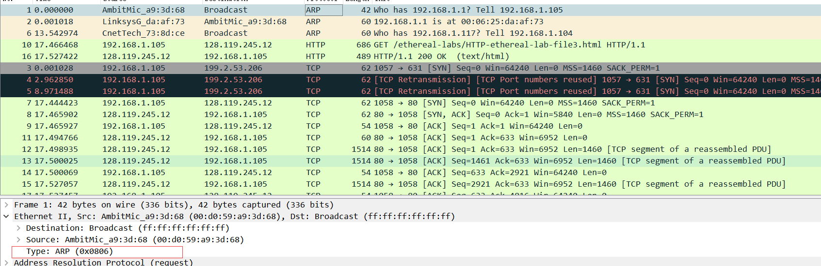

回答第十二个问题
(a)20个字节
(b)0x0001
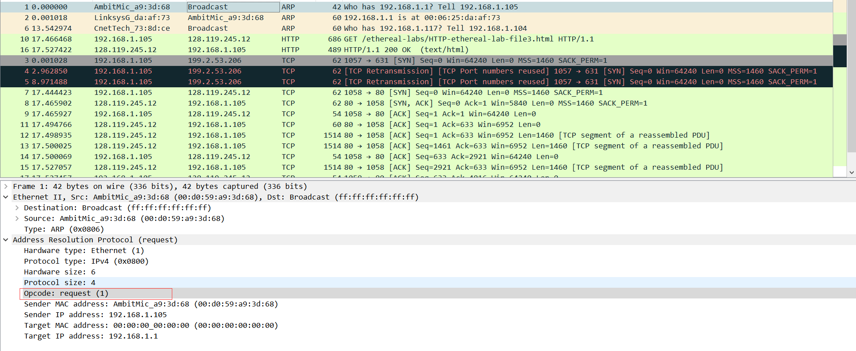
(c)192.168.1.105
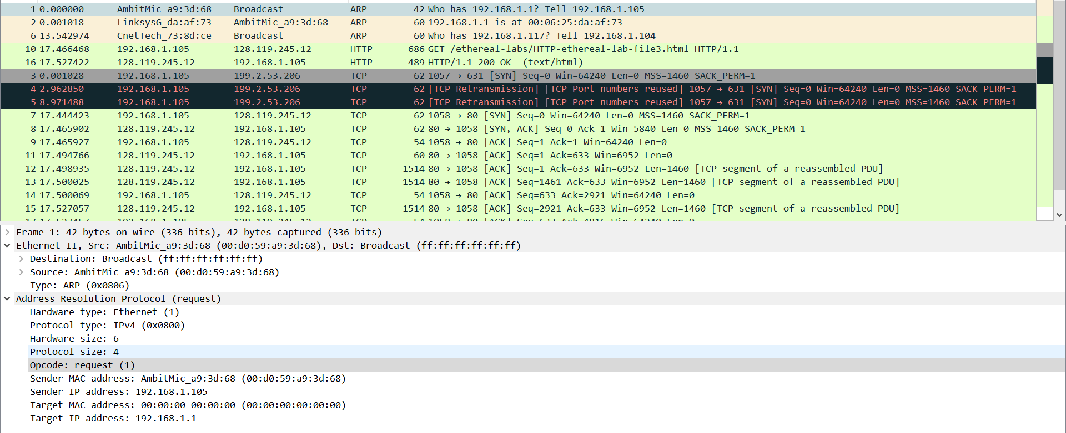
(d) 目标MAC字段：00:00:00:00:00:00
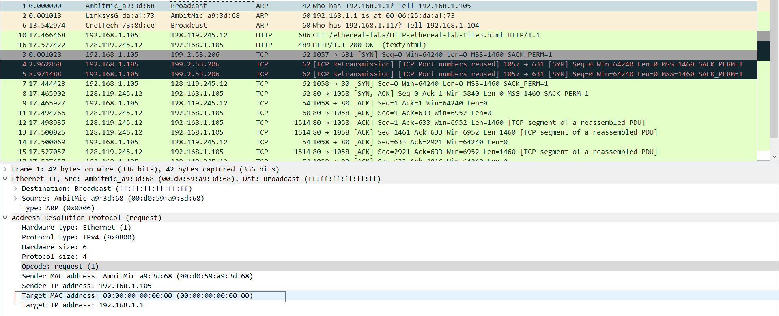
回答第十三个问题
(a)20个字节
(b)0x0002
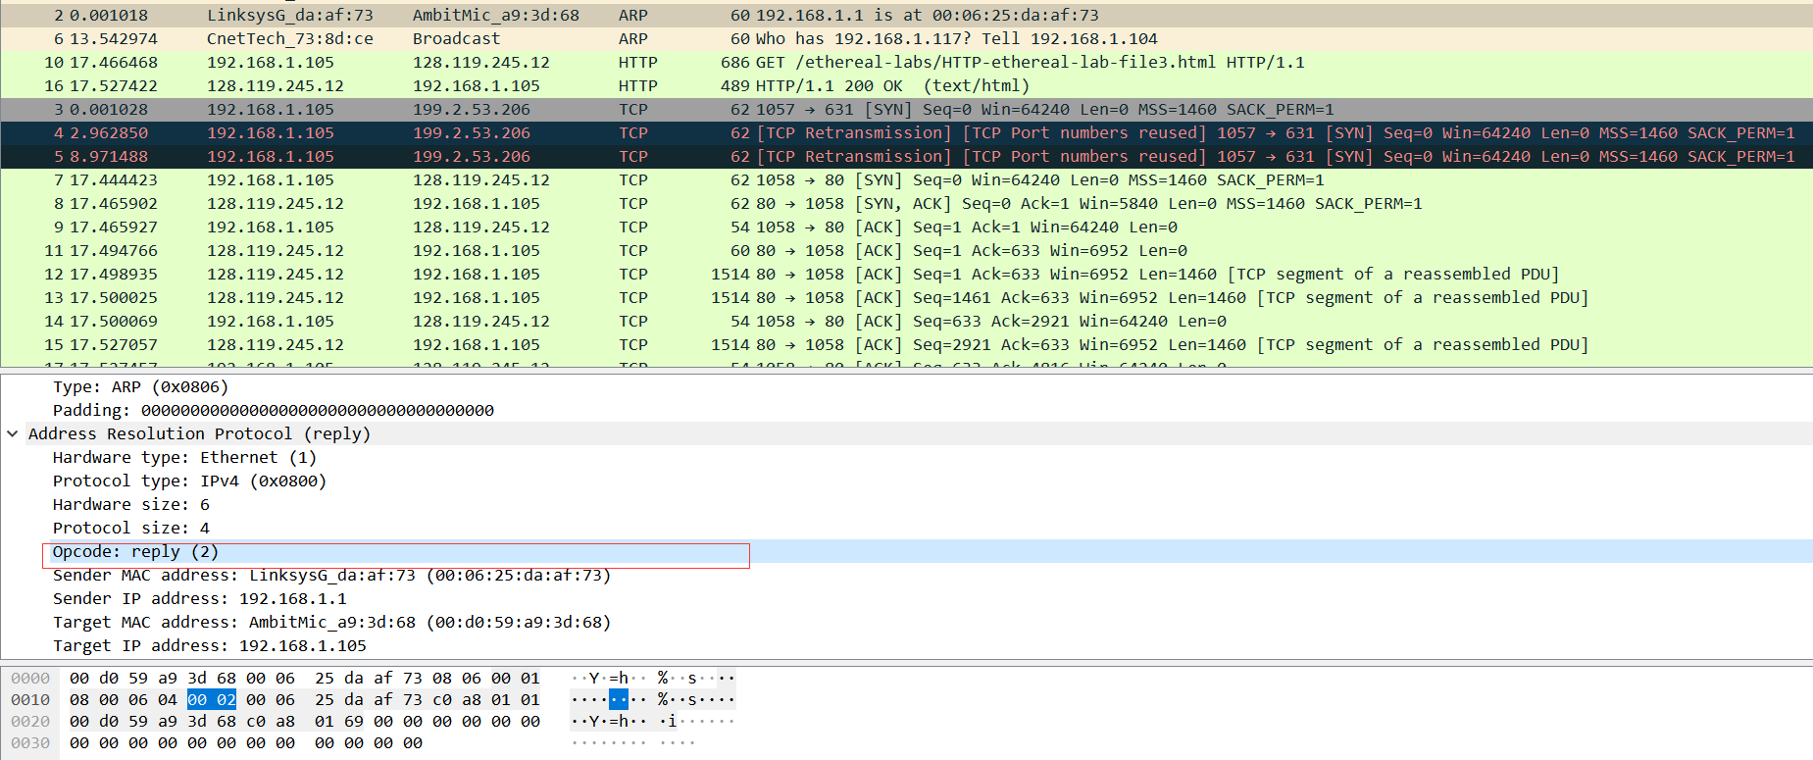
(c)IP地址为192.168.1.1
MAC地址为00:06:25:da:af:73
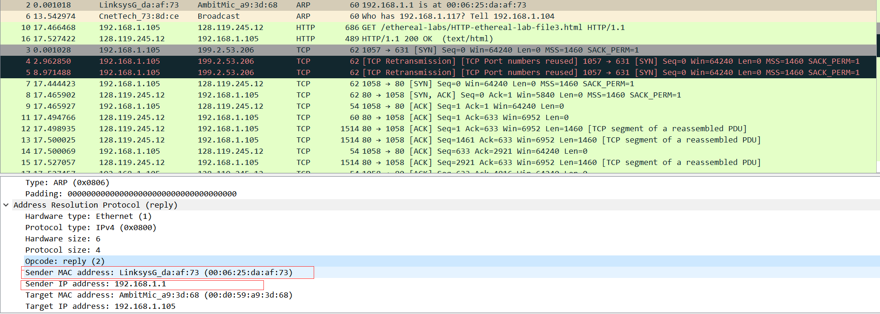

回答第十四个问题
源地址：00:06:25:da:af:73
目的地址：00:d0:59:a9:3d:68

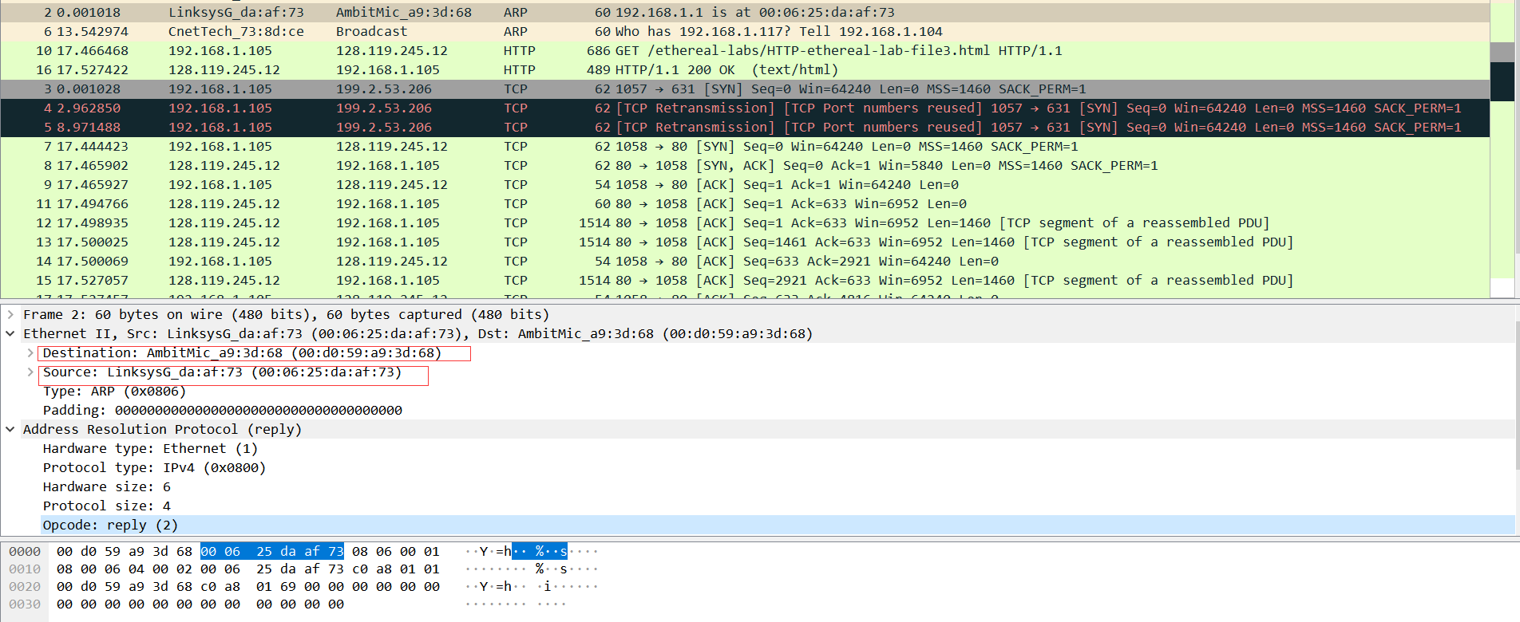

回答第十五个问题
这个ARP请求没有回应是因为我们不是这个请求的主机。
ARP 请求是广播的，但 ARP 回复直接发送回发送者的以太网地址。
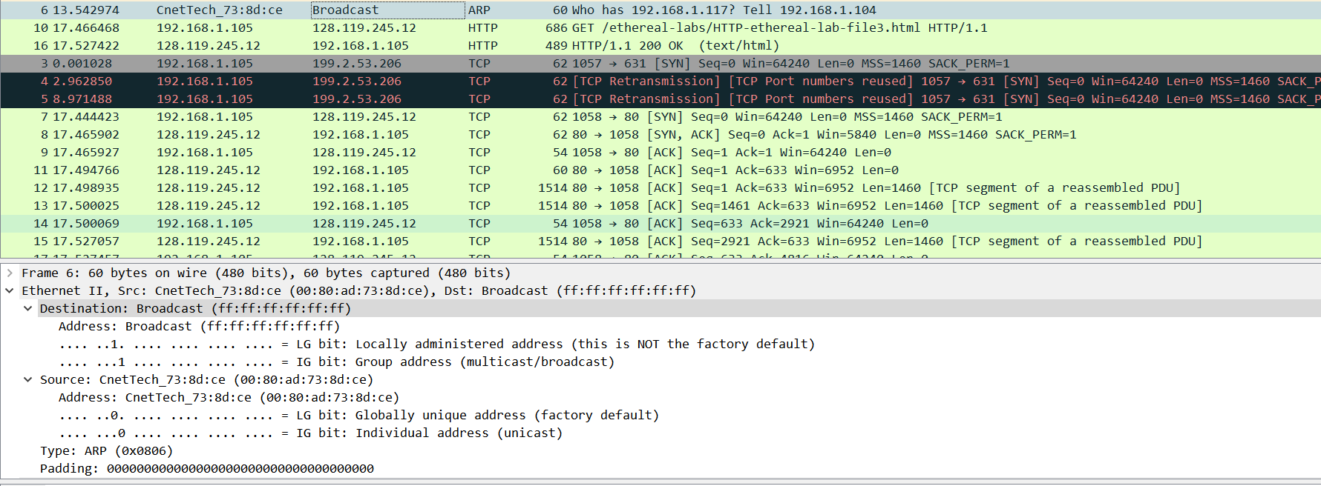

三、实验中存在问题及分析。
1.获取不到ARP报文
分析：可能因为我使用的是WLAN，而不是以太网，所以抓取不到ARP报文。

