Not So Complicated Guide

For the Not So Simple Mobs 2.0

Introduction
The 2.0 version of Nssm (Not_so_simple_mobs) has many new features – first of all:
All 42 mobs are all aggressive.
Next, all mobs spawn in specific conditions, relating to standard biomes. This guide will present them divided by biomes, and describes them using 3 attributes: General Description, Threat Level, and their Drops.

The spawning is calibrated to use Mapgen v6.

General description is a brief description of the mob and of his features.
Threat Level is measured in "*", from 1 (for embarrassing creatures) to 8 (your worst mob nightmare). (1-2 weak, 3-4-5 medium difficult, 6-7 bosses, 8 final boss).
After that you will read something about the monsters' attack type.
Drop is the list containing the objects that the monsters drop when killed.

In all biomes there are some weak creatures but in very rare occasions you may meet their boss: not a happy time, but very rewarding! When killed the bosses drop an object using which you will be able to craft the Mese Egg. Using it it will spawn the Final Boss: the Mese Dragon.

Plains: the Lands of Ducks
Flowery plains are now entirely populated by ducks, a society structured and ruled by powerful and wise kings.

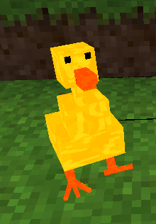
-Standard Duck
General description:
The Standard Duck is a cute but evil creature. It walks around the plains with nothing better to do than to peck players' feet.
It is quite small and it can survive Minetest's cruel world only with the help of its big brothers and sisters that attack the nasty players who want to eat their delicious duck legs!
Threat Level (*)
The Standard Duck can't represent a real danger.
Drops:
-Duck legs
-Life energy
-Duck beak
-Duck feather

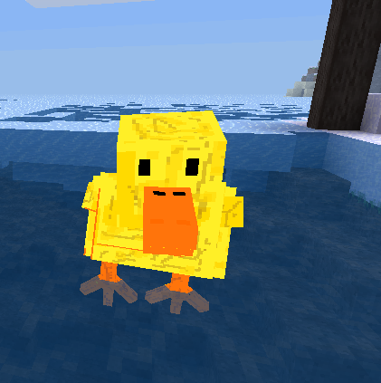
-Swimming Duck
General description:
The Swimming Duck loves to paddle around in the water. It spawns and lives only in rivers and lakes as it can't leave water for obvious reasons: no towel can be crafted for it.
Threat Level (**)
Better not swim next to a Swimming Duck, or anywhere near a group of them, even if the most dangerous thing they can do is peck you.
Drops:
-Duck legs
-Life energy
-Duck beak
-Duck feather

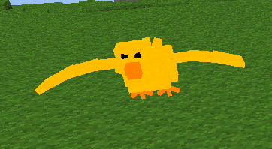
-Flying Duck
General description:
More evil but not faster than Nathan Petrelli, the Flying Duck scours the lands from the sky for the presence of intruders, and attacks them with mighty anger!
Don't be fooled by their silly faces, you'd better not underestimate these flying war machines (just kidding – Always judge the book by its cover!)
Threat Level (***)
The Flying Duck is not too smart, but it can see you from a great distance and rapidly chase you.
You probably won't see it until it is too late, but in this moment it would be too late for it too, as it isn't powerful enough to be sure to hurt you.
Drops:
-Duck legs
-Life energy
-Duck beak
-Duck feather

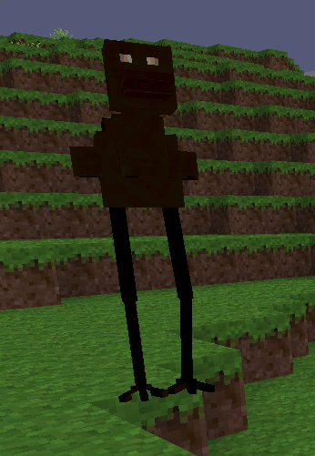
-Enderduck
General description:
Enderducks are tall and dark. They spawn at night, hunting poor miners thanks to their great speed and their brilliant eyes, that allow them to see through the darkness.
Threat Level (****)
Medium Threat Level. Enderducks are fast enough to catch you while you're running and they can kick you very hard. Fortunately they're not so common and they spawn only at night.
Their view range is long but if you use your own keen eye sight, you will easily be able to escape in time, maybe by digging holes, or building a quick shelter, hoping they will despawn sooner or later.
Drops:
-Duck legs
-Life energy
-Duck beak

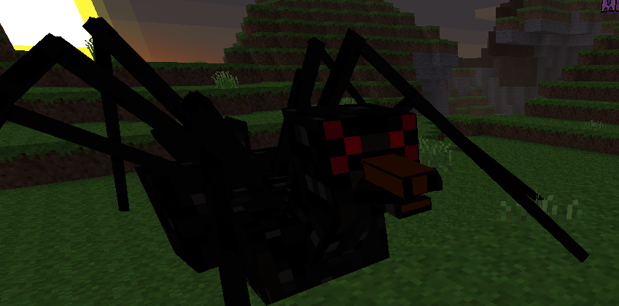
-Spiderduck
General description:
Put your naughty little duck/spider slash fiction away (ew!) – that's not what happened. The DNA sequences are highly preserved between Enderducks and Spiderducks, and spiders and Spiderducks share very few genes, most notably the silk-spinning ones. No mating between those species are possible, so how did it happen? It is obviously a clear example of convergent evolution!
Spiderducks spawn only at night, they're black with six red eyes above their beak, and a pair of chelicerae on the sides of it. Fortunately they're not venomous!
Threat Level (*****):
Like spiders, Spiderducks are very patient, and able to wait for hours for their prey, flipping their head from left to right in an irritating way.
They shoot web projectiles from their mouth and when one of these projectiles hits the target, a sticky web covers the ground trapping the victim. Trying to move in their web is nearly impossible: better to try to break it with your weapons, or to hit the beast from afar with something like a bow. But be careful: the Spiderduck's long legs may still hit you even from a distance.
Drops:
-Many duck legs
-Life energy
-Web
-Duck beak

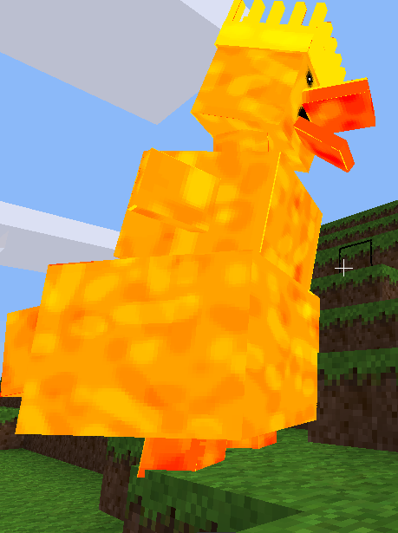
Duckking
General description: Can you imagine a giant Standard Duck with a crown on his head? There you go.
Threat Level (******):
Duckkings have two different ways to attack you: directly with their crowned head, or by shooting duck eggs at you. You may think that Duck eggs aren't so scary, but when the egg hits the ground (or you) a bunch of cute litle Standard Ducks will spawn and chase after you. And no, you don't get to be the daddy.
Drop
-Cloudy with a chance of duck legs!
-Duck crown (necessary to craft the Mese Egg)
-Life energy

Deciduous forest
Giant insects that plagues your nightmares are now infesting each forest in Minetest! Nice!

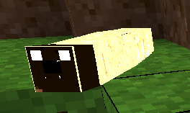
-Larva
General description: Larvae are the first stage of the Mantis and Mantis Beast's development. Their body is white and their head is brown. After some time they evolve into Mantis or Mantis Beasts, so be careful and slay all of them before it is too
late!
Threat Level (*):
Larvae are very slow and weak.
Drop:
-Life Energy

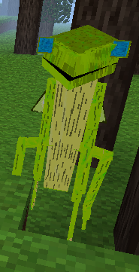
-Mantis
General description:
Tall and human-like, the Mantis exists in two colours and attacks with two powerful kung-fu moves using its 4 arms! They walk on two legs looking for fresh meat: you. Certainly more appetizing than cooked rats!
Threat Level (**):
Their melee attack isn't so violent so don't worry too much about it. But thanks to the Larvae's evolution it is very easy to find them in the forest – as easy as it is to spot a nerd in "The Big Bang Theory".
Drop:
-Mantis claw: with 2 of them you can craft an amazing Mantis Sword!
Recipe
[ ][Mantis claw][ ]
[ ][Mantis claw][ ]
[ ][Stick] [ ]
-Life energy

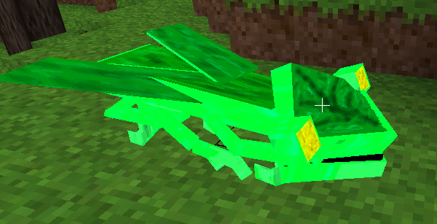
-Mantis Beast
General description:
In spite of being very similar to their bipedal relatives, Mantis Beasts are faster as they run on their 6 claws, in a more beast-like position.
Threat Level (***):
Not too strong but fast and scary, the real problem with it is in how easy it is to find it in your way, for as you already know, larvae are everywhere in the forest.
Drops:
-Mantis claw: with 2 of them you can craft an amazing Mantis Sword!
Recipe
[ ][Mantis claw][ ]
[ ][Mantis claw][ ]
[ ][Stick] [ ]
-Life energy

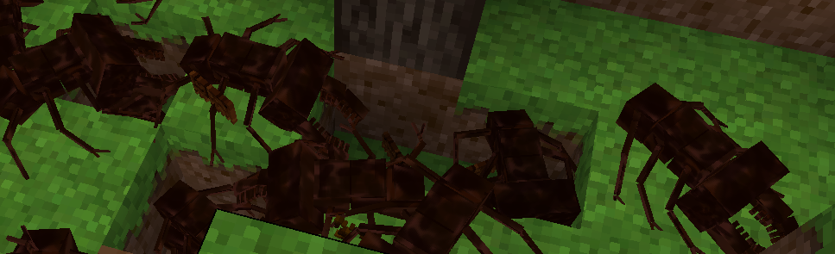
-Masticone
General description:
Masticoni (plural of "Masticone") are insidious creatures. They are the bosses of the deciduous forest and you will soon understand why I'm talking about many of them together. A lonely Masticone isn't a real danger, but when you kill one of them, two others come to take avenge their fallen comrade. The Masticoni's population grows thus exponentially (at a rate of y = 2^{x}, where x is the number of dead Masticoni). Pretty "hydraous" don't you think? (Hydraous is a neologism coming from the Hydra of Lerna in Greek mythology, the monster that Heracles kills in his second labor. To understand how to win over this monster remember that from history and myths we can learn even today: it's up to you to know how Heracles killed the Hydra!)
Threat Level (*******):
I don't want to make the same speech about teamwork that the evil hopper makes in A Bug's Life as
you're are able to understand by yourself how a great number of medium powerful mobs can cooperate to provide you some painful minutes. Kill those that you have to and then run as fast as you can!!
Drop:
-Masticone fang, craft a powerful and fast sword!
Recipe
[ ][Masticone fang][Masticone fang ]
[ ][Masticone fang][ ]
[ ][Stick] [ ]
-Masticone skull fragment (necessary to craft a Masticone Skull, then necessary to craft the Mese Egg)
-Life energy

Coniferous forest
The coniferous forest is the Pumpking's kingdom, where he reigns over his explosive minions.

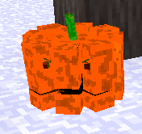
-Big Pumpboom (****)
-Medium Pumpboom (***)
-Small Pumpboom (**)
General description:
Pumpbooms are pumpkin-like creatures that explode next to you following the crazy orders of their evil kings! Of course, the size of the Pumpboom influences the size of their attacks.
Threat Level:
They are dangerous as their explosion can be really painful, but they won't ever be fast as a trained Sam: a careful player can easily escape before the explosion.
Drop:
-Life energy

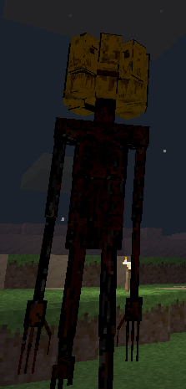
-Pumpking
General description:
The Pumpbooms' kings are tall and creepy creatures. Their human-like black thin body is covered with their victims' blood while their head is very similar to a Pumpboom. Some naturalists have hypothesized an ancient symbiosis between a Signosigno and a Pumpboom that created new dreadful creatures!
Threat Level (*******):
Pumpkings are strong opponents thanks to their powerful heads and arms. Furthermore, on their death, they hide a little surprise for the unlucky warrior strong enough to be able to defeat them...
Drop:
-Cursed pumpkin seed (necessary to craft the Mese Egg)
-Life energy

Underground
While you're mining you always risk of hurting yourself from a fall, but another great danger is certainly lava... What would you think if I told you that lava can now shape evil titans?

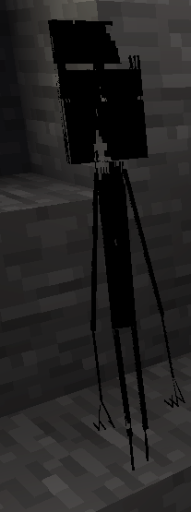
-Signosigno:
General description:
When miners die in the darkness, under many tons of stone, their soul can't simply go to Heaven or Hell: the shadows swallow it, giving birth to really creepy monsters. They're thin as spaghetti, nearly invisible and faceless, but you will meet them only in the darker corners as light is for them the greatest danger.
Threat Level (***):
Signosignos slide behind you while you're mining and brutally attack you with their sharp nails. You won't detect their presence very easily: their transparent skin is their best weapon and your worst friend.
Drop:
-Life energy

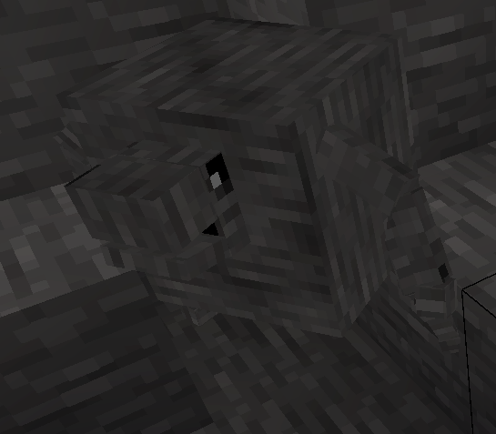
-Bloco:
General description:
The Bloco is a cuboid creature made of stone, equipped with a little face and short arms and legs. It's a little clumsy while walking but he can chase its enemies rolling like a ball – a cubic ball of course!
Threat Level (**):
Their skin is strong but they have limitations. They aren't very clever: they only attack using their head, but only to hit you, with very little thought put into it. Their stone-skin may help them in camouflage, but when they start rolling and walking rolling and walking they mess up everything.
Drop:
-Stone
-Life energy

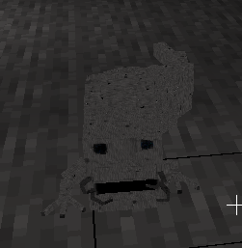
-Stoneater
General description:
Stoneaters are ugly worms that keep eating stone day and night with their mouth-claws, faster than diamond picks… they probably don't have anything better to do. Oh no, I forgot: they also love the taste of Sam-flesh, but to save yourself remember that they aren't able to jump.
Threat Level (***)
Their digging ability is quite formidable, but they aren't a great danger otherwise.
Drop:
-Life energy
-Stone

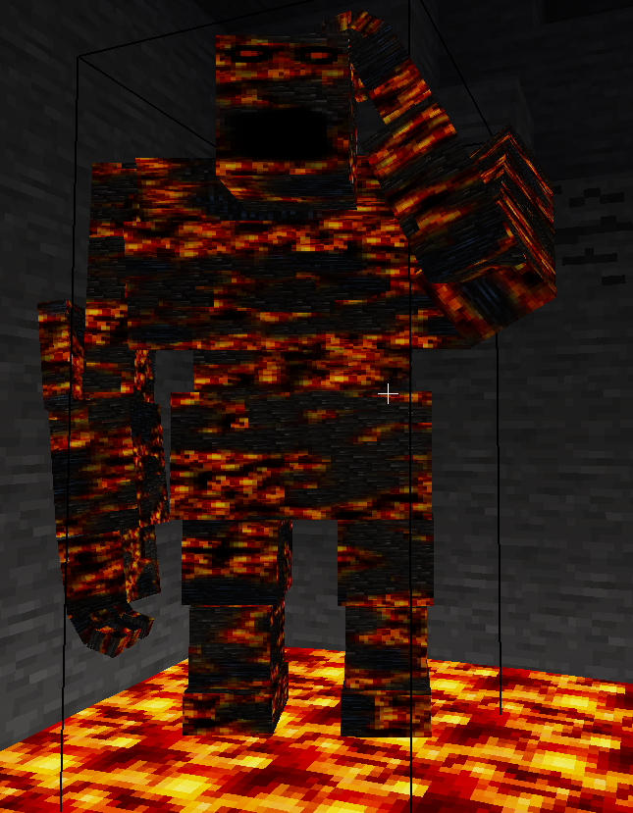
-Lava Titan
General description:
Lava Titans are huge and slow but not too smart, made of obsidian, stone and lava. The high temperature of their body can melt stone creating new lava, the source of their power.
They're very strong and well armored: defeating them could be complicated for unprepared players.
Threat Level (*******):
Hitting the ground with their fist, Lava Titans can surround you with four lava columns, while with another fist they can crash you to into the ground, flattening you like an omelette!
Drop:
-Lava Titan eye (necessary to craft the Mese Egg)
-Life energy

Jungle
Being entirely populated by arachnids and covered by webs, the jungle is probably one of the most dangerous places in Minetest's world… I'm warning you, arrogant player!

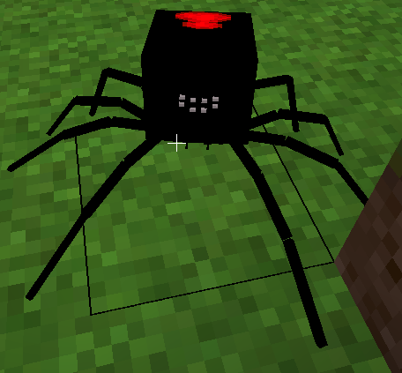
-Black Widow
General description:
Black Widows are medium sized spiders with a big red marked abdomen. The light coloured eyes are the only part of the body that aren't black. While they're walking they generate web around them.
Threat Level (****):
The webs are really sticky and many Black Widows desire only to eat you while you're trapped inside them.
They attack with small but powerful chelicerae, moving in a regular but deadly dance.
Drop:
-Spider legs
-Life energy
-Web

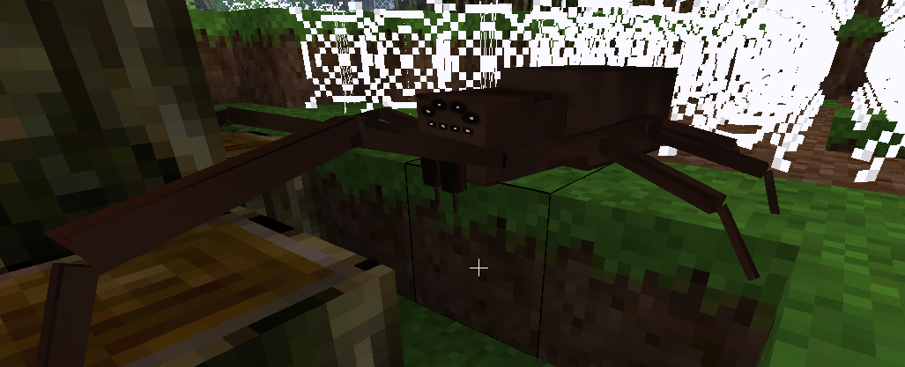
-Uloboros
General description:
Uloboros are medium/high sized brown spiders with a small abdomen, creepy eyes and long anterior legs. As others they generate webs too.
Threat Level (****):
Nothing particular to add. They attack with their anterior legs and their head.
Drop:
-Spider legs
-Life energy
-Web

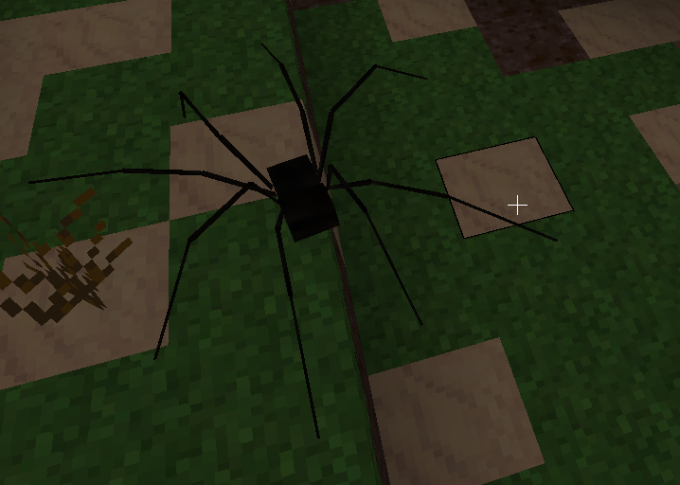
-Daddy Longlegs
General description:
Daddy Longlegs are small spider-like creatures with a small body and obviously, long legs!
Threat Level (***):
It's not dangerous as its relatives but its attack is powerful.
Drop:
-Spider legs
-Life energy

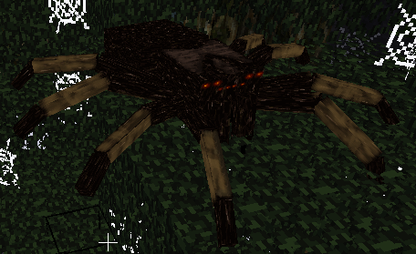
-Tarantula:
General description:
Big, brown and hairy, Tarantulas are the bosses in the jungle. They're very aggressive and characterized by thick legs and a small abdomen.
Threat Level (******):
I think that describing them as very strong predators hunting you in a dark jungle full of webs is already exhaustive.
Drop:
-Tarantula chelicerae (necessary to craft the Mese Egg)
-Spider legs
-Life energy

Sky
The sky is ruled in the day by the Phoenix and in the night by the Night Master. They're both followed by their henchmen.

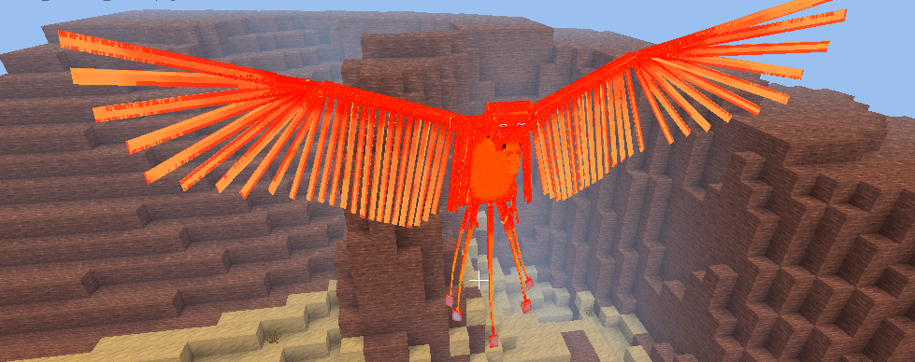
-Scrausics
General description:
The Scrausics is weaker, colder and smaller than the Phoenix. Their tail and head are less adorned too but in each case they're powerful sky mobs! It's a bit like comparing Pidgeotto to Moltres.
Threat Level (****):
Scrausics have powerful beaks with which they attack those who invade their territories.
Drop:
-Raw Scrausics wing
-Life energy

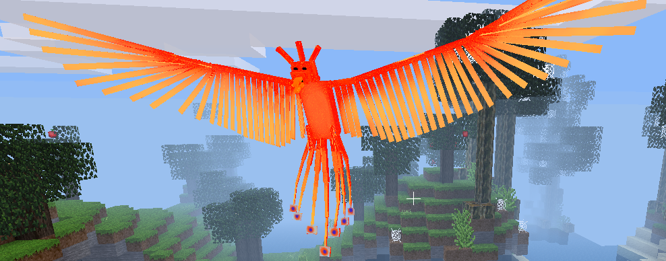
-Phoenix
General description:
The Phoenix is a beautiful bird made of fire and energy, outshone only by the sun itself. The Scrausics, their weak but more common relatives, serve them.
Threat Level (******):
The Phoenix attacks fluttering its wings: this action generates a column of fire in their victims' direction.
Drop:
-Sun feather (necessary to craft the Mese Egg)
-Phoenix nuggets
-Phoenix tear
-Life energy

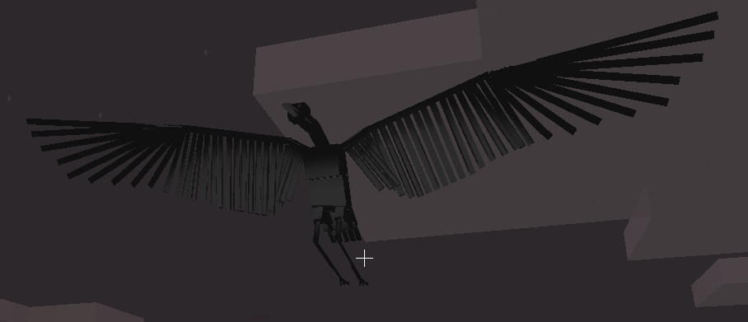
-Moonheron
General description:
Once upon a time, when ancient Minetesters looked at the sky during the night, they were shocked by seeing half-moons flying here and there. But after some time they discovered which kind of trick it was: new birds in the darkness, flying around showing the half-moon painted on the underside of their wings. They called them “Moonherons”.
Threat Level (****):
The long beak and the sharp view make a Moonheron a strong enemy in the night.
Drop:
-Moonheron leg (by cooking a Moonheron leg you will obtain a Chichibio's * Moonheron leg.
-Life Energy

* Chichibio is the main character of one of the short stories that appears in Boccaccios's Decameron. Chichibio was a cook who was cooking a heron to his master, but he decided to give one of its legs to a beautiful girl to seduce her. Of course his master became very angry but he forgave him thanks to Chichibio's funny and intriguing answer.)

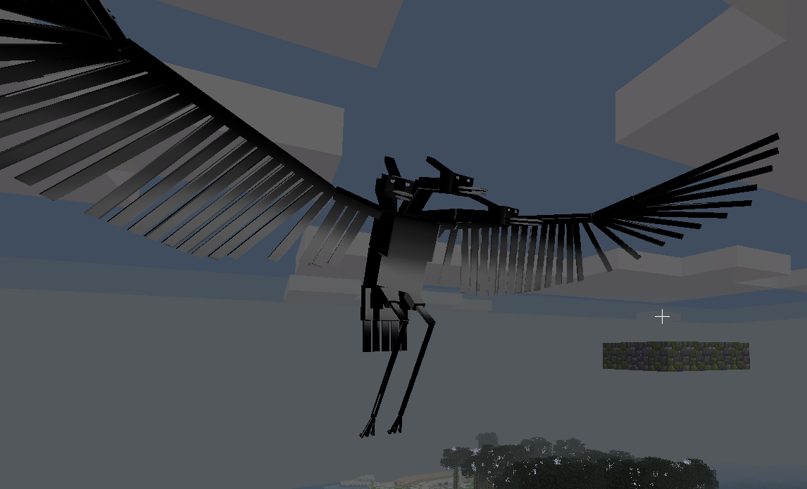
-Night Master
General description:
Night Masters are a special kind of Moonheron with three heads and of some other particulars that you will discover on your own.
Threat Level (******):
They're very fast, and thanks to their three heads they can see for great distances. Few people survive to tell their meeting with the three beaks of this great fierce bird.
Drop:
-Life energy
-Moon Feather (necessary to craft the Mese Egg)
-Moonheron Leg

Mountains
Mythical creatures conquered, a long time ago, the hills and the mountains in Minetest. Probably they were inspired by the ancient Greeks who used to build their temples and cities on the top of the hills.

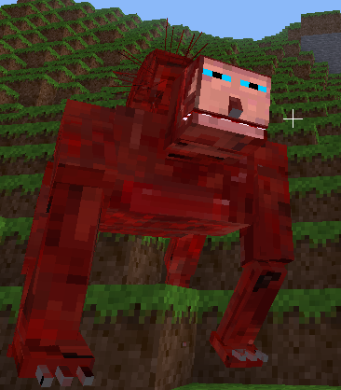
-Manticore
General description:
I offer you the words of someone more knowledgeable than me who expounded what a Manticore is:
Ctesias, Indica (summary from Photius) (Greek historian C4th B.C.) :
“The Martikhora (Manticore) is an animal that was found in this country [India]. It has a manlike face, its skin as red as cinnabar, and is as large as a lion. It has three rows of teeth, but his ears and his blue eyes are exactly those of a human. Its tail is that of a land scorpion, ending with a sting more than a cubit long. It has other stings on each side of its tail and one more on the top of its head, with which it can inflict an absolutely fatal wound. The stings are about one foot long, and as thick as a small rush. Only the elephant can survive to its attack.”
If it is attacked from a great distance, it raises its tail and it uses it as a bow to loose its stings. If attacked from behind, it straightens it out and throws its stings in a direct line, covering the distance of a hundred feet.
The Martikhora is a Persian name and this beast is called in Greek “Anthropophagos,” both the Persian and the Greek name mean “Man-Eater.” In fact, even if it hunts a large variety of animals, it kills and devours a greater number of human beings.
It fights with both its claws and its stings, that, according to Ktesias (Ctesias), grow back again after being discharged. There is a great number of these animals in India, and they're hunted with spears or arrows by natives on the neck of huge elephants”.
Threat Level (*****):
You have to be very careful with Manticores as they are strong and fast and their projectiles hurts a lot.
Drop:
-Life energy

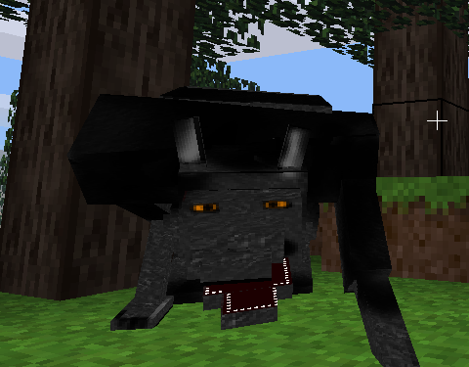
-Mountain Werewolf
General description:
Mountain Werewolves, different from the Winter Werewolves that you can find in cold biomes, are tall and dark gray creatures. They have yellow crazy eyes and powerful jaws that they use to break human bones.
Threat Level (****):
Werewolves are dangerous and fast enemies.
Drop:
-Werewolf fur
With 3 werewolf furs you can craft 16 ropes!
[ ][Werewolf fur][ ]
[ ][Werewolf fur][ ]
[ ][Werewolf fur][ ]
-Werewolf leg
-Life energy

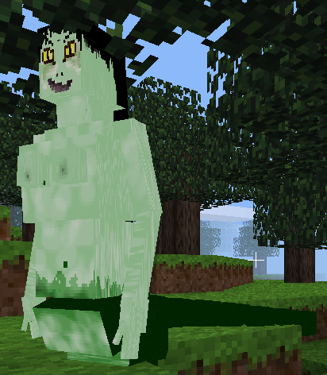
-Echidna
General description:
Echidnae could be beautiful women if they hadn't that terrible snake tail and that sick-green pale skin. They've got black hair, as black as a crow's wings. They're half naked but you probably won't have the time to care about it: the one who gets lost in those terrible but beautiful eyes, is dead.
Threat Level (*******):
Echidnae are probably the most dangerous creatures in Minetest, if not considering the most powerful creature in history, the sovereign of all mobs.
They exhale a cloud of venomous gas, invisible to you until it's to late: it hurts you and painfully suffocates you. When you come too close to them they hit you with their powerful tail.
Drop:
-Life energy
-Snake scute (necessary to craft the Mese Egg)

Cold regions
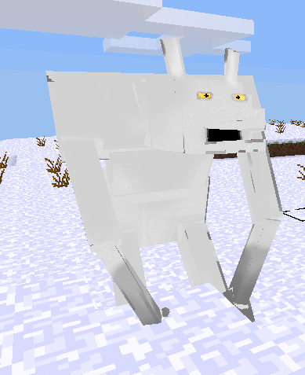
-Winter Werewolf
General description:
Winter Werewolves are similar to their cousins but they seem to disappear in the snowy biomes, thanks to their colour.
Threat Level (****):
They don't do anything different than their mountain counterparts – except that they prefer to drink fresh blood directly from the throat of their victims.
Drop:
-White Werewolf fur
-Werewolf leg
-Life energy

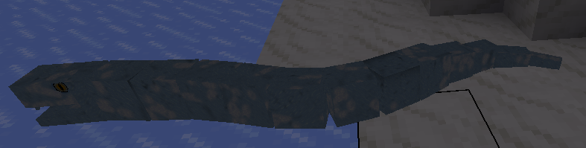
-Icesnake
General description:
This amphibian may seem to an ice-made snake that slices on ice blocks and freezes the water next to him. Icesnakes aren't very big or evil but they attack enemies with their fangs very rapidly.
Threat Level (***):
Open your eyes and use them very well: their ice-like skin is very efficient for camouflage.
Drop:
-Frosted amphibian heart
-Life energy

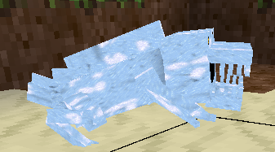
-Snowbiter
General description:
Those little amphibians are ice-made frogs with dreadful jaws! As the icesnake, its so cold that it can freeze water.
Threat Level (**):
Their bites are very dangerous but Snowbiters aren't very resistant to direct attacks.
Drop:
-Frosted amphibian heart
-Life energy

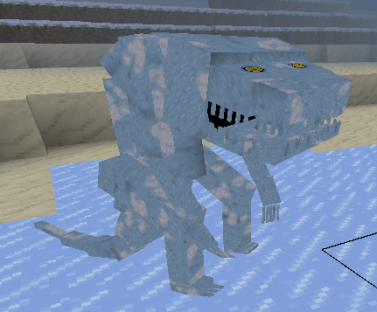
-Icelamander
General description:
Taller than a normal Sam, the Icelamanders have even more frightening jaws than Snowbiters!
They have a long tail that helps them to keep the balance on their two legs. The Icelamanders are so cold that they frost everything while walking, not only water!
Threat Level (*******):
They're frosting power is so strong that they can freeze you in an ice column even from a great distance! But when you get to near to them they prefer to devour you with their terrifying fangs. You have now certainly understood that Icelamanders are really really dangerous.
Drop:
-Frosted amphibian heart
-Life energy
-Ice tooth (necessary to craft the Mese Egg)

Ocean and beach
Water is the origin of life and for this reason many different creatures evolved and now live in this biome.

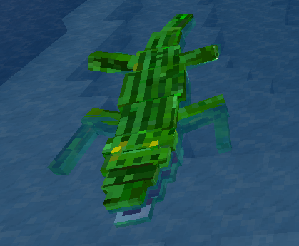
-Crocodile
General description:
I don't think that Minetesters may ignore what a crocodile is so I won't spend too many words for it.
Threat Level (***):
Crocodiles are slow but strong. They don't have a wide view range but they know how to bite.
Drop:
-Crocodile tail
-Energy life

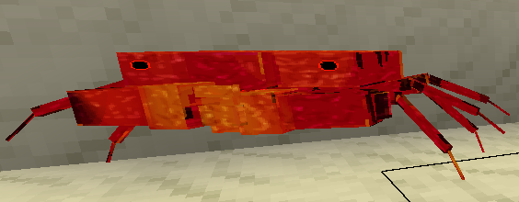
-Crab
General description:
Crabs live in the beach and they don't float in water, preferring walking on the sand pinching their enemies with their powerful claws. They can be in two different colours: red or light orange.
Threat Level (***):
Crabs are dangerous because of their strong attack, but a careful adventurer would be able to slay one of them without losing a drop of blood!
Drop:
-Energy life
-Crab chela (claw) craft two powerful maces, light and faster, heavy and stronger!
Crab light mace:
[ ][Chela][ ]
[ ][Stick][ ]
[ ][Stick][ ]
Crab heavy mace:
[ ][Chela][ ]
[Chela][Chela][Chela]
[ ][Stick][ ]
-Surimi

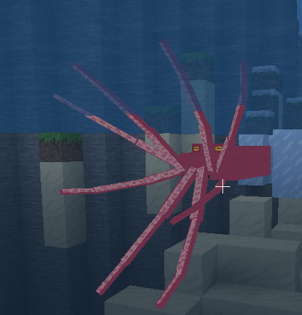
-Octopus
General description:
Octopuses are the red-rose little brothers of Krakens, but they are much weaker.
Threat Level (**):
Octopuses attack hugging strongly their victims but in reality they're not very powerful. They have survived only because of they are a great number and thanks to the help of their master.
Drop:
-Tentacle
-Life energy

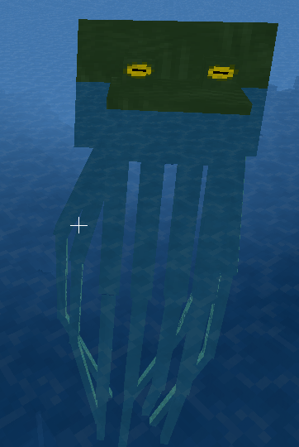
-Kraken
General description:
The sea's kings are giant Octopuses with longer tentacles. They use them to attack in a devastating way but their huge dimension doesn't allow them to swim fast. Females are red-rose as Octopuses while males are dark green.
Threat Level (*******)
Krakens have a huge amount of life and a powerful attack.
Drop:
-Tentacle
-Life energy
-Kraken tentacle (necessary to craft the Mese Egg)

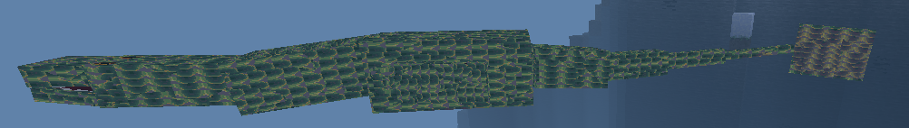
-Dolidrosaurus
General description:
Dolidrosauruses are the most variegated monsters in Minetest as they can have more different colours, remaining all the same evil beasts. They're aquatic reptiles provided of a long tail ending with a fin. They have two more fins on the side, that allows to swim faster and more precisely.
The name Dolidrosaurus derives from Greek: Dolichol is a terpenoid family, Hydor is water and Sauros stays for lizard.
Threat Level (*****)
Dolidrosauruses attack with a strong bite made stronger by the propulsion of their neck. They're fast but not so big and armored.
Drop:
-Life energy

Desert
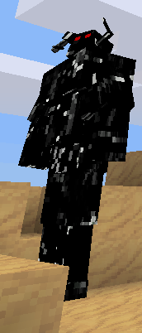
-Dahaka
General description:
The Dahaka appears in Prince of Persia Warrior Within as the guardian of the time-line. Thanks to its power it came to Minetest: it's so strong that it can cross even videogames, not only time!
Dahakas are black, humanlike, massive monsters. Nothing can stop them: they simply keep walking and all the materials in front of them just disappears.
Threat Level (*******):
Dahaka is unstoppable because of its power: he can chase you even if there are obstacles. Fortunately it's very slow but it attacks with a powerful punch or with creepy tentacles that exit from its belly.
Drop:
-Black sand (necessary to craft the Mese Egg)
-Energy life

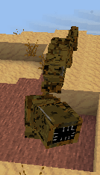
-Sandworm
General description:
Sandworms are huge eyeless worms that live digging and eating sand. For this reason they life in the desert, where they can find all sand they want. They attack people only to defend their precious sand. Their body is always half buried in the ground.
Threat Level (*****)
Sandworms are strong and they attack with their mouth biting the unlucky sand digger. The only weak part of the Sandworm is its head: keep it in mind!
Drop:
-Worm flesh
-Energy life

Dungeons
The standard dungeons are replaced with creepy ones made of "ants' dirt": normal dirt previously digested by them. Lots of ants spawn there, so be careful!

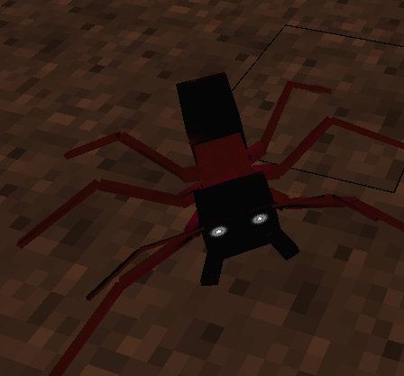
-Ant Worker
General description:
Ant workers can only think about working so they would not attack you unless you hit them first.
They are smaller and thinner than other ants and their thorax and their legs are red. The head and the abdomen are black.
Threat Level (*):
They aren't dangerous at all.
Drop:
-Ant leg
-Energy life

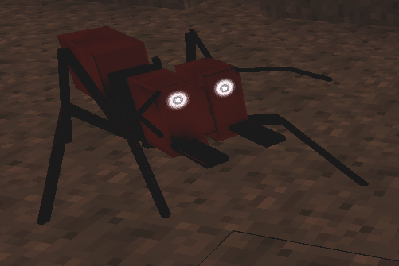
-Ant Soldier
General description:
Ant Soldiers live only to serve their Queen and to
preserve the integrity of their colony, fighting against each kind of intruder. They have a larger head than Ant Workers, their abdomen is red as their head, while the other parts are black.
Threat Level (***):
If you meet a lonely Ant Soldier you won't be in a great danger, but many of them could be a really huge problem!
Drop:
-Ant leg
-Energy life

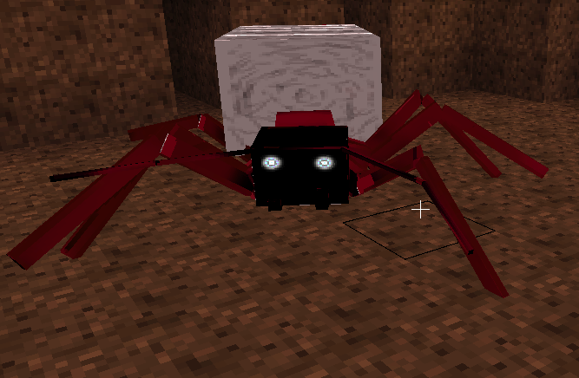
-Ant Queen
General description:
Ant Queens look like Ant Workers but they have huge abdomens with which they spawn their great number of
children.
Threat Level (******):
Ant Queens are too aristocratic to attack you but at each punch they spawn an Ant Soldier that will defend her.
Drop:
-Ant leg
-Energy life
-Ant Queen abdomen (necessary to craft the Mese Egg)

Life energy
With 9 Life energy you can craft an Energy globe, with 9 Energy globe you can craft a Great energy globe, with 9 Great energy globe you can craft a Superior energy globe. With Great energy globe you can craft amazing energy weapons: Kienzan and Kamehameha.
Kienzan can cut everything, Kamehameha explode when hit stone.
Kienzan:
[ ][ ][ ]
[Great energy globe][Great energy globe][Great energy globe]
[ ][ ][ ]
Kamehameha:
Great energy globe][Great energy globe][Great energy globe]
Great energy globe][ ][Great energy globe]
Great energy globe][Great energy globe][Great energy globe]

Final boss

How to summon him:
You need all the bosses special drops:
-Black sand
-Ant Queen abdomen
-Tarantula chelicerae
-Ice tooth
-Cursed pumpkin seed
-Kraken tentacle
-King Duck crown
-Snake scute
-Lava Titan eye
-Moon feather
-Sun feather
-Masticone skull

Now you have to craft some intermediate products:
Black ice tooth:
[ ][Black sand][ ]
[ ][Ice tooth][ ]
[ ][ ][ ]

Sky feather:
[ ][ ][ ]
[sun feather][ ][moon feather]
[ ][ ][ ]

Masticone skull:
[Masticone skull fragments][Masticone skull fragments][Masticone skull fragments]
[Masticone skull fragments][Masticone skull fragments][Masticone skull fragments]
[Masticone skull fragments][Masticone skull fragments][Masticone skull fragments]

Masticone skull crowned:
[ ] [King duck crown][ ]
[ ][Masticone skull][ ]
[ ][ ][ ]

Eyed tentacle:
[ ][Lava Titan eye][ ]
[ ][Kraken tentacle ][ ]
[ ][ ][ ]

Now its time to craft the egg
[Tarantula chelicerae][Masticone skull crowned][Eyed tentacle]
[Black ice tooth][Superior energy globe][Sky feather]
[Cursed pumpkin seed][Ant Queen abdomen][Snake scute]

Now point the egg on the ground and use it!
Its time to fight!
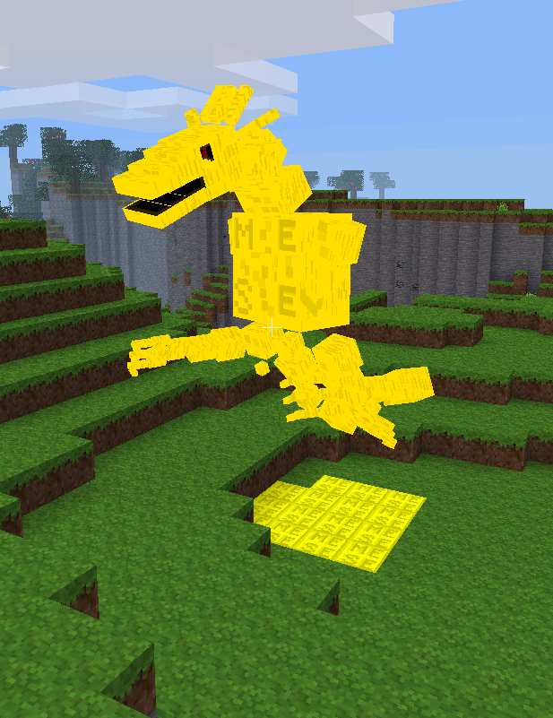
-Mese Dragon
General description:
The Mese Dragon is the most powerful mob of all times! Nobody really knows its power, as nobody is returned after having fought against him yet.
We know that it has the most amazing object that is possible to imagine but nobody knows what it is. Many legends and songs have been written about it!
If you manage to defeat it we would be happy to write your name on the first post of our thread, so in case make a screenshot and send it to us!
Threat Level (********):
It is very dangerous and it can attack in three different ways! He has the power of his voice, of his strength and of the sky!
Drop: who knows...

Good luck Minetest players!

