# Selections from “Great Pictures, as Seen and Described by Famous Writers”

The selections here have been taken from “*Great Pictures, as Seen and Described by Famous Writers*, Edited and Translated By Esther Singleton, 1899”

## THE LAST JUDGEMENT (MICHAEL ANGELO)

ALEXANDRE DUMAS

While Michael Angelo worked upon his *Moses*, Clement VII., following the example of Julius II., would not leave him alone for a moment. It was a trick of all these Popes to exact from the poor artist something different to what he was doing at the time. To obtain some respite, he was forced to promise the Pope that he would occupy himself at the same time with the cartoon of *The Last Judgment*. But Clement VII. was not a man to be put off with words; he supervised the work in person, and Buonarroti was obliged to pass continually from the chisel to the pencil and from the pen to the mallet. *The Last Judgment!* *Moses!* these are two works of little importance and easy to do off-hand! And yet he had to. His Holiness would not listen to reason.

One day it was announced to Michael Angelo that he would not receive his accustomed visit: Clement VII. was dead. The artist breathed freely just during the Conclave.

The new Pope, Paul III., had nothing more pressing to do than to present himself in Buonarroti's studio, followed pompously by ten cardinals. The newly-elected Pope was easily recognized there!

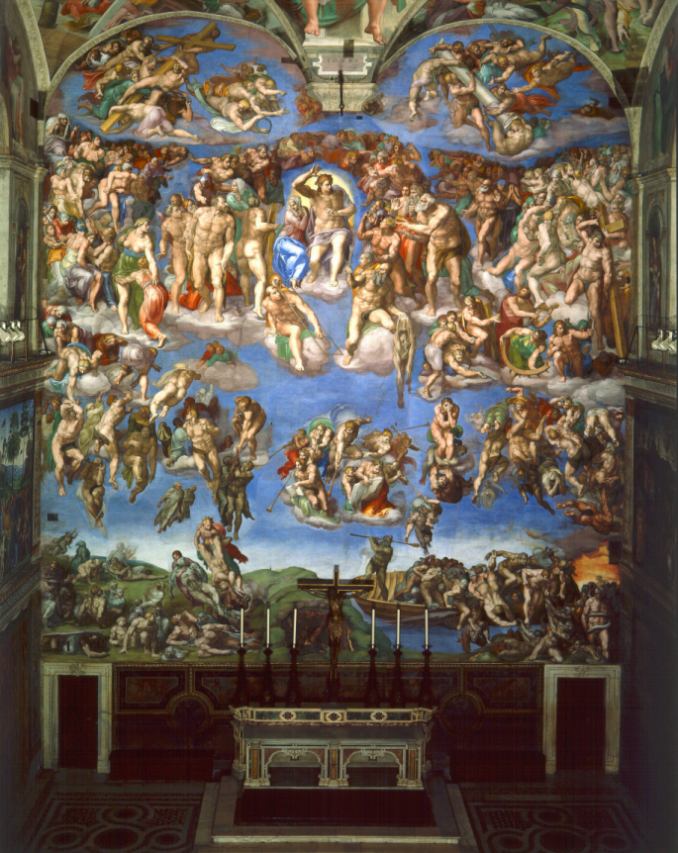

The Last Judgment.  
*Michael Angelo.*

"Ah!" said the Holy Father, in a tone of firm decision, "I hope that henceforth the whole of your time will belong to me, Maestro Buonarroti."

"May your Holiness deign to excuse me," replied Michael Angelo, "but I have just signed an engagement with the Duke of Urbino, which forces me to finish the tomb of Pope Julius."

"What!" exclaimed Paul III.: "for thirty years I have had a certain wish and now that I am Pope I cannot realize it!"

"But the contract, Holy Father, the contract!"

"Where is this contract? I will tear it up."

"Ah!" exclaimed in his turn the Cardinal of Mantua, who was one of the suite, "your Holiness should see the *Moses* which Maestro Michael Angelo has just finished: that statue alone would more than suffice to honour the memory of Julius."

"Cursed flatterer!" muttered Michael Angelo in a low voice.

"Come, come, I will take charge of this matter myself," said the Pope. "You shall only make three statues with your own hand: the rest shall be given to other sculptors, and I will answer for the Duke of Urbino's consent. And now, Maestro, to the Sistine Chapel. A great empty wall is waiting for you there."

What could Michael Angelo reply to such an emphatic wish expressed so distinctly? He finished in his best style his two statues of *Active Life* and *Contemplative Life*—Dante's symbolical Rachel and Leah—and not wishing to profit by this new arrangement to which he was forced to submit, he added fifteen hundred and twenty-four ducats to the four thousand he had received, to pay with his own gains for the works confided to the other artists.

Having thus terminated this unfortunate affair, which had caused him so much worry and fatigue, Michael Angelo was at last enabled to occupy himself exclusively with the execution of his *Last Judgment*, to which he devoted no less than eight to nine years.

This immense and unique picture, in which the human figure is represented in all possible attitudes, where every sentiment, every passion, every reflection of thought, and every aspiration of the soul are rendered with inimitable perfection, has never been equalled and never will be equalled in the domain of Art.

This time the genius of Michael Angelo simply attacked the infinite. The subject of this vast composition, the manner in which it is conceived and executed, the admirable variety and the learned disposition of the groups, the inconceivable boldness and firmness of the outlines, the contrast of light and shade, the difficulties, I might almost say the impossibilities vanquished, as if it were all mere play, and with a happiness that savours of prodigy, the unity of the whole and the perfection of the details, make *The Last Judgment* the most complete and the greatest picture in existence. It is broad and magnificent in effect, and yet each part of this prodigious painting gains infinitely when seen and studied quite near; and we do not know of any easel-picture worked upon with such patience and finished with such devotion.

The painter could only choose one scene, several isolated groups, in this appalling drama which will be enacted on the last day in the Valley of Jehoshaphat, where all the generations of man shall be gathered together. And yet, admire the omnipotence of genius! With nothing but a single episode in a restricted space, and solely by the expression of the human body, the artist has succeeded in striking you with astonishment and terror, and in making you really a spectator of the supreme catastrophe.

At the base of the picture, very nearly in the centre, you perceive the boat of the *Inferno*, a fantastic reminiscence borrowed from Pagan tradition, in accordance with which first the poet and then the painter were pleased to clothe an accursed being with the form and occupation of Charon.

"Charon with the eyes of burning embers gathering together with a gesture all these souls, and striking with his oar those who hesitate."[1]

It is impossible to form an idea of the incredible science displayed by Michael Angelo in the varied contortions of the damned, heaped one upon the other in the fatal bark. All the violent contractions, all the visible tortures, all the frightful shrinkings that suffering, despair, and rage can produce upon human muscles are rendered in this group with a realism that would make the most callous shudder. To the left of this bark you see the gaping mouth of a cavern; this is the entrance to Purgatory, where several demons are in despair because they have no more souls to torment.

This first group, which very naturally attracts the spectator's attention, is that of the dead whom the piercing sound of the eternal trumpet has awakened in their tombs. Some of them shake off their shrouds, others with great difficulty open their eyelids made heavy by their long sleep. Towards the angle of the picture there is a monk who is pointing out the Divine Judge with his left hand; this monk is the portrait of Michael Angelo.

The second group is formed of the resuscitated ones who ascend of themselves to the Judgment. These figures, many of which are sublime in expression, rise more or less lightly into space, according to the burden of their sins, of which they must render account.

The third group, also ascending to the right of Christ, is that of the Blessed. Among all these saints, some of whom show the instrument of their execution, others the marks of their martyrdom, there is one head especially remarkable for beauty and tenderness: it is that of a mother who is protecting her daughter, turning her eyes, filled with faith and hope, towards the Christ.

Above the host of saints, you see a fourth group of angelic spirits, some bearing the Cross, others the Crown of Thorns,—instruments and emblems of the Saviour's Passion.

The fifth group, parallel to the fourth which we have just pointed out, is composed of angels; such, at least, they seem to be by the splendour of their youth and the aërial lightness of their movements; and these also bear, as if in triumph, other emblems of the divine expiation—the column, the ladder, and the sponge.

Above these angels, on the same plane as the saints and to the left of Christ, is the choir of the just; the patriarchs, the prophets, the apostles, the martyrs, and the holy personages form this sixth group.

The seventh is the most horrible of all and the one in which the art of Michael Angelo has displayed itself in all its terrific grandeur: it is composed of the rejected ones, overwhelmed by the decree and led away to punishment by the rebel angels. The very coldest spectator could not remain unmoved by this spectacle. You believe yourself in hell; you hear the cries of anguish and the gnashing of the teeth of the wretched, who, according to the terrible Dantesque expression, vainly desire a second death.

The eighth, ninth, and tenth groups, occupying the base of the composition, are composed, as we have already said, of the bark of Charon, the grotto of Purgatory, and the Angels of Judgment, eight in number, blowing their brazen trumpets with all their might to convoke the dead from the four quarters of the earth.

Finally, in the eleventh group, in the centre, very near the upper part of the picture, between the two companies of the blessed, and seated upon the clouds, the sovereign Judge with a terrible action hurls his malediction upon the condemned: *"Ite maledicti in ignem aeternum."* The Virgin turns away her head and trembles. On Christ's right is Adam, and on his left, St. Peter. They have exactly the same positions assigned to them by Dante in his *Paradiso*.

This immense work was exhibited to the public on Christmas Day, 1541. It had cost eight years of work. Michael Angelo was then sixty-seven years old.

Several anecdotes relating to this great picture have come down to us.

It is related that the Pope, scandalized at the nudity of certain figures, a nudity which Daniele da Volterra was afterwards charged to clothe, sent word to Michael Angelo that he must cover them.

Michael Angelo replied with his usual brusqueness:

"Tell the Pope that he must employ himself a little less in correcting my pictures, which is very easy, and employ himself a little more in reforming men, which is very difficult."

It is said that Maestro Biaggio, master of ceremonies to Paul III., having accompanied the Pope on a visit that His Holiness made to see Michael Angelo's fresco when it was about half finished, allowed himself to express his own opinion upon *The Last Judgment*.

"Holy Father," said the good Messer Biaggio, "if I dare pronounce my judgment, this picture seems more appropriate to figure in a tavern than in the chapel of a Pope."

Unfortunately for the master of ceremonies, Michael Angelo was behind him and did not lose a word of Messer Biaggio's compliment. The Pope had scarcely gone before the irritated artist, wishing to make an example as a warning for all future critics, placed this Messer Biaggio in his hell, well and duly, under the scarcely flattering guise of Minos. That was always Dante's way when he wanted to avenge himself upon an enemy.

I leave you to imagine the lamentations and complaints of the poor master of ceremonies when he saw himself damned in this manner. He threw himself at the Pope's feet, declaring that he would never arise unless His Holiness would have him taken out of hell: that was the most important thing. As for the punishment, that the painter deserved for this dreadful sacrilege, Messer Biaggio would leave that entirely to the high impartiality of the Holy Father.

"Messer Biaggio," replied Paul III. with as much seriousness as he could maintain, "you know that I have received from God an absolute power in heaven and upon the earth, but I can do nothing in hell; therefore you must remain there."

While Michael Angelo was working at his picture of *The Last Judgment*, he fell from the scaffold and seriously injured his leg. Soured by pain and seized with an attack of misanthropy, the painter shut himself up in his house and would not see any one.

But he reckoned without his physician; and the physician this time was as stubborn as the invalid.

This excellent disciple of Æsculapius was named Baccio Rontini. Having learned by chance of the accident that had befallen the great artist, he presented himself before his house and knocked in vain at the door.

No response.

He shouted, he flew into a passion, and he called the neighbours and the servants in a loud voice.

Complete silence.

He goes to find a ladder, places it against the front of the house, and tries to enter by the casements. The windows are hermetically sealed and the shutters are fast.

What is to be done? Any one else in the physician's place would have given up; but Rontini was not the man to be discouraged for so little. With much difficulty he enters the cellar and with no less trouble he goes up into Buonarroti's room, and, partly by acquiescence and partly by force, he triumphantly tends his friend's leg.

It was quite time: exasperated by his sufferings, the artist had resolved to let himself die.

*Trois Maîtres* (Paris, 1861).

## PORTRAIT OF GEORG GISZE (HOLBEIN)

ANTONY VALABRÈGUE

When Holbein returned to London towards the end of 1531, leaving Basle, where he had worked for nearly three years, he found himself immediately occupied with several portraits of the merchants of the Hanseatic League. During his first sojourn in England, he had painted the chancellor, Sir Thomas More, his protector and friend, and he had traced the features of several members of the aristocracy. On his return, circumstances for his gaining access to the court were less favourable. Henry VIII. was obeying his own good pleasure and satisfying all his caprices, and the chancellor was holding aloof, and could not exert his influence. Holbein did not now possess the title of Painter to the King, consequently he had to consider himself happy in obtaining the favour of his compatriots.

The German merchants had formed themselves into a powerful association; they found themselves united in a kind of city, which went by the name of Stahlhof. There they had their Guildhall, their Bourse, the place where their affairs were managed and which contained their stores of merchandise, and their counting-houses. It was a separate quarter, where each one could also have his own dwelling.

The company was opulent; the industry of the members of the Hanseatic League was chiefly in iron and the precious metals; among them were armourers, watch-makers, and goldsmiths. In the Stahlhof, called in English the Steelyard, and which the founders themselves had designated the Palace of Steel, was to be noted a certain opulence and pursuit of comfort which is to be found in all ages. After having finished their business, the merchants formed a social circle of their own. They had a festival-hall of their own, and they could walk about in spacious gardens which extended along the banks of the Thames.

Among these representatives of high finance a painter might find a choice *clientèle* that would never care about the price of an order. We know that Holbein painted the portraits of many of these rich merchants, for to-day we find these canvases, whose authenticity has been established, in Museums and important collections. We may therefore suppose that the German merchants appreciated Holbein at his true value; doubtless they disputed the honour of having their features reproduced by a master of such remarkable talent.

The portrait of Georg Gisze, which is before our readers, is certainly the finest work of this series. When we saw this masterly work in the Museum of Berlin, to which it belongs, it left an indelible impression upon us which we still feel at this distance. It is incontestably a masterpiece from every point of view; in the Gallery there is but one other picture of the same kind which may be compared to it, a painting which suggests a parallel in a single detail,—*The Man with the Pinks*, by Van Eyck.

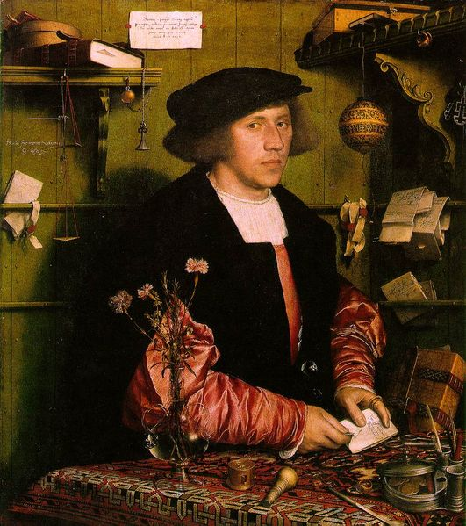

Portrait of Georg Gisze.  
*Holbein.*

Holbein has represented Georg Gisze in his mercantile office, at a table, holding a letter which he is about to open, and surrounded by small objects, articles for which he has use in his business and in his every-day life. This man appears before us in a marvellous pose, among these material surroundings and in this professional scene. Observe his calm attitude and his almost placid physiognomy: we notice, however, the firm and decided air of a wealthy and elegant merchant. And, at the same time, we are sure that the type represented here is not of sudden growth: everything about him reveals intelligence.

Georg Gisze is young; the painter has told us his name and his age in an inscription on the wall: he is thirty-four. We do not lack information about him. We like him under that air of youthful seriousness; we see upon his face that dawning gravity in which the blossom of feeling already exists, but its plenitude and maturity are still to come. And in attentively examining our personage we are struck with his reflective and searching glance. We seem to have a glimpse in him of an undefined melancholy. This expression surprises us in this man, who ought to be happy at living and who lacks no pleasures that Fortune can procure.

This is a state of mind which is indicated to us, moreover, by a motto traced above his name on one of the walls of his office: *Nulla sine mærore voluptas*. Why this thought? Is it purely emblematic, or does it contain an allusion to some private matter? We are led to believe that it is intended as a complementary explanation, that it was placed upon the picture because it was in sympathy with a train of ideas special to the model. Perhaps it recalls some domestic sorrow, the lively grief left by an absent one, or by some eternal separation. A moral mystery, which seems to us very attractive, hovers around Georg Gisze.

He has long fair hair confined beneath a black cap; his smooth-shaven face is rather thin. He wears a rich costume, a pourpoint of cerise silk with puffed sleeves, and, over this pourpoint, a cloak of black wool lined with fur. The table on which he is leaning is covered with a Persian rug, and, beside the various objects scattered upon it, you notice a bunch of carnations in an artistically wrought Venetian glass. These carnations, like the motto, awake in us an image, a poetical reminiscence. Sentiment, Germanic in its essence, mingled with dreams and vague ideals, is introduced into this merchant's office.

The master has fully displayed with supreme power, and with all the resources of his art, the colours of the costume, the paleness of the face, and the freshness of the flesh standing out from the background of green panels. He has played with all the various tones of the accessories, book and registers, inkstand, watch, and scales for weighing the gold. Every detail, with no link missing, contributes to form the perfect harmony of the whole.

We cannot too greatly admire the singular clearness and extraordinary precision with which the artist has placed in relief every detail that can make a figure live and render a work essentially eloquent.[2]

People have tried to make out that Georg Gisze was a merchant of Basle. He would then have been of the race connected most closely with the Master's life. This opinion has been discussed by Woltmann, Holbein's historian. The superscriptions on the sufficiently numerous letters, which are reproduced in this painting, must be especially noticed; they are written in an ancient dialect which seems rather to be that of central Germany.[3]

Jouin, *Chefs-d'œuvre: Peinture, Sculpture, Architecture* (Paris, 1895-97).

## THE ADORATION OF THE LAMB (VAN EYCK)

KUGLER

Hubert van Eyck was born, according to the common acceptation, in 1366. John van Eyck was his junior by some unknown number of years. Chroniclers of the Sixteenth Century vaguely suggest that the two brothers settled at Ghent in 1410. There is every reason to believe that all these dates are incorrect; that Hubert was born after 1366, and that the date of his migration to Ghent must be placed later in the century. It is credible that both the brothers were court painters to Philip of Charolois, heir apparent to the throne of Burgundy, who lived with his wife Michelle de France at Ghent between 1418 and 1421. In the service of the prince, painters were free from the constraint of their guild, but on the withdrawal of the court the privilege would cease; and this explains how the names of the Van Eycks were not recorded in the register of the corporation of St. Luke till 1421, when, on the death of the Countess Michelle, and as a tribute to her memory, they were registered as masters without a fee. John van Eyck soon found employment in the court atmosphere, which seemed congenial to him, whilst Hubert remained at Ghent, received commissions from the municipality (1424), and became acquainted with Jodocus Vydts, for whom he composed the vast altar-piece known as the *Adoration of the Lamb*. It was not fated that he should finish the great work which he was then induced to begin. He probably sketched the subjects that were to adorn the panels, and completed some of the more important of them. At his death in 1426 he was buried in the chapel, the decoration of which had been the last occupation of his life. We may sum up the qualities which distinguished him, and the services which he rendered to the art of his country, in the following sentences:—

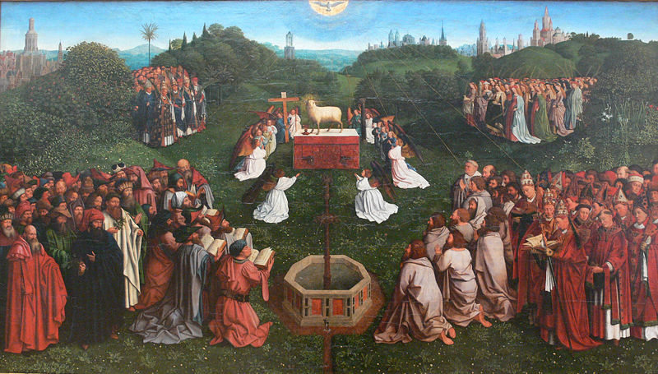

The Adoration of the Lamb.  
*Van Eyck.*

He carried the realistic tendency, already existing in the Flemish masters, to an extraordinary pitch of excellence, whilst in many essential respects he adhered to the more ideal feeling of the previous period, imparting to this, by the means of his far richer powers of representation, greater distinctness, truth of nature, and variety of expression. Throughout his works he displayed an elevated and highly energetic conception of the stern import of his labours in the service of the Church. The prevailing arrangement of his subject is symmetrical, holding fast the early architectonic rules which had hitherto presided over ecclesiastic art. The later mode of arrangement, in which a freer and more dramatic and picturesque feeling was introduced, is only seen in Hubert van Eyck's works in subjection to these rules. Thus his heads exhibit the aim at beauty and dignity belonging to the earlier period, only combined with more truth of nature. His draperies unite its pure taste and softness of folds with greater breadth; the realistic principle being apparent in that greater attention to detail which a delicate indication of the material necessitates. Nude figures are studied from nature with the utmost fidelity; undraped portions are also given with much truth, especially the hands; only the feet remain feeble. That, however, which is almost the principal quality of his art, is the hitherto unprecedented power, depth, transparency, and harmony of his *colouring*. To attain this he availed himself of a mode of painting in oil which he and his brother had perfected. Oil painting, it is true, had long been in use, but only in a very undeveloped form, and for inferior purposes. According to the most recent and thorough investigations, the improvement introduced by the Van Eycks, and which they doubtless only very gradually worked out, were the following. First, they removed the chief impediment which had hitherto obstructed the application of oil-paint to pictures properly so called. For, in order to accelerate the slow drying of the oil colours, it had been necessary to add a varnish to them, which consisted of oil boiled with a resin. Owing to the dark colour of this varnish, in which amber, or more frequently sandarac, was used, this plan, from its darkening effect on most colours, had hitherto proved unsuccessful. The Van Eycks, however, succeeded in preparing so colourless a varnish that they could apply it without disadvantage, to all colours. In painting a picture they proceeded on the following system. The outline was drawn on a *gesso* ground, so strongly sized that no oil could penetrate the surface. The under painting was then executed in a generally warm brownish glazing colour, and so thinly that the light ground was clearly seen through it. They then laid on the local colours, thinner in the lights, and, from the quantity of vehicle used, more thickly in the shadows; in the latter availing themselves often of the under painting as a foil. In all other parts they so nicely preserved the balance between the solid and the glazing colours as to attain that union of body and transparency which is their great excellence. Finally, in the use of the brush they obtained that perfect freedom which the new vehicle permitted; either leaving the touch of the brush distinct, or fusing the touches tenderly together, as the object before them required. Of all the works which are now attributed to Hubert, but one is genuine and historically authenticated. This noble work is certified by an inscription. It is a large altar picture, consisting of two rows of separate panels, once in the Cathedral of St. Bavon at Ghent. It was painted, as before remarked, for Jodocus Vydts, Seigneur of Pamele, and Burgomaster of Ghent, and his wife Elizabeth, of the then distinguished family of Burlunt, for their mortuary chapel in that cathedral.[4] When the wings were opened, which occurred only on festivals, the subject of the upper centre picture was seen, consisting of three panels, on which were the Triune God—the King of heaven and earth—and at his side the Holy Virgin and the Baptist; on the inside of the wings were angels, who with songs and sacred music celebrate the praises of the Most High: at the two extremities, each inside the half-shutters which covered the figure of God the Father, were Adam and Eve, the representatives of fallen man. The lower central picture shows the Lamb of the Revelation, whose blood flows into a cup; over it is the dove of the Holy Spirit; angels, who hold the instruments of the Passion, worship the Lamb, and four groups, each consisting of many persons, advance from the sides: they comprise the holy martyrs, male and female, with priests and lay-men; in the foreground is the fountain of life; in the distance the towers of the heavenly Jerusalem. On the wing pictures, other groups are coming up to adore the Lamb; on the left, those who have laboured for the kingdom of the Lord by worldly deeds—the soldiers of Christ, and the righteous judges; on the right, those who, through self-denial and renunciation of earthly good, have served Him in the spirit—holy hermits and pilgrims; a picture underneath, which represented hell, finished the whole.

This work is now dispersed: the centre pictures and the panels of Adam and Eve only being in Ghent.[5] The lower picture of hell was early injured and lost, and the others form some of the greatest ornaments of the gallery of the Berlin Museum.[6]

The three figures of the upper centre picture are designed with all the dignity of statue-like repose belonging to the early style; they are painted, too, on a ground of gold and tapestry, as was constantly the practice in earlier times: but united with the traditional type we already find a successful representation of life and nature in all their truth. They stand on the frontier of two different styles, and, from the excellence of both, form a wonderful and most impressive whole. In all the solemnity of antique dignity the Heavenly Father sits directly fronting the spectator—his right hand raised to give the benediction to the Lamb, and to all the figures below; in his left is a crystal sceptre; on his head the triple crown, the emblem of the Trinity. The features are such as are ascribed to Christ by the traditions of the Church, but noble and well-proportioned; the expression is forcible, though passionless. The tunic of this figure, ungirt, is of a deep red, as well as the mantle, which last is fastened over the breast by a rich clasp, and, falling down equally from both shoulders, is thrown in beautiful folds over the feet. Behind the figure, and as high as the head, is a hanging of green tapestry adorned with a golden pelican (a well-known symbol of the Redeemer); behind the head the ground is gold, and on it, in a semicircle, are three inscriptions, which again describe the Trinity, as all-mighty, all-good, and all-bountiful. The two other figures of this picture display equal majesty; both are reading holy books and are turned towards the centre figure. The countenance of John expresses ascetic seriousness, but in the Virgin's we find a serene grace, and a purity of form, which approach very nearly to the happier efforts of Italian art.

On the wing next to the Virgin stand eight angels singing before a music-desk. They are represented as choristers in splendid vestments and crowns. The brilliancy of the stuffs and precious stones is given with the hand of a master, the music-desk is richly ornamented with Gothic carved work and figures, and the countenances are full of expression and life; but in the effort to imitate nature with the utmost truth, so as even to enable us to distinguish with certainty the different voices of the double quartet, the spirit of a holier influence has already passed away. On the opposite wing, St. Cecilia sits at an organ, the keys of which she touches with an expression of deep meditation: other angels stand behind the organ with different stringed instruments. The expression of these heads shows far more feeling, and is more gentle; the execution of the stuffs and accessories is equally masterly. The two extreme wings of the upper series, the subjects of which are Adam and Eve, are now in the Museum at Brussels. The attempt to paint the nude figure of the size of life, with the most careful attention to minute detail, is eminently successful, with the exception of a certain degree of hardness in the drawing. Eve holds in her right hand the forbidden fruit. In the filling up, which the shape of the altar-piece made necessary over these panels, there are small subjects in chiaroscuro: over Adam, the sacrifice of Cain and Abel; over Eve, the death of Abel—death, therefore, as the immediate consequence of original sin.

The arrangement of the lower middle picture, the worship of the Lamb, is strictly symmetrical, as the mystic nature of the allegorical subject demanded, but there is such beauty in the landscape, in the pure atmosphere, in the bright green of the grass, in the masses of trees and flowers, even in the single figures which stand out from the four great groups, that we no longer perceive either hardness or severity in this symmetry. The wing picture on the right, representing the holy pilgrims, is, in the figures, less striking than the others. Here St. Christopher, who wandered through the world seeking the most mighty Lord, strides before all, a giant in stature, whilst a host of smaller pilgrims, of various ages, follow him. A fruitful valley, with many details, showing a surprising observation of nature, is seen through the slender trees. The cast of the folds in the ample red drapery of St. Christopher, as in the upper picture, reminds us still of the earlier style. The whimsical and singular expression in the countenances of the pilgrims is also very remarkable. The picture next to the last described is more pleasing; it represents the troop of holy anchorites passing out of a rocky defile. In front are St. Paul the Hermit and St. Anthony, the two who set the first example of retirement from the world; and the procession closes with the two holy women who also passed the greater part of their lives in the wilderness, Mary Magdalen and St. Mary of Egypt. The heads are full of character, with great variety of expression: on every countenance may be traced the history of its life. Grave old men stand before us, each one differing from the other; one is firm and strong, another more feeble; one cheerful and single-minded, another less open. Some inspired fanatics wildly raise their heads, whilst others with a simple and almost humorous expression walk by their side, and others again are still struggling with their earthly nature. It is a remarkable picture, and leads us deep into the secrets of the human heart—a picture which in all times must be ranked amongst the master-works of art, and which to be intelligible needs no previous inquiry into the relative period and circumstances of the artists who created it. The landscape background, the rocky defile, the wooded declivity, and the trees laden with fruit, are all eminently beautiful. The eye would almost lose itself in this rich sense of still life if it were not constantly led back to the interest of the foreground.

The opposite wing pictures differ essentially in conception from those just described. Their subject did not in itself admit such varied interest, and it is rather the common expression of a tranquil harmony of mind, and of the consciousness of a resolute will, which attracts the spectator, combined at the same time with a skilful representation of earthly splendour and magnificence. Inside the wing to the right we see the soldiers of the Lord on fine chargers, simple and noble figures in bright armour, with surcoats of varied form and colour. The three foremost with the waving banners appear to be St. Sebastian, St. George, and St. Michael, the patron saints of the old Flemish guilds, which accompanied their earls to the Crusades. In the head of St. George, the painter has strikingly succeeded in rendering the spirit of the chivalry of the Middle Ages—that true heroic feeling and sense of power which humbles itself before the higher sense of the Divinity. Emperors and kings follow after him. The landscape is extremely beautiful and highly finished, with rich and finely-formed mountain ridges, and the fleecy clouds of spring floating lightly across. The second picture (the last to the left) represents the righteous judges; they also are on horseback, and are fine and dignified figures. In front, on a splendidly caparisoned grey horse, rides a mild benevolent old man, in blue velvet trimmed with fur. This is the likeness of Hubert, to whom his brother has thus dedicated a beautiful memorial. Rather deeper in the group is John himself, clothed in black, with his shrewd, sharp countenance turned to the spectator. We are indebted to tradition for the knowledge of these portraits.

Both these wing pictures have the special interest of showing us, by means of armour, rich costumes, and caparisons, a true and particular representation of the Court of Burgundy in the time of Philip the Good—when it was confessedly the most superb court in Europe.

The upper wings, when closed, represented the Annunciation, and this was so arranged that on the outer and wider ones (the backs of the two pictures of angels singing and playing) were the figures of the Virgin and the Angel Gabriel,—on the inner narrower ones (that is, on the back of the Adam and Eve), a continuation of the Virgin's chamber. Here, as was often the case in the outside pictures of large altar-pieces, the colouring was kept down to a more uniform tone, in order that the full splendour might be reserved to adorn with greater effect the principal subject within. The angel and the Holy Virgin are clothed in flowing white drapery, but the wings of the angel glitter with a play of soft and brilliant colour, imitating those of the green parrot. The heads are noble and well painted; the furniture of the room is executed with great truth, as well as the view through the arcade which forms the background of the Virgin's chamber, into the streets of a town, one of which we recognize as a street in Ghent.

In the semicircles which close these panels above, on the right and left, are the prophets Micah and Zechariah, whose heads have great dignity, but are somewhat stiff and unsatisfactory in their attitudes. In the centre (corresponding with the figures in chiaroscuro over Adam and Eve) are two kneeling female figures represented as sibyls.

The exterior portion of the lower wings contains the statues of the two St. Johns. These display a heavy style of drapery, and there is something peculiarly angular in the breaks of the folds, imitated perhaps from the sculpture of the day, which had also already abandoned the older Northern mould. This peculiarity by degrees impressed itself more and more on the style of painting of the Fifteenth Century, and the drapery of the figures in the Annunciation already betrays a tendency towards it. The heads exhibit a feeling for beauty of form which is rare in this school. John the Baptist, who is pointing with his right hand to the Lamb on his left, is appropriately represented, as the last of the Prophets, as a man of earnest mien and dignified features, with much hair and beard. John the Evangelist, on the other hand, appears as a tender youth with delicate features, looking very composedly at the monster with four snakes which, at his benediction, rises from the chalice in his hand.

The likenesses of the donors are given with inimitable life and fidelity. They show the careful hand of Jan van Eyck, but already approach that limit within which the imitation of the accidental and insignificant in the human countenance should be confined. The whole, however, is in admirable keeping, and the care of the artist can hardly be considered too anxiously minute, since feeling and character are as fully expressed as the mere bodily form. The aged Jodocus Vydts, to whose liberality posterity is indebted for this great work of art, is dressed in a simple red garment trimmed with fur; he kneels with his hands folded, and his eyes directed upwards. His countenance, however, is not attractive; the forehead is low and narrow, and the eye without power. The mouth alone shows a certain benevolence, and the whole expression of the features denotes a character capable of managing worldly affairs. The idea of originating so great a work as this picture is to be found in the noble, intellectual, and expressive features of his wife, who kneels opposite to him in the same attitude, and in still plainer attire.

At Hubert van Eyck's death, on the 16th of September, 1426, Jodocus Vydts engaged Jan van Eyck, the younger brother and scholar of Hubert, to finish the picture in the incomplete parts.[7] A close comparison of all the panels of this altar-piece with the authentic works of Jan van Eyck shows that the following portions differ in drawing, colouring, cast of drapery, and treatment, from his style, and may therefore with certainty be attributed to the hand of Hubert:—of the inner side of the upper series, the Almighty, the Virgin, St. John the Baptist, St. Cecilia with the angels playing on musical instruments, and Adam and Eve; of the inner side of the lower series, the side of the centre picture with the apostles and saints, and the wings with the hermits and pilgrims, though with the exception of the landscapes. On the other hand, of the inner side of the upper series, the wing picture with the singing angels is by Jan van Eyck; of the inner side of the lower series, the side of the centre picture of the Adoration of the Lamb, containing the patriarchs and prophets, etc., and the entire landscape; the wing with the soldiers of Christ and the Righteous Judges, and the landscapes to the wing with the hermits and pilgrims; finally, the entire outer sides of the wings, comprising the portraits of the founders, and the Annunciation. The Prophet Zechariah and the two sibyls alone show a feebler hand.[8]

About one hundred years after the completion of this altar-piece an excellent copy of it was made by Michael Coxis for Philip II. of Spain. The panels of this work, like those of the original, are dispersed; some are in the Berlin Museum, some in the possession of the King of Bavaria, and others in the remains of the King of Holland's collection at the Hague. A second copy, which comprises the inside pictures of this great work, from the chapel of the Town-house at Ghent, is in the Antwerp Museum.

*Handbook of Painting: the German, Flemish, and Dutch Schools*, based on the handbook of Kugler remodelled by Dr. Waagen and revised by J.A. Crowe (London, 1874).

## THE FIGHTING TÉMÉRAIRE TUGGED TO HER LAST BERTH TO BE BROKEN UP, 1838 (TURNER)

JOHN RUSKIN

"The flag which braved the battle and the breeze

No longer owns her."

Exhibited at the Academy in 1839, with the above lines cited in the Catalogue. Of all Turner's pictures in the National Gallery this is perhaps the most notable. For, *first* it is the last picture he ever painted with *perfect* power—the last in which his execution is as firm and faultless as in middle life; the last in which lines requiring exquisite precision, such as those of the masts and yards of shipping, are drawn rightly at once. When he painted the *Téméraire* Turner could, if he liked, have painted the *Shipwreck* or the *Ulysses* over again; but when he painted the *Sun of Venice*, though he was able to do different, and in some sort more beautiful things, he could not have done *those* again. His period of central power thus begins with the *Ulysses* and closes with the *Téméraire*. The one picture, it will be observed, is of sunrise, the other of sunset. The one of a ship entering on its voyage, and the other of a ship closing its course for ever. The one, in all the circumstance of the subject, unconsciously illustrative of his own life in its triumph, the other, in all the circumstances of its subject, unconsciously illustrative of his own life in its decline. Accurately as the first sets forth his escape to the wild brightness of nature, to reign amidst all her happy spirits, so does the last set forth his returning to die by the shore of the Thames. And besides having been painted in Turner's full power, the *Téméraire* is of all his large pictures the best preserved. *Secondly*, the subject of the picture is, both particularly and generally, the noblest that in an English National Gallery could be. The *Téméraire* was the second ship in Nelson's line at the Battle of Trafalgar; and this picture is the last of the group which Turner painted to illustrate that central struggle in our national history. The part played by the *Téméraire* in the battle will be found detailed below. And, generally, she is a type of one of England's chief glories. It will be always said of us, with unabated reverence, "They built ships of the line." Take it all in all, a Ship of the Line is the most honourable thing that man as a gregarious animal, has ever produced. By himself, unhelped, he can do better things than ships of the line; he can make poems and pictures, and other such concentrations of what is best in him. But as a being living in flocks, and hammering out, with alternate strokes and mutual agreement, what is necessary for him in those flocks, to get or produce, the ship of the line is his first work. And as the subject was the noblest Turner could have chosen so also was his treatment of it. Of all pictures of subjects not visibly involving human pain, this is, I believe, the most pathetic that was ever painted. The utmost pensiveness which can ordinarily be given to a landscape depends on adjuncts of ruin; but no ruin was ever so affecting as this gliding of the vessel to her grave. A ruin cannot be so, for whatever memories may be connected with it, and whatever witness it may have borne to the courage and glory of men, it never seems to have offered itself to their danger, and associated itself with their acts, as a ship of battle can. The mere facts of motion, and obedience to human guidance, double the interest of the vessel: nor less her organized perfectness, giving her the look, and partly the character of a living creature, that may indeed be maimed in limb or decrepit in frame, but must either live or die, and cannot be added to nor diminished from—heaped up and dragged down—as a building can. And this particular ship, crowned in the Trafalgar hour of trial with chief victory—prevailing over the fatal vessel that had given Nelson death—surely, if ever anything without a soul deserved honour or affection, we owed them here. Those sails that strained so full bent into the battle—that broad bow that struck the surf aside, enlarging silently in steadfast haste full front to the shot—resistless and without reply—those triple ports whose choirs of flame rang forth in their courses, into the fierce revenging monotone, which, when it died away, left no answering voice to rise any more upon the sea against the strength of England—those sides that were wet with the long runlets of English life-blood, like press planks at vintage, gleaming goodly crimson down to the cast and clash of the washing foam—those pale masts that stayed themselves up against the war-ruin, shaking out their ensigns through the thunder, till sail and ensign drooped—steeped in the death-stilled pause of Andalusian air, burning with its witness-clouds of human souls at rest,—surely, for these some sacred care might have been left in our thoughts, some quiet space amidst the lapse of English waters? Nay, not so. We have stern keepers to trust her glory to—the fire and the worm. Never more shall sunset lay golden robe on her, nor starlight tremble on the waves that part at her gliding. Perhaps, where the low gate opens to some cottage-garden, the tired traveller may ask, idly, why the moss grows so green on its rugged wood; and even the sailor's child may not answer, nor know, that the night-dew lies deep in the war-rents of the wood of the old *Téméraire*. And, *lastly*, the pathos of the picture—the contrast of the old ship's past glory with her present end; and the spectacle of the "old order" of the ship of the line whose flag had braved the battle and the breeze, yielding place to the new, in the little steam-tug—these pathetic contrasts are repeated and enforced by a technical *tour de force* in the treatment of the colours which is without a parallel in art. And the picture itself thus combines the evidences of Turner's supremacy alike in imagination and in skill. The old masters, content with one simple tone, sacrificed to its unity all the exquisite gradations and varied touches of relief and change by which nature unites her hours with each other. They gave the warmth of the sinking sun, overwhelming all things in its gold, but they did not give those gray passages about the horizon, where, seen through its dying light, the cool and the gloom of night gather themselves for their victory.... But in this picture, under the blazing veil of vaulted fire, which lights the vessel on her last path, there is a blue, deep, desolate hollow of darkness out of which you can hear the voice of the night wind, and the dull boom of the disturbed sea; the cold deadly shadows of the twilight are gathering through every sunbeam, and moment by moment, as you look, you will fancy some new film and faintness of the night has risen over the vastness of the departing form. (Compiled from *Modern Painters*, Vol. I. pt. ii. Sec. I. ch. vii. § 46 *n.*, Sec. II. ch i. § 21; *Harbours of England*, p. 12; and *Notes on the Turner Gallery*, pp. 75-80.)

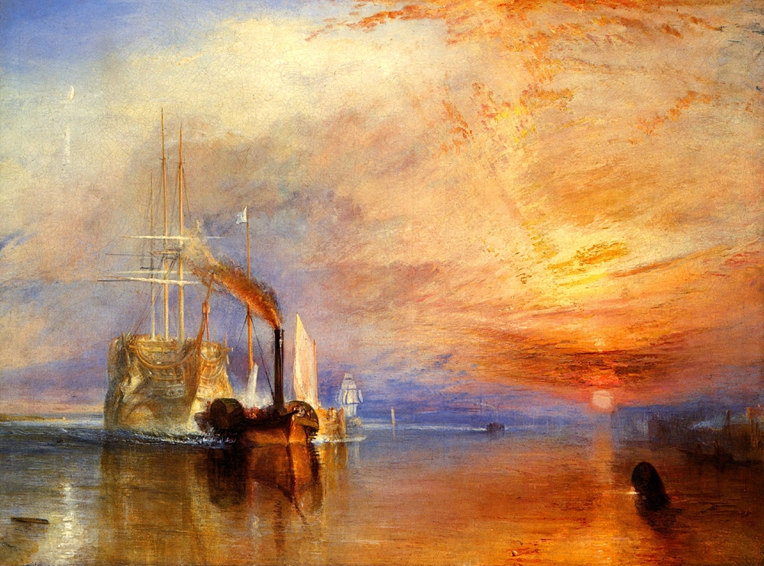

The Fighting Téméraire.  
*Turner.*

Finally a few words about the history of the picture itself may be interesting. The subject of it was suggested to Turner by Clarkson Stanfield (who himself, it will be remembered, had painted a *Battle of Trafalgar*). They were going down the river by boat, to dine, perhaps, at Greenwich, when the old ship, being tugged to her last berth at Deptford, came in sight. "There's a fine subject, Turner," said Stanfield. This was in 1838. Next year the picture was exhibited at the Academy, but no price was put upon it. A would-be purchaser offered Turner 300 guineas for it. He replied that it was his "200 guinea size" only, and offered to take a commission at that price for any subject of the same size, but with the *Téméraire* itself he would not part. Another offer was subsequently made from America, which again Turner declined. He had already mentally included the picture, it would seem, amongst those to be bequeathed to the nation; and in one of the codicils to his will, in which he left each of his executors a picture to be chosen by them in turn, the *Téméraire* was specially excepted from the pictures they might choose.[9]

Edward T. Cook, *A Popular Handbook to the National Gallery*.

## SPRING (BOTTICELLI)

MARCEL REYMOND

Of all the ancient Italian painters, Botticelli has, for several years, been the master most in fashion. Why? The first reason should be sought in that reaction against the pseudo-classic style of the Renaissance which has seemed to be the dominant tendency of art in the Nineteenth Century. But this explanation does not suffice to tell us for what reasons the favour of the public has specially fallen upon Botticelli. Why select Botticelli rather than any other artist of the Fourteenth or Fifteenth Century? Why Botticelli and not Giotto, or Fra Angelico, or, to cite none but his contemporaries, why not Signorelli, or Ghirlandajo? It is because Fra Angelico's art is too religious for our century and Giotto's art too philosophical, or, at least, it is because our century no longer thinks of demanding from its artists, as in the time of Giotto and Fra Angelico, the expression of the moral questions with which it is occupied. And if we seem to-day somewhat indifferent to the art of Ghirlandajo, or Signorelli, it is because their thought is too grave and because we desire before all else that art shall bring smiles into our laborious life; we demand that it shall give repose to our tired brains by charming us with the vision of all terrestrial beauties, without exacting any labour or any effort from our minds.

In this quest of beauty, our curious minds, which know so many things and which have been able to compare the works of the most diverse civilizations, are perpetually seeking novelty, eager for rare forms, and inimical to everything banal and to everything that ordinary life brings before our eyes. And in our *fin de siècle* we have been so much the more prone to subtle pursuits because for some time our French art has seemed to take delight in the forms of a gross realism.

This refinement of art, this intimate analysis of form and thought, this love of sensual beauty, had appeared at the court of the Medici by the same causes that prompt us to seek them; they are the fruit of a society that has attained the highest degree of well-being, wealth and knowledge.

This kind of art lasted only for a moment in Florence. It is correct to say that Florentine art did not seem destined to speak the charms of feminine beauty. From its beginning, this school had been stamped by Giotto with the philosophic impress, and for two centuries its artists had been before everything else, thinkers, occupied more with moral ideas than with the beauty of form.

The first in Florence to be enthralled by the charm of beautiful eyes was the poor Filippo Lippi. It was he who created that new form of art which was to continue with Botticelli, his pupil, and which attained its perfection under the hands of Leonardo. If, to the Lucrezia Buti of Filippo Lippi, we join Botticelli's Simonetta and Leonardo's Monna Lisa, we should have the poem of love sung by Florentine genius under its most exquisite form.

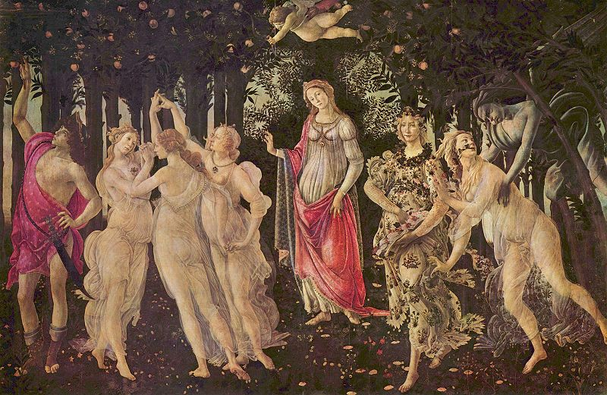

Spring.  
Botticelli.

What Botticelli was, *Spring* will tell us; and this work is so significant, its essence expresses the thought of the master so clearly that it has preserved all its charm for us, although its particular meaning is not known to us. We call it *Spring*, but if one of the figures in the picture really represents Spring, it is only an accessory figure; and, moreover, this name given to the picture is entirety modern. Vasari says that it represents *Venus surrounded by the Graces*, but if we find the three Graces in the picture, it is not likely that the principal figure represents Venus. In my opinion, it is that principal figure that is the key to the picture; it is for this figure that everything has been done, and this it is, above all, that we must interrogate if we wish to know Botticelli's meaning. Evidently it is neither Venus, nor Spring; and the precision of the features, and the fidelity of the smallest details of the costume make us believe that we are in the presence of a veritable portrait.... Around her, Nature adorns herself with flowers; Spring and the Graces surround her like a train of Fays. Here is one of the familiar poetical forms of the Fifteenth Century; and, doubtless, by attentively reading the Florentine poets, we should discover the meaning of all the allegorical figures that Botticelli has united in his work and which we do not understand.[10]

But whatever may be the particular meaning of each of these figures, it is certain that here we have to do with love and beauty, and that perhaps in no other work may we find the charm of woman described in more passionate accents.

In this world of feminine fascination Botticelli loved everything. He knows the attraction of the toilet and of jewels, but he knows above all that no gem and no invention of man can rival the beauty of the female form. He was the first to understand the exquisite charm of silhouettes, the first to linger in expressing the joining of the arm and body, the flexibility of the hips, the roundness of the shoulders, the elegance of the leg, the little shadow that marks the springing of the neck, and, above all, the exquisite carving of the hand. But, even more, he understood "*le prestige insolent des grands yeux*,"—large eyes, full, restless, and sad, because they are filled with love.

Look at these young maidens of Botticelli's. What a heavenly vision! Did Alfred de Musset know these veiled forms that seem to float over the meadow and did he think of them in the sleeplessness of his nights of May? Did he think of that young girl whose arm rises supple as the stem of a flower, of that young Grace so charming in the frame of her fair hair confined by strings of pearls, or, indeed, of that *Primavera*, who advances so imperiously beautiful, in her long robe of brocade, scattering handfuls of flowers that she makes blossom, or of that young mother more charming still in her modest grace, with her beautiful eyes full of infinite tenderness.

And around this scene, what a beautiful frame of verdure and flowers! Nature has donned her richest festal robes; the inanimate things, like the human beings, all speak of love and happiness, and tell us that the master of this world is that little child with bandaged eyes, who amuses himself by shooting his arrows of fire.

To say a word about the technique of this work, we should remark that Botticelli always painted in fresco or distemper, and that he did not seek the supple modelling that painting in oil affords; and, on the other hand, he submitted profoundly to the influence of Pollaiolo; he observed Nature with the eyes of a goldsmith; and he painted his works as if, working a niello or enamel, he had to set each figure in gold-wire.

Finally, is it necessary to speak of the date of the *Primavera*? This would occasion a long discussion if the space were accorded me. Let it suffice to say that the biography written by Vasari merits no credence, that it has been unfortunately accepted by the majority of historians, and that we have not yet a good chronology of Botticelli's works, nor even a simple catalogue. As for the chronology, most historians, relying upon Vasari, place nearly all of Botticelli's works before his trip to Rome in 1481. I think, on the contrary, and I will prove it elsewhere, that the great productive period of Botticelli belongs to the ten last years of the century and that the *Primavera* should be classed in this period. The *Primavera* represents, with *The Birth of Venus* and *The Adoration of the Magi*, the culminating point of Botticelli's art.

Jouin, *Chefs-d'œuvre; Peinture, Sculpture, Architecture* (Paris, 1895-97).

1. Dante, *Inferno* III.
2. In one corner of the picture is found this inscription with its Latin distich:

   Imaginem Georgii Gysenii

   Ista refert vultus, quâ cernis Īmago Georgi

   Sic oculos vivos, sic habet ille genas.

   Anno ætatis suæ XXXIII.

   *Anno dom. 1532.*
3. We read on one of these letters: *Dem erszamen Jergen Gisze to Lunden in Engelant, mynem broder to handen.*
4. Carton, *Les Trois Frères van Eyck*, p. 36.
5. Marc van Vaernewijck in a MS. of 1566-8, describing the Ghent troubles, states that on the 19th of August, two days before the iconoclasts plundered St. Bavon, the picture of the Mystic Lamb was removed from the Vijdts chapel and concealed in one of the towers. See the MS., *Van die Beroerlicke Tijden in die Nederlanden*, recently printed at Ghent (1872), p. 146. On the same page in which Vaernewijck relates this story he says that he refers his readers, for the lives of the Van Eycks to his book, *Mijn leecken Philosophie int xxe bouck*. This book, which probably still exists on the shelves of some library, has not as yet been discovered.
6. "The pictures here exhibited as the works of Hemmelinck, Messis, Lucas of Holland, A. Dürer, and even Holbein, are inferior to those ascribed to Eyck in colour, execution, and taste. The draperies of the three on a gold ground, especially that of the middle figure, could not be improved in simplicity, or elegance, by the taste of Raphael himself. The three heads of God the Father, the Virgin, and St. John the Baptist, are not inferior in roundness, force, or sweetness to the heads of L. da Vinci, and possess a more positive principle of colour."—*Life of Fuseli*, i. p. 267. This is a very remarkable opinion for the period when it was written.
7. This appears from the following inscription of the time, on the frame of the outer wing:—

   "Pictor Hubertus ab Eyck, major quo nemo repertus

   Incepit; pondusque Johannes arte secundus

   Frater perfecit, Judoci Vyd prece fretus

   [VersV seXta MaI Vos CoLLoCat aCta tVerI]."

   [The last verse gives the date of May 6, 1432.] The discovery of this inscription, under a coating of green paint, was made in Berlin in 1824, when the first word and a half of the third line, which were missing, were [imperfectly] supplied [with "frater perfectus"] by an old copy of this inscription, found by M. de Bast, the Belgian connoisseur.
8. [Dr. Waagen did not always hold decided opinions as to what portions of the altar-piece of Ghent are by Hubert and John van Eyck, respectively. There is no doubt that some of "the sublime earnestness" which Schlegel notes in the Eternal, the Virgin, and John the Baptist, and much of the stern realism which characterizes those figures, is to be found in the patriarchs and prophets, and in the hermits and pilgrims, and in the Adam and Eve; but it is too much to say that these wing pictures can "with certainty be assigned to Hubert," and it is not to be forgotten that John van Eyck worked in this picture on the lines laid down by his elder brother, and must have caught some of the spirit of his great master.]
9. Mr. W. Hale White recently drew up for Mr. Ruskin, from official records, the following history of the *Téméraire*. To him and to Mr. Ruskin I am indebted for permission to insert the history here. It will be seen that Turner was right in calling his picture the *Fighting Téméraire* and the critic who induced him to change the title in the engraving to the *Old Téméraire* wrong:—

   "The *Téméraire*, second-rate, ninety-eight guns, was begun at Chatham, July, 1793, and launched on the 11th September, 1798. She was named after an older *Téméraire* taken by Admiral Boscawen from the French in 1759, and sold in June, 1784. The Chatham *Téméraire* was fitted at Plymouth for a prison ship in 1812, and in 1819 she became a receiving ship and was sent to Sheerness. She was sold on the 16th August, 1838, to Mr. J. Beatson for £5,530. The *Téméraire* was at the Battle of Trafalgar on the 21st October, 1805. She was next to the *Victory*, and followed Nelson into action; commanded by Captain Elias Harvey, with Thomas Kennedy as first lieutenant. Her maintopmast, the head of her mizzenmast, her foreyard, her starboard, cathead and bumpkin, and her fore and main topsail yards were shot away; her fore and main masts so wounded as to render them unfit to carry sail, and her bowsprit shot through in several places. Her rigging of every sort was cut to pieces; the head of her rudder was taken off by the fire of the *Redoutable*; eight feet of the starboard side of the lower deck abreast of the mainmast were stove in, and the whole of her quarter-galleries on both sides carried away. Forty-six men on board of her were killed, and seventy-six wounded.... The *Téméraire* was built with a beakhead, or, in other words, her upper works were cut off across the catheads; a peculiarity which can be observed in Turner's picture. It was found by experience in the early part of the French war that this mode of construction exposed the men working the guns to the enemy's fire, and it was afterwards abandoned. It has been objected," adds Mr. White, "that the masts and yards in the picture are too light for a ninety-eight gun ship; but the truth is that when the vessel was sold she was juryrigged as a receiving ship, and Turner, therefore, was strictly accurate. He might have seemed more accurate by putting heavier masts and yards in her; but he painted her as he saw her. This is very important, as it gets rid of the difficulty which I myself have felt and expressed, that it was very improbable that she was sold all standing in sea-going trim, as I imagined Turner intended us to believe she was sold, and answers also the criticism just mentioned as to the disproportion between the weight of the masts and yards and the size of the hull." Part of the *Téméraire*, Mr. White tells me, is still in existence. Messrs. Castle, the shipbuilders of Millbank, have the two figures of Atlas which supported the sterngallery.
10. See notably the *Stanze* of Politian, where one will find nearly all the details of Botticelli's picture; the shady grove, the flowery meadow, even the attitudes and the garments of the personages. Is it not a figure of Botticelli's which is thus described:

    "She is white and white is her robe,

    All painted with flowers, roses, and blades of grass."