|  |
| --- |
| Sonata Software Limited, Microsoft Corporation, Intergen Limited and DAISY Consortium |
| Open XML to DAISY XML Translator Instructions Guide |
| Installing and using Open XML to DAISY XML Translator Add-in  This documentation references version 2.5.0.0 of the Add-in |

Contents

1 Introduction 4

1.1 Prerequisites For Installing The Open XML to DAISY XML Translator 4

2 Features covered 5

3 Do’s/Don’ts and FYI’s 6

4 Installing The Add-in 7

4.1 Installing The Add-in from DaisyAddinForWordSetup.exe 7

4.2 Confirmation Procedure after Installation is complete. 14

5 Save As DAISY Features 15

5.1 Converting Word 2007 Document In to DAISY XML format 16

5.2 Converting Word 2007 Document In to DAISY DTBook 23

5.3 Converting Multiple Word 2007 documents In to Daisy Xml Format 37

5.4 Converting Multiple Word 2007 Documents in to DTBook 45

6 Save As DAISY FEATURES WORD2003/wordXP 60

6.1 Converting Word 2003/XP Document In To DAISY XML format 60

6.2 Converting word2003/XP Document In to DAISY DTBook 68

6.3 Converting Multiple Word 2003/XP documents To DAISY XML Format: 79

6.4 Converting Multiple Word 2003/XP Documents in to DAISY DTBook: 86

7 Accessibility Ribbon 97

7.1 How to use Accessibility ribbon 98

7.2 Importing Custom Styles: 103

7.3 Translator Help 104

7.4 Helper Wizard - Validating the document against DAISY validation rules 106

7.5 Language Detection 113

7.6 Daisy Settings 114

7.7 Footnotes 116

8 Text-to-Speech Configuration 121

9 Progress Bar 122

10 Multiple Versions of Office 123

11 Command Line Utility 124

11.1 Command line Usage 124

12 Reader and Producer Software 125

13 Table of Short Cut Keys 126

13.1 General shortcut keys: 126

13.2 Shortcut keys for DAISY XML (from Single docx) Form: 126

13.3 Shortcut keys for Full DAISY(from Single docx) Form 127

13.4 Shortcut keys for DAISY XML(from Multiple docx) Form 128

13.5 Shortcut keys for Full DAISY(from Multiple docx) Form 129

13.6 Shortcut keys for Abbreviations and Acronyms 130

# Introduction

This document provides guidance on installing the Open XML to DAISY XML translator application along with instructions on how to convert an Office Open XML document within Microsoft Word to the DAISY XML format and/or a full DAISY talking book. Using screenshots (alt text is provided) the procedure for installing the add-in and converting a document is explained. The whole procedure is explained step by step.

The following are the specific aspects which are explained:

* Prerequisites for installing and using the Open XML to DAISY XML Translator Application.
* Features provided by the Daisy translator.
* Installing the Open XML to DAISY XML Translator application.
* Conversion from Office Open XML in Word to the DAISY XML Format.
* Reader and Producer software.
* Authoring guidelines.
* Fidelity Losses.
* Accessibility ribbon

## Prerequisites For Installing The Open XML to DAISY XML Translator

Following are the prerequisites for installing and converting documents. The installer for the DAISY add-in will install these prerequisites during the setup process; however, in a managed desktop environment it may be useful for administrators to be able to use this list to provide all prerequisites beforehand.

* The Microsoft .NET Framework 3.0.
* Microsoft Office 2007 or above, or alternatively Microsoft Office 2003 or XP with the Microsoft Office 2007 compatibility pack installed on the machine.
* The Microsoft Office compatibility pack for Word 2007
* In the case of Office 2003, 2007 or 2010 the Primary Interop Assemblies
* Java run time 1.5 or above

For the creation of large DTBook documents it is recommended to use a machine with a minimum of 2GHz processors and 2GB of RAM

# Features Provided

Following features are provided by the Save as DAISY add-in:

* Dublin Core Metadata
* UID metadata
* Front matter, Book matter and rear matter mapping
* Levels and Headings
* Paragraphs
* Tables
* Lists
* Note’s and Note References
* Emphasis and Strong
* Superscript and Subscript
* Images
* Validity
* Captions
* Page Numbers
* Sidebar
* Abbreviations and Acronyms
* Language Detection
* Block quotes
* Anchor
* BDO (Bidirectional object)
* Citation
* Table of Contents
* Custom styles
* MathML (Support for Mathematics)
* Multiple OOXML documents
* Helper Wizard
* Full Audio Support
* Shapes and Objects
* Alternative Footnote

# Do’s/Don’ts and FYI’s

Refer Authoring Guidelines.

# Installing The Add-in

This section details on the steps that should be followed while installing an Add-In:

Before installation user should close all office applications, as because it may cause some conflict during installation.

## Installing The Add-in from DaisyAddinForWordSetup.exe

Step: 1 Click on the DaisyAddinForWordSetup.exe.

The installation will start the user will be presented an installation wizard at the Welcome screen.

Click on the Next button or hit Enter.

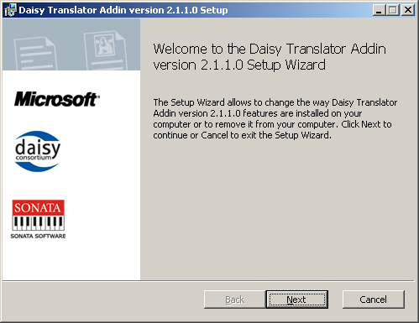

Step 2: The user will be presented with a “License Agreement”.

To continue the user must read and accept the license agreement. Check the Accept box and click next to continue

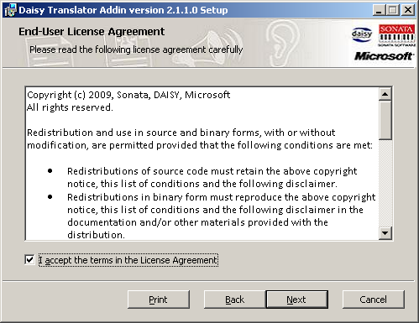

Step 3: Next the user may select an installation scope. This will determine whether the add-in is installed for all users of the machine or just the current user.

Choose the appropriate option and click on Next.

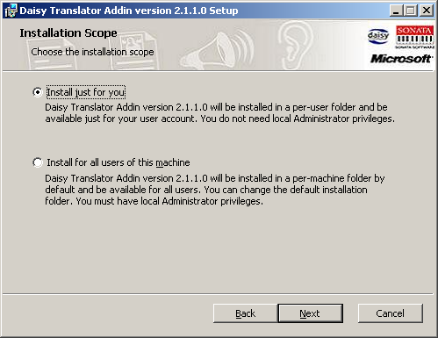

Step 4: The user may now specify the installation folder  
Hit enter or click on Next button. Users are given option to browse for a folder either by pressing the *Change* button or by pressing (Alt + C) on the keyboard.

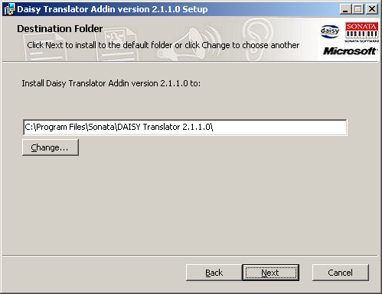

Step 5: The user will be presented with a final step to “Confirm Installation”. Hit Enter or click on Install button.

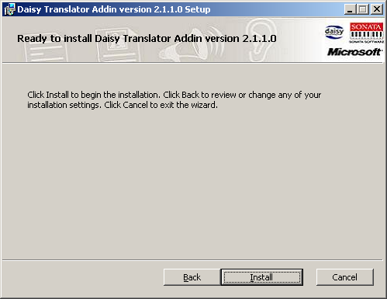

Step 6: Finally, a progress window appears showing the progress of the installation. The user may be prompted during the installation with additional dialogs to install certain prerequisites

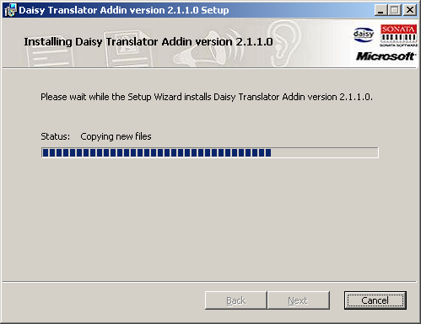

Step 7: On completion of the install process the last step of the wizard, “Completed the DAISY Translator Setup”, provides an option to open the Help file. Hit Enter or click on Finish button.

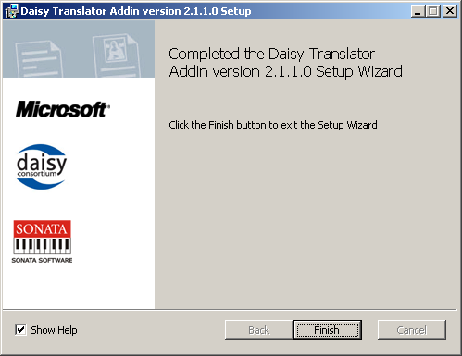

Leaving the Show Help checkbox selected will show this help document.

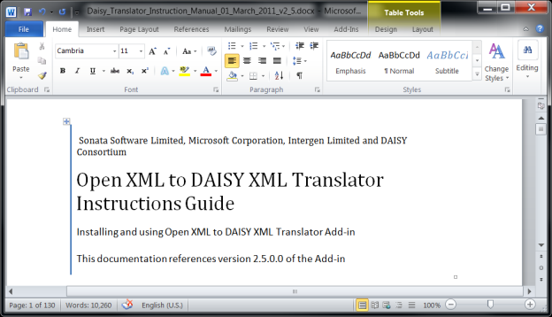

## Confirmation Procedure after Installation is complete and quickstart guide

After the set up is complete a user can confirm that the installation has been successful by following the steps given below:

**For Office 2007 or below**

* Open a new word document.
* Click on Office button or hit “Alt+F”
* Ensure “Save As DAISY” appears in the menu.

**For Office 2010**

* Open a new word document.
* Click on the *Accessibility* Ribbon tab
* Ensure that the “Save As DAISY” button appears in the ribbon menu.

The DAISY add-in installer will install a QuickStart Guide file alongside the DAISY help file. This can be found on the start menu at *Start > DAISY Translator > Save as DAISY Quickstart*

# Save As DAISY Function

The Save functionality provided by the add-in is exposed in a different way for each of Word 2007 and Word 2010.

### Word 2007

**Step1:** Click on the Office Button (Top left hand corner of the Word 2007 user interface) or hit Alt+F to open the File menu

**Step 2:** Select “Save as DAISY menu” or Hit (Alt + F) +Y.

It will show four sub menus, as shown below

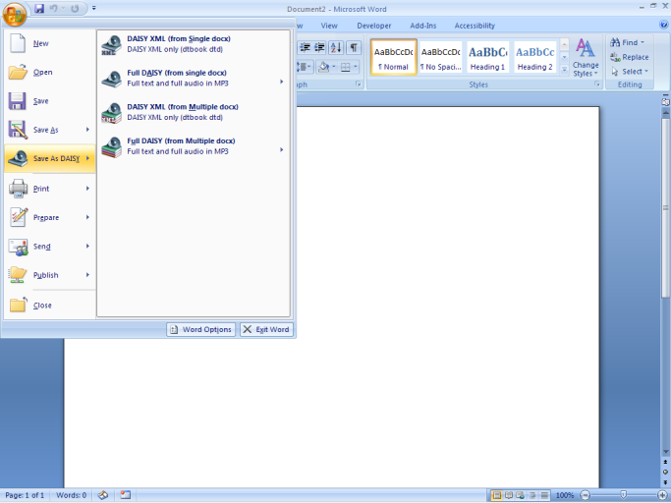

### Word 2010

**Step1:** Click on the File ribbon tab (Top left hand corner of the Word 2010 user interface) or hit Alt+F

**Step 2:** Click on the Add-ins menu on the left hand side of the Backstage interface window, or press Alt-Z

**Step 2:** Select “Save as DAISY menu” or Press Y.

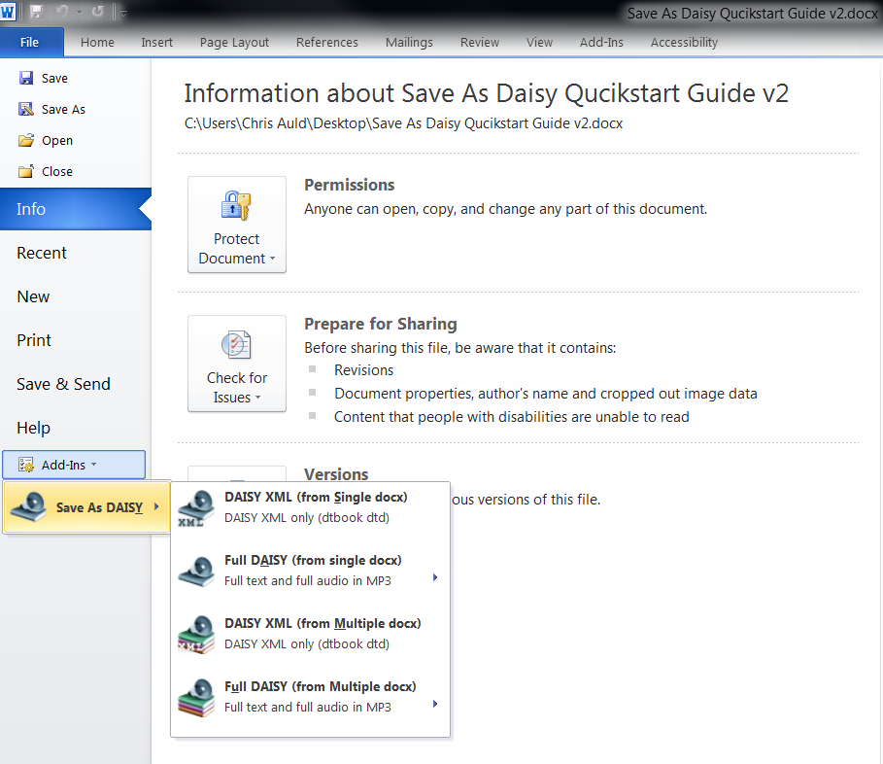

In both cases the user will have access to It will show four sub menus. The Save As menu is also available directly from a Ribbon button on the Accessibility tab in both Word 2007 and Word 2010

1. **DAISY XML (from Single docx):** This sub menu will translate a Word document format to the “DAISY XML” format.
2. **Full DAISY (from Single docx):** This sub menu will show a further sub menu providing for Text to Speech Translation which will translate a Word document to a full “DAISY DTBook”.
3. **DAISY XML (from Multiple docx):** This sub menu will translate a group of documents into a single “DAISY XML” format.
4. **Full DAISY (from Multiple docx):** This sub menu will show a further sub menu providing for Text to Speech Translation which will translate a group of documents to a full “DAISY DTBook”.

## Converting Word Documents In to DAISY XML format

To convert a Word document to DAISY XML format the user should follow the steps below.

1. Open a document that needs to be translated in Microsoft Word
2. Ensure that document is saved before proceeding with the translation.
3. Open the Save As DAISY menu as detailed above
4. Choose the appropriate save option

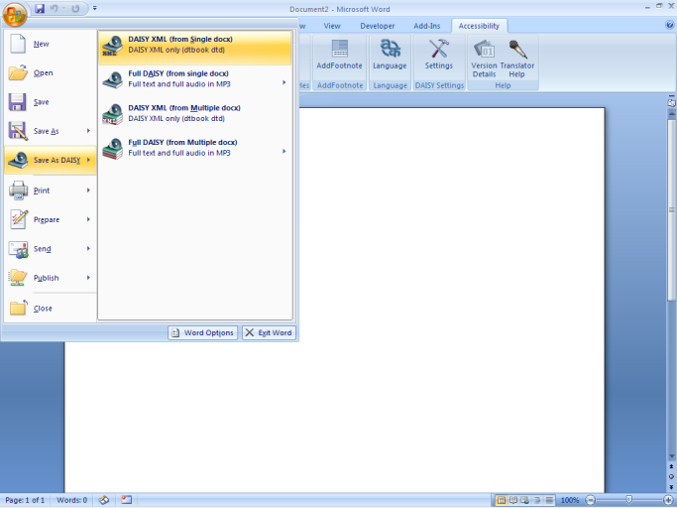

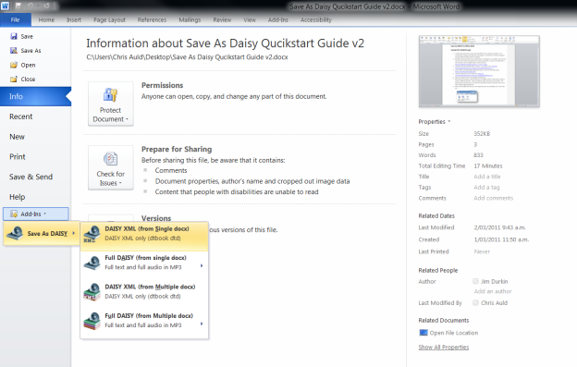

1. If the document is a master sub document (current document having sub documents), the following dialog box will be displayed to the user.

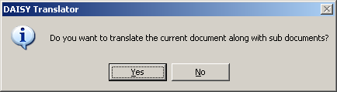   
  
On selecting *Yes*, the translation process will continue and the tool will translate the current document along with sub documents included in it. Otherwise, the tool will translate the current document excluding its sub documents. Before showing the Translation form, the user is presented with an Initializing Translation message momentarily.

1. The user is presented with a Translation dialog as shown below.  
    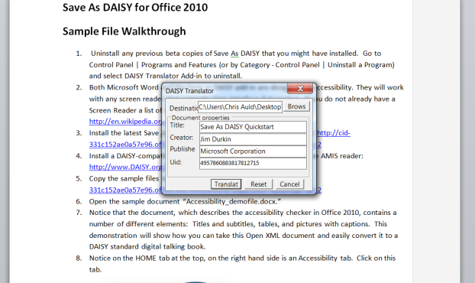

Translator form contains fields: Destination, Document Title, Document creator, Document Publisher, Document UID; all these fields will be auto populated from the document properties. The user may modify or change these values if required and then click on “Translate” button or hit Alt + T to continue.  
 **Note**: Keyboard users can navigate through the form using following options:

* Destination Field (Alt +D)
* Browse (Alt + B) to browse for destination folder.
* Title (Alt +I)
* Creator (Alt +C)
* Publisher (Alt +P)
* UID (Alt +U).
* Translate (Alt +T)
* Reset (Alt +R) to reset all the field values.

1. A Progress bar will show the progress of the translation as shown below.  
    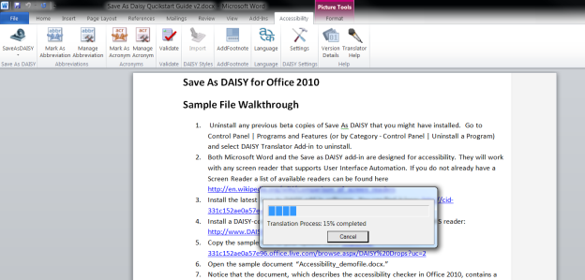
2. After successful translation a success message is displayed. Click on Ok or press enter. To close the dialog  
   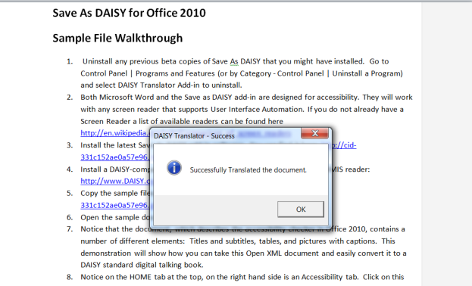
3. If the translation is successful and there were some fidelity loses identified in the process the *Fidelity Loss* dialog box will be displayed with an itemized list of loses that occurred during translation.  
   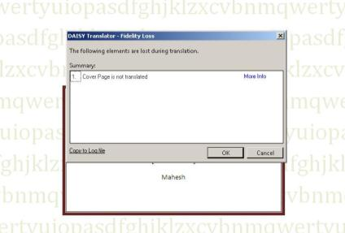

The screen shot above shows the Fidelity loss message “Cover Pages not translated “ and provides a More Info button and an ability to copy the log messages to a file. The log file may be used for detailed analysis and rectification of fidelity loss issues.

In case of Master and Sub documenta single dialog will be show for all fidelity loss issues.

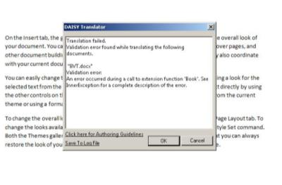

The “Daisy translator – Validation error” window provides an option to open the Authoring guidelines documentation for more information and guidance.

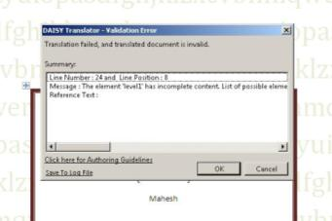

## Converting Word Documents In to DAISY DTBook

To convert a Word document to a full DAISY DTBook is a similar process to above.

Follow steps 1 through 6 above choosing the respective Full DAISY option from the Save As menu

The translation dialog for a full DAISY DTBook output provides additional options.

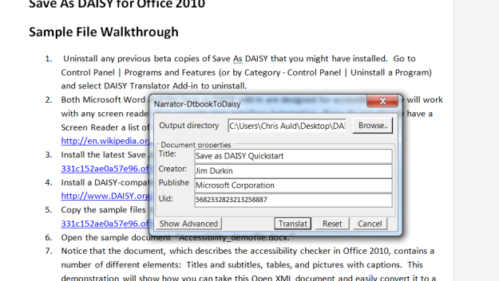

The Advanced options may be accessed by clicking the Show Advanced button of pressing Ctrl-V

The "Show Advanced" form contains the following fields:

1. **DTBook Fix (drop-down list)**

Selects whether to apply DTBook Fix routines to the input document. These routines endeavour to clean and repair the input DAISY XML document to enforce the best compatibility with the remaining steps. The "Apply DTBook Fix routines" option is recommended and is seleced by default

1. **Apply sentence detection (check-box)**

Selects whether to apply sentence detection to the input document text to enable a finer-grained audio synchronization.

1. **MP3 Bitrate (drop-down list)**

Selects the bit rate of the generated MP3 audio files. A higher value will result in better sound quality but the audio files will be larger. The default value is 32 kbit/s which is generally appropriate for speech.

1. **2.02 href target (drop-down list)**

Selects the SMIL element (text or par) to target by href URIs in the content document and navigation control file of the generated DAISY DTB. "text" is the default value but some DAISY players will behave more gracefully if "par" is selected.

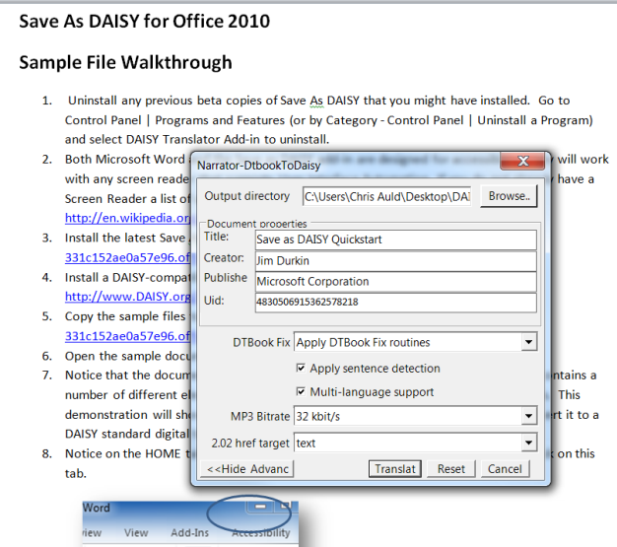

Clicking the “Translate” button or pressing Alt+T will start the translation process.

**Note:** Keyboard users can navigate through the form using following options:

* Browse (Alt + B) to browse for destination folder.
* Title (Alt +I)
* Creator (Alt +C)
* Publisher (Alt +P)
* UID (Alt +U).
* Translate (Alt +T)
* Reset (Alt +R) to reset all the field values.
* Show Advanced (Alt + V)
* Hide Advanced (Alt + H)

On completion of the "Translating to DAISY" step, that is once the DAISY XML has been generated, the DAISY Pipeline Lite tool starts the DAISY XML to DAISY DTBook translation and the user is presented with the "Pipeline Job Progress" dialog.

DAISY Ppeline Progress dialog


A progress bar shows the progress of the translation and a label (below the progress bar) shows the name of the currently running step.

*Note that the translation process will take several minutes (and on some systems even hours) for large documents.  
The minimum recommended requirements for producing a large DTBook are a 2Ghz Processor and 2GB of RAM*

The "Cancel" button allows the user to prematurely abort the translation. Note that the Pipeline Lite process might not terminate immediately but wait for the current task to complete. Some temporary files may then be left in the output directory.

When the translation completes successfully, the user is shown a "Pipeline Job Completed" dialog box displaying the message "Job Completed".

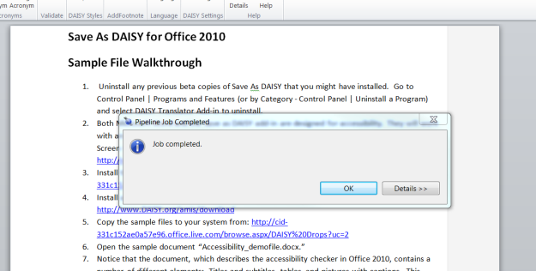*.*

The "Details" button expands a list of Pipeline messages produced during the translation process.

Job completion details view


The output directory will contain both a DAISY 2.02 DTB and DAISY 3 DTB (Z39.86-2005), sharing the same audio files.

*Note that on some cases dummy headings may be added to the document to conform to the DAISY specification (this happens for instance when no heading were found in the entire input document).*

Press the "OK" button to return to the Microsoft Word document.

Step 13: When errors occurred during the translation, the user will be shown a "Pipeline Job Failed" dialog box displaying the message indicating the detailed step where the translation failed.

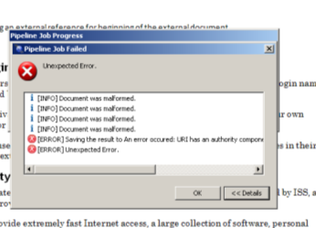

The "Details" button provides the Pipeline messages produced during the translation process.

Refer to the "Troubleshooting" section for further information on what to do. Press the "OK" button to return to the Microsoft Word document.

If the translation is successful but there were some fidelity loses the Fidelity loss dialog box will be shown. Please see the previous section for information on this dialog.

Screen shot above shows the Fidelity loss message “Cover Pages not translated “ ,at the bottom left shown is a Hyperlink which says “Copy to Log file” which will create a log file(.txt file) giving description of all the Fidelity loss messages at the location specified by the user. On clicking OK (press enter) or Cancel a message will be shown to the user. On clicking “Yes” or pressing “Enter” key follow Step 9 to step 13. On clicking Cancel the process will stop.

If an error occurswhile translating theinput Documentthe“Daisy Translator - Validation error” dialog box will bedisplayed to the user with details as to where the error ofccured and how to correct.

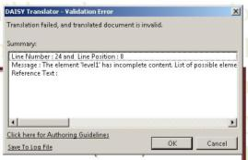 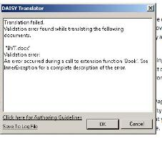

## Converting Multiple Documents

The Save as DAISY add-in supports both single document translation, as set out above, as well as multiple document batch translation.

When one of the Multiple Documents options is selected from the Save as DAISY menu the multiple documents dialog will be displayed.

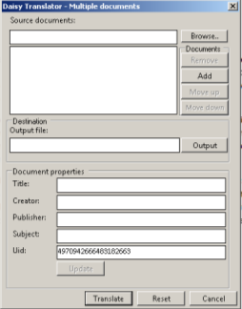

The dialog has the following fields and user interface elements

1. Browse – Allows the user to select a folder containing the documents to be translated.
2. Output – Allows user to specify a destination folder.
3. The documents can be re-ordered the resulting order will determine the output order into the final DAISY XML file):
   1. Move up --Moves the selected document to one level up.
   2. Move down -- Moves the selected document to one level down.
   3. Add -- adds the selected document into the list of sub documents.
   4. Remove -- removes the selected document from the list of sub documents.
4. Translate --Translates all the documents which are in the list
5. Update - - populates the document properties fields with information from the currently selected source document
6. Reset -- Resets all the field values.
7. Cancel – exits from the form.

**Note:** Keyboard users can navigate through the form using following options:

* Browse button (Alt + B) to browse for input folder which is having sub documents.
* Output directory Browse button (Alt +w)
* Move up (Alt +U)
* Move down(Alt +D)
* Add(Alt +A)
* Remove(Alt +M)
* Title (Alt +I)
* Creator (Alt +C)
* Publisher (Alt +P)
* Subject (Alt +S)
* UID (Alt +U).
* Translate (Alt +T)
* Reset (Alt +R) to reset all the field values.
* Cancel (Esc) to exit from the Translator form.
* Show Advanced (Alt + V)
* Hide Advanced (Alt + H)

# Save As DAISY FEATURES WORD2003/wordXP

Version 2.5.0.0 of the Save as DAISY add-in specifically supports Office 2007 and Office 2010. If you are using Office 2003 or Office XP then the add-in version 2.5.0.0 may work with these versions, however testing has not been undertaken on these platforms.

We encourage you to install a previous version of the DAISY add-in version 2.1.1.0 and refer to the documentation for that version.

# Accessibility Ribbon

On successful installation of Daisy Translator Add-in a new tab “Accessibility” will be added in the Microsoft Word ribbon. This “Accessibility” tab provides access to a number of key features in the add-in.

* **SaveAsDAISY:** This button provides access to the Save As DAISY menu.

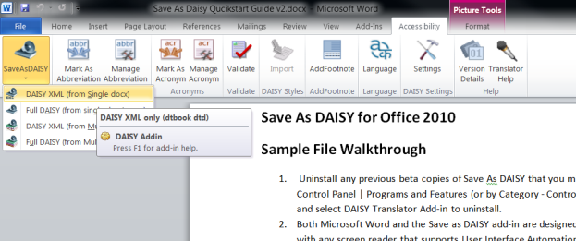

1. **DAISY XML (from Single docx):** This sub menu will translate a Word document format to the “DAISY XML” format.
2. **Full DAISY (from Single docx):** This sub menu will show a further sub menu providing for Text to Speech Translation which will translate a Word document to a full “DAISY DTBook”.
3. **DAISY XML (from Multiple docx):** This sub menu will translate a group of documents into a single “DAISY XML” format.
4. **Full DAISY (from Multiple docx):** This sub menu will show a further sub menu providing for Text to Speech Translation which will translate a group of documents to a full “DAISY DTBook”.

* **Mark As Abbreviation**-To mark a particular word as Abbreviation, select the text within Word, click on Accessibility tab and select Mark as Abbreviation.
* **Manage Abbreviations** – The button opens a dialog box showing all the text marked as abbreviations listed. Any text marked as Abbreviation can be Unmarked using unmark button.
* **Mark As Acronym** - To mark a particular word as Acronym, select the text within Word, click on Accessibility tab and select Mark as Acronym.
* **Manage Acronyms** - The button opens a dialog box showing all the text marked as listed. Any text marked as an acronym can be Unmarked using unmark button.

## How to use Accessibility ribbon

**Abbreviations:**

1. To mark an abbreviation for a word, follow below steps.
2. Select a piece of text within the Word interface.
3. Click on “**Accessibility**” tab or hit (Alt + Y)
4. Click on “**Mark** **as** **Abbreviation**” button or hit (Alt +Y) +B.
5. This opens the Manage Acronym dialog  
   The user can then specify the full form of the selected word

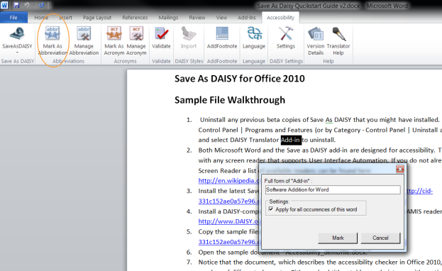

1. The dialog provides the option of marking all occurrences of the selected word throughout the document as abbreviations.
2. Click on “Mark” button or press (ALT+M), to mark abbreviation for the selected text.
3. To unmark an abbreviation for a word, follow below steps.
4. Click on “**Accessibility**” tab or hit (Alt +Y)
5. Click on “**Manage Abbreviation**” button or hit (Alt +Y) +N.
6. The Manage Abbreviations dialog will be shown.

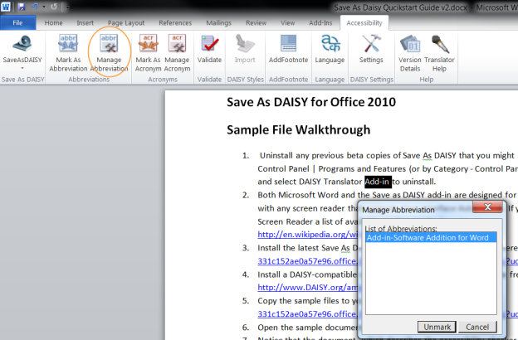

1. To unmark an abbreviation for a word, select that word from the existing items list and click on the “**Unmark**” button or press ALT + U .
2. This will unmark as abbreviation all the occurrences of that particular word in the document.

**Acronyms:**

To mark a word as an acronym follow these steps..

1. Select a piece of text within the Word interface
2. Click on “Accessibility” tab or hit (Alt + Y).
3. Click on “Mark as Acronym” button or hit (Alt + C).
4. The “ Manage Acronym” dialog will be show. Enter the Full form of the selected text

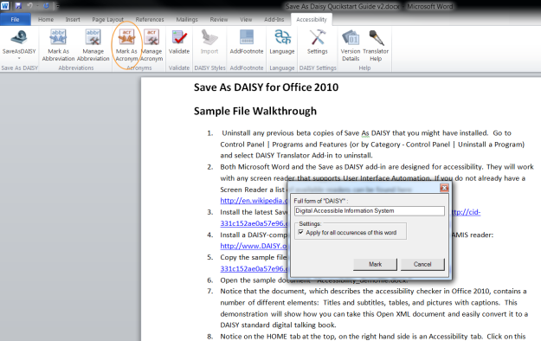

1. The “Apply for all occurrences of this word” checkbox allows all instances of the selected text within the document to be marked as acronyms
2. The “Pronounce the acronym in the reader” checkbox determines whether the acronym is pronounced as it would sound or spelled out, letter by letter in the reader. For example, the acronym EULA (End User License Agreement) would be pronounced “you-la” or spelled “E-U-L-A”
3. Click on “Mark” button or hit (ALT+M), to mark acronym for the selected text.
4. To unmark an acronym for a word, follow below steps.
5. Click on “**Accessibility**” tab or hit (Alt +Y).
6. Click on “Manage Acronym” button or hit (Alt + G).
7. The manage acronyms dialog will be shown listing all acronyms in the document.

Manage acronyms dialog


1. To unmark an acronym for a word, select that word from the existing items list click on the “Unmark” button or hit (ALT + U) .
2. All occurrences of that particular word in the document will be unmarked.

## Importing Custom Styles:

A key to producing quality DAISY output from a Microsoft Word document is the use of the appropriate Styles. These are used to markup text such as headings. When this text is converted into DAISY XML it is correspondingly marked as having special properties in the XML

The DAISY add-in for Word leverages the native Styles feature in Microsoft Word by providing a set of predefined styles that can be applied to text. These styles must be imported into the Style collection for the document before they can be used.

To import the custom styles:

1. Click on “**Accessibility**” tab or hit (Alt +Y).
2. Click on the Import button or press (Alt +Y) +S to import the custom styles.

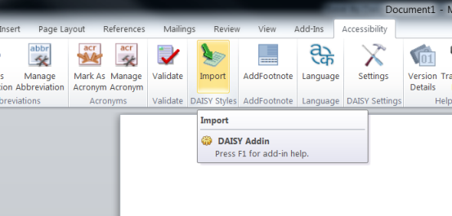

The custom styles will be added to the styles collection in the Word document. To mark a custom style for a piece of content content, select the content within Word and apply the styles from styles menu or press (Alt +Ctrl +Shift +S).

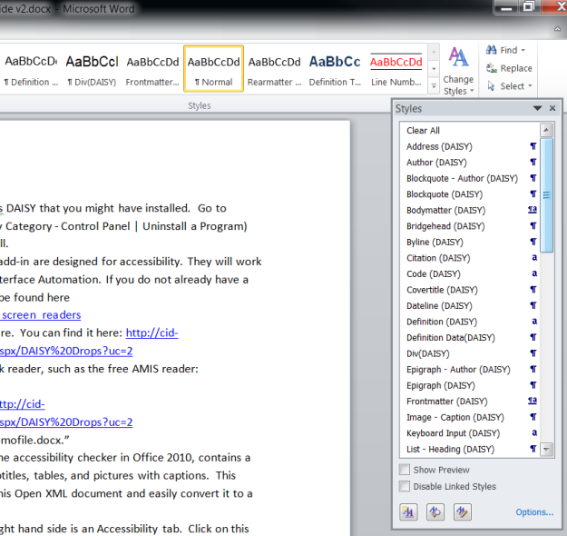

**Enable and Disable of Import Daisy button:** If the active document has already imported the daisy styles then the “Import Daisy Styles” ribbon button will be in disabled state. If the active document doesn’t contains the daisy styles the “Import Daisy Styles” ribbon button will be in enabled state.

## Translator Help

Translator Help provides access to several Microsoft Word Documents

* Authoring Guidelines
* Instruction manual
* Troubleshooting Guidelines for the Translator.

To use Translator Help click on Accessibility Ribbon tab, click the Translator Help menu and choose the appropriate help document as either a Word File or as a DAISY DTB folder.

## Helper Wizard - Validating the document against DAISY validation rules

The add-in supports the authoring of high quality DAISY XML by allowing this to be validated against a set of DAISY rules.

To use the validation function.

1. Click on “**Accessibility**” tab or press (Alt + Y).
2. Click on “**Validate**” button or press (Alt +Y) +V.  
   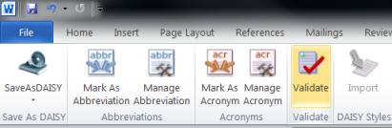
3. On clicking the “**Validate**” button a progress bar will appear.  
   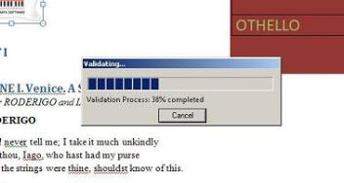
4. If the input document contains validation errors then a Message Box indicating this.  
   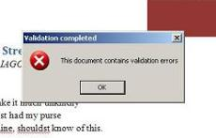
5. If the input document does not contains validation error then a Message Box appears indicating that the document is valid.  
   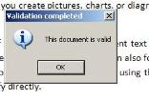
6. After the validation process has completed, any validation errors identified are displayed in the Validation Errors dialog along with access to resolution information.  
   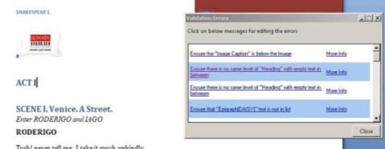
7. The user can navigate to the document location of the error by clicking the error message in the dialog.  
   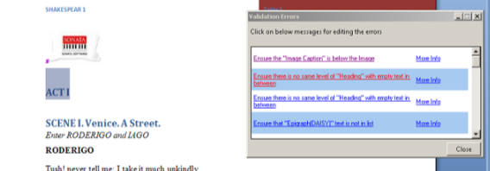
8. Clicking the More Info link will open the Authoring guidelines help file.  
   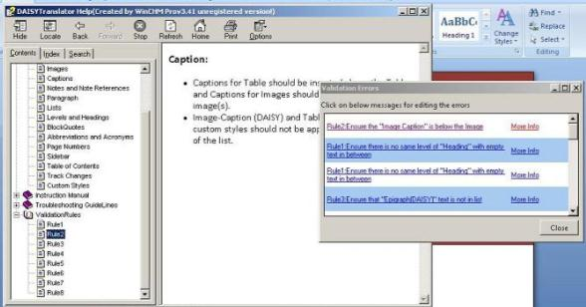

## Language Detection

This feature allows the user to set the language for the selected paragraph/paragraphs in the document.

1. Select the text in the Word document.
2. Click on “**Accessibility**” tab or hit (Alt + Y).
3. Click on “**Language**” button or hit (Alt +Y) +L.
4. This opens the “Language” dialog providing a list of languages.
5. Select the appropriate language and click on “Apply” or press (ALT+A), to set the chosen language for the selected paragraph.  
   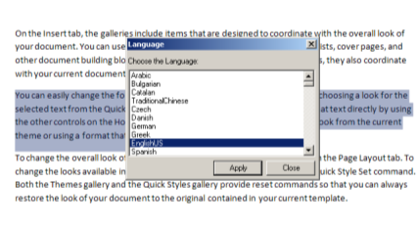

**Note:** The Language feature uses a paragraph as the smallest indivisible unit. i.e. the language may be set for a whole paragraph only or multiple paragraphs. It may not be set for a single sentence in a paragraph.

## Daisy Settings

These are a number of global settings that can be set that will affect the translation process.

These are accessed from the Settings button on the Accessibility ribbon.

The following screen-shot shows various pre-translation settings (options) provided to the user:

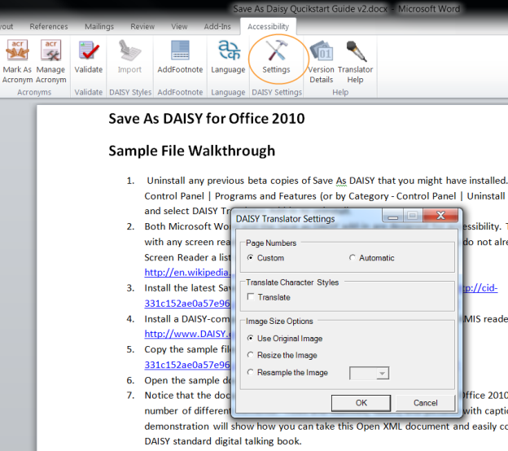

* Page Numbers: The user can choose between using custom page numbering or automatic page numbering for the document.
* Translate Character Styles: The user can choose to preserve character styles such as underline, strikethrough, indentation, alignment in the output xml.
* Image Size Options: The user may specify a an approach for handling images embedded in the document
  + Use Original image: This will preserve the original size of the image as inserted in the word document and same size of the image will be retained in the destination folder along with the output xml.
  + Resize: Selecting this radio button will put two new attributes namely “height” and “width” in the output xml indicating that the image in the word document has been resized.
  + Resample: Allows the user to resample images to a lower “dpi” value i.e. 72, 96 or 120

Resampling is performed on the image inserted into the document based on the dpi value selected by the user and same image is placed in the destination folder along with the output xml.

## Footnotes

Footnotes are the links made to cite your reference on a word document. Word defaults numbering of footnotes from 1. These numbers are usually used as the reference for footnotes.

A footnote should ideally have two parts - Reference no & Footnote text.

**Footnote in daisy translator:**

Footnotes are found missing when scanned documents are converted back to the document. In such a scenario the footnote text can be selected by the user and he would have the provision to see all the available occurrence of the reference throughout the document. The right text can be selected and set it back to footnote reference *following the steps below*:

* Select the text from the document which has to be converted to a footnote along with its reference.

|  |
| --- |
|  |

* Selecting the text, click on Accessibilty -> AddFooteNote in Excel Ribbon

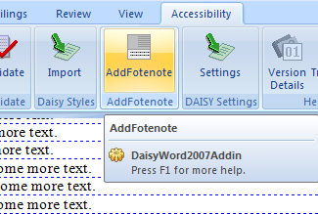

* The list of suggested references will be displayed on a new window. Suggested references will contain all the occurrences of reference (reference-text) throughout the document.

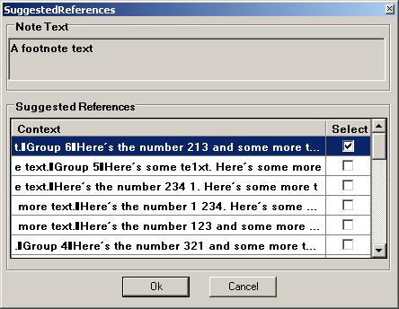

* Clicking on any of the line in suggested-references window, will select the same range of text in the document. This helps the user to decide or confirm if the text in that particular range of text has to be converted to a footnote reference.
* The user should select the line in suggested reference window by selecting the checkbox standing for the line and click OK button, to consider the text in it to be converted to the footnote reference.  
  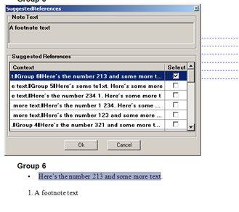

Below image shows the newly converted footnote reference through suggested reference window.

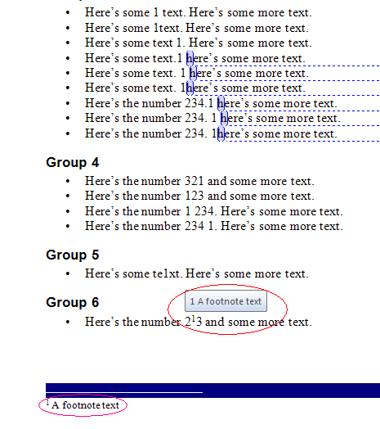

**Note:** Converted reference would be a custom footnote. There is no linking between word’s default footnote and word’s custom footnotes.

# Text-to-Speech Configuration

The TTS voice used by the Pipeline Lite Narrator tool to produce the audio content is the voice configured by default on the Windows environment of the user.

The user can change this voice via the Windows Control Panel:

1. Go to the "Control Panel" (available via the "Start" menu)
2. Switch to "Classic View" (or "Category View")
3. Open the "Speech" item
4. Select the "Text to Speech" tab
5. Select the required voice in the "Voice Selection" drop-down button

Further fine-grained configuration (such as silence duration, multiple language support, accronym pronunciation, etc) is currently not directly exposed to the end user. Advanced users can however refer to the DAISY Pipeline developer documentation to fine tune the internal configuration files located in the Pipeline Lite installation directory: <<http://daisymfc.sourceforge.net/doc/index-developer.html>>

# Multiple Versions of Office

In an environment where the user has installed multiple versions of Microsoft Office (known as side-by-side installation), the DAISY translator Add in installer will install for the default (recently used) Office version.

# Command Line Utility

The Daisy Command Line Translator is a tool for translating Office Open XML format documents to Daisy format documents using the command line.

## Command line Usage

DaisyTranslator.exe /I PathOrFilename [/O PathOrFilename] [BATCH-DOCX] [/REPORT Filename] [/TITLE] [/CREATOR] [/PUBLISHER] [/UID] [/M] [/APAGE] [/CPAGE] [/STYLE]

Where options are:

|  |  |
| --- | --- |
| /I PathOrFilename | Name of the file to transform (or input folder in case of batch conversion)(ex: D:\newfolder or D:\newfloder\input.xml) |
| /O PathOrFilename | Name of the output file (or output folder)(ex: D:\newfolder or D:\newfloder\output.xml) |
| /BATCH-DOCX | Do a batch conversion over every DOCX file in the input folder (note: existing files will be replaced)(ex: D:\newfolder) |
| /REPORT Filename | Name of the report file that must be generated (existing files will be replaced)(ex: D:\newfloder\sample.txt) |
| /TITLE | Title of the output file that must be generated |
| /CREATOR | Creator of the output file that must be generated |
| /PUBLISHER | Publisher of the output file that must be generated |
| /UID | Uid of the report output that must be generated |
| /M | Filename To translate Multiple Documents |
| /APAGE | To Translate the current document with Automatic PageNumber Style |
| /CPAGE | To Translate the current document with Custom PageNumber Style (**Default**) |
| /STYLE | To Translate the current document with Character Styles |

# Reader and Producer Software

This section provides a list of links for DAISY production and playback software

The following link provides a list of available producer software

* <http://www.daisy.org/tools/tools.shtml?Cat=production>

The following link provides a list of available playback software

* <http://www.daisy.org/tools/tools.shtml?Cat=playback>

After installing the reader and producer software, follow these steps:

* Load the translated XML file to the producer from the physical path provided during the translation of the document.
* This will create a package in same location which will contain some ten files, in which one file would be “OPF” file.
* Reader software only reads the “OPF “file created by the producer.
* Load the “OPF” file created by the producer in the reader.
* Reader reads the “OPF “file containing all the contents of Word document.

# Table of Short Cut Keys

## General shortcut keys:

|  |  |  |
| --- | --- | --- |
| **S.No** | **Description** | **Shortcut Keys** |
| 1 | Office Button | (Alt+ F) |
| 2 | Save As DAISY button | (Alt +F) +Y. |
| 3 | Import Daisy Style | (Alt + Y)+I |
| 4 | Translator Help | (Alt + Y)+H |
| 5 | Settings | (Alt + Y)+S |
| 6 | Version Details | (Alt + Y)+D |

## Shortcut keys for DAISY XML (from Single docx) Form:

|  |  |  |
| --- | --- | --- |
| **S.No** | **Description** | **Shortcut Keys** |
| 1 | Destination Field | (Alt +D) |
| 2 | Browse to browse for destination folder. | (Alt + B) |
| 3 | Title | (Alt +I) |
| 4 | Creator | (Alt +R) |
| 5 | Publisher | (Alt +P) |
| 6 | UID | (Alt +U) |
| 7 | Translate | (Alt +T) |
| 8 | Reset to reset all the field values. | (Alt +R) |
| 9 | Cancel to exit from the Translator form. | (Alt +C) |

## Shortcut keys for Full DAISY(from Single docx) Form

|  |  |  |
| --- | --- | --- |
| **S.No** | **Description** | **Shortcut Keys** |
| 1 | Browse to browse for Output directory. | (Alt + B) |
| 2 | Title | (Alt +I) |
| 3 | Creator | (Alt +R) |
| 4 | Publisher | (Alt +P) |
| 5 | UID | (Alt +U) |
| 6 | Translate | (Alt +T) |
| 7 | Reset to reset all the field values. | (Alt +R) |
| 8 | Cancel to exit from the Translator form. | (Alt +C) |
| 9 | Show Advanced | (Alt + V) |
| 10 | Hide Advanced | (Alt + H) |

## Shortcut keys for DAISY XML(from Multiple docx) Form

|  |  |  |
| --- | --- | --- |
| **S.No** | **Description** | **Shortcut Keys** |
| 1 | Browse button to browse for input folder which is having sub documents. | (Alt + B) |
| 2 | Output File button | (Alt +O) |
| 3 | Move up | (Alt +U) |
| 4 | Move down | (Alt +D) |
| 5 | Add | (Alt + A) |
| 6 | Remove | (Alt +M) |
| 7 | Creator | (Alt +R) |
| 8 | Publisher | (Alt +P) |
| 9 | UID | (Alt +U) |
| 10 | Translate | (Alt +T) |
| 12 | Reset to reset all the field values. | (Alt +R) |
| 13 | Cancel to exit from the Translator form. | (Alt +C) |

## Shortcut keys for Full DAISY(from Multiple docx) Form

|  |  |  |
| --- | --- | --- |
| **S.No** | **Description** | **Shortcut Keys** |
| 1 | Browse button to browse for input folder which is having sub documents. | (Alt + B) |
| 2 | Output File button | (Alt +O) |
| 3 | Move up | (Alt +U) |
| 4 | Move down | (Alt +D) |
| 5 | Add | (Alt + A) |
| 6 | Remove | (Alt +M) |
| 7 | Creator | (Alt +R) |
| 8 | Publisher | (Alt +P) |
| 9 | UID | (Alt +U) |
| 10 | Translate | (Alt +T) |
| 12 | Reset to reset all the field values. | (Alt +R) |
| 13 | Cancel to exit from the Translator form. | (Alt +C) |
| 14 | Show Advanced | (Alt + V) |
| 16 | Hide Advanced | (Alt + H) |

## Shortcut keys for Abbreviations and Acronyms

|  |  |  |
| --- | --- | --- |
| **S.No** | **Description** | **Shortcut Keys** |
| 1 | Mark As Abbreviation | (Alt + Y)+B |
| 2 | Manage Abbreviation | (Alt + Y)+ N |
| 3 | Marks As Acronym | (Alt + Y)+C |
| 4 | Manage Acronym | (Alt + Y)+G |