# Accessibility Checker In Office 2010

The importance of Accessibility is becoming larger and larger in the government and business sectors. One of the recent concerns in these areas is that many documents that are being authored are not accessible to people with disabilities.

Office 2010 has made steps to improve this process by creating an Accessibility checker in the Office applications.

## What is the Accessibility Checker for Microsoft Office 2010?

## What is

The Accessibility Checker is a tool that works much like the document inspector. It looks for items that could be a potential problem for people with disabilities.

The table below shows what items are checked in Word when the accessibility checker runs and offers suggestions to make the document easier to work with for people with disabilities.

## Table 8 Items checked by Accessibility Checker

|  |  |  |
| --- | --- | --- |
| Issue | Warning vs. Error | Accessibility Checker Suggestion |
| Table has default name (“Table1”) | Error | Prompt for a new table name |
| Picture has no alt text | Error | Prompt for alt text |
| Clip Art image has no alt text | Error | Prompt for alt text |
| SmartArt has no description | Error | Description of what SmartArt shows |
| Chart has default name (“Chart1”) | Error | User will be prompted for chart title in the form: “Chart1 – Name of Chart” |
| Word documents exceed a certain length | Warning | It will be suggested that user adds headers and other structure to the document |
| Theme is not accessible | Warning | It will be suggested that the user change the font and color scheme (this can also be done automatically if they click ‘change’) |

After the checker runs on a document, if there are any warnings or errors are detected, they will appear in the **Accessibility Checker** task pane. t The pane will lists the items as either errors or warnings based on the table above.

When an item is clicked in the task pane, there are suggestions as to what needs to be changed to make it acceptable.

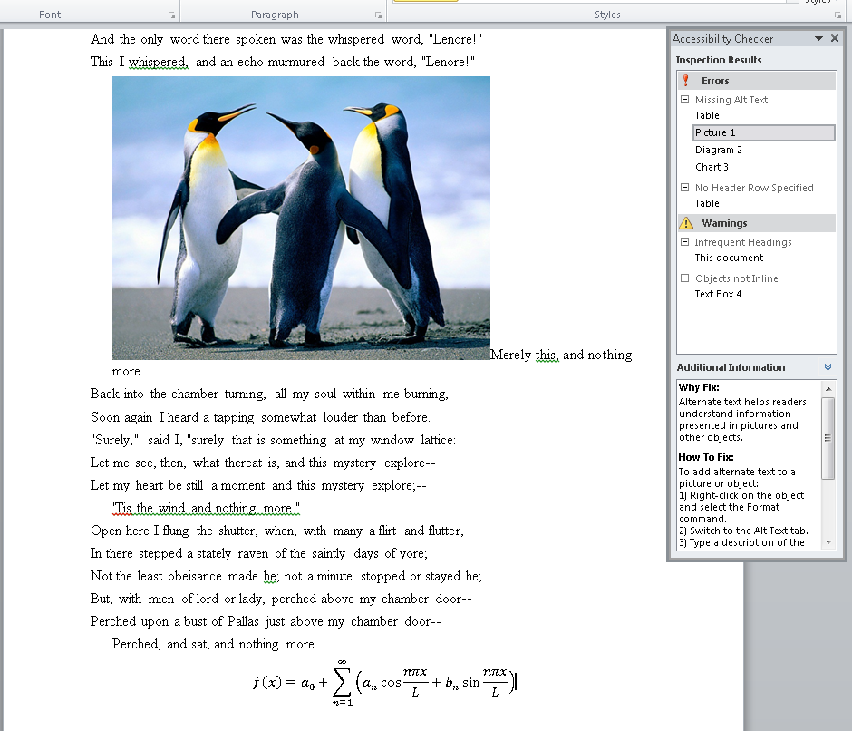

Penguins frolicking 1

Figure 64: Inspection Results

## Launching the Accessibility Launcher

The Accessibility Checker can be invoked either manually or automatically.

### Manually

If a user is not running in Accessibility Mode but would still like to create accessible documents, they can invoke the Accessibility Checker from the File Tab. The Accessibility checker is located in the Info Section under Prepare for Sharing.

### Automatically if the user is running in Accessibility Mode

If there is a policy set that enables Accessibility mode, the dialog will be launched automatically, either when the user attempts to publish the document or when they save it, depending on the level of the policy. Various buttons will also be disabled or enabled depending on the level, because at the highest accessibility level, users will not be able to ‘ignore’ accessibility errors.

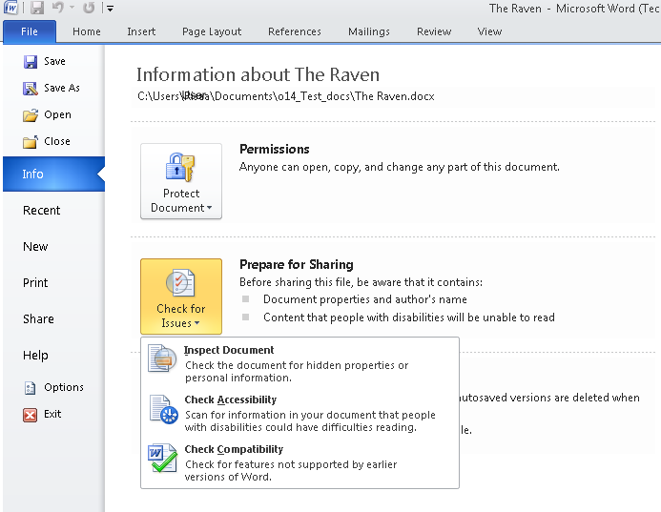

Information About The Raven 1