# DOCUMENT PREPARATION GUIDELINES FOR USING SaveAsDAISY

*Updated 26 January 2021*



***DAISY Consortium***

*www.daisy.org*

# Contents

DOCUMENT PREPARATION GUIDELINES FOR USING SaveAsDAISY 1

Contents 2

INTRODUCTION 3

WHY CARE ABOUT MAKING THE WORD DOCUMENT ACCESSIBLE? 3

PREPARING ACCESSIBLE MICROSOFT WORD DOCUMENTS 4

USING STYLES IN MICROSOFT WORD 4

SaveAsDAISY specific styles 5

HEADINGS 5

ALT TEXT OR IMAGE DESCRIPTIONS 6

HYPERLINKS 7

TABLES 7

BULLETED AND NUMBERED LISTS 8

FILE NAME AND PROPERTIES 8

USE OF COLOR 8

SPACING, ALIGNMENT AND MARGINS 9

Page numbering strategy for Print to Digital conversion 9

HEADER & FOOTER 10

ABBREVIATIONS AND ACRONYMS 10

FOOTNOTES AND ENDNOTES 10

TABLE OF CONTENTS 10

COLUMNS 11

TEXT BOXES 11

SIDE BARS 11

CAPTIONS 11

WATER MARK 11

SOME OTHER POINTS 11

THE MICROSOFT ACCESSIBILITY CHECKER 12

ACCESSIBILITY CHECKER ERRORS, WARNINGS, AND TIPS 15

MANUAL TESTING FOR ACCESSIBILITY 17

Convert your document now 19

# INTRODUCTION

This document includes guidelines for preparing Microsoft Word documents for conversion to DAISY format with the SaveAsDAISY add-in, also known in previous versions as DAISY Translator, provided by DAISY Consortium.

Using the SaveAsDAISY add-in remains one of the fastest ways to create a DAISY book or DTBook XML file from a text document.

Preparation for using SaveAsDAISY add-in requires proper mark-up of the document using appropriate formatting styles. There are numerous rules that need to be followed while applying the styles to different text elements such as headings, footnotes, page numbers, tables, lists and images.

Adherence to these guidelines will provide you with a document that will pass the Microsoft Accessibility Checker tests and will be a great source document for conversion to various other alternative formats like Braille or just for direct reading with assistive technologies like a screen reader.

Primarily you need to prepare a Microsoft Accessibility Checker verified document before using SaveAsDAISY to convert it to DAISY XML or full DAISY book. Only a few SaveAsDAISY specific styles need to be applied as per requirement otherwise a well-structured Microsoft Word document that passes Microsoft Accessibility Checker tests should work with the SaveAsDAISY add-in.

Note that the 2021 release SaveAsDAISY add-in replaces the DAISY Translator Validator with the Microsoft Accessibility Checker. The Accessibility Check button in the Accessibility ribbon will now launch the Microsoft Accessibility Checker.

# WHY CARE ABOUT MAKING THE WORD DOCUMENT ACCESSIBLE?

When you use SaveAsDAISY, your objective is to create accessible versions of the document which will be easy to read and navigate for the users. The accessibility and ease of use of the SaveAsDAISY output depends upon the source Word document. If the Word document is not well structured, is not prepared as per text processing guidelines then the resulting outputs such as the DAISY book will not be easy to read and navigate for the users.

People with disabilities use digital documents in different ways. Some of them may want to get it Read Aloud using Text-To-Speech software, or read it on Refreshable Braille Devices, while others may want to magnify the text and change the foreground and background color to suit their visual disability. Some of your readers may be using the keyboard to navigate through your documents, while others may be using touch, voice commands, a modified mouse, Head Stylus, or even Eye Tracking technology.

Keep in mind that the content you create will be consumed by people in different ways. If you don’t consider this variety while creating content, millions of people will find it hard or impossible to use your creations.

Adherence to the guidelines in this document will ensure you create a Word document that will provide a great reading experience when used as is and will convert to a good quality accessible format on conversion with SaveAsDAISY.

The accessibility guidelines and best practices for the creation of digital documents are intended to achieve the following objectives:

1. Creating a structured and navigable document – It should be possible for all readers to easily identify and move to any position in the document such as a Chapter or sub-section. Tables, lists, notes, etc. should have been created using the best practices instead of customized methods.
2. Provision of text descriptions for graphical content such as pictures, flow charts and maps so that visually impaired readers do not miss out on important aspects of understanding the document.
3. Providing an adaptable format that is marked-up semantically – It should be possible for readers to adapt the visual presentation of the document to suit their reading needs. The meaning of different text elements should be conveyed not only through visual presentation, e.g., color, alignment, but also through the appropriate use of built-in styles.

Microsoft provides an **Accessibility Checker**within its Office applications. Ensuring that your documents pass the tests of this Accessibility Checker is generally sufficient to ensure that people with different disabilities will not have major difficulty using the content. In this document, the Microsoft Office Accessibility Checker has been used as a benchmark. Note that accessibility for all users cannot be guaranteed, however, documents that pass the Accessibility Checker and the manual testing (described later) will certainly be more accessible and easier to use.

# PREPARING ACCESSIBLE MICROSOFT WORD DOCUMENTS

The accessible Microsoft Word files creation process is summarized below.

Step 1: Prepare a structured document with image descriptions in Microsoft Word.

Step 2: Use the Accessibility Checker and fix errors if any.

Step 3: Use at least one assistive technology such as NVDA (recommended) to test the reading experience and identify any remaining accessibility barriers.

Step 4: Accessible Word document is ready. Use SaveAsDAISY to create DAISY book or other accessible formats.

## USING STYLES IN MICROSOFT WORD

You will need to frequently access the styles panel when marking the document. In Microsoft Word 2007 and later to open the Styles list in the Home ribbon click the arrow below the Change Styles button. You can also use the keyboard shortcut CTRL + SHIFT + S to bring up the Styles dialog.

## SaveAsDAISY specific styles

The SaveAsDAISY add-in inserts a new ribbon named Accessibility in Microsoft Word. You can click the Import button in the Accessibility ribbon to add DAISY specific styles to the document.

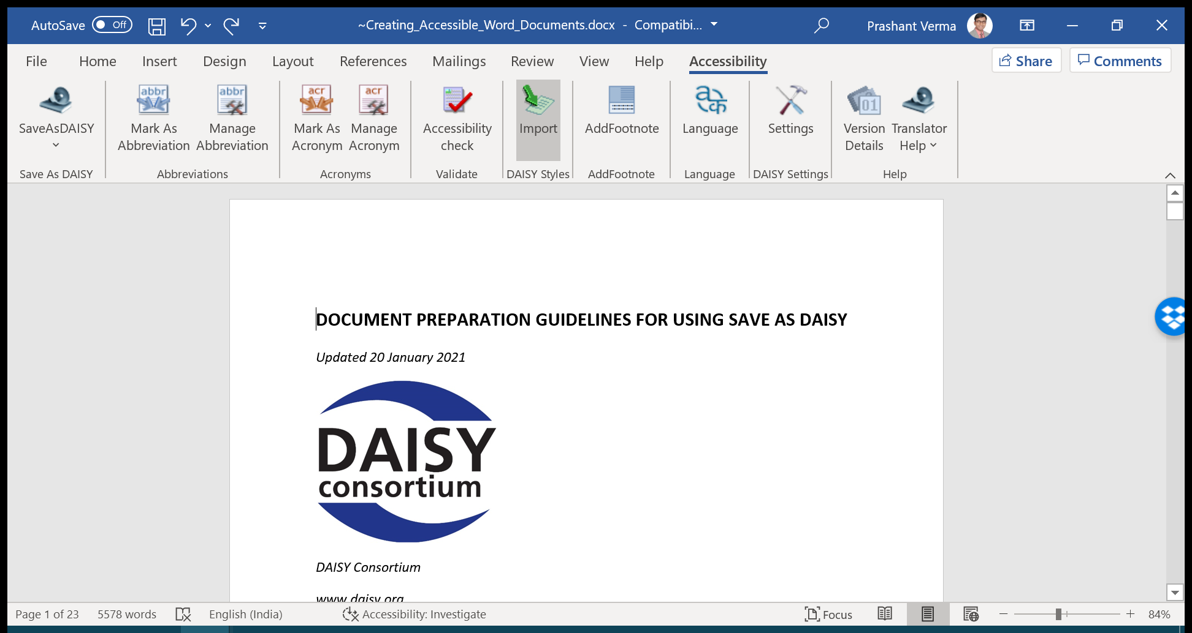

Several styles with the word (DAISY) appended to their name will get added to the list of available styles on clicking this Import button. Some of these are “Page Number (DAISY)”, Frontmatter (DAISY)” and “Bodymatter (DAISY)”.

**IMPORTANT: Use these new DAISY specific styles with caution. It is recommended that you only use the “Page Number (DAISY)” style as there are specific rules associated with other styles and their use may lead to document validation and conversion issues. Further, assistive technologies and conversion tools may ignore most of the other styles and their application will be redundant.**

## HEADINGS

Clear, well-formatted headings can go a long way toward making sure your Word documents meet global accessibility standards. Many people use screen readers to create a list of headings, allowing them to skim the document to find the content they want. But this type of navigation only works when the document’s author uses appropriate heading styles. Screen readers and text-to-speech tools are programmed to recognize them.

**To add a heading style to text in Word, select the text, choose the Home Tab in the Ribbon, and in the Styles Box, pick the heading style you want.**

Keyboard shortcuts are available for Heading level 1, 2 & 3 only.

* ALT + CTRL + 1 for HEADING 1
* ALT + CTRL + 2 for HEADING 2
* ALT + CTRL + 3 for HEADING 3

In Microsoft Word Heading Level 1 through 9 styles is available but Daisy books support Heading Level only up to level 6. Most documents will however have headings only 3 to 4 level deep.

Also note that:

* A heading should not have any line break in between. This will result in two headings of the same level without any text in between. This mark-up is invalid. For example, if the document has the following:

**Chapter 1:**

**Basics of Programming**

If the same heading style is applied to both the lines above, there will be two headings of the same level since the section name is broken up into two paragraphs. Manually bring the heading name in one paragraph and then apply the heading style. The correct format will be as follows:

**Chapter 1: Basics of Programming**

* Begin with a H1 at the very start of the document

Always use heading styles in a logical order and do not skip levels. For example, Heading 1 will always be followed by Heading 2, and Heading 2 will be followed by Heading 3 or another Heading 2. If this is not done, the document will not pass the Accessibility Checker tests. Further, screen reader users may think they have missed a heading or may get confused by the order. Remember, when you are writing headings, keep them short, specific to the information that follows them, and clear to someone new to the topic.

**Keeping the Navigation Pane open is very helpful while applying the heading styles. Click on the View Tab and then select Navigation Pane to open the window which displays the list of all headings in the document.**

## ALT TEXT OR IMAGE DESCRIPTIONS

Blind and low vision users cannot see and understand the non-textual content e.g. pictures, charts, maps in the document. However, screen readers can read out the text description called alt text provided by you in place of the graphical content. You should add alt text to pictures, clip art, charts, tables, shapes, smart art, graphics, and embedded objects to help blind and low vision users fully understand your content.

To add all text to an object, RIGHT CLICK on the object and choose FORMAT PICTURE. Then click on ALT TEXT and in the DESCRIPTION field type or paste the image description text and click Close.

Note that in different versions of Microsoft Word the Alt Text option may be placed differently.

To add alt text to a table RIGHT CLICK the table, choose TABLE PROPERTIES. Then select the ALT TEXT TAB. In the description box type a short description for the table and click OK.

### Guidelines for writing alt text:

1. Use alt text to convey the important content or function of the object.
2. Be concise. Typically a few words are all you need, although sometimes a short sentence or two may be required.
3. Often the object is described in the surrounding text. In such cases, your alt text can be very brief. It should not repeat the information already provided in the document.
4. Screen readers generally announce the type of content, so you don’t need phrases like “image of”, “table of” or “linked to” in your alt text.
5. Decorative images need not be described. In the newer Word versions, you can select the “Mark as decorative” checkbox in place of writing anything in the alt text field. In the older Microsoft versions as the “Mark as decorative” option is not available, you can write the word “decorative” in the alt text field.

A comprehensive set of [Image Description Guidelines are available from the DIAGRAM Center.](http://diagramcenter.org/table-of-contents-2.html)

If you think your audience needs more information, you can write the description just below the object. For complex objects like charts, people often write the description below the object. It is also common to prefix the description text with the words “Image description:”

## HYPERLINKS

If you have hyperlinks in the document, changing their display text to ordinary language can make them much easier to understand for users who rely on screen reading programs.

RIGHT-CLICK the hyperlink on the page. Then choose EDIT HYPERLINK. In the TEXT TO DISPLAY box, type a description and click OK.  
When adding display text, avoid phrases like “Click here” or “Learn more”. Screen reader software users often rely on a list of hyperlinks to browse the document. If the display text for links is the same generic phrase, such users will not be able to differentiate between the purpose of the hyperlinks.

## TABLES

Keep the following points in consideration while creating tables in Word documents.

* Use the default Microsoft Word functionality to create tables.
* Keep the table as simple as possible.
* If appropriate, designate a header row.

Do not draw a table using lines, or insert an image of a table. The correct approaches are to use INSERT then TABLE, or CONVERT TEXT TO TABLE.

Screen readers and other assistive technologies do not cope well with complex tables. Avoid using merged cells, split cells, and nested tables. These will result in warnings from the accessibility checker.

Define the table and column width in percentages so that they adjust to different screen and page sizes.

Here are a few ways to check the accessibility of your tables.

First, try navigating all the way through your table using only the tab key. If you can tab smoothly through the table, cell by cell, and row by row, a screen reader should have no trouble with it. In English-language tables, the tab key should move from left to right, starting in the top-left cell, and ending in the bottom right.

Next, consider the use of a designated header row for your table. Designated header rows make it easier for a screen reader to navigate your table, so the screen reader can announce the column name before reading the data.

To designate a row as a header, select it, then RIGHT CLICK and select TABLE PROPERTIES. Select the ROW TAB. And check REPEAT AS HEADER ROW AT THE TOP OF EACH PAGE. Make sure ALLOW ROW TO BREAK ACROSS PAGES is unchecked.  
To provide alt text for a table, in the TABLE PROPERTIES dialog, switch to the ALT TEXT tab and provide the text description.  
To fix split cells, where two cells occupy the space of a single cell, select the cells, RIGHT CLICK, and choose MERGE CELLS.

## BULLETED AND NUMBERED LISTS

Use the bullets and numbering feature to create lists in the Word document. The list numbers or bullets should not be manually typed.

When the lists are created using the automatic styles, assistive technology users are informed of the beginning and end of lists, and also of the number of list items. This helps them in better understanding of the content.

To convert a list where the numbers e.g. a), b).. have been typed manually, select the entire content of the list, RIGHT CLICK and then in NUMBERING choose an appropriate style.

## FILE NAME AND PROPERTIES

Giving your documents meaningful filenames and document properties makes them easier to find for everyone. These steps are especially important for meeting new accessibility guidelines, like the US Section 508 Refresh, the new EU directive on Accessibility, and many others around the world. A good file name provides clues to a document’s content and age.

To rename a document in file explorer, RIGHT-CLICK the file and choose RENAME. Type the new name and hit ENTER.

When the document is open in Word, you can add a TITLE and AUTHOR name to the document properties, which makes the file easier for others to find. Adding these properties is also part of the US 508 accessibility guidelines.

To modify properties of the document, click on FILE. The TITLE, TAGS,, AUTHOR and other fields will be displayed on the right side of the window.

## USE OF COLOR

Text color alone should not be used to convey information in a document. People with visual disabilities, such as low vision and color blindness are likely to miss out on this information.

Wherever possible use the heading styles. Alternatively, the colored text can be underlined. If using color in charts, supplement color coding with texture, different line styles, text in graphs, or shades of one color to improve accessibility. Printing a color document in black and white is the best test to see if you have lost any meaning.

Also, take care of color contrast, avoid putting very similar colors on top of one another. Good contrast between the text and background color makes the document easier to read for everyone especially those with visual impairments.

## SPACING, ALIGNMENT AND MARGINS

People sometimes press the Enter key repeatedly to create white space between paragraphs. The Tab key is also commonly used to position text or create an indentation effect. These blank lines and white space are annoying to screen readers while reading the document. Such formatting also creates issues in converting the document to other formats. Use the Word built-in features such as indentations, line spacing, and Styles to achieve the desired visual presentation.

To create extra space before or after a paragraph without pressing enter, RIGHT CLICK and go to PARAGRAPH. Under SPACING, adjust the Before, After, and LINE SPACING options.

## Page numbering strategy for Print to Digital conversion

When a print book is converted to a digital format, the attempt should be to create a true copy that retains all text, pictures, and even page numbering.

For example, suppose you have been tasked to convert a printed school textbook to an accessible format such as EPUB or DAISY format. In that case, you will need to decide how you will number the pages in the intermediary Microsoft Word document so that the final output has the same number of pages as the print book.

The first obvious strategy is to adjust the text in the Microsoft Word document so that every page has the same content as the print copy. This requires manual work but can be done by inserting page breaks (Ctrl+Enter), choosing a larger page size, adjusting the margins, and text size. If you do so, you should choose the “Automatic” page numbering option in Accessibility ribbon > Settings.

However, in some cases, it may be extremely difficult to accommodate the desired text on each page and maintain an acceptable visual presentation.

The other strategy is to make use of “print page” inclusion features of the accessible format conversion tools like WordToEPUB or SaveAsDAISY.

For example, SaveAsDAISY gives you the option of writing the print book page number in Microsoft Word document exactly after the word or sentence as it is in the print book and apply a specific style i.e. Page Number DAISY. When such a document is converted using SaveAsDAISY, these numbers with the chosen style are treated as page numbers and the Microsoft Word pagination is ignored.

This strategy can be illustrated with an example.

You have a 100-page print book. When you bring all its contents to Microsoft Word by scanning/typing you notice that the Word document is now just 80 pages.

1. You should now check the pages in the print book and make insertions as follows:
2. Locate the first sentence on page 1 in the print book. Now locate the same sentence in the Word document before it and type “1” and press Enter.
3. Apply Page number DAISY style on “1” that you just typed.
4. Repeat steps 1,2,3 for each page in the print book.

At the end of this process, your Word document will have numbers 1 to 100 written in between paragraphs with Page number DAISY style on them. When this document is converted with SaveAsDAISY using the Custom page numbering option in Accessibility ribbon > Settings, the resulting output will have 100 pages for navigation. Each page will have the same text as the print book.

Also, be aware that these custom page numbers inserted in between text may not be treated as desired or ignored by Braille and other conversion tools.  Your organization should finalize a strategy for the inclusion of page numbers in Word documents considering all factors. It should be made a part of the accessible book creation workflow.

## HEADER & FOOTER

You may provide useful information such as document title, chapter name, author name In header or footer or both. This information is however ignored by SaveAsDAISY as it is not required in the DAISY books and other accessible formats.

## ABBREVIATIONS AND ACRONYMS

Text such as C.R.Y. UN, WHO are liable to be pronounced wrongly by the Text to speech engines. These can be marked as abbreviations or acronym using the SaveAsDAISY tools. Select the text and in the Accessibility ribbon click on Mark as Abbreviation or mark as Acronym as the case may be.

This is a SaveAsDAISY specific feature and its impact may not be seen when the Word document is used for conversion to other formats.

## FOOTNOTES AND ENDNOTES

Footnotes and endnotes should be inserted as prescribed by the word processing software. The footnote text gets automatically linked to the footnote text when proper method is used.

To insert a footnote in Microsoft word, click where the footnote reference is required and then in the References ribbon click on Footnote. Now type or paste the footnote text in the footnote pane.

## TABLE OF CONTENTS

In longer documents you may like to insert a Table of Contents in the beginning to give readers easy navigation to different chapters and sub-sections. Make use of the Microsoft Word Table of Content insertion feature if you decide to add this facility in your document. Word will create a list of sections and sub-sections based on the heading styles used by you.

**IMPORTANT: It is recommended that the Table of Content is removed before conversion with SaveAsDAISY. This is because navigation structure similar to the Table of Content is automatically created by SaveAsDAISY in the output. When the Word document also has a Table of Contents, there is unnecessary duplication of content for readers. However, if you decide to keep the Word automatically generated Table of Contents, you must use the “Bodymatter – (DAISY)” style just after the Table of Contents.**

## COLUMNS

If columns are being used to emulate a table then the column breaks should be removed and text should be formatted using a table or tab stops. Running text formatted as columns should be converted to a single column.

## TEXT BOXES

The text inside the textbox should be retained without the border. This text should be placed at an appropriate location in the reading order. The textbox should not be inserted as a picture. The words “Textbox starts" and textbox ends" may be inserted at the start and end of the textbox contents.

## SIDE BARS

The sidebar text should be placed at an appropriate location in the reading order. The words “Sidebar starts" and Sidebar ends" may be inserted at the start and end of the textbox contents.

## CAPTIONS

The captions if available should be placed immediately after the image and immediately before the tables. The “Image-caption (DAISY)” and the “Table-caption (DAISY)” styles should be applied respectively.

## WATER MARK

Water mark should be removed from the document. If the water mark is essential then insert it as text in the beginning or just after the beginning of the document e.g. CONFIDENTIAL.

## SOME OTHER POINTS

* Use simple language while creating the content
* Define the language of the content. This helps assistive technology like screen readers choose the correct voice for reading. To define the language, select the text, click REVIEW, click LANGUAGE and then click SET LANGUAGE
* Ensure that the font size is sufficiently large across the document. The minimum size generally used is 11 points.
* Avoid using Watermarks. They can impact readability and create low contrast.
* If you are working on a long document then it is advisable to validate the document after you complete mark-up of a part of the document. This will help in locating mark-up errors if reported by the Accessibility Checker. After correcting the errors you can continue mark-up of the document and validate again after completing more sections/pages.

# THE MICROSOFT ACCESSIBILITY CHECKER

It is recommended that you validate the word document with the Microsoft Accessibility Checker before conversion with SaveAsDAISY.

The Accessibility Checker tool finds accessibility issues in your Word documents. The tool generates a report of issues that could make your content difficult for people with disabilities to understand. The Accessibility Checker also explains why you should fix these issues and how to fix them.

### Start Accessibility Checker

For Office 2013 and newer versions, the Accessibility Checker can be launched by opening the REVIEW TAB of the ribbon and clicking on the CHECK ACCESSIBILITY button.

If you have an older version of Word such as Word 2010, and do not see the Check Accessibility button on the Review tab on the Ribbon, follow these steps to open the accessibility checker.

1. Click FILE > INFO.
2. Select the CHECK FOR ISSUES button.
3. In the Check for Issues drop-down menu, select CHECK ACCESSIBILITY.

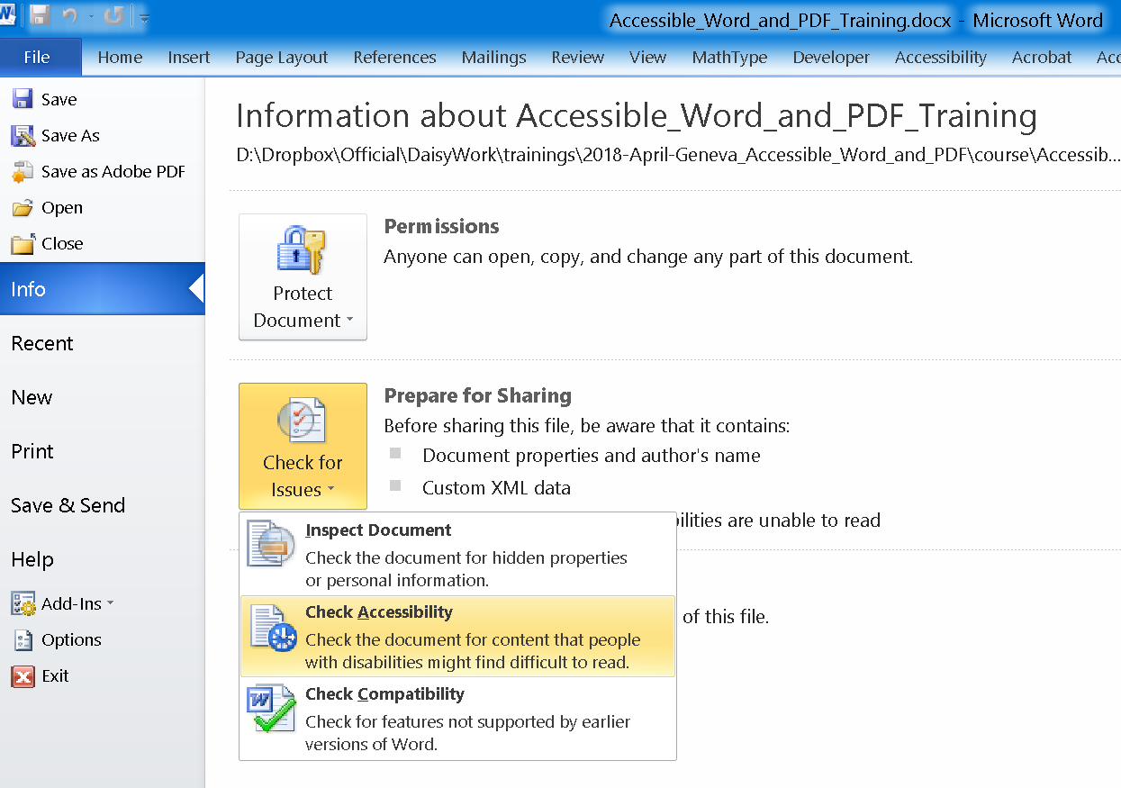

The ACCESSIBILITY CHECKER TASK PANE appears next to your content and shows the inspection results.

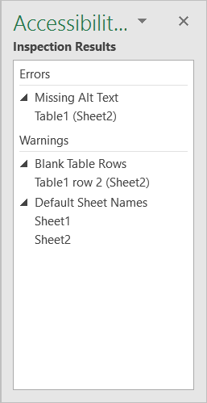

See details about an issue, including why and how to fix it, under Inspection Results, then select an issue. Results appear under Additional Information, and you are directed to the inaccessible content in your file.

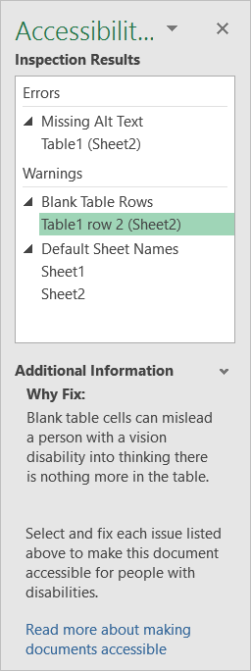

### Understand the inspection results

After Accessibility Checker inspects your content, it reports the inspection results based on the severity of the issue found, categorized as follows:

* Errors: Issues that are reported as Errors include content that is very difficult or impossible for people with disabilities to understand.
* Warnings: In many cases, Warnings mean that the content is challenging for people with disabilities to understand.

Tips: Tips let you know that, even though people with disabilities can understand the content, it could be better organized or presented to improve their experience

## ACCESSIBILITY CHECKER ERRORS, WARNINGS, AND TIPS

The following tables itemize the Accessibility Checker rules, what they check for, where to learn how to fix each issue, and why you should fix each one.

### Errors

If content in the file makes it very difficult or impossible for someone with a disability to use, the Accessibility Checker will classify it as an error.

| **Rule** | **Accessibility Checker verifies** | **Why fix this?** |
| --- | --- | --- |
| **All non-text content has alternative text (alt text).** | All objects have alt text and the text does not contain images or file extensions. | Screen readers speak the alternative text to describe images and other non-text content that users can’t see. Based on the alt text of non-text content, users should understand the purpose and meaning. |
| **Tables specify column header information.** | Tables and/or blocks of cells have the header box selected, or a header row indicated. | Users rely on the table headings to understand the content that is subsequently read by the screen reader. Also, assistive technology often uses the table header row to help convey to users the current cursor location in the table and to provide information that enables the user to navigate the table. |
| **Documents use heading styles** | Content is organized with headings and/or a Table of Contents (TOC). | Headings and TOCs provide structural context to users and enable navigation and easier searching in the document. |

### Warnings

If the content in most (but not necessarily all) cases is difficult for people with disabilities to understand, the Accessibility Checker gives a warning.

| **Rule** | **Accessibility Checker verifies** | **Why fix this?** |
| --- | --- | --- |
| Hyperlink text is meaningful. | Link text makes sense as standalone information, providing accurate information about the destination target. | Based on the text, users decide whether to click a hyperlink. The text should provide clear information about the link destination. |
| Table has a simple structure. | Tables are simple rectangles with no split cells, merged cells, or nesting. | Users navigate tables via keyboard shortcuts and assistive technology, which rely on simple table structures. |
| Tables don’t use blank cells for formatting. | There are no entirely blank rows or columns in the table. | Blank table cells can mislead a user into thinking that there is no more content in the table. |
| Avoid the use of repeated blank characters. | There are no runs of blank spaces, tabs, or carriage returns. | Spaces, tabs, and empty paragraphs often are read as blanks by assistive technology. After hearing several “blanks,” people might think they have reached the end of the information. |

### Tips

When there is content that people with disabilities can understand but that could be better organized or could be presented to improve their experience, you see a tip.

| **Rule** | **Accessibility Checker verifies** | **Why fix this?** |
| --- | --- | --- |
| Layout tables are structured for easy navigation. | The layout order is logical for the language, and the tab order is not circular. | Users rely on the table layout to navigate through the content. It must be ordered logically for users to understand and navigate the content. |
| No image watermarks are used. | There are no watermarks. | Watermarks might be misunderstood as being part of the main content on the page and could cause confusion. |
| All headings are in the correct order. | All headings follow a logical order. | Sequential headings with appropriate levels help users navigate, search, and understand the document’s organization. |

After fixing all the issues flagged by the Accessibility Checker, you will get a message “No accessibility issues found. People with disabilities should not have difficulty reading this document.” Your aim should be to achieve this status before distributing any Word document.

## MANUAL TESTING FOR ACCESSIBILITY

Manual testing of the Word document using a standard assistive technology tool is highly recommended. In addition to using the Microsoft Accessibility Checker. Several issues such as suitability of image alt text and reading order cannot be checked with automated tools. Testing the document with a screen reader is one of the best ways of finding accessibility issues. Below testing with [NVDA](https://www.nvaccess.org/), the popular free screen reader is described. You can perform similar testing with any other similar tool such as [Jaws](https://www.freedomscientific.com/products/software/jaws/).

### Using NVDA for manual accessibility testing

NVDA is a popular free and open-source screen reading software for Windows. It can be used to check the reading experience that people with visual impairments will get. NVDA can also help identify issues that cannot be picked up by the Accessibility Checker, such as appropriateness of the image alt text. The Accessibility Checker can only test whether or not the images have text descriptions. Whether or not the text description is appropriate for the image can be checked only with NVDA or a similar screen reading software.  
Using NVDA keystrokes below, you should check the document for reading order, navigability and image descriptions.

1. Download and install NVDA from the NV-ACCESS website: [nvaccess.org/download](http://www.nvaccess.org/download)
2. Start NVDA by clicking its ICON ON THE DESKTOP or using the keystroke CTRL + ALT + N.
3. Select “USE CAPS LOCK as the NVDA MODIFIER KEY” in the WELCOME DIALOG. You can then press CAPSLOCK in place of NVDA KEY mentioned below.
4. Press NVDA KEY + CTRL + S to select a SPEECH SYNTHESIZER. You might like the MICROSOFT SAPI voices.
5. Now use the keystrokes listed below to check various aspects of the document accessibility.
6. Press CTRL key to interrupt speech (mute NVDA temporarily) when required
7. Press NVDA KEY + Q to quit NVDA

| **Feature** | **Keystroke** | **What to test** |
| --- | --- | --- |
| Headings/structure | Press NVDA KEY + SPACEBAR to activate the BROWSE MODE  Then press H to move to the next heading  SHIFT + H to move to the previous heading  NVDA will read the heading and announce its “LEVEL”  Press NVDA KEY + F7 to open ELEMENTS LIST and check the order and hierarchy of headings. | 1.      The document should start with a Heading 1. All the major sections/chapters should be marked up at the same heading level.  2.      Heading level should not be skipped e.g. a Heading 3 after a Heading 1 is a violation of guidelines  3.      A document should have a sufficient number of headings. A long document with very few headings is likely to fail Accessibility Checker tests.  4.      Heading text should not be too long |
| Graphics | When in BROWSE MODE:  Press G to go to the next graphic  SHIFT + G to previous graphic  NVDA will read alt text of the graphic if available | 1.      Listen to the NVDA voice while navigating between the graphics.  2.      Check if the description read out by NVDA is meaningful and appropriate  3.      Often NVDA might read the file name of the image or its size etc. In such cases the ALT TEXT should be checked by going into IMAGE PROPERTIES |
| Tables | When in BROWSE MODE:  Press T for the next table SHIFT + T for the previous table  Press the TAB key to navigate between the cells of a table | 1.      Only tabular data should be represented as a table.  2.      While pressing the TAB key check if the NVDA focus moves through the table in a logical order. In general, the table should be read from left to right row by row. Split or merged cells may present in understanding the table.  3.      NVDA will read the column and row headings while navigating the table. Check if the header association is appropriate for the cells being read out. |
| Hyperlinks | When in BROWSE MODE:  Press K for the next hyperlink  SHIFT + K for the previous hyperlink  Press NVDA KEY + F7 to open ELEMENTS and then check the list of links. | Listen to the NVDA and check if the link text is being read out correctly. In general, the URLs should have meaningful display text. |
| Reading order | NVDA key + DOWN ARROW to read continuously  DOWN ARROW to read next line  UP ARROW to read the previous line | Check if NVDA is reading the document in a logical order. This should be tested where columns, sidebars, text boxes are present in the document. Accessibility guidelines require the document to have a simple and logical reading order |

If issues are discovered with NVDA testing, they should be fixed. The document should then be verified with the Accessibility Checker again.

# Convert your document now

You are now ready to use SaveAsDAISY to convert your document.

1. Go to the Accessibility ribbon and click on Settings
2. Under Page numbers choose “Custom” if you have used Page Number (DAISY) style else select “Automatic” and click OK.
3. Now you can click on SaveAsDAISY button in Accessibility ribbon and choose “DAISY XML (from single docx)” or “Full DAISY (from single docx)” as per requirement.
4. Provide the required information (Title, Creator etc.) and click on Translate
5. The processing should finish soon and you will get the output in destination folder.

More information on using SaveAsDAISY is included in the Instruction Manual provided with the tool.