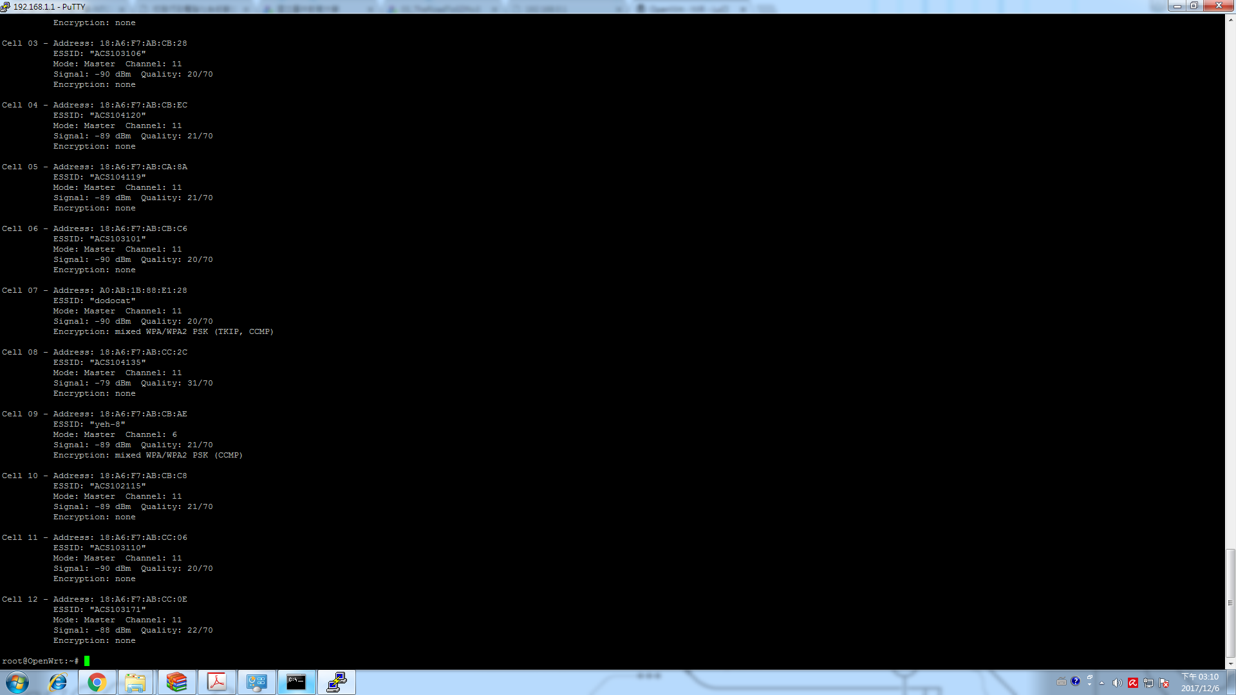

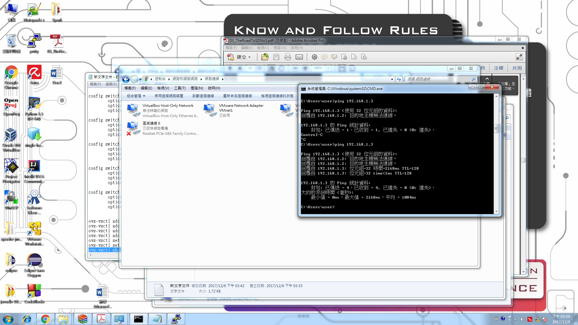

config interface 'loopback'

option ifname 'lo'

option proto 'static'

option ipaddr '127.0.0.1'

option netmask '255.0.0.0'

config globals 'globals'

option ula_prefix 'fd7e:e8ac:cc65::/48'

config interface 'wan'

option ifname 'eth0'

option proto 'dhcp'

config interface 'wan6'

option ifname '@wan'

option proto 'dhcpv6'

config interface 'port1'

option ifname 'eth1.6'

option proto 'static'

config interface 'port2'

option ifname 'eth1.5'

option proto 'static'

config interface 'port3'

option ifname 'eth1.4'

option proto 'static'

config interface 'port4'

option ifname 'eth1.3'

option proto 'static'

option ipaddr '192.168.1.1'

option netmask '255.255.255.0'

config switch

option name 'switch0'

option reset '1'

option enable_vlan '1'

config switch_vlan

option device 'switch0'

option vlan '2'

option ports '5 6'

config switch_vlan

option device 'switch0'

option vlan '3'

option ports '1 0t'

config switch_vlan

option device 'switch0'

option vlan '4'

option ports '2 0t'

config switch_vlan

option device 'switch0'

option vlan '5'

option ports '3 0t'

config switch_vlan

option device 'switch0'

option vlan '6'

option ports '4 0t'

ovs-vsctl add-br ACS104115

ovs-vsctl add-port ACS104115 eth1.4

ovs-vsctl add-port ACS104115 eth1.5

ovs-vsctl add-port ACS104115 eth1.6

ovs-vsctl set-controller ACS104115 tcp:120.108.205.150:6633

ovs-vsctl set bridge ACS104115 protocols=OpenFlow13

ovs-vsctl show