說明：請各位使用此template進行Report撰寫，如果想要用其他排版模式也請註明題號以及題目內容（請勿擅自更改題號），最後上傳前，請務必轉成PDF檔，並且命名為report.pdf，否則將不予計分。
----------------------------------------------------------------------------------------------------------------

學號： 系級： 姓名：

- (0.5%) Please answer the following question.
  - Please write down the Bellman consistency equation in terms of $V^{π}$ on both sides.
  - The UCB score is describe as the following formula, please describe how R(a)/N(a) and c exploration and exploitation.
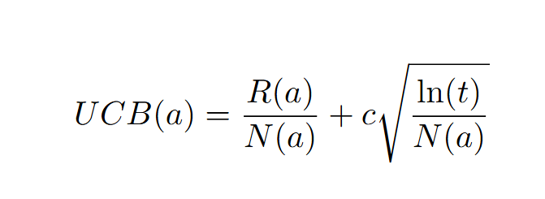

- (0.5%) Please implement the epsilon-greedy algorithm or the UCB algorithm. Paste the code and compare the public leaderboard scores of it and the default greedy algorithm (directly choose the state with maximum value).

- (1%) How to encourage the agent to catch the pawn as soon as possible?
Please make two modifications (for example, change the reward function, discount factor, …)
  - What is your first modification? How does it affect your public score?
  - What is your second modification? How does it affect your public score?

