HO CHI MINH CITY UNIVERSITY OF TECHNOLOGY

FACULTY OF COMPUTER SCIENCE AND ENGINEERING

COURSE: COMPUTER NETWORK

LAB 4b: DHCP

Supervisor : Nguyễn Hồng Nam.

Author : Nguyễn Quang Long.

ID : 1812917.

Sunday, November 1th , 2020

1. Are DHCP messages sent over UDP or TCP?

* 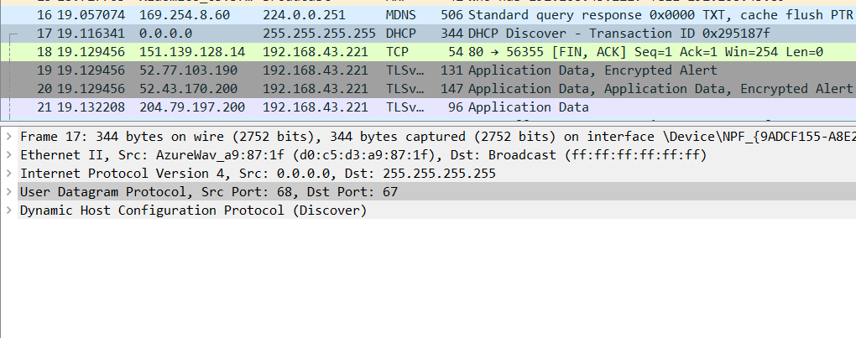**Answer :**  The messages are sent over UDP.

Figure

1. Draw a timing datagram illustrating the sequence of the first four-packet Discover/Offer/Request/ACK DHCP exchange between the client and server. For each packet, indicated the source and destination port numbers. Are the port numbers the same as in the example given in this lab assignment?

* 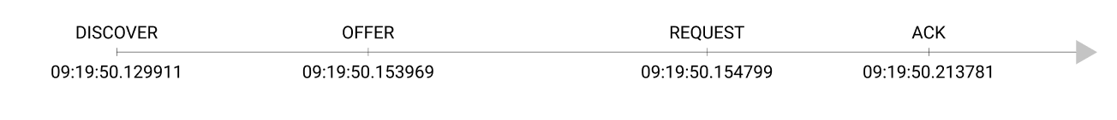**Answer :**

For Discover and Request packages, the source if 68 and des is 67. The other 2 packages are opposite, their source is 67 and des is 68.

And yes they do use 68 and 67 similar to the ports in example.

1. What is the link-layer (e.g., Ethernet) address of your host?

* **Answer :** The Ethernet address of my host is AzureWav_a9:87:1f (d0:c5:d3:a9:87:1f).

1. What values in the DHCP discover message differentiate this message from the DHCP request message?

* **Answer :** there ‘s a different in the DHCP message type and the discover message don’t have 2 field which are DHCP server identifier and client fully qualified domain name.

1. What is the value of the Transaction-ID in each of the first four (Discover/Offer/Request/ACK) DHCP messages? What are the values of the Transaction-ID in the second set (Request/ACK) set of DHCP messages? What is the purpose of the Transaction-ID field?

* **Answer** :
  + Transaction-ID of all first fall DHCP message are 0x0295187f.
  + Transaction-ID of the second set of DHCP messages are 0x0f336e9b.
  + 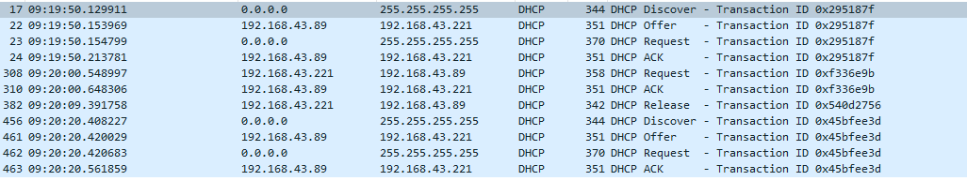The purpose of the Transaction-ID field is usually to allow the client to recognize which dhcp response to which request has been associated.

1. A host uses DHCP to obtain an IP address, among other things. But a host’s IP address is not confirmed until the end of the four-message exchange! If the IP address is not set until the end of the four-message exchange, then what values are used in the IP datagrams in the four-message exchange? For each of the four DHCP messages (Discover/Offer/Request/ACK DHCP), indicate the source and destination IP addresses that are carried in the encapsulating IP datagram.

* **Answer** :
  + Discover : 0.0.0.0 -> 255.255.255.255
  + Offer : 192.168.43.89 ->192.168.43.221
  + Request : 0.0.0.0->255.255.255.255
  + ACK : 192.168.43.89 ->192.168.43.221

1. What is the IP address of your DHCP server?

* **Answer** : my DHCP server address is 192.168.43.89

1. What IP address is the DHCP server offering to your host in the DHCP Offer message? Indicate which DHCP message contains the offered DHCP address.

* 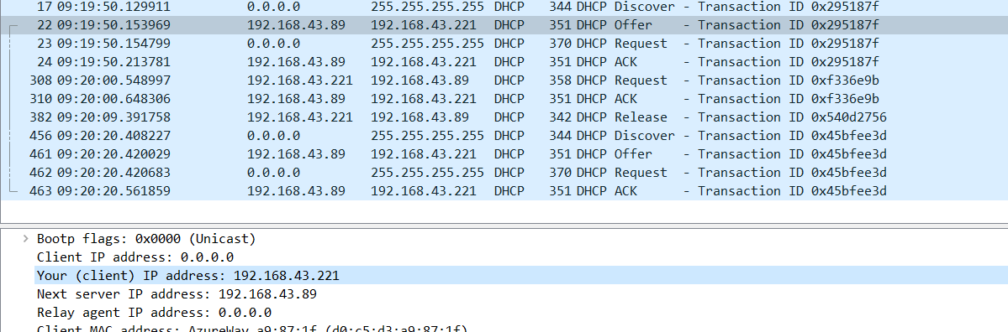**Answer** : the DHCP server offers me the IP 192.168.43.221

1. In the example screenshot in this assignment, there is no relay agent between the host and the DHCP server. What values in the trace indicate the absence of a relay agent? Is there a relay agent in your experiment? If so what is the IP address of the agent?

* 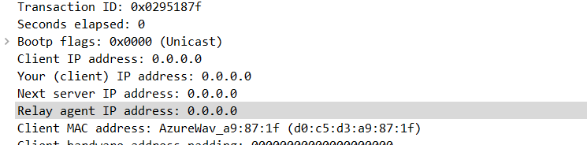**Answer** : in the example, the realia agent IP address has the value of 0.0.0.0 indicate the absence of a relay agent. So does in my experiment, there there is no relay agent between the host and the DHCP server.

1. Explain the purpose of the router and subnet mask lines in the DHCP offer message.

* **Answer** : The subnet mask line tells the client which subnet mask to use.The router line indicates where the client should send messages by default.

1. In the DHCP trace file noted in footnote 2, the DHCP server offers a specific IP address to the client (see also question 8. above). In the client’s response to the first server OFFER message, does the client accept this IP address? Where in the client’s RESPONSE is the client’s requested address?
2. Explain the purpose of the lease time. How long is the lease time in your experiment?

* **Answer** : in my experiment, the trace doesn’t have the lease time field but it does have a *renewal time value* field which have the value of 1800s. it indicates that my host have 30 minutes to use the IP the DHCP provide before it get renewed.

1. What is the purpose of the DHCP release message? Does the DHCP server issue an acknowledgment of receipt of the client’s DHCP request? What would happen if the client’s DHCP release message is lost?

* **Answer** :
  + the purpose of the DHCP release message is to notify the DHCP that we release the current using IP to the server.
  + The DHCP server don’t issue an acknowledgment of receipt of the client’s DHCP request.
  + If the client’s DHCP release message is lost, the server won’t able to know that the IP been released and it will wait to the end of renewal time then release the IP.

1. Clear the bootp filter from your Wireshark window. Were any ARP packets sent  
   or received during the DHCP packet-exchange period? If so, explain the purpose  
   of those ARP packets.

* 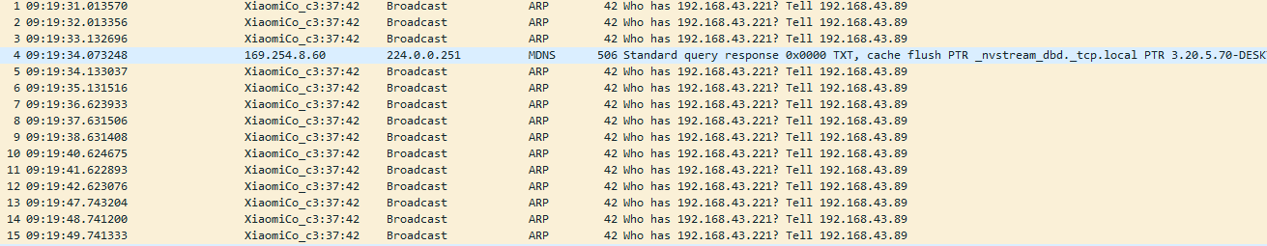**Answer** : yes there were some ARP packets were received. It purpose is to build up the known IP addresses by the clients network.