HO CHI MINH CITY UNIVERSITY OF TECHNOLOGY

FACULTY OF COMPUTER SCIENCE AND ENGINEERING

COURSE: COMPUTER NETWORK

LAB 4b: ICMP

Supervisor : Nguyễn Hồng Nam.

Author : Nguyễn Quang Long.

ID : 1812917.

Sunday, November 1th , 2020

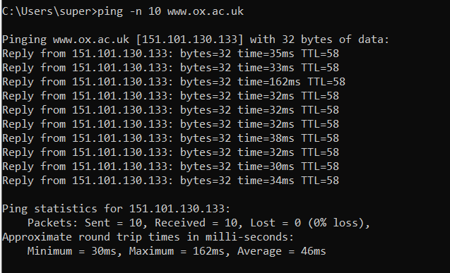

1. What is the IP address of your host? What is the IP address of the destination host?

* **Answer** :
  + My host: 10.228.215.146
  + Destination: 151.101.130.133.

1. Why is it that an ICMP packet does not have source and destination port numbers?

* **Answer** : According to text book, “The Internet Control Message Protocol (ICMP), specified in [RFC 792], is used by hosts and routers to communicate network-layer information to each other. The most typical use of ICMP is for error reporting.”. The ICMP packet doesn’t have the source and destination port beacause it just use the network-layer for communication so its main consider is IP address.

1. Examine one of the ping request packets sent by your host. What are the ICMP type and code numbers? What other fields does this ICMP packet have? How many bytes are the checksum, sequence number and identifier fields?

* **Answer** :
  + The IMCP type is 8 and code number is 0.
  + There are also checksum, identifier (LE and BE), sequence number (LE and BE), data in ICMP packet.
  + 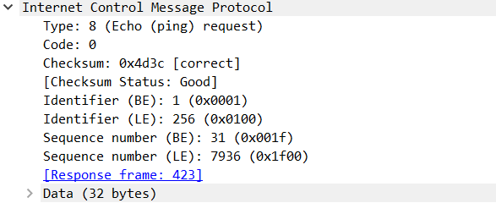Each of them is 2 bytes len (there is 4 hexa number in there value) exept data field which has 32 bytes length.

1. Examine the corresponding ping reply packet. What are the ICMP type and code numbers? What other fields does this ICMP packet have? How many bytes are the checksum, sequence number and identifier fields?

* Answer :
  + The IMCP type is 0 and code number is 0.
  + There are also checksum, identifier (LE and BE), sequence number (LE and BE),data in ICMP packet.
  + Each of them is 2 bytes len (there are 4 hexa number in there value) exept data field which has 32 bytes length.

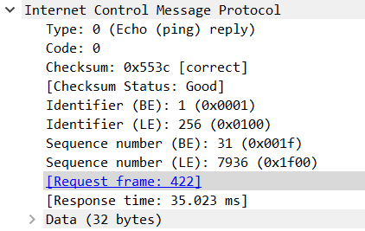

1. What is the IP address of your host? What is the IP address of the target destination host?

* **Answer** :
  + My host: 10.228.215.146
  + Destination: 128.93.162.63



1. If ICMP sent UDP packets instead (as in Unix/Linux), would the IP protocol number still be 01 for the probe packets? If not, what would it be?

* Answer : the

1. Examine the ICMP echo packet in your screenshot. Is this different from the ICMP ping query packets in the first half of this lab? If yes, how so?

* Answer : No, they have the same fields exept the data field have 64 bytes length.

1. Examine the ICMP error packet in your screenshot. It has more fields than the ICMP echo packet. What is included in those fields?

* 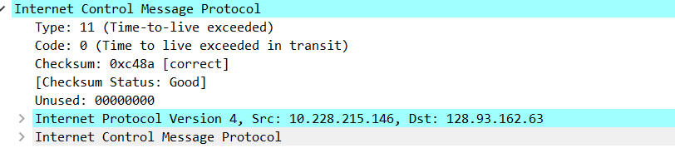Answer : it has a unused field and internet protocol and internet control message protocol which contain the datagram and ICMP of the message that cause the error.

1. Examine the last three ICMP packets received by the source host. How are these packets different from the ICMP error packets? Why are they different?

* Answer : the ICMP type is different, error is 11 and the other is 0. The reason is the reply message made it to destiantion in time of time to live.

1. Within the tracert measurements, is there a link whose delay is significantly longer than others? Refer to the screenshot in Figure 4, is there a link whose delay is significantly longer than others? On the basis of the router names, can you guess the location of the two routers on the end of this link?

* 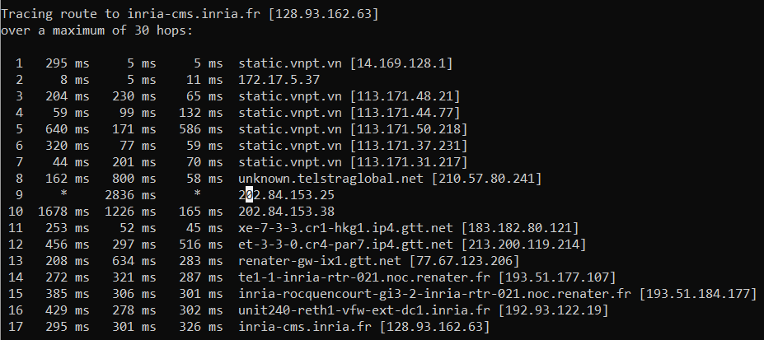**Answer** : Yes, there is a significantly longer delay than other which is between 8 and 9. Which is from Japan(210.57.80.241) to HongKong, Wong Chuk Hang (202.84.153.25).