Project Proposal Report – W6
Nguy Quang Son – 20225998
Project Topic: Face shape classification and hair style recommendations
Dataset: https://www.kaggle.com/datasets/niten19/face-shape-dataset
- Work Completed
  - Overview
During this phase, I focused on getting familiar with cv2, mediapipe, recognize image, face through webcam. Also include data preprocessing, facial landmark extraction, clean data.
  - Task sequence
- Getting familiar with tools like cv2, mediapipe
- Dataset collection (Collected and organized face images into training/testing sets).
- Landmark Extraction (Used MediaPipe to extract 468 facial landmarks (x, y, z)).
- Data Cleaning (Removed missing/invalid samples, checked outliers).
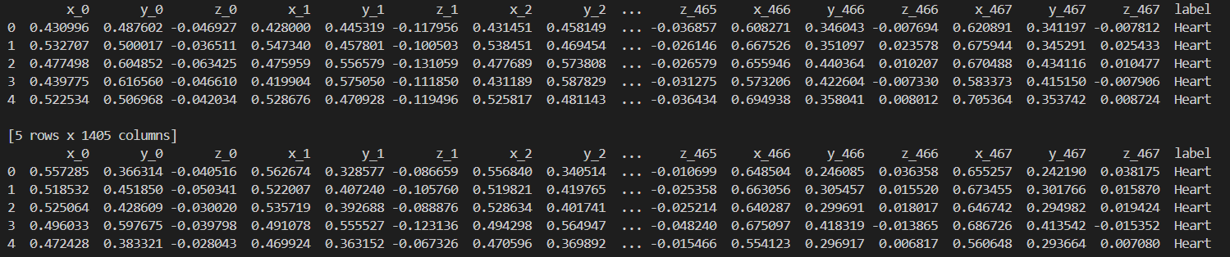
  - Result

- Issues and Challenges
- Mediapipe installation: Not compatible with Python 3.13. Need to using venv for using another version of python (3.10)
- Data quality: Some images failed landmark detection
- Planned Solutions / Next Steps
- Standardized the data for training using machine learning model (SVM)
- Integrate CNN features (Combine landmark-based and CNN-based embeddings.)

