Midterm Report – W8
Nguy Quang Son – 20225998
Project Topic: Face shape classification and hair style recommendations
Dataset: https://www.kaggle.com/datasets/niten19/face-shape-dataset
- System Implementation / Methodology
  - System Architecture
The system is divided into three main modules:
- Face Detection: Detects and crops the face region from the uploaded image using MediaPipe.
- Face Shape Classification: Predicts the face shape using machine learning model: SVM, deep learning model: MLP, CNN (Intergrated in later phase)
- Recommendation: Suggests suitable hairstyles based on the predicted shape. (Intergrated in later phase)
  - Implementation Details
Module | Tool/Library | Description | Output
Face Detection | MediaPipe | Detects face and extracts landmarks | Landmark CSV file
Data Preprocessing | NumPy, Pandas, scikit-learn | Cleaning, standardization, outlier removal. | Normalized dataset
Model Training | Scikit-learn, tensorflow | Training model with coresponding feature | Trained .pkl model
Visualization | Matplotlib | Plots raw vs standardized data and results. | Distribution plots

- Testing/Evaluation Method
  - Dataset split
- Traning set: 80% of training dataset
- Validation set: 20% of training dataset
- Testing set: Testing dataset
  - Evaluation metrics
- Accuracy
- Precision/ Recall/ F1-Score
- Confusion Matrix
  - Experimental Setup
- Kernel Type: RBF
- C (regularization): 1.0 for preliminary and [0.1, 1, 10, 100] for gridsearchCV
- Gamma: scale for preliminary and ['scale', 0.01, 0.1, 1] for gridsearchCV
- Cross-validation: 5-fold
- Result
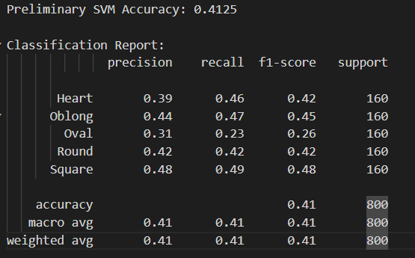
Preliminary SVM
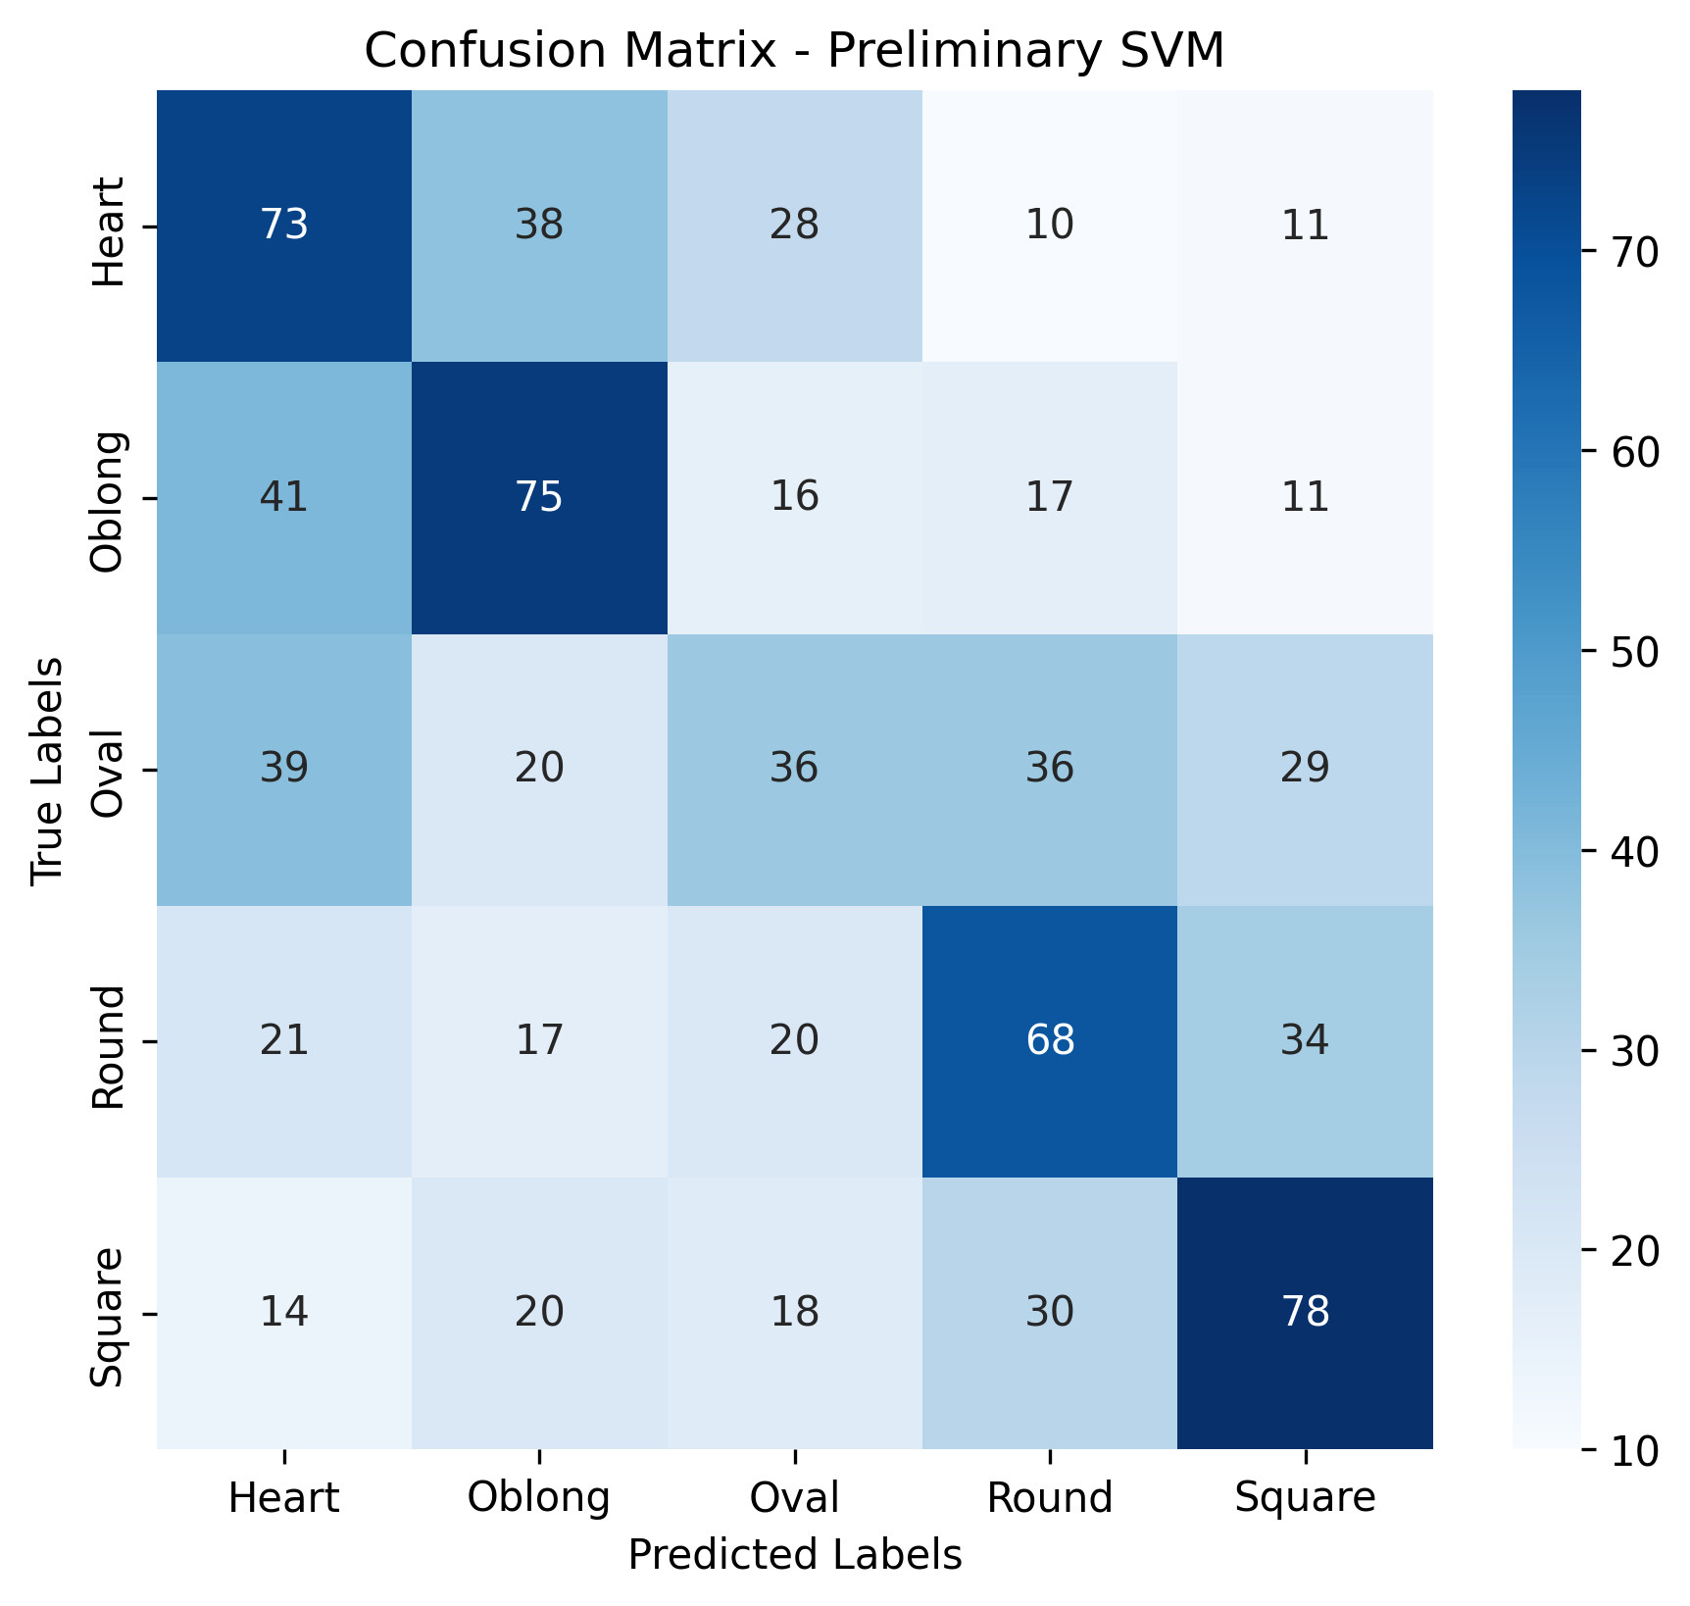

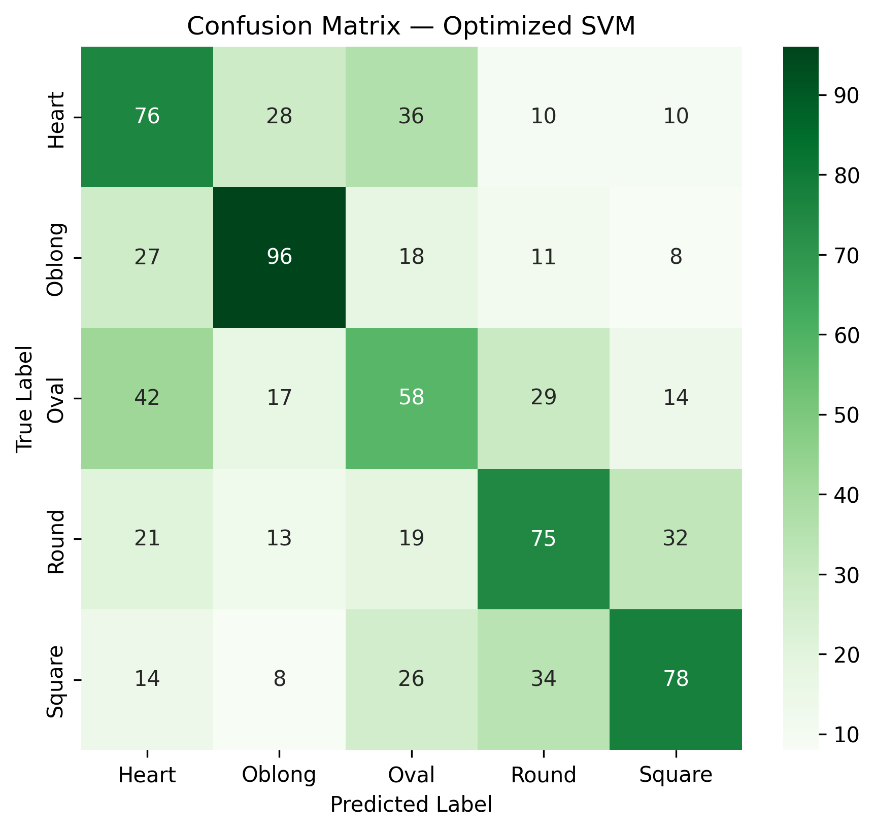
GridsearchCV SVM
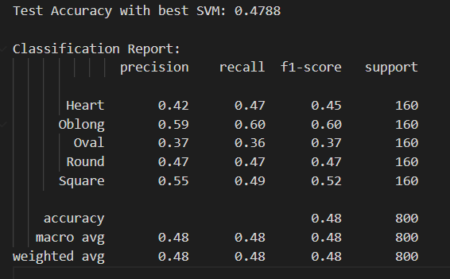

- The SVM model achieved moderate performance, with accuracy improving from 41.25% to 47.88% after optimization. The Oblong and Square face shapes were classified most accurately, while Oval shapes showed the weakest results due to overlapping geometric features. These results suggest that facial landmarks alone are insufficient for robust classification, as subtle differences between face shapes are difficult to capture. Incorporating image-based features or deep learning models could significantly improve overall accuracy.

- Future Improvement
- Applying MLP model
- Combine landmark and image-based CNN features.
- Recommendation hairstyle

