|  |
| --- |
| SNAP  Symbolic Nuclear Analysis Package |
| TRACE Plug-in Multiple-Junction Specification |
|  |
|  |
| May 6, 2021 |
|  |

|  |
| --- |
|  |

Table of Contents

1. Introduction 1

2. Design Overview 1

2.1. ASCII Export 1

2.1.1. Component Number 1

2.1.2. Junction Number 1

2.1.3. IOrder Array 1

2.1.4. Side Junction Array 2

2.1.5. Vessel Junction Array 2

2.2. ASCII Import 2

2.3. Creation Dialog 2

2.4. GUI Editors 3

2.5. Drawn Elements 4

2.6. Signal Variable References 4

2.7. Model Notebook 4

2.8. Renodalization 4

3. Functional Requirements 4

3.1. Basic Behavior 5

3.2. ASCII Export 5

3.3. ASCII Import 5

3.4. Creation Dialog 5

3.5. GUI Editors 6

3.6. Drawn Elements 6

3.7. Signal Variable Reference 7

3.8. Model Notebook 7

3.9. Renodalization 7

# Introduction

This document describes the proposed design for implementing a Multiple-Junction (multi-jun) component in the SNAP TRACE plug-in. The TRACE analysis code does not support a multiple-junction component to assist with building zipper connections between hydraulic components. It is proposed that the SNAP TRACE plug-in be updated to include a meta-component similar to the vessel-to-vessel junction component that generates multiple single junction pipe components when exported to ASCII. This component would include ASCII meta-data tags that would allow the SNAP Model Editor to recreate the Multi-Jun component during an ASCII import operation.

# Design Overview

The Multi-Jun component would be a meta-data hydro-component under the Hydraulic Components category in the Navigator. Each instance of the multi-jun component will generate single junction components that connect two hydraulic components together. The two scenarios that are supported are zipper crossflow connections between two 1D-hydraulic components and zipper cross-flow connections between a 1D-hydraulic component and a vessel.

## ASCII Export

During ASCII export a single junction component will be generated for each of the junctions in the zipper connection. This section describes the behavior for generating a TRACE input model including a multi-jun component.

### Component Number

The single junctions will have a component number derived from the component number from the multiple-junction component. They will start with CCC * 1000 + 1 and will progress to CCC * 1000 + N where CCC is the component number of the multi-jun and N is the number of junctions. The multiple-junction component will be limited to 999 junctions.

If there is a conflict in the generated component number, the next available number will be used instead. If the component number for the multiple-junction component is greater than 999, the spawned single junctions will use the next available component number.

### Junction Number

Connections between hydraulic components in TRACE are identified by a unique junction number referenced by the hydraulic components on either side of the connection. The junction number for the spawned components will be derived from the component number of the spawned single junction. The single junction component number will be multiplied by 10 and an offset added to identify the inlet and the outlet connections.

### IOrder Array

TRACE ASCII input models include a list of the component numbers for all of the thermo-hydraulic components in the model. The IOrder array at the top of the input model will include the single junctions that will be spawned from the multi-jun. They will appear in the array after all of the regular components in order of multiple-junction component number. A comment will appear after the entry to identify the source multi-jun component.

### Side Junction Array

1D-hydraulic components that include cross-flow connections have a portion of their input that identifies the connection numbers and angle for each cross flow connection. These components will be modified to identify any connections to multiple-junction components. These connections will appear in the list of side junctions after the standard list of side junctions. The angle portion of this input will be a user-configurable property of the multi-jun component.

### Vessel Junction Array

Vessel components include a set of input records that identifies the cell and target face for any hydraulic connection to the vessel. The vessel component already identifies vessel-to-vessel junction components to include spawned single junction connections. This behavior will be updated to include the junctions that are spawned from a multiple-junction component. The target connection face portion of this input will be a user-configurable property of the multi-jun component

## ASCII Import

The TRACE plug-in will identify the meta-data comment above the spawned single junctions in a SNAP generated ASCII input file and attempt to rebuild the multi-junction component from the spawned single junctions. This will include identifying the cross-flow angles from the 1D hydraulic components and the target face from the 3D hydraulic components. Additionally signal variables will automatically identify connections to a multiple-junction component and correctly select the spawned single junction that matches the signal source number (ICLN) in the input file.

## Creation Dialog

When a new Multiple-junction component is created, the TRACE plug-in will open the multiple-junction initialization dialog. This dialog will behave similarly to the vessel junction component. A mockup of the initialization dialog is shown below in Figure 2.1. The first panel directs the user to select an inlet and outlet hydraulic component. Then the user selects a starting and ending cell for each component. When connecting to a Vessel Component the user must select a Planar Cell number and a Vessel Connection face (e.g. Positive Radial).

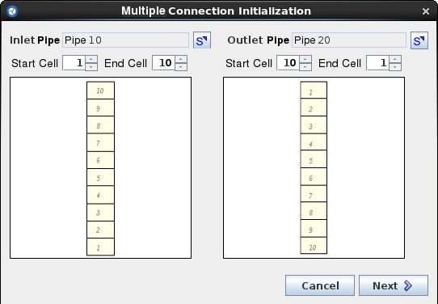

‑ Creation Dialog Panel 1

The next panel will display the results of iterating connections in order from the starting cell to ending cell on both sides of the connection. This is illustrated below in Figure 2-2. At this point the user can change the number of junctions and change the mapped source and target cells before completing the component. These can be updated after initialization through the Property View.

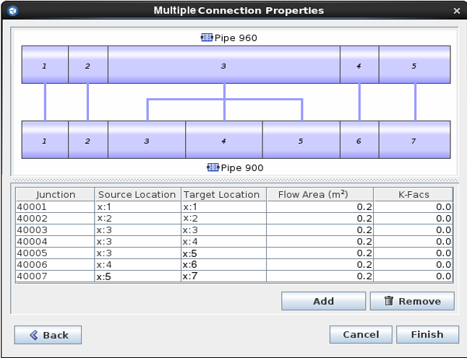

‑ Creation Dialog Panel 2

## GUI Editors

The multiple-junction component will include properties for the meta-data component, as well as properties that will be used to spawn the single junction components. The name, number, and description fields will appear the same as any other component. A single custom editor will allow opening the junction properties dialog. The following properties for the single junctions will be configurable for each junction in the connection:

|  |  |
| --- | --- |
| Property Type | Property Name |
| Junctions | Source Cell |
| Junctions | Inlet Crossflow Angle (1D) |
| Junctions | Inlet Connection Face (3D) |
| Junctions | Target Cell |
| Junctions | Outlet Crossflow Angle (1D) |
| Junctions | Outlet Connection Face (3D) |
| Geometry | Flow Area |
| Geometry | Hydraulic Diameter |
| Geometry | CCFL Model |
| Friction | Forward Fric. / K-Factor |
| Friction | Reverse Fric. / K-Factor |
| Initial Conditions | Liquid Velocity |
| Initial Conditions | Vapor Velocity |

‑ : User Editable Properties

## Drawn Elements

The multi-jun component will be visible in a 2D view. When unconnected, the multi-jun component will render as an icon with connection points on either side. The component will otherwise render in two ways: a single connection line from the middle junction or a connection line for each junction. Right-clicking on the drawn component will allow the user to choose which rendering option to use.

## Validation

The multi-jun component will include a number of automated validation tests. The spawned component number validation test will ensure that the generated single junction numbers do not conflict with any existing component. Additionally, the elevation loop check test will ensure that the multi-jun component have a consistent elevation change between the single junctions.

## Signal Variable References

Junction signal variables will be updated to allow selecting an individual spawned single junction. The user will select the Multiple-junction as the signal source and then select the spawned single junction by number. This will result in the signal variable using the spawned single junction for its ICLN field.

## Model Notebook

The model notebook component will contain a section for each multiple-junction component, in the same way as the vessel junction component. A table will be presented for each of the property types listed in Table 2-3.

## Renodalization

The multiple-junction component will automatically update when one side of the connection is renodalized. After a component is renodalized the multi-jun will attempt to ensure that the original junction area is preserved by adding new junctions when appropriate. After adding additional junctions any adjacent junctions that point to the same cells on both sides will be combined together using the existing split behavior.

## Split-Pipe Behavior

When a Split-Pipe operation is performed on a pipe that is connected to a multi-junction component, the multi-junction component will also be split at the same junction point as the pipe. The counter behavior, Merge-Pipe, will not automatically merge the junctions together.

# Functional Requirements

This section enumerates the functional requirements for the Multiple-junction component. These requirements are numbered to facilitate testing the component.

## Basic Behavior

The TRACE plug-in shall [MJ_1] include a multiple-junction hydraulic component.

The multi-jun component shall [MJ_2] connect two hydraulic components with a set of spawned single junctions.

## ASCII Export

The multi-jun component shall [MJ_AO_1] export to ASCII by spawning a set of single junction components.

The multi-jun component shall [MJ_AO_2] include a meta-data section that identifies the source multiple-junction component data.

The spawned single junction components shall [MJ_AO_3] have a component number defined as CCC * 1000 + N, where CCC is the multi-jun component number, and N is the junction index.

The properties of the spawned single junction components shall [MJ_AO_4] be initialized from the multi-jun component data.

The I-Order array shall [MJ_AO_5] be updated to include the component numbers for the spawned single junctions during ASCII export.

The side-junction arrays for 1D hydraulic components connected to multi-juns shall [MJ_AO_6] include an entry for each of the spawned single junctions.

The 3D connection arrays for vessel components connected to multi-juns shall [MJ_AO_7] include an entry for each of the spawned single junctions.

## ASCII Import

The TRACE plug-in shall [MJ_AI_1] attempt to rebuild a multiple-junction component from the embedded meta-data in a TRACE ASCII file.

The imported multi-jun component shall [MJ_AI_2] extract the junction angle from the 1D hydraulic component cross-flow input data.

The imported multi-jun component shall [MJ_AI_3] extract the junction face from the 3D hydraulic component connection data.

The imported multi-jun component shall [MJ_AI_4] rebuild signal variable references to multi-jun components.

## Creation Dialog

The TRACE plug-in shall [MJ_CD_1] open the multi-jun creation dialog when a new multi-jun is added through the Navigator or inserted into a drawn view.

The multiple-junction completion dialog shall [MJ_CD_2] allow selecting two hydraulic components.

The multiple-junction completion dialog shall [MJ_CD_3] allow selecting the start and end cell on both the source and target components.

The multiple-junction completion dialog shall [MJ_CD_4] provide an initial layout of crossflow connections between the two selected components.

The multiple-junction completion dialog shall [MJ_CD_5] provide a calculated flow area.

The multiple-junction completion dialog shall [MJ_CD_6] add the component to the Navigator when completed.

## GUI Editors

The multiple-junction component shall [MJ_ED_1] include the following properties:

* Name
* Description
* Component Number
* Junction/Edge Data

The multiple-junction component shall [MJ_ED_2] include a tabular dialog that allows defining the following properties for each junction:

* Inlet Cell
* Inlet Angle / Face
* Outlet Cell
* Outlet Angle / Face
* Flow Area
* Hydraulic Diameter
* CCFL Model (Optional)
* Forward Friction / K-Factor
* Reverse Friction / K-Factor
* Liquid Velocity
* Vapor Velocity

## Drawn Elements

The multiple-junction component shall [MJ_DE_1] be a visual component.

The drawn component for the multiple-junction component shall [MJ_DE_2] display an icon when only connected on one side.

The drawn component for the multiple-junction component shall [MJ_DE_3] include two drawing modes: Single Junction mode and Multiple-junction mode.

The drawn multi-jun shall [MJ_DE_4] display a single connection line between the source and target components when in Single Junction mode.

The drawn multi-jun shall [MJ_DE_5] display a connection line for each internal junction between the correct source and target cells when in Multiple-junction mode.

## Validation

The multi-jun shall [MJ_VA_1] report an error if there is a conflict with the generated component numbers.

The multi-jun shall [MJ_VA_2] report an error if the elevation change between adjacent single junctions on the source side differs from the target side.

## Signal Variable Reference

The multiple-junction component shall [MJ_SV_1] be available for junction signal variables to select as a signal source.

When selecting a multi-jun component, signal variables shall [MJ_SV_2] include a drop-down list for selecting a spawned single junction.

Signal variables shall [MJ_SV_3] export the spawned single junction number for the signal source (ICLN) when connected to a multi-jun component.

## Model Notebook

The model notebook shall [MJ_MN_1] include a section for the model notebook component in the hydraulic components section.

The multi-jun model notebook section shall [MJ_MN_2] include tables defining the geometry, friction and initial conditions data for each junction in the multi-jun.

## Renodalization & Split-Pipe

The multiple-junction component shall [MJ_RN_1] automatically update the internal junctions when the source or target component is renodalized.

The multiple-junction component shall [MJ_RN_2] be split in parallel with the split-pipe operation when one side of multiple-junction is split at a junction index inside the set of multiple junction indexes.