**Practice Certification:**

Trimble GPS Field Collection with CartoPac

**Purpose**

To leverage existing NRCS technology to improve the collection and distribution of practice certification data in the field

**Technology**

Using the Trimble GeoXT with CartoPac provides the NRCS with a platform for improved field collection by:

* Integrating ArcMap with the GPS device
* Creating custom collection interfaces
* Utilizing databases for advanced querying and reporting
* Standardizing data formats
* Improving data collection and distribution efficiency

**Practice Certification Collection**

The CartoPac solution for practice certification provides users with the ability to collect point, line, and polygon data types and attribute corresponding practices.

* Each data type can be attributed with feature notes and a dropdown selection input for practice type
* Only applicable practice types can be selected for the corresponding data type
* The line data type is 3D with each line vertex collecting the northing, easting, and elevation

**GPS Collection Interface**

CartoPac provides the Trimble GPS with a simple custom interface for practice certification.

* Collect a feature



* Select a data type: Point, Line, or Polygon

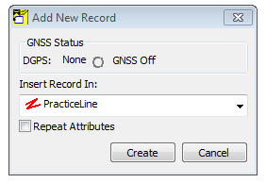

* Collect field points to build the practice feature shape



* Once the feature’s points are collected, attribute the practice’s code with additional notes

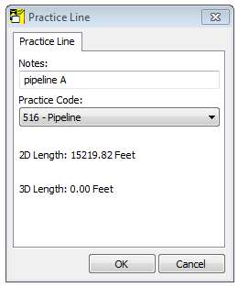

* Practice certification collection is complete

**Practice Metadata**

PracticePoint

* **OBJECTID:** Unique Identifier
* **SHAPE:** Geometry coordinate values
  + XY point vertex in meters: UTM Zone 12 NAD 83
* **PracticeCode**: Coded Value Text Field
  + Practice Code
  + Practice Description
* **Notes**: Text Field – 254 characters

PracticeLine

* **OBJECTID:** Unique Identifier
* **SHAPE:** Geometry coordinate values
  + XYZ point vertices in meters: UTM Zone 12 NAD 83
* **PracticeCode**: Coded Value Text Field
  + Practice Code
  + Practice Description
* **Notes**: Text Field – 254 characters
* **Length_Feet_2D**: Double Precision Number in Feet
  + Calculates line length without elevation consideration
* **Length_Feet_3D:** Double Precision Number in Feet
  + Calculates line length with elevation consideration
* **SHAPE_Length:** Double Precision Number in Meters
  + Length in meters: UTM Zone 12 NAD 83

PracticePolygon

* **OBJECTID:** Unique Identifier
* **SHAPE:** Geometry coordinate values
  + XYZ point vertices in meters: UTM Zone 12 NAD 83
* **PracticeCode**: Coded Value Text Field
  + Practice Code
  + Practice Description
* **Notes**: Text Field – 254 characters
* **Area_Acres_2D**: Double Precision Number in Acres
  + Calculates area without elevation consideration
* **Area_Acres_3D:** Double Precision Number in Acres
  + Calculates area with elevation consideration
* **SHAPE_Length:** Double Precision Number in Meters
  + Perimeter Length in meters: UTM Zone 12 NAD 83
* **SHAPE_Area:** Double Precision Number in Square Meters
  + Area in square meters: UTM Zone 12 NAD 83