BC Ministry of Sustainable Resource Management
Feature Skeletonizer Utility

Mark Sondheim (MSRM) – Project Lead
David Skea (MSRM) – Technical Advisor
Justin De Oliveira (Refractions Research) – Systems Development

Table of Contents
1 Introduction to the Skeletonizer Utility 4
2 Data Pre-Processing 5
2.1 Expected Data Inputs to the Skeletonizer Utility 5
2.2 Common Skeletonizer Utility Data Preparation Tasks 5
2.2.1 Preparing Point and Polygon Input Data 5
2.2.2 Generation of the Points Layer 7
2.2.3 Pre-Validation of Geometries in the Polygon Layer 8
2.2.4 Anticipating Polygon-to-Polygon Connectivity 9
2.2.5 Feature Attribution 10
3 Installing the Required System Components 11
3.1 Installing the JAVA Runtime Environment 12
3.2 Pre-existing Versions of the JAVA Application Framework 12
3.3 Installing the JUMP Environment and the Skeletonizer Utility Plug-in 12
3.4 Tips for Launching the Skeletonizer Utility 13
3.5 Obtaining Skeletonizer Utility Data Packages 13
3.6 Opening Data-set Packages in the Skeletonizer Utility 14
3.7 Minimal System Requirements 14
3.8 Updates to the CWB Application Files 14
4 Running the Skeletonizer Utility 15
4.1 Running the Skeletonizer Utility in GUI Mode 15
4.2 Running the Skeletonizer Utility from the Command Line 16
5 Outputs from the Skeletonizer Utility 19
5.1 Output Files 19
5.2 Interpreting the Output Report 19
5.3 Consolidating Multiple Reports from Batch Processes 20
6 Testing the Skeletonizer Utility 20
7 Troubleshooting Skeletonizer Utility Errors 21
8 Technical Summary of the Skeletonization Process 21
8.1 Voronoi Processing 21
8.2 Handling Exceptional Cases in the Skeletonizer Utility 25
8.2.1 Co-circularity Adjustments 25
8.2.2 Automatic Removal of Close-Points 26
8.2.3 Feature Densification 26
8.2.4 Corner-Trimming at Acute Angle Entries 28
8.2.5 Treating Cases with One or No INPUT / OUTLET Points 29
8.3 Adding Directionality to Skeleton Lines 29
8.3.1 Directionality - Fusing Skeleton Lines 30
8.3.2 Directionality - Path Calculation 31
8.3.3 Directionality - Inferring Direction 33
9 More Information 35
9.1 Future Development in the Skeletonizer Utility 35
9.1.1 Alternate Skeleton Representations 35
9.1.2 Flow Classification 35
9.1.3 Linking Voronoi Linework to Feature Attributes 36
9.2 GNU General Public Licence 38
9.3 The Skeletonizer Utility Development Team 38

Introduction to the Skeletonizer Utility
The Skeletonizer Utility automatically simplifies polygonal hydrographic features into medial linear representations. Features submitted to the Skeletonizer Utility can include bodies of water (lakes, swamps, ponds, marshes etc.) or river features captured as polygons (‘double-line’ rivers). Once derived, these skeletons can be tied to the fabric of existing linear stream information to produce a continuous and directional hydrographic network.
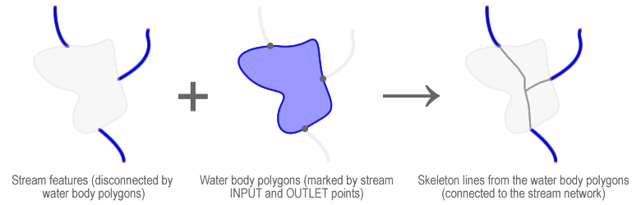
The Skeletonizer Utility can be run in batch mode from the command line or as an interactive wizard through the JUMP Unified Mapping Platform (JUMP). The JUMP is a framework for the development of tools that perform geometric operations on spatial datasets, and provides a graphical user interface (GUI) to access a set of spatial tools common to many other desktop geographic information systems.

The Skeletonizer Utility was developed to support the government of British Columbia (BC) Base Mapping and Geomatic Services (BMGS) branch’s initiative to assemble a 1:20,000 scale stream network in their Corporate Watershed Base (CWB). This network is mapped and updated continuously - and with each update comes the need to adjust the placement of the skeletons within the network. The ability of the Skeletonizer Utility to run automatically in large batches across several data-sets, saves the expense of manually checking and adjusting each skeleton following an update.
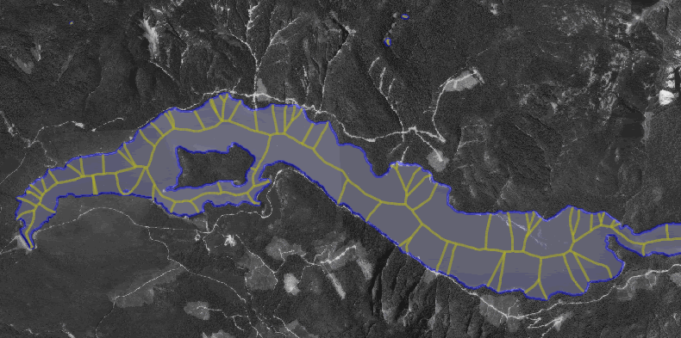
Provided that data are conditioned to meet a few requirements, the Skeletonizer Utility has application in any jurisdiction that is preparing a stream atlas for network analysis and data management.

Data Pre-Processing

Expected Data Inputs to the Skeletonizer Utility
The Skeletonizer Utility requires two sets of input files in ESRI Shapefile (.SHP, .SHX and .DBF) format:
- A Polygonal Layer comprising the simple or complex shapes that represent the water bodies that will be skeletonized.
- A Point Layer that defines all of the flow entry (INPUT) and exit (OUTLET) points for each water body in the data-set above.
Both of these datasets must be submitted to the utility in a meter-based projection system such as Universal Transverse Mercator (UTM) or the BC-specific Albers-Equal-Area (BCALBERS). A coordinate system such as Latitude and Longitude (‘LatLon’), which is based on decimal-degrees, will produce erroneous results. For more technical information on the implications of data units on the skeletonization process please refer to Sections 8.2.

Common Skeletonizer Utility Data Preparation Tasks

Preparing Point and Polygon Input Data
The BC BMGS basemap data used to build the CWB stream network was first compiled from ~7500 individual 1:20,000k mapsheets into a single dataset for the entire province. To avoid the prohibitively large computational power required to process this super-data-set, the data were then sub-divided into Shapefiles for each of the major watershed groups throughout the province.
Before running the skeletonization process on a watershed group, operators should ensure that no water body features are split by a watershed boundary. To accurately produce the linear representation of a water body polygon, each feature submitted for skeletonization should occur entirely within exactly one dataset.
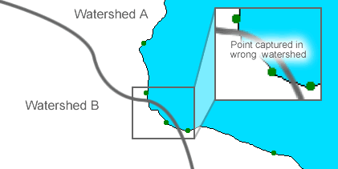
When pre-conditioning lake boundary and INPUT/OUTLET data, it is not unlikely that features will be split by boundary lines.
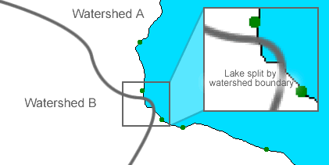
In the previous examples, potential errors would be avoided by adjusting the watershed boundary lines appropriately around intersecting features:
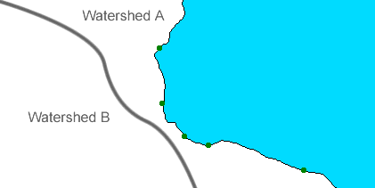
When preparing data from other jurisdictions for use in the Skeletonizer Utility, care should be taken that water bodies split by two or more watershed boundaries are resolved into their single parent features.

Generation of the Points Layer
The points layer is generated by intersecting the termini of features in the stream layer to which the skeletons will be eventually tied, with the edges of the water bodies that will be subject to skeletonization. All points in the INPUT/OUTLET points layer must occur at a coordinate that is mathematically equivalent to a vertex in the polygon layer.
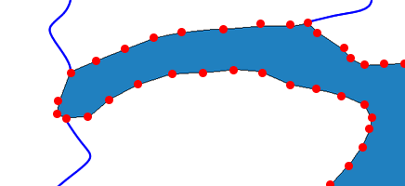
In the diagram above the blue stream lines enter and exit the water body polygon at various locations at its boundary. INPUT/OUTLET points are to be defined to at the closest vertex on the water body polygon’s edge. Most GIS applications include tools for interactively or automatically snapping nodes from one feature layer to mathematically equivalent nodes in another.

 | 
In the diagram above, the terminus of the stream line (blue) is snapped to the exact location of the water body boundary point (red disk) within the tolerance radius specified by the grey circle.
The generation of the INPUT/OUTLET points layer is discussed in greater detail in the document Conformace Levels for Hydrography Network Data. As well, errors that might occur because of a poorly formed points layer are discussed in Section 8.2.

Pre-Validation of Geometries in the Polygon Layer
If data for use in the Skeletonizer Utility are rendered from another application that does not consider polygon integrity, users must ensure that all polygons are closed and valid following translation into .SHP files.
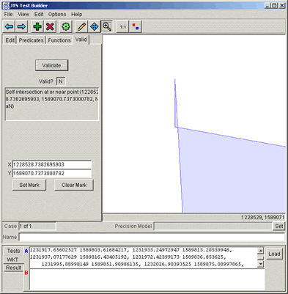
The diagram above shows the offending corner of a non-validated polygon located using the validation tools of the JUMP framework.
The conditioning of the water body polygon layer is discussed in greater detail in the Skeletonization Utility Conformance Document. As well, errors that might occur because of a poorly formed polygon layer are discussed in Section 8.2.
For more information on the JUMP and related components please visit the JUMP-Project website (http://www.jump-project.org).

Anticipating Polygon-to-Polygon Connectivity
Where distinct features in the polygon layer flow into one another, the shared edges of both features must be identical. This situation is likely to occur where one or more double-line rivers flow into a lake or flow into another double line river.
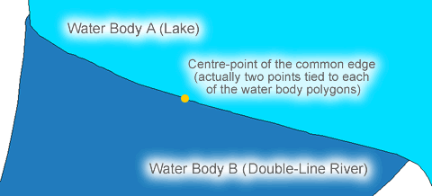
Prior to running the skeletonization process, operators must include the centre-points from these common edges in the list of INPUT/OUTLET points used to seed the skeletons for those features. Note that two instances of each of these points must be generated - one for each of the polygons sharing the common edge.
More information regarding the attribution of both the point and polygon layers and the relationships between key attribute fields is provided in the next section.

Feature Attribution
The polygon layer is expected to contain at least an integer field named ID that uniquely identifies all of the polygon features in that layer.
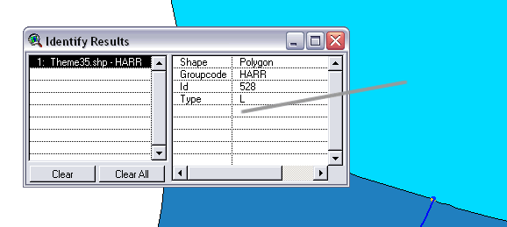
Any other fields (Groupcode and Type in the example above) are permitted but not necessary.
The INPUT/OUTLET points layer is expected to contain at least two integer fields: one named ID that uniquely identifies the point features, and one named POLYID that identifies the polygons to which each point is tied. The values in POLYID need not be unique, but must correspond to a polygon ID that exists in the polygon layer.
At present, features derived from the Skeletonizer Utility are both adirectional and without flow classification. To accommodate future versions of the application that will assign direction and classification to the skeletons, it is desirable that point features also contain the attributes: FLOW and CLASS. FLOW is an ordinal character field that classifies the point as either a flow input (“INPUT”) or a flow outlet (“OUTLET”). CLASS is an ordinal character field that classifies the point as either a primary (“P”) or secondary (“S”) flow element.
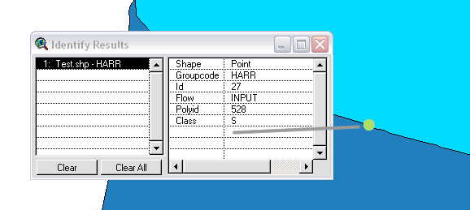

Installing the Required System Components
To run the Skeletonizer Utility in either wizard or batch mode, operators will need to have the following components installed on their machines:
- The JAVA Runtime Environment (JRE)
- The JUMP framework, and
- The Skeletonizer Utility plug-in
Please use the following instructions to set up the Skeletonizer Utility components.

Installing the JAVA Runtime Environment
To run the Skeletonizer Utility, operators will need to install the JRE version 1.4 on their machines.
- JRE 1.4 is included in the Skeletonizer Utility package.
- Double click the file j2re-1_4_2_01-windows-i586.exe
- Follow the on-screen prompts to set up the Java environment.
It is highly recommend that users accept the setup program’s default location for the JRE (“C:\Program Files\Java\j2re1.4.2_01\”)

Pre-existing Versions of the JAVA Application Framework
Operators are advised not to use any version of the JRE other than the version specified above. The recommended version contains classes that are critical to the proper function of the Skeletonizer Utility and to the format of the final skeletonized Shapefile objects.
Use of the Skeletonizer Utility with other versions of the JRE
WILL NOT BE SUPPORTED
If a different version of the JRE is already installed on your machine, remove it and use the release specified above.

Installing the JUMP Environment and the Skeletonizer Utility Plug-in
- Copy the folder SkeletonizerUtility from the Skeletonizer Utility package to a location your hard-drive. The utility will run directly from that location.
- Set the value of the system’s JAVA_HOME environment variable to the location of the JRE installation. From the (Windows) Control Panel, select:
SYSTEM > Advanced > Environmental Variables > New
Enter JAVA_HOME as the variable name, and the location of the JRE as the variable value.
In the following example (as per the installation default), the value of the JAVA_HOME variable would be “C:\Program Files\Java\j2re1.4.2_01\” (including the quotation marks).
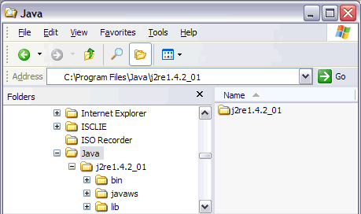

Tips for Launching the Skeletonizer Utility
- Locate and open the folder SkeletonizerUtility copied from the Skeletonizer Utility package.
- Open the bin subfolder and locate the file SkeletonizerGUI.bat
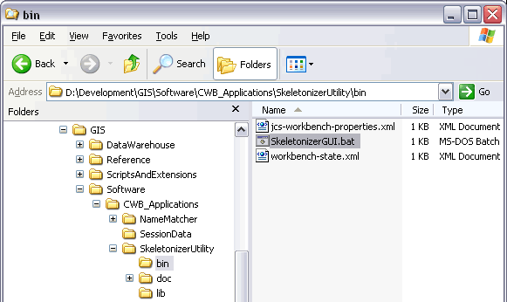
- To run the utility, double-click SkeletonizerGUI.bat
- HINT .. A shortcut can be created to this .BAT file and placed at any location on the system from which the utility would be accessed (i.e. The Windows Desktop or Start Menu).

Obtaining Skeletonizer Utility Data Packages
Users will be supplied with samples of input data for the Skeletonizer Utility representing areas near Vancouver and Harrison Lake, BC.
Users are kindly asked not to redistribute any portions these data-sets without the expressed consent of Government of BC. For more information, please contact Dr. Mark Sondheim of the BMGS branch (mailto:Mark.Sondheim@gems3.gov.bc.ca).

Opening Data-set Packages in the Skeletonizer Utility
Specifying the input and output data-sets to Skeletonizer Utility GUI sessions, interpreting the processing results and spatial outputs, and alternatives for operating the Skeletonizer Utility from the command line are presented forthcoming.

Minimal System Requirements
The following specifications are the minimum requirements for operation:
System Specifications:
- Pentium III / 1.0 GHz processor
- 256Mb RAM (512 Mb RAM recommended)

Updates to the CWB Application Files
Any updates to the JUMP or the Skeletonizer Utility files will be made available through the conflation project website (http://conflate.refractions.net).
Where possible, update notifications will be sent to operators by email, otherwise please check the URL above frequently for updated information.

Running the Skeletonizer Utility
The skeletonizer can be run either from the command line or in interactive GUI mode.

Running the Skeletonizer Utility in GUI Mode
The Skeletonizer Utility can be accessed in wizard mode through the GUI of the JUMP. The Skeletonizer Utility should have been installed alongside the JUMP as per the instructions in Section 3.
An Operators’ Guide to the JUMP Framework is provided in Appendix A of this document.
To launch the JUMP:Skeletonizer environment execute the file skeletonizer_gui.bat (Windows platforms) or skeletonizer_gui.sh (Unix platforms).
To run the Skeletonizer Utility Wizard, select SKELETONIZE WIZARD under the SKELETONIZE menu in the main JUMP menu bar:
SKELETONIZE > SKELETONIZE WIZARD
This invokes the Skeletonizer Utility Wizard Panel.
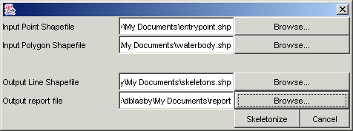
Users are presented with four file options in the Skeletonizer Utility Wizard Panel:
File Caption | Description | Input / Output | Format | Required
Input Point Shapefile | This file lists the INPUT/OUTLET points used to seed feature skeletons in the Skeletonizer Utility. | INPUT | Shapefile (.SHP) | YES
Input Polygon Shapefile | This file contains the water body polygons for which the medial linear values will be computed. | INPUT | Shapefile (.SHP) | YES
Output Line Shapefile | This file contains the linear features skeletonized from the point and polygon input files | OUTPUT | Shapefile (.SHP) | YES
Output Report File | This file contains the Processing Report / Error Log from the Skeletonization process | OUTPUT | ASCII (.TXT) | YES
The name and location of each of these files can be specified through familiar Open and Save As dialog boxes which are accessed using the Browse button to the right of each input box.
When acceptable values have been provided for each of the Skeletonizer Utility’s necessary parameters, users can click on the Skeletonize button to begin processing or Cancel to abort the operation.
If any of the input parameters are invalid (i.e. either of the input files does not exist or the output files cannot be generated because of illegal write permissions or disk space / computational issues) the application will abort immediately and display the following error message:
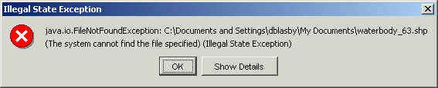]

Running the Skeletonizer Utility from the Command Line
Command line executions of the Skeletonizer Utility are useful for iteratively preparing skeletons for multiple jurisdictions without repeatedly specifying parameters to the GUI interface, or where the utility is to be accessed from other applications. Sample .BAT files are included with the Skeletonizer Utility package in the /bin directory.
The Skeletonizer Utility can be run from the command line or system shell using the files skeletonizier.bat or skeletonizer.sh, respectively.
Windows/MS-DOS Command Line .BAT Script
@ECHO OFF
if NOT DEFINED JAVA_HOME (
ECHO ERROR: JAVA_HOME not set. Please set to root of your java installation.
GOTO END
)
set JAVA=%JAVA_HOME%/bin/java
set CP=.;lib/jts-1.4.1-RC1.jar;lib/jump-1.1.2.jar;lib/skeletonizer.jar;lib/Chart2D.jar;lib/Jama-1.0.1.jar;lib/jdom.jar;lib/junit.jar;lib/xerces.jar;lib/network.jar;lib/graph.jar;lib/utilities.jar;bsh-2.0b1.jar
%JAVA% -Xmx500M -cp %CP% net.refractions.skeletons.SkeletonizeDatasetPlugin %1 %2 %3 %4 %5
:END
Unix Shell .SH Script
#!/bin/sh
JAVA=$JAVA_HOME/bin/java
if [ "$JAVA" == "/bin/java" ]; then
echo "ERROR: JAVA_HOME not set. Please set to the root of your JAVA installation"
exit;
fi
CP=.:lib/jts-1.4.1-RC1.jar:lib/jump-1.1.2.jar:lib/skeletonizer.jar:lib/Chart2D.jar:lib/Jama-1.0.1.jar:lib/jdom.jar:lib/junit.jar:lib/xerces.jar:lib/network.jar:lib/graph.jar:lib/utilities.jar:lib/bsh-2.0b1.jar
$JAVA -Xmx500M -cp $CP net.refractions.skeletons.SkeletonizeDatasetPlugin $1 $2 $3 $4 $5
Both the .BAT and .SH scripts are run with 5 arguments (passed as %1 to %5, or $1 to $5, respectively). These arguments are as follows:
- The location and name of the flow INPUT/OUTLET points Shapefile (for input)
- The location and name of the water body polygon Shapefile (for input)
- The location and name of the skeleton line Shapefile (to be output)
- The location and name of the processing report text file (to be output)
- The location and name of the Shapefile that contains any polygons that could not be processed by the utility (potentially output).
To run the Skeletonizer Utility from the command line repeatedly on several datasets (batch mode) the following syntax should be used:

set JAVA=%JAVA_HOME%\bin\java.exe
set CLASSPATH=.;%JAVA_HOME%/lib/tools.jar;../lib/JTS-1_3.jar;../lib/jump.jar;../lib/skel.jar;../lib/Chart2D.jar;../lib/Jama-1.0.1.jar;../lib/jdom.jar;../lib/junit.jar;../lib/xerces.jar
%JAVA% -Xmx800m -cp %CLASSPATH% net.refractions.skeletons.SkeletonizeDatasetPlugin "L:\Refractions\BMGS\CWB\Tasks\ExportViews\AllData\river_points_dead.shp" "L:\Refractions\BMGS\CWB\Tasks\ExportViews\AllData\rivers_dead.shp" "L:\Refractions\BMGS\CWB\Tasks\ExportViews\SKELS\dead.shp" "L:\Refractions\BMGS\CWB\Tasks\ExportViews\SKELREPORTS\dead.txt" "L:\Refractions\BMGS\CWB\Tasks\ExportViews\SKELBADPOLY\dead.shp"
%JAVA% -Xmx800m -cp %CLASSPATH% net.refractions.skeletons.SkeletonizeDatasetPlugin "L:\Refractions\BMGS\CWB\Tasks\ExportViews\AllData\river_points_guic.shp" "L:\Refractions\BMGS\CWB\Tasks\ExportViews\AllData\rivers_guic.shp" "L:\Refractions\BMGS\CWB\Tasks\ExportViews\SKELS\guic.shp" "L:\Refractions\BMGS\CWB\Tasks\ExportViews\SKELREPORTS\guic.txt" "L:\Refractions\BMGS\CWB\Tasks\ExportViews\SKELBADPOLY\guic.shp"
%JAVA% -Xmx800m -cp %CLASSPATH% net.refractions.skeletons.SkeletonizeDatasetPlugin "L:\Refractions\BMGS\CWB\Tasks\ExportViews\AllData\river_points_nbnk.shp" "L:\Refractions\BMGS\CWB\Tasks\ExportViews\AllData\rivers_nbnk.shp" "L:\Refractions\BMGS\CWB\Tasks\ExportViews\SKELS\nbnk.shp" "L:\Refractions\BMGS\CWB\Tasks\ExportViews\SKELREPORTS\nbnk.txt" "L:\Refractions\BMGS\CWB\Tasks\ExportViews\SKELBADPOLY\nbnk.shp"
Users will note that this example simply repeats the configuration line of the previous example, calling the Skeletonizer Utility plug-in and re-defining the input/output file arguments for each desired run of the utility. This closing block can be repeated as many times as needed.

Outputs from the Skeletonizer Utility

Output Files
For each Wizard run, and for each iteration in a batch run of the Skeletonizer Utility several sets of files are output:
  - Output lines - The suite of Shapefiles (.SHP, .SHX and .DBF) representing the medial linear skeletons of the input water body features
  - Processing report - A textual (ASCII) report of the Skeletonization process
  - Failed polygons - The suite of Shapefiles representing any polygons that could not be processed by the utility,.

Interpreting the Output Report
The Output line and Failed polygon Shapefiles can be opened in the JUMP or any ESRI GIS application for visual verification, in conjunction with the utility’s processing report. The processing report contains detailed information about the success or failure of the process and is formatted as follows:

Mon Nov 24 16:12:27 PST 2003
(easy fast ones - NEVER enhance precision) --> 784
(easy fast ones - SOMETIMES enhance precision) --> 34
(double densified, enhanced circle) --> 7
(quadruple densified, enhanced circle) --> 3
(3/4 densified, jiggled, enhanced circle) --> 0
(failed) --> 0
Mon Nov 24 16:12:45 PST 2003
Timestamps surround the results from the six operational tiers the utility uses to derive medial skeletons. Subsequent tiers increase in computational complexity and the utility will process each feature on the simplest level possible, noting the number of features processed on each tier.
For the most part, features are processed, without adjustment on the first tier. The second and third tiers see limited processing, while processes on the fourth tier and onwards are rarely, if ever used.
DENSIFICATION – Densification refers to the automatic addition of points along the polygon boundary so that a more accurate set of Voronoi lines can be generated for use in the Skeletonization process. Features processed on tiers 1 and 2 are single densified. Features processed on subsequent tiers are densified to the appropriate degree listed below.
  - (Single) Densification - Points are added to the polygon boundaries at a maximum interval of 1.25 metres.
  - Double Densification (tier 3) - Points are added to the polygon boundaries at a maximum interval of 0.75 metres (1/2 of 1.25).
  - Quadruple Densification (tier 4) - Points are added to the polygon boundaries at intervals of 0.3125 metres (1/4 of 1.25).
  - Three-Quarter (3/4) Densification (tiers 5) - Points are added to the polygon boundaries at 0.9375 meter intervals (3/4 of 1.25).
PRECISION ENHANCEMENT – Precision enhancement refers to a computational adjustment from normal arithmetic to arbitrary arithmetic which allows the precision of boundary point coordinates to be increased adaptively so that no decimal precision is lost from the more precise entities. Enhancing co-ordinate precision increases the threshold at which co-circularity errors are detected. Features processed on the first tier are NEVER adjusted for precision, while features processed on the second tier are only SOMETIMES subject to this enhancement. Features processed on subsequent tiers are ALWAYS subject to precision enhancement. Precisionaly enhanced calculations significantly slow computation times and are only used as needed.
JIGGLING – Jiggling refers to very minor adjustments (on the order of millimetres) that are made to the individual boundary point coordinates, to further avoid co-circularity errors. Jiggling adjustments are only ever applied as a last resort to features processed on the fifth operational tier.
FAILED – If the application cannot successfully generate a clean Voronoi skeleton for a polygon on the fifth operational tier, the feature is output as failed and the application moves to the next feature. Polygons fail the skeletonization process only very rarely, in exceptional cases.

Consolidating Multiple Reports from Batch Processes
A minor Perl script is provided with the Skeletonizer Utility package that consolidates the reports from multiple batch processes into a single file with the same format as the individual reports.
Examples of the use of and the output from this script are provided in Appendix B.

Testing the Skeletonizer Utility
The Skeletonizer Utility has been tested on two large hydrographic data-sets provided by the governments of British Columbia and Quebec. The data from BC comprised 400,000 water body polygons, while that from Quebec comprised 6000 polygons.
The Skeletonizer Utility worked flawlessly in both test data-sets, producing no degenerative cases (failed polygon outputs) and consistently reproducible skeletons.

Troubleshooting Skeletonizer Utility Errors
Based on repeated runs of aforementioned tests, by accurately implementing a deterministic computational geometry algorithm, the Skeletonizer Utility will typically yield no failure cases. However rare, errors in the Skeletonizer Utility are logically possible.
Section 8.2 addresses some exceptional cases where the Skeletonizer Utility’s Voronoi treatments (Section 8.1) might fail, and suggests solutions for resolving failures.
Failure cases are anticipated to be quite complex, and operators are invited to contact the developers of the Skeletonizer Utility directly should they encounter any of these (or other) failures.
dblasby@refractions.net
http://www.refractions.net

Suite 400 – 1207 Douglas Street
Victoria - British Columbia
CANADA – V8W2E7
Phone: (250) 383 3022
Fax: (250) 383 2140

Technical Summary of the Skeletonization Process

Voronoi Processing
The following section presents a much-simplified version of the workflow that the Skeletontizer Utility uses to generate linear representations of water body polygons. The process finds its foundation in the Voronoi tessellation of the polygon boundary points using the “Fortune” algorithm.
Generally, a Voronoi diagram assumes the following form:
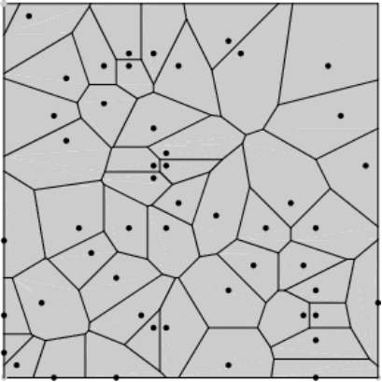
The input to the Voronoi process is a set of points (black discs above). These points are interleaved by a network of lines arranged into irregular polygons. The Voronoi lines are placed such that:
  - Only one point falls within each polygon
  - The location of any intersection is equidistant to the same number of points as the number of lines intersecting at that location (i.e. An intersection of three lines is equidistant to three points).
  - Any location on a given inner line (other than at an intersection) is equidistant to exactly two points.
  - Any location within a given cell is closest to the point within that cell.
It is important to recognize that when a Voronoi diagram is generated for a water body polygon, it is generated about the points (nodes and vertices) that make up the polygon’s boundary. A diagram illustrates this concept:
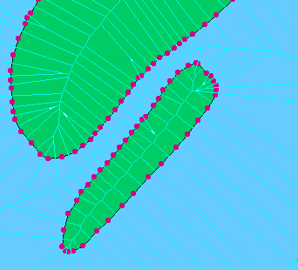
The red discs in the diagram above represent the vertices and nodes in the boundary of the (blue) water body polygon. Voronoi lines (light blue) are built for each of these boundary points.
In a similar pattern, the Skeletonizer Utility generates Voronoi lines for each point in each water body in an input dataset:
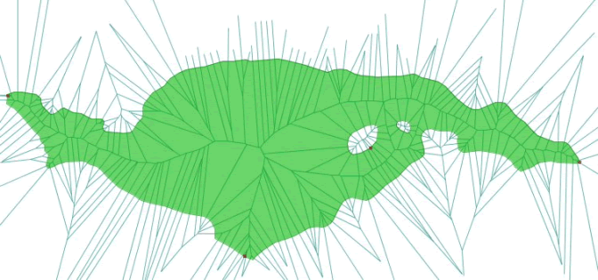
The diagram above shows the entire set of Voronoi lines generated for the boundary point co-ordinates of a large water body. For clarity the actual boundary points have been omitted from the graphic. The graphic however does show four points situated on either the inner (1 point) or outer (3 points) rings of the water body. These points are the INPUT and OUTLET points are used by Skeletonizer process to seed network paths through the skeleton in a subsequent step.
Between the INPUT and OUTLET points we are able to identify those parts of the Voronoi skeleton that need to be retained (shown as a red highlight in the diagram below). All of the other Voronoi lines are extraneous and need to be removed by the utility.
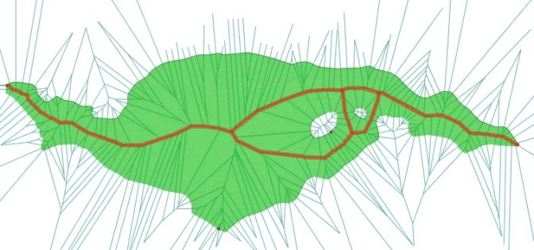
The first type of extraneous lines that are removed from the Voronoi diagram are those that leave the lake but are not associated with an INPUT/OUTLET point.

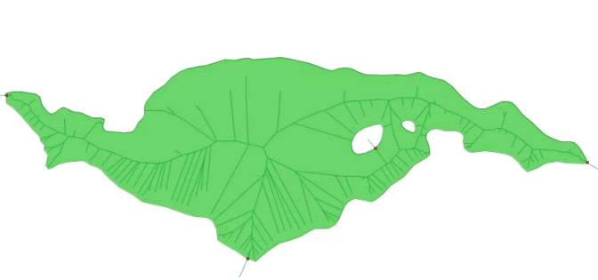

This culling process does not remove all of the extraneous lines. To resolve the final skeleton, any Voronoi edges that are not part of the closest network joining all of the INPUT and OUTLET points are removed.
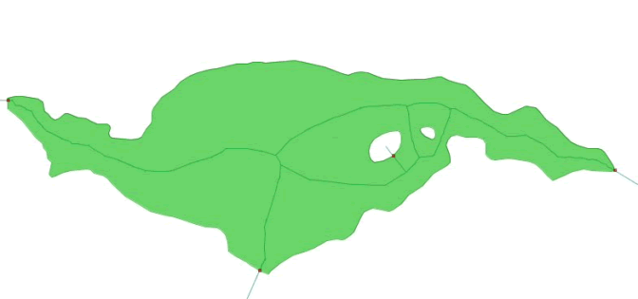
The result is the medial linear skeleton of the original water body polygon. Note that this skeleton touches all INPUT/OUTLET points and circulates all of the islands found in the water body.

Handling Exceptional Cases in the Skeletonizer Utility
As features are submitted to the Skeletonizer Utililty for processing, the utility automatically adjusts is processing mode to avoid failure.
Expanding on the basic introduction to the Voronoi process presented above, this section illustrates five exceptional cases where the Skeletonizer Utility might adjust the input polygons slightly to accommodate situations that cannot be processed ‘as is’.
Because of these pro-active adjustments, failure in the Skeletonizer Utility is rare. However if a polygon is likely not to be processed by the utility, it is in one of these cases:

Co-circularity Adjustments
Co-circularity occurs when four or more points on the outer ring of a water body polygon occur mathematically on a common circle. As per the following diagram, the Voronoi representation of these four (or more) points would produce a 4-way (or higher intersection) that might later confuse the skeletonization process.
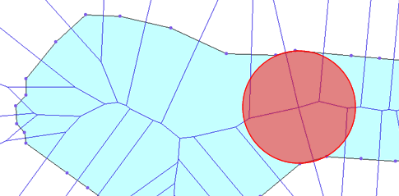
The red circle in the diagram above joins four co-circular points. At the centre of this circle is a four-way intersection of Voronoi lines.
Occurrences of co-circular points are rare, and the Voronoi generator employed by the Skeletonizer Utility will usually accommodate them. Moving or removing the least important co-circular vertex from the offending polygon could rectify a co-circularity error that repeatedly causes a polygon to fail.

Automatic Removal of Close-Points
Close-point issues arise when a node or vertex on a water body polygon adjacent to an INPUT or OUTLET point occurs within 0.3m (<= 30 cm) of that INPUT or OUTLET point. The Skeletonizer Utility will automatically remove the close-point from the polygon causing a slight adjustment to the shape of the input water body. There are no documented cases where this minor adjustment adversely affects either the generation of skeletons or the subsequent use of these skeletons in stream network analyses.
If they wish, users might proactively find and adjust any close-points in their data-sets using the tools native to their data-conditioning applications.

Feature Densification
The Skeletonizer Utility is able to proactively discern close edges (i.e. a narrow channel in a water body between its own opposing boundaries or between one boundary and that of an island) in a water body and will add points (densification yields more points per unit boundary length) to those areas where more information is needed to build non-conflicting Voronoi edges.
In the example below a narrow channel exists between two islands.
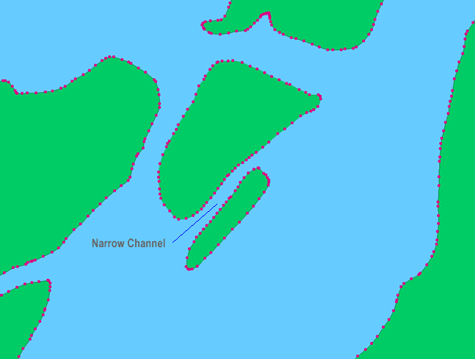
Without densification, the Voronoi lines would produce a skeleton that passed into the islands. By densifying the points along the boundaries of this channel, we are able to form a proper Voronoi skeleton. A very general rule in this situation would be to densify the boundaries to the degree that the point-to-point distance is just less than the island-to-island distance.
The Skeletonizer Utility applies its densification routines selectively only to the areas where it is needed and implements a set of sophisticated checking algorithms that check and recheck the current densification level to ensure that it is neither too high nor too low.
Over-densification comes at the risk of introducing co-circularity errors onto the polygon. However, whenever this occurs the Voronoi adjustments for co-circularity are able handle the event in all but the most distinct cases.
It is also logically possible that the polygon would not be densified enough – this would result in a failure, but has not been observed thus far.

Corner-Trimming at Acute Angle Entries
Acute angle entries are found where the angle of the water body boundary, defined between two water body boundary points and an entry exit point (actually the water body point that corresponds to the entry exit point), is less than 67 degrees.
At such an acute angle the Voronoi lines (yellow) generated for the singly densified water body boundary points (red discs) illegally exit and (re)-enter the water body boundary. To rectify this, the offending corner is virtually ‘clipped back’ no further than the two points immediately before and after the INPUT/OUTLET point (grey arrows).
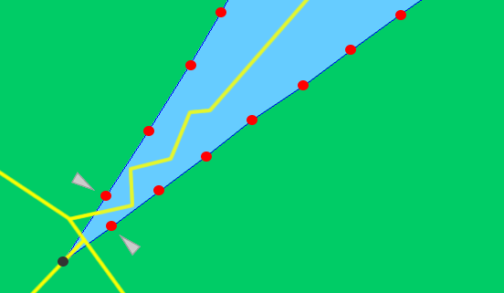
The clipping process generates three additional points: Two on the water body polygon boundary and one between them on the edge that has been created by the clipped corner. These points force the Voronoi line to pass directly through the original corner (INPUT/OUTLET) point.
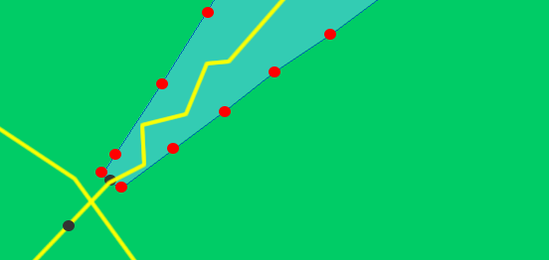
The diagram above superimposes the virtual clipped-back version of the water body polygon over the unclipped version and its Voronoi skeleton. The skeleton no longer illegally crosses the polygon boundary and passes directly through the original corner point.

Treating Cases with One or No INPUT / OUTLET Points
The Skeletonizer Utility is also able to treat polygons for which there are either only one or no INPUT/OUTLET points.
If a water body is submitted with only one corresponding INPUT/OUTLET point, a second point is created at the water body boundary point that is approximately opposite to point supplied. If a water body is submitted to the Skeletonizer Utility with no corresponding INPUT/OUTLET points, the utility automatically creates two points on the water body boundary along the longest available axis.
In either case above, the Vornoni diagram retains the lines that form the shortest path between these manufactured points to produce the medial skeleton.

Adding Directionality to Skeleton Lines
The final operation performed by the Skeletonizer Utility produces directions for each of the output segments. The production of segment directions is broken into three steps:
- Fusing skeleton lines
- Performing path calculations
- Inferring direction for each skeleton line

Directionality - Fusing Skeleton Lines
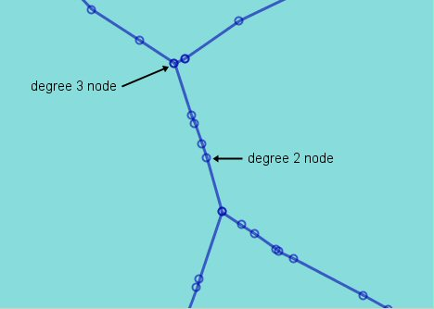
The raw output of Voronoi processing is a set of line segments. A line segment is defined as a linear feature with exactly two points.
In the diagram above, a node is represented by an open circle. A node occurs wherever two line segments join. A node’s degree is denoted by the number of line segments adjacent to the node.
The process of fusing skeletons removes all degree 2 nodes, such that nodes only occur when 3 or more line segments connect. The following diagram represents the previous example after the fusion process.
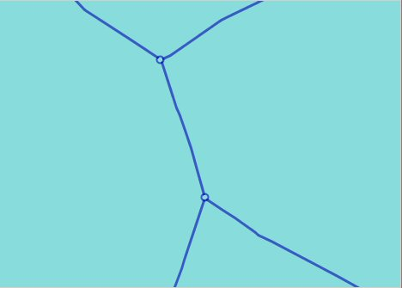
Fusing the skeletons converts a collection of line segments into a collection of line strings. A line string is defined as a linear feature with 2 or more points.
The process of fusing skeletons drastically reduces the number of features in a network, thus lowering the size of the skeleton data set.

Directionality - Path Calculation
Following segment fusion, the Skeletonizer Utility runs skeleton line strings through a process to determine the number of possible paths through the skeletonized network. Initially, the Skeletonizer Utility classifies input and output points as inflows or outflows.
In the figure above, inputs are denoted with red dots, and outputs are denoted with green dots.
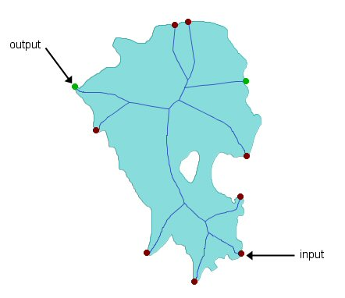
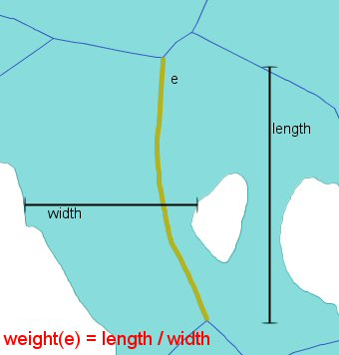
Secondly, the Skeletonizer calculates a path from each input point, to each output point using Dijkstra’s Shortest Path algorithm. This algorithm is weighted by a combination of line string length, and channel width.

In the following example with two output points, two sets of “shortest paths” are generated.
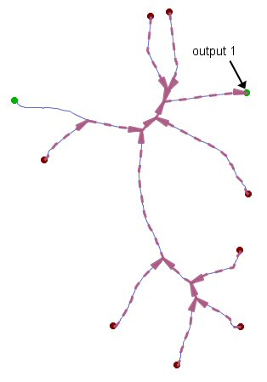
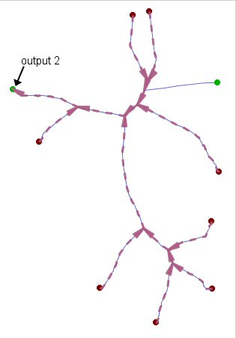
Path Set 1
Path Set 2
From each path set, the longest path is selected – this becomes the medial path for the data set. The path set with the longest medial path is then chosen as the final path set for the skeleton set.
In the above example, Path Set 2 is the chosen path set.

Directionality - Inferring Direction
The path set chosen in the previous phase is used to determine the direction of the underlying skeleton lines.

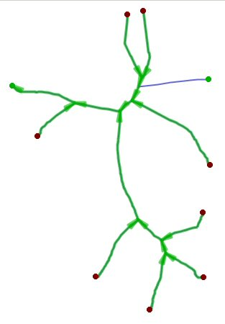
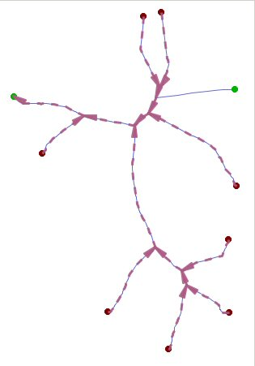
In the diagram above, skeleton lines with direction are shown in green. The remaining line without direction is the line connected to the other output. The direction placed on this final skeleton line is one toward the output it is connected to.
The final result is as follows:

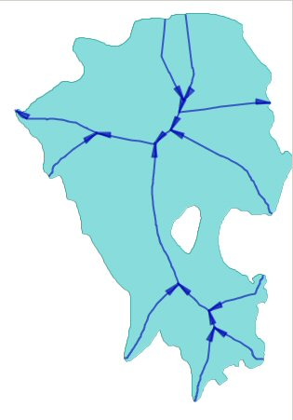

More Information

Future Development in the Skeletonizer Utility
Future releases of the Skeletonizer Utility, intend to make the following improvements to the current version.

Alternate Skeleton Representations
Multiple paths formed through channels around islands can sometimes over describe water body skeletons. Oftentimes, these skeletons could be simplified to fewer components.
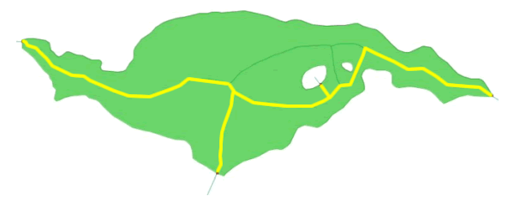
Returning to our first example of skeletonization, a simplified alternate path is shown in the diagram above superimposed in yellow over the original complex path. The alternate path meets all of the INPUT/OUTLET points but does not circulate unnecessarily around the island features.

Flow Classification
Future versions of the Skeletonizer Utility will use information provided in both the CLASS attribute of the INPUT/OUTLET points and in the Voronoi areas, to classify the skeleton lines as PRIMARY or SECONDARY flow elements.
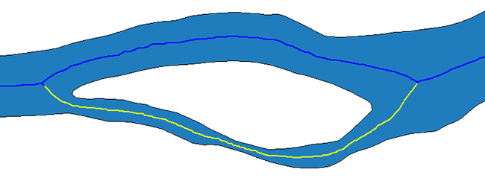
In the diagram above, the upper (blue) path would be given PRIMARY flow classification, while the lower path (yellow) would be classified as a SECONDARY flow element. Criteria that determine the classification of a flow element may include the length of the diversion: a longer path, more prone to wandering, is more likely to be a secondary flow element; or the width of the channel: a more narrow channel is likely to support the lower flow volumes of a secondary flow element.

Linking Voronoi Linework to Feature Attributes
Using the spatial tools available in the JUMP framework, it is possible to use topological queries and shape building routines to convert elements of the Voronoi skeleton into water body ‘areas’ that can be tied to attributes of the underlying features or related datasets.

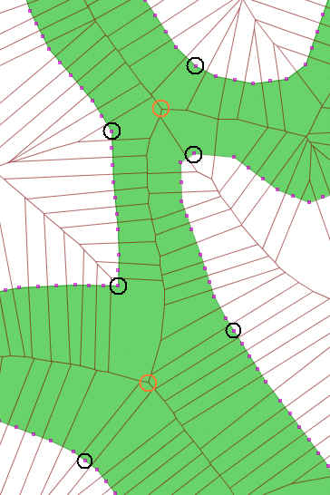 | 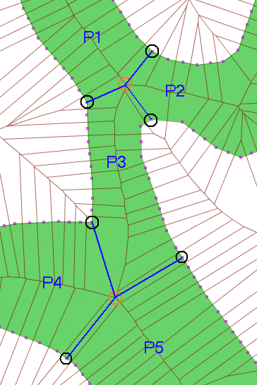
The diagram above at left shows where intersections of the Voronoi skeleton lines (highlighted by orange circles) are tied back to the boundary of the lake polygons. For each part of an intersection, there will be one polygon (containing a single boundary point) that boarders on both the intersection and the water body boundary. Lines can be drawn from each intersection to each of the boundary points contained by the ‘intersecting’ polygons (this is not a true topological intersection) to form subdivisions within the Voronoi lines.
The diagram above at right shows where two intersection points have been tied back to six points on the water body boundary (the blue lines) to form five distinct channel areas (P1 – P5). Because the tie-back lines end exactly on the water body boundary, they can be used to ‘cut’ the water body (or a copy thereof) into distinct polygons. The elements of the Vornonoi skeletons, which also occur exactly within the boundaries of these sub-shapes can be assigned distinct properties computed from the attributes of these shapes or from related components in other datasets based on spatial queries.
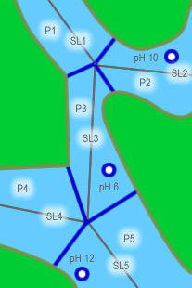
In the example above, the blue and white dots represent locations (stored in a separate dataset) where river water pH was recorded. After generating a system of Voronoi lines and dividing the original double-line river feature into sub-components based the intersection of the skeleton features spatial queries can be used to relate the pH attributes to the relevant Voronoi components:

River Polygon (P#) | Skeleton Line (SL#) | PH Attribute Value
P1 | SL1 | NO DATA
P2 | SL2 | 10.0
P3 | SL3 | 6.0
P4 | SL4 | NO DATA
P5 | SL5 | 12.0

GNU General Public Licence
The Skeletonizer Utility is distributed under GNU General Public Licence – It is free software and can be redistributed and/or modified under the terms of the GNU General Public License as published by the Free Software Foundation; either version 2 of the License, or (at your option) any later version.

This program is distributed in the hope that it will be useful, but comes WITHOUT ANY WARRANTY; without even the implied warranty of MERCHANTABILITY or FITNESS FOR A PARTICULAR PURPOSE. Please see the GNU General Public License for more details.

You should have received a copy of the GNU General Public License along with this program; if this is not the case, please write to:

The Free Software Foundation, Inc.
59 Temple Place - Suite 330
Boston - MA
02111-1307 - USA.

The Skeletonizer Utility Development Team
Suite 400 – 1207 Douglas Street
Victoria - British Columbia
CANADA – V8W2E7
Phone: (250) 383 3022
Fax: (250) 383 2140
http://www.refractions.net

Appendix A
JUMP Unified Mapping Platform Operators’ Guide
Appendix B
Consolidating Processing Reports from Multiple Skeletonizer Batch Files
Where many reports are generated by a batch run of the Skeletonizer Utility, they can be consolidated into a single processing report by running a complementary Perl script that is distributed with the Skeletonizer Utility package. This script is run from the command lines as follows:
C:\ Perl parse_report.pl [ReportDirectory]
Where …
  - Perl is a valid path to a PERL installation
  - [ReportDirectory] is the path to the directory in which ONLY the textual processing results can be found
This script outputs to the screen a report identical in format to an individual textual processing report but contains tier-wise aggregated counts for each of the specified individual processing summaries.

To achieve this, it is recommended that the termini of features in the stream layer be automatically snapped to the nearest node of the appropriate feature(s) in the polygon layer. Most common GIS applications, including the JUMP, provide automatic or manual options for node-snapping at user-defined tolerance levels.
BC Ministry of Sustainable Resource Management (In Draft)
A polygon is considered valid in the Skeletonizer Utility when it is an entirely closed ring and where no internal holes (islands) touch either the outer ring of the water body or the edge of another island. Most common GIS applications, including the JUMP, provide automatic or manual options for validating polygon geometries.
Please note that the POLYID is not required in the current release of the Skeletonizer Utility, but will be needed to support the more advanced features in future versions. Please see Section 10.1 for more information on future development efforts.
This file will only be output if polygons exist in the input file that cannot be processed by the utility.
When run in batch mode the user is able to specify implicitly the name and location of the Failed Polygons Shapefile. When run in wizard mode, failed polygons are output by default to “C:\BadPolys.shp”.
More information on the Voronoi tessellation, specifically using the Fortune algorithm can be found on the following websites: http://www.cg.tuwien.ac.at/studentwork/CESCG99/RCuk/ http://www.diku.dk/hjemmesider/studerende/duff/Fortune/ http://www.msci.memphis.edu/~giri/7713/f98/cyang.html

