System dynamics to support growth in the nascent U.S. bioproducts industry

Rebecca Hanes1, Brian Bush1, Lauren Sittler1, Anthony Foretich2

1. Strategic Energy Analysis Center, National Renewable Energy Laboratory, Golden, CO, USA
2. Affilation TBD

# Abstract

Bioproducts have the potential to improve the sustainability and economic performance of integrated biorefineries, reduce the dependence of the U.S. chemical sector on imported fossil feedstocks, and contribute to an improvement in the sustainability of the U.S. chemical sector. However, it has historically been difficult to develop bioproduct technology to full commercial scale and to capture market share from incumbent products. To support bioproduct industry stakeholders in making decisions that will increase the likelihood of a bioproduct entering the commercial market, this work presents the Bioproduct Transition Dynamics (BTD) model, a system dynamics model of the bioproduct technology development process that will contribute to a greater understanding of the factors that contribute to or hinder a bioproduct’s market success. At the core of the BTD model is the feedback loop between technology developers, investors providing financial support, and government entities providing funds for research, development, and commercialization. The model serves as a decision support tool usable by bioproduct industry stakeholders to inform decisions around which bioproduct development projects to pursue, which to invest in, and which would benefit most from government support. We apply the BTD model to determining the critical factors that cause the Valley of Death for bioproducts and identifying ways of navigating the Valley of Death through to commercialization. We also compare direct replacement bioproducts with performance advantaged bioproducts, to determine if these two types of bioproducts have substantially different paths to commercial success. Results show that while there are few factors that are critical to success by themselves, there are many combinations of factors that generally lead to market success.

# Introduction

Transitioning to a domestic bioeconomy in the U.S. would offer economic, energy security, environmental, and social benefits and has been a goal at the federal level since the Biomass Research and Development Board began work on the Bioeconomy Initiative in 2013. (1) Bioproducts, chemicals produced from biomass rather than fossil feedstocks, are a fundamental part of the emerging bioeconomy and have the potential to convert much of the U.S. chemical and manufacturing sectors to biomass-derived feedstocks. Bioproducts have the potential to reduce the U.S. chemical sector’s dependence on imported fossil feedstocks and to improve the overall sustainability of integrated biorefineries that also produce liquid biofuels. (2) Some high value bioproducts can also improve the economic feasibility of biorefineries by providing an additional revenue stream without requiring a separate processing facility. Bioproducts, like biofuels, rely on domestic supply chains based in the agricultural sector; increased demand for the biomass feedstocks is likely to increase activity in the agricultural sector and generate jobs both seasonal (farming, harvesting and transportation work) and year-round (biomass depot and biorefinery work). The Bioenergy Technologies Office (BETO) within the U.S. Department of Energy Office of Energy Efficiency and Renewable Energy has developed a broad understanding of the processes that produce bioproducts and the associated technological, economic, and sustainability attributes. (3) Work is ongoing to develop the different feedstocks, production pathways, microorganisms, and separation techniques necessary to commercialize bioproducts. However, the drivers behind successful bioproduct commercialization and possible scenarios under which the bioproducts industry can capture additional market share are not yet well understood. Bioproducts have historically proven difficult to develop to full commercial scale, and industry anecdotes are clear that even economically competitive performance-advantaged bioproducts are not guaranteed to succeed in the market in the medium to long term. This lack of understanding both contributes to the low market share of existing bioproducts – as of 2013, bioproducts comprised approximately 4% of the U.S. chemical market (4) – and the difficulty and uncertainty of commercializing new bioproducts and bioproduct technologies.

The present work addresses this knowledge gap with the development of a decision support tool that consists of a system dynamics model of early-market bioproduct development from the pre-piloting research stage through piloting and demoing to commercial-scale production. (5) The Bioproduct Transition Dynamics (BTD) model captures the pre-commercial-scale technology development process and early-market transition processes such as market entry and competition between new and incumbent products. To the best of our knowledge there is no comparable extant model of early-market transition dynamics that focuses on technology development and does not model beyond operation of the first commercial scale plant. The core of the BTD is the feedback loop between the bioproduct development process (including the impact on bioproduct techno-economics) and the decision-making process used by investors when determining whether to fund a project. Both quantitative and semi-quantitative factors are represented, including bioproduct techno-economic criteria, industrial demand for and acceptance of bioproducts, investor optimism and risk tolerance, and investor expectations around continued government support.

The primary use of the BTD model is as a decision support tool for bioproduct industry stakeholders including technology developers in both start-up and established firms, venture capitalists and other investors, industry analysts, and government agencies providing funding and other support to bioproduct development projects. The BTD was built to model a general bioproduct development process and can therefore be used to analyze many types of bioproducts, including commodity-scale products with high demand and relatively low value, niche market products with low demand but relatively high value, performance advantaged products which are novel molecules with functionality similar to molecules on the market, and direct replacement products which are molecules identical to those on the market. Additionally, the BTD can represent a variety of exogenous scenarios under which bioproduct development takes place, such as the existence of incumbent products in the market and increasing or decreasing long-term trends in biomass and fossil feedstock prices. This flexibility enables analysts and other BTD users to formulate and explore technological and market scenarios that lead to a bioproduct succeeding or failing to reach continuous commercial production, to investigate how their or their firm’s decisions impact a bioproduct’s chances of reaching the commercial market, and to highlight how financial and scientific support from BETO can enhance a bioproduct’s likelihood of success along with the associated funding needs.

The primary objective of this paper is to demonstrate the insights and value provided by the BTD with an application to an analysis topic that was determined in collaboration with stakeholders within BETO. This paper investigates the factors – both exogenous and endogenous – that contribute to the Valley of Death (the period between research and commercialization when many projects across industries fail) for bioproducts, and how these factors differ for performance advantaged bioproducts versus direct replacement bioproducts.

The remainder of this paper is structured as follows. The Background section summarizes the research done to lay the groundwork for the present analysis. In the Methods section, the BTD itself is discussed along with a brief overview of the system dynamics modeling method, and the experimental design used to obtain BTD results. Current limitations of the BTD and the resulting analysis are also discussed in the Methods section. BTD outcomes are provided and interpreted in the Results and Discussion section. Finally, conclusions of this analysis and next steps for the BTD project are given in the Conclusions section.

# Background

## Valley of Death: Definitions and Causes

The process of developing a new product from concept to market varies dramatically in terms of time and resources required across industries, developers, and product types. In the medical field, where several phases of rigorous testing are necessary before a drug or device can be sold on the market, the time from patenting a new drug to commercialization typically takes 11-12 years and over $1 billion USD (6). Different types of products present different risks and are constrained by distinct regulations, supply chains, funding systems, and consumption models. Additionally, those who study the innovation process present different models for the product development sequence, such as the technology readiness level (TRL) model first developed by the U.S. National Aeronautics and Space Administration (NASA). The names and number of stages within the technology development process are not consistent across different models. However, one consistent aspect of the technology development process that exists across industries and products is a specific challenging phase during which projects are particularly likely to fail, commonly referred to as the Valley of Death.

Although there is general agreement that the Valley of Death occurs in the period between initial concept development and full commercialization – that is, at some point during the technology development process – a literature review on the concept reveals several definitions that are not always in agreement. Markham, Ward, Aiman-Smith, and Kingon (2010) identify Valley of Death as a metaphor for the “relative lack of resources and expertise” in the “discrete segment of development between research and product development” (7). Ford, Koutsky, and Spiwak (2007) suggest that the Valley of Death manifests during the development phase when a product’s economic and technical feasibility must be established before the product is commercialized. The authors assert that conditions that lead to the Valley of Death are created during the basic research stage, when funding tends to be more readily available than during the feasibility-proving stage. This gap in funding in the intermediate development phase – the authors also assert that, relatively speaking, funding is more easily obtained when the product is ready for commercialization – is what causes the Valley of Death (8). This definition is limited to a smaller range of activities than those given by other authors.

The U.S. Department of Energy Inventions and Innovation Program offers a much broader definition in a guide for innovators planning business and commercialization strategies. This guide defines the Valley of Death as the entire region of development during which the innovator must rely on debt from impersonal sources to finance the project. (9) According to this definition, the Valley encompasses virtually all technology development activities from building a working model to selling the fully commercialized product.

Some more heavily regulated industries experience higher project failures rates in general and during the Valley of Death. Adams (2010) presents a table of 22 factors known to contribute to the failure of cancer drug development and commercialization. (10) While some factors such as *healthcare culture* and *choice of drug type* are specific to the pharmaceutical industry, others apply across industries. The more broadly applicable factors include *lack of financial resources*, *lack of human resources*, *communication*, *lack of incentives in academia*, *intellectual property issues*, and *lack of innovation*.

Renewable energy technologies and environmentally friendly products tend to face an additional barrier in that early on in development, the products are more expensive than incumbents and so may require greater investment in research and development. Moreover, the benefits of renewable, environmentally friendly and eco-conscious products in general manifest over a long period and may be in the form of externalities rather than direct economic benefits. (11) Several solutions have been proposed to help bring such societally beneficial products through the Valley of Death and to market. The first type of solution comes in the form of additional funding, either by a government or from a large corporation performing internal research and development. In the case of renewable energy, government support may be essential for commercialization. While it is difficult for firms to profit from these products in the early stages, the innovation is doubly important to society because it both adds technologically sound solutions to the market and has a positive environmental impact (11). If this reasoning is extended to the private industry, it is wise for companies to invest now in products that will be profitable and environmentally beneficial in the future.

Also important to overcoming the Valley of Death problem are macro-scale organizational relationships at the city, state or national level. Collaborations between academia, industry and government can enable entrepreneurial hotspots such as Boston and the Bay Area that support and advance innovation. (12) Each of the three spheres supports the others through funding, research and development, and training in a synergistic relationship.

Within an organization, there are several informal roles that will increase the chances of a product making it through the Valley of Death: a champion, a sponsor and a gatekeeper. Champions adopt and advocate for a product; sponsors sanction the project and secure resources; and gatekeepers establish success criteria and are responsible for planning the project’s future. (7) There tends to be overlap among the roles – for instance, a technology developer could be both a champion and a gatekeeper. Each role is important to the development process; however, equally if not more important is that business development activities occur early in the innovation cycle, before formal new product development processes take place.

Finally, it is critical to a product’s eventual success that a commercialization strategy be developed and maintained throughout the technology development process. (9) Developers and innovators, particularly those working on their own as opposed to internally to an established firm, must be able to reach and communicate with venture capitalists and potential business partners.

Throughout the literature that describes the Valley of Death several themes emerge:

1. Heavy investment in basic research may promote the development of more ideas than the market can sustain.
2. Funding is more difficult to obtain in the intermediate stages of product development than in the early and later stages.
3. Underinvestment in stages past basic research is particularly a problem for products with benefits that are realized over the long term or cannot be monetarily quantified.
4. Communication and planning are essential and can be even more important than technical merit in carrying a product to market.
5. Each individual, organization, and department has a role to play and successful collaboration is needed, as roles often overlap.

Engaging in business development activities early will help to ensure that 1) the project is will be supported by the market in the first place 2) it can be successfully sold to the business professionals who will need to “buy in” and provide funding or expertise.

## Direct replacement and performance advantaged bioproducts

Direct replacement bioproducts are identical to fossil-derived products already on the market. Such bioproducts are the same molecule or mixtures already on the market, with identical physical, thermodynamic and chemical properties as the incumbent product. Barring any quality issues or contaminants, direct replacement bioproducts can be swapped out for the incumbent fossil-derived products with no impact on downstream processing and manufacturing stages. The incentive for purchasing direct replacement bioproducts lies almost entirely in the cost difference between the bioproduct and the incumbent product. Obstacles to firms purchasing a direct replacement bioproduct include reluctance to rely on relatively new and potentially unstable supply chains and concerns with contaminants or general quality issues. If the bioproduct does not have a cost advantage over the incumbent product, that creates an additional obstacle. One way bioproduct firms mitigate these risks is with offtake agreements established in advance of commercialization: the purchaser, amount to purchase and price are all set beforehand, in some cases before bioproduct manufacturing capacity has been built and is operational. In the case that an offtake agreement cannot be established, firms will often decide not to pursue construction of a commercial scale bioproduct plant.

Performance advantaged bioproducts are functionally similar to incumbent products, but may have different chemical makeups and different chemical, thermodynamic and/or physical properties. These different properties give some advantage to the bioproduct; for instance, a performance advantaged cleaning agent might require smaller amounts than the incumbent product, reducing consumption and therefore costs for the purchaser. Purchasers must balance the performance advantage offered by the bioproduct with the disruption to downstream operations.

# Methods

## System dynamics

As “simplifications of reality which can be used for guiding decisions for long term consequences,” models are often useful, however, they are never perfect. (13) Using a mental model, conceptualizing the repercussions of pressing one’s finger to a hot stove are easily enough grasped. A person feeling a resulting burn can accurately construct a mental model that states when a hot stove is touched painful burns occur. Sometimes, however, causality is not so obvious and immediate. When dealing with complex, dynamic systems, causality is often hidden in unseen feedback processes. To better understand causal structure of systems such as these, the special modeling processes of the field of System Dynamics can be of extraordinary use.

Developed in the early sixties by systems thinker and computer scientist Jay Wright Forrester, the computer-aided simulation approaches of System Dynamics are particularly suited to analyzing problems in dynamic social, managerial, economic, and ecological systems. (14) System dynamics concepts are advantageous in identifying the core structure of such systems as they incorporate holistic thinking, feedback loops, dynamic processes, nonlinearities, and accumulations in the connections between variables. For this reason, system dynamics models are commonly used for policy analysis and design. (14)

The basic components of a system dynamics model are constants, variables, flow rates, non- linear functions, stocks (levels), and the feedback loops comprised of these elements. (14) Because levels and rates capture the accumulations within a system, they are often the most critically studied portions of a system dynamics model. (15) Mathematically, a level can be represented through integral calculus as:



and through differential calculus as:



Stock and flow architectures are used in many system dynamics models to represent accumulations, an example of which can be seen below in Figure 1.



Figure 1. A visual representation of a stock and flow architecture within a system dynamics model. Rates can be seen in both the inflow to and outflow from the level. The difference between the inflow rate and outflow rate determines whether the stock is increasing or decreasing in size. (14)

Feedback loops exist when one action in a system creates information that travels in some cyclical fashion and returns to the point of origin with momentum. The momentum with which the information restarts the loop may reinforce the original action in the system with greater strength or counteract (balance) it. Reinforcing loops perpetuate growth or accelerate collapse as they are destabilizing. Balancing loops tend to be goal-seeking and to stabilize the momentum of a system. The stock and flow structure of a basic feedback loop can be seen below in Figure 2 within the context of goods production capital.

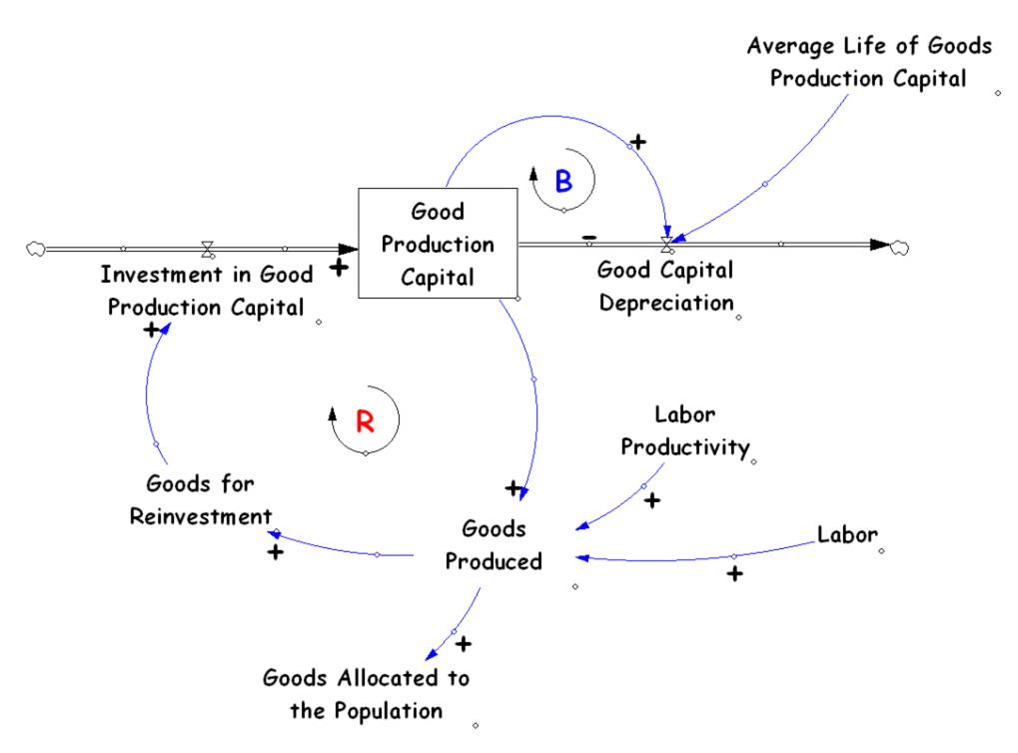

Figure 2 When a company decides to invest the production of goods, after a time-delay goods production capital is produced. This capital can of course be used to produce goods, which can be sold for funds and be reinvested in capacity. With more capacity for reinvestment, more investments in production capital are made and again more goods production capital is produced. Such a cycle is reinforcing as it generates increased momentum for reinvestment and goods production capital. The reinforcing loop can be seen labeled with the red R towards the left of Figure 2. Balancing this momentum is the loop labeled with the blue B where the depreciation of goods production capital leads to less production capital and less goods. The “Average Life of Goods Production Capital” variable determines the rate at which the goods production capital depreciates in this balancing loop.

With the incorporation of such reinforcing and balancing loops, system dynamics model output can be of any dynamic pattern; examples of which can be seen below in Figure 3*.* (14)

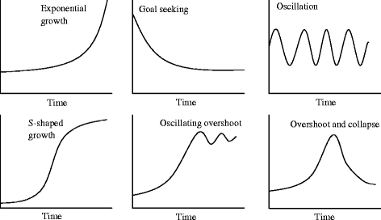

Figure 3 Six behavior-over-time graphs representing classic system dynamics model output shown. Exponential growth is likely when one or several reinforcing loops are dominant over the balancing ones and drive momentum in a certain direction away from stability. Goal seeking behavior tends to resolve the momentum of a system towards stability as balancing loops become dominant. Oscillatory behavior also arises from the dominance of balancing loops; however, with the addition of time delays in the system causing it to constantly overshoot, attempt to correct itself, undershoot, attempt to correct itself and so on. S-shaped growth occurs when a system experiences exponential growth until the limits on that growth are reached at which time balancing loops become dominant and halt the growth near a steady state. When these limits on growth are coupled with time delays, oscillating overshoot may be the resulting behavior output. Finally, overshoot and collapse output is caused by exponential growth accompanied by decreased limits on growth as the growth intensifies. (16)

Non-linear functions are often responsible for changing the direction of momentum (the dominant loop) as they impose limits on sustained growth or degradation. Such limits are important as they can stop or reduce flow rates from becoming too powerful and levels from accumulating too rapidly, which can cause overshoot and collapse.

System dynamics models are designed specifically to draw simplicity from the particular, complex problem at hand. (14) This is done by first developing a mental model of the scope and structure of the problem through discussions with experts and stakeholders involved with it. Next, diagrams are made to identify information feedback, circular causality, and accumulations within the system. With the system’s basic structure outlined, mathematical relationships between variables can be assigned using coupled, nonlinear, and first-order differential (integral) equations. The model is then calibrated by comparing it to empirical data for discrepancies and tweaking it to better emulate the real-world system. (14) Sensitivity analyses are also conducted to validate the inputs to the models, reducing output uncertainty and increasing model legitimacy. Once developed and calibrated, the model can be simulated and experimented with while conducting “what if” scenarios on inputs to gauge potential impacts of the system in the short and long term. System dynamics models are not used for exact prediction; however, they are useful for determining whether a certain action will benefit or degrade the condition of a problem over a certain time frame, usually with much greater accuracy than that of a mental model.

## Bioproduct Transition Dynamics Model

The BTD model is based on background research into historical bioproduct development efforts, trends in technology development processes across the bioproduct and other industries, the techno-economic and market characteristics of bioproducts that have been studied within BETO and elsewhere, and interviews with professionals currently and formerly working in the bioproducts industry.

Inputs to the model include bioproduct techno-economic information on the eventual commercial scale plant, obtainable from preliminary scale-up work and techno-economic analyses. Relatedly, the bioproduct selling price and trends over time, if available, are required, as is the feedstock type, and price short-term behavior and long-term trends if the feedstock type is not already modeled in the BTD. The rest of the BTD inputs deal with how investors, technology developers, and government agencies are expected to behave and the decisions they are expected to make. Model outputs include time series for technology readiness level (TRL) and cumulative production (only commercial production or commercial plus demo production). A development timeline showing when the project transitioned between stages and how long each stage took to complete. Project finances over time are also calculated. Complete details on the BTD are available in (5).

Figure 4. The primary feedback loop in the BTD model is between technology developers, investors, and government agencies (not shown) providing support.

## Base cases

## Experimental design

### Parameter ranges

Previous sensitivity and scenario analyses of earlier revisions of the BTD have identified the parameters (“input variables”) that have the greatest potential for influencing outcomes. For this exploratory sensitivity analysis of the current revision of the BTD, we undertook a comprehensive review of all input variables and used past analyses and modeler judgment to select parameters for variation and their ranges of variation in the present study. Table 1 below shows the 84 parameters to be varied, their default value in the model, and their range of variation. (See the BTD technical documentation for more information on these variables and on the model sectors in which they reside.)

Table 1. Model input parameters and their ranges in the sensitivity analyses.

| **Variable** | **Units** | **Minimum** | **Maximum** | **Default** |
| --- | --- | --- | --- | --- |
| advertising budget | USD/year | 150000 | 1900000 | 500000 |
| advertising start time | Year | 2015 | 2050 | 2020 |
| aversion to NPV deviation | Dmnl | 0.06 | 2.66 | 0.2 |
| base external investor ask rate | 1/year | 2.4 | 18.4 | 8 |
| bioproduct long term price | USD/tonProduct | 1500.5 | 9000 | 5000 |
| bioproduct offtake agreement | Dmnl | 0.15 | 2.9 | 0.5 |
| bioproduct performance advantage | tonProduct/tonIncumbent | 0.35 | 5.8 | 1 |
| bioproduct price fluctuations | Dmnl | 0 | 0.025 | 0 |
| bioproduct price reversion time | Year | 0.35 | 3.3 | 1 |
| business as usual runway | Year | 0.5 | 3.7 | 1.5 |
| commercial capital cost input | USD | 120374400 | 1320998400 | 4.01248e+08 |
| commercial fixed operating cost input | USD/year | 3420000 | 34120000 | 1.14e+07 |
| commercial plant capacity | tonProduct/year | 8589.5 | 2522904 | 28630 |
| commercial plant capacity input | tonProduct/year | 8589.5 | 2522904 | 28630 |
| commercial plant startup period | Year | 0.9095 | 12.4 | 3 |
| commercial process yield input | tonProduct/tonFeedstock | 0.236 | 1.116 | 0.77 |
| commercial variable operating cost input | USD/tonProduct | 365.7 | 1975.2 | 1219 |
| custom feedstock long term price change | Dmnl | -0.05 | 0.05 | 0 |
| custom feedstock maximum fluctuation magnitude | Dmnl | 0.1425 | 0.76 | 0.475 |
| custom feedstock periodic fluctuation magnitude | USD/tonFeedstock | 1.05 | 5.6 | 3.5 |
| custom feedstock reversion time | Year | 0.3095 | 3.3 | 1 |
| custom feedstock starting price | USD/tonFeedstock | 12.5 | 282 | 40 |
| demo capacity | tonProduct/year | 5153.3 | 513741 | 17176 |
| demoing acceptable rate | hours/year | 2607.3 | 11111.8 | 8411 |
| demoing failure default recovery time | Year | 0.32 | 2.02 | 0.65 |
| demoing failure distribution max | Dmnl | 1.5 | 9 | 5 |
| demoing management overhead | USD/year | 450050 | 6200000 | 1.5e+06 |
| duration of intellectual property | Year | 6 | 32 | 20 |
| effectiveness of intellectual property | Dmnl | 0.12 | 0.82 | 0.4 |
| elasticity of demand | Dmnl | 0.35 | 5.8 | 1 |
| elasticity of supply | Dmnl | 0.35 | 5.8 | 1 |
| expected continuity of government policy | Dmnl | 0.3 | 1.3 | 1 |
| expected green premium | Dmnl | 0 | 0.5 | 0 |
| feedstock approval maximum cost | USD | 300500 | 5800000 | 1e+06 |
| feedstock approval maximum time | Year | 1.5 | 9 | 5 |
| feedstock approval required switch | Dmnl | 0 | 1 | 0 |
| government capital cost share | Dmnl | 0.15 | 0.9 | 0.5 |
| government operating cost share | Dmnl | 0.15 | 0.9 | 0.5 |
| government operating grant period | Year | 0.7 | 3.7 | 1.5 |
| government production incentive | USD/tonProduct | 0 | 5000 | 0 |
| government research cost share | Dmnl | 0.15 | 0.9 | 0.5 |
| incumbent long term price trend | Dmnl | -4.97 | 5.08 | 0.1 |
| incumbent market share target economic | Dmnl | 0.12 | 0.82 | 0.4 |
| incumbent maximum fluctuation | Dmnl | 0.015 | 2.54 | 0.05 |
| incumbent price response magnitude | Dmnl | 0.06 | 0.66 | 0.2 |
| incumbent reversion time | Year | 0.0395 | 2.58 | 0.1 |
| incumbent starting price | USD/tonIncumbent | 480 | 2560 | 1600 |
| initial market size | tonProduct/year | 60050 | 50160000 | 200000 |
| investor history | Year | 1.625 | 9 | 5 |
| investor optimism | Dmnl | 0.35 | 3.3 | 1 |
| long term market size | tonProduct/year | 13250 | 50035200 | 44000 |
| management response time | Year | 0.0995 | 2.74 | 0.3 |
| market growth rate | 1/year | 0.015 | 0.115 | 0.05 |
| max management runway response | Dmnl | 1.5 | 29 | 5 |
| minimum runway | Year | 0.0995 | 2.74 | 0.3 |
| number of missed stagegates allowed | Stages | 0.9 | 7.4 | 3 |
| pathway approval maximum cost | USD | 300500 | 5800000 | 1e+06 |
| pathway approval maximum time | Year | 1.5 | 9 | 5 |
| pathway approval required switch | Dmnl | 0 | 1 | 1 |
| payback period multiplier | Dmnl | 0.3 | 5.8 | 1 |
| pilot and demo response time | Year | 0.0845 | 2.7 | 0.25 |
| pilot capacity | tonProduct/year | 270.5 | 500720 | 900 |
| piloting acceptable rate | hours/year | 2334 | 10383 | 7500 |
| piloting failure default recovery time | Year | 0.26 | 1.86 | 0.45 |
| piloting failure distribution max | Dmnl | 1.5 | 9 | 5 |
| piloting management overhead | USD/year | 300050 | 5800000 | 1e+06 |
| product approval maximum cost | USD | 300500 | 5800000 | 1e+06 |
| product approval maximum time | Year | 1.5 | 9 | 5 |
| product approval required switch | Dmnl | 0 | 1 | 1 |
| random stream | Dmnl | 0 | 24 | 0 |
| regulatory process starting point | Dmnl | 0.225 | 1.1 | 0.75 |
| required internal return | 1/year | 0.029 | 2.564 | 0.08 |
| required return multiplier | Dmnl | 0.305 | 5.8 | 1 |
| researching impact on demoing | Dmnl | 0.06 | 0.635 | 0.2 |
| researching impact on piloting | Dmnl | 0.075 | 0.675 | 0.25 |
| retrofit delay | Year | 0.15 | 5.4 | 0.5 |
| stagegate length | Year | 0.425 | 3.3 | 1 |
| startup demoing period | Hours | 300 | 1600 | 1000 |
| startup demoing rate | hours/year | 140 | 4623 | 300 |
| startup piloting period | Hours | 150 | 900 | 500 |
| startup piloting rate | hours/year | 110 | 4543 | 200 |
| strategic value to external investors | USD | 0 | 500000000 | 0 |
| target demo hours | Hours | 1550 | 12766 | 5000 |
| target pilot hours | Hours | 950 | 11166 | 3000 |

Several parameters play special roles in the model. The random stream variable sets the random number seed for the whole simulation, which is deterministic for each random seed but which is stochastic given an ensemble of these random seeds. Furthermore, the BTD model permits the selection of the feedstock for input into the bioproducts pathway; the variable feedstock selector array permits selection of the feedstock type (commodity sugar, corn, corn stover, perennial crops, soybean, etc.), and only one of these may be selected for a particular simulation. Furthermore, three binary switches (feedstock approval switch, pathway approval switch, and product approval switch) determine whether various types of regulatory approval are required for commercial use of the bioproduct.

### One-at-a-Time (OAT) experiment

In the one-at-a-time elementary-effects (EE) analysis, we keep all but one of the variables in Table 1 at their default values and just vary the single variable. (17) Experiments like this provide general information regarding the influence of a single parameter, but only in relation to the default case, so the analytic strength depends critically on the default parameters matching the most likely state of affairs. Such experiments are ideally suited for generating “tornado diagrams”, but they provide no information on the joint influence of multiple parameters on outcomes.

We realized the OAT approach by selecting 5 levels for each input variable (except 10 for the random seed and just two for the switch variables), ranging from the minimum to the maximum in twenty-percent increments. Replicating the OAT process 500 times yields an ensemble of 42,500 simulations. The variables not varied as part of the experiment take their values from the Advantaged Commodity case described above.

### Sobol’ Sensitivity Analysis (SA) Experiment

In contrast to the OAT method, one can use a quasi-random sequence (Saltelli, Tarantola, Campolongo, & Ratto, 2004) in a high dimensional space to sample the input parameters over their ranges in a uniform, but slightly irregular, manner. We employed this method for the 32 most influential (see Results below) input parameters among the 84 studied in the OAT experiment. We use Saltelli’s recommendation for implementing the Sobol’ method, which involves carefully interleaving two designs based on quasi-random sequences: in our SA design we use pair of sequences of 200 points each, with 34 simulations for each, yielding 6800 simulations per case (Saltelli, et al., 2010). Because there are four cases (direct vs performance-advantaged and niche vs commodity), ran a total of 27,200 simulations.

# Results and Discussion

## Model outputs

We collected timeseries for each of the 49 output variables listed in Table 2. These variables are the key metrics that indicate progress from the pre-pilot stage to the full commercial stage of conversion-pathway development.

Table 2. Output variables for which results were collected and analyzed.

|  |  |  |  |
| --- | --- | --- | --- |
| bioproduct market share mass | current market size economic | current market size mass | long term market share |
| long term market value | Adopters | NonAdopters | Potential Adopters |
| abandoning bioproduct | Cumulative Demoing Production | Cumulative Production | prepiloting |
| pilot plant construction | pilot plant is built | startup piloting complete | piloting ongoing |
| piloting progress | piloting complete | predemoing | demo plant construction |
| demo plant is built | regulatory process ongoing | startup demoing completed | demoing ongoing |
| demoing progress | demoing complete | regulatory delay | precommercial |
| commercial plant construction | commercial plant is built | commercial plant operation | technology readiness level |
| stage in progress | BS equity | payback period | NPV at required return |
| profitability indicator | bioproduct favorability indicator | long term selling price without green premium after market entry | total approval cost |
| total approval time | in business indicator | internal project cancelled indicator | investing |
| granting | Total Government Grants | Total Investment | Working Capital |
| IS production incentive |  |  |  |

## Base cases

## One-at-a-Time experiment

Figure 5 shows the technology readiness level (TRL) trajectories for the OAT experiment: most simulations remain at TRL 6 in 2050, but a small number progress through TRL 7 and 8 all the way to commercial viability at TRL 9. In elementary-effects analysis (Saltelli, Tarantola, Campolongo, & Ratto, 2004), statistics called “mu-star” and “sigma” are computed to measure the influence of an input variable upon an output variable. Figure 6 and Figure 7 show the values of these statistics for the OAT experiment. Table 3 ranks those influences. Combing these results with modelers’ judgment on the importance of input variables, we arrive at the following list of influential variables that will be explored in the SA experiment:

* aversion to NPV deviation
* base external investor ask rate
* bioproduct long term price
* bioproduct performance advantage
* commercial capital cost input
* commercial plant capacity
* commercial plant capacity input
* commercial process yield input
* commercial variable operating cost input
* expected continuity of government policy
* government capital cost share
* government production incentive
* initial market size
* management response time
* market growth rate
* minimum runway
* number of missed stagegates allowed
* payback period multiplier
* pilot and demo response time
* pilot capacity
* piloting acceptable rate
* piloting failure default recovery time
* piloting failure distribution max
* random stream
* required internal return
* required return multiplier
* researching impact on piloting
* startup piloting period
* startup piloting rate
* strategic value to external investors
* target demo hours
* target pilot hours

These figures and the table show that the random number stream strongly affects the results and that different input variables show different sensitivities to stochasticity. The most significant conclusion here is than one cannot make system-level inferences in the BTD model without running ensembles of a least a dozen or so random-number seeds.

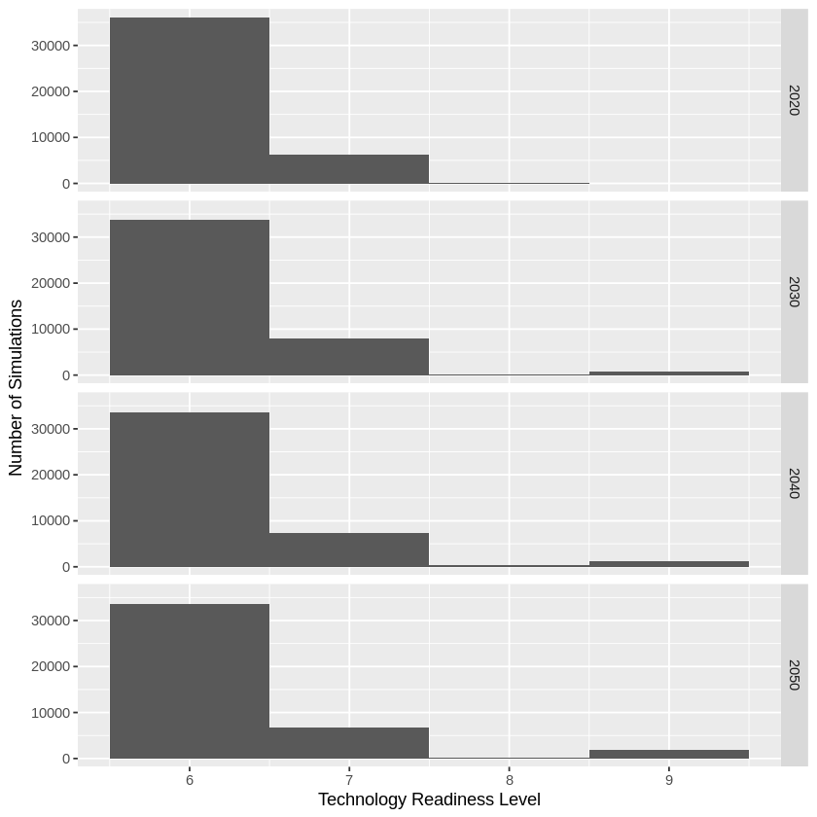

Figure 5. Histograms of technology readiness level as a function of time for the OAT experiment.

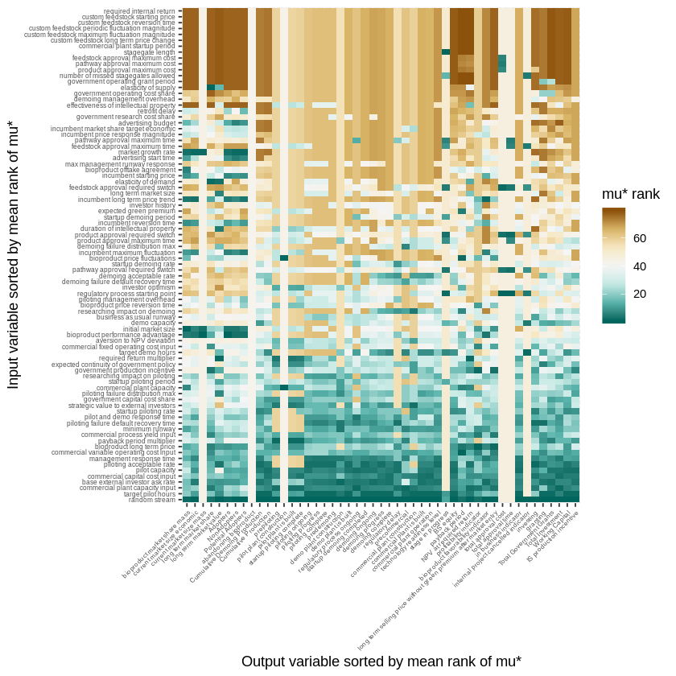

Figure 6. Value of the elementary-effects variable mu-star in 2050 for the OAT experiment. The more highly ranked mu-star is, the more influential that input variable (row) is upon the output variable (column).

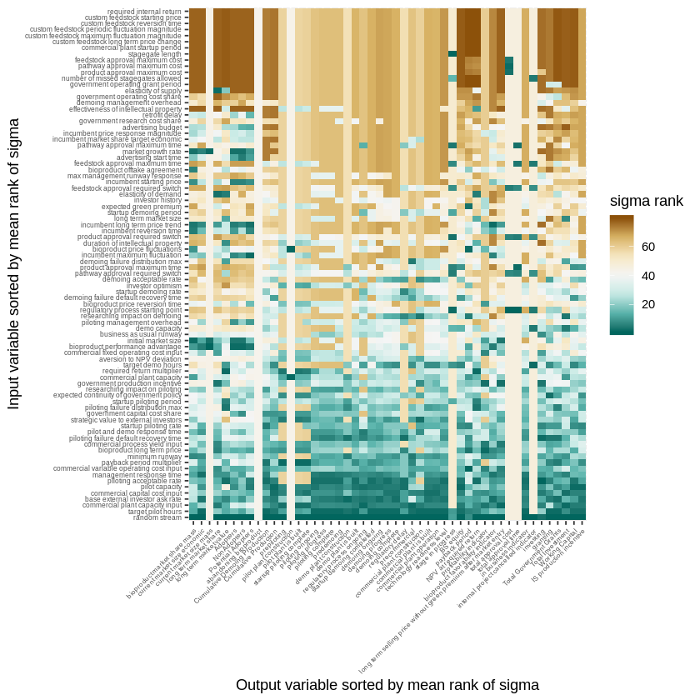

Figure 7. Value of the elementary-effects statistics sigma in 2050 for the OAT experiment. The more highly ranked sigma is, the more influential that input variable (row) is upon the output variable (column).

Table 3. Ranking of influence of input variables based on the mu-star and sigma statistics for elementary effects in the OAT experiment.

| **Input** | **mu* minimum rank** | **mu* mean rank** | **mu* median rank** | **sigma minimum rank** | **sigma mean rank** | **sigma median rank** |
| --- | --- | --- | --- | --- | --- | --- |
| random stream | 1.0 | 5.816327 | 1.0 | 1.0 | 5.816327 | 1.0 |
| target pilot hours | 2.0 | 11.948980 | 6.0 | 2.0 | 11.775510 | 6.0 |
| base external investor ask rate | 2.0 | 13.744898 | 7.0 | 2.0 | 14.755102 | 9.0 |
| commercial plant capacity input | 2.0 | 13.673469 | 7.0 | 2.0 | 14.428571 | 7.0 |
| pilot capacity | 3.0 | 14.632653 | 7.0 | 2.0 | 15.285714 | 8.0 |
| commercial capital cost input | 3.0 | 14.326531 | 8.5 | 3.0 | 15.173469 | 9.0 |
| piloting acceptable rate | 2.0 | 17.908163 | 9.0 | 1.0 | 17.826531 | 9.5 |
| management response time | 4.0 | 18.091837 | 11.0 | 3.0 | 18.897959 | 10.0 |
| commercial variable operating cost input | 1.0 | 19.183673 | 16.0 | 1.0 | 20.000000 | 17.0 |
| payback period multiplier | 2.0 | 22.020408 | 16.0 | 2.0 | 21.285714 | 15.0 |
| minimum runway | 4.5 | 22.683673 | 17.5 | 4.5 | 22.785714 | 17.0 |
| pilot and demo response time | 4.5 | 23.581633 | 19.0 | 5.0 | 24.030612 | 20.0 |
| startup piloting rate | 6.0 | 24.122449 | 19.0 | 5.0 | 24.377551 | 19.0 |
| commercial process yield input | 5.0 | 22.500000 | 20.0 | 5.0 | 22.938776 | 20.0 |
| piloting failure default recovery time | 3.0 | 23.000000 | 20.0 | 2.0 | 23.857143 | 24.0 |
| bioproduct long term price | 1.0 | 21.989796 | 20.5 | 2.0 | 22.938776 | 21.5 |
| researching impact on piloting | 10.0 | 28.571429 | 22.0 | 10.0 | 28.755102 | 23.0 |
| government capital cost share | 10.0 | 27.520408 | 23.0 | 8.0 | 27.357143 | 23.0 |
| strategic value to external investors | 3.0 | 26.132653 | 23.0 | 3.0 | 26.265306 | 20.0 |
| piloting failure distribution max | 7.0 | 27.571429 | 24.0 | 4.0 | 27.397959 | 24.0 |
| startup piloting period | 11.0 | 28.459184 | 25.5 | 6.0 | 28.020408 | 25.5 |
| commercial plant capacity | 1.5 | 28.193878 | 27.0 | 1.5 | 29.418367 | 26.0 |
| expected continuity of government policy | 6.0 | 29.071429 | 27.0 | 3.0 | 28.653061 | 28.0 |
| government production incentive | 2.0 | 28.897959 | 29.0 | 3.0 | 29.295918 | 29.0 |
| aversion to NPV deviation | 11.0 | 34.142857 | 30.5 | 12.5 | 33.285714 | 30.0 |
| required return multiplier | 2.0 | 30.326531 | 30.5 | 2.0 | 30.285714 | 30.0 |

### Sobol’ Sensitivity Analysis Experiment

The results of the SA experiment in Figure 8 show nuanced difference in the evolution of direct versus performance-advantaged product replacements in niche versus commodity markets. The direct replacements in commodity markets tend to take more time to develop to commercial readiness, but then have a higher propensity to develop. Direct replacements in niche markets are less likely to progress to the commercial stage. Performance-advantaged replacements have an intermediate propensity to develop commercially, regardless of whether they are in niche or direct markets. Note that these results show less difference between the four base cases shown in the “Base cases” results section because the SA experiment overrides many of the variables that differentiate those base cases.

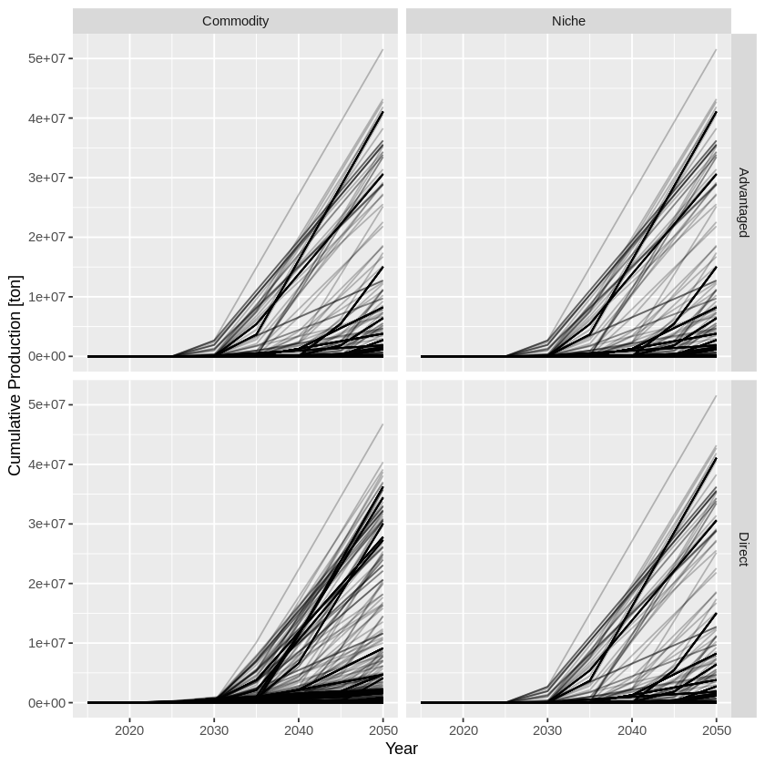

Figure 8. Cumulative production as a function of time for direct and performance-advantaged bioproducts in niche and commodity markets. Each line represents one of the SA simulations.

Figure 12 illustrate the pattern of correlation between the influence of a government capital cost grant versus a government production incentive upon whether a bioproduct successfully reaches commercial maturity and how much of the product is produced by the year 2050. The capital cost shares tend to have a stronger influence than the production incentive, but there clearly are many other factors at play in determining the bioproduct’s commercial viability.



Figure . Relationship between government capital and production incentives in the SA experiment. Each point represents the 2050 outcome of a simulation in the SA experiment. Note that capital cost shares tend to influence success more strongly than production incentives, but many other factors influence the outcome.

* Figure 9 and Figure 10 display the sensitivity statistics (Saltelli, Tarantola, Campolongo, & Ratto, 2004) computed in the SA experiment. The first-order sensitivity in Figure 9 indicates the dependence of the various outputs (rows in the figure) upon the sensitivity inputs (columns), where higher sensitivity indicates that the varying the input value, with other inputs held fixed, results in greater variation in the output variable. In contrast, the total sensitivity in Figure 10 ranks the influence of the variable in all of its combinations with other variables. Comparing the two figures indicates that the variables are rarely influential in isolation, but generally influential in combination with other variables. (This is a somewhat unusual situation compared to the typical results for variance-based sensitivity analysis of system-dynamics models, where it is often the case that a handful of variables show first-order influence and a modestly larger set show influence on total effects.) Overall, the following variables have the highest significant sensitivity indices:
* aversion to NPV deviation
* bioproduct long term price
* bioproduct performance advantage
* pilot capacity
* piloting failure distribution max
* target demo hours

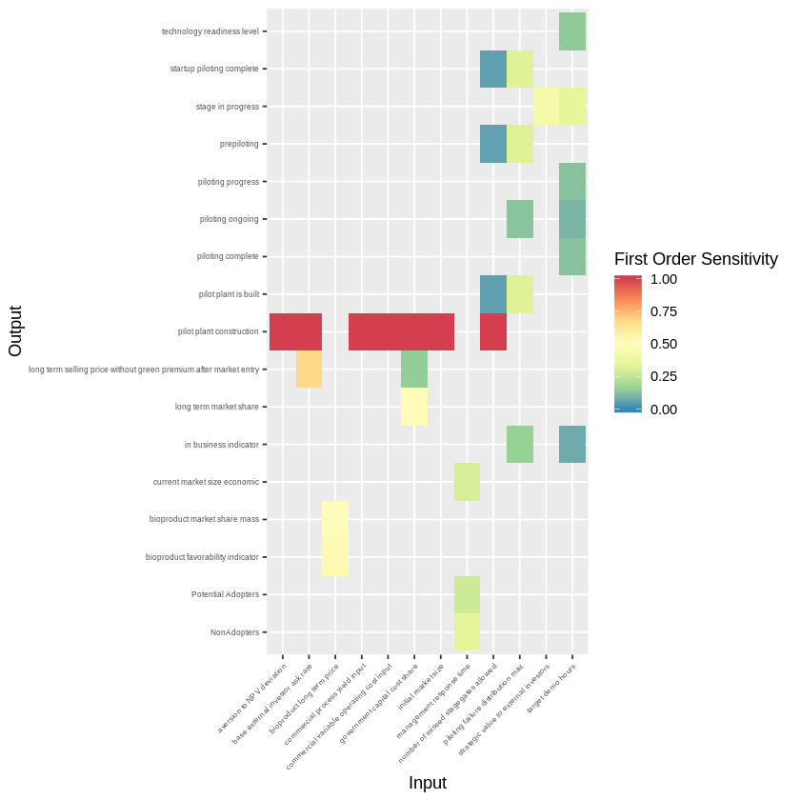

Figure . First-order variance-based sensitivity-analysis results for the SA experiment; higher values indicate more *direct* influence of the input variable upon the output variable. Only results that are at least four standard deviations above zero are shown.

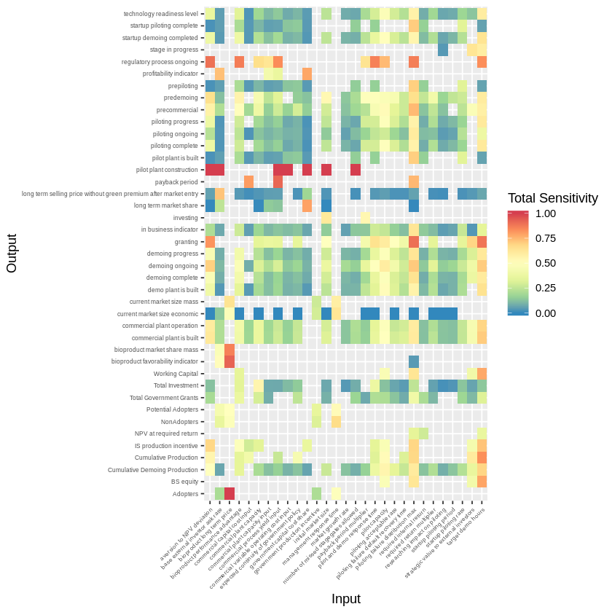

Figure . First-order variance-based sensitivity-analysis results for the SA experiment; higher values indicate more *total* influence of the input variable upon the output variable. Only results that are at least four standard deviations above zero are shown.

A complementary approach to analyzing sensitivities in simulation models uses a classification and regression tree (CART) to semi-quantitatively rank and diagnose influence upon an outcome in a format like a decision tree (21). Figure 11 illustrates the critical values of key inputs that determine whether a bioproduct technology reaches commercial readiness (i.e., a commercial plant is built). Ten variables (listed below in order of influence) most determine that commercial readiness:

1. target pilot hours
2. startup piloting rate
3. required return multiplier
4. expected continuity of government policy
5. piloting acceptable rate
6. commercial plant capacity
7. bioproduct long term price
8. researching impact on piloting
9. direct vs performance-advantaged replacement
10. niche vs commodity market



Figure 11. CART regression on the achievement of commercial readiness.

# Conclusions

The OAT and SA sensitivity experiments highlighted the primary importance of thirty-two variables in the BTD. These sensitivities analyses have highlighted that progression of a bioproduct technology beyond the Valley of Death depends jointly upon the constraints on piloting (i.e., required hours, rate, research, and acceptance), plant size, continuity of government policy, and market characteristics (i.e., type of replacement, type of market, and bioproduct price). The sensitivity analysis also confirmed the variability (stochasticity) of outcomes and hence the need to perform analyses using ensembles based on multiple random-number seeds.

# Acknowledgement

This work was authored by the National Renewable Energy Laboratory, operated by Alliance for Sustainable Energy, LLC, for the U.S. Department of Energy (DOE) under Contract No. DE-AC36-08GO28308. Funding provided by U.S. Department of Energy Office of Energy Efficiency and Renewable Energy Bioenergy Technologies Office. The views expressed in the article do not necessarily represent the views of the DOE or the U.S. Government. The U.S. Government retains and the publisher, by accepting the article for publication, acknowledges that the U.S. Government retains a nonexclusive, paid-up, irrevocable, worldwide license to publish or reproduce the published form of this work, or allow others to do so, for U.S. Government purposes.

# References

1. Biomass Research and Development Board. The Bioeconomy Initiative: Implementation Framework [Internet]. BR&D Board; 2019 Mar. Available from: biomassboard.gov/pdfs/Bioeconomy_Initiative_Implementation_Framework_FINAL.pdf

2. Biddy MJ, Davis R, Humbird D, Tao L, Dowe N, Guarnieri MT, et al. The Techno-Economic Basis for Coproduct Manufacturing To Enable Hydrocarbon Fuel Production from Lignocellulosic Biomass. ACS Sustain Chem Eng. 2016 Jun 6;4(6):3196–211.

3. Biddy MJ, Scarlata C, Kinchin C. Chemicals from Biomass: A Market Assessment of Bioproducts with Near-Term Potential [Internet]. National Renewable Energy Lab. (NREL), Golden, CO (United States); 2016 Mar [cited 2019 Sep 10]. Report No.: NREL/TP-5100-65509. Available from: https://www.osti.gov/biblio/1244312-chemicals-from-biomass-market-assessment-bioproducts-near-term-potential

4. Golden J, Handfield R, Daystar J, Mcconnell T. An Economic Impact Analysis of the U.S. Biobased Products Industry: A Report to the Congress of the United States of America. Ind Biotechnol. 2015 Aug 15;11:201–9.

5. Hanes R, Bush B, Sittler L, Newes E, Foretich A, Jenkin T. Bioproduct Transition Dynamics Technical Report. National Renewable Energy Laboratory (NREL); 2020 Sep. Report No.: NREL/TP-XXXXX. In preparation.

6. Hudson J, Khazragui HF. Into the valley of death: research to innovation. Drug Discov Today. 2013 Jul 1;18(13):610–3.

7. Markham SK, Ward SJ, Aiman‐Smith L, Kingon AI. The Valley of Death as Context for Role Theory in Product Innovation. J Prod Innov Manag. 2010;27(3):402–17.

8. Ford GS, Koutsky T, Spiwak LJ. A Valley of Death in the Innovation Sequence: An Economic Investigation [Internet]. Rochester, NY: Social Science Research Network; 2007 Sep [cited 2019 Jul 19]. Report No.: ID 1093006. Available from: https://papers.ssrn.com/abstract=1093006

9. Rorke M. From Invention to Innovation [Internet]. National Renewable Energy Laboratory, Golden, CO (US); 2000 Jul [cited 2019 Jul 31]. Report No.: NREL/BR-330-26620; DOE/GO-10099-810. Available from: https://www.osti.gov/biblio/757073-from-invention-innovation

10. Adams DJ. The Valley of Death in anticancer drug development: a reassessment. Trends Pharmacol Sci. 2012 Apr 1;33(4):173–80.

11. Karneyeva Y, Wüstenhagen R. Solar feed-in tariffs in a post-grid parity world: The role of risk, investor diversity and business models. Energy Policy. 2017 Jul 1;106:445–56.

12. Etzkowitz H. The new visible hand: An assisted linear model of science and innovation policy. Sci Public Policy. 2006 Jun 1;33(5):310–20.

13. Meadows DL. Tools for Understanding the Limits to Growth: Comparing a Simulation and a Game. Simul Gaming. 2001 Dec 1;32(4):522–36.

14. Martin E, MacDonald R. A system dynamics-based evaluation of the New York State HIV testing law. N Y State AIDS Advis Counc N Y City NY—cancelled Due Hurric Sandy. 2012;

15. Forrester J. Market Growth as Influenced by Capital Investment. Massachusetts Institute of Technology; 1972.

16. Sterman J. Business Dynamics: Systems Thinking and Modeling for a Complex World. McGraw-Hill Higher Education; 2000. 108–396 p.

17. Daniel C. One-at-a-Time Plans. J Am Stat Assoc. 1973 Jun 1;68(342):353–60.

18. Hedayat AS, Sloane NJA, Stufken J. Orthogonal arrays: theory and applications. Springer Science & Business Media; 2012.

19. Box GE, Hunter JS, Hunter WG. Statistics for experimenters. In: Wiley Series in Probability and Statistics. 2nd ed. Wiley Hoboken, NJ, USA; 2005.

20. Sloane N. A Library of Orthogonal Arrays [Internet]. [cited 2019 Sep 25]. Available from: http://neilsloane.com/oadir/

21. Brieman L, Friedman JH, Olshen RA, Stone CJ. Classification and Regression Trees. Wadsworth. Monterey, CA: Wadsworth & Brooks/Cole Advanced Books & Software; 1984.