ComStock Change
  - v11 Ground Heat Transfer Correction
Implementer: Matthew Dahlhausen
Change Document Author: Matthew Dahlhausen
Reviewer: Andrew Parker

Description of Change

Summary
This updates the floor constructions in ComStock to use FC factor constructions. FC factor constructions assumes the dominant means of ground heat transfer occurs at the slab perimeter, with the ground temperature being a three-month lag of the monthly average outdoor drybulb temperature. Prior to this, the model was assuming a default 18°C (64.4°F) ground contact temperature across the entire uninsulated slab surface area.

Existing Methodology

Ground contact floor construction type (existing)
The existing ground contact floor is an ext_slab construction which consists of a 6” thick slab of concrete and is identical for all buildings.
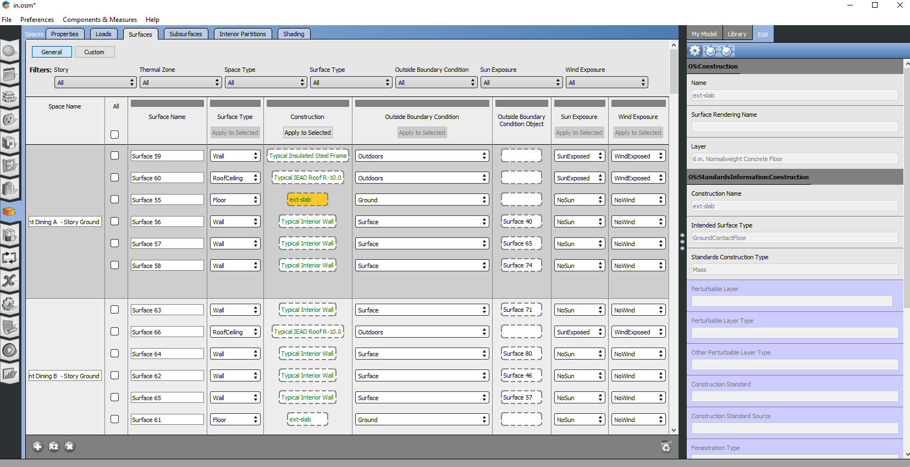
This type of ground construction requires an input for ground surface temperatures. While the model includes ground temperatures for FC factor constructions, representing the effective ground temperature at the slab perimeter, it does not have surface temperatures for the slab. The result is that the model uses a default 18°C (64.4°F) ground temperature per an EnergyPlus default:
** Warning ** GetHTSurfaceData: Surfaces with interface to Ground found but no "Ground Temperatures" were input.
** ~~~ ** Found first in surface=SURFACE 163
** ~~~ ** Defaults, constant throughout the year of (18.0) will be used.

The result is that heat transfer is effectively decoupled from the climate zone. The slab acts as a constant 18°C (64.4°F) which has considerable impact on heating and cooling loads given that typical zone air setpoint temperatures are higher. Slab constructions are permanent for the life of the building.

Heating and Cooling Load Components
The result of the low, constant slab temperature is that the ground contributes nearly as much as roof conduction to heating loads and offsets a considerable portion of cooling loads. We should expect ground to have minimal impact on loads given the size and perimeter insulation levels typical of most commercial buildings.
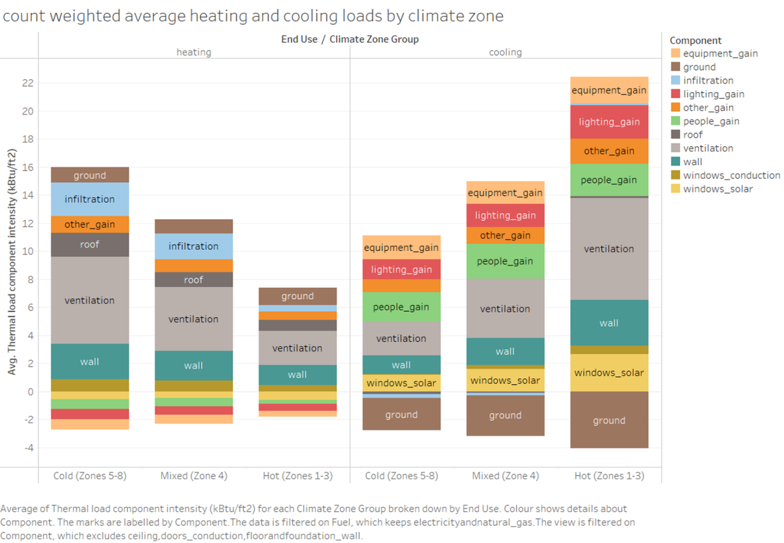

New Methodology

Ground contact floor construction type (new)
The new methodology is to use FC factor constructions for ground contact surfaces instead of using the default exterior slab composed 6” of concrete. There are two components to this update. The first is to update the openstudio-standards construction properties sheet to include FC factor constructions across all climate zones and combination types of GroundContactFloor constructions, detailed in this openstudio-standards pull request: https://github.com/NREL/openstudio-standards/pull/1259. Note that the OS prototypes use FC factor constructions, so this is simply extending this data to all GroundContactFloor construction types. A component of this is changing the standards construction type from “Mass” to “Unheated” to match the definitions in the 90.1 prescriptive envelope tables, with older vintages following the same values as 90.1-2004.
The next step is to call a method to set the FC factor constructions prior to adding other constructions in the model. If the method that adds the rest of the construction set detects and FC factor construction for ground contact floors, it will skip over applying the default ground construction. The FC factor constructions are surface – specific constructions with calculated area and exposed perimeter values, calculated using methods from openstudio-standards. The F-factors are from the updated standards lookup table. This change is implemented in the os_lib_model_generation.rb resource file of the create_typical_building_from_model measure, detailed in the pull request: https://github.com/NREL/comstock-internal/pull/105.
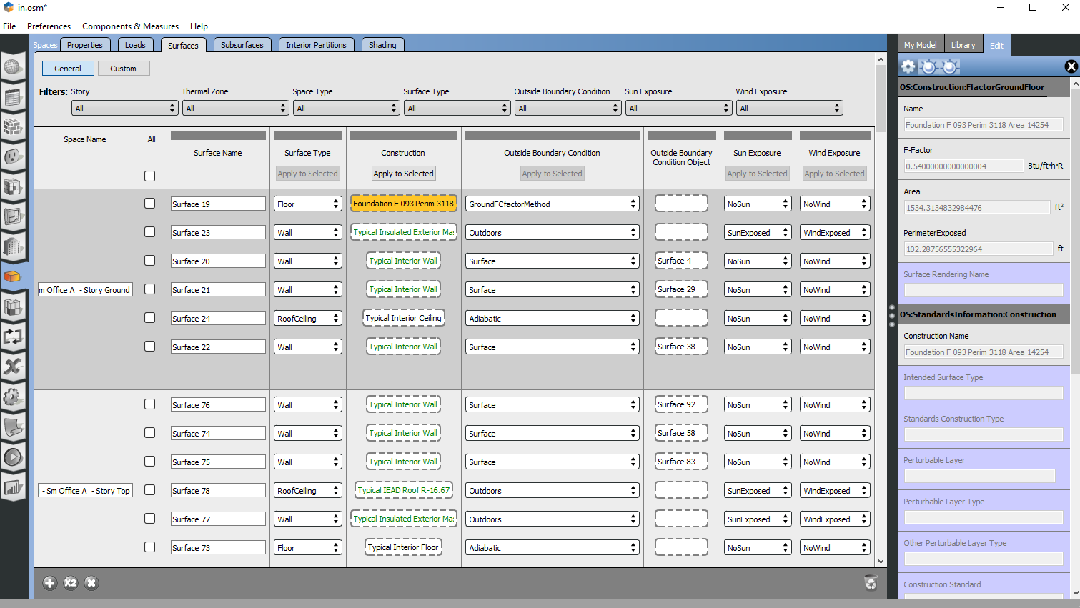

Impact of Change

Individual Model Input Change
The FC factor construction values depend only on climate zone and vintage. This table does some spot checks of models to make sure the F factors are correct. Note that warehouse buildings are currently assuming the “semiheated” category for the F-factor lookup, regardless of the HVAC systems type. There should be some warehouses that are the normal “nonresidential” and some “semiheated” with a co-dependency of HVAC system type. This would have broader implications on how envelope type is modeled and is outside the scope of this change.
Climate Zone | Vintage | Expected Value | Actual Value
1A | DOE Ref Pre-1980 | 0.73 | 0.73
4A | 90.1-2004 | 0.73 | 0.73
3C | DEER Pre-1975 | 0.73 | 0.73
5B | 90.1-2004 | 0.73 | 0.73
8 | DOE Ref Pre-1980 | 0.54 | 0.54
6A | DOE Ref 1980-2004 | 0.73 | 0.73
4B | 90.1-2013 | 0.73 (semiheated)* | 0.73 (semiheated)*
6A | 90.1-2010 | 0.54 | 0.54

Stock-Level Input Change
The model inputs change from having a U-value for ground contact surface constructions to using FC factors, so there is not a direct comparison available. Ground FC factors values can be added to the comstock reporting measure in the future.

Stock-Level Output Change
The primary comparison is to look at the influence of the ground components (foundation wall, floor, and ground) on the thermal load component intensity for heating and cooling. Comparing this to the baseline figure shows a much lower contributions for heating (0.13 to 0.35 kbtu/sf compared to ~1 kbtu sf) and cooling (-0.43 to -0.53 kbtu/sf instead of -2 to -4 kbtu/sf). These values are much more in line with what expect is the relative importance of ground heat transfer.
