ComStock Change
V12 – Wall Construction Type Fix
Implementer: Andrew Parker
Change Document Author: Andrew Parker
Reviewer: Matthew Dahlhausen

Description of Change

Summary
This update improves the diversity of wall constructions represented in ComStock. The goal of this change is to better enable us to identify applicable envelope measures and to better represent the building stock.

Existing Methodology

Wall construction type (existing)
The existing methodology assumes that the exterior wall construction type for each building type is fixed. These assumptions were taken from the DOE Reference Buildings and the DOE Prototype Models, and the details are shown in the table below.
 | DOE Ref and 90.1 |  | DEER (CA only)
Building Type | Construction Type | Building Category for Exterior Walls | Construction Type | Building Category for Exterior Walls
FullServiceRestaurant | SteelFramed | Nonresidential | WoodFramed | Nonresidential
Hospital | Mass | Nonresidential | Mass | Nonresidential
LargeHotel | Mass | Nonresidential | Mass | Nonresidential
LargeOffice | Mass | Nonresidential | SteelFramed | Nonresidential
MediumOffice | Mass | Nonresidential | SteelFramed | Nonresidential
Outpatient | SteelFramed | Nonresidential | SteelFramed | Nonresidential
PrimarySchool | SteelFramed | Nonresidential | WoodFramed | Nonresidential
QuickServiceRestaurant | WoodFramed | Nonresidential | Mass | Nonresidential
Retail | Mass | Nonresidential | Mass | Nonresidential
SecondarySchool | SteelFramed | Nonresidential | Mass | Nonresidential
SmallHotel | SteelFramed | Nonresidential | WoodFramed | HighriseResidential
SmallOffice | Mass | Nonresidential | WoodFramed | Nonresidential
StripMall | SteelFramed | Nonresidential | Mass | Nonresidential
Warehouse | Metal Building | Semiheated | Mass | Nonresidential

Per the documentation from those sources, these assumptions were made based on an analysis of construction types from CBECS 2003 data. The limitation of this methodology is that envelope retrofits that are only applicable to a certain existing wall type (for example, only Mass walls) will have a sharp and unrealistic discontinuity between different building types. This discontinuity does not represent the diversity of construction types found in buildings of the same type in reality.

Wall Thermal Performance (related - not changing)
No data sources were found which contained thermal performance (U-Value/R-Value) of walls in the commercial building stock, likely because surveys would need to either find building plans, which can be difficult or impossible for older buildings, or disassemble part of the structure to look inside the walls, which building owners are unlikely to allow. To account for the lack of data, we chose to estimate wall thermal performance based on an estimate of the energy code followed when the wall was constructed. Refer to the ComStock documentation to learn how the energy code was determined. The thermal performance of walls for each energy code varies based on climate zone and construction type, as shown in the figure below.
Target from Standards |  | Whole-wall R-value by Climate Zone (ft^2*F*hr/Btu) – includes interior and exterior air films
Wall Type | Energy Code | 1A | 2A | 2B | 3A | 3B | 4A | 4B | 4C | 5A | 5B | 6A | 6B | 7 | 8
Mass | Pre-1980 | 4.3 | 4.3 | 4.3 | 4.4 | 4.3 | 5.6 | 5.4 | 5.7 | 6.4 | 6.2 | 6.9 | 6.9 | 7.4 | 8.0
 | 1980-2004 | 1.0 | 2.9 | 2.4 | 3.4 | 3.4 | 8.3 | 5.3 | 10.0 | 10.0 | 7.1 | 14.1 | 12.7 | 16.4 | 21.3
 | 90.1-2004 | 1.7 | 1.7 | 1.7 | 6.6 | 6.6 | 6.6 | 6.6 | 6.6 | 8.1 | 8.1 | 9.6 | 9.6 | 11.1 | 12.5
 | 90.1-2007 | 1.7 | 6.6 | 6.6 | 8.1 | 8.1 | 9.6 | 9.6 | 9.6 | 11.1 | 11.1 | 12.5 | 12.5 | 14.1 | 14.1
 | 90.1-2010 | 1.7 | 6.6 | 6.6 | 8.1 | 8.1 | 9.6 | 9.6 | 9.6 | 11.1 | 11.1 | 12.5 | 12.5 | 14.1 | 14.1
 | 90.1-2013 | 1.7 | 6.6 | 6.6 | 8.1 | 8.1 | 9.6 | 9.6 | 9.6 | 11.1 | 11.1 | 12.5 | 12.5 | 14.1 | 20.8
Metal Building* | Pre-1980 | 4.3 | 4.3 | 4.3 | 4.4 | 4.3 | 5.6 | 5.4 | 5.7 | 6.4 | 6.2 | 6.9 | 6.9 | 7.4 | 8.0
 | 1980-2004 | 1.0 | 6.7 | 4.2 | 7.7 | 6.3 | 11.2 | 10.0 | 10.9 | 12.2 | 12.2 | 15.4 | 13.9 | 17.2 | 22.2
 | 90.1-2004 | 8.8 | 8.8 | 8.8 | 8.8 | 8.8 | 8.8 | 8.8 | 8.8 | 8.8 | 8.8 | 8.8 | 8.8 | 17.5 | 17.5
 | 90.1-2007 | 8.8 | 8.8 | 8.8 | 8.8 | 8.8 | 8.8 | 8.8 | 8.8 | 8.8 | 8.8 | 8.8 | 8.8 | 17.5 | 17.5
 | 90.1-2010 | 10.8 | 10.8 | 10.8 | 11.9 | 11.9 | 11.9 | 11.9 | 11.9 | 14.5 | 14.5 | 14.5 | 14.5 | 17.5 | 17.5
 | 90.1-2013 | 10.6 | 10.6 | 10.6 | 10.6 | 10.6 | 16.7 | 16.7 | 16.7 | 20.0 | 20.0 | 20.0 | 20.0 | 22.7 | 25.6
SteelFramed | Pre-1980 | 4.3 | 4.3 | 4.3 | 4.4 | 4.3 | 5.6 | 5.4 | 5.7 | 6.4 | 6.2 | 6.9 | 6.9 | 7.4 | 8.0
 | 1980-2004 | 1.0 | 6.7 | 4.2 | 7.7 | 6.3 | 11.2 | 10.0 | 10.9 | 12.2 | 12.2 | 15.4 | 13.9 | 17.2 | 22.2
 | 90.1-2004 | 8.1 | 8.1 | 8.1 | 8.1 | 8.1 | 8.1 | 8.1 | 8.1 | 11.9 | 11.9 | 11.9 | 11.9 | 15.6 | 15.6
 | 90.1-2007 | 8.1 | 8.1 | 8.1 | 11.9 | 11.9 | 15.6 | 15.6 | 15.6 | 15.6 | 15.6 | 15.6 | 15.6 | 15.6 | 15.6
 | 90.1-2010 | 8.1 | 8.1 | 8.1 | 11.9 | 11.9 | 15.6 | 15.6 | 15.6 | 15.6 | 15.6 | 15.6 | 15.6 | 15.6 | 15.6
 | 90.1-2013 | 8.1 | 11.9 | 11.9 | 13.0 | 13.0 | 15.6 | 15.6 | 15.6 | 18.2 | 18.2 | 20.4 | 20.4 | 20.4 | 27.0
WoodFramed | Pre-1980 | 4.3 | 4.3 | 4.3 | 4.4 | 4.3 | 5.6 | 5.4 | 5.7 | 6.4 | 6.2 | 6.9 | 6.9 | 7.4 | 8.0
 | 1980-2004 | 1.0 | 6.7 | 4.2 | 7.7 | 6.3 | 11.2 | 10.0 | 10.9 | 12.2 | 12.2 | 15.4 | 13.9 | 17.2 | 22.2
 | 90.1-2004 | 11.2 | 11.2 | 11.2 | 11.2 | 11.2 | 11.2 | 11.2 | 11.2 | 11.2 | 11.2 | 11.2 | 11.2 | 11.2 | 19.6
 | 90.1-2007 | 11.2 | 11.2 | 11.2 | 11.2 | 11.2 | 11.2 | 11.2 | 11.2 | 15.6 | 15.6 | 19.6 | 19.6 | 19.6 | 27.8
 | 90.1-2010 | 11.2 | 11.2 | 11.2 | 11.2 | 11.2 | 11.2 | 11.2 | 11.2 | 15.6 | 15.6 | 19.6 | 19.6 | 19.6 | 27.8
 | 90.1-2013 | 11.2 | 11.2 | 11.2 | 11.2 | 11.2 | 15.6 | 15.6 | 15.6 | 19.6 | 19.6 | 19.6 | 19.6 | 19.6 | 31.3

Wall System Turnover Rate (related - not changing)
As described in the ComStock documentation, some building systems, including exterior walls, are assumed to be replaced over the lifespan of the building. Practically, for exterior walls, the structural elements of the wall would be maintained, while the cladding, insulation, sheathing, etc. would be replaced. As noted in the ComStock documentation, the EUL for exterior walls was assumed to be 200 years, which means that most buildings are modeled with the walls they were built with. Once the wall construction type probabilities and performance characteristics are carried through the sampling process and simulations are created, the distribution of construction types and energy code levels can be reviewed. As shown in the figure below, because the majority of the building stock is older, and because of the low rate of replacement of wall systems, most of the building floor area is assumed to follow the oldest energy codes. Because of the high prevalence, the thermal performance assumptions for these older windows have a disproportionately higher impact on the overall ComStock heating and cooling demand than the newer vintages do. Unfortunately, the ComStock DOE Ref Pre-1980 assumptions are from a study of only offices (https://www.osti.gov/biblio/6795134) but are used for all building types.

New Methodology

Wall construction type (changing)
First, we selected the general types of wall construction methods to represent. We chose the four general wall types commonly using in commercial building energy codes because these cover the most common wall construction types and can be linked to nominal thermal characteristics. The definitions of these types from 90.1-2010 are as follows, with the corresponding ComStock enumerations shown in parentheses:
- mass wall (Mass): a wall with an HC exceeding (1) 7 Btu/ft2·°F or (2) 5 Btu/ft2·°F, provided that the wall has a material unit weight not greater than 120 lb/ft3.
- metal building wall (Metal Building): a wall whose structure consists of metal spanning members supported by steel structural members (i.e., does not include spandrel glass or metal panels in curtain wall systems).
- steel-framed wall (SteelFramed): a wall with a cavity (insulated or otherwise) whose exterior surfaces are separated by steel framing members (i.e., typical steel stud walls and curtain wall systems).
- wood-framed and other walls (WoodFramed): all other wall types, including wood stud walls.
To determine the prevalence of each wall construction type, we queried a database (LightBox) containing among other building type, number of stories, location, and wall construction. The database did not use the same categories selected for ComStock, so we created a mapping between the database entries and the wall types listed above, which is described in the table below. Some construction categories in the database were excluded from the mapping, either because the meaning was ambiguous or because they represented an insignificant fraction of the entries in the database. The excluded constructions represent only 5% of the total samples, with 4.5% labeled “OTHER,” which there was no clear way to map.
LightBox Construction | Grand Total | ComStock Construction | Note
FRAME | 24.96% | SteelFramed | Believe that this mostly represents steel stud construction based on survey of samples of this type
WOOD | 23.93% | WoodFramed | Clearly meets wood-framed wall definition
MASONRY | 20.78% | Mass | Could be CMU or brick veneer, both meet definition of mass wall
STEEL | 8.48% | SteelFramed | Believe that this mostly indicates curtain wall with steel framing for tall buildings, and steel stud for shorter buildings
BRICK | 6.01% | Mass | Could either be structural brick or brick veneer, both meet definition of mass wall
OTHER | 4.49% | N/A | Meaning unclear
CONCRETE BLOCK | 4.48% | Mass | Clearly meets mass wall definition
CONCRETE | 3.34% | Mass | Clearly meets mass wall definition
TILT-UP (PRE-CAST CONCRETE) | 1.59% | Mass | Clearly meets mass wall definition
METAL | 1.26% | Metal
STONE | 0.22% | N/A | Inconsistent, but often used to describe buildings with a small percentage of decorative stone veneer around the base of the wall. Insignificant fraction of stock.
MIXED | 0.21% | N/A | Meaning unclear from survey, and insignificant fraction
LOG | 0.09% | N/A | Insignificant fraction
LIGHT | 0.07% | N/A | Insignificant fraction
ADOBE | 0.04% | N/A | Insignificant fraction
MANUFACTURED | 0.03% | N/A | Meaning unclear from survey, and insignificant fraction
HEAVY | 0.00% | N/A | Meaning unclear from survey, and insignificant fraction
DOME | 0.00% | N/A | Meaning unclear from survey, and insignificant fraction

Upon reviewing the data, there were two instances that we deemed likely misclassifications. The first was buildings higher than 5 stories with WoodFramed walls. Based on our experience, it is was not historically possible to use WoodFramed construction for buildings over 5 stories, and even today this practice is uncommon. Buildings with this combination were reassigned to Mass walls, with the assumption that people were observing large wood internal structural members in old buildings and classifying them as WoodFramed. The second was buildings higher than 2 stories with MetalBuilding walls. Based on our experience, this construction technique is commonly reserved for 1-2 story buildings only. Buildings with this combination were reassigned to SteelFramed, with the assumption that this would be the most likely alternative classification if a person observed some type of steel structural elements.
After mapping each entry in the database to one of the ComStock construction types, we analyzed the data to determine what other building characteristics available in the database were correlated with construction type. Older buildings were slightly more likely to use mass constructions, but the change over time was minor. Construction type varied significantly as a function of number of stories. Shorter buildings were much more likely to be wood-framed, while taller buildings were more likely to be mass, and very tall buildings were likely to be steel-framed (steel studs or curtain wall). Based on a spot-checking of the database, the building type classification was found to be less reliable than other building characteristics. Although there was some correlation between building type and wall construction, there was also a correlation between building type and number of stories. Because of the joint correlation, number of stories was selected instead of building type. There was a clear correlation between climate zone and construction type, most notably a much lower incidence of mass walls in cold climate zones. There was some correlation between construction type and building floor area. However, there was also a correlation between the number of stories and the building area. Because the construction type is physically limited by the height of the buildings, it was more logical to use number of stories as driving characteristic of construction type. The conclusion of this analysis was to use number of stories and climate zone as drivers of wall construction type. Processing the data to calculate probabilities for each combination of number of stories and climate zone resulted in the input distribution used in ComStock, which is shown summarized below.
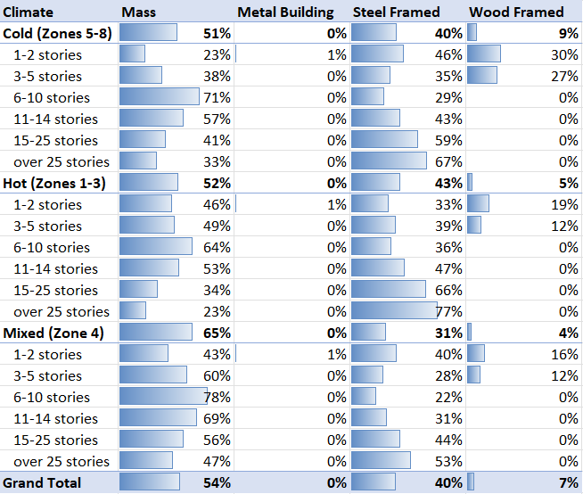
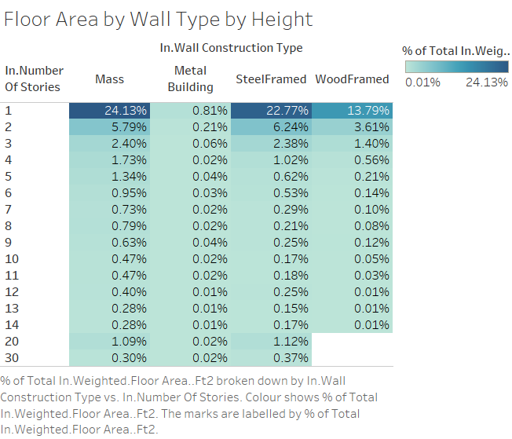

Impact of Change

Individual Model Input Change
Model | Default Construction Set Exterior Wall Construction
 | Before | After
11 – FullServiceRestaurant – Mass | Typical Insulated Exterior Mass Wall R-3.45 | Typical Insulated Exterior Mass Wall R-3.45
3 – Office – WoodFramed | Typical Insulated Exterior Mass Wall R-3.45 | Typical Insulated Exterior WoodFramed Wall R-3.45
36 – Warehouse – Metal Building | Typical Insulated Metal Building Wall R-4.44 | Typical Insulated Metal Building Wall R-4.44
49 – Warehouse- SteelFramed | Typical Insulated Metal Building Wall R-4.44 | Typical Insulated Steel Framed Exterior Wall R-4.44
50 – Warehouse – WoodFramed | Typical Insulated Metal Building Wall R-4.44 | Typical Insulated Wood Framed Exterior Wall R-4.44
60 – Warehouse - Mass | Typical Insulated Metal Building Wall R-7.69 | Typical Insulated Exterior Mass Wall R-3.45

Stock-Level Input Change
As the figure below shows, the main difference was a significant decrease in the amount of floor area in buildings using the Metal Building wall construction type. Most of this was made up by a corresponding increase in the floor area of buildings using the Mass wall construction type. This is because the existing methodology assumes that all Warehouses use Metal Building walls, which is not supported by the data used to create the new distribution.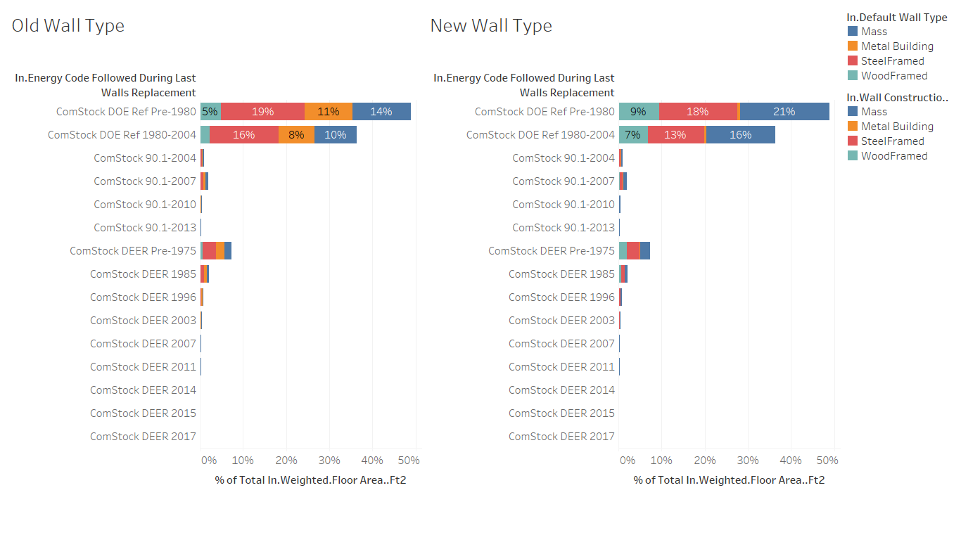
The figure below shows the wall type breakdown by building type before and after the change. As described in the existing methodology section and shown in the figure below, previously, a single construction type was used for each building type, but a different assumption was made for CA and non-CA buildings. The new breakdown shows that the biggest change was in warehouses, which switched from primarily Metal Building to primarily Mass and SteelFramed.
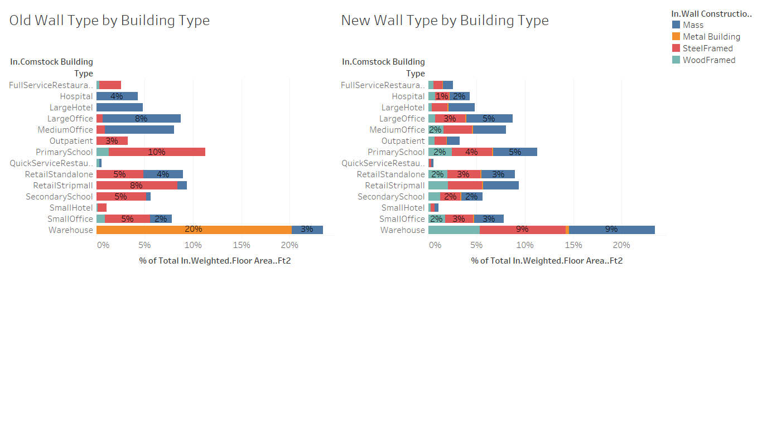
After applying the new distribution of wall construction types and applying the relevant thermal properties based on the energy code in force during the last wall replacement, the count-weighted wall average R-value changed slightly. As shown in the table below, the overall change was minor for each building type, with some building types increasing slightly and others decreasing slightly.
Count weighted Average R-value
(ft^2*F*hr/Btu)
Building Type | Old | New | Change
FullServiceRestaurant | 7.5 | 6.8 | -10%
Hospital | 6.4 | 7.3 | 13%
LargeHotel | 6.5 | 7.2 | 11%
LargeOffice | 6.4 | 6.7 | 5%
MediumOffice | 6.7 | 7.2 | 8%
Outpatient | 7.7 | 7.0 | -9%
PrimarySchool | 8.7 | 7.8 | -11%
QuickServiceRestaurant | 8.3 | 7.7 | -8%
RetailStandalone | 6.0 | 6.8 | 14%
RetailStripmall | 6.5 | 6.5 | -1%
SecondarySchool | 8.4 | 7.9 | -6%
SmallHotel | 8.0 | 8.1 | 1%
SmallOffice | 6.4 | 6.6 | 2%
Warehouse | 6.9 | 6.9 | 0%

As the figure below shows, a large majority (90% by floor area) of the building stock uses walls that follow the thermal performance characteristics of DOE Ref Pre-1980 (47%), DOE Ref 1980-2004 (36%), and DEER Pre-1975 (7%). In the figure, the R-value (ft^2*F*hr/Btu) is the count-weighted average for that portion of the stock. Based on these R-values, most of the stock is assumed to have either no or very little insulation.
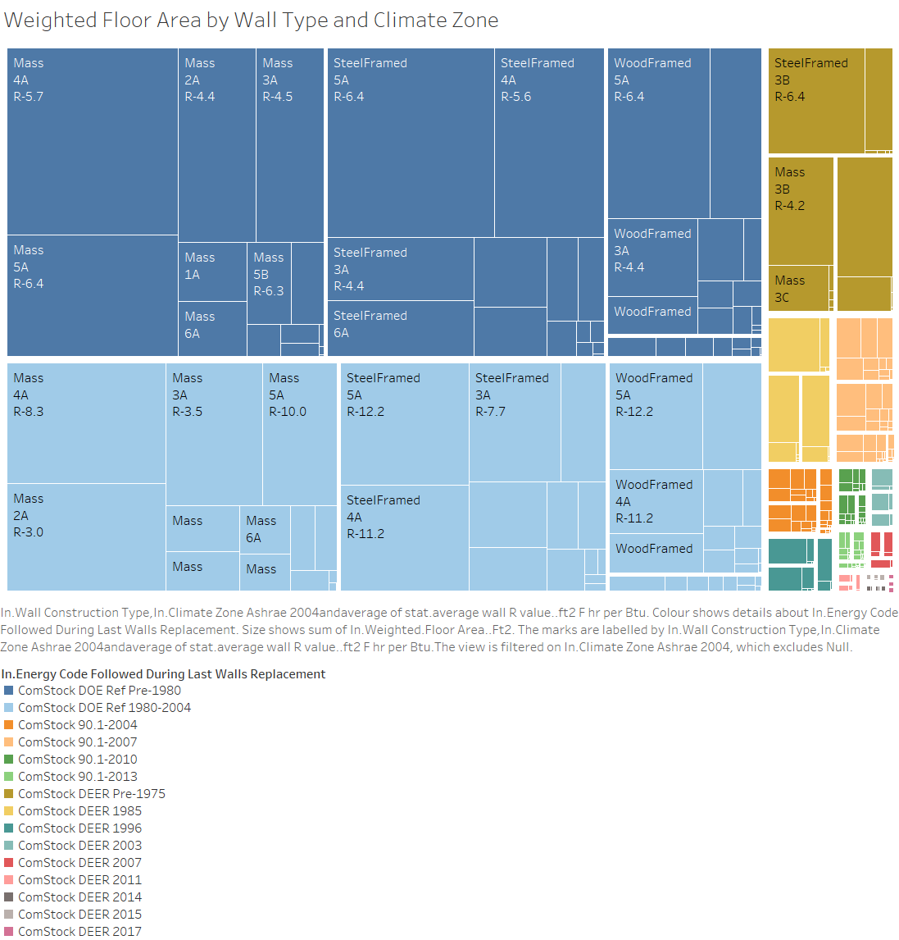

Stock-Level Output Change
As seen in the figure below, the overall impact of this change on heating and cooling energy consumption is minor. This is consistent with the minor change in R-value overall and the fact that some building types increased while others decreased.
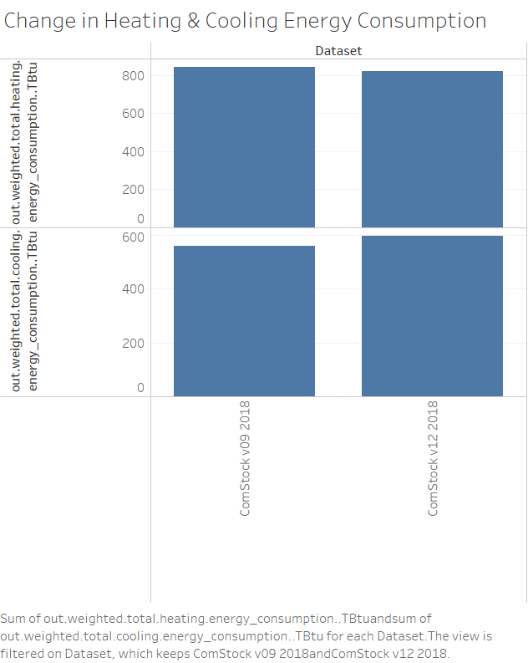
The breakdown below shows the change in heating and cooling by building type. The magnitude of the change for each building type is low, on the same order as the change in the R-value. The one exception is SmallHotel, which shows a much more drastic change. This is because the SmallHotel models in the old run (V09) had a bug roof insulation, which was fixed before the new run (V11). Thus the majority of the change in heating and cooling energy consumption in SmallHotel is the result of a change in roof insulation, not wall insulation.
