ComStock Change
  - v13 – Replacing Baseline Window Constructions
Implementer: Marley Praprost
Change Document Author: Marley Praprost
Reviewer: Andrew Parker

Description of Change

Summary
This update improves the diversity of window constructions represented in ComStock. In addition, it associates a window technology with the baseline window constructions, which better enables us to identify applicable envelope measures and to better represent the building stock.

Existing Methodology

Window construction type (existing)
The existing methodology assumes that the window construction type for each combination of vintage and climate zone is fixed. There is little diversity in window properties within climate zones and building types. For example, every Pre-1980 Large Office building in Climate 5A has the same window construction. We know this is not representative of the actual commercial window stock, but until recently we did not have enough data to support changing our baseline assumptions.
In the DOE Ref Pre-1980 and DOE Ref 1980-2004 vintages, the window construction is modeled as a Simple Glazing object in OpenStudio. This is a simplified glazing object that represents the entire glazing system, including framing, rather than modeling individual layers separately. The associated inputs for this object are U-Factor, Solar Heat Gain Coefficient, and Visible Transmittance. For 90.1-2004 and newer vintages, window constructions are modeled as a Glazing object in OpenStudio. This object models each layer separately and requires many additional inputs.
The naming convention for the existing Simple Glazing and standard Glazing objects are “U ___ SHGC ____ Simple Glazing Window” and “U ____ SHGC ____ Dbl Ref-D Clr 6mm/6mm Air”, respectively. The blanks indicate where the U-Factor and SHGC values would be included in the nomenclature. This naming convention, especially in pre-2004 buildings with Simple Glazing Objects (which is a large portion of the stock) is somewhat ambiguous and does not give enough information to the user about what type of window is installed (single vs. double pane, low-E coating, etc.). Therefore, it is difficult to determine applicability for window upgrade measures.

Window Thermal Performance (existing)
Thermal performance (U-Value) of windows is derived from the ASHRAE 90.1 fenestration requirements by climate zone, and currently assumed metal framed windows for all building types. An example is shown below.
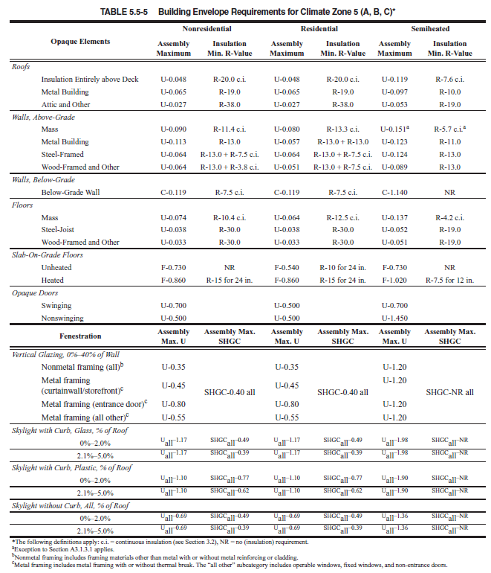

Window System Turnover Rate (existing)
As described in the ComStock documentation, some building systems, including exterior windows, are assumed to be replaced over the lifespan of the building. The Effective Useful Life for windows was assumed to be 70 years, which means that buildings built after the mid-1950s are modeled with the windows they were built with. This may be surprising, but data supports that commercial window replacements are uncommon. The EUL assumptions were based on a reliability analysis of windows from the 2014 Commercial Building Stock Assessment from the Pacific Northwest. DEER uses an EUL of 20 years for window replacement as the DEER EULs are capped at 20 years per CPUC policy.
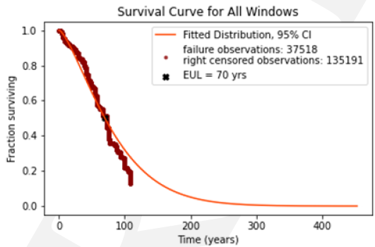
Because the majority of the building stock is older, and because of the low rate of replacement of window systems, much of the building stock is assumed to follow the oldest energy codes. When a building reaches 70 years old, the windows are replaced according to the ASHRAE 90.1 standard followed by the state in which the building is located.

New Methodology

Window construction type (new)
As described earlier, the current modeling approach has little to no diversity within building types or climate zones; the only diversity is based on the age of the windows, and therefore is not representative of the commercial window stock. To address this issue, data from the NFRC Commercial Fenestration Market Study was used to develop the new modeling approach for windows in ComStock. This study, conducted by Guidehouse in collaboration with NFRC, intended to characterize the national commercial window stock through data collection and analysis. Six primary data sources representing all regions of the United States were used in the study – a 2020 Guidehouse survey, NEEA CBSA, DOE Code Study, CAEUS, CBECS, and RECS. A variety of window properties were collected, including window-to-wall ratio, number of panes, frame material, glazing type, low-E coating, gas fill, SHGC, U-factor, and many others. In total, the database contained approximately 16,000 samples, each with an appropriate weighting factor based on coverage, completeness, and fidelity of each data source. The WWR data was already incorporated into the ComStock baseline during the EULP project. Some of the other key window properties were then used to create the new baseline window constructions and distributions discussed in this change document. A summary of the data sources and their associated information provided is show in the table below.
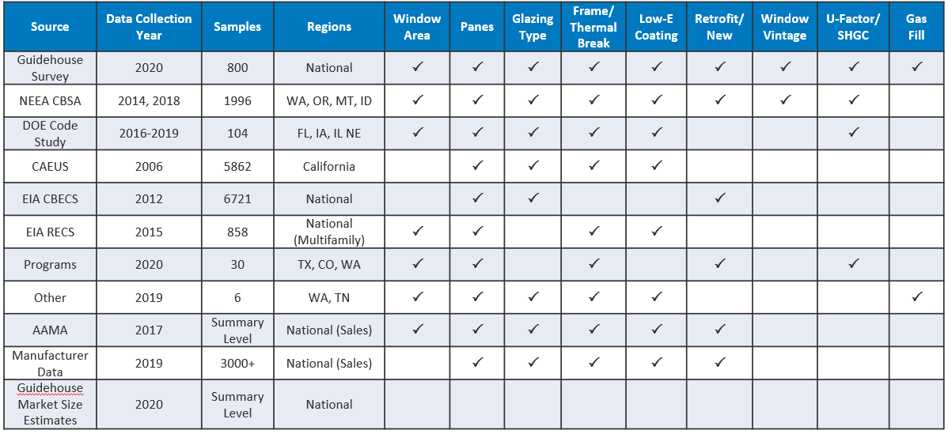Four window properties were used to create the baseline window configurations – number of panes, glazing type, frame material, and low-E coating. The selection of these four parameters was based on which characteristics have the most impact on window performance, which have the most data filled in from the various data sources, and which inputs we trust from the average building owner or survey recipient. The options for each property are shown in the image below.
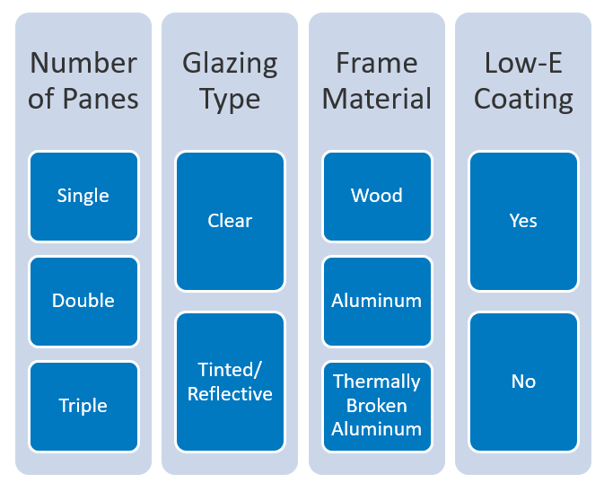
If every combination of these four properties was modeled, it would result in 36 different window configurations, which would add significant complexity to the sampling process. Instead, 12 combinations were selected to be modeled, based on which combinations are the most common and most realistic. There are 4 single pane, 6 double pane, and 2 triple pane configurations. The unrealistic/uncommon combinations that were eliminated include:
- Single pane with thermally broken aluminum frame
- Single pane with low-E coating
- Double pane with wood frame
- Triple pane with no low-E coating
- Triple pane without thermally broken aluminum frame
- Thermally broken double or triple pane without low-E coating
The 12 remaining window configurations are shown in the table below.
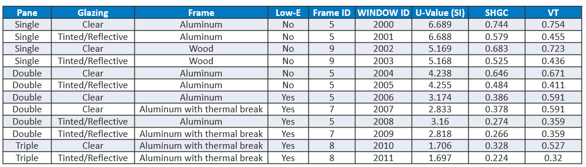
A sampling distribution for the new window constructions was created for the entire country, which is shown below. Overall, single pane windows make up approximately 54% of the stock, double pane 46%, triple pane <1%.
Window Configuration | Percent of National Stock
Single - No LowE - Clear - Aluminum | 24.24
Single - No LowE - Tinted/Reflective - Aluminum | 17.70
Single - No LowE - Clear - Wood | 9.14
Single - No LowE - Tinted/Reflective - Wood | 2.78
Double - No LowE - Tinted/Reflective - Aluminum | 9.28
Double - No LowE - Clear - Aluminum | 11.70
Double - LowE - Clear - Aluminum | 5.90
Double - LowE - Tinted/Reflective - Aluminum | 6.47
Double - LowE - Clear - Thermally Broken Aluminum | 5.70
Double - LowE - Tinted/Reflective - Thermally Broken Aluminum | 6.98
Triple - LowE - Clear - Thermally Broken Aluminum | 0.06
Triple - LowE - Tinted/Reflective - Thermally Broken Aluminum | 0.05

Initially, we created distributions based on census division to incorporate geographic location into the sampling. However, we realized that we also needed to incorporate the energy codes into our distributions to prevent scenarios where a single pane window was sampled for a certain location, but according to the energy code for that location, a double pane window was required. For this reason, we created the sampling distribution with two dependencies – climate_zone and energy_code_followed_during_last_window_replacement.
To generate these sampling distributions, we used the maximum U-values specified for each climate zone in each version of ASHRAE 90.1. For each combination of climate zone and energy code, we determined which of the 12 window configurations were both realistic and met code (i.e. had a U-value lower than the code maximum U-value). For the older energy codes, we made several assumptions about technology adoption in determining which window configurations were realistic:
- Low-E Coating – not adopted until DOE Ref 1980-2004
- Thermally Broken Aluminum Frame – not adopted until 90.1-2004
- Triple Pane – not adopted until 90.1-2004
For each combination of climate zone and energy code, we had anywhere from 2 to 12 window configurations that met the criteria. From here, we took the percentages from the national distribution, removed the non-relevant window configurations, and then normalized the percentages to 100%. This way, we kept the percentages from the national distribution, but incorporate intelligent assumptions around climate zone and energy codes. Below is an example of the window configurations that were sampled for each code year in climate zone 4A.
 |  |  |  | Meets code AND is realistic for buildings of this vintage
Energy Code Followed During Last Windows Replacement | Climate Zone | Assembly Maximum  U-Value | Assembly Maximum SHGC | Single - No LowE - Clear - Aluminum U-1.178 SHGC-0.744 | Single - No LowE - Tinted/Reflective - Aluminum U-1.178 SHGC-0.579 | Single - No LowE - Clear - Wood U-0.91 SHGC-0.683 | Single - No LowE - Tinted/Reflective - Wood U-0.91 SHGC-0.525 | Double - No LowE - Tinted/Reflective - Aluminum U-0.749 SHGC-0.484 | Double - No LowE - Clear - Aluminum U-0.746 SHGC-0.646 | Double - LowE - Clear - Aluminum U-0.559 SHGC-0.386 | Double - LowE - Tinted/Reflective - Aluminum U-0.557 SHGC-0.274 | Double - LowE - Clear - Thermally Broken Aluminum U-0.499 SHGC-0.378 | Double - LowE - Tinted/Reflective - Thermally Broken Aluminum U-0.496 SHGC-0.266 | Triple - LowE - Clear - Thermally Broken Aluminum U-0.3 SHGC-0.328 | Triple - LowE - Tinted/Reflective - Thermally Broken Aluminum U-0.299 SHGC-0.224
DOE Ref Pre-1980 | 4A | 1.22 | 0.54 | X | X | X | X | X | X
DOE Ref 1980-2004 | 4A | 0.59 | 0.36 |  |  | X | X | X | X | X | X
90.1-2004 | 4A | 0.57 | 0.39 |  |  |  |  |  |  | X | X | X | X | X | X
90.1-2007 | 4A | 0.55 | 0.4 |  |  |  |  |  |  | X | X | X | X | X | X
90.1-2010 | 4A | 0.55 | 0.4 |  |  |  |  |  |  | X | X | X | X | X | X
90.1-2013 | 4A | 0.42 | 0.4 |  |  |  |  |  |  |  |  | X | X | X | X

As you can see, for DOE Ref Pre-1980, the only windows that meet code and are realistic are single pane or double pane with no low-E coating. For DOE Ref 1980-2004, the maximum U-value dropped significantly so single pane aluminum windows no longer met code, but double pane low-E windows were now available on the market. For 90.1-2004 through 90.1-2010, code required a U-value equivalent to double pane low-E or better, and in 90.1-2013 code improved again, meaning double pane low-E with a thermal break or better is required. This type of logic was applied to all combinations of climate zone and energy code, and converted to percentage distributions used in sampling.
We did apply a small manual override to the final distributions, because we know that some states or localities do not follow or enforce energy codes strictly. Therefore, we were likely overestimating window performance by following the code exactly. Therefore, we assumed that in scenarios where single pane windows were technically below code, that 5% of all windows in the stock would still have the worst performing single pane windows installed. We adjusted the distributions accordingly by subtracting 5% total from the double pane configurations, and adding to the single pane aluminum configurations. In making this manual adjustment, the new distributions had the same overall breakdown of 54% single pane, 46% double pane as the national distribution generated from the Guidehouse data.

Window Thermal Performance (new)
Once the 12 new window constructions were determined, a team from LBNL’s Windows and Daylighting Group used the WINDOW program to assign thermal performance properties to each construction. We decided to model all the new window constructions as SimpleGlazing objects in OpenStudio to reduce complexity and the number of inputs necessary. It also simplifies the process of applying upgrades when all fenestration objects in the baseline are the same object type. The inputs for the SimpleGlazing object are U-factor, SHGC, and VLT. For each window configuration, LBNL assigned a Frame ID and Window ID from the WINDOW database, and filled in the respective U-factor SHGC, and VLT, which are shown in the table below.
The U-factors originally ranged from U-1.18 Btu/h·ft2·F for the worst performing single pane window to U-0.30 Btu/h·ft2·F for the best performing triple pane window. As mentioned earlier, the maximum U-Factor that EnergyPlus can model with a simple glazing object is U-1.02 Btu/h·ft2·F , which is governed by the limitations of a 2-D heat transfer model when interior and exterior air films are included. Therefore we had to adjust the U-factor for the first two single pane windows to be U-1.02 Btu/h·ft2·F rather than U-1.18 Btu/h·ft2·F such that they could be modeled in ComStock.
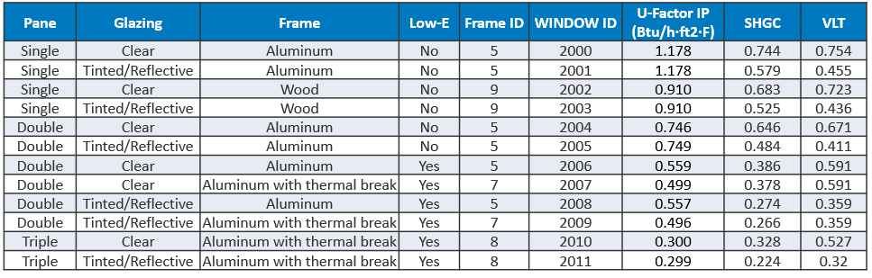

Impact of Change

Individual Model Input Change
The table below shows an example of a primary school in climate zone 3A. The existing window had a U-Factor of U-0.72 Btu/h·ft2·F, but the construction name is not linked to a specific window technology. In this example, the new window construction is a better-performing double pane window with a low-E coating, which comes with a U-Factor of U-0.498 Btu/h·ft2·F.
In the baseline window, the construction name includes the thermal properties but no description of what technology the window represents. After applying the new baseline window distributions, the construction name is much more descriptive, and the thermal properties have changed to reflect the technology being modeled. This not only helps users better understand the baseline window technology, but also makes it much easier to determine applicability criteria for upgrade measures. For example, it is now much easier to identify which buildings have single pane windows, and we can easily apply an upgrade measure to that sector of the stock to upgrade those buildings to double pane windows.
Model | Primary School – Climate Zone 3A
 | Before | After
Window Construction Name | U 0.72 SHGC 0.25 Simple Glazing Window U-0.72 SHGC 0.25 | Simple Glazing Double - LowE - Clear - Thermally Broken Aluminum
U-Factor (Btu/h·ft2·F) | 0.720 | 0.498
SHGC | 0.25 | 0.38
VLT | 0.13 | 0.59

Stock-Level Input Change
The new window distributions are input into the baseline in the form of a new sampling tsv, which then populates a new column in the buildstock.csv called baseline_window_type. For each combination of climate zone and energy code followed, there is a percentage associated with each baseline window type, adding up to 100%. The plots below show the breakdown of baseline window type by building vintage and by climate zone. There is an obvious trend when plotted by vintage. This is because of the assumptions discussed previously around energy code followed, such that newer construction buildings have better performing windows according to the energy code followed in that location. In pre-2004 buildings, around 50% of the buildings have single pane windows and in most cases the windows are not retrofitted for 50-70 years or more, meaning most of these buildings still have their original windows installed. In buildings built after 2004, double pane windows dominate. However, since pre-2004 buildings make up most of the stock, the overall stock breakdown comes out to be approximately 54% single pane, 46% double pane, and <1% triple pane.
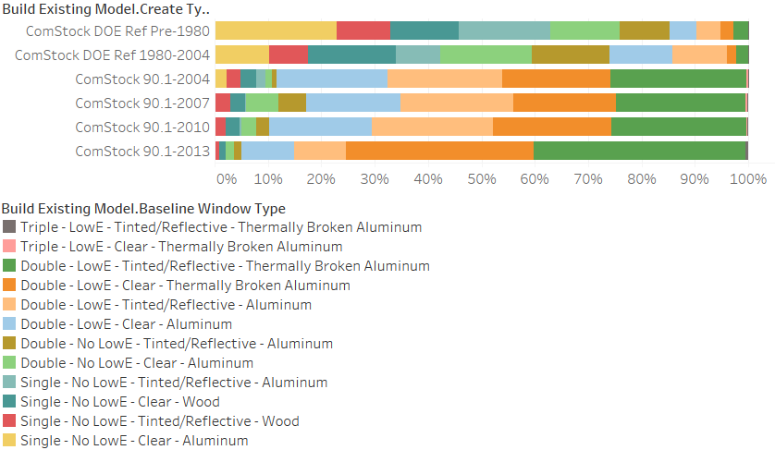
The distributions are not vastly different by climate zone, but there is a trend suggesting that as we move to colder climates, the windows are better performing. This is due to the maximum U-values defined in ASHRAE 90.1 for each climate zone. Once again, because pre-2004 buildings dominate the stock, stricter code requirements for colder climates in 90.1-2004 and beyond have minimal impact on the overall stock breakdown.

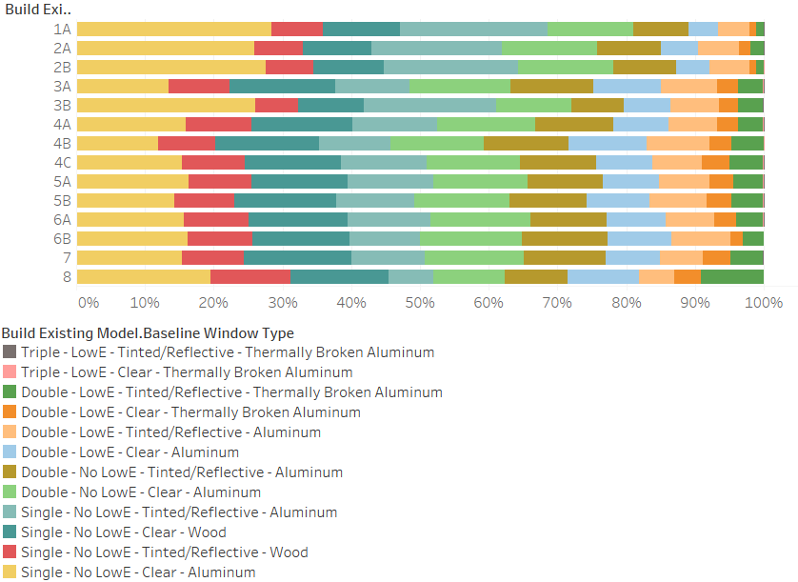
In the next image, we show the breakdown of baseline window type for the entire stock weighted by square footage. Single pane windows with aluminum frames are the most common category of windows present in the current stock, representing approximately 31% of the stock. Overall, buildings with single pane windows represent approximately 53% of the total square footage, double pane is 47%, and triple pane is <1%. This breakdown is almost the same as the breakdown by building count.
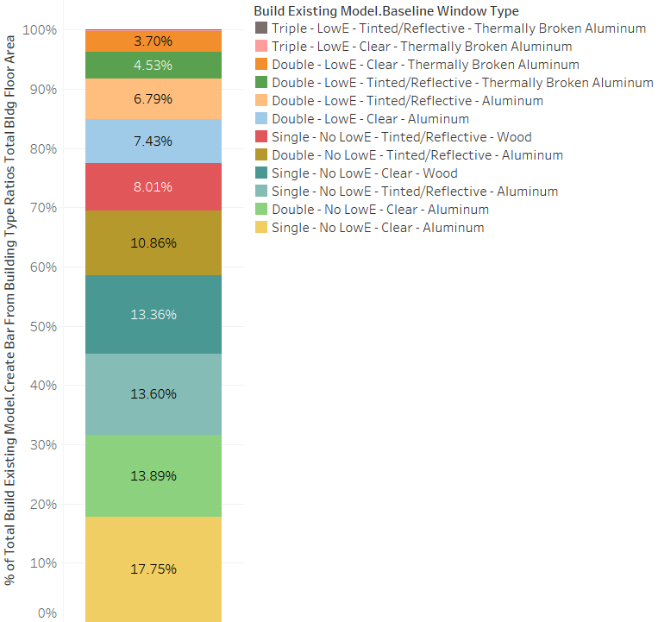
After applying the new distribution of window construction types and applying the relevant thermal properties based on the WINDOW assumptions, the average U-factor and SHGC both increased. In all building types, the average window U-factor increased from 3-11% after the change was made, meaning that previously, we were slightly overestimating window performance. The average SHGC increased significantly after the change was made, indicating that we were previously assuming much less solar gain through the windows. The U-factors and SHGCs by building type before and after the change was made are shown in the table below.
Building Type | Average U-Factor - Before | Average U-Factor - After | % Change U-Factor | Average SHGC - Before | Average SHGC - After | % Change SHGC
full_service_restaurant | 4.34 | 4.65 | 7 | 0.43 | 0.56 | 31
hospital | 4.31 | 4.61 | 7 | 0.41 | 0.56 | 36
large_hotel | 4.24 | 4.65 | 10 | 0.40 | 0.56 | 39
large_office | 4.32 | 4.64 | 7 | 0.43 | 0.56 | 32
medium_office | 4.27 | 4.64 | 9 | 0.43 | 0.56 | 31
outpatient | 4.42 | 4.69 | 6 | 0.42 | 0.56 | 33
primary_school | 4.19 | 4.66 | 11 | 0.42 | 0.56 | 34
quick_service_restaurant | 4.26 | 4.66 | 9 | 0.40 | 0.56 | 41
retail | 4.38 | 4.65 | 6 | 0.43 | 0.56 | 31
secondary_school | 4.13 | 4.58 | 11 | 0.41 | 0.55 | 36
small_hotel | 4.50 | 4.65 | 3 | 0.46 | 0.56 | 22
small_office | 4.44 | 4.65 | 5 | 0.44 | 0.56 | 29
strip_mall | 4.40 | 4.66 | 6 | 0.45 | 0.56 | 25
warehouse | 4.47 | 4.68 | 5 | 0.44 | 0.56 | 28

While the average window properties were not drastically affected by this new methodology, the significant change comes in the fact that there is now diversity in window constructions modeled within building types and climate zones. This helps to create a baseline stock that is more representative of the actual commercial fenestration stock. In addition, it has converted the baseline window stock to a technology basis, which is much more valuable in evaluating energy usage in the baseline stock, as well as estimating savings potential when determining applicability criteria and running window retrofit measures.

Stock-Level Output Change
As seen in the figure below, the overall impact of this change on total energy consumption is approximately a 5% increase. This is consistent with previous section, which indicated that we were previously modeling windows that were better performing than what may exist in reality.
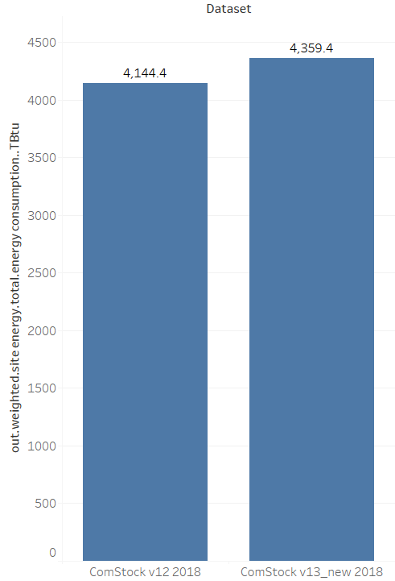

The breakdown below shows the change in heating and cooling energy consumption. Natural gas heating and electric heating decreased slightly, about 5% and 12% respectively, while cooling energy increased rather significantly, about 32%. This is also consistent with the results in the last section, which indicate that we were previously underestimating both U-factor and SHGC. We increased the SHGC by approximately 20-40%, meaning more heat is now entering the buildings during the summer, causing the cooling system to work harder. During the winter this has the opposite effect, as more passive solar enters the building, warming the space and saving heating energy.
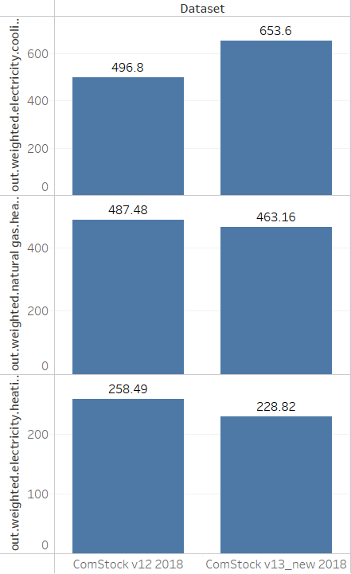

Load Shape Impacts
TODO add a section here showing a before/after of the QOIs so that we can understand how much the change did/didn’t influence the load shape. Assuming the QOIs were reported for both of these runs.

