ComStock Change
V14 – Interior Lighting Technology Baseline
Implementer: Matthew Dahlhausen, Amy LeBar
Change Document Author: Matthew Dahlhausen, Amy LeBar
Reviewer: Andrew Parker

Description of Change

Summary
This update changes interior lighting to follow a technology baseline approach, meaning lighting is set by an assumed distribution of lighting technologies in the stock (e.g. T8 or linear LEDs), rather than following an LPD allowance defined in a specific energy code version. Previously, interior lighting followed ASHRAE 90.1-2019 lighting power densities per openstudio-standards space type. The 90.1-2019 values best explained the installed lighting power densities, lighting energy, and load shape from the EULP project calibration data sources. However, 90.1-2019 assumes all LEDs, so the ComStock lighting measures became meaningless; we were already assuming the lighting stock was universally using the most efficient technology which isn’t true. The technology baseline approach recognizes that buildings typically don’t use the full the lighting allowance, and explicitly labels lighting technology and subsystems in the energy model for granular energy efficiency measure analysis.

Existing Methodology
Interior lighting is determined by a mix of two variables – the lighting power density and the interior lighting schedule. The existing methodology is outlined in the EULP report “End-Use Load Profiles for the U.S. Building Stock: Methodology and Results of Model Calibration, Validation, and Uncertainty Quantification”, specifically sections 3.3.1 Interior Lighting Schedules, 3.3.4 Interior Lighting Schedule Magnitude Variability, and section 3.3.12 Lighting Power Density.
For several key building types, default lighting schedules come from an analysis of enduse lighting data. Not all building types had sufficient enduse data, and for these building types the default schedule comes from the prototype building models. The default schedules are adjusted by occupancy hours and base to peak ratios to get the final lighting schedule. The schedule methodology did not change for this update. There were some specific changes to default schedules detailed below.
Lighting power densities follow 90.1-2019 values are detailed in Table 20 below from the EULP report.

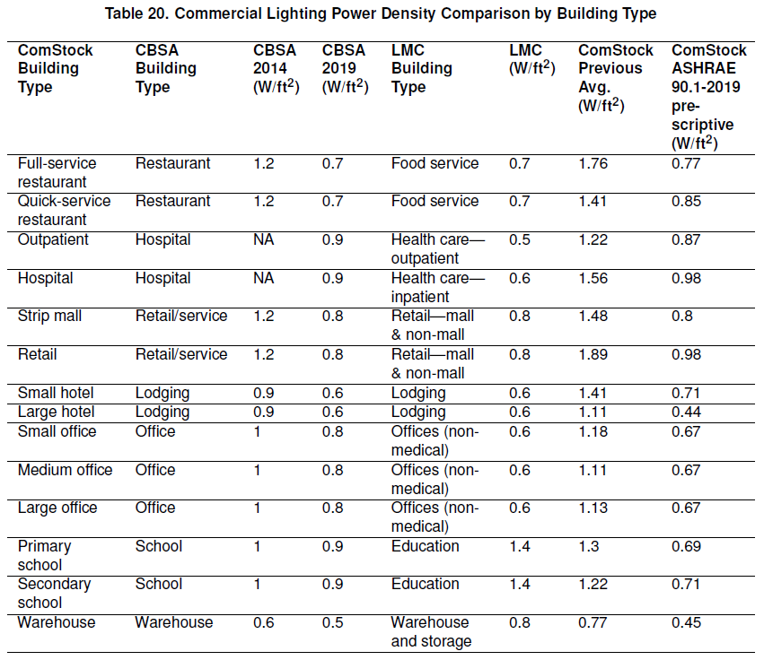

New Methodology
The new methodology consists of three parts:
- Switch to using a technology baseline approach for interior lighting
- New TSV structure to determine the lighting generation used in each building
- Updates to default lighting schedules and schedule assignments

Technology Baseline Approach
The technology baseline approach uses a similar process to how the 90.1 lighting subcommittee determines the LPD allowance for a given space type. In the lighting model, there are 4 kinds of lighting systems which together target a specific illuminance level.
$$LPD= General Lighting + Task Lighting + Supplemental Lighting + Wall Wash Lighting$$
$$LPD= \frac{{\%LS}_{1}*fc}{RSDD*{TF}_{1}}+ \frac{{\%LS}_{1}*fc}{RSDD*{TF}_{1}}+ \frac{{\%LS}_{1}*fc}{RSDD*{TF}_{1}}+ \frac{{\%LS}_{1}*fc}{RSDD*{TF}_{1}}$$
% LS_{x} = The percent of the horizontal illuminance met by a specific lighting system
fc = the target horizontal illuminance value
RSDD = room surface dirt depreciation, an estimate of how much surface dirt on ceilings and walls reduces light from reaching the horizontal surface
TF_{x} = total lighting factor = Source luminous efficacy * Coefficient of Utilization * LFF
Source luminous efficacy = the lumens per watt for a specific lighting technology
Coefficient of utilization = a term that capture how many of the lumens generated from the lighting system reaches the horizontal plane
LLF = Lighting loss factor = Luminaire Dirt Depreciation (LDD) * Lamp Lumen Depreciation (LLD)
Values for all these terms are specified in the 90.1 lighting subcommittee model (referred to as LSM henceforth), maintained by PNNL. The LSM is exact, using a specific lighting product, room geometry, distribution of lighting systems, and other properties to determine the lighting power density allowance for a given space type.
ComStock generalizes and differs from the LSM in several important ways.
1) ComStock generalizes lighting technology, e.g. T8 linear fluorescent luminaires for general lighting, rather than modeling a specific lighting product. Source efficacy, lighting loss properties, and radiant fractions are tied to lighting technology. Source efficacy values come from the DOE 2015 Lighting Market Characterization Report for older lighting technologies and the DOE 2019 Solid State Lighting report for LEDs.
2) Lighting technologies are broken out into lighting generations depending on the most common general lighting technology in that generation, as general lighting accounts for most (~80-90%) of total lighting. High bay is treated as general lighting, and the lighting measure uses the general high bay technology as the lighting technology for rooms with height >= 20ft. Lighting generations 4-8 are all LED with improving efficacy over time.
Lighting Generation | General Lighting  Technology | General Lighting (High Bay) Technology | Task Lighting Technology | Supplemental Lighting Technology | Wall Wash Lighting Technology
Gen 1 | T12 Linear Fluorescent | HID Mercury Vapor | Incandescent A-Shape | Incandescent Decorative | Incandescent Decorative
Gen 2 | T8 Linear Fluorescent | HID Metal Halide | Halogen A-Shape | Halogen Decorative | Halogen Decorative
Gen 3 | T5 Linear Fluorescent | HID Metal Halide | Compact Fluorescent Screw | Compact Fluorescent Pin | Compact Fluorescent Pin
Gen 4-8 | LED Linear | LED High Bay Luminaire | LED general purpose | LED decorative | LED directional

The lighting_technology.csv in the resources directory of the set_interior_lighting_technology measure details the properties of lighting generations and technologies.
3) The coefficient of utilization depends on both luminaire properties and room geometry which makes the calculation in the LSM quite complicated. The ComStock model associates the coefficient of utilization entirely with room properties independent of lighting technology. ComStock further assumes that rooms of the same space type have similar enough properties that they can use the same coefficient of utilization. To retain some of the variation due to luminaire properties, for each space type each kind of lighting system has a different coefficient of utilization.
The prototype_light_space_type.csv in the resources directory of the set_interior_lighting_technology measure details the illuminance value, light system fractions, and lighting system coefficient of utilization values for each lighting space type. Lighting space types are the lighting space types defined in 90.1 and determined based on a mapping of openstudio-standards space types to prototype lighting space type in the prototype_space_type_assignment measure.
4) The LSM assumes a high fraction of non-general lighting systems for certain space types. For example, half of the illuminance in retail sales spaces is from supplemental and wall wash lighting systems. In older lighting generations there is a significant difference in source efficacy between general and non-general lighting systems. In lighting generation 2, general lighting assumes T8 linear fluorescent lamps at 94 lumens per watt and supplemental and wall wash lighting assumes halogens at 15 lumens per watt. For retail spaces using the LSM values, that means half the lighting comes from lighting technologies 6 times less efficient than the general lighting technology. While this may be appropriate for setting a code lighting allowance, most retail spaces have a much greater percentage of their lighting from more efficient general lighting technologies. ComStock adjusts the lighting system fractions for commonly used space types so that around 80-90% of lighting comes from the general lighting system.
5) The LSM offers a generous allowance for lighting power density to account for the lighting loss factor over time. Including lighting losses and depreciation can result in a lighting power density ~40% higher than when these terms are ignored. As this resulted in unreasonably high installed lighting power densities, ComStock assumes that most existing lighting systems were not designed to account for depreciation over time, and therefore excludes lighting loss and depreciation terms from the calculation.

Determination of lighting technology distribution in the stock
Lighting generations were assigned to each building model during sampling based on the year of and energy code in force during the last interior lighting replacement. Probability distributions were generated first by using an approximate start and end year for when each technology generation is being installed in commercial buildings (Table 1). A Gaussian distribution was generated for each lighting generation using these start and end years, and the resulting distribution for each year of last interior lighting replacement was normalized to create 0-1 probabilities. The probability distributions were duplicated for each energy code in force and further modified to ensure they were realistic (i.e., not let Generation 1 be installed in a ComStock 90.1-2019 building). This was done using a cutoff generation for each energy code in force (Table 2). Rows in the tsv that had non-zero probability values for generations below the cutoff generation were modified by zeroing the pre-cutoff generations and re-normalizing the distribution. Each of the lighting generations were also assigned an arbitrary weight to scale the distributions. This was done to represent realistic installation trends. For example, while the installation years of Generation 2 and Generation 3 overlapped, Generation 2 was much more popular and was therefore assigned a higher weight than Generation 3 in the lighting generation script.
Finally, an additional level of diversity was added to the process. Small commercial buildings (<50,000 sqft) tend to retrofit their lighting technology less frequently than large commercial buildings (>50,000 sqft). To capture this, the interior lighting lifespan values were changed so that large buildings updated their lighting every seven years on average, with small buildings updating their lighting every 13 years. These timespans average to 10 years, the average lifespan for interior lighting used previously (from code adoption update).
Table 1. Generation start and end years to generate Gaussian distributions.
Generation | Start year | End year
gen1_t12_incandescent | 1950 | 2040
gen2_t8_halogen | 1980 | 2040
gen3_t5_cfl | 1995 | 2035
gen4_led | 2005 | 2040
gen5_led | 2017 | 2040
gen6_led | 2021 | 2040
gen7_led | 2026 | 2040
gen8_led | 2031 | 2043
Source: Engineering judgement.
Table 2. Lighting cutoff generation for each energy code.
Energy code in force | Cutoff generation
ComStock DOE Ref Pre-1980 | gen1_t12_incandescent
ComStock DOE Ref 1980-2004 | gen1_t12_incandescent
ComStock 90.1-2004 | gen1_t12_incandescent
ComStock 90.1-2007 | gen2_t8_halogen
ComStock 90.1-2010 | gen2_t8_halogen
ComStock 90.1-2013 | gen2_t8_halogen
ComStock 90.1-2016 | gen3_t5_cfl
ComStock 90.1-2019 | gen4_led
ComStock DEER Pre-1975 | gen1_t12_incandescent
ComStock DEER 1985 | gen1_t12_incandescent
ComStock DEER 1996 | gen1_t12_incandescent
ComStock DEER 2003 | gen1_t12_incandescent
ComStock DEER 2007 | gen2_t8_halogen
ComStock DEER 2011 | gen2_t8_halogen
ComStock DEER 2014 | gen3_t5_cfl
ComStock DEER 2015 | gen3_t5_cfl
ComStock DEER 2017 | gen4_led
ComStock DEER 2020 | gen4_led
Source: Engineering judgement

Validation
The distributions were validated against data from the 2015 Lighting Market Characterization Study and the 2019 Solid State Lighting Report (Table 3). As this data covers lighting technologies installed in the stock for each year, we ran the ComStock sampling and compared the resulting installed technology generations to the “truth” data. The comparison results for 2017 and 2020 simulation years are shown in Figure 1.
Table 3. Truth data: installed lighting distributions by year.
 | 2015 | 2017 | 2020 | 2025 | 2030 | 2035
gen1_t12_incandescent | 0.215 | 0.159 | 0.121 | 0.059 | 0.025 | 0.015
gen2_t8_halogen | 0.660 | 0.488 | 0.371 | 0.181 | 0.077 | 0.046
gen3_t5_cfl | 0.065 | 0.048 | 0.037 | 0.018 | 0.008 | 0.005
gen4_led | 0.060 | 0.274 | 0.330 | 0.371 | 0.267 | 0.093
gen5_led | 0 | 0.030 | 0.141 | 0.334 | 0.401 | 0.187
gen6_led | 0 | 0 | 0 | 0.037 | 0.134 | 0.374
gen7_led | 0 | 0 | 0 | 0 | 0.089 | 0.187
gen8_led | 0 | 0 | 0 | 0 | 0 | 0.093

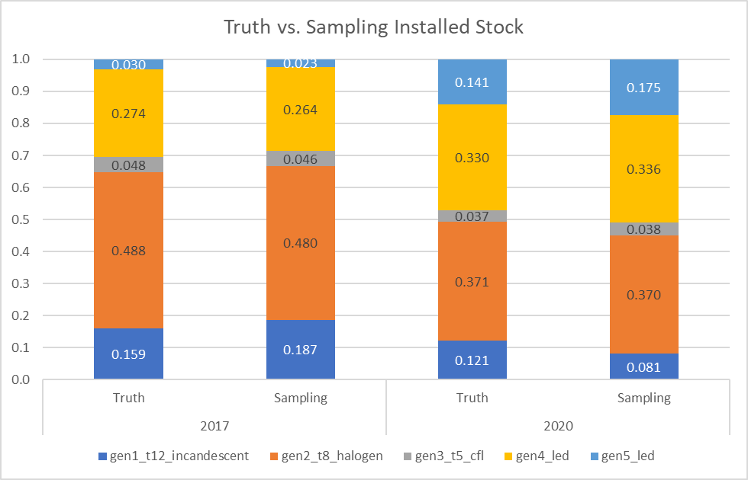
Figure 1. Sampling results compared to truth data for 2017 and 2020 simulation years.
We focused on simulation years 2017 and 2020 because these represent the range of simulation years typically run for ComStock. Additionally, for a given iteration of the lighting generation tsv, the comparison results were inconsistent across the various simulation years. For example, for a lighting tsv that showed close comparisons for 2017 and 2020, years 2025-2035 were significantly different compared to the other future projections. With improvements to the tsv generation script, we expect to achieve close comparisons across all simulation years.
Table 4 provides a snapshot of the final tsv file, which shows a gradual shift to higher generations as the year of last interior lighting replacement increases. For this code year (ComStock 90.1-2013), we would not expect Generation 1 lighting technologies to be installed. This is reflected in the distributions, as the minimum lighting generation installed is at least Generation 2. The relative popularity of each generation is also apparent in the distributions: Generation 2 has a much higher probability of being installed in any year than Generation 3, a less popular technology set.
Table 4. Lighting generation distributions for ComStock 90.1-2013 code year.
Dependency=energy_code_in_force_during_last_interior_lighting_replacement | Dependency=year_bin_of_last_interior_lighting_replacement | Option=gen1_t12_incandescent | Option=gen2_t8_halogen | Option=gen3_t5_cfl | Option=gen4_led | Option=gen5_led | Option=gen6_led | Option=gen7_led | Option=gen8_led
ComStock 90.1-2013 | pre_1978 | 0 | 1 | 0 | 0 | 0 | 0 | 0 | 0
ComStock 90.1-2013 | 1978 | 0 | 1 | 0 | 0 | 0 | 0 | 0 | 0
ComStock 90.1-2013 | 1979 | 0 | 1 | 0 | 0 | 0 | 0 | 0 | 0
ComStock 90.1-2013 | 1980 | 0 | 1 | 0 | 0 | 0 | 0 | 0 | 0
ComStock 90.1-2013 | 1981 | 0 | 1 | 0 | 0 | 0 | 0 | 0 | 0
ComStock 90.1-2013 | 1982 | 0 | 1 | 0 | 0 | 0 | 0 | 0 | 0
ComStock 90.1-2013 | 1983 | 0 | 1 | 0 | 0 | 0 | 0 | 0 | 0
ComStock 90.1-2013 | 1984 | 0 | 1 | 0 | 0 | 0 | 0 | 0 | 0
ComStock 90.1-2013 | 1985 | 0 | 1 | 0 | 0 | 0 | 0 | 0 | 0
ComStock 90.1-2013 | 1986 | 0 | 1 | 0 | 0 | 0 | 0 | 0 | 0
ComStock 90.1-2013 | 1987 | 0 | 1 | 0 | 0 | 0 | 0 | 0 | 0
ComStock 90.1-2013 | 1988 | 0 | 1 | 0 | 0 | 0 | 0 | 0 | 0
ComStock 90.1-2013 | 1989 | 0 | 1 | 0 | 0 | 0 | 0 | 0 | 0
ComStock 90.1-2013 | 1990 | 0 | 1 | 0 | 0 | 0 | 0 | 0 | 0
ComStock 90.1-2013 | 1991 | 0 | 1 | 0 | 0 | 0 | 0 | 0 | 0
ComStock 90.1-2013 | 1992 | 0 | 1 | 0 | 0 | 0 | 0 | 0 | 0
ComStock 90.1-2013 | 1993 | 0 | 1 | 0 | 0 | 0 | 0 | 0 | 0
ComStock 90.1-2013 | 1994 | 0 | 1 | 0 | 0 | 0 | 0 | 0 | 0
ComStock 90.1-2013 | 1995 | 0 | 0.990 | 0.010 | 0 | 0 | 0 | 0 | 0
ComStock 90.1-2013 | 1996 | 0 | 0.983 | 0.017 | 0 | 0 | 0 | 0 | 0
ComStock 90.1-2013 | 1997 | 0 | 0.992 | 0.008 | 0 | 0 | 0 | 0 | 0
ComStock 90.1-2013 | 1998 | 0 | 0.985 | 0.015 | 0 | 0 | 0 | 0 | 0
ComStock 90.1-2013 | 1999 | 0 | 0.987 | 0.013 | 0 | 0 | 0 | 0 | 0
ComStock 90.1-2013 | 2000 | 0 | 0.973 | 0.027 | 0 | 0 | 0 | 0 | 0
ComStock 90.1-2013 | 2001 | 0 | 0.981 | 0.019 | 0 | 0 | 0 | 0 | 0
ComStock 90.1-2013 | 2002 | 0 | 0.967 | 0.033 | 0 | 0 | 0 | 0 | 0
ComStock 90.1-2013 | 2003 | 0 | 0.966 | 0.034 | 0 | 0 | 0 | 0 | 0
ComStock 90.1-2013 | 2004 | 0 | 0.964 | 0.036 | 0 | 0 | 0 | 0 | 0
ComStock 90.1-2013 | 2005 | 0 | 0.911 | 0.040 | 0.049 | 0 | 0 | 0 | 0
ComStock 90.1-2013 | 2006 | 0 | 0.910 | 0.049 | 0.041 | 0 | 0 | 0 | 0
ComStock 90.1-2013 | 2007 | 0 | 0.887 | 0.050 | 0.062 | 0 | 0 | 0 | 0
ComStock 90.1-2013 | 2008 | 0 | 0.826 | 0.058 | 0.115 | 0 | 0 | 0 | 0
ComStock 90.1-2013 | 2009 | 0 | 0.810 | 0.047 | 0.143 | 0 | 0 | 0 | 0
ComStock 90.1-2013 | 2010 | 0 | 0.782 | 0.050 | 0.168 | 0 | 0 | 0 | 0
ComStock 90.1-2013 | 2011 | 0 | 0.738 | 0.055 | 0.207 | 0 | 0 | 0 | 0
ComStock 90.1-2013 | 2012 | 0 | 0.598 | 0.055 | 0.348 | 0 | 0 | 0 | 0
ComStock 90.1-2013 | 2013 | 0 | 0.670 | 0.043 | 0.287 | 0 | 0 | 0 | 0
ComStock 90.1-2013 | 2014 | 0 | 0.568 | 0.055 | 0.377 | 0 | 0 | 0 | 0
ComStock 90.1-2013 | 2015 | 0 | 0.553 | 0.059 | 0.387 | 0 | 0 | 0 | 0
ComStock 90.1-2013 | 2016 | 0 | 0.519 | 0.051 | 0.430 | 0 | 0 | 0 | 0
ComStock 90.1-2013 | 2017 | 0 | 0.413 | 0.042 | 0.313 | 0.231 | 0 | 0 | 0
ComStock 90.1-2013 | 2018 | 0 | 0.241 | 0.031 | 0.345 | 0.382 | 0 | 0 | 0
ComStock 90.1-2013 | 2019 | 0 | 0.191 | 0.022 | 0.264 | 0.523 | 0 | 0 | 0
ComStock 90.1-2013 | 2020 | 0 | 0.195 | 0.022 | 0.311 | 0.472 | 0 | 0 | 0
ComStock 90.1-2013 | 2021 | 0 | 0.146 | 0.011 | 0.196 | 0.551 | 0.096 | 0 | 0
ComStock 90.1-2013 | 2022 | 0 | 0.107 | 0.009 | 0.168 | 0.612 | 0.104 | 0 | 0
ComStock 90.1-2013 | 2023 | 0 | 0.058 | 0.006 | 0.116 | 0.738 | 0.082 | 0 | 0
ComStock 90.1-2013 | 2024 | 0 | 0.049 | 0.004 | 0.100 | 0.689 | 0.157 | 0 | 0
ComStock 90.1-2013 | 2025 | 0 | 0.037 | 0.003 | 0.069 | 0.695 | 0.195 | 0 | 0
ComStock 90.1-2013 | 2026 | 0 | 0.025 | 0.002 | 0.061 | 0.691 | 0.154 | 0.067 | 0
ComStock 90.1-2013 | 2027 | 0 | 0.017 | 0.002 | 0.043 | 0.594 | 0.213 | 0.131 | 0
ComStock 90.1-2013 | 2028 | 0 | 0.013 | 0.002 | 0.035 | 0.615 | 0.195 | 0.140 | 0
ComStock 90.1-2013 | 2029 | 0 | 0.011 | 0.001 | 0.024 | 0.463 | 0.236 | 0.264 | 0
ComStock 90.1-2013 | 2030 | 0 | 0.007 | 0.001 | 0.017 | 0.396 | 0.220 | 0.360 | 0
ComStock 90.1-2013 | 2031 | 0 | 0.007 | 0.000 | 0.013 | 0.332 | 0.167 | 0.445 | 0.036
ComStock 90.1-2013 | 2032 | 0 | 0.010 | 0.000 | 0.014 | 0.287 | 0.164 | 0.410 | 0.116
ComStock 90.1-2013 | 2033 | 0 | 0.004 | 0.000 | 0.009 | 0.183 | 0.143 | 0.509 | 0.152
ComStock 90.1-2013 | 2034 | 0 | 0.006 | 0.000 | 0.009 | 0.176 | 0.096 | 0.408 | 0.305
ComStock 90.1-2013 | 2035 | 0 | 0.002 | 0.000 | 0.006 | 0.133 | 0.089 | 0.317 | 0.452
ComStock 90.1-2013 | 2036 | 0 | 0.003 | 0 | 0.007 | 0.098 | 0.069 | 0.311 | 0.512
ComStock 90.1-2013 | 2037 | 0 | 0.006 | 0 | 0.005 | 0.080 | 0.051 | 0.169 | 0.688
ComStock 90.1-2013 | 2038 | 0 | 0.006 | 0 | 0.006 | 0.077 | 0.068 | 0.131 | 0.713
ComStock 90.1-2013 | 2039 | 0 | 0.004 | 0 | 0.004 | 0.088 | 0.047 | 0.117 | 0.740
ComStock 90.1-2013 | 2040 | 0 | 0.006 | 0 | 0.005 | 0.069 | 0.008 | 0.061 | 0.851
ComStock 90.1-2013 | 2041 | 0 | 0 | 0 | 0 | 0 | 0 | 0 | 1
ComStock 90.1-2013 | 2042 | 0 | 0 | 0 | 0 | 0 | 0 | 0 | 1
ComStock 90.1-2013 | 2043 | 0 | 0 | 0 | 0 | 0 | 0 | 0 | 1

Future Improvements
There are two primary areas for improvement for this process:
- The first is in the initial Gaussian distributions. While we have a good sense of when the lighting generations were first installed and finally lost popularity, we do not know when the generations peaked in their install popularity. The current method assumes the peak is directly in the middle of the start and end year. This is most likely incorrect. If we can gain data on peak year of each generation, this would improve the distribution generation process.
- The second improvement area is the final weighting process. The weights are currently determined using a guess-and-check method. Further improvements to the distribution script would make this method more robust (e.g., using an optimization algorithm).

Updates to Default Lighting Schedules
The default lighting schedule, occupancy hours, and base to peak ratios determine the annual Equivalent Full Load Hours (EFLH). EFLH multiplied by the lighting power density gives the annual lighting energy use. EFLH values seemed incorrect based on comparison to the LMC – too high for some building types (restaurants) and too low for others (office buildings). Changes to lighting schedules include:
- Changing the peak lighting value in the hourly schedule for offices spaces from ~0.5 To 0.85.
- Quick service restaurants and kitchens now use the FoodService_Restaurant BLDG_LIGHT_EndUseData schedule rather than the prototype schedule
- Changed all largehotel guestroom lighting schedules to HotelLarge BLDG_LIGHT_GUESTROOM_SCH_2013
- Changed SmallHotel guest rooms to all follow the same schedule and reduce midday lighting fraction from ~0.3 to 0.15
- Changed SmallHotel vacant guest rooms to have an always off lighting schedule
In addition, older vintages of hotels used a different set of space type ratios that did not include vacant rooms. This difference was eliminated; all small hotels now assume some fraction of vacant rooms.

Impact of Change

Individual Model Input Change
Here is a look at a retail building with lighting generation gen2_t8_halogen. The Point_of_Sale space type is mapped to the retail_mass_merchandising_sales_area space type which assumes 90% general lighting (T8) and 10% task lighting (halogens). These are reflected in the model:
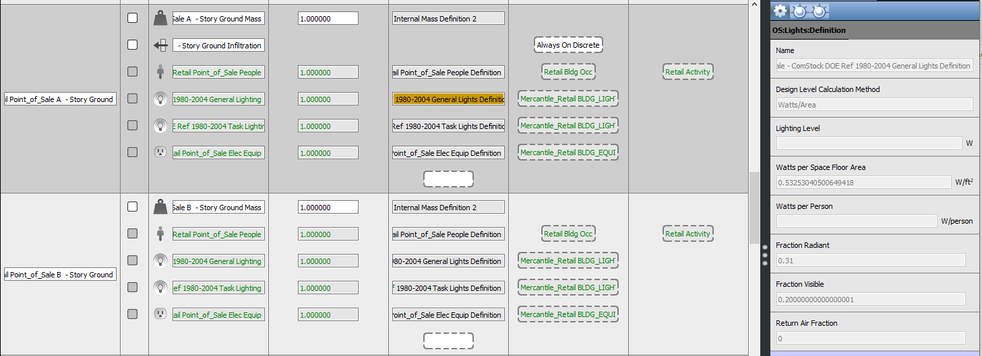
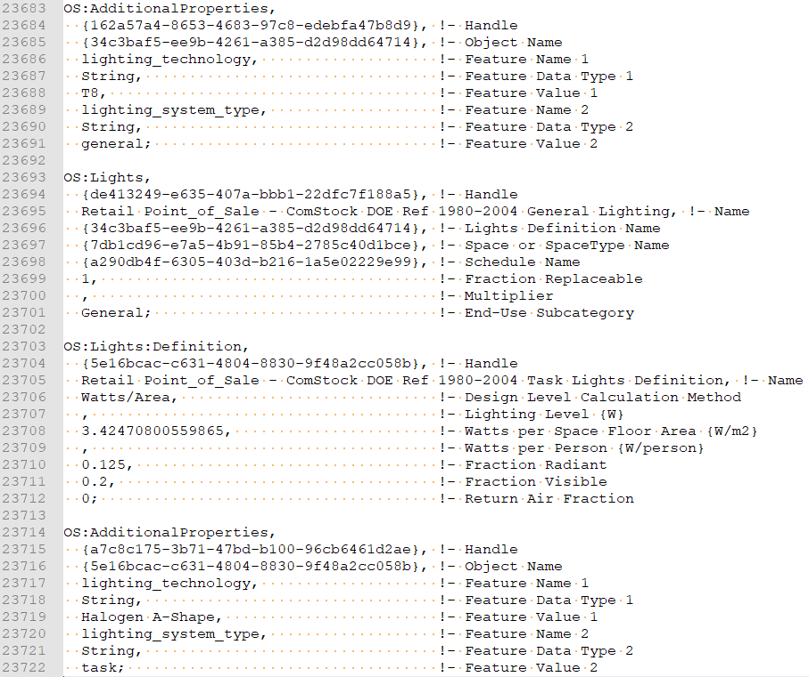

Stock-Level Input Change
This change adds diversity and granularity to the lighting stock. In the previous version of ComStock, all building models were assigned the most efficient lighting technology (ASHRAE 90.1-2019). As such, comparison graphics showing inputs before and after the lighting generation update are not all that useful. Instead, this section illustrates the lighting generation distributions, achieved using the new data/method, by building size and type for a 2018 simulation year.
Figure 2 shows the breakdown of lighting generation distribution (by count) by building size. Small buildings are those under 50,000 sqft and are assumed to have slower retrofit frequency than larger buildings (>50,000 sqft). The data trend matches this assumption, as there is a larger percentage of smaller building models that have Generation 1 and 2 lighting technologies.
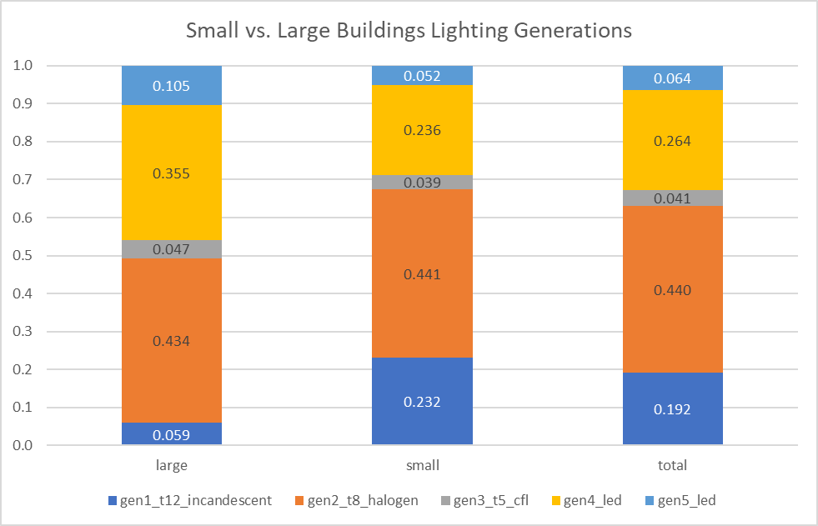
Figure 2. Installed lighting generations by building size (count-based distribution).
Figure 3 provides a breakdown of lighting generation distributions by building type. There is not huge variation among the building types. However, we see building types that are typically smaller (QSR, small office, strip mall) lagging the other building types in terms of lighting technology. This is consistent with the data in Figure 2.
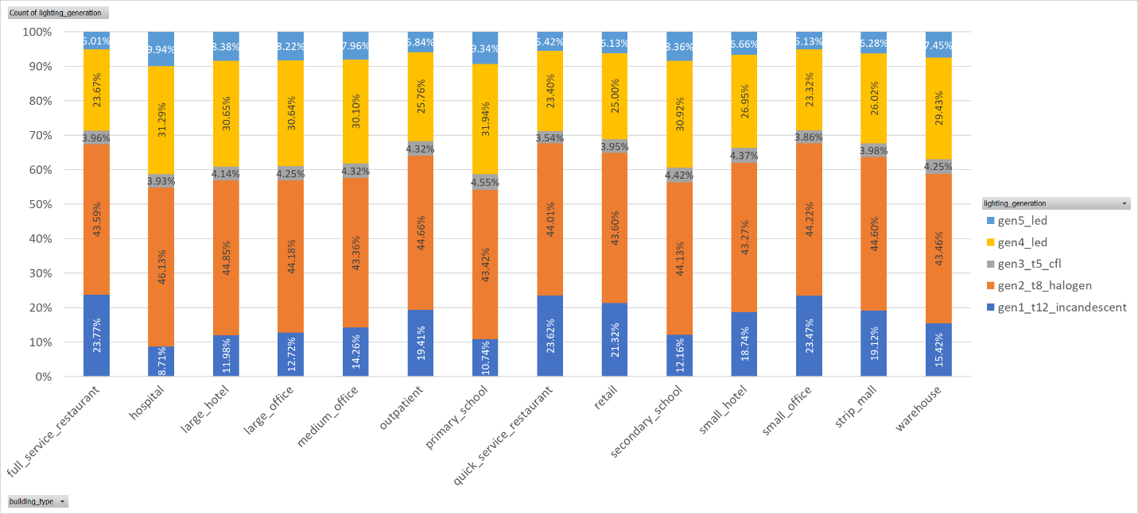
Figure 3. Installed lighting generation by building type (count-based distribution).

Stock-Level Output Change
The following graphics show the changes in lighting properties across the stock.
First, lighting power density. comstock v11 represents the baseline, and comstock v14_5 includes all lighting technology baseline. There are still some further changes to the TSVs to account for an adoption in newer lighting technology by building type. These will change the lighting generation distributions slightly, particularly for smaller buildings.
The comparison points are CBSA 2014 and 2019 which included detailed walk throughs of many buildings of different types. ComStock LPDs are in agreement with CBSA values with the exception of schools which are lower in ComStock. CBSA included university buildings under schools which may explain some of the difference.
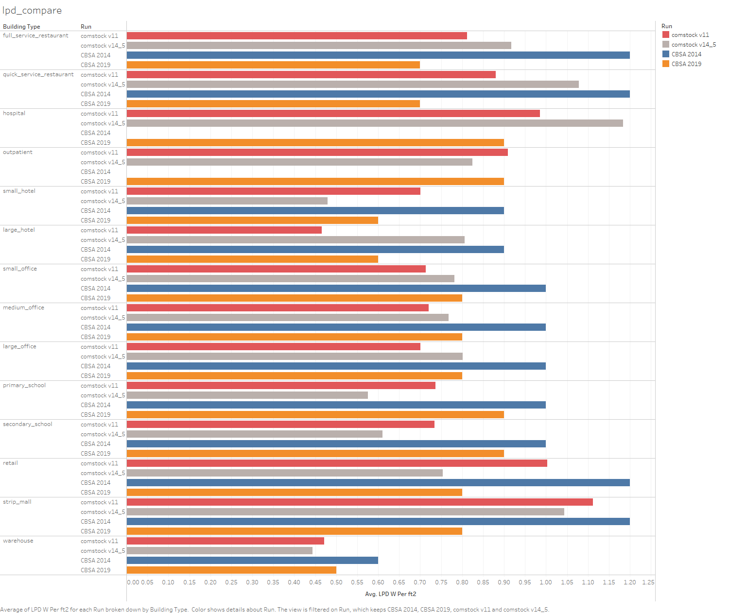

There isn’t ample comparison data for EFLHs. The 2015 LMC has an estimate for daily operating hours by building type, but these are suspect for some building types. Generally, EFLHs should be >2,000 hours (8 hrs/day * 5 days/wk * 40 wks/yr) and < 6,000 hours (16.5 hrs/day * 365 days/yr). Baseline ComStock had hours that were unrealistically low for offices and unrealistically high for quick service restaurants, and small hotels. Changes to these schedules resulted in much more reasonable EFLHs.
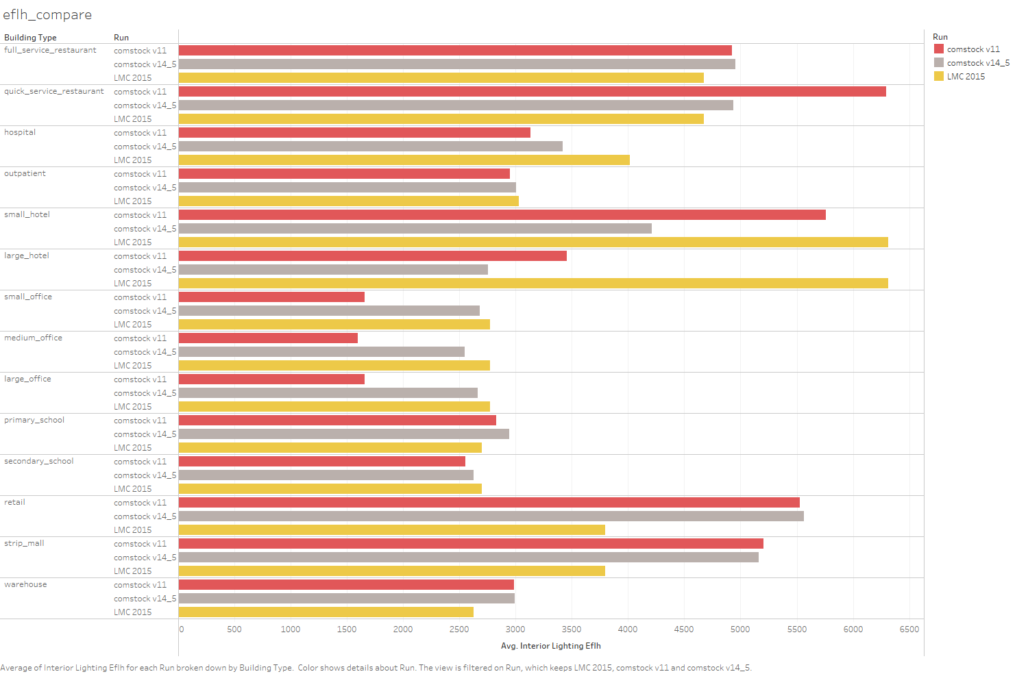
The last point of comparison is lighting energy use – compared on a kwh per sf basis. Again, there isn’t ample data for comparison. LMC includes some numbers, and these can somewhat be calculated at a stock level for CBECS too. I estimate values between 2-6 kWh/ft2-yr (7-20 kBtu/ft2-yr) are reasonable depending on building type. I'm amazed how significantly this is understudied in the buildings space. I only found one study that compared measured lighting energy use from multiple buildings - a 2015 study by LBNL of 15 office buildings in China (avg ~13 kBtu/ft2-yr / ~4 kWh/ft2-yr, range 5-19 kBtu/ft2-yr / 1.5-5.5 kWh/ft2-yr). Our results aren’t wildly different from this.
