ComStock Change
  - OpenStudio 2.9.1 to 3.4.0
Implementer: Andrew Parker
Change Document Author: Andrew Parker
Reviewer: Chris CaraDonna, Matthew Dahlhausen

Description of Change

Summary
This updates the version of OpenStudio used by ComStock from 2.9.1 (EnergyPlus 9.2.0, released Dec 2019) to 3.4.0 (EnergyPlus 22.1.0, released May 2022). There were many changes to the EnergyPlus engine between these two versions, as described in the EnergyPlus release notes. Many of those changes impacted things such as the equipment sizing routines, which have a carry-on effect on ComStock. A summary of the changes that were observed in the models is included here.

Dockerfile Update

Existing Method
The previous approach uses a modified version of the OpenStudio 2.9.1 Dockerfile, which started from an Ubuntu 16.04 base image and downloaded and installed OpenStudio, Ruby, and required development libraries. Custom versions of OpenStudio-Standards were installed by modifying a SHA in the Dockerfile.

New Method
The new approach starts with the OpenStudio 3.4.0 base image. Custom gems are chosen by editing the /resources/.Gemfile in the ComStock repository, which is then loaded and installed via bundler to replace the default set of gems that comes with OpenStudio 3.4.0. When building a Singularity image for HPC, the custom gems are installed directly inside the image. When running locally using Docker, the custom gems are installed into the /.custom_gems directory in the ComStock repository. This latter approach allows developers to quickly test changes to OpenStudio-Standards without having to repeatedly re-clone that repository.

Heat Loss for Service Water Heating

Existing Method
All service water heating systems in ComStock are created with a Pipe:Indoor object between the water heater and the water use connection(s). The assumption is that the ambient air around this pipe is 70F.

New Method
In the EnergyPlus 9.6.0 release, a change was made to add warnings about service water heating temperatures. Additionally, the default behavior was changed such that if the “Cold Water” (from the water mains) was warmer than the “Hot Water” (for ComStock, the outlet of the Pipe:Indoor) object, the water draw would be taken from the cold water side. We believe this new behavior to be a bug and have reported the issue to EnergyPlus.
As a result of this behavior, in warm climates with high water mains temperatures, after a night of low/no flow in the SWH system, the water in the Pipe:Indoor would have dropped to assumed ambient temperature (70F). To avoid having EnergyPlus not draw hot water during the summer in warmer climates, a change was made to set the ambient temperature for the Pipe:Indoor objects to the maximum water mains temperature for the site plus 3C. In warm climates such as Orlando, FL, this changed the ambient temperature from 70F to approximately 90F. This decreases the heat loss from the Pipe:Indoor objects and therefore decreases the energy consumption of the water heaters.

Handling of Minimum OA for Multizone Systems
In multizone systems such as VAV and PVAV, there is a default minimum damper position of roughly 30% (depending on the template). However, depending on system loads and flow rates, in some cases this minimum damper position for some zones needs to be increased such that the minimum OA requirement for the whole system is not driven artificially high by those zones. This is done by increasing the minimum damper position for those zones to achieve a minimum zone ventilation efficiency of 60%.

Existing Method
Prior to EnergyPlus 9.3.0, there was no method to achieve this modification of minimum damper positions in the sizing routine. For this reason, OpenStudio-Standards implemented the methodology to perform this reduction based on the results of a sizing run.

New Method
In EnergyPlus 9.3.0 and higher, there is an option to set the minimum zone ventilation efficiency for each zone, and EnergyPlus will increase the minimum flows for each zone to achieve this, lowering the total system minimum OA rate. In OpenStudio-Standards, a change has been made to use this default EnergyPlus methodology. The result in most cases is a slight change in minimum total system OA flow rates. However, in a small number of cases the minimum OA flow rate can increase more significantly. The exact reasons for this difference have not been tracked down.
The table below shows the changes in the average annual operation OA flow fraction. The largest changes are in the VAV and PVAV systems. Note that these are NOT OA flow rates, so an increase in design OA coupled with an increase in overall system airflow may mask an overall increase in OA delivered to the building.

Sizing of Heating Coils
For reasons that could not be traced down, somewhere between EnergyPlus 9.2.0 and 22.1.0 the routine for sizing heating coils changed. In most cases, the coil sizing changes are zero or minimal, but in other cases the coil sizes change more substantially, generally increasing. This has the effect of changing the air-side flow rates, and for buildings with hydronic heating coils, also the pump sizing and flow rates. The images below show the changes in total heating capacity by HVAC system type for boilers and direct gas-fired heating coils. Note that changes appear to be in coils inside of AirLoopHVAC:UnitarySystem objects. Realism of coil sizing had not previously been confirmed, so the assumption is made that EnergyPlus engine improvements have fixed bugs and improved sizing as part of their update process.

Boiler Capacity

Furnace/Direct Gas-fired Heating Coil Capacity

Impact of Change
These changes were tested using two 10k sample runs with identical buildstock.csv files.

National Scale Impact
As shown in the figures below, there was virtually no change in total electricity or natural gas consumption at the total building stock level.
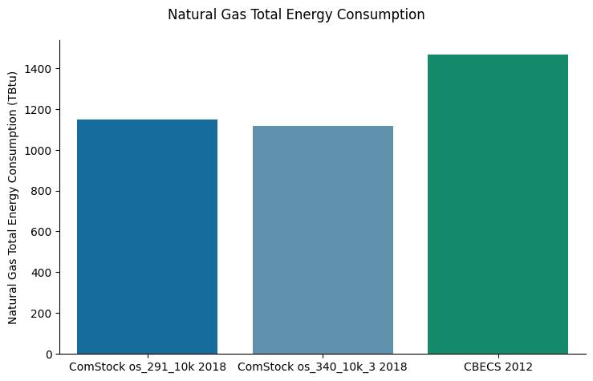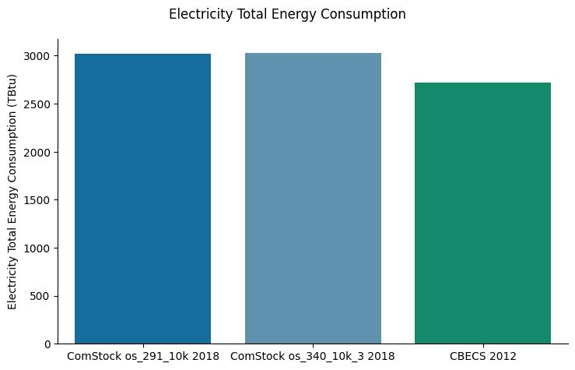
Digging in further, we see slightly more noticeable changes in the energy consumption at a building type level, but the trend across building types is not uniform.

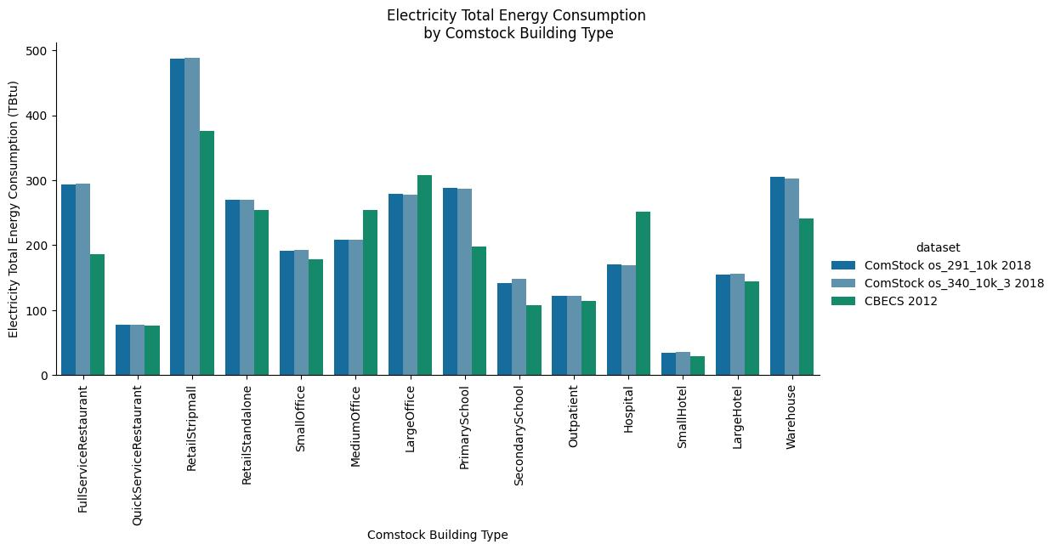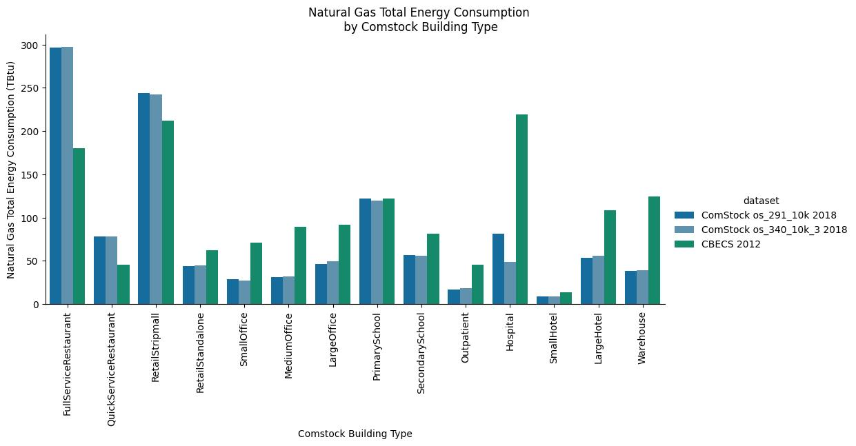

Distribution of Impacts by End Use
The image below shows the distribution of impacts across the 10k simulations included in the test runs by end use and fuel type. In this image, the update to OS 3.4.0 was treated as an upgrade, so positive savings mean a decrease in energy consumption, while negative savings mean an increase in energy consumption. This image does not include the differences in weights between building types.
The initial takeaway is that the box and whiskers segments for most of the distributions are much less than +/- 5% change, which means that a vast majority of buildings had almost no change from the update. This is consistent with the minimal changes in stock-level total seen above.
The paragraphs that follow the image describe the changes that explain the outliers for each end use. As expected, the internal load end uses show almost exactly zero change, which is why their box and whisker plots are nearly invisible on this scale.
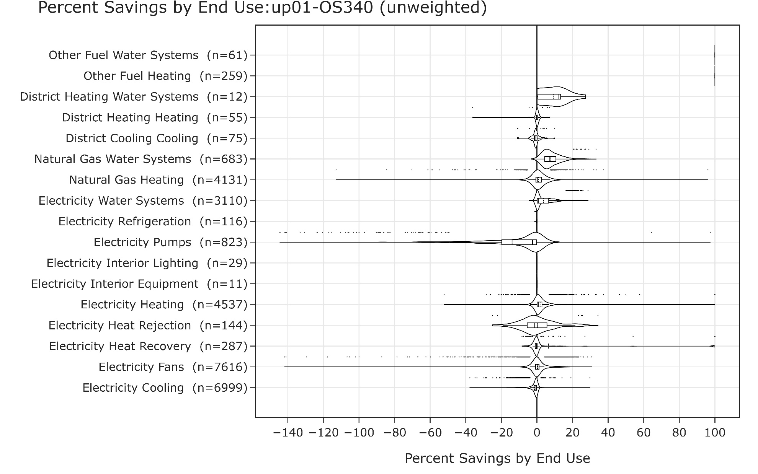

Other Fuel Heating and Water Systems
The 100% savings is the result of EnergyPlus changing the reporting of Propane and Fuel Oil #2 consumption. It does not reflect the actual change in the models, which was minimal.

Natural Gas and Electricity Water Systems
The changes in water systems were almost entirely skewed toward a decrease in energy consumption. This is a result of the previously described change in the ambient temperature assumptions for the Pipe:Indoor objects in the models. A more detailed evaluation of these outliers show that the largest decreases are found in models in the hottest climate zones. This is expected, because in these climate zones, the water mains temperature is highest, which forces the use of a higher ambient air temperature assumption for the Pipe:Indoor objects, lowering the delta-T and therefore decreasing the heat losses and ultimately decreasing energy consumption from the water heater. The short tail of increased energy consumption occurs from a handful of buildings in the very coldest climates where the maximum water mains temperature is very low, thus the ambient air assumption for the Pipe:Indoor objects is driven lower than the previous 70F assumption, increasing heat loss and therefore energy consumption.

Natural Gas and Electricity Heating
The outliers for the decreases in heating energy happen almost entirely in PVAV systems. It appears that these are associated with changes in the minimum OA requirements for systems caused by the previously described changes in VRP calculation methods. The outliers for increases in heating energy happen in a variety of building types, some with PSZ-AC and others with PVAV systems. The PVAV systems all have the biggest change. The most extreme outliers occur in CA climates with low heating requirements, where a small change in absolute heating energy consumption registers as a higher percent savings.

Electricity Pumps
The outliers in pumping energy decreases correlate with the decreases in heating energy consumption in VAV and PVAV systems with boilers. The outliers in pumping energy increases are correlated with decreases in heating capacity, almost entirely in PSZ-AC with gas boiler system. This appears to be a byproduct of the changes in heating coil sizing previously discussed.

Electricity Fans
The outliers in fan energy decreases correlate with changes in heating capacity, heating energy, and pumping energy. The most extreme outliers are in systems with PVAV with gas heat and electric reheat. These decreases appear to be a combination of minimum OA flow changes and heating coil sizing changes previously described. The outliers in fan energy increases are correlated with increases in heating capacity, and the vast majority are in warehouses with residential forced air furnaces. These appear to be a product of heating coil sizing changes.

Electricity Cooling
The outliers in cooling energy decreases appear most commonly in PVAV and VAV systems and appear to be a result of minimum OA sizing changes. The outliers in cooling energy increases appear most commonly in PSZ-AC systems in colder climates, where cooling load is relatively low, and therefore smaller absolute changes result in a higher percentage change.

Electricity Heat Rejection and Heat Recovery
Both heat rejection energy and heat recovery energy are directly dependent on the sizing of airflow and of heating and cooling capacity. The changes in these end uses appear to be caused by the minimum OA and heating coil sizing changes previously mentioned.

Distribution of Total Energy Consumption Impacts
The image below shows the distribution of impacts across the 10k simulations included in the test runs by total energy consumption for each fuel. In this image, the update to OS 3.4.0 was treated as an upgrade, so positive savings mean a decrease in energy consumption, while negative savings mean an increase in energy consumption. This image does not include the differences in weights between building types.
The initial takeaway is that the box and whiskers segments for all of the distributions are less than +/- 5% change, which means that a vast majority of buildings had almost no change from the update. This is consistent with the minimal changes in stock-level total seen above. An investigation of the outliers shows that many of the highest outliers are a result of a major change in the number of unmet hours, indicating either and improvement or worsening of the HVAC performance in those models. The symmetrical nature of the electricity and gas consumption is expected given the complexity and number of changes in EnergyPlus between the versions being compared.
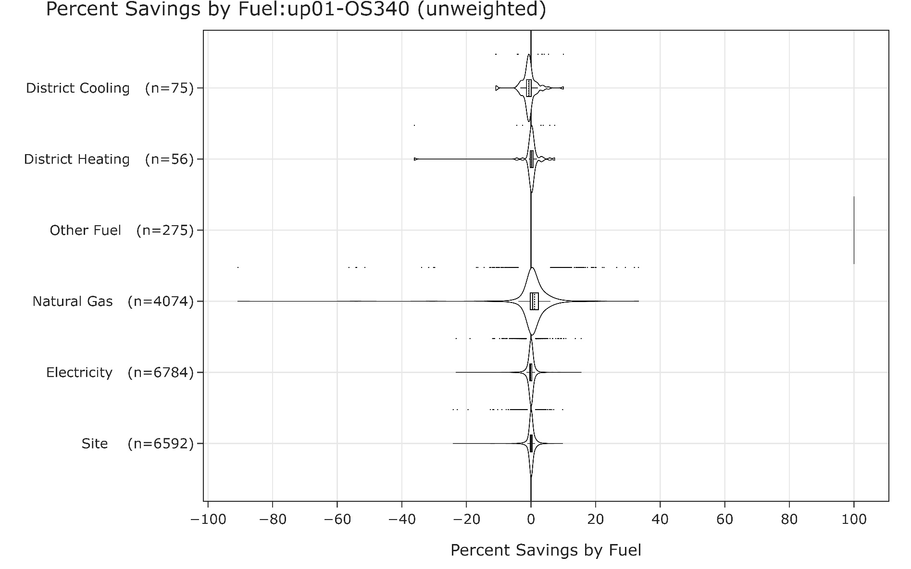

Changes in Aggregate Statistics

Unmet Hours
As the pivot tables of average unmet hours for colling and heating below show, there was a change in unmet hours. In some cases, there were extreme changes in percentage, but the resulting numbers are still within acceptable limits for the systems with large changes. Note that some systems don’t have heating or don’t have cooling, which is why some systems have very high unmet hours (for example, Gas unit heaters have no cooling). One thing this does highlight is that some of the less common systems such as direct evaporative coolers do not seem to be functional. This is something that should be investigated as part of the ongoing improvements to ComStock.

