ComStock Change
  - Hardsize Models
Implementer: Andrew Parker
Change Document Author: Andrew Parker
Reviewer: Chris CaraDonna, Matthew Dahlhausen

Description of Change

Summary
This updates ComStock to hard-size models at the end of the model articulation process such that upgrades applied to non-HVAC components of the building do not modify the size of the HVAC systems.

HVAC Sizing

Existing Method
Currently, the HVAC components inputs are autosized in the model created to represent the building at original construction. During this step, a sizing run is performed to determine capacities and flow rates and the relevant HVAC controls and efficiencies are applied, but the component inputs are left autosized.
If the model is updated to reflect non-HVAC changes, such as envelope or lighting improvements, between original construction and the year of simulation, the HVAC efficiencies and controls are not modified.
If the model is updated to reflect HVAC changes between original construction and the year of simulation, a sizing run is performed to determine capacities, assuming that HVAC is sized based on building conditions found at the time of replacement. The result is that HVAC component inputs are left autosized at the end of the baseline model articulation process.
When Upgrades are applied to these models with autosized HVAC component inputs, the HVAC system capacities, flow rates, etc. change to reflect the impact of the upgrades. For example, a building that received a wall insulation upgrade may have HVAC capacity reduced due to lower peak loads. In reality, it is unlikely that HVAC systems would be retroactively modified as a byproduct of another upgrade. In many cases, the impacts of the sizing changes are minimal relative to the impacts of the upgrades. However, in some cases, the impacts can be larger, and can lead to counter-intuitive impacts at the end-use level.

New Method
At the outset of this update, it was envisioned that the capacities would be hard-sized at original construction and then only modified again if the HVAC system were updated. However, ComStock does not track the order in which changes happened to the building between original construction and the year of simulation, and it was deemed unlikely that changes to the building that significantly increased unmet setpoint hours would be left unaddressed. Thus, in the updated workflow, after all changes to the building between original construction and the final baseline state in the year of simulation have been made, a sizing run is performed to determine equipment capacities and flow rates, then the inputs to the final baseline model are hard-sized to these values. The result is that the HVAC components are all hard-sized at the end of the baseline model articulation process. Table 1 shows the steps in the workflow, including the newly-added hard-sizing Measure.
When Upgrades are applied to the hard-sized models, the HVAC system capacities, flow rates, etc. do not change to reflect the impact of upgrades. If a particular Upgrade intentionally impacts the HVAC sizing, the OpenStudio Measure(s) for this Upgrade may elect to autosize some or all of the HVAC components, perform a sizing run, and then hard-size the final model once again. This last step of hard-sizing the final model is to ensure that if multiple Measures are included in an Upgrade Package, they don’t inadvertently change the sizing of the model. Additionally, because of this change, the order of Measures in an Upgrade Package matters; upgrading lighting then upgrading HVAC would not result in the same savings as upgrading HVAC then upgrading lighting.
Table 1. ComStock Workflow Steps
Measure Name | Measure Actions
ChangeBuildingLocation | Sets the weather file
create_bar_from_building_type_ratios | Makes geometry and assigns stub space types
create_typical_building_from_model | Add space types with lights, people, equipment, and ventilation requirements per template of original construction
 | Add schedules for all space types and associated loads
 | Add constructions and set properties per template of original construction
 | Add elevators
 | Add exterior lights
 | Add zone exhaust fans
 | Add SWH
 | Add daylighting controls
 | Add refrigeration
 | Add internal mass
 | Add thermostat for zones based on associated space types
 | Add HVAC system with default efficiencies and properties
 | Modify the schedules to match new hours of operation
 | Apply 90.1 PRM sizing parameters
 | Do a sizing run, which populates the SQL file with the EnergyPlus-calculated capacities and flows
 | Reset minimum damper positions for VAV systems per 62.1 VRP
 | Apply DOE prototype HVAC assumptions, which sets fan pressure rises and efficiencies based on flow rates, pump part-load curves, and economizer types
 | Apply HVAC controls and efficiencies per template of original construction based on equipment capacities and flow rates
 | Remove unused objects from the model
set_wall_template | Updates wall construction properties if template is newer than the template of original construction
Set_roof_template | Updates roof construction properties if template is newer than the template of original construction
set_exterior_lighting_template | Updates exterior lighting properties if template is newer than the template of original construction
set_interior_equipment_template | Updates interior equipment properties if template is newer than the template of original construction
set_service_water_heating_template | Updates SWH equipment efficiencies and controls if template is newer than the template of original construction
set_hvac_template | Move to next measure unless template is newer than template of original construction
 | Do a sizing run, which populates the SQL file with the EnergyPlus-calculated capacities and flows
 | Updates HVAC equipment efficiencies and controls based on updated equipment sizes.
simulation_settings | Modifies year and start day of week to match weather files
add_blinds_to_selected_windows | For CA buildings only, adds blinds to a fraction of the windows in the model based on building type
prototype_space_type_assignment | Adds AdditionalProperties info to space types. No changes to EnergyPlus model inputs.
set_space_type_load_subcategories | Adds subcategory names to interior lights and plug loads for reporting purposes. No changes to model results.
set_service_water_heating_fuel | If service water heating fuel is fuel oil or propane, changes natural gas water heaters to this fuel. If service water heating fuel is district heating, changes electric water heaters to this fuel. No change for models with electricity or natural gas SWH fuel (most models)
set_heating_fuel | If space heating fuel is fuel oil or propane, changes natural gas coils and boilers to this fuel. No change for models with other fuel types (most models).
set_interior_lighting_technology | Replaces interior lighting in model (originally based on code) with lighting based on a specific technology type (T12, LED, etc.)
set_interior_lighting_bpr | Changes the base-to-peak ratio for interior lighting schedules, which modifies night-time lighting operation.
set_electric_equipment_bpr | Changes the base-to-peak ratio for interior equipment schedules, which modifies night-time plug load operation.
add_hvac_nighttime_operation_variability | Sets nighttime fan and OA behavior, which may modify operation or OA damper schedules from those previously applied by a standard.
add_thermostat_setpoint_variability | Modifies the heating and cooling setpoints and setbacks/setups.
replace_baseline_windows | Replaces windows in model (originally based on code) with windows of a specific technology type (single-pane, double-pane, etc.)
hardsize_model (new step in workflow) | Do a sizing run, which populates the SQL file with the EnergyPlus-calculated capacities and flows
 | Hard-size HVAC and SWH equipment in the model based on EnergyPlus-calculated capacities and flows. No model changes from here forward will be reflected in the sizing of HVAC equipment unless done intentionally as part of an upgrade.
End of baseline model articulation process
Upgrade 1 | If the measure intends to change the sizing of the HVAC system(s), it will need to autosize the correct new or existing components, run a sizing run, and then hard-size the models such that the final model is again hard-sized.
Upgrade 2 | If the measure does not intend to change the sizing of the HVAC system(s), any impacts that the measure might have on building loads will not affect the HVAC system. This could result in models with higher or lower unmet hours than the original model.

Software Changes
From a software perspective, this change requires three modifications to the workflow. The first modification is the addition of a measure called “hardsize_model,” which happens as the last step in the baseline model articulation process. In order for this measure to work, a column called “baseline_hvac_sizing” needs to be added to the buildstock.csv, and the value should be “hardsize” to enable hard-sizing of the baseline models, or “autosize” to skip this hard-sizing in the event that we want to disable it.
The second modification is an update to OpenStudio-Standards. This modification is to remove the Ruby implementation of the OpenStudio “model.autosize()” and “model.applySizingValues()” methods. This Ruby implementation overrides the C++ implementation, and the C++ implementation is maintained by the OpenStudio team, so that method should be used.
The final modification is not to the baseline workflow, but to any Upgrade measures that need to modify HVAC systems. Those measures will need to be written to preferentially pull hard-sized equipment values then fall back to autosized values. Additionally, they will need to autosize any subset of the HVAC that they are modifying, and then re-hardsize the model afterward.

Impact of Change
These changes were tested using two 10k sample runs with identical buildstock.csv files. The original run, where the final baseline models are autosized, is called “autosz_10k,” and the new run, where the final baseline models are hard-sized, is called “hardsz_10k.” In addition to the baseline, both runs contained a single measure, Exterior Wall Insulation, which brings the insulation level of walls up to the Zero Energy Small/Medium Office AEDG recommended levels by climate zone. A comparison of the savings for this measure is presented for both runs.

National Scale Impact
As shown in Figure 1 and Figure 2 below, as desired, there was essentially no change in electricity consumption or natural gas consumption at the building stock level.
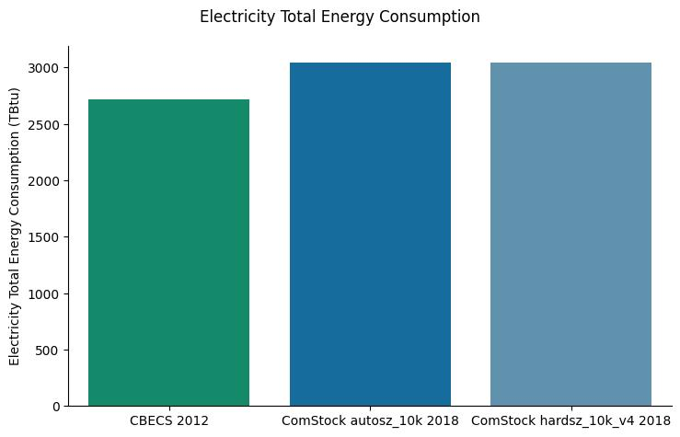
Figure 1. Total Building Stock Electricity Consumption
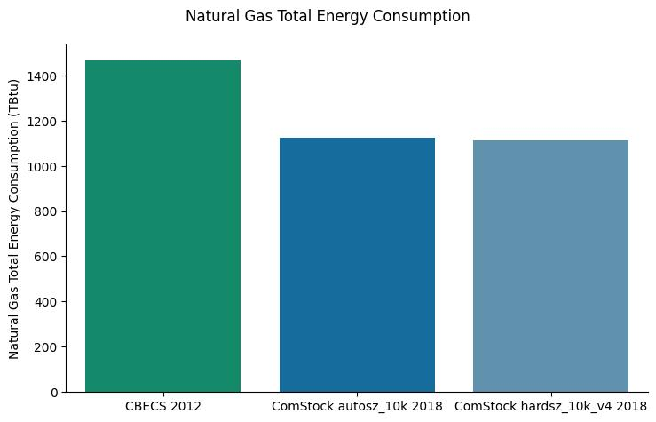
Figure 2. Total Building Stock Natural Gas Consumption
An investigation of electricity by building type in Figure 3 shows that for most building types there was no change in electricity consumption. The slight changes in a few building types was due to a slight variation in which of the 10k models timed out during each run.
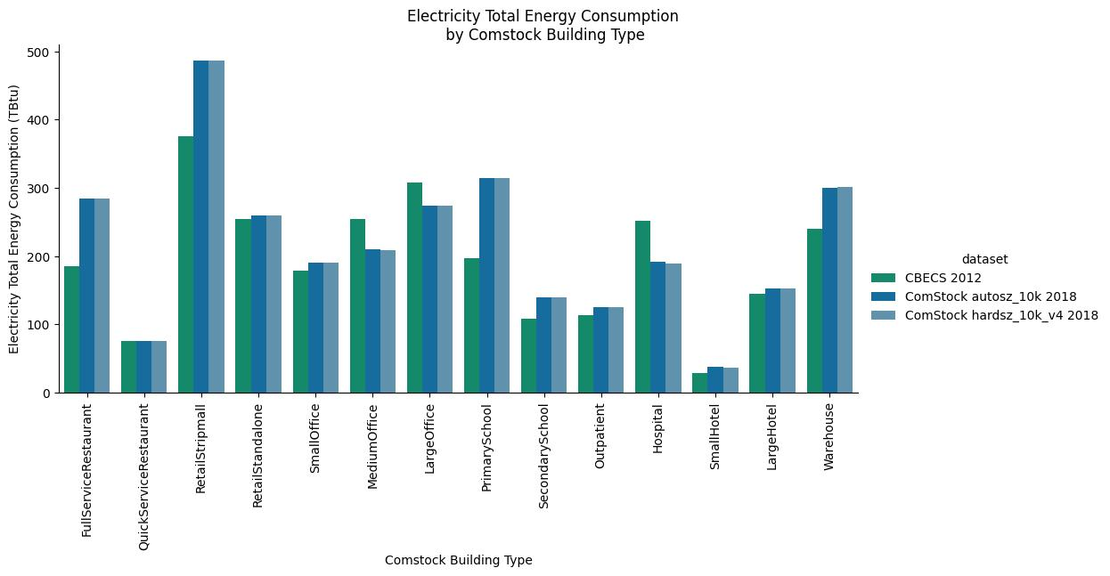
Figure 3. Electricity Consumption by Building Type

An investigation of natural gas by building type in Figure 4 shows that for most building types there was no change in natural consumption. The slight changes in a few building types was due to a slight variation in which of the 10k models timed out during each run.
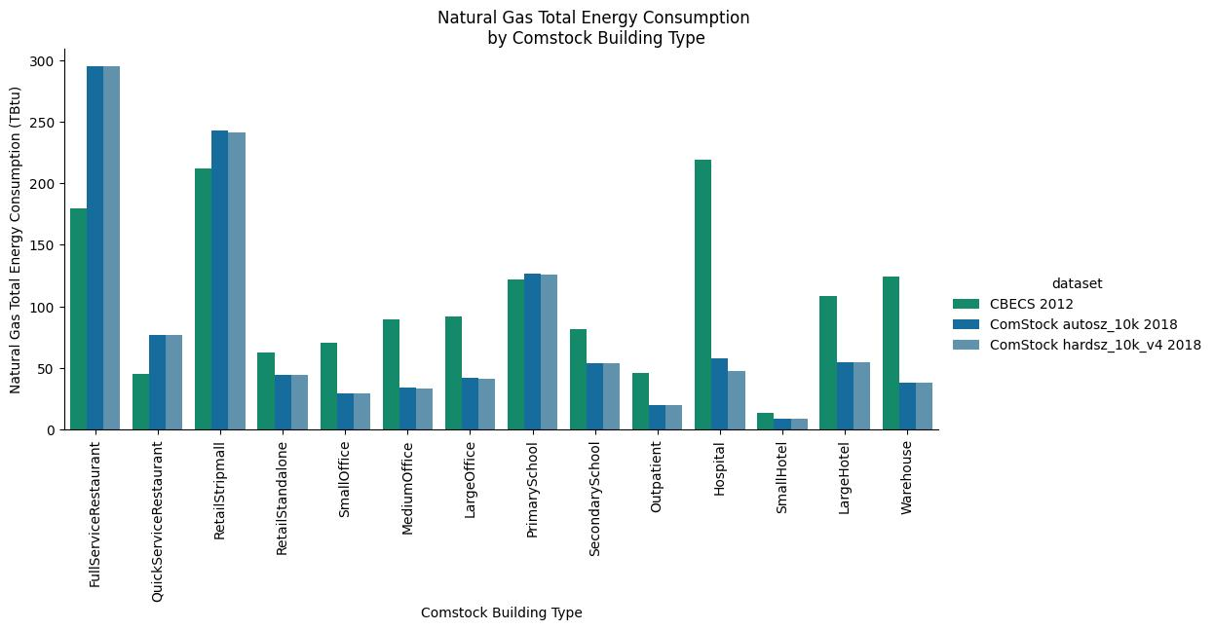
Figure 4. Natural Gas Consumption by Building Type

Distribution of Total Energy Consumption Impacts
Figure 5 and Figure 6 below show the distribution of impacts across the 10k simulations included in the test runs by total energy consumption for each fuel. In this image, the update to hard-size the baseline models was treated as an upgrade, so positive savings mean a decrease in energy consumption, while negative savings mean an increase in energy consumption from the existing, autosized baseline models. This image does not include the differences in weights between building types. As the figures show, the vast majority of changes are less than +/- 2 kBtu/sqft*yr, with most of the outliers staying within +/- 5kBtu/sqft*yr. The end uses with the largest spreads are Natural Gas and Electricity Heating, which appear to be primarily attributed to changes in models with PVAV systems. Further investigation of the inputs for PVAV systems is likely merited as part of natural gas calibration of the baseline model, but for purposes of this update the difference identified in the figures is acceptable.

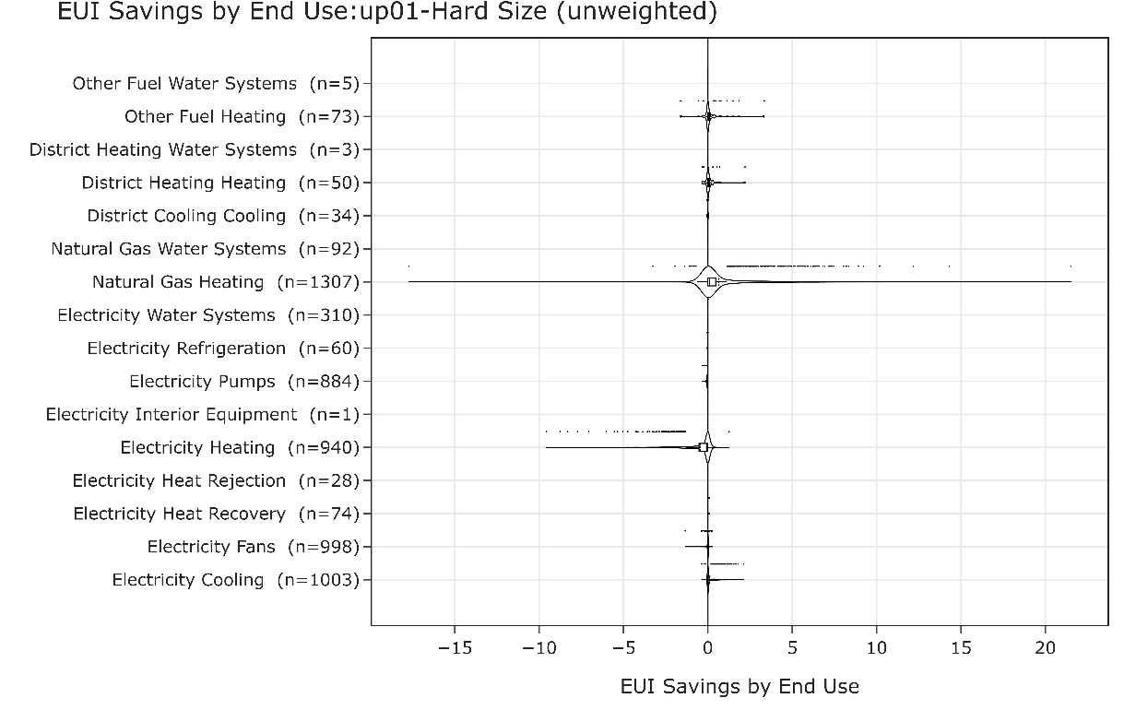
Figure 5. EUI Savings by End Use - Autosized Baseline

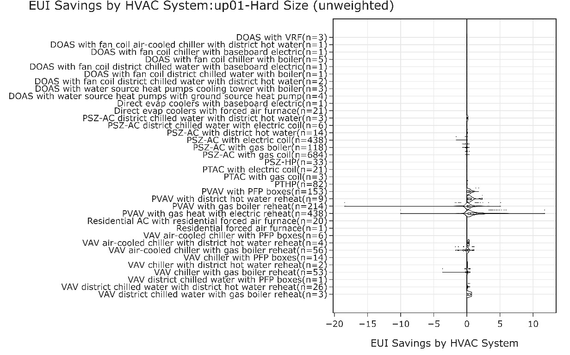
Figure 6. EUI Savings by HVAC System Type - Autosized Baseline

Changes in Aggregate Statistics

Changes Associated with Upgrades
When applying a measure that does not touch the HVAC system, such as the addition of exterior wall insulation, building characteristics such as installed heating or cooling capacity should not change. Figure 7 shows the change in cooling capacity due to adding exterior wall insulation to autosized baseline models. As expected, because the models were autosized, the HVAC systems sized were reduced to meet the newly-lowered loads. Figure 8 shows the change in cooling capacity due to adding exterior wall insulation to hard sized baseline models. As desired, because the models were hard sized, the HVAC system capacity stayed almost completely unchanged for the vast majority of buildings, with a few buildings having only minor changes. The small changes in the remaining models is unexpected, but because of the minimal magnitudes involved, these were not investigated further. As shown by the contrast between Figure 9 and Figure 10, furnace heating capacity exhibits the same change before and after the baseline model hard sizing was applied.

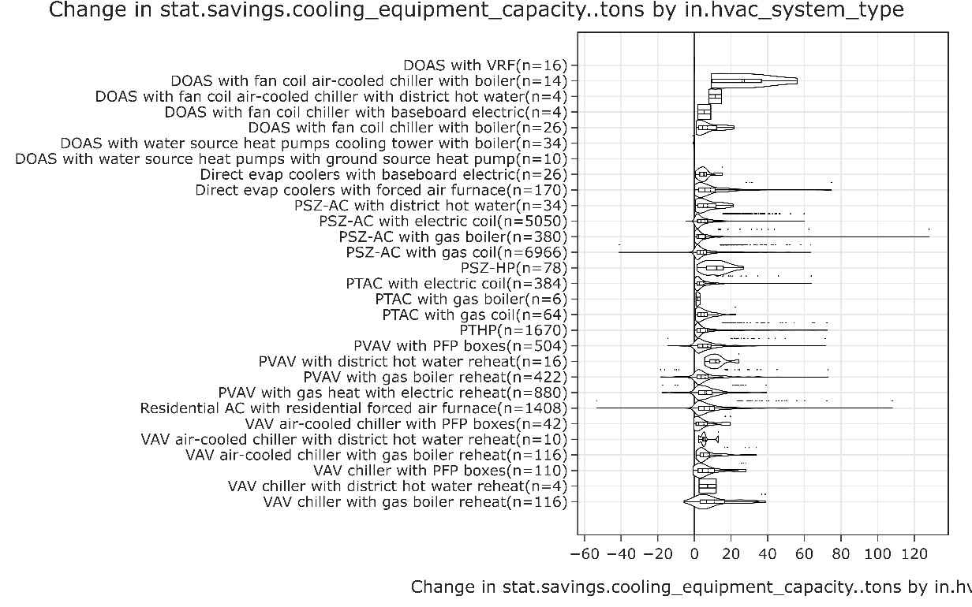
Figure 7. Change in Cooling Capacity from Wall Insulation Upgrade - Before Hard Sizing Baseline Models

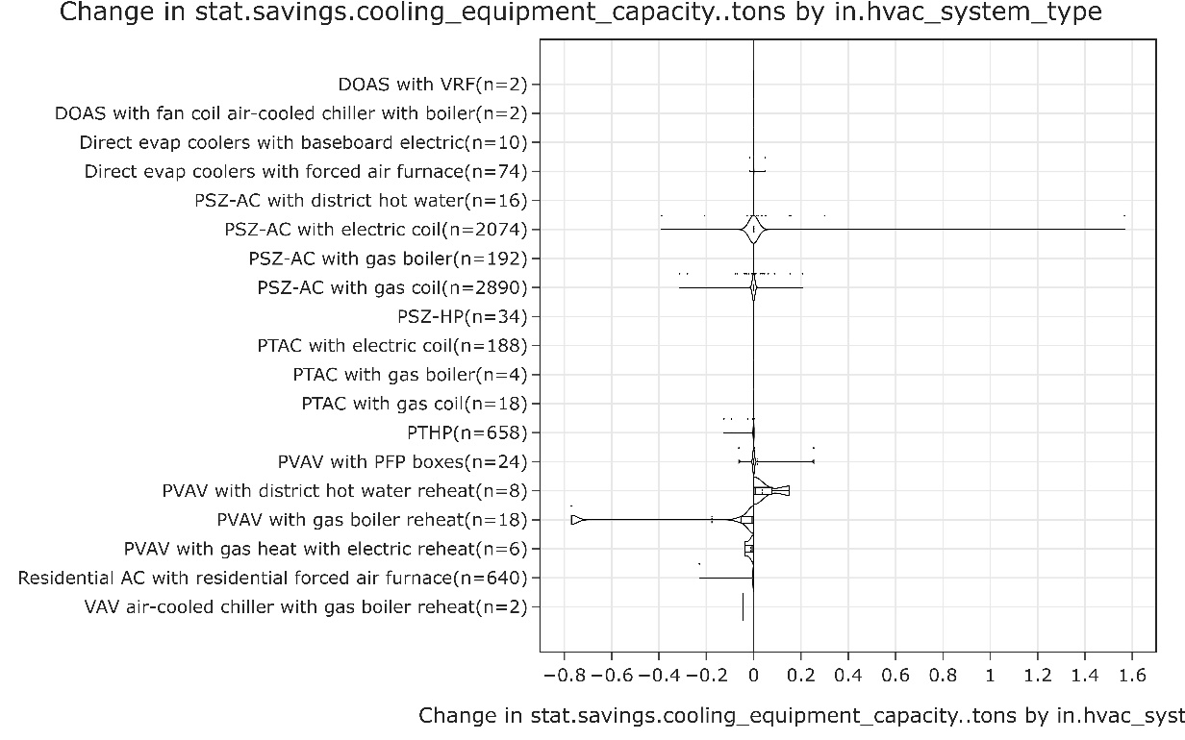
Figure 8. Change in Cooling Capacity from Wall Insulation Upgrade - After Hard Sizing Baseline Models

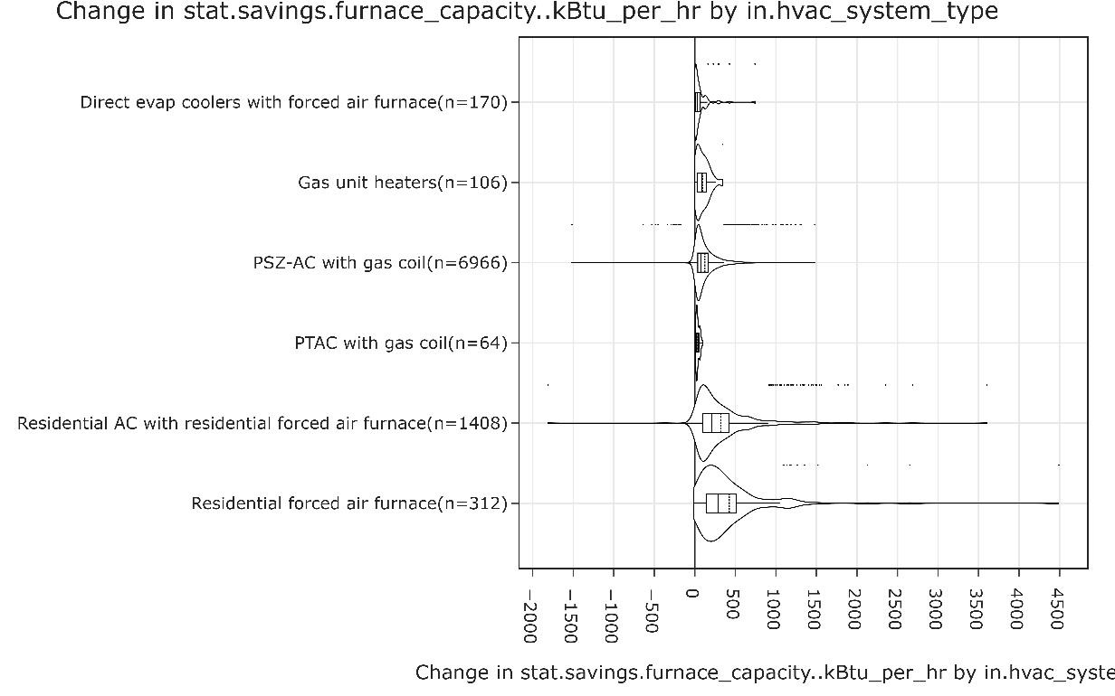
Figure 9. Change in Furnace Capacity from Wall Insulation Upgrade - Before Hard Sizing Baseline Models

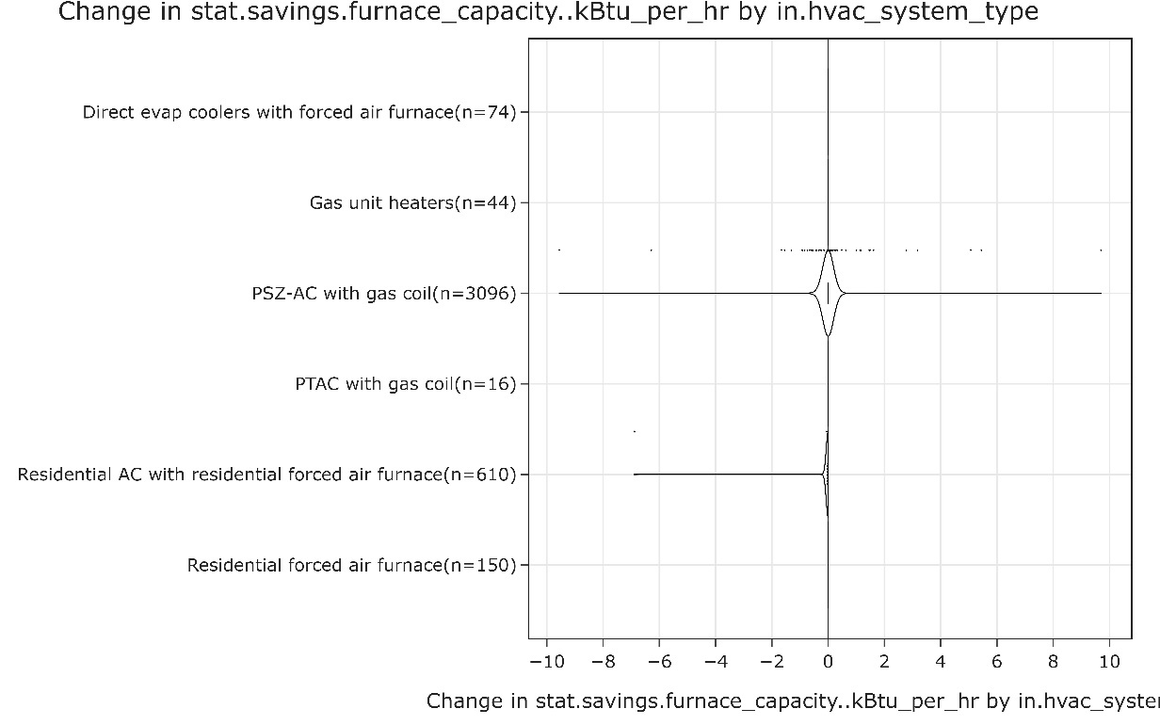
Figure 10. Change in Furnace Capacity from Wall Insulation Upgrade - After Hard Sizing Baseline Models
While some fixed characteristics such as installed heating or cooling capacity would not be expected to change as the result of a measure that does not touch the HVAC system, other operational characteristics would be expected to change somewhat. For example, adding wall insulation likely decreases the amount of time an HVAC system needs to run. Depending on the outdoor air control strategy, this may change the amount of outdoor air brought in over the course of the year. As shown in Figure 11, this change was seen before the baseline buildings were hard sized. As shown in Figure 12, this change is still seen after the baseline buildings were hard sized, but the magnitudes of the changes is smaller because the HVAC system capacities and associated design flow rates were unchanged.

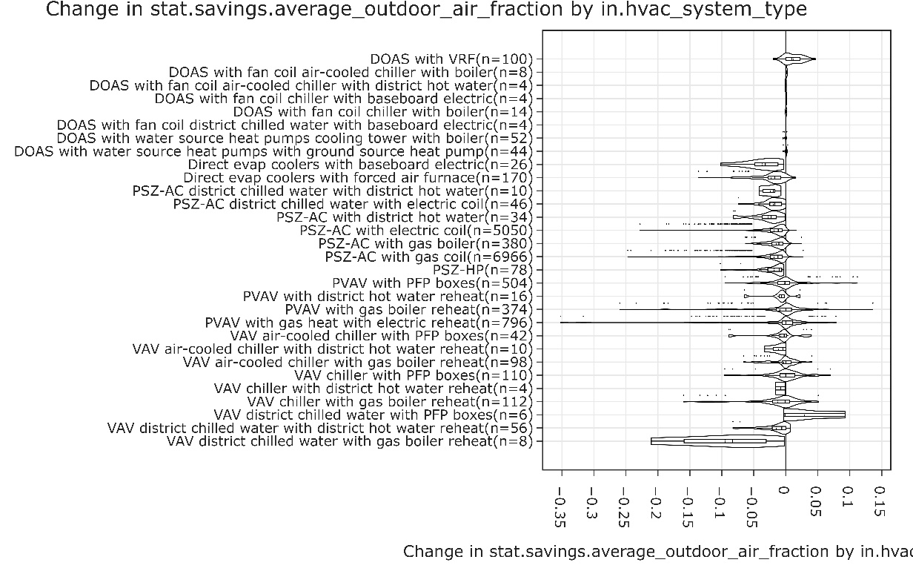
Figure 11. Change in Average OA Fraction from Wall Insulation Upgrade - Before Hard Sizing Baseline Models

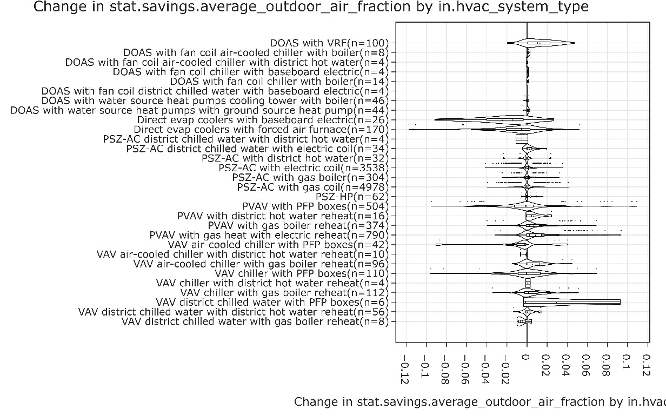
Figure 12. Change in Average OA Fraction from Wall Insulation Upgrade - After Hard Sizing Baseline Models

Changes in Baseline Model Characteristics
In addition to the model equipment capacities not changing due to the hard-sizing of the baseline models, changes to the characteristics of the baseline models would be expected to be very small if the same model were simply hard-sized before simulation. In order to investigate this, a few characteristics of the autosized and hard-sized baseline models were compared, with the autosized models acting as the baseline. As exemplified Figure 11, Figure 12, and Figure 13, the vast majority of changes are extremely small. The outliers inspected were caused by rounding differences between autosized and hard-sized values.

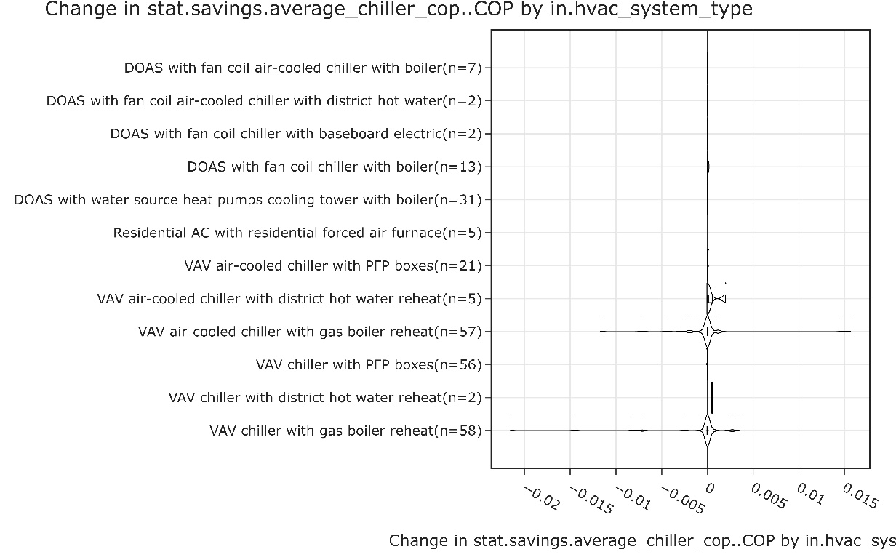
Figure 13. Change in Chiller COP Relative to Existing Autosized Method

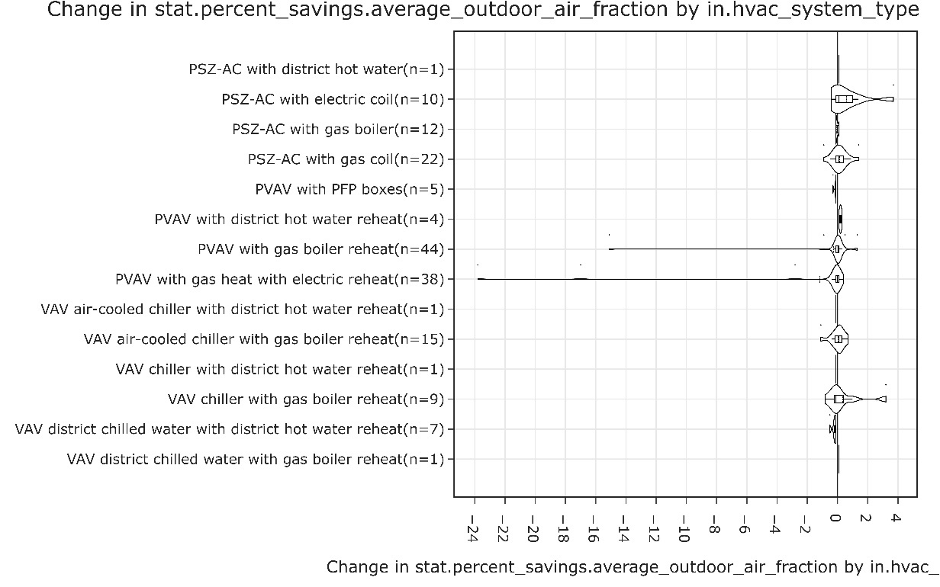
Figure 14. Change in OA Fraction Relative to Existing Autosized Method
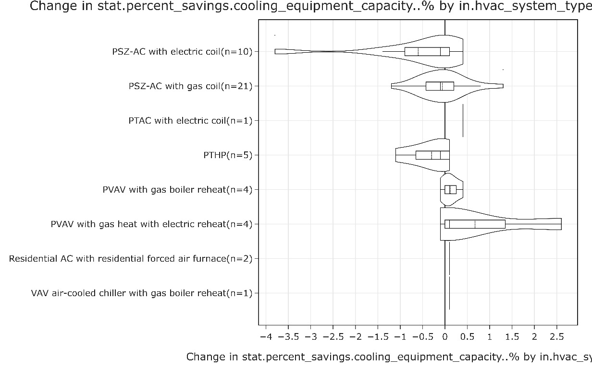
Figure 15. Change in Cooling Capacity Relative to Existing Autosized Method

Changes in Upgrade Savings Estimates
When applying a measure which should not affect equipment sizing, like exterior wall insulation, the savings in runs using the existing approach (autosized baseline model) would be the combined result of a) the savings due to reduced load from the insulation and b) the savings due to reduced equipment capacities and flows driven by the reduced load. When applying upgrades to a run using the new hard-sized baseline models, the HVAC equipment capacities remain unchanged and the only savings should be from reduced operation. Depending on the specific upgrade, how much the savings change may vary. Between the existing methodology in Figure 14 and the new methodology in Figure 15, the aggregate electricity savings is reduced by about 30%. Between the existing methodology in Figure 16 and the new methodology in Figure 17, the aggregate natural gas savings is reduced by about 20%. These changes were expected.
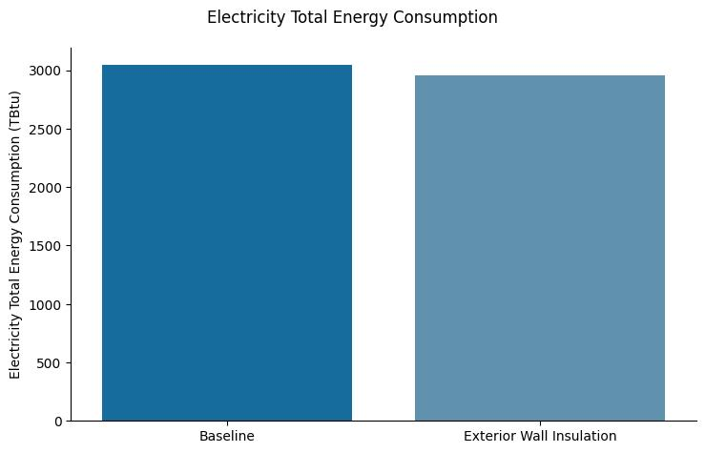
Figure 16. Savings in Electricity – Before Change
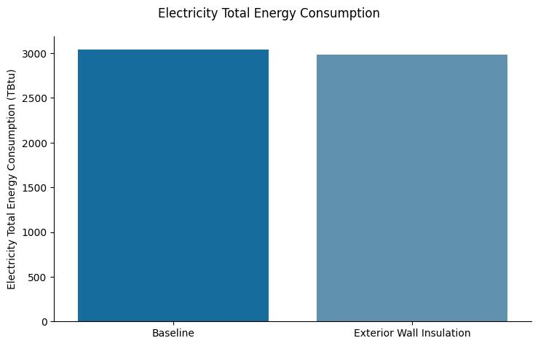
Figure 17. Savings in Electricity – After Change

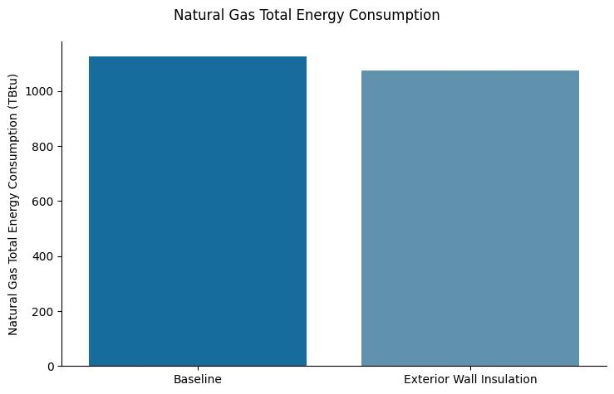
Figure 18. Savings in Natural Gas – Before Change
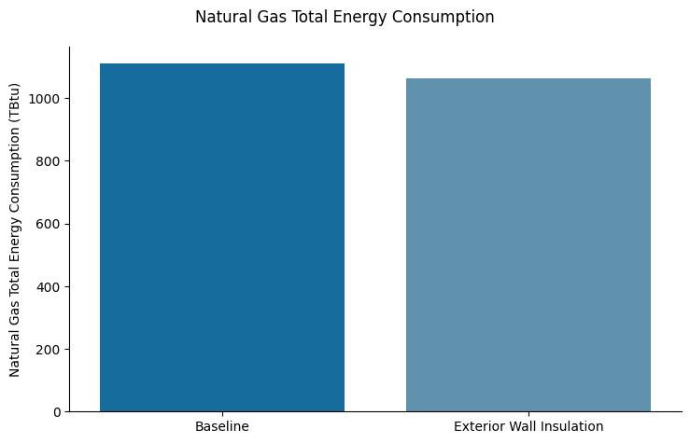
Figure 19. Savings in Natural Gas – After Change

A more in-depth look at the savings distributions before and after the change shows an additional aspect of the impact. Looking at the savings in the Natural Gas Heating category before the change (Figure 18), there are roughly ten models with negative natural gas savings. This is not an expected change due to adding wall insulation. Looking at the savings in the Natural Gas Heating category after the change (Figure 19), the number of models with negative natural gas savings decreases to two. This same impact can be seen across other end uses as well.
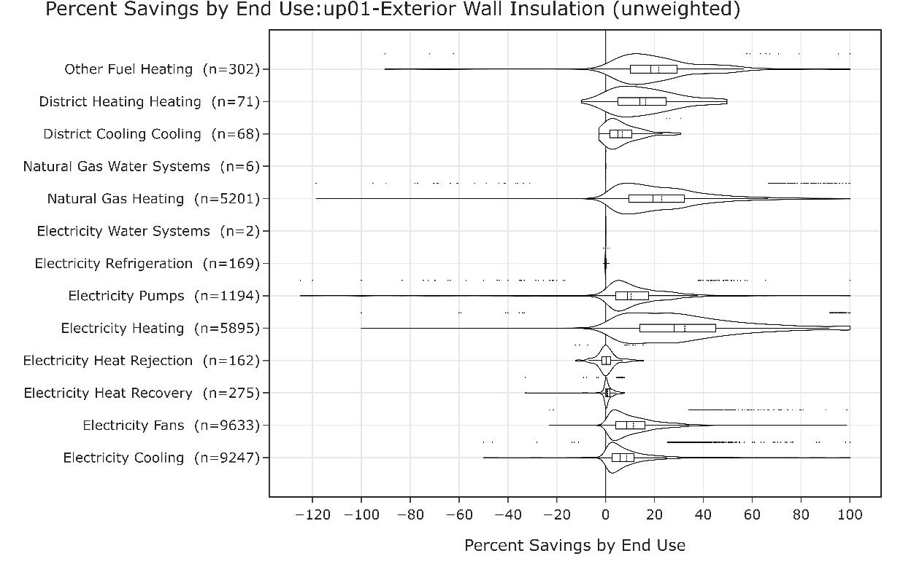
Figure 20. Savings from Wall Insulation Upgrade - Before Change

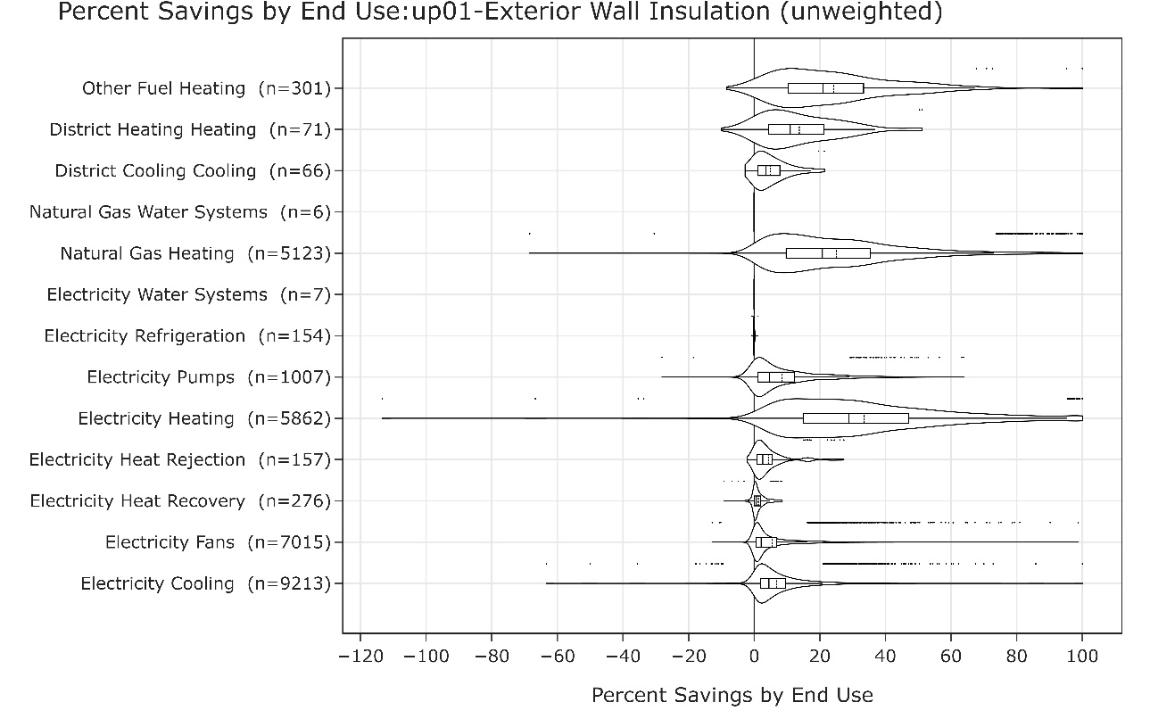
Figure 21. Savings from Wall Insulation Upgrade - After Change

