ComStock Change
  - NIST Infiltration Update
Implementer: Matthew Dahlhausen
Change Document Author: Matthew Dahlhausen
Reviewer: Andrew Parker

Description of Change

Summary
This changes the infiltration in ComStock from a fixed value across models with only a wind term coefficient to instead use airtightness ratings from the NIST airtightness database and coefficient from NIST’s CONTAM modeling of the DOE prototype building models.

Infiltration
Infiltration in ComStock models is calculated with this equation:
I_design is the design infiltration flow rate
F_schedule is a 0-1 factor schedule
A is a constant term
B is a temperature dependent term based on the zone to outside air temperature difference
C is a wind speed term
D is a wind speed squared term

Existing Method
Existing infiltration assumptions in ComStock come from the PNNl DOE Prototype buildings and are described in Gowri, Krishnan, Winiarski, David W, and Jarnagin, Ronald E. Infiltration modeling guidelines for commercial building energy analysis. United States: N. p., 2009. Web. doi:10.2172/968203.

Existing Infiltration Rates
The infiltration rates are hard-coded in openstudio-standards per standard, and ComStock doesn’t override them. The values are 5-sided infiltration rates at 75 Pa.
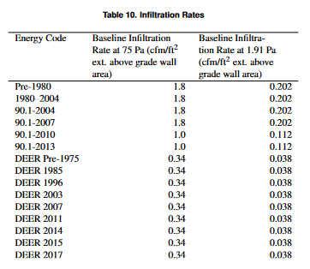
Note that for comparison to the NIST data, 1.0 cfm/ft^2 = 18.23 m^3/hr-m^2. The NIST data shows 6-sided infiltration, while the PNNL numbers are for 5-sided infiltration.
The PNNL values also assume a natural pressure of 1.906 Pa for the design infiltration rate.
Ultimately, the natural pressure value is arbitrary – and will change depending on a range of circumstances. What matters is that the design pressure and coefficients were calculated together and are dependent on each other. As an imperfect similar input, we could assume all our models have 50 W/ft^2 of equipment load, as long as they are only used with design and annual schedules fractional schedules that peak out around 0.01.

Existing Infiltration Coefficients
Existing ComStock models use only the ‘C=0.224’ term for wind driven infiltration with A=B=D=0. Why? Well that’s what DOE-2 uses. No idea why PNNL chose to stick with it – maybe it was easiest to make the regressions for?
The coefficients matter more – without a temperature term, there is no stack driven infiltration.

New Method
The new method is implemented by adding a step to the workflow set_nist_infiltration_correlations after new wall construction types are applied. The measure is separately posted on the model articulation gem repo as a replacement to NIST’s previous measure on BCL, which no longer works in recent OpenStudio versions. The measure is stand-alone and the measure description covers much of the explanation below.

Changes to Infiltration Rates
The model no longer uses a direct design infiltration rate. Instead, the design infiltration rate is calculated from airtightness data from Steven J Emmerich & Andrew K Persily (2014) Analysis of U.S. Commercial Building Envelope Air Leakage Database to Support Sustainable Building Design, International Journal of Ventilation, 12:4, 331-344, DOI: 10.1080/14733315.2014.11684027. The most significant variation is by wall construction type, shown in Figure 6 in the NIST article. Building type and vintage are not predictive. Size is predictive, but this is a function of larger buildings having a smaller surface area to volume ratio. Whether the building has an air barrier or not is predictive, but there is no way of knowing that in advance. Lisa Ng at NIST recommended using wall construction alone and going with the 6-sided airtightness data from Figure 6 in the 2014 paper. NIST has since collected a lot more airtightness data but isn’t able to share it yet. In the meantime, it’s assumed that the airtightness distributions follow a lognormal distribution with means from Figure 6 in the 2014 paper, as shown in Figure 1 below, and as calculated using this spreadsheet: https://nrel.sharepoint.com/:x:/r/sites/comstock/Shared%20Documents/ComStock%20Filing%20Cabinet/Efforts/ComStock%20Core/Infiltration/comstock_infiltration_distributions.xlsx?d=w6b42e16e5fc24dadbd4e2a7698d58a1b&csf=1&web=1&e=tLehS7
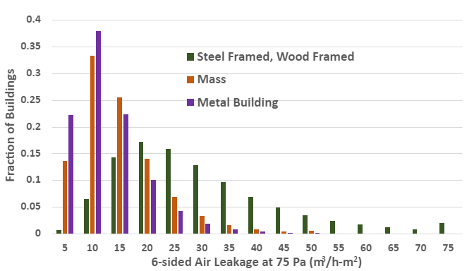
Figure 1. Distributions of Airtightness by Construction Type
The design infiltration rate is calculated as:
airtightness_value_m3_per_hr_per_m2_at_4pa = airtightness_value * ((4.0 / 75.0)**0.65)
Where the airtightness_value is the 6-sided air leakage rate at 75 Pa.
The design infiltration rate is further adjusted to translate it to a 5-sided infiltration rate in m^3/s-m^2 required by EnergyPlus. EnergyPlus does not treat ground conditions as exterior for the purposes of calculated in the infiltration rate by exterior area, thus the need to do the surface area adjustment. The calculation is commented extensively in the measure.
Looking at the distribution of airtightness values in the final models on a weighted floor area basis Figure 5 shows that the distributions match the input probability distributions as expected.

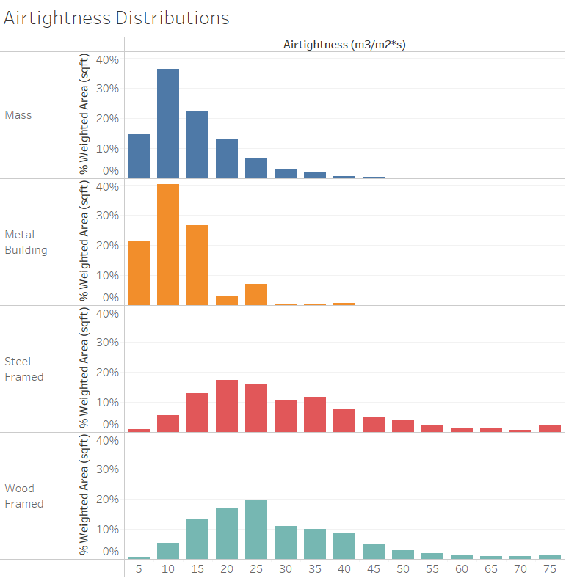
Figure 2. Distribution of Airtightness in Models

Changes to Infiltration Coefficients
ComStock has been changed to use the NIST derived coefficients by building CONTAM models of all of the DOE prototype buildings, presented in Table 2 in this article: Ng, L. , Dols, W. and Emmerich, S. (2021), Evaluating Potential Benefits of Air Barriers in Commercial Buildings using NIST Infiltration Correlations in EnergyPlus, Building and Environment, [online], https://doi.org/10.1016/j.buildenv.2021.107783, https://tsapps.nist.gov/publication/get_pdf.cfm?pub_id=931112. The table included here:
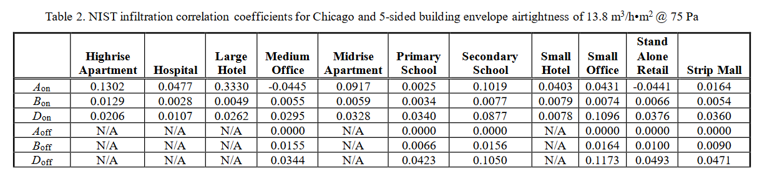The coefficients are calibrated such that with the effective leakage scaled to 75 Pa, the infiltration would match the average value from their studies.
The coefficients are A, B, and D terms (C is 0) by building type, with separate coefficients for whether the HVAC system is on or off, and also separate coefficients for whether the building has an air barrier. The new ComStock baseline does not use the air barrier coefficients, but it’d be easy to switch to those as part of future ComStock energy efficiency measure.
NIST did not model all DOE prototype buildings. Matt made some executive decisions to map the missing building types to ones NIST did model, including for DEER building types. The mapping is hardcoded in the measure and shown in the table below.
ComStock Building Type | NIST Building Type
Office | SmallOffice (<2750 ft2) / MediumOffice
Retail | RetailStandalone
Retail – Strip Mall | RetailStripmall
Warehouse | RetailStripmall
QuickServiceRestaurant | RetailStripmall
FullServiceRestaurant | RetailStripmall
Outpatient | MediumOffice
Supermarket | RetailStandalone
EPr | PrimarySchool
ESe | SecondarySchool
RtL | RetailStandalone
RtS | RetailStripmall
RSD | RetailStripmall
RFF | RetailStripmall
Mtl | SmallHotel
Htl | LargeHotel
Hsp | Hospital
OfS | SmallOffice
OfL | MediumOffice
SCn | RetailStripmall
All Others Not Listed | Same as ComStock Building Type

Software Changes
There are two changes to ComStock. First, an airtightness distribution .tsv is added to generate a distribution of 6-sided airtightness values based on the lognormal distributions explained above. Next, the set_nist_infiltration_correlations measure takes the 6-sided airtightness value at 75 Pa, converts it to a model design infiltration value, and applies the appropriate coefficients.

Impact of Change
These changes were tested using two 10k sample runs with identical buildstock.csv files. The original run, where the final baseline models are autosized, is called “autosz_10k,” and the new run, where the final baseline models are hard-sized, is called “hardsz_10k.” In addition to the baseline, both runs contained a single measure, Exterior Wall Insulation, which brings the insulation level of walls up to the Zero Energy Small/Medium Office AEDG recommended levels by climate zone. A comparison of the savings for this measure is presented for both runs.

National Scale Impact
As shown in Figure 1 and Figure 2 below, there is a modest increase in electricity use, and a significant increase in gas use at the stock level. The larger increase in heating consumption is expected, because on a hot day, the difference between indoor air (~70F) and outdoor air (~100F) is ~30F, whereas on a cold day, the difference between indoor air (~70F) and outdoor air (~20F) can be much higher ~50F. Since heating is primarily done using gas, and cooling is primarily done using electricity, the trends shown in the figures is expected.
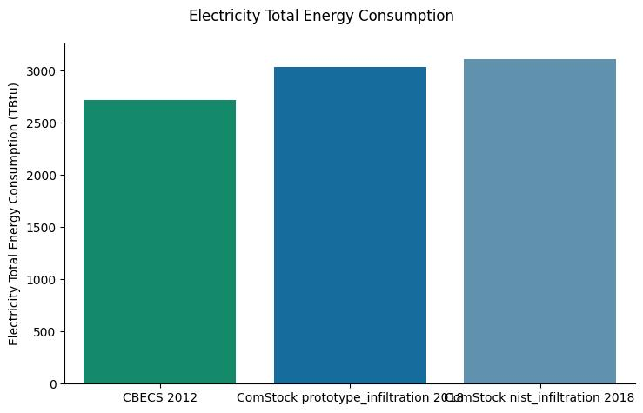
Figure 3. Total Building Stock Electricity Consumption
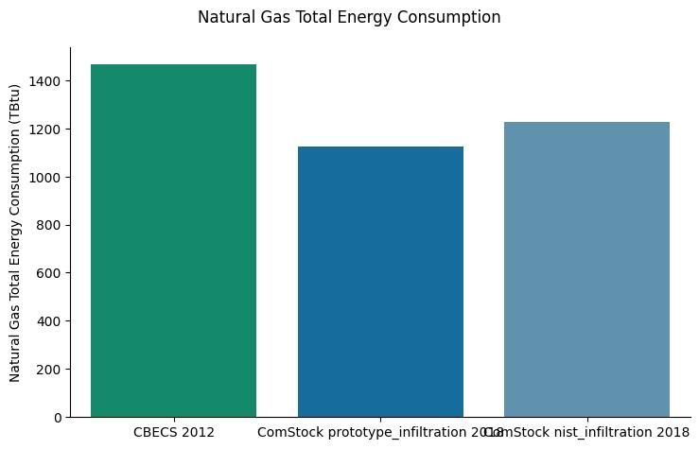
Figure 4. Total Building Stock Natural Gas Consumption
An investigation of electricity by building type in Figure 3 shows that for most building types there was little to no change in electricity consumption. Smaller buildings, including retail buildings, schools, small offices, and warehouses had the largest changes.
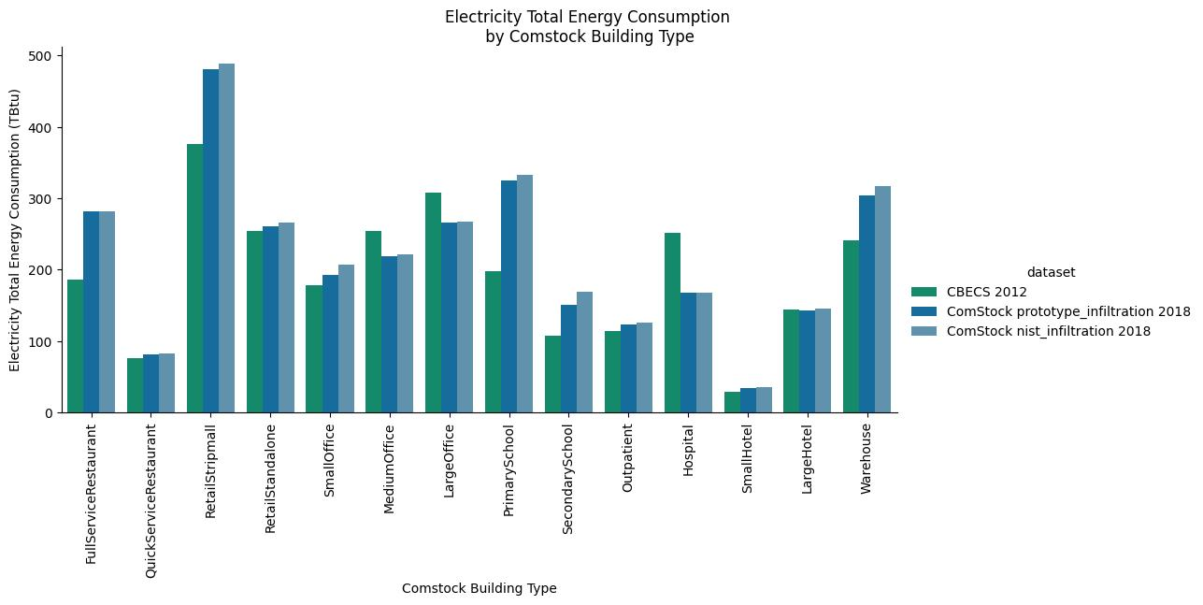
Figure 5. Electricity Consumption by Building Type

An investigation of natural gas by building type in Figure 4 shows an increase in natural gas use for most building types.
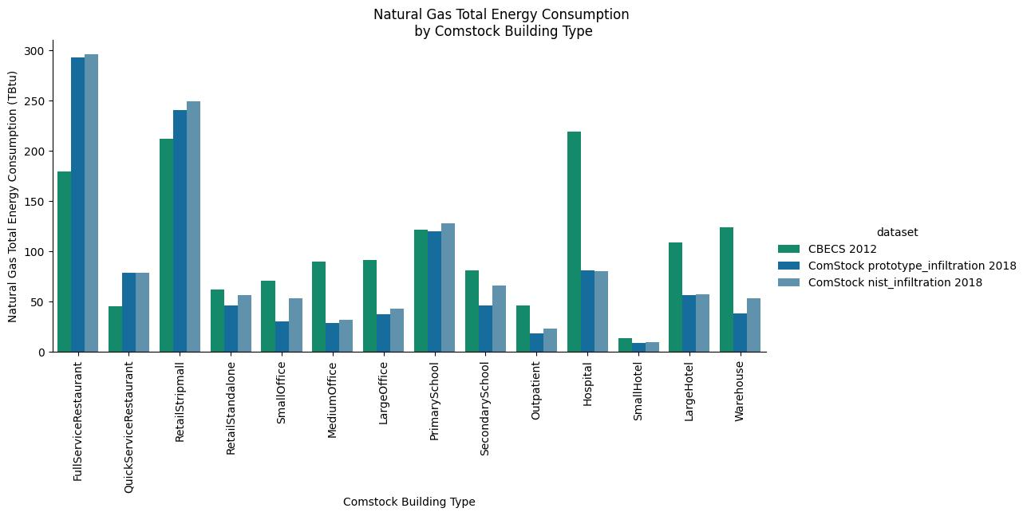
Figure 6. Natural Gas Consumption by Building Type
Looking at the distribution of gas heating EUI vs. airtightness for two different building types in Figure 7, we can see that, as expected, heating EUI generally increases as infiltration rates increase. The trend is not perfect because this data is from the 10,000 model test run, so other factors such as heating degree days are not controlled for in the plot.
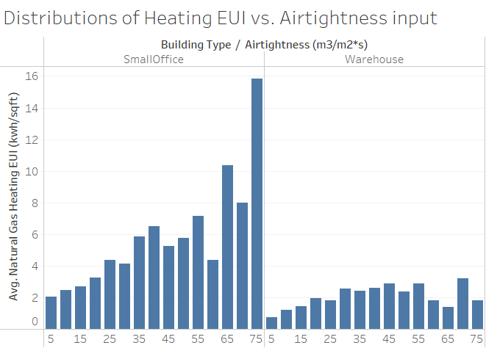
Figure 7. Distribution of Natural Gas Heating EUI by Airtightness
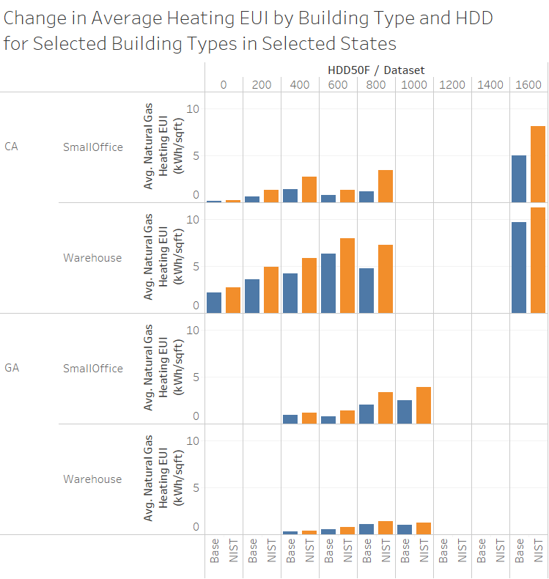
Figure 8. Natural Gas Heating EUI Change by Building Type and Heating Degree Days
As shown in Figure 8, as expected, the gas heating EUI increases more dramatically in locations with more heating degree days.
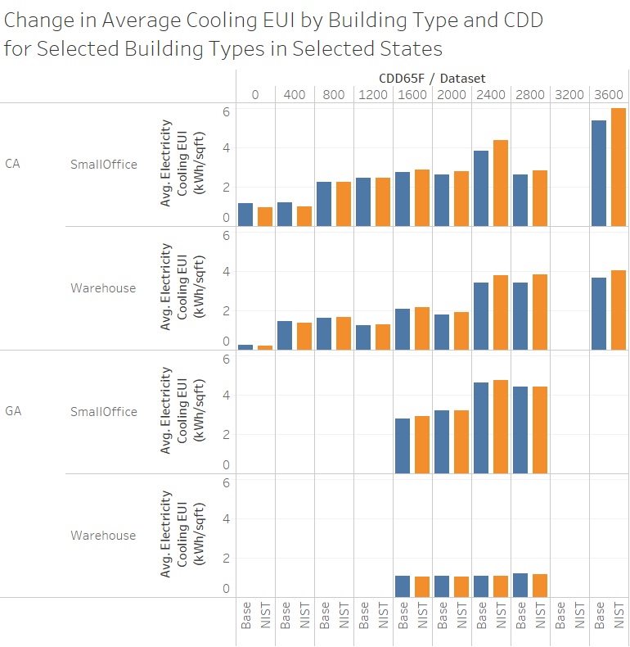
Figure 9. Electric Cooling EUI Change by Building Type and Cooling Degree Days
As shown in Figure 9, as expected, cooling electricity consumption increases more in areas with higher cooling degree days and stays almost unchanged in milder climates. The changes in electricity consumption are smaller than those for natural gas consumption, matching the national scale impacts shown in Figure 3 and Figure 4.

