ComStock Change
  - Change from CBECS 2012 to 2018 for scaling factors and main point of comparison.
Implementer: Andrew Parker
Change Document Author: Andrew Parker
Reviewer: Chris CaraDonna

Description of Change

Summary
This updates the default source for national scaling factors and the default point of comparison for ComStock from CBECS 2012 to CBECS 2018. This does not update any of the building characteristic probability distributions that may have been previously sources from CBECS 2012. Those characteristics may be updated at a future time.

CBECS Update

Existing Method
The previous approach uses the CBECS 2012 microdata to calculate the scaling factors used to weight the ComStock modeling results to be nationally representative. It also uses the CBECS 2012 microdata as the point of comparison for how well ComStock matches measured data. CBECS 2012 is not ideal for either of these uses because ComStock represents the building stock circa ~2018.

New Method
The new approach uses the CBECS 2018 microdata to calculate the scaling factors used to weight the ComStock modeling results to be nationally representative. It also uses the CBECS 2018 microdata as the point of comparison for how well ComStock matches measured data. CBECS 2018 is an improvement for both of these use cases because ComStock represents the building stock circa 2018 and typically uses 2018 weather data for published datasets.

Confidence Intervals in CBECS Results
Because CBECS is a survey, each estimate has uncertainty. For estimates with the largest number of samples (such as the total square footage of all buildings), the published 95% confidence interval (CI) is roughly +/- 10%, and estimates at lower granularity are often +/-20%. The graphic below shows the published 95% CI for total floor area estimate for CBECS building types used in ComStock. The highlighted bars and note explains how to read the figure. There is often a large overlap in the CI from version to version. An overlap does NOT indicate that the change is not statistically significant, but is useful for getting a qualitative handle on how precise CBECS is and how that changes from survey to survey. The largest changes are quantified later in Table 3.
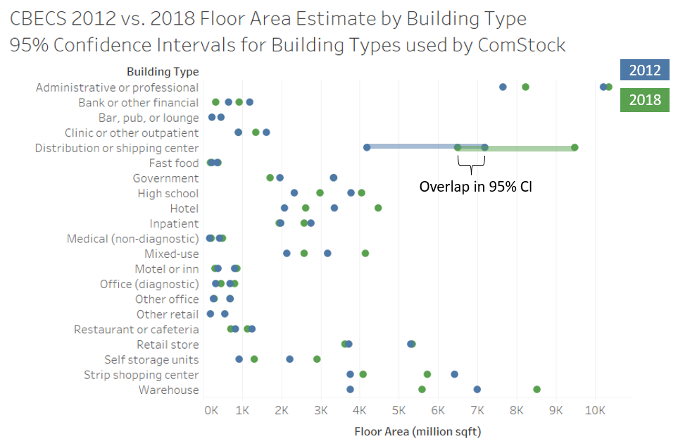
Figure 1. CBECS Confidence Interval Example for Floor Area

Impact of Change
These changes were tested by taking a single 10k ComStock run (the most recent ComStock run at the time of testing, nist_infiltration_10k_test2), and scaling this same run to both CBECS 2012 and CBECS 2018. In this way, the only differences in the results are due to the change in the CBECS microdata; the raw ComStock results are identical, but the scaling is different.

National Scale Impact
As expected, the floor area in CBECS 2012 exactly matches the floor area in the ComStock run scaled to 2012 on a building type basis, while the floor area in CBECS 2018 exactly matches the floor area in the ComStock run scaled to CBECS 2018 on a building type basis. Also as expected, the total floor area increased from 2012 to 2018 reflecting growth in the building stock.
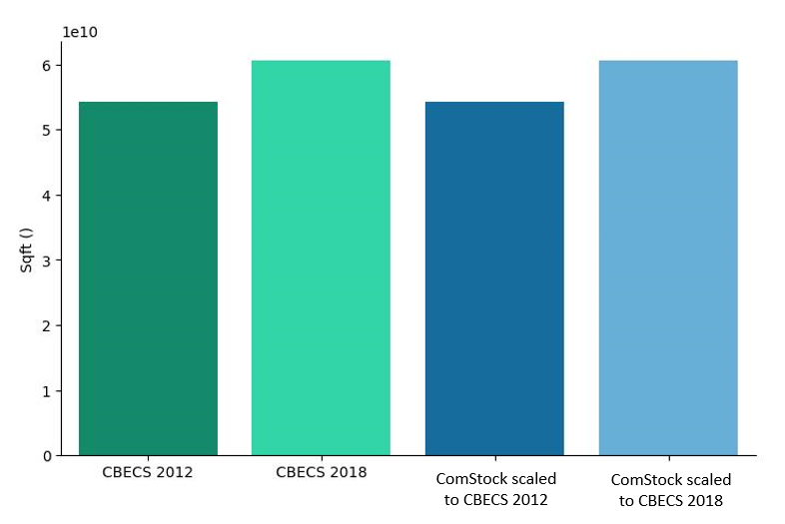
Figure 2. Floor area total. Dark blue is ComStock scaled to CBECS 2012, light blue is ComStock scaled to CBECS 2018

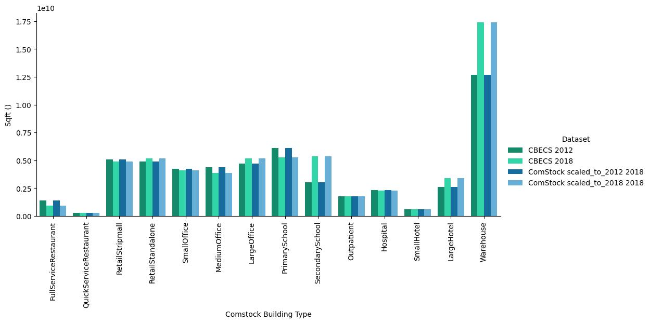
Figure 3. Floor area by building type
Looking at a breakdown of scaling factors from the ComStock run to CBECS by building type in Table 1, we see the largest decreases in Full Service Restaurants (-34%), Primary Schools (-14%), and Medium Office (-11%). We see the largest increases in Secondary Schools (+75%), Warehouses (+37%), and Large Hotels (+31%).
Table 1. Comparison of Scaling Factors from 10k Run to National Scale, CBECS 2012 to CBECS 2018
Building Type | CBECS 2012 | CBECS 2018 | Percent Change
FullServiceRestaurant | 445 | 295 | -34%
QuickServiceRestaurant | 306 | 294 | -4%
RetailStripmall | 69 | 67 | -4%
RetailStandalone | 109 | 116 | 6%
SmallOffice | 314 | 304 | -3%
MediumOffice | 369 | 328 | -11%
LargeOffice | 163 | 179 | 9%
PrimarySchool | 387 | 334 | -14%
SecondarySchool | 160 | 281 | 75%
Outpatient | 194 | 192 | -1%
Hospital | 257 | 250 | -3%
SmallHotel | 113 | 111 | -2%
LargeHotel | 481 | 631 | 31%
Warehouse | 83 | 113 | 37%

To confirm these changes, we compared the published total floor area and relative standard error between CBECS 2012 Table PBA1 and CBECS Table B15, as shown in Table 2. Scaling factor increases in Warehouse and Large Hotel were confirmed directly. CBECS does not split out Offices by size in the published tables, but the overall change in Small, Medium, and Large Office is in the same ballpark as the total change in the office sector (+4%) in CBECS. For the Full Service Restaurant change (-34%), a direct comparison is not possible because CBECS 2018 lumps Bar, pub, or lounge into Other food sales. However, the 35% decrease largely matches the 24% decrease in the overall Food service category. In ComStock, Primary School only includes elementary schools, while Secondary School includes both middle and high schools. The large change (+75%) for Secondary School is not possible to validate using the published tables because CBECS 2012 lumps elementary school with middle/junior high school, presumably because these subcategories separately had large RSEs. The +75% change in Secondary School exceeds the +15% change in the CBECS High school subcategory, which means that it stems from an increase in the estimate of Middle schools. While we do not plan to modify the CBECS data, this example reminds us that CBECS is an estimate which can have large uncertainties.
Table 2. Comparison of CBECS 2012 Table PBA1 to CBECS 2018 Table B15
ComStock Building Type | CBECS 2012  Principal building activity | 2012 Total Area (million sqft) | 2012 RSE | CBECS 2018  Principal building activity | 2018 Total  Area (million sqft) | 2018 RSE | Percent Change 2012 to 2018
 | Education | 12,239 | 5.8 | Education | 13,623 | 5.3 | 11%
Other | College or university | 1,883 | 19.7 | College or university | 1,827 | 14.1 | -3%
 | K-12 | 9,175 | 6.0 | K–12 | 10,619 | 5.9 | 16%
 | Elementary or middle school | 6,118 | 7.9
PrimarySchool |  |  |  | Elementary school | 3,626 | 10.1
SecondarySchool |  |  |  | Middle/junior high school | 1,832 | 10.7
SecondarySchool | High school | 3,056 | 12.1 | High school | 3,510 | 7.7 | 15%
 |  |  |  | Multi-grade school (any K–12) | 1,651 | 14.2
Other | Preschool or daycare | 431 | 18.4 | Preschool or daycare | 482 | 32.8 | 12%
Other | Other classroom education | 750 | 14.7 | Other classroom education | 695 | 17.7 | -7%
 | Food sales | 1,252 | 12.8 | Food sales | 1,006 | 17.0 | -20%
Other | Convenience store² | 470 | 13.5 | Convenience store (w/ or w/o gas station) | 371 | 19.2 | -21%
Other | Grocery store or food market | 763 | 18.9 | Grocery store or food market | 604 | 23.6 | -21%
Other | Other food sales | Q | 71.6 | Other food sales | Q | 58.7
 | Food service | 1,819 | 7.6 | Food service | 1,385 | 8.5 | -24%
QuickServiceRestaurant | Fast food | 302 | 11.8 | Fast food | 291 | 17.6 | -4%
FullServiceRestaurant | Restaurant or cafeteria | 1,039 | 10.1 | Restaurant or cafeteria | 924 | 11.6 | -11%
FullServiceRestaurant | Bar, pub, or lounge | 350 | 17.0
Other | Other food service | 128 | 27.6 | Other food service | 171 | 19.7 | 34%
 | Health care | 4,155 | 7.4 | Health care | 4,018 | 5.5 | -3%
Hospital | Inpatient | 2,374 | 8.2 | Inpatient | 2,259 | 7.2 | -5%
 | Outpatient | 1,781 | 11.2 | Outpatient | 1,760 | 8.0 | -1%
Outpatient | Office (diagnostic) | 510 | 18.8 | Office (diagnostic) | 638 | 14.5 | 25%
Outpatient | Clinic or other outpatient | 1,271 | 14.3 | Clinic or other outpatient | 1,122 | 10.0 | -12%
 | Lodging | 5,826 | 8.5 | Lodging | 6,976 | 8.3 | 20%
LargeHotel | Hotel | 2,717 | 11.8 | Hotel | 3,551 | 13.3 | 31%
SmallHotel | Motel or inn | 602 | 18.2 | Motel or inn | 592 | 23.9 | -2%
Other | Dormitory, fraternity, or sorority | 805 | 26.4 | Dormitory, fraternity, or sorority | 840 | 25.5 | 4%
Other | Nursing home or assisted living | 1,275 | 13.5 | Nursing home or assisted living | 1,525 | 14.3 | 20%
Other | Other lodging | 426 | 26.5 | Other lodging | 467 | 29.2 | 10%
 | Mercantile | 11,330 | 8.5 | Mercantile | 10,781 | 6.0 | -5%
 | Retail (other than mall) | 5,439 | 8.3 | Retail (other than mall) | 5,193 | 8.6 | -5%
RetailStandalone | Retail store | 4,504 | 9.0 | Retail store | 4,487 | 9.7 | 0%
Other | Vehicle dealership | 559 | 23.5 | Other retail | 706 | 19.7 | 26%
RetailStandalone | Other retail | 376 | 25.2
 | Enclosed and strip malls | 5,890 | 12.0 | Enclosed and strip malls | 5,588 | 7.6 | -5%
RetailStripmall | Strip shopping center | 5,087 | 13.3 | Strip shopping center | 4,904 | 8.5 | -4%
Other | Enclosed mall | 803 | 18.9 | Enclosed mall | 684 | 19.5 | -15%
 | Office | 15,952 | 6.1 | Office | 16,662 | 5.5 | 4%
Office | Administrative or professional | 8,937 | 7.3 | Administrative or professional | 9,294 | 5.8 | 4%
Office | Bank or other financial | 920 | 15.0 | Bank or other financial | 628 | 24.3 | -32%
Office | Government | 2,655 | 13.1 | Government | 2,526 | 16.5 | -5%
Office | Medical (non-diagnostic) | 302 | 21.6 | Medical (non-diagnostic) | 356 | 21.1 | 18%
Office | Mixed-use | 2,656 | 10.1 | Mixed-use | 3,359 | 11.9 | 26%
Office | Other office | 482 | 21.5 | Other office | 500 | 20.7 | 4%
 | Public assembly | 5,559 | 9.4 | Public assembly | 7,192 | 5.8 | 29%
Other | Library | 761 | 32.7 | Library | 433 | 24.3 | -43%
Other | Entertainment or culture | 1,266 | 14.9 | Entertainment or culture | 1,318 | 16.3 | 4%
Other | Recreation | 1,898 | 14.0 | Recreation | 2,279 | 9.1 | 20%
Other | Social or meeting | 948 | 23.1 | Social or meeting | 2,469 | 11.2 | 160%
Other | Other assembly | 685 | 16.0 | Other assembly | 694 | 17.8 | 1%
 | Public order and safety | 1,440 | 13.7 | Public order and safety | 1,538 | 15.9 | 7%
Other | Fire or police station | 572 | 21.0 | Fire or police station | 586 | 21.7 | 2%
Other | Courthouse or probation office | 436 | 29.0 | Courthouse or probation office | 452 | 19.7 | 4%
Other | Other public order | 432 | 25.1 | Other public order | 501 | 35.5 | 16%
Other | Religious worship | 4,557 | 8.8 | Religious worship | 5,471 | 9.3 | 20%
 | Service | 4,630 | 9.2 | Service | 6,240 | 8.1 | 35%
Other | Post office or postal center | 446 | 41.7 | Post office or postal center | 367 | 31.4 | -18%
Other | Repair shop | 535 | 16.8
Other | Vehicle service or repair | 1,653 | 13.6 | Vehicle service or repair | 1,923 | 15.7 | 16%
Other | Vehicle storage or maintenance | 1,311 | 14.1 | Vehicle storage or maintenance | 2,805 | 13.0 | 114%
Other | Other service | 685 | 21.1 | Other service | 1,145 | 15.1 | 67%
 | Warehouse and storage | 13,077 | 11.7 | Warehouse and storage | 17,483 | 7.2 | 34%
 | Nonrefrigerated | 12,635 | 12.0 | Nonrefrigerated | 17,155 | 7.2 | 36%
Warehouse | Warehouse | 5,377 | 15.3 | Warehouse | 7,050 | 10.6 | 31%
Warehouse | Distribution or shipping center | 5,688 | 13.6 | Distribution or shipping center | 7,998 | 9.5 | 41%
Warehouse | Self storage units | 1,571 | 21.0 | Self storage units | 2,107 | 19.4 | 34%
Other | Refrigerated | 443 | 29.8 | Refrigerated | 327 | 27.7 | -26%
 | Other | 2,002 | 15.6 | Other | 2,435 | 15.1 | 22%
Other | Laboratory | 467 | 26.0 | Laboratory | 711 | 22.9 | 52%
Other | Other | 1,535 | 18.1 | Other | 1,724 | 18.2 | 12%
Other | Vacant | 3,256 | 13.4 | Vacant | 1,612 | 14.1 | -50%

In Table 3, we focus on the CBECS building types that are used in ComStock. Using the process described by EIA, we calculate the difference between CBECS 2012 and 2018 and use the RSEs to check whether that difference is statistically significant at 95% confidence. Most ComStock building types use multiple CBECS building types, so the comparison is not perfect. However, the difference from 2012 to 2018 is only statistically significant at the 95% level for one of the individual CBECS (Distribution or shipping center) building types.
Table 3. Changes in Floor Area from CBECS 2012 to 2018 for Building Types Used in ComStock
ComStock Building Type | CBECS Principal building activity | 2012 Total floorspace (million sqft) | 2012 RSE | 2012 Std Err | 2018 Total floorspace (million sqft)3 | 2018 RSE | StdErr 2018 | Std Err  2018 - 2012 | Std Err  2018 - 2012 * 1.96 | Diff  2018 - 2012 | Diff Stat. Signif. at 95%? | Percent Change 2012 to 2018
PrimarySchool | Elementary school |  |  | - | 3626 | 10.1 | 365
SecondarySchool | Middle/junior high school |  |  | - | 1832 | 10.7 | 197
SecondarySchool | High school | 3056 | 12 | 369 | 3510 | 7.71 | 271 | 457 | 897 | 454 | FALSE | 15%
QuickServiceRestaurant | Fast food | 302 | 12 | 36 | 291 | 17.6 | 51 | 62 | 122 | -11 | FALSE | -4%
FullServiceRestaurant | Restaurant or cafeteria | 1039 | 10 | 105 | 924 | 11.6 | 107 | 150 | 294 | -115 | FALSE | -11%
FullServiceRestaurant | Bar, pub, or lounge | 350 | 17 | 60 |  |  | -
Hospital | Inpatient | 2374 | 8.2 | 195 | 2259 | 7.22 | 163 | 254 | 498 | -115 | FALSE | -5%
Outpatient | Office (diagnostic) | 510 | 19 | 96 | 638 | 14.5 | 92 | 133 | 261 | 128 | FALSE | 25%
Outpatient | Clinic or other outpatient | 1271 | 14 | 182 | 1122 | 10 | 112 | 214 | 420 | -149 | FALSE | -12%
LargeHotel | Hotel | 2717 | 12 | 321 | 3551 | 13.3 | 473 | 572 | 1121 | 834 | FALSE | 31%
SmallHotel | Motel or inn | 602 | 18 | 109 | 592 | 23.9 | 142 | 179 | 351 | -10 | FALSE | -2%
RetailStandalone | Retail store | 4504 | 9 | 404 | 4487 | 9.73 | 437 | 595 | 1165 | -17 | FALSE | 0%
RetailStandalone | Other retail | 376 | 25 | 95 |  |  | -
RetailStripmall | Strip shopping center | 5087 | 13 | 676 | 4904 | 8.46 | 415 | 793 | 1555 | -183 | FALSE | -4%
Office | Administrative or professional | 8937 | 7.3 | 656 | 9294 | 5.83 | 542 | 851 | 1668 | 357 | FALSE | 4%
Office | Bank or other financial | 920 | 15 | 138 | 628 | 24.3 | 152 | 205 | 403 | -292 | FALSE | -32%
Office | Government | 2655 | 13 | 347 | 2526 | 16.5 | 416 | 542 | 1062 | -129 | FALSE | -5%
Office | Medical (non-diagnostic) | 302 | 22 | 65 | 356 | 21.1 | 75 | 99 | 195 | 54 | FALSE | 18%
Office | Mixed-use | 2656 | 10 | 267 | 3359 | 11.9 | 398 | 480 | 940 | 703 | FALSE | 26%
Office | Other office | 482 | 22 | 104 | 500 | 20.7 | 103 | 146 | 287 | 18 | FALSE | 4%
Warehouse | Warehouse | 5377 | 15 | 823 | 7050 | 10.6 | 749 | 1113 | 2181 | 1673 | FALSE | 31%
Warehouse | Distribution or shipping center | 5688 | 14 | 771 | 7998 | 9.53 | 762 | 1084 | 2125 | 2310 | TRUE | 41%
Warehouse | Self storage units | 1571 | 21 | 330 | 2107 | 19.4 | 408 | 525 | 1029 | 536 | FALSE | 34%

Looking at the distribution of floor area by vintage, for CBECS 2018, the biggest change is the addition of buildings built after 2012, although the other vintages change somewhat as well. ComStock continues to include substantially more buildings of the pre-1946 vintage and substantially fewer of the 2000 to 2012 vintage relative to CBECS.
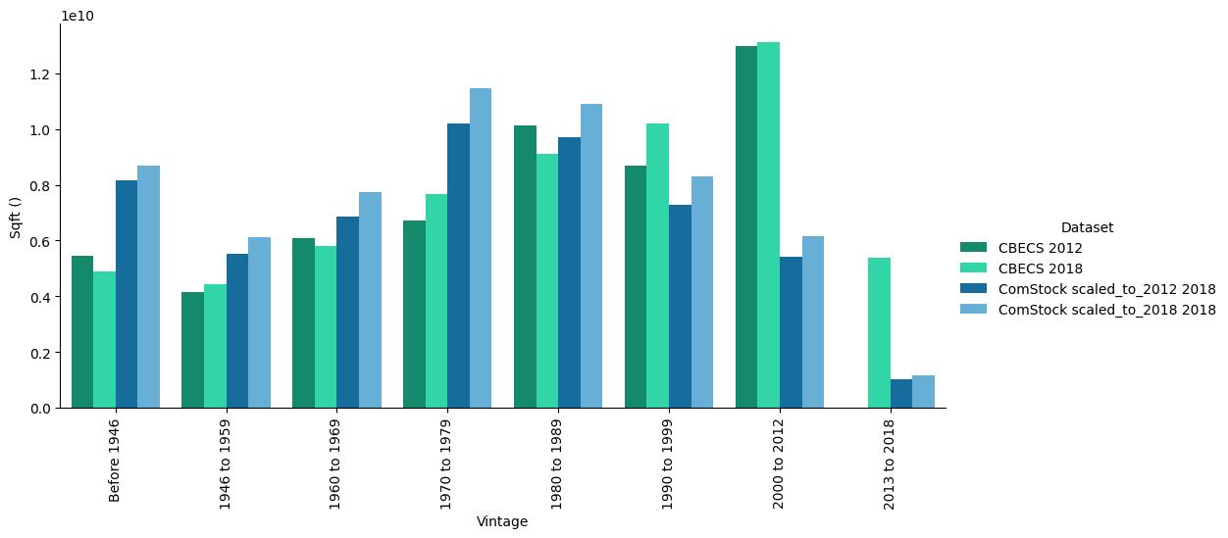
Figure 4. Floor area by vintage

Looking at the distribution of floor area by census division, for CBECS 2018, the biggest changes are the increase in floor area in the east north central and mountain divisions. The changes in ComStock roughly mirror the geographic changes in CBECS. Note that ComStock applies scaling factors to align with CBECS square footage nationally, not by census division, so some difference is expected between the two at the census division level.
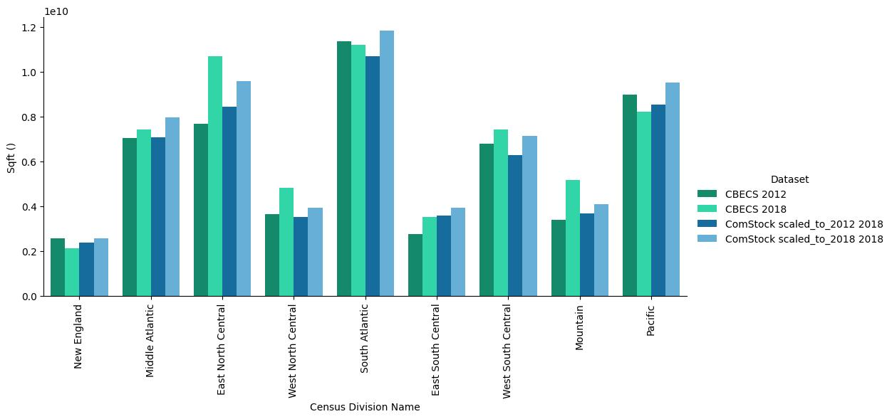
Figure 5. Floor area by census division

Focusing on the distribution of warehouses, the largest relative changes happened in the east north central, east south central, and middle Atlantic divisions. There is an overall improvement in the match between CBECS 2018 and ComStock on a census division basis for warehouses.
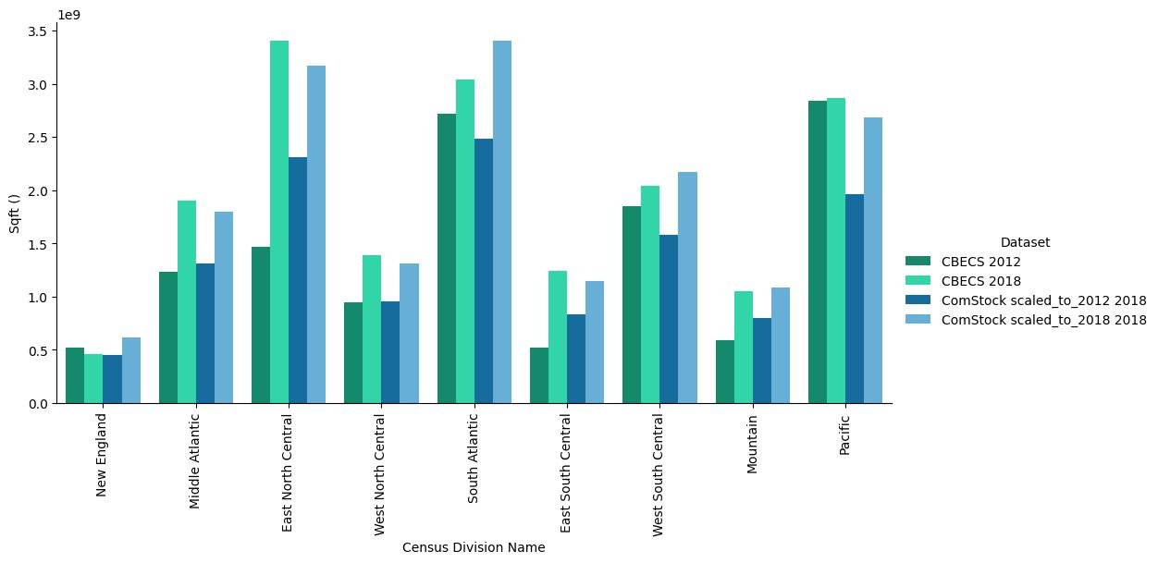
Figure 6 Floor area of warehouses by census division

Focusing on the distribution of secondary schools, the largest difference between CBECS and ComStock continues to be a significant over-representation of schools in the pacific division. This can occur since ComStock area is scaled to align with CBECS on a per building type basis nationally, not by census division. Otherwise there isn’t much change in the difference between ComStock and CBECS 2018 compared to CBECS 2012.
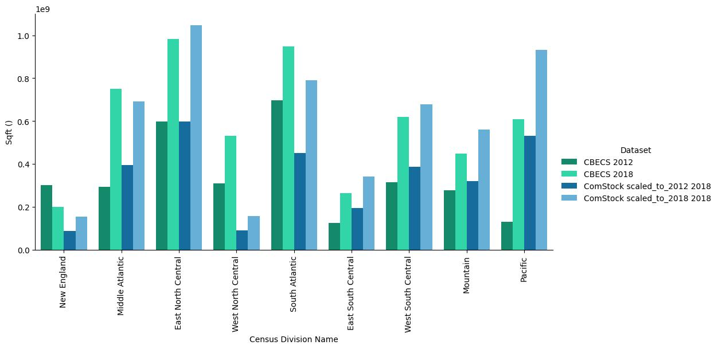
Figure 7. Floor area of secondary schools by census division

Focusing on the distribution of full service restaurants, there was a decrease in all divisions except mountain. The biggest changes in CBECS were in the west north central, south Atlantic, and west south central divisions. Generally, ComStock shows similar area alignment with CBECS 2012 and 2018 on a geographic basis.
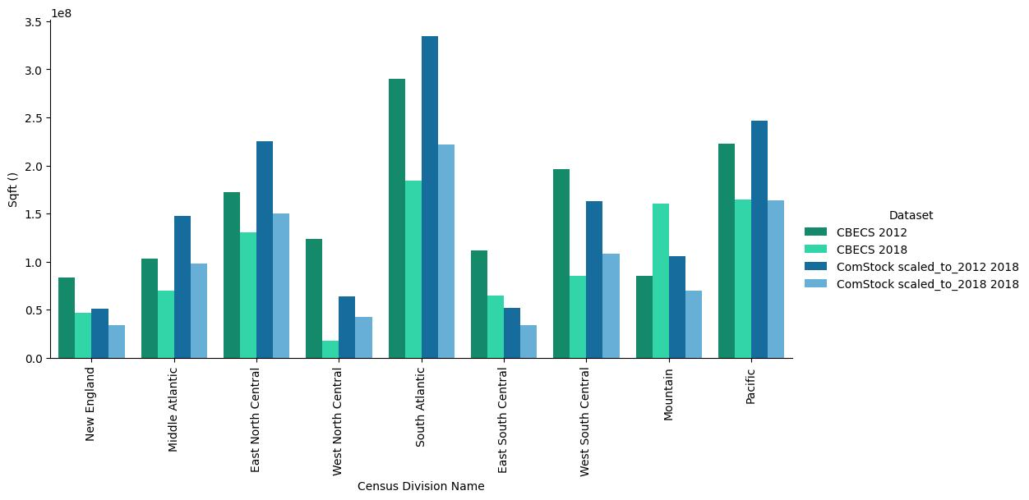
Figure 8. Floor area of full service restaurants by census division

Looking at annual electricity consumption, CBECS shows a small decrease while ComStock shows a small increase. This means that ComStock is further away from CBECS 2018 electricity consumption than it was from CBECS 2012.
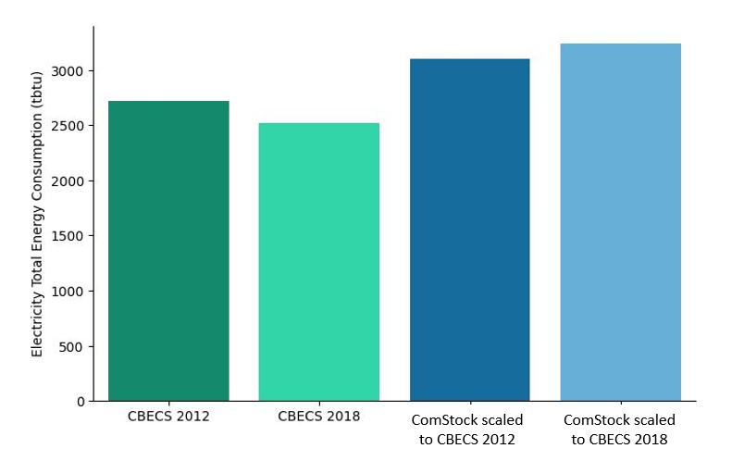
Figure 9. Total annual electricity consumption

Looking at the annual electricity consumption by building type, the differences between ComStock largely remain the same, with the most notable changes in the building types also having the largest change in floor areas; Full Service Restaurants, Secondary Schools, and Warehouses. The Warehouses that were added to the stock appear to be less electricity-intensive than ComStock assumes.
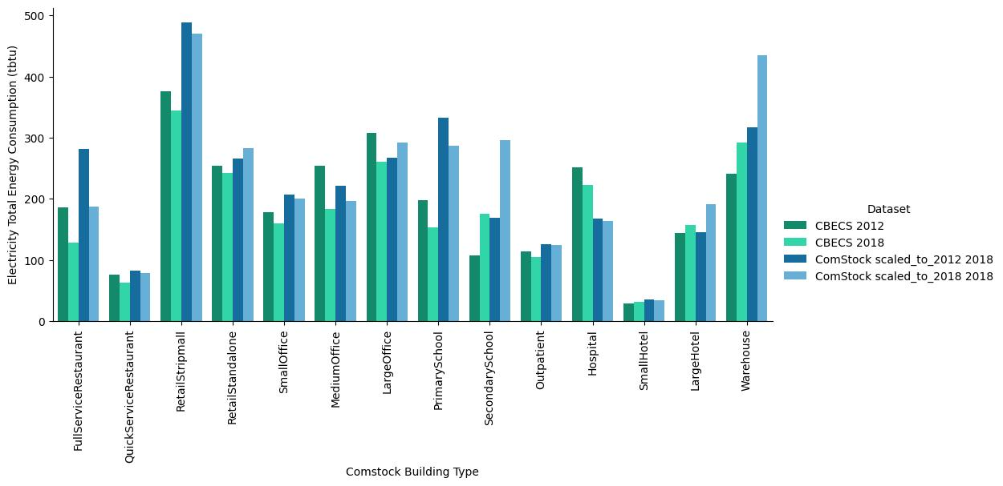
Figure 10. Electricity consumption by building type

Looking at the distribution of electric EUIs, there were slight shifts in the distributions between CBECS 2012 and 2018, the most notable being the increase in full service restaurants. However, there was a slight decrease in the mean in most building types, which broadly aligns with the slight stock-wide reduction in electricity consumption.
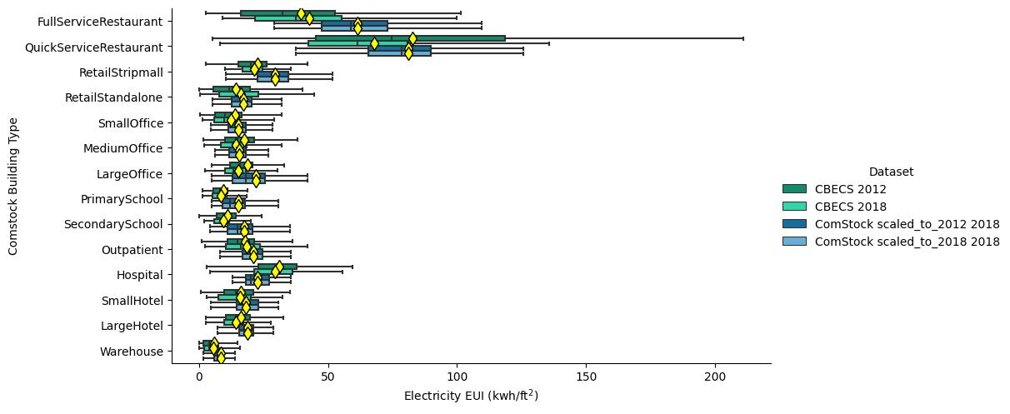
Figure 11. Distribution of electric energy use intensity by building type
Looking at annual natural gas consumption, CBECS shows an almost imperceptible change, while the rescaled ComStock shows a small decrease. This means that ComStock is slightly further away from CBECS 2018 natural consumption than it was from CBECS 2012.
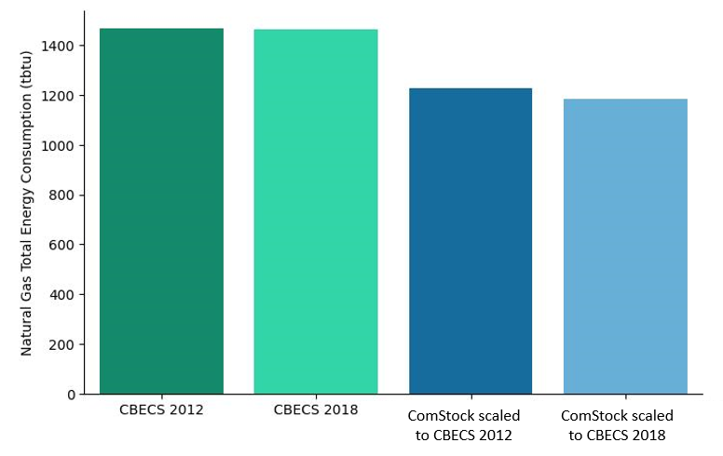
Figure 12. Total annual gas consumption

Looking at natural gas consumption by building type, the most notable changes between CBECS 2012 and 2018 are in the building types with the largest floor area changes. However, the change in natural gas consumption in hospitals (-20%) is much larger than the decrease (-3%) in hospital floor area would suggest.
The difference between ComStock and CBECS 2018 continues to be an over-estimate in buildings with kitchens and an under-estimate in all other building types.
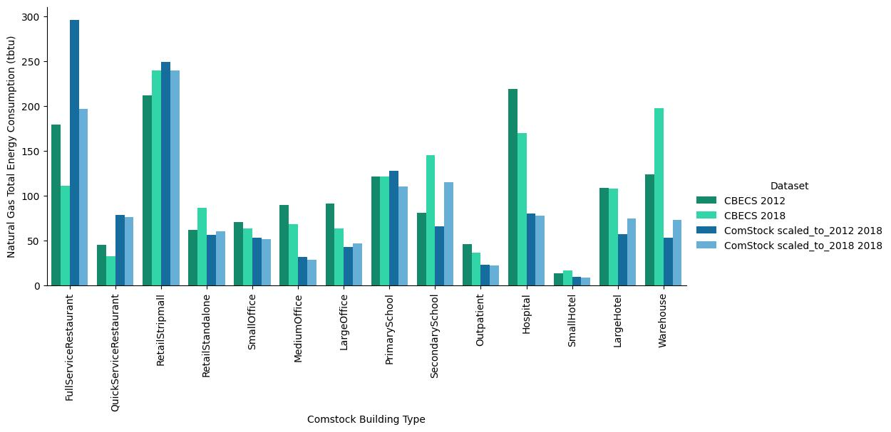
Figure 13. Natural gas consumption by building type

Looking at the distribution of natural gas EUIs, the most notable change is a decrease in natural gas EUI for hospitals. There is a small decrease in the mean EUI for most building types. Overall, the small decrease in EUIs seems to counter-balance the growth in building floor area, resulting in essentially no change in the stock-wide natural gas consumption.
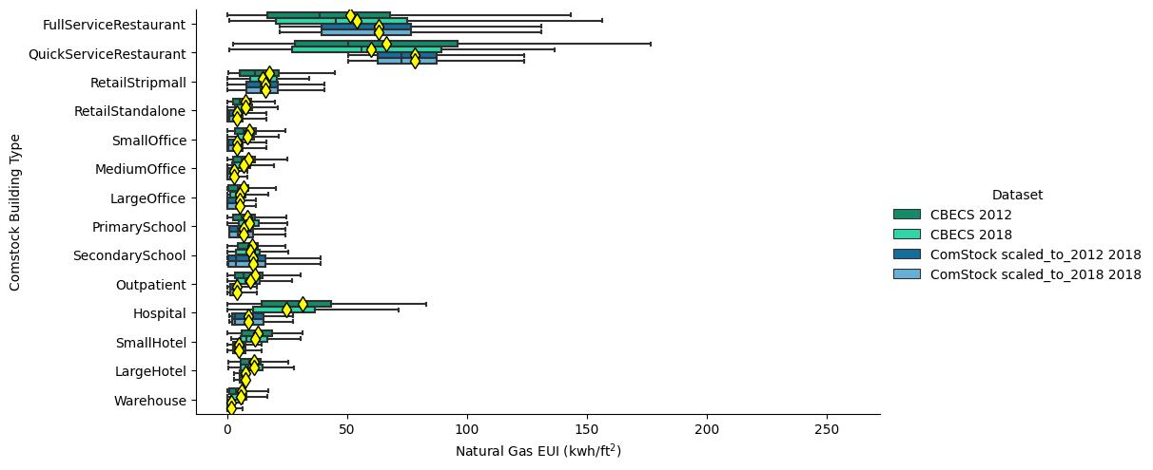
Figure 14. Distribution of natural gas energy use intensity by building type

Zooming in on the three largest natural gas end uses in hospitals, there is no clear pattern for heating consumption, while interior equipment estimates mostly increase, and water systems consumption estimates mostly decrease, often dramatically (> 50%).
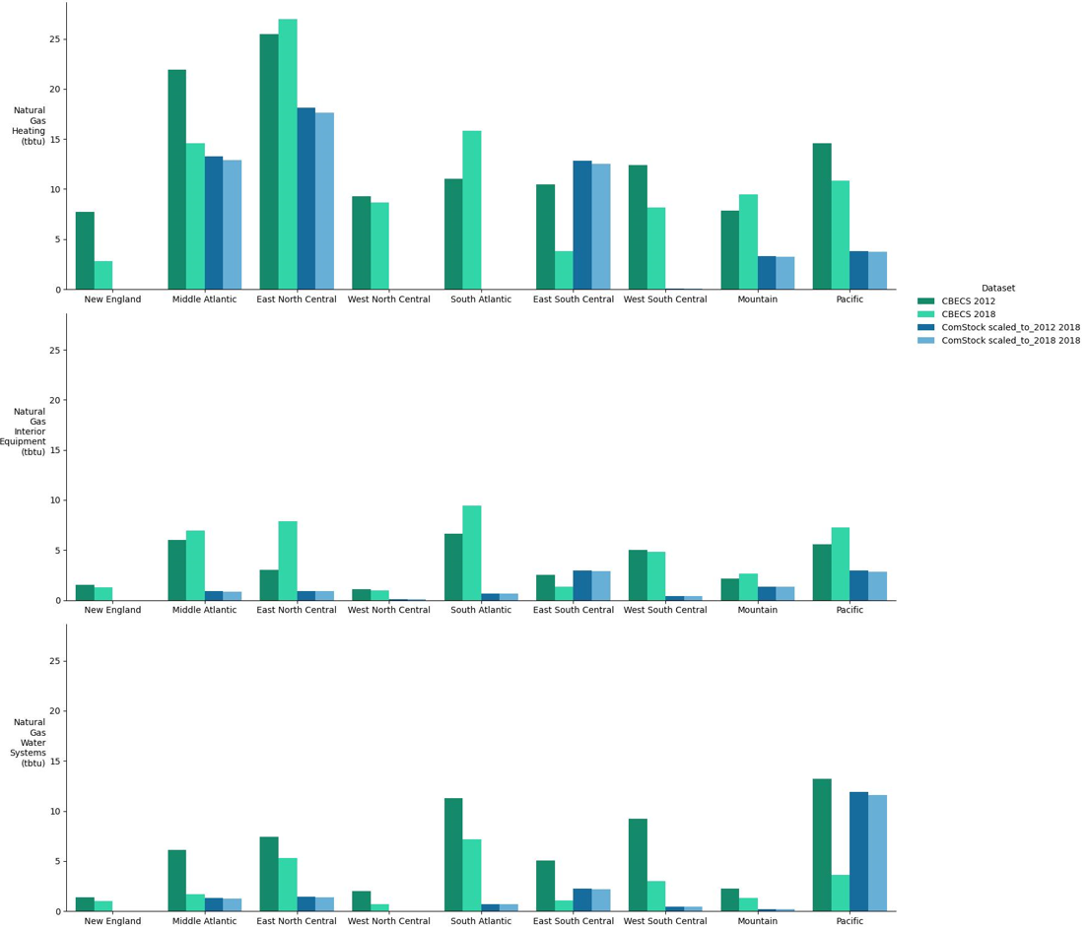
Figure 15. Natural gas consumption by end use and census division
Renovations in CBECS:
- For buildings built before 2012, ask “Has any part of this building undergone renovations?”
As the image below shows, slightly less than half of the building square footage represented in CBECS 2018 has had renovations of any type since 2000.
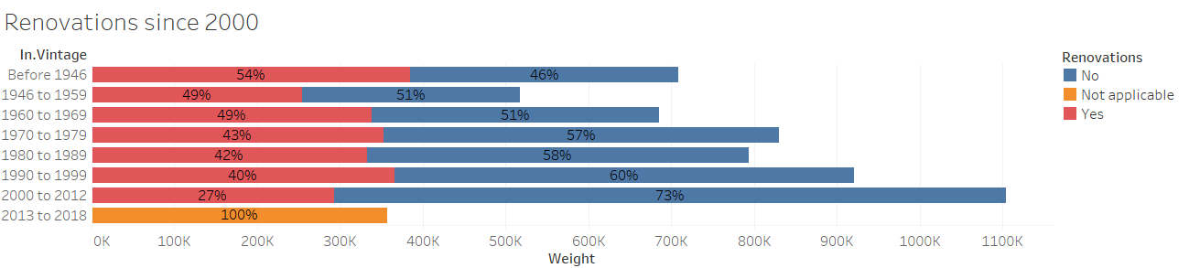
- If year built < 2012 and renovations = Yes, ask “Which renovations have happened since the year 2000? Select all that apply.”
- Cosmetic improvements (interior or exterior) (Examples: new paint, siding, furniture, wallpaper, carpeting)
- Addition or annex Reduction of enclosed floorspace (Example: demolition of unused wing of building)
- Interior wall re-configuration (Example: individual offices turned into area for cubicles)
- Roof replacement
- Window replacement
- HVAC (heating, ventilation, or air conditioning) equipment upgrade
- Lighting upgrade
- Plumbing system upgrade (includes hot water heaters)
- Electrical upgrade
- Insulation upgrade
- Fire, safety, or security upgrade
- Structural upgrade (Examples: foundation upgrade, seismic upgrade)
- Other
In the figures below, “Not applicable” is shown for all the buildings that answered “No” to the previous question about renovations. Only buildings answering “Yes” indicated a renovation in the relevant building system since 2000.
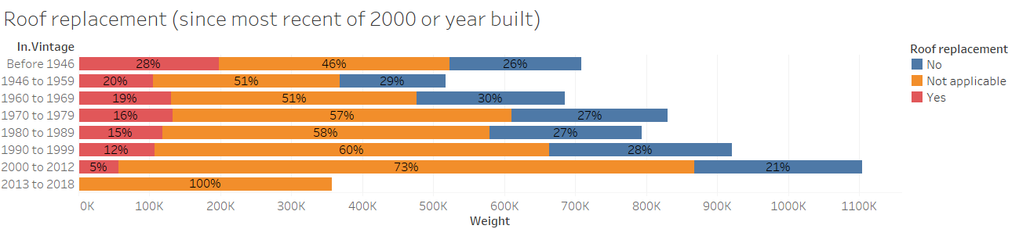
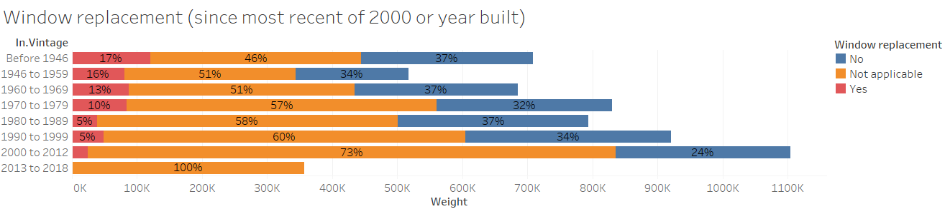
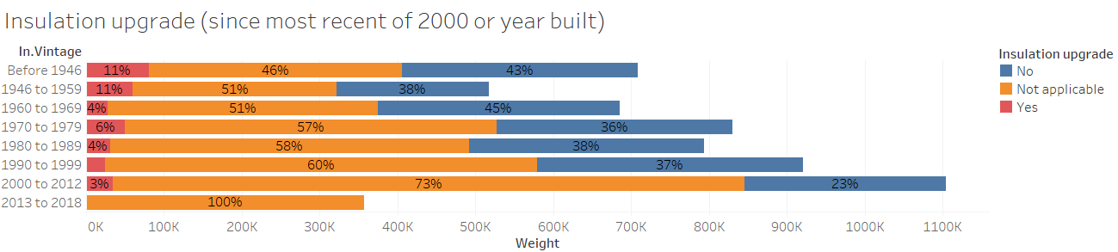
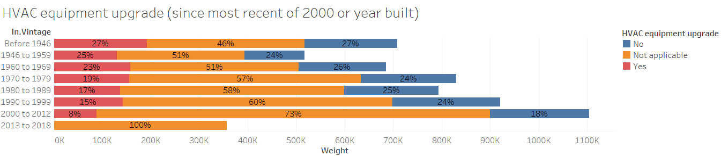

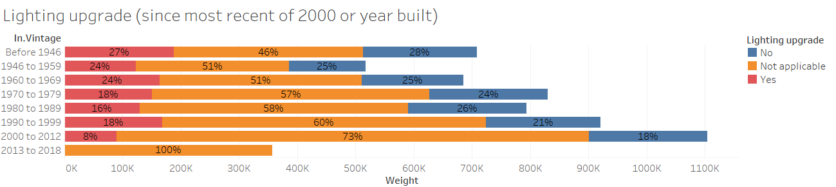
The lighting upgrade question allows a rare chance to check the consistency of CBECS. LED lighting was not commonly installed in commercial buildings until the mid-2000’s. Therefore, any building that has not had a lighting upgrade since 2000 should not have LED lighting. However, as shown in the figure below, many of the buildings which reportedly had “No renovations” or “No lighting upgrade” since 2000 also report being 10% or more lit by LED lighting. This contradiction holds true even when all of CBECS imputations are filtered out, leading to the conclusion that it is likely that one of these questions is not reported accurately.
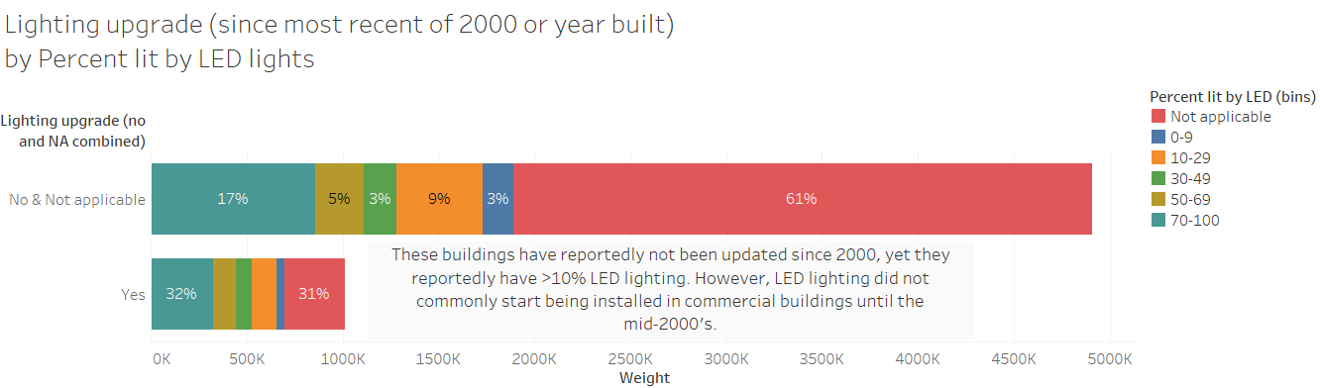

Some building types are blank for some versions of CBECS because they do not break out this building type separately, presumably because the RSE for that individual building type is too high to make presentation meaningful.

