ComStock Change
  - Economizers
Implementer: Janghyun Kim
Change Document Author: Janghyun Kim, Andrew Parker

Description of Change

Summary
This change modifies the prevalence, control type, and operational status for airside economizers in the baseline building stock.

Baseline Economizer Prevalence
The absence or presence of economizer control went from being based on energy code requirements during the year of initial construction to the energy code requirements during the most recent HVAC replacement, as show in Figure 1.
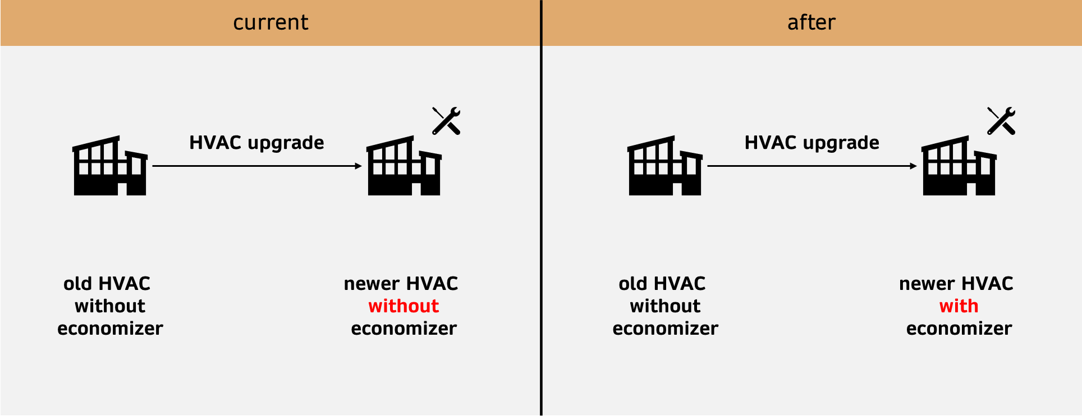
Figure 1. Baseline change: old buildings with newer HVAC system

Existing Method
In the baseline model, the type of economizer, or lack thereof, was based on the energy code in force when and where the building was originally constructed. For buildings built outside of CA before 2004, the 90.1-2004 economizer applicability criteria was used. This generally means no economizers for warmer climate zones, and economizers in cooler climate zones only for units greater than five or ten tons of cooling capacity. For buildings built inside of CA before 2015, no economizers were assumed. These assumptions mean that even in buildings where the HVAC system may have been updated several times, the absence or presence of an economizer was based on the requirements during original construction as depicted in Figure 1.

New Method
Buildings go through different types of retrofits over the years after they are built. ComStock baseline models reflect this aspect by making upgrade(s) to the old buildings separately for the HVAC system, lighting, envelope, etc. For the baseline models, ComStock now re-evaluates the requirement for an economizer based on the energy code in force at the time of the latest HVAC system replacement. This will increased the prevalence of economizers in the baseline model, which is broadly in line with what is necessary to make ComStock match the CBECS 2018 stock data. Additionally, the CA energy code requirements were evaluated by looking at the CA DEER MASControl3 models [2], where the economizer limits and applicability were found as shown in Table 1 and Table 2.°
Table 1. Economizer limits in MASControl3
Climate Zone | Drybulb Limit (F) | Enthalpy Limit (Btu/lb)
CZ01 | 70 | 28
CZ02 | 73 | 28
CZ03 | 70 | 28
CZ04 | 73 | 28
CZ05 | 70 | 28
CZ06 | 71 | 28
CZ07 | 69 | 28
CZ08 | 71 | 28
CZ09 | 71 | 28
CZ10 | 73 | 28
CZ11 | 75 | 28
CZ12 | 75 | 28
CZ13 | 75 | 28
CZ14 | 75 | 28
CZ15 | 75 | 28
CZ16 | 75 | 28

Table 2. Economizer applicability by cooling type in MASControl3
Vintage | Packaged DX | Chilled Water | Water Loop HP
1975 | FALSE | TRUE | FALSE
1985 | FALSE | TRUE | FALSE
1996 | FALSE | TRUE | FALSE
2003 | FALSE | TRUE | FALSE
2007 | FALSE | TRUE | FALSE
2011 | FALSE | TRUE | FALSE
2014 | TRUE | TRUE | TRUE
2015 | TRUE | TRUE | TRUE
2017 | TRUE | TRUE | TRUE
2020 | TRUE | TRUE | TRUE

Baseline Economizer Type
The defaults economizer control type went from being differential dry-bulb to fixed dry-bulb, as shown in Figure 2.
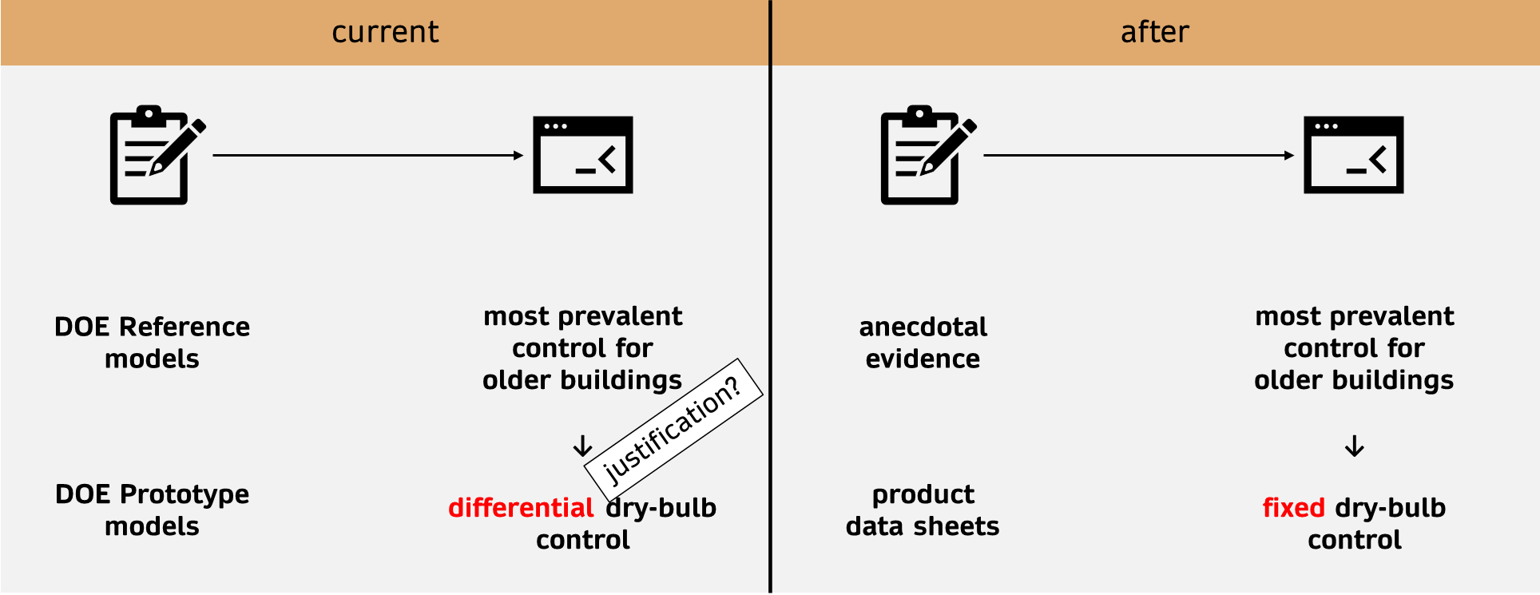
Figure 2. Baseline change: prevalent economizer control type

Existing Method
The type of economizer control used in the building is in large part up to the engineer (although in newer energy codes, some control types are prohibited in certain climate zones). The baseline models currently follow the assumption made in the DOE Reference and Prototype models and assume differential dry-bulb control in all climates, but justification for this assumption could not be located. This results in the most prevalent economizer control type for the older buildings being the differential dry-bulb control as depicted in Figure 2.

New Method
Based on a large body of anecdotal evidence from conversations with fault-focused field engineers and a brief review of common current (Trane, Carrier, Daikin) rooftop unit product data sheets [3]–[5], fixed dry bulb controls are a more common choice than differential dry bulb controls, although manufacturers also offer dual enthalpy (fixed dry bulb + fixed enthalpy) options with the addition of an enthalpy sensor. The assumption will be made to change the baseline model to fixed dry bulb controls for almost all building vintages and climate zones, with the exception being ASHRAE 90.1-2010 and 2013 which prohibited fixed dry bulb economizers in the warmer humid climate zones. These restrictions were lifted in ASHRAE 90.1-2016.

Economizer Faults
Economizers are well known for frequent faulty operations. There were many efforts in the past to understand fault characteristics in commercial buildings [6]–[9]. While this evidence (without common schema and metric) is still insufficient to reflect all aspects (e.g., prevalence, incidence, intensity, and evolution described in [6]) of all faults in the commercial building stock across the country, it is possible to make simplifications for modeling certain fault types based on available data.

Existing Method
In the existing baseline, all economizers are assumed to operate as-intended with no faults.

New Method
Table 3 shows how the first fault is modeled for buildings with economizers. Crowe et al. [7] acquired data from AFDD venders that monitored 3,660 AHUs and 7,974 RTUs and reported 31% of all economizers were experiencing faulty operations. Shoukas et al. [10] received data from a clothing retailer and food chain that monitored 1,416 RTUs and reported 60% of all faults related to economizers were related to economizer not effectively reducing cooling load compared to the theoretical potential. The description of “ineffective economizing” can be due to different faults: damper stuck, damper bias, sensor bias, sensor frozen, inappropriate configuration, etc. A report [11] published by Minnesota Department of Commerce Division of Energy Resources monitored 41 RTUs in Minnesota that were installed in many different building types (e.g., office, restaurant, retail, hotel, etc.) and reported the actual changeover temperature setting in the economizer were not configured efficiently (average of 52°F) resulting in missed free cooling opportunity.
Based on this information focusing on different aspects of the fault, a fault measure was developed as shown in Table 3. The table includes a verbal description of the fault as well as four different metrics that define the characteristics of a fault. Fault intensity (or severity) is when a fault can have severity level. For example, if the sensor is drifting, the intensity becomes the difference between true value versus (biased) measured value. Fault prevalence refers to the portion of systems/components with the fault among all systems/components in the sample space (e.g., 30% of all economizers have the fault). Fault incidence refers to the occurrence rate of a fault for a given system/component and for a given time (e.g., economizer damper gets stuck once every year). Fault evolution refers to certain faults where the severity naturally changes over time. Sensor drifting is typically a fault where the severity changes over the course of time. For the incorrect high limit setting described in Table 3, the fault changes the changeover temperature setting of an economizer to 52°F and applies fault to 30% of economizers that use fixed dry-bulb control. Fault incidence and fault evolution were not considered for modeling because these aspects are relatively irrelevant for this fault.
Table 3. Description of fault: incorrect changeover temperature setting
Evidence data | translate evidence data to fault | Fault Characteristic | Definition
From 3,660 AHUs and 7,974 RTUs,  Economizer faults occurred in 31% of all economizers.  From 1,416 RTUs (owned by food chain and clothing retailer),  60% of economizer faults were due to not leveraging 100% colder air properly.  From 41 RTUs (across office, restaurant, retail, hotel),  average changepoint temperature with RTUs with economizers = 52℉ |  | Description | changeover temperature for fixed dry-bulb control incorrectly configured
 |  | Intensity/severity | changeover temperature = 52℉
 |  | Prevalence | 30% of buildings with economizers
 |  | Incidence | fault present whenever economizing
 |  | Evolution | not relevant so not implemented

Figure 3 shows a comparison of simulated operation with and without the fault. As a result, the fault will reduce the changeover (high limit) temperature of the economizer, disabling the economizer even if the outdoor air temperature is favorable (e.g., 52-72℉), thus, losing opportunities for free cooling. How the fault impacts the annual cooling energy, how the changepoint temperature changes with fault, and how the transient response changes with fault are highlighted in the figure.

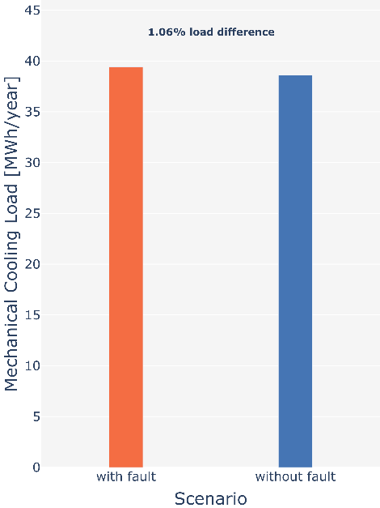 | 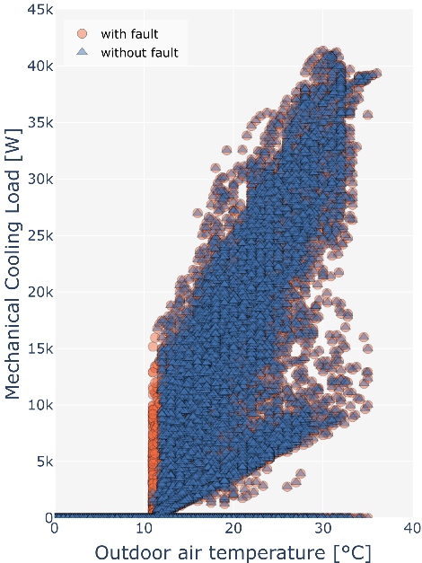 | 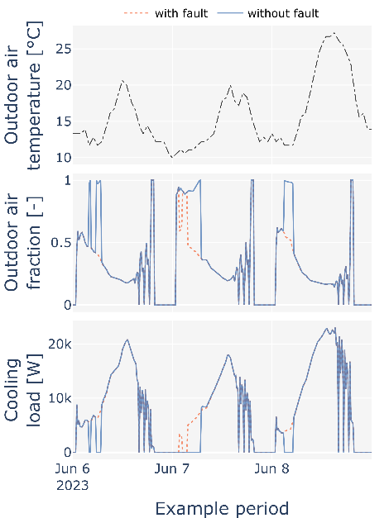
(a) mechanical cooling load | (b) changepoint temperature | (c) transient behavior
Figure 3. Simulation example of fault implementation
As reported by Heinemeier [12], contractors in California have witnessed 30-40% of economizers they have worked with were disabled with fully closed dampers. This is often caused by mechanical linkage issues between damper and actuator and where the economizer automatically reverts to the fully closed position as a safety measure. An economizer with a fully closed damper will not draw any fresh outdoor air causing an air quality issue and depending on the outdoor air condition (i.e., favorable or not favorable for economizing), it can either reduce or increase the energy consumption. Table 4 shows the description of the fault for the economizer outdoor air damper fully closed and stuck. Unlike from the fault described in Table 3, this fault has a bigger impact on air quality and energy and the incidence of the fault is important.

Table 4. Description of fault: damper fully stuck closed
Evidence data | translate evidence data to fault | Fault Characteristic | Definition
From a survey from 20 contractors,  30-40% of all economizers were disabled with dampers fully closed.  From 3,660 AHUs,  30% of all economizers had outdoor damper issue. And having outdoor air flow issue for 30% of the time.  From 1,416 RTUs (owned by food chain and clothing retailer),  economizer damper fully closing happened between 0.2-1 times per year per economizer |  | Description | economizer outdoor air damper fully closed during faulted period
 |  | Intensity/severity | damper fully closed
 |  | Prevalence | 35% of buildings with economizers
 |  | Incidence | Once per year with the duration of one month
 |  | Evolution | not relevant so not implemented

Figure 4 shows example simulation results for a building with and without the damper fully closed fault. The fault was imposed once during the entire April period resulting in 1.8% mechanical load increase. As mentioned previously, the energy impact of the fault can either be increased or decreased consumption, and Figure 4 (c) highlights the transition from negative to positive savings when the outdoor air temperature transitions from favorable to unfavorable conditions.

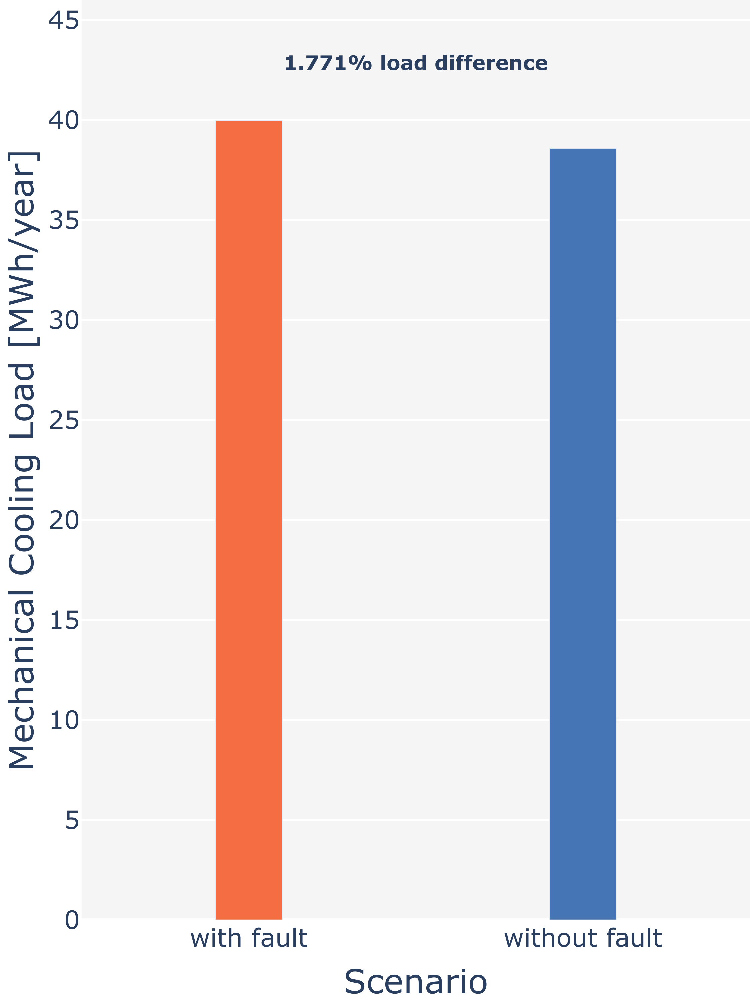 | 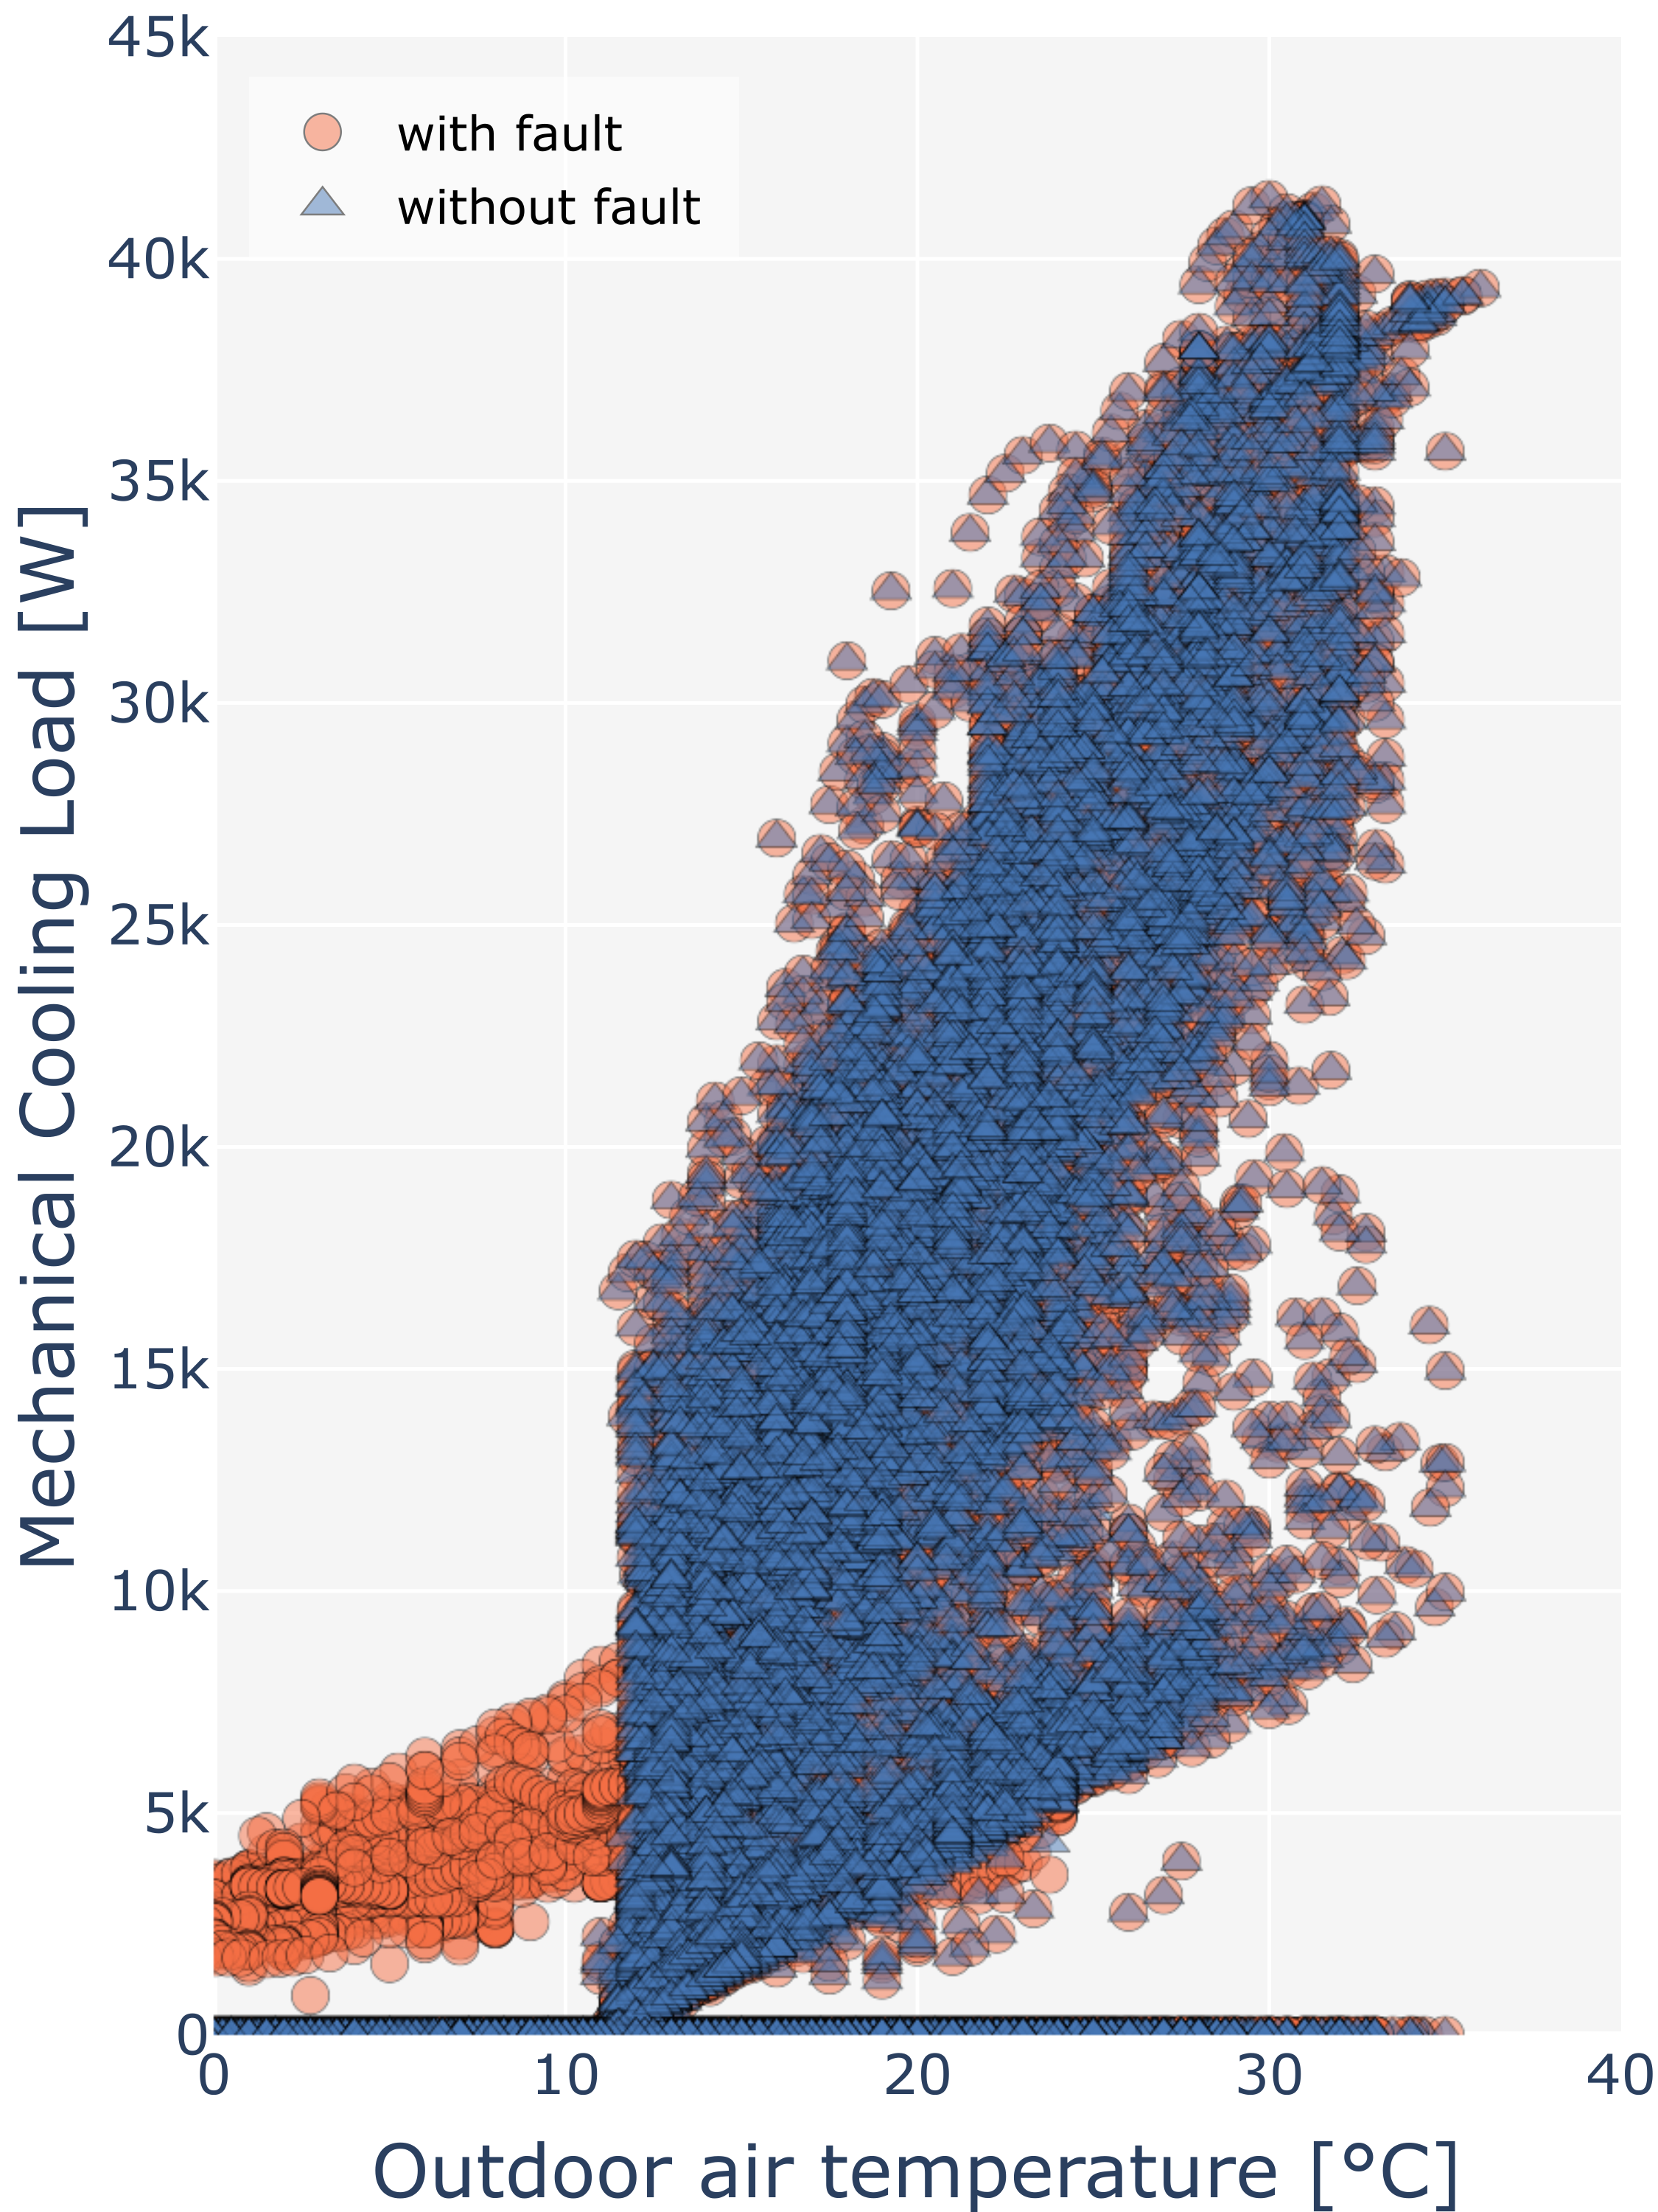 | 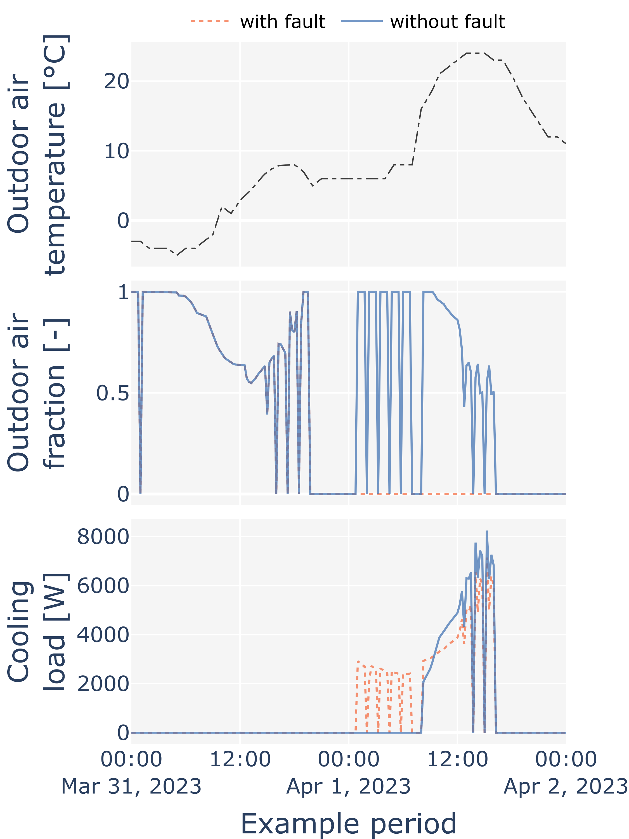
(a) mechanical cooling load | (b) changepoint plot | (c) transient behavior
Figure 4. Simulation example of fault implementation: damper stuck closed
Although faults (e.g., damper fully closed) are implemented with fixed prevalence (e.g., 35%), the actual percentage of economizers being faulted (among applicable economizers) is less than the defined prevalence due to implementation limitation. For example, 35% of randomly selected buildings that include certain HVAC system types (that are categorized as the air system) are imposed with damper fully closed fault. However, certain portions of these air systems do not have economizers, thus, it is not applicable to implement any economizer faults. In other words, the current limitation is that the random selection of faulted economizers is not fully aligned with buildings that actually have economizers. In these cases, we are losing the opportunity for applying faults and decreasing the representation of fault prevalence in final building stock. Additional to sampling limitations, another limitation is that the economizer faults are currently not applied to packaged single zone systems due to incorrect applicability implementation.
In reality, California’s TITLE 24 energy code requires fault detection and diagnostics (FDD) for economizers which prevents and quickly mitigates, not all but, faults that can happen in economizers. However, the current version of ComStock does not reflect the preventative or quickly resolving FDD methodologies, thus, possibly overestimating the impact of faults in buildings in California.

Software Changes
Two new TSVs were introduced. The first, fault_economizer_db_limit.tsv, controls the prevalence of the incorrect economizer drybulb limit fault. Prevalence depends on HVAC system type, energy code during last HVAC replacement, and climate zone. The second, fault_economizer_damper_fully_closed.tsv, controls the economizer damper stuck fault. Prevalence depends on HVAC system type. These TSVs are sampled independently, which means that some buildings will get neither fault, some will get one or the other, and some will get both faults.

Impact of Change

National Scale Impact

Change in economizer population
Figure 16 shows the impact of the baseline change with 10k model results that is described in section 3.1. Two changes including (1) economizer application updates on TITLE 24 standards (for buildings in California) and (2) adding code-required economizers when an existing building goes through HVAC upgrade resulted in increased floor area covered by economizers and reduction in electricity usage for cooling.
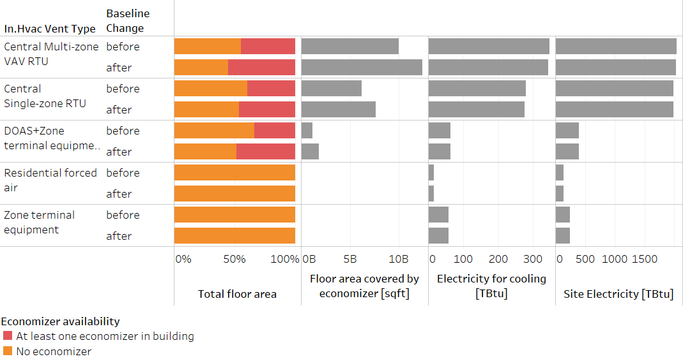
Figure 16. Impact of baseline change: increased economizer population

Change in prevalence of economizer control type
Figure 17 shows the impact of the baseline change (described in section 3.2) with 10k model results in terms of total floor area coverage. As shown in the figure, the most prevalent control type after the change is fixed dry-bulb control (36%) followed by differential dry-bulb (4.4%) and differential enthalpy (4.3%) control. The figure also shows the overall decrease of total floor area of buildings without economizer (shown as “NoEconomizer” in the figure) that was highlighted in Figure 16.

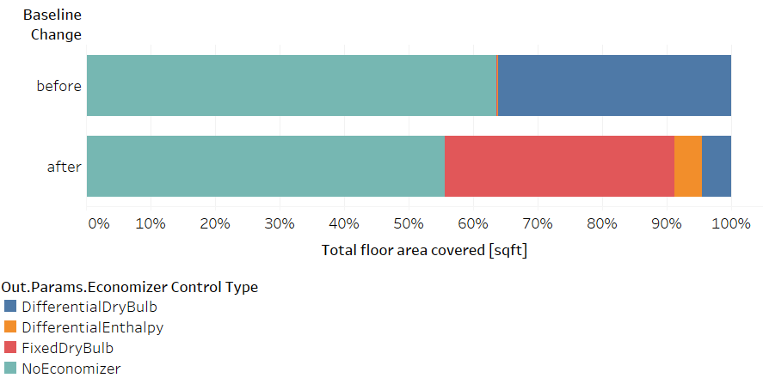
Figure 17. Impact of baseline change: economizer control type

New addition of fault implementation
Figure 18 shows the impact of the baseline change that is described in section 3.3. This figure does not represent the full (350,000 samples) ComStock run and rather it is based on 10,000 sample runs. Three scenarios are conducted to highlight the implementation and impact of two faults: baseline run without faults, baseline run only with improper high-limit (changeover temperature) fault, and baseline run only with damper fully closed fault.

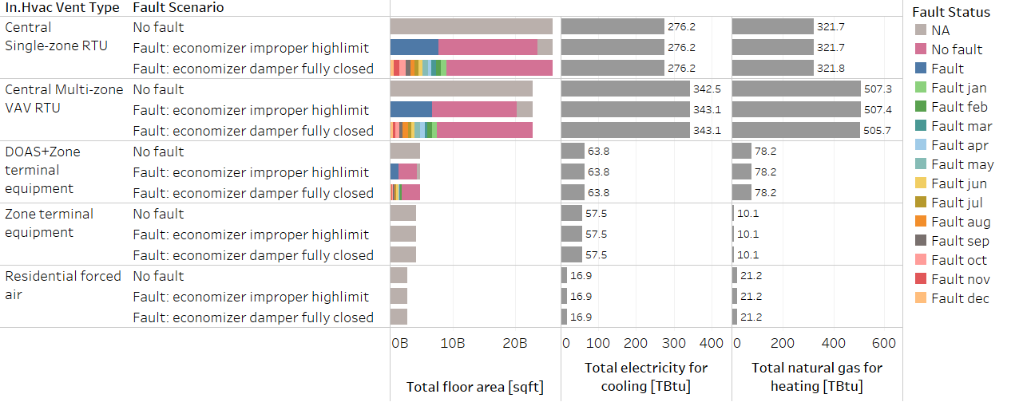
Figure 18. Impact of baseline change: economizer fault implementation
The legend (shown as “Fault Status”) represents whether the fault was implemented or not. Based on the prevalence assumptions of each fault, only some portion (defined in section 3.3) of the economizers are faulted resulting in economizers with and without faults under faulted scenarios. “NA” under faulted scenarios means these buildings do not have economizers (i.e., cannot impose fault) and “No fault” under faulted scenarios means these buildings happened to be not experiencing economizer faults. Economizer changeover temperature fault is applied across the entire year where the high-limit temperature is reduced to a fixed number of 52ºF/11ºC and indicated as “Fault” in the figure. Economizer damper fully closed fault is applied for a duration of one month (instead of applying across the entire year), however, even distribution was applied for selecting the month for applying the fault. For example, “Fault jan” shown in the figure represents a building model where damper fully closed fault is only applied in January. Theoretically, there are more detailed approaches for randomizing the incidence and prevalence of a fault. For example, randomly picking one day from a year and let the fault present for a month from that day. However, during this initial implementation, we chose a balance between ease of implementation and proper distribution of fault prevalence/incidence.

References
[1] S. Taylor and H. Cheng, “Economizer High Limit Controls and Why Enthalpy Economizers Don’t Work,” ASHRAE Journal, vol. 52, no. 11, 2010, Accessed: May 29, 2023. [Online]. Available: https://www.proquest.com/openview/22130ec043823a40fc7ae0770962a00a/1.pdf?pq-origsite=gscholar&cbl=41118
[2] “MASControl3.” https://cedars.sound-data.com/deer-resources/tools/mas-control/file/3011/download
[3] Trane, “Packaged Rooftop Air Conditioners FoundationTM.”
[4] Carrier, “EconoMi$ter X.”
[5] Daikin, “Rebel® Commercial Packaged Rooftop Systems.”
[6] J. Kim et al., “Research challenges and directions in HVAC fault prevalence,” Science and Technology for the Built Environment, vol. 27, no. 5, pp. 624–640, May 2021, doi: 10.1080/23744731.2021.1898243.
[7] E. Crowe et al., “What We Learned From Analyzing 18 Million Rows of Commercial Buildings’ HVAC Fault Data,” Aug. 2022, Accessed: Apr. 17, 2023. [Online]. Available: https://escholarship.org/uc/item/8d378066
[8] S. Katipamula, R. M. Underhill, N. Fernandez, W. Kim, R. G. Lutes, and D. Taasevigen, “Prevalence of typical operational problems and energy savings opportunities in U.S. commercial buildings,” Energy and Buildings, vol. 253, p. 111544, Dec. 2021, doi: 10.1016/j.enbuild.2021.111544.
[9] S. M. Frank, J. Kim, J. Cai, and J. E. Braun, “Common Faults and Their Prioritization in Small Commercial Buildings: February 2017 - December 2017,” National Renewable Energy Lab. (NREL), Golden, CO (United States), NREL/SR-5500-70136, Jun. 2018. doi: 10.2172/1457127.
[10] G. Shoukas, M. Bianchi, and M. Deru, “Analysis of Fault Data Collected from Automated Fault Detection and Diagnostic Products for Packaged Rooftop Units,” National Renewable Energy Lab. (NREL), Golden, CO (United States), NREL/TP-5500-77077, Sep. 2020. doi: 10.2172/1665808.
[11] Seventhwave and Center for Energy and Environment, “Commercial Roof-top Units in Minnesota: Characteristics and Energy Performance,” 2016.
[12] K. Heinemeier, “Free Cooling: At What Cost?,” ACEEE Summer Study Energy Efficiency Build, 2014.
[13] A. Parker et al., “ComStock Reference Documentation: Version 1,” National Renewable Energy Laboratory, Golden, CO, NREL/TP-5500-83819. [Online]. Available: https://www.nrel.gov/docs/fy23osti/83819.pdf
[14] “Cambium | Energy Analysis | NREL.” https://www.nrel.gov/analysis/cambium.html (accessed Sep. 02, 2022).
[15] “Emissions & Generation Resource Integrated Database (eGRID) | US EPA.” https://www.epa.gov/egrid (accessed Sep. 02, 2022).
[16] E. Present, Pieter Gagnon, Eric J.H. Wilson, Noel Merket, Philip R. White, and Scott Horowitz, “Choosing the Best Carbon Factor for the Job: Exploring Available Carbon Emissions Factors and the Impact of Factor Selection,” 2022.
[17] G. Vijayakumar et al., “ANSI/RESNET/ICC 301-2022 - Standard for the Calculation and Labeling of the Energy Performance of Dwelling and Sleeping Units using an Energy Rating Index,” Oceanside, CA, 2022.

