Commercial Cooking Equipment
Implementer: Chris CaraDonna
Change Document Author: Chris CaraDonna
Reviewer: Andrew Parker, Matthew Dahlhausen

Introduction
Cooking equipment in commercial buildings can consume high amounts of energy and contribute substantial heat gain to spaces. CEUS estimates cooking equipment to consume 23% of natural gas consumption and 4% of electricity consumption in commercial buildings [1]. CBECS estimates cooking equipment to consume 517 trillion BTUs annually or 7% of total commercial building energy consumption [2].
Commercial building energy modeling often assumes an energy intensity per area for cooking equipment, such as what is found in the DOE prototype buildings [3]. However, little information exists regarding representative equipment-specific modeling of cooking appliances, as well as how cooking equipment scales with building area. The CBECS survey does provide some level of guidance for area-based intensity as they disaggregate cooking energy consumption separately and provide building area for their samples, but this end use energy consumption data is derived using statistical means from monthly billing data rather than directly measured making it less reliable [2], [3].
The current ComStock implementation of cooking equipment uses simple power density assignments based on space type and building type derived from the DOE prototype models [3]. This approach assumes cooking loads scale linearly with kitchen square footage, which is not necessarily accurate [2], [3], and it does not allow for straightforward analysis of specific cooking equipment. Furthermore, appliance fuel type is static per these assignments, with no representation of the fuel type variation that exists with cooking appliances [2], [4].
This study uses published data to create representative probability distributions of commercial cooking equipment, by building type, for both gas and electric appliances, for application to the ComStock model. Additionally, the equipment distributions are scaled by area to represent the non-linear scaling suggested in the literature.

Methodology
This measure replaces the incumbent power-density based methodology for kitchen cooking loads in ComStock with an equipment-count based approach that employs several food establishment archetypes. The measure only applies to building types in ComStock that already have kitchens and works on both gas and electric kitchen appliances. The measure does not impact kitchen schedules which is a limitation in this study that could be improved upon as needed in future work.
ComStock currently includes cooking equipment in the following building types:
- Hospital
- Large Hotel
- Primary School
- Secondary School
- Strip Mall
- Quick Service Restaurant
- Full Service Restaurant
Although other building types likely include some degree of cooking equipment as well, such as larger offices [2], this analysis is limited only to the building types in ComStock that currently include cooking equipment. Figure 1 shows the fraction of buildings by type that includes various food service types according to CBECS 2012: the 60% and 20% prevalence of food service in large offices and outpatient, respectively, suggests that food service should be added to these building types in ComStock future work. Figure 2 shows the stock natural gas comparison between ComStock (version 12) and CBECS 2012 for both total site consumption and interior equipment specifically, which would include cooking loads. These results show ComStock generally predicting less total site natural gas consumption, aside from a few building types, while the interior equipment comparison is more haphazard with ComStock showing both higher and lower predictions compared to CBECS.
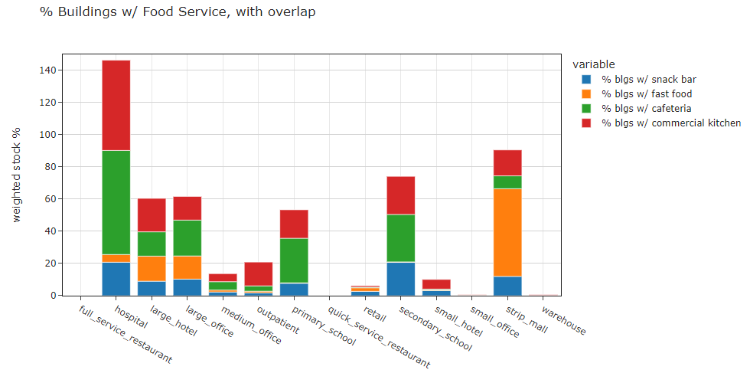
Figure 1: Weighted fraction of stock floor area with food service by building type. Data is from CBECS 2012. CBECS samples can include more than one food service type, so total stock percentage may exceed 100%. Note that food service building types in CBECS do not use these metrics, so they show 0%, when in reality they would be 100%.
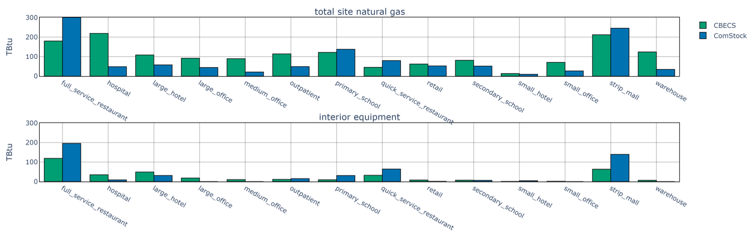
Figure 2: Natural gas energy use comparison of ComStock (V12) vs. CBECS 2012 for both total site usage and interior equipment, which would include cooking loads.

ComStock currently uses power density assignments by building type and space type to address cooking loads. The power densities come from the DOE prototype buildings. The primary goal of this analysis is to create informed building-type-specific probability distributions of commercial cooking equipment. Multiple data sources are used to derive these distributions.
First, the prevalence of gas vs. electric fuel types for each equipment type and the rated power are derived from a DOE study [4], which are shown in Table 1.
Table 1: Gas vs. electric prevalence and rated power for various cooking appliances. Data is from [4]
Appliance | % Gas | % Electric | Rated Energy - Gas (BTU/hr) | Rated Energy - Electricity (kW)
Broiler | 0.91 | 0.09 | 88000 | 11
Fryers | 0.58 | 0.42 | 164000 | 22
Griddles | 0.5 | 0.5 | 70000 | 12
Ovens | 0.55 | 0.45 | 56000 | 15
Ranges | 0.91 | 0.09 | 179000 | 12
Steamers | 0.33 | 0.67 | 210000 | 24

Next, the prevalence of equipment quantities was determined for each ComStock building type. This was done using an older dataset of equipment counts per restaurant type, and the prevalence of the restaurant type [5]. The restaurant types were mapped to ComStock building types. A summary of this dataset is shown in Table 2. Unfortunately, little data of this type was found in literature, so this older source was ultimately used for equipment counts. However, even with changes in culinary trends, it is not expected that counts of equipment types in a restaurant would have changed drastically over the past few decades. Additionally, a “None” restaurant type was created for schools, with a prevalence determined by the fraction of schools is CBECS that have kitchens (Figure 1).
To create the final probability distributions, a restaurant type is sampled for each model as per the prevalences shown by building type in Table 2. This yields the corresponding equipment counts for the restaurant type shown in Table 2. Next, the equipment fuel type is sampled as per the prevalence shown in Table 1 for each piece of equipment. Combined, this yields quantities of gas and electric cooking equipment for each ComStock sample. Note that kitchen spaces in ComStock already include some prevalence of electric load. 10% of this is retained to account for non-major electrical appliances still found in kitchens such as microwaves, heating lamps, toasters, coffee machines, electric kettles, etc.
This workflow also includes modifiers to the equipment counts shown in Table 2 to scale equipment count for different size kitchens. As mentioned previously, it is not expected that equipment scales linearly with kitchen size, but there is little information in the literature to suggest appropriate scaling [3]. This can be derived from CBECS 2012 to some extent, as shown in Figure 3, which shows smaller quick service restaurants having relatively higher EUIs than larger ones, suggesting that smaller kitchens may use equipment to the same degree as larger ones to some extent. However, it should be noted that CBECS data to derive cooking equipment scaling would be based on CBECS disaggregation methods, making this approach less reliable.
To account for kitchen scaling, we assume most kitchens will have the same quantity of equipment. However, especially small and large kitchens will include scaling factors to account for very large changes in kitchen area that would likely correlate to higher/lower meals served (Figure 4). These factors were determined using engineering judgment and are summarized in Figure 3.
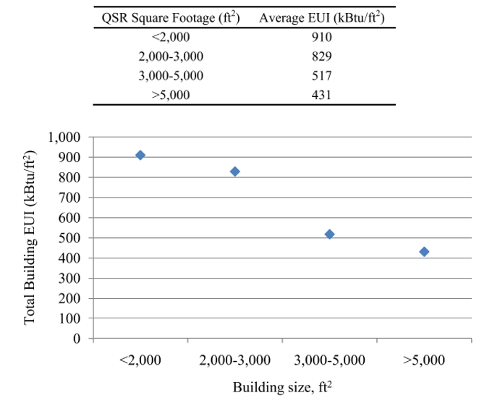
Figure 3: Quick service restaurant EUI relationship to building area for quick service restaurants from CBECS 2012. Image taken from [3].

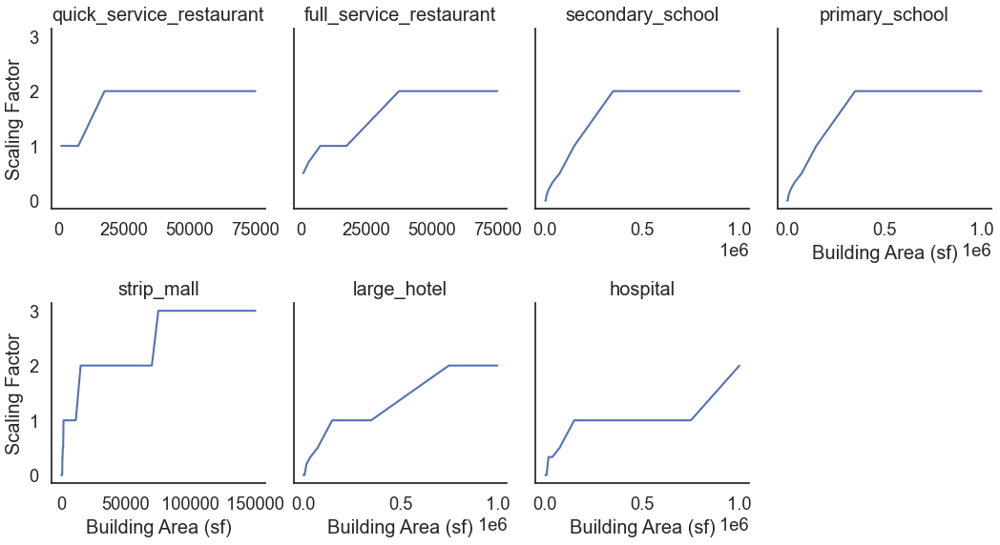
Figure 4: Equipment count scaling factors per area by building type applied to ComStock models. Strip mall includes food service area only.

It was discovered during this work that standalone retail buildings in California, which follow the DEER building type articulation, include kitchens. Kitchens are not included in standalone retail buildings for the DOE prototype articulation which is used elsewhere in the country. This work therefore includes removing the kitchen space type from the DEER models in ComStock by reallocating the kitchen floor area to the other space types proportionally. This change makes retail building types in ComStock more consistent across the country.

QAQC and Discussion

The comparisons of ComStock V18, ComStock V19 with cooking equipment changes, and CBECS 2012 are discussed in this section. It should be noted that these comparisons are for a 2018 run year for ComStock, while CBECS is for year 2012, so perfect alignment should not be the end goal.
Figure 5 shows the annual energy comparison between the incumbent ComStock V18 run (titled “baseline” in the plot) and the new ComStock V19 run with the discussed changes to kitchen equipment. Interior gas equipment shows the largest change with a 31% decrease in consumption for the new V19 run from the new cooking equipment methodology. The change is largely due to decrease consumption in the full-service restaurant, quick service restaurant, and retail strip mall building types. This was a desired outcome considering the overestimation of gas equipment consumption in these building types between ComStock versus CBECS 2012 shown in Figure 2, noting once again that the CBECS dataset is a disaggregated estimate and should be considered as another point of comparison rather than ground truth. Alternatively, electricity equipment consumption shows a 5.4% increase in the new V19 run. Other HVAC end uses also show minimal differences due to changes in zone loads.
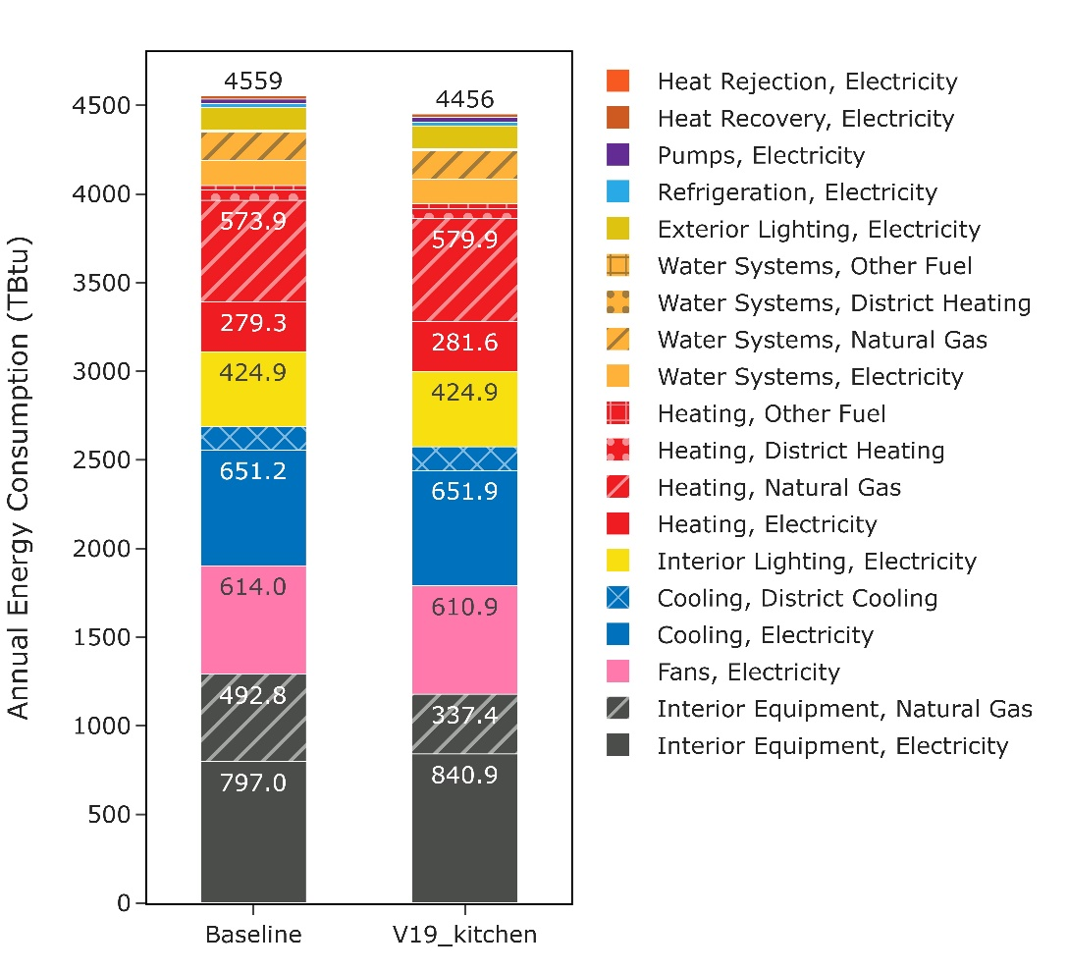
Figure 5: Comparison of annual site energy consumption by end use and fuel type for the ComStock baseline (V18) run and the new ComStock V19 kitchen equipment run.
Stock electricity consumption increased slightly in the V19 cooking run (Figure 5). Observing individual building types (Figure 6), the cooking run shows closer alignment to CBECS 2012 with hospitals and primary schools, albeit by very small amounts. Full-service restaurants, quick-service restaurants, and strip malls show increased aggregate electricity consumption which brings them further from the CBECS 2012 aggregate totals. However, the difference between ComStock runs in less than 10% in each case. Overall, the changes to annual electricity consumption are minimal, but the new approach allows for a more interpretable analysis of cooking equipment by modeling specific pieces of equipment instead of a general power density. It should also be noted that at the time of writing this document, ComStock is known to overpredict electric heating energy compared to CBECS. With all else held equal, this suggests ComStock should currently overpredict electricity consumption compared to CBECS 2012.
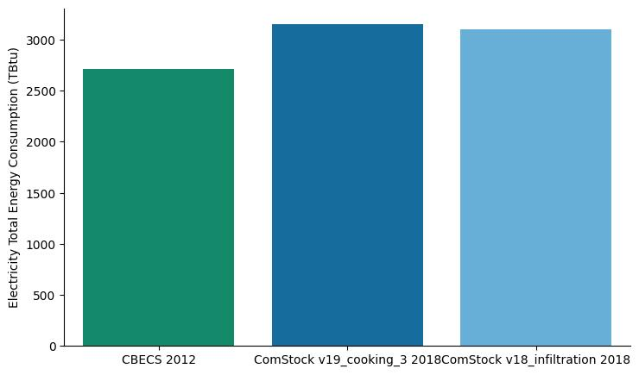
Figure 6: Stock electricity consumption comparison between ComStock v12, CBECS 2012, and the new ComStock Cooking run.
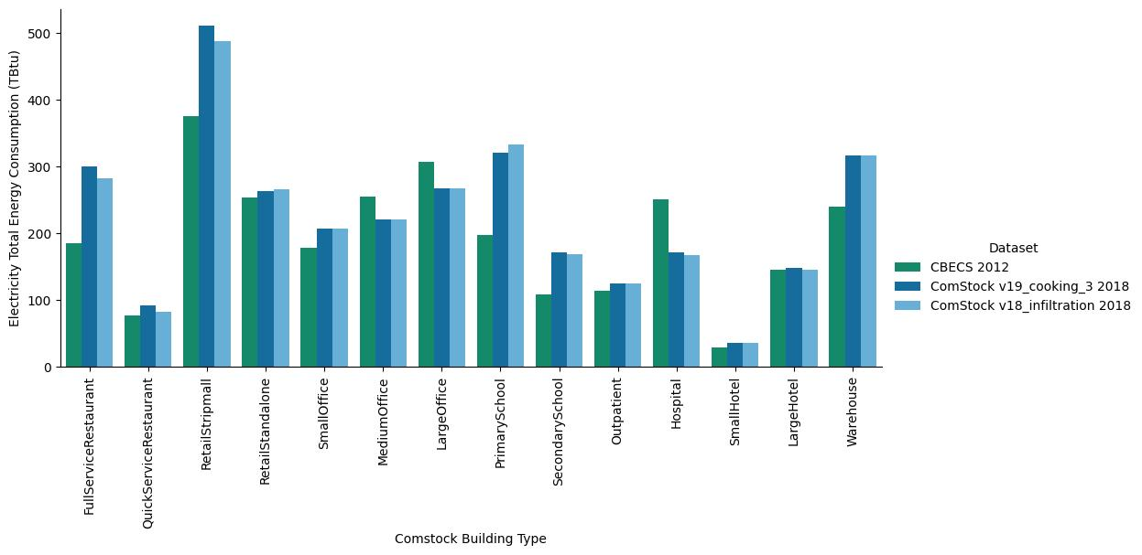
Figure 7: Stock electricity consumption comparison by building type between ComStock v12, CBECS 2012, and the new ComStock Cooking run.
Stock natural gas consumption decreased in the cooking run compared to CBECS 2012 (Figure 7). Since ComStock V18 only shows ~85% of the gas consumption of CBECS 2012, this brings the ComStock model-at-large further from alignment with gas consumption with CBECS 2012. Before further discussion on this, it should be noted that CBECS 2012 is modeling the 2012 building stock with 2012 weather, while both ComStock V18 and ComStock V19 (with cooking equipment changes) model the 2018 building stock with 2018 weather. Therefore, differences in gas consumption are expected between CBECS and ComStock, sometimes even to a large degree.
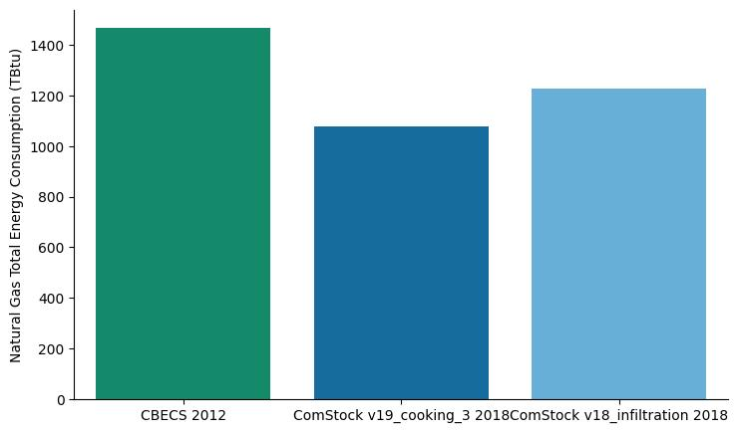
Figure 8: Stock gas consumption comparison between ComStock v12, CBECS 2012, and the new ComStock Cooking run.

For individual building types, the cooking equipment changes generally caused a reduction in gas consumption compared to ComStock V18 (Figure 8). The exceptions to this are Hospitals, which show a very minimal increase in gas consumption, and Large Hotels, which show a moderate increase of roughly 6%. In both cases, ComStock was underpredicting natural gas consumption compared to CBECS 2012 for the stock total (Figure 9) and natural gas equipment specifically (Figure 2), indicating the new methodology increases alignment for these building types.
Full-service restaurants, quick-service restaurants and retail strip mall all show notable decreases in gas consumption with the new methodology. In all cases, ComStock V18 was overpredicting stock gas consumption relative to CBECS 2012, suggesting the proposed V19 cooking equipment change increases alignment. Figure 2 further reinforces this, showing notable overestimation of gas equipment for these building types compared to CBECS.
Primary and secondary schools also show decreased gas consumption in the new V19 run. The change is very minimal for secondary schools. Primary schools show a larger decrease in gas consumption compared to V18, which causes ComStock to change from slightly overestimating gas consumption compared to CBECS 2018 to underestimating gas consumption to a larger degree (Figure 9). However, Figure 2 shows ComStock V18 underpredicting gas equipment by a similar margin, indicating this change better aligns cooking equipment in primary schools to CBECS 2012 with natural gas heating potentially being the cause of the remaining deficit. However, as a reminder, the natural gas calibration of primary schools is still within 10% which is very reasonable especially considering the different weather years.

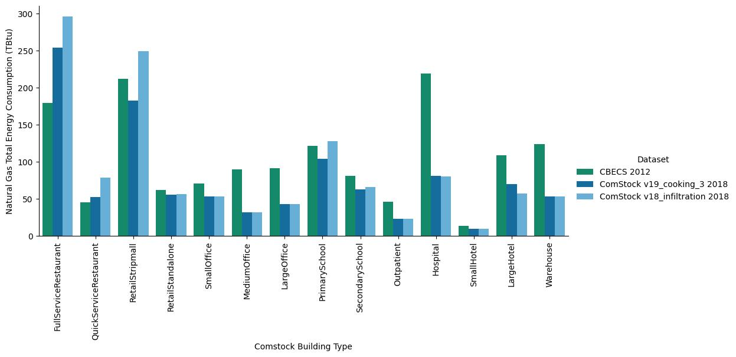
Figure 9: Stock gas consumption comparison by building type between ComStock v12, CBECS 2012, and the new ComStock Cooking run.

Figure 10 shows the distribution of percent energy savings by building type for ComStock V19 models (with kitchen equipment changes) compared to the corresponding incumbent ComStock V18 models. Building types not shown were not impacted by the proposed changes. Offices and outpatient were also not impacted by the proposed changes; however, they do show a small amount of near negligible savings some a few select models. Upon investigation, this appears to be caused by small rounding differences in HVAC consumption unrelated to the equipment end use.
Many building types show notable differences in the savings distribution between ComStock versions with some samples exceeding 100%. There are multiple reasons for this. First, ComStock V18 used a simple equipment load intensity which would linearly scale equipment load perfectly with building area. V19 assumes most kitchens will have the same equipment counts except for especially large or small kitchens. Second, the V18 assumed a constant equipment load intensity for all kitchens of a building type. Alternatively, V19 creates a distribution of various food service types within a building type. Some samples are assigned a food service type with lower equipment count such as “cookie shop”, while others are assigned a higher intensity food service type such as “chicken A” which assumes very high counts of deep fryers. This variation leads to more variety in equipment loads.
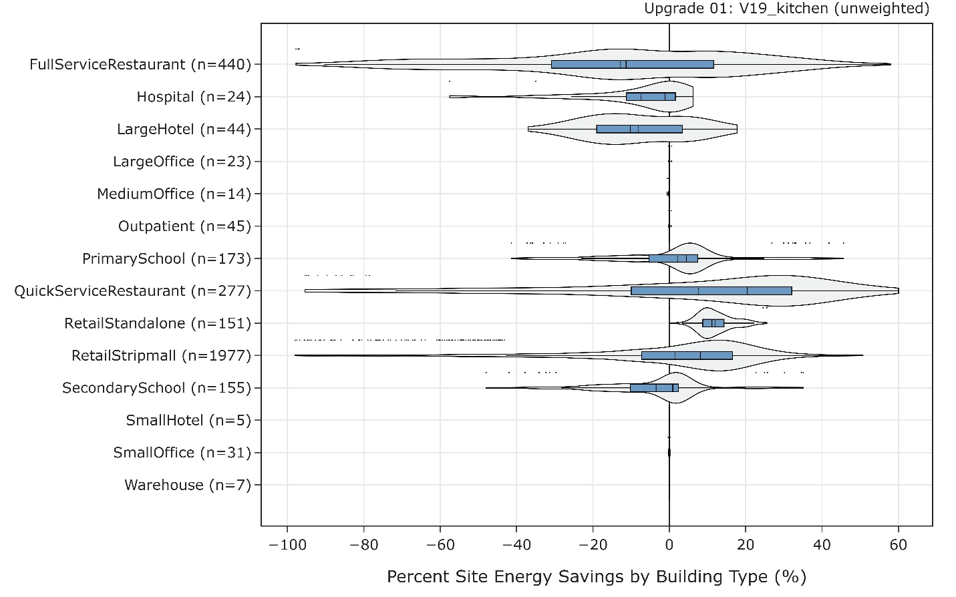
Figure 10: Percent site energy savings by building type of ComStock V18 to V19. Note that the changes for the RetailStandalone building type only reflect retail buildings in California as a result of removing kitchens from the DEER articulation.

Figure 11 shows the distribution of percent energy savings by end use for ComStock V19 models (with kitchen equipment changes) compared to the corresponding incumbent ComStock V18 models. Equipment shows the largest change, as expected, since the V19 update only directly modifies equipment loads. However, there are many HVAC changes as well. These occur due to changes in load intensity within the spaces which the HVAC system must address. Additionally, the water systems and refrigeration end uses show small changes for similar reasons.
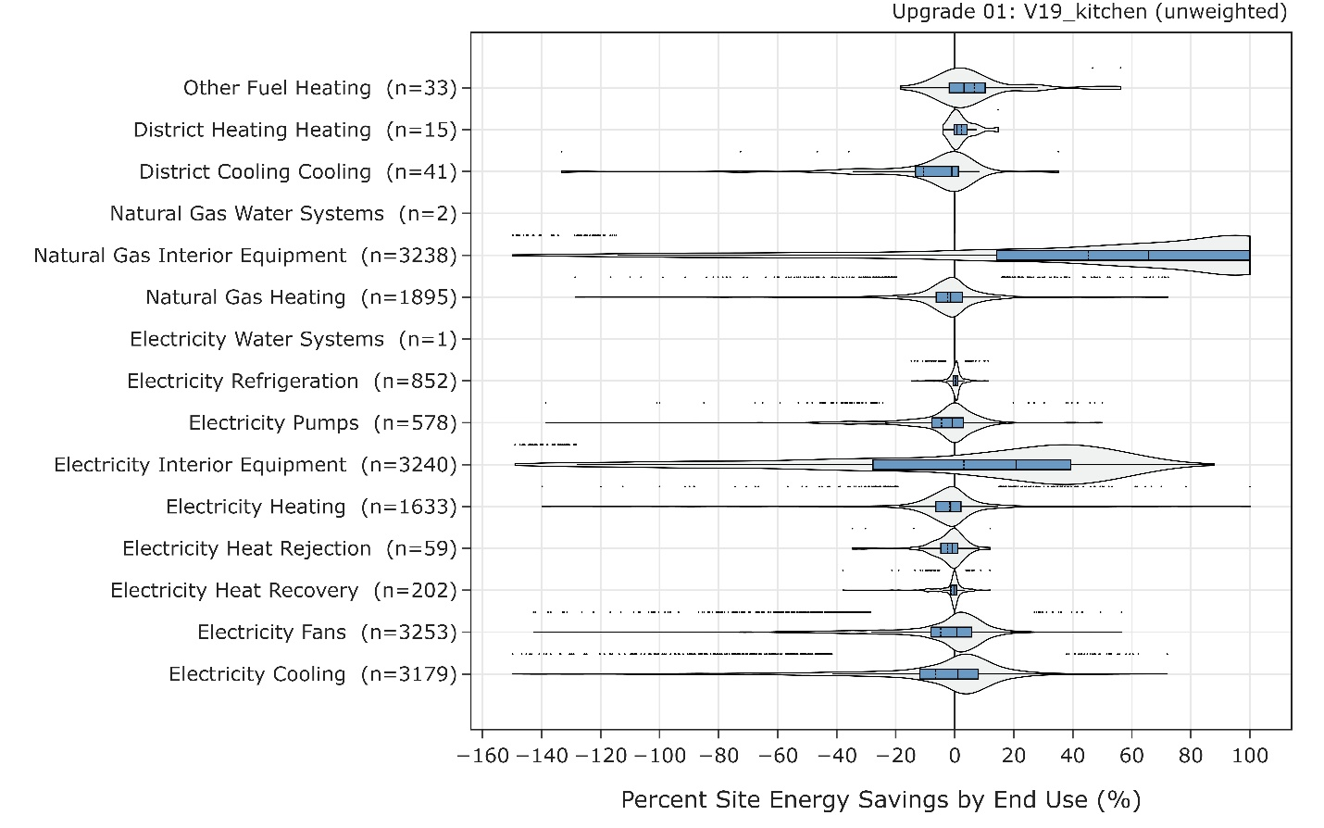
Figure 11: Percent site energy savings by end use of ComStock V18 vs. V19.

Figure 12 compares the EUI distribution of the impacted building types for CBECS 2012, ComStock V18, and ComStock V19. Full-service restaurants show a much wider distribution for V19 compared to V18, largely due to the variety in food service types implemented in V19. However, the EUI distribution of ComStock V19 notably exceeds that of CBECS 2012, suggesting ComStock full-service restaurants are more intensive than those included in CBECS 2012. V19 also shows a few outliers that greatly exceed that of any CBECS 2012 sample, but this could be due to lower sample counts in CBECS decreasing the chances of including extraneous buildings. The EUI distribution of V19 quick-service restaurants show closer alignment to CBECS 2012 than V18 both in terms of critical statistical points as well as the range of the distribution. V19 also shows a few higher outliers for quick-service restaurants similarly to full-service restaurants. Note that the EUI distribution of some buildings types is not as impacted by the V19 changes since food service can comprise a much smaller fraction of the building use case in non-restaurant building types.
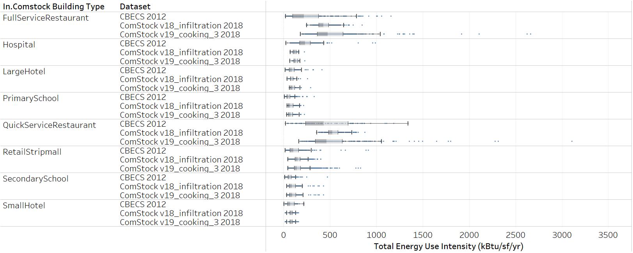
Figure 12: Comparison of EUI distributions between CBECS 2012, ComStock V18 (baseline), and ComStock V19 (baseline + cooking changes).

Figure 13 compares the relationship between area and EUI for CBECS 2012 and ComStock V19. This comparison is specifically for full-service restaurants and quick-service restaurants. The highest EUIs are found in buildings with the lowest floor areas in both datasets, further reinforcing the idea that kitchen size does not scale linearly with cooking energy. As discussed previously, ComStock does show higher maximum EUIs than CBECS, and as expected, these occurrences exist in the smallest building samples. It is difficult to conclude if these samples area realistic representations of food service establishments with high quantities of cooking equipment in a relatively small space, noting once again that the ComStock dataset is larger than CBECS (even for the 10k runs done for this work) which increases the likelihood of including uncharacteristic outliers. It is also possible that some of the assigned restaurant types are unlikely to occur in certain building sizes, or that the scaling factors should be adjusted in these cases.

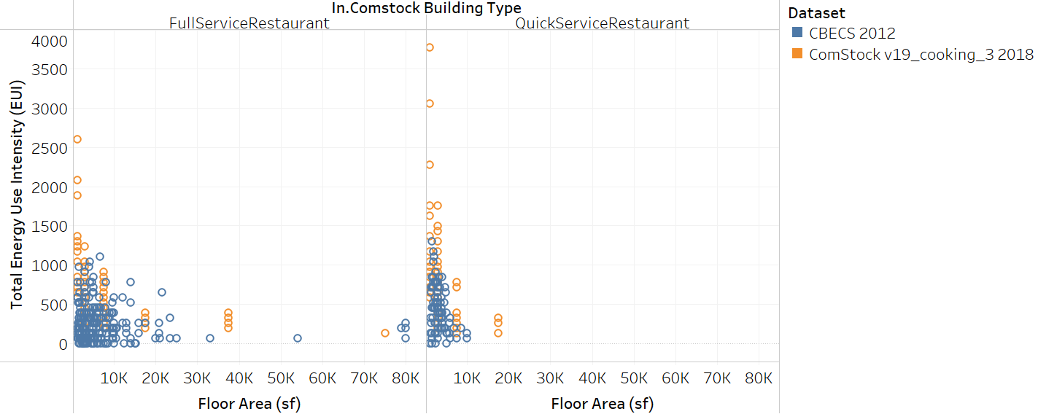
Figure 13: EUI vs. Floor area of CBECS 2012 and ComStock V19 for full-service restaurants (left) and quick-service restaurants (right).
Figure 14 compares distributions of natural gas EUI for full-service restaurants. The distribution for the V19 cooking run aligns much closer to the distribution for CBECS with a relavively wider data spead. Comparitevly, the V18 distribution is narrow with datapoints heavily concentrated around the mean. The increase variation in the distribution is primarily attributed to variation amongst restaurant archytypes introduced in the V19 run. The mean EUI value for the V19 run is also much closer to CBECS. The same plot is shown in Figure 15 for full-service restaurants. The V19 run shows some improvement with a wider data spread compared to V18, but there are still differences compared to CBECS, with the largest being overall lower EUI values for CBECS.

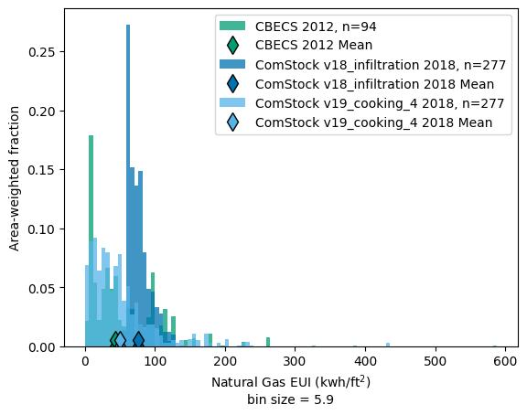
Figure 14: Natural gas EUI comparison for quick-service restaurants.
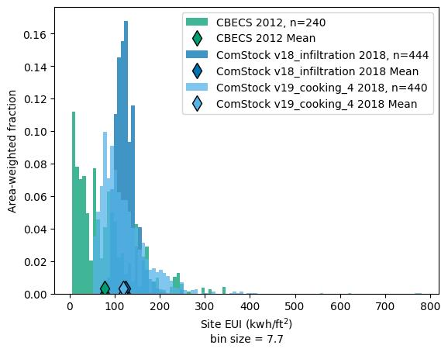
Figure 15: Natural gas EUI comparison for full-service restaurants.

Citations
[1] California Energy Commission, “California Commercial End-Use Survey (CEUS),” 2006.
[2] EIA, “2012 Commercial Buildings Energy Consumption Survey (CBECS),” 2012. [Online]. Available: https://www.eia.gov/consumption/commercial/.
[3] J. Zhang et al., “Technical Support Document : 50 % Energy Savings for Quick-Service Restaurants,” 2010.
[4] W. Goetzler, M. Guernsey, K. Foley, J. Young, and G. Chung, “Energy Savings Potential and RD&D Opportunities for Commercial Building Appliances (2015 Update),” 2016.
[5] S. Rahbar, D. Fisher, J. Nickel, S. Ardley, and D. Zabrowski, “TECHNOLOGY REVIEW OF COMMERCIAL FOOD SERVICE EQUIPMENT FINAL REPORT,” 1996.

Appendix

Table 2: Restaurant type probability distributions of cooking appliance quantities by ComStock building type. Data from [5]. The prevalence of the ‘None’ restaurant type was derived from CBECS 2012 [2].
Restaurant Type | ComStock Building Type | Fraction of ComStock Building Type | Griddle | Fryer | Broiler | Oven | Range | Steamer
Restaurant A | full_service_restaurant | 0.42 | 1 | 2 | 1 | 1 | 1 | 0
Restaurant B | full_service_restaurant | 0.01 | 1 | 2 | 2 | 2 | 2 | 3
Restaurant C | full_service_restaurant | 0.13 | 1 | 3 | 4 | 2 | 2 | 1
Chinese A | full_service_restaurant | 0.16 | 0 | 2 | 0 | 1 | 1 | 1
Chinese B | full_service_restaurant | 0.03 | 0 | 3 | 1 | 2 | 1 | 2
Pancake | full_service_restaurant | 0.01 | 2 | 2 | 0 | 0 | 0 | 0
Grills | full_service_restaurant | 0.02 | 1 | 1 | 0 | 0 | 1 | 0
Diner | full_service_restaurant | 0.02 | 1 | 1 | 0 | 0 | 0 | 0
Pubs/Taverns | full_service_restaurant | 0.21 | 1 | 2 | 1 | 2 | 2 | 3
Hospitals Large | hospital | 0.75 | 1 | 2 | 1 | 10 | 1 | 10
Hospitals Small | hospital | 0.25 | 0 | 2 | 0 | 4 | 2 | 5
Hotel A | large_hotel | 0.69 | 0 | 3 | 3 | 4 | 6 | 3
Hotel B | large_hotel | 0.31 | 1 | 2 | 1 | 1 | 1 | 1
None | large_office | 1.00 | 0 | 0 | 0 | 0 | 0 | 0
None | medium_office | 1.00 | 0 | 0 | 0 | 0 | 0 | 0
None | outpatient | 1.00 | 0 | 0 | 0 | 0 | 0 | 0
None | primary_school | 0.70 | 0 | 0 | 0 | 0 | 0 | 0
High School | primary_school | 0.30 | 2 | 2 | 1 | 4 | 3 | 2
Burger A | quick_service_restaurant | 0.06 | 1 | 3 | 1 | 0 | 0 | 0
Burger B | quick_service_restaurant | 0.10 | 3 | 3 | 0 | 1 | 0 | 0
Chicken A | quick_service_restaurant | 0.06 | 1 | 10 | 0 | 1 | 0 | 1
Chicken B | quick_service_restaurant | 0.04 | 0 | 4 | 1 | 5 | 0 | 1
Fish A | quick_service_restaurant | 0.01 | 1 | 4 | 1 | 2 | 1 | 2
Fish B | quick_service_restaurant | 0.07 | 1 | 4 | 0 | 0 | 0 | 0
Hot Dog | quick_service_restaurant | 0.01 | 1 | 2 | 0 | 0 | 0 | 1
Pizza A | quick_service_restaurant | 0.14 | 0 | 1 | 0 | 1.5 | 0 | 1
Pizza B | quick_service_restaurant | 0.14 | 0 | 1 | 0 | 2 | 0 | 0
Roast Beef | quick_service_restaurant | 0.01 | 0 | 2 | 0 | 1 | 0 | 0
Donut | quick_service_restaurant | 0.12 | 0 | 1 | 0 | 2 | 0 | 0
Muffin | quick_service_restaurant | 0.02 | 0 | 0 | 0 | 3 | 0 | 0
Potato | quick_service_restaurant | 0.02 | 1 | 3 | 0 | 0 | 0 | 0
Cookie | quick_service_restaurant | 0.01 | 0 | 0 | 0 | 1 | 0 | 0
Cafe | quick_service_restaurant | 0.14 | 0 | 1 | 0 | 0 | 1 | 0
Truck Stop | quick_service_restaurant | 0.01 | 1 | 1 | 0 | 0 | 1 | 0
Dept. Stores | quick_service_restaurant | 0.04 | 1 | 2 | 1 | 2 | 2 | 3
None | retail | 1.00 | 0 | 0 | 0 | 0 | 0 | 0
None | secondary_school | 0.65 | 0 | 0 | 0 | 0 | 0 | 0
High School | secondary_school | 0.35 | 2 | 2 | 1 | 4 | 3 | 2
None | small_hotel | 1.00 | 0 | 0 | 0 | 0 | 0 | 0
None | small_office | 1.00 | 0 | 0 | 0 | 0 | 0 | 0
Burger A | strip_mall | 0.06 | 1 | 3 | 1 | 0 | 0 | 0
Burger B | strip_mall | 0.10 | 3 | 3 | 0 | 1 | 0 | 0
Chicken A | strip_mall | 0.06 | 1 | 10 | 0 | 1 | 0 | 1
Chicken B | strip_mall | 0.04 | 0 | 4 | 1 | 5 | 0 | 1
Fish A | strip_mall | 0.01 | 1 | 4 | 1 | 2 | 1 | 2
Fish B | strip_mall | 0.07 | 1 | 4 | 0 | 0 | 0 | 0
Hot Dog | strip_mall | 0.01 | 1 | 2 | 0 | 0 | 0 | 1
Pizza A | strip_mall | 0.14 | 0 | 1 | 0 | 1.5 | 0 | 1
Pizza B | strip_mall | 0.14 | 0 | 1 | 0 | 2 | 0 | 0
Roast Beef | strip_mall | 0.01 | 0 | 2 | 0 | 1 | 0 | 0
Donut | strip_mall | 0.12 | 0 | 1 | 0 | 2 | 0 | 0
Muffin | strip_mall | 0.02 | 0 | 0 | 0 | 3 | 0 | 0
Potato | strip_mall | 0.02 | 1 | 3 | 0 | 0 | 0 | 0
Cookie | strip_mall | 0.01 | 0 | 0 | 0 | 1 | 0 | 0
Cafe | strip_mall | 0.14 | 0 | 1 | 0 | 0 | 1 | 0
Truck Stop | strip_mall | 0.01 | 1 | 1 | 0 | 0 | 1 | 0
Dept. Stores | strip_mall | 0.04 | 1 | 2 | 1 | 2 | 2 | 3
None | warehouse | 1.00 | 0 | 0 | 0 | 0 | 0 | 0

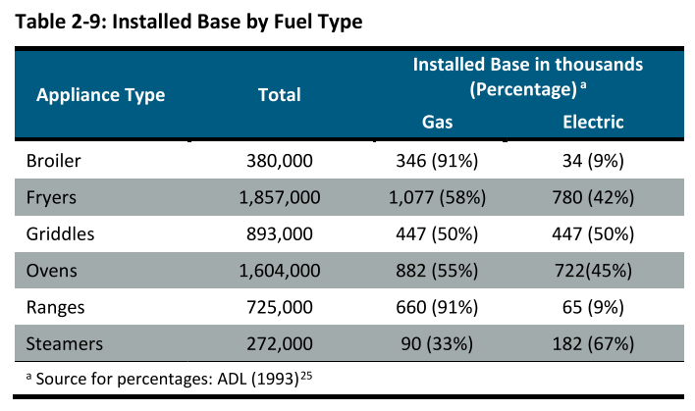
Figure 16: Quantities of installed cooking equipment and prevalence of gas vs. electric. Image from [4].

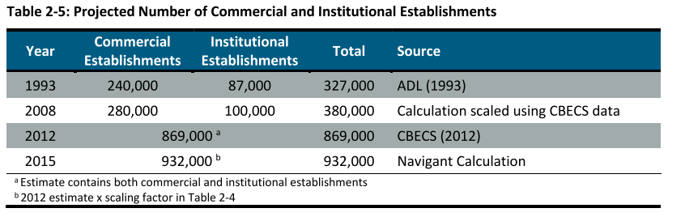
Figure 17: Total number of establishments with commercial cooking equipment. Image from [4].

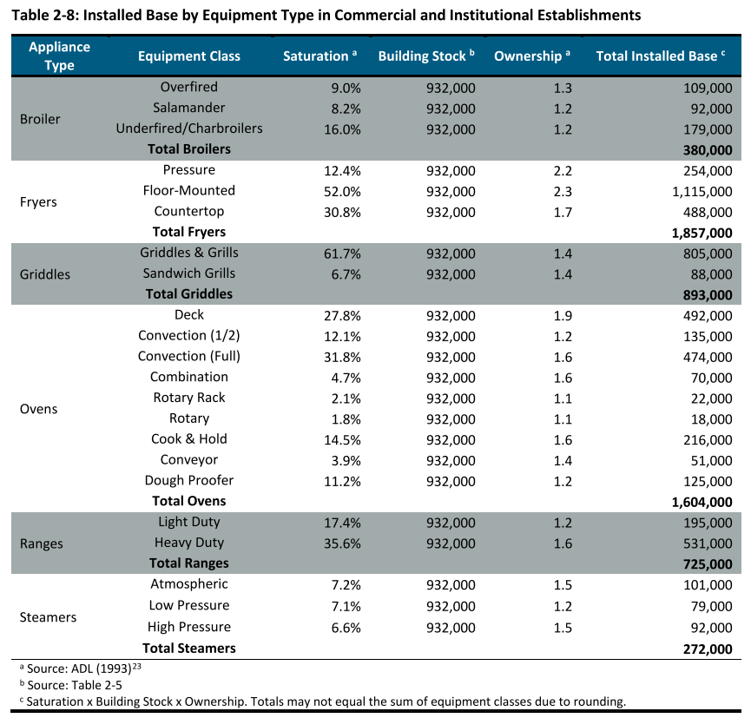
Figure 18: Installed quantities of cooking equipment. Image from [4].

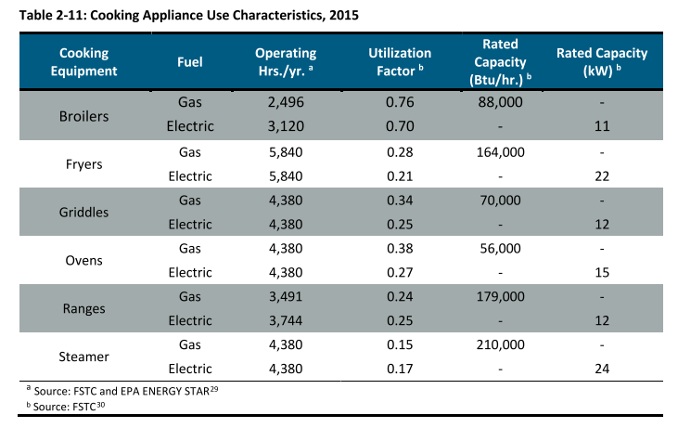
Figure 19: Operating hours for various pieces of cooking equipment and rated capacity. Image from [4].

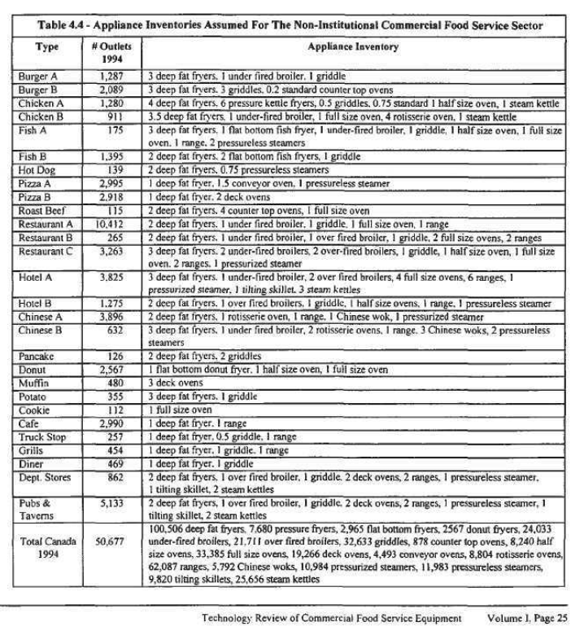
Figure 20: Appliance inventory and number of establishments for various establishment types. Image from [5]

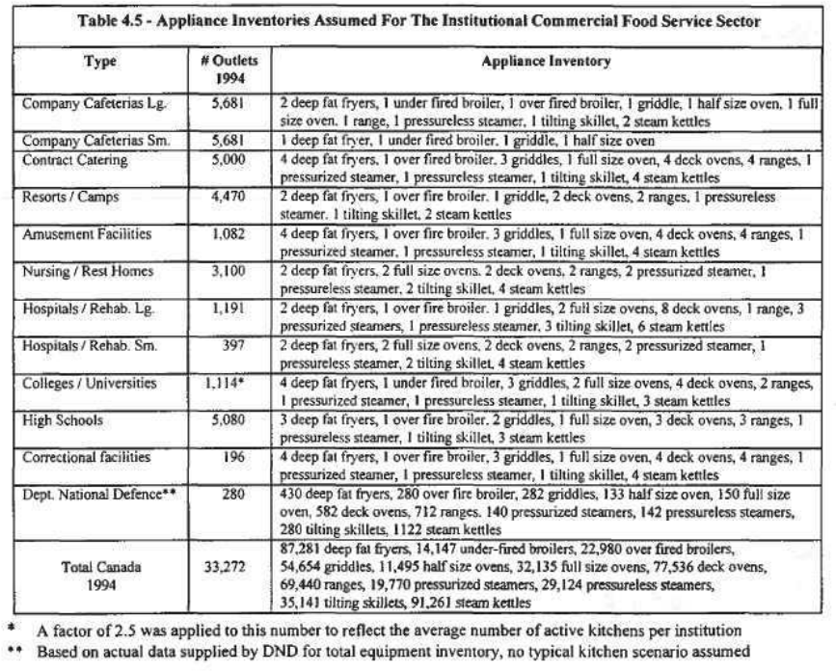
Figure 21: Figure 13: Appliance inventory and number of establishments for various establishment types. Image from [5].

