ComStock Change
  - OpenStudio 3.4.0 to 3.6.1
Implementer: Marley Praprost
Change Document Author: Marley Praprost
Reviewer: Matt Dahlhausen, Andrew Parker

Description of Change

Summary
This updates the version of OpenStudio used by ComStock from 3.4.0 (EnergyPlus 22.1.0, OpenStudio-Standards 0.2.16, released May 2022) to 3.6.1 (EnergyPlus 23.1.0, OpenStudio-Standards 0.4.0, released May 2023). This update includes several new features, performance improvements, and bug fixes, as described in the EnergyPlus release notes. A summary of the changes that were observed in the models is included here.

Dockerfile Approach
The existing approach starts with the OpenStudio 3.4.0 base image. Custom gems are chosen by editing the /resources/.Gemfile in the ComStock repository, which is then loaded and installed via bundler to replace the default set of gems that comes with OpenStudio 3.4.0. When building a Singularity image for HPC, the custom gems are installed directly inside the image. When running locally using Docker, the custom gems are installed into the /.custom_gems directory in the ComStock repository. This latter approach allows developers to quickly test changes to OpenStudio-Standards without having to repeatedly re-clone that repository.
This approach will be maintained, but instead uses the OpenStudio 3.6.1 base image instead of 3.4.0. The only gem required that changed from OpenStudio 3.4.0 to 3.6.1 was the OpenStudio-Standards gem, which updated from 0.2.16 to 0.4.0.

California DEER Ventilation Rates

Existing Method
In the previous release of OpenStudio-Standards (0.2.16), space type ventilation rates in the DEER models were defined by a ventilation_per_area value. The ventilation_per_person field was not utilized previously.

New Method
In the new method (OpenStudio-Standards 0.4.0), values for ventilation_per_person were added to the DEER models in OpenStudio-Standards. In addition, the ventilation_per_area values were modified. These changes were made to enable DCV controls in the DEER models. An example code snippet of this change is shown below.
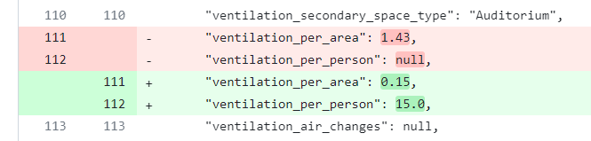
As a result of this change, the design outdoor air flow rates for most space types and vintages increased. The magnitude of the increase is heavily dependent on the building type. Restaurants had the smallest change while small hotels had the largest change, based on the median design flow rate increase for all California models tested.
ComStock Building Type | Design Outdoor Air Flow Rate (m^3/s-m^2) |  | Percent Increase
 | Old Method | New Method
FullServiceRestaurant | 0.0027 | 0.0028 | 1.17
QuickServiceRestaurant | 0.0022 | 0.0024 | 6.16
Warehouse | 0.0008 | 0.0009 | 22.00
PrimarySchool | 0.0023 | 0.0028 | 24.71
SecondarySchool | 0.0022 | 0.0028 | 25.45
RetailStripmall | 0.0016 | 0.0024 | 48.07
Hospital | 0.0008 | 0.0013 | 62.27
RetailStandalone | 0.0014 | 0.0024 | 77.14
LargeHotel | 0.0005 | 0.0011 | 109.14
MediumOffice | 0.0006 | 0.0012 | 113.97
Outpatient | 0.0006 | 0.0012 | 113.97
LargeOffice | 0.0006 | 0.0012 | 113.97
SmallOffice | 0.0004 | 0.0012 | 192.93
SmallHotel | 0.0003 | 0.0012 | 248.37

COP Variable Types
Several COP variables in the models required changes because of the OpenStudio version update. The following DX coil variables changes from Optional Double to Double, requiring an update to the OpenStudio results measure code:
- Rated High Speed COP
- Rated Low Speed COP
- Rated COP
In models with OpenStudio version > 3.4.0, the three variables listed above are Double arguments. To address this change, code was added to accommodate both Optional Double and Double arguments depending on the OpenStudio version of the model. An example of this change is below.
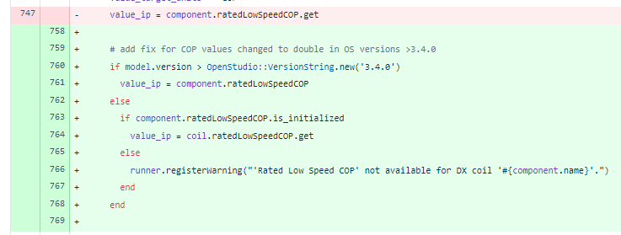

Boiler Output Variables
A few residual errors caused by the name changes to Propane and Fuel Oil fuel types (changed in EnergyPlus 9.4) were caught and fixed in this OS version update. The changes were in the ComStock sensitivity reports measure and related to Boiler output variables. Two reporting variables were added using the new nomenclature, and the code snippet is shown below.
In addition, some boiler models were reporting infinity for annual efficiency because a calculation was mistakenly resulting a denominator of 0. A check was added to the sensitivity reports measure to ensure that the denominator for boiler_annual_efficiency cannot be 0. The code from this change is below.

Impact of Change
These changes were tested using two 10k sample runs with identical buildstock.csv files.

National Scale Impact
As shown in the figures below, there was virtually no change in total electricity or natural gas consumption at the total building stock level.
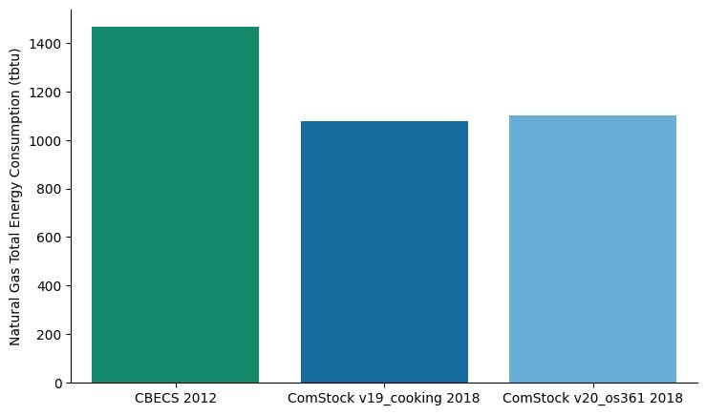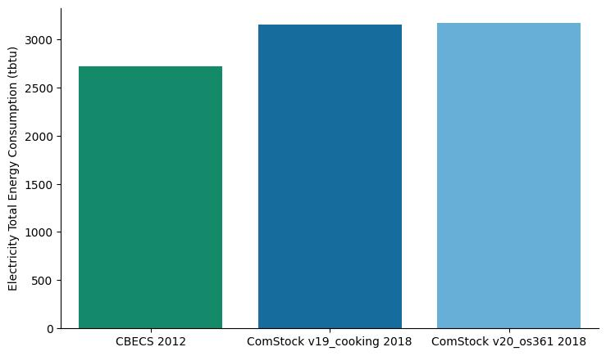
Digging in further, we also see minimal changes in the energy consumption at a building type level. In almost every building type, the natural gas and electricity consumption values are either exactly the same or a very slight increase.

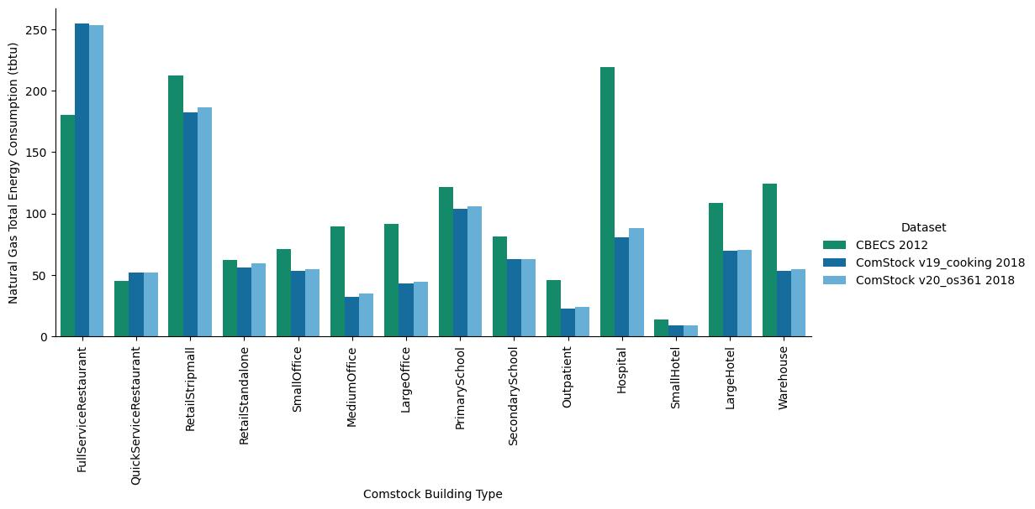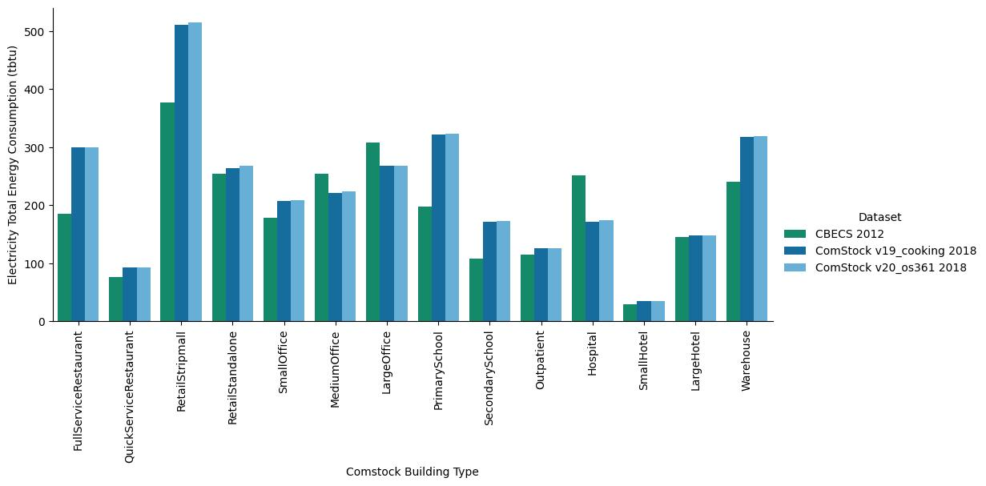
Perhaps the most notable change can be seen when plotting natural gas and electricity totals by census division. The Pacific region has a non-trivial increase in natural gas consumption. The increase in electricity consumption is not as significant, but still the largest change of any census division.
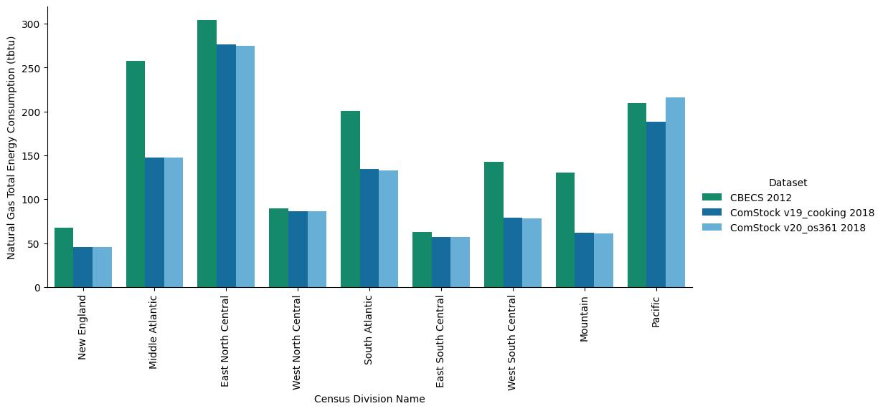
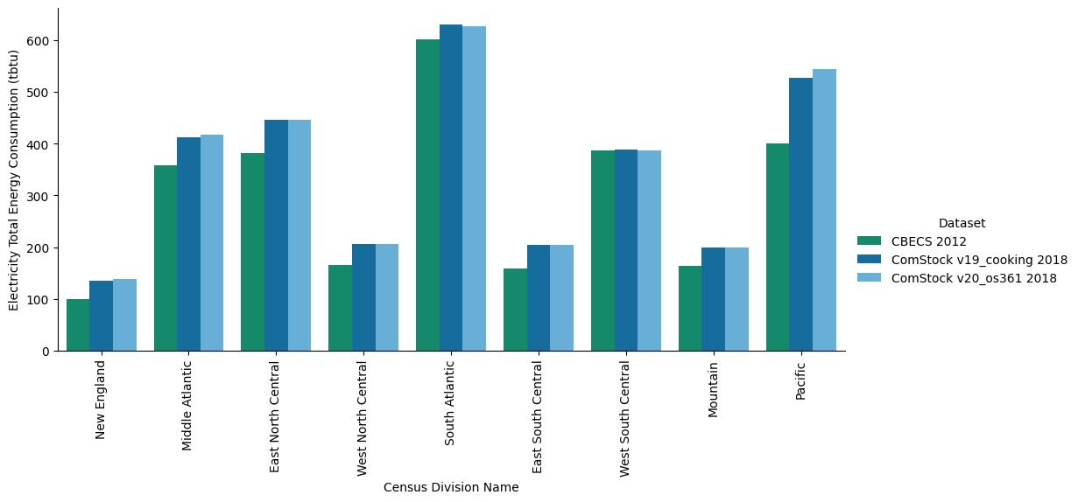
When sorting the results by the change in total site energy, we see that the buildings with the largest increase in energy consumption are exclusively located in California. In fact, California buildings represent the top 847 buildings out of 10,000 with the largest change in site energy. In addition, the HVAC systems most affected appear to be primarily PVAV and DOAS systems, and retail standalone appears to be the most affected building type. This leads one to believe that there may have been a change in the DEER models, either in OpenStudio-Standards or through an OpenStudio or EnergyPlus change that impacted DEER models more significantly.
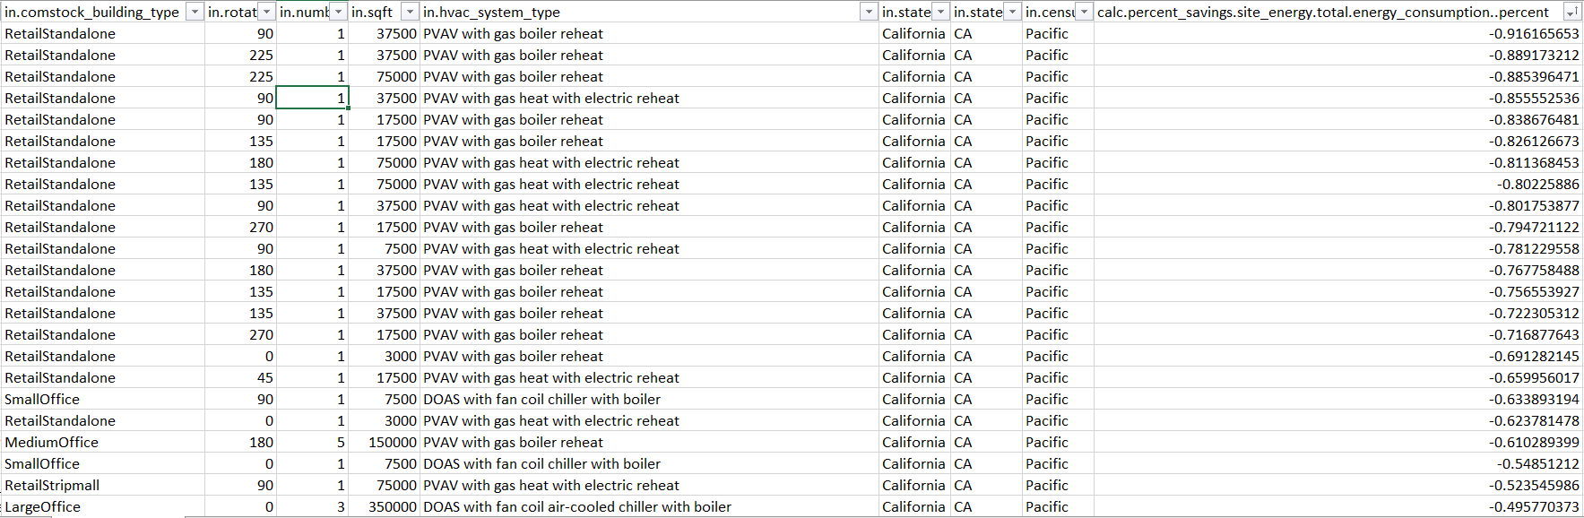
Digging further into the California models, a few individual models were pulled and model outputs were compared side by side to identify which properties of the model changed. The most significant change identified was related to design outdoor air flow rates and outdoor air fraction. Across all California models, the median increase in outdoor air fraction was 30% and the median increase in design outdoor air flow rate was 48%. There were no other model outputs that showed drastic changes, therefore we must assume that this change is the primary cause of the increased energy consumption we are seeing across most California models.
It was determined that a change was made to the DEER ventilation rates in OpenStudio-Standards in February 2023, which resulted in the increase in design outdoor air flow rates. This change modified the way ventilation rates were calculated by adding a ”ventilation_per_person” value and modifying the ”ventilation_per_area” value for all DEER vintages and space types. It was confirmed that this change was intentional and that outdoor air rates should have increased as a result of this OpenStudio-Standards update.

Distribution of Impacts by End Use
The image below shows the distribution of impacts across the 10k simulations included in the test runs by end use and fuel type. In this image, the update to OS 3.6.1 was treated as an upgrade, so positive savings mean a decrease in energy consumption, while negative savings mean an increase in energy consumption. This image does not include the differences in weights between building types.
The initial takeaway is that the box and whiskers segments for most of the distributions are much less than +/- 5% change, which means that a vast majority of buildings had almost no change from the update. This is consistent with the minimal changes in stock-level total seen above.
The two end uses that saw significant increases in energy consumption are natural gas heating and electricity pumps. In these cases, the entire box and left whisker (representing 75% of the sample) is in the negative half of the x-axis, meaning most buildings experienced an increase in these end uses. While the median percent increase (solid line) in both of these end uses is less than 5%, the mean percent increase (dotted line) is closer to 20%. When looking at the outliers on the violin plot (the individual dots), we can see that there are quite a few buildings that experienced a 100+% change in consumption in those end uses, which is why the mean percent increase is much higher than the median.
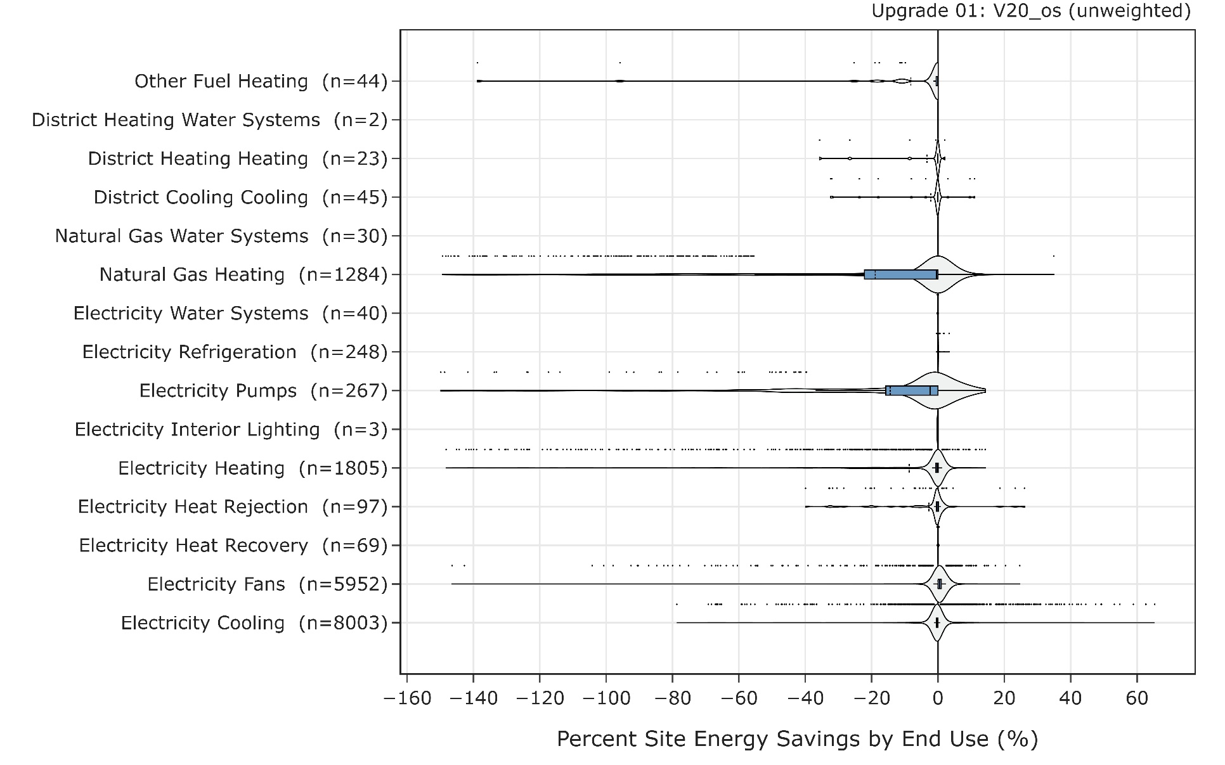
Percent change in energy can sometimes be deceiving because a building with low load requirements can have a small absolute change in energy consumption, but this registers as a very large percent savings. California buildings with low heating requirements are a primary example of this phenomenon. To ensure that the high percent changes in consumption are legitimate, the increase in EUI by end use was also plotted below. In this plot, we can see that natural gas heating does in fact still show a significant change from the baseline. Electricity pumps, on the other hand, which had a high percent increase, shows a trivial change in the EUI. Other fuel heating is the only other end use that shows a noticeable EUI increase, however given that this end use is only present in 44 buildings, it is rather insignificant in big picture.
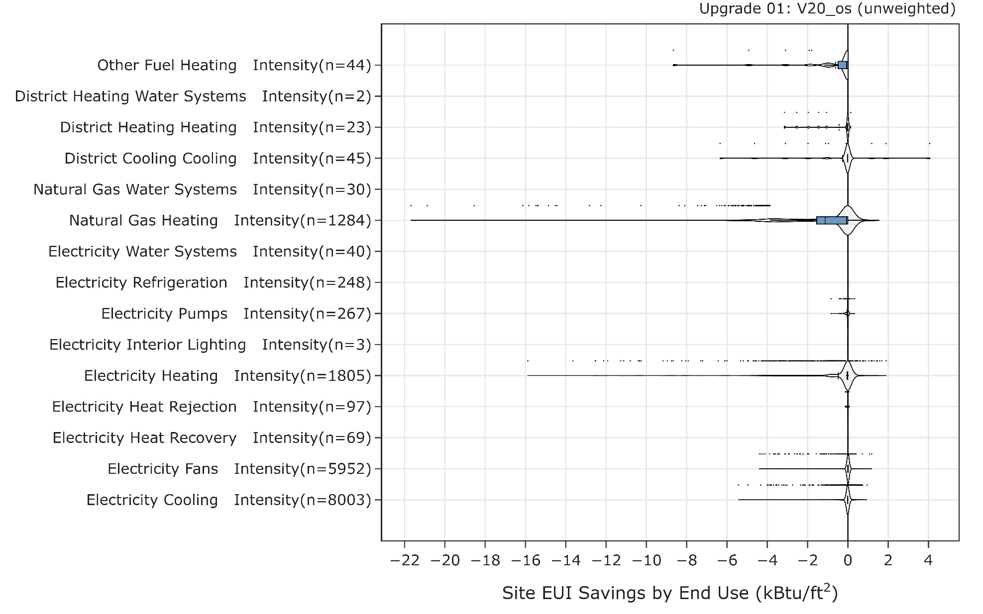

Natural Gas Heating
The results were sorted by buildings with the largest increase in natural gas energy, and the California models appear to be primarily responsible. Based on this, we can safely assume that the increases in ventilation rates discussed earlier are responsible for the increased heating requirements. As discussed earlier, while the percent increase looks very high for many of the California models, because their total heating load is inherently low, a small absolute change in heating will register as a very large percent change.
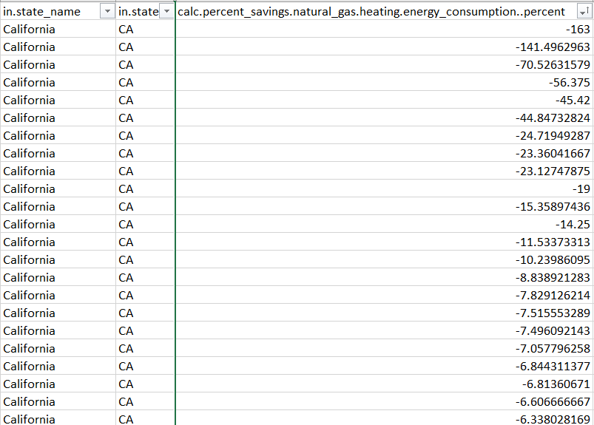

Electricity Pumps
Following the same logic, the results were sorted by buildings with the largest increase in pump energy, and once again the California models appear to be the exclusively responsible for the large outliers. This is very likely tied to the increases in ventilation rates discussed earlier.
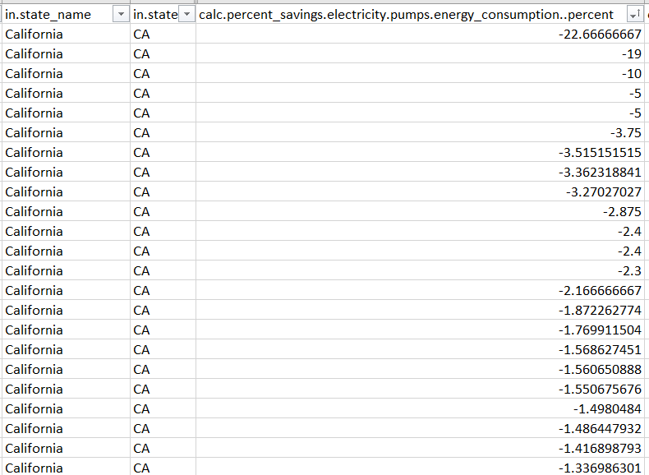

End Uses with Minimal Changes on Average
The following end uses showed minimal changes in consumption on average across the stock, but had a number of outliers with significant changes. This can be seen in end uses with a very narrow box and whisker centered around the y-axis, but with a notable number of individual outliers in the positive and/or negative sides of the graph.
- Other Fuel Heating
- Electricity Heating
- Electricity Fans
- Electricity Cooling
The results for Other Fuel Heating are notable in that there are no buildings that had a decrease in energy in this end use. However, given that only 44 buildings in the 10,000 building sample have an “other fuel” heating system, we are not too concerned about the implications of this change on the full stock results.
For Electricity Heating, Fans, and Cooling, the data was filtered to examine the positive and negative outliers. Once again, all of the top outliers were from California, leading us to the believe that the changes in these end uses were another result of the ventilation rate changes in the DEER models.

End Uses with Effectively Zero Change in Consumption
The following end uses saw effectively zero change in energy consumption when updating to OS 3.6.1. These end uses either had no visible violin plot (indicating that no buildings had changes in consumption) or extremely narrow violin plots with only a handful of outliers out of 10,000 buildings.
- District Heating Water Systems
- District Heating Heating
- District Cooling Cooling
- Natural Gas Water Systems
- Electricity Water Systems
- Electricity Refrigeration
- Electricity Interior Lighting
- Electricity Heat Rejection
- Electricity Heat Recovery
- Electricity Interior Equipment

Distribution of Total Energy Consumption Impacts
The image below shows the distribution of impacts across the 10k simulations included in the test runs by total energy consumption for each fuel. In this image, the update to OS 3.4.0 was treated as an upgrade, so positive savings mean a decrease in energy consumption, while negative savings mean an increase in energy consumption. This image does not include the differences in weights between building types.
The initial takeaway is that the box and whiskers segments for all of the distributions except natural gas are less than +/- 5% change, which means that a majority of buildings had almost no change from the update. This is consistent with the changes in stock-level total seen above. An investigation of the outliers shows that almost all of the highest outliers are a result of the ventilation changes to the DEER models, as the California models saw the most significant change in both the fuel type and end use results.
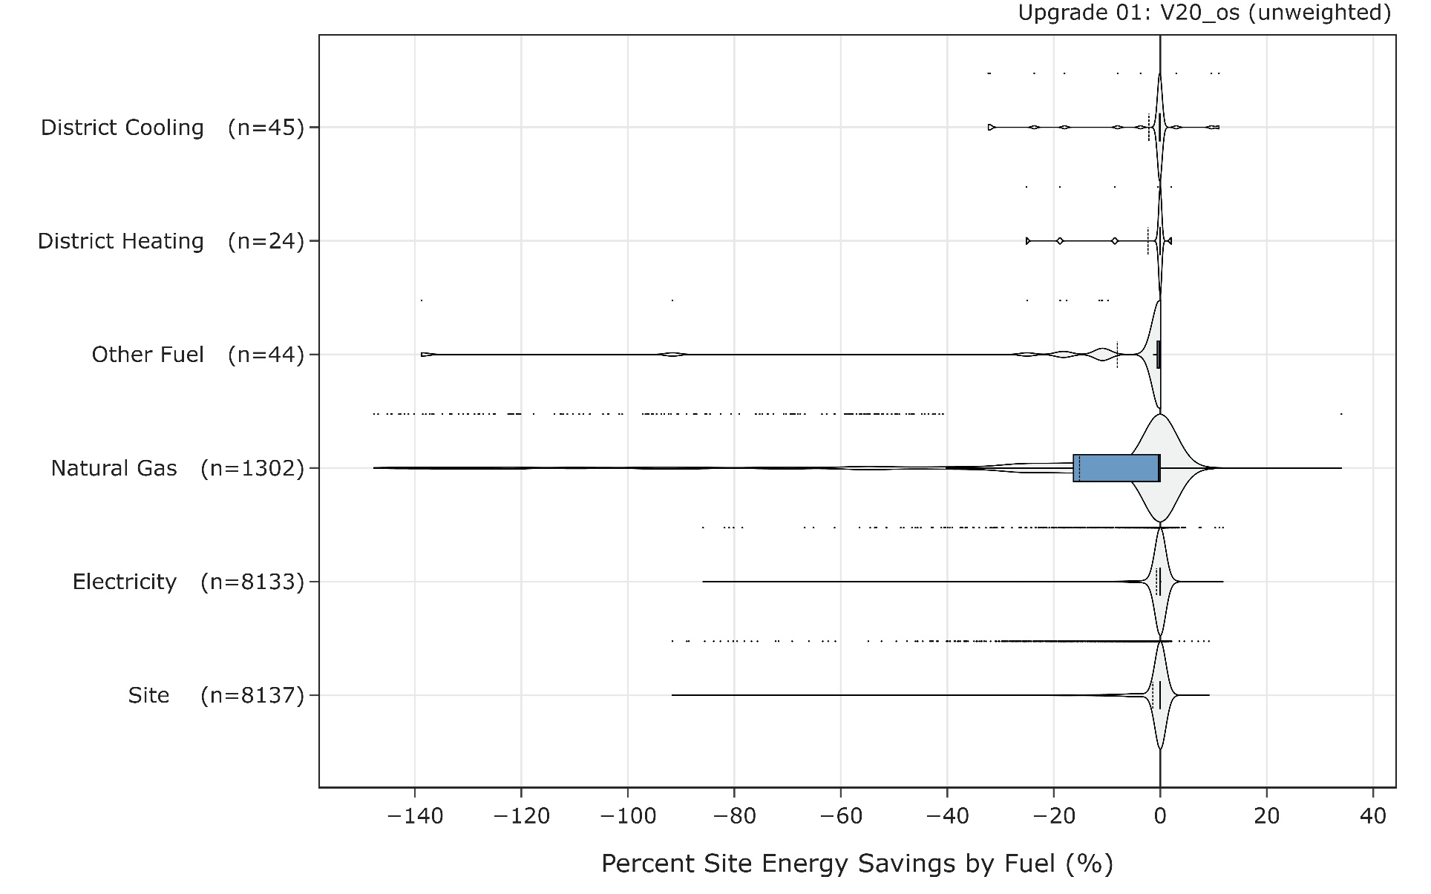

Changes in Aggregate Statistics

Unmet Hours
As the pivot tables of average unmet hours for colling and heating below show, there were minimal changes in unmet hours across most system types. In some cases, there were extreme changes in percentage, but the resulting numbers are still within acceptable limits for the systems with large changes. For example, VAV district chilled water with gas boiler reheat had a 675% increase in unmet cooling hours, however when looking at the absolute number of hours, it increased from 1 hour to 9 hours, which does not raise concerns about the system’s operation. Several DOAS systems showed a significant decrease in unmet hours, indicating an improvement in system operation. Note that some systems don’t have heating or don’t have cooling, which is why some systems have very high unmet hours (for example, Gas unit heaters have no cooling).
