ComStock Change
  - Update distributions for HVAC heating fuel and system type from CBECS 2012.
Implementer: Chris CaraDonna
Change Document Author: Chris CaraDonna
Reviewer: Andrew Parker

Description of Change

Summary
This update modifies the existing framework for generating probability distributions for HVAC heating fuel and system type from CBECS 2012 microdata. Changes include more robust catches for heat pump systems, allowing samples labeled as “electric” heating in CBECS to be reclassified as natural gas based on the reported consumption data, lower thresholds for regional/national fuel type blending (from 90 to 15), and transitioning to a regional/national blending approach for HVAC system type (similar to fuel type).

HVAC Update

Existing Method
The original framework uses CBECS 2012 microdata to determine probability distributions for heating fuel and HVAC system type. The heating fuel type distributions are based on the primary heating fuel type from CBECS 2012 and ResStock county level fuel types (from ResStock sampling TSVs). CBECS 2012 data is used to set the prevalence of each fuel type building type for each census division. The ResStock county level data is then used to proportionally modify distributions at the county level distributions while ensuring they still add up to the CBECS census division targets (or close to them since there are too many constraints to solve this as a perfect linear system). This approach is intended to introduce county-level granularity from residential data while still adhering to the commercial totals from CBECS since residential data alone may not appropriately represent the commercial building stock. Note that district heating is not available in the residential data, so a constant value is used for all counties for a given building type and census division combination based on CBECS 2012.
Some combinations of census division and building type in CBECS lead to very few samples which can be unreliable for representing the trends of a region. To remedy this, a national-regional blending approach is introduced. If there are over 90 samples of a building type in a census division, the distribution will be based entirely on the regional samples. If there are fewer than 90 samples, the national average is blended with the regional average with a weight of 1-(n samples/90). For example, if there are 45 samples of a building type in a census division, the distribution will be weighted 50% from the regional average for the building type and 50% from the national average of the building type.
The HVAC system type distributions are similarly derived from CBECS data, but unlike the fuel type distributions, there is no county level data to inform the distributions beyond census division. The HVAC distributions are derived from CBECS using a hierarchical approach. First, a sample is assigned a primary heating fuel type. Next, the sample is checked to fit into one of the following categories:
- VAV systems
- DOAS + zone equipment
- Packaged single zone equipment
- Unitary zone equipment (PTAC, residential systems, unit heaters, dry coolers, etc.)
Because CBECS samples often suggest multiple systems, the sample category is checked in the order listed above. The intent is that major system types, such as VAV systems, should not be deprioritized to smaller equipment that may also exist in a building, such as PTACs. The idea is that if a major, more complicated system is present, it is likely the dominant system in the building. The above ordering is based on engineering judgment to operationalize this concept, since finding system “tiebreakers” in CBECS can be impractical.
Once a heating fuel type and an HVAC system category are selected, a system type is assumed. For example, a sample may have electric heat and be flagged for the packaged single zone system category. Following the logic explained before, this would mean the system was not flagged for the VAV or DOAS categories. This system would first be assumed to be a packaged single zone with electric coil. Other CBECS survey questions are then engaged to justify changing the system from the default option. In this instance, if air-source heat pumps are selected as a primary heating source, the system would be changed to a packaged single zone heat pump. This approach is taken due to the wide variety of responses in CBECS, where relying too heavily on a single question can be unreliable.
The HVAC system distributions are ultimately based on building type, census division, and heating fuel. The heating fuel is informed by the methods described previously. The heating fuel for the sample then determines the allowable HVAC system types to sample from. Note that mixed fuel system types, such as VAVs with gas heat at the air handling unit and electric reheat, are sampled in the natural gas category. The reasoning is that buildings with electric heat may not have natural gas service.

New Method
The new method updates the existing framework. The updates are described below.
Heating Fuel Category
Previously, mixed fuel system types were assigned under the natural gas fuel type distributions. However, examining CBECS 2012 data, buildings with electricity listed as their primary heating fuel still received about 1/3rd of their heating from combustion fuels, so this may not be appropriate. Note that these estimates are based on disaggregated end use data from CBECS which will include some degree of error, however, the total prevalence of natural gas found in CBECS samples comes from billing data which would be considered reliable. This suggests that buildings with electric heating often have a mixed fuel heating system. Since ComStock is generally high on electric heating and low on gas heating, it is more suitable to assign mixed fuel heating systems under the electric heating distribution. Practically, this is intended to increase the prevalence of natural gas systems since mixed fuel systems will no longer consume a portion of the natural gas heating distribution. Furthermore, the prevalence of electric heating systems will be reduced since mixed fuel systems will now consume a portion of the electric heating distribution. The original and new heating fuel categories are shown in Table 1

Table 1: Original vs. new heating fuel categories for each HVAC system type. Heating fuel category determines which heating fuel types the system is sampled from. Changes are shown in red.
System Type | Heating Fuel Category, Original | Heating Fuel Category, New
PVAV with gas heat with electric reheat | Fuel | Electricity
DOAS with fan coil district chilled water with district hot water | District_Heating | District_Heating
VAV district chilled water with district hot water reheat | District_Heating | District_Heating
PSZ-AC with gas coil | Fuel | Fuel
VAV chiller with PFP boxes | Electricity | Electricity
VAV chiller with gas boiler reheat | Fuel | Fuel
VAV air-cooled chiller with gas boiler reheat | Fuel | Fuel
PTAC with electric coil | Electricity | Electricity
PSZ-AC with gas boiler | Fuel | Fuel
VAV air-cooled chiller with district hot water reheat | District_Heating | District_Heating
Residential AC with residential forced air furnace | Fuel | Fuel
PSZ-AC with electric coil | Electricity | Electricity
VAV air-cooled chiller with PFP boxes | Electricity | Electricity
PTHP | Electricity | Electricity
PVAV with gas boiler reheat | Fuel | Fuel
PVAV with PFP boxes | Electricity | Electricity
VAV chiller with district hot water reheat | District_Heating | District_Heating
DOAS with fan coil air-cooled chiller with boiler | Fuel | Fuel
DOAS with fan coil chiller with boiler | Fuel | Fuel
DOAS with VRF | Electricity | Electricity
Residential forced air furnace | Fuel | Fuel
DOAS with water source heat pumps with ground source heat pump | Electricity | Electricity
DOAS with water source heat pumps cooling tower with boiler | Fuel | Electricity
Direct evap coolers with forced air furnace | Fuel | Fuel
VAV district chilled water with PFP boxes | Electricity | Electricity
PVAV with district hot water reheat | District_Heating | District_Heating
DOAS with fan coil chiller with district hot water | District_Heating | District_Heating
Direct evap coolers with baseboard gas boiler | Fuel | Fuel
PTAC with gas boiler | Fuel | Fuel
PSZ-AC with district hot water | District_Heating | District_Heating
PSZ-HP | Electricity | Electricity
Gas unit heaters | Fuel | Fuel
DOAS with fan coil chiller with baseboard electric | Electricity | Electricity
PSZ-AC district chilled water with district hot water | District_Heating | District_Heating
Direct evap coolers with baseboard electric | Electricity | Electricity
VAV district chilled water with gas boiler reheat | Fuel | Fuel
Baseboard electric | Electricity | Electricity
DOAS with fan coil air-cooled chiller with district hot water | District_Heating | District_Heating
PSZ-AC district chilled water with electric coil | Electricity | Electricity
DOAS with fan coil district chilled water with boiler | Fuel | Fuel
PTAC with gas coil | Fuel | Fuel
DOAS with fan coil district chilled water with baseboard electric | Electricity | Electricity
Baseboard gas boiler | Fuel | Fuel
PTAC with baseboard district hot water | District_Heating | District_Heating
DOAS with fan coil air-cooled chiller with baseboard electric | Electricity | Electricity

Threshold for Blending National and Regional Heating Fuel Distributions
As previously mentioned, the method used to generate fuel type probability distributions involved blending the national and regional (census division) averages for groupings of building type and census division to cases where the number of samples in CBECS is fewer than 90. Although this reduces the risk of variability associated with low sample counts, it also reduces very real regional differences of heating fuel type that occur in various parts of the country when fewer samples are available. The new method changes the blending rate threshold from 90 samples to 15 samples to introduce more regional variety while still maintaining some safeguard against low sample count. The intention behind this modification is to align with national trends, which indicate a higher prevalence of electric heating in warmer regions and a greater reliance on natural gas heating in colder regions.

Threshold for Blending National and Regional HVAC System Type Distributions
The original method did not use a national-regional blending method for HVAC systems like what was done with heating fuel type. This was not included in the original version simply because of time. The implication is that some combinations of building type, census division, and fuel type sample as few as a single HVAC system, which introduces error and uncertainty. The new method introduces a national-regional blending rate similar to the heating fuel distribution with a 15 sample count minimum threshold. The objective is to mitigate the variability and uncertainty that arise when distributions are solely informed by low sample counts, especially when this leads to a single HVAC system in the distribution.
County Weighting
As discussed, the heating fuel type distributions use county-level ResStock data to allocate the census-division-level CBECS fuel type prevalence among counties for higher geospatial granularity. This is important due to the variety of fuel type prevalence that exists within census divisions. Previously, the ResStock county weights we used for determining the “weight” of the county to facilitate census division alignment to CBECS. However, this can lead to increased error for aligning to CBECS at the census division and building type (which is ultimately the “target”) level as the ResStock weights do not necessarily align with ComStock county weights per building type. This update uses building area data from a previous ComStock run for weighting counties in this calculation.
Assessing Electric Resistance Systems
The original HVAC system distributions suggest roughly 20% of the stock floor area being served by electric resistance RTUs. Although it is difficult to disprove this with the limited data available on HVAC system prevalence, anecdotal feedback suggests this number to be high. The new approach modifies the criteria for classifying a system type as an electric resistance RTU. The key changes include adding more robust checks for heat pump systems, but also checking the prevalence of natural gas consumption and natural heating consumption from CBECS. If CBECS estimates over 30% of the space heating comes from natural gas, then the sample is reclassified as gas heating and a gas RTU is used. Similar considerations were added for boiler systems which is especially important in ComStock since ComStock does not use electric resistance boiler systems. This added layer of checks for gas heating classification allows samples that show gas heating usage and have a boiler noted in the building to be assigned a gas boiler system, even if the user specified electric primary heating.

Impact of Change
The new HVAC distributions are shown in Figure 1 by floor area for the old distributions (used in EUSS cycle 1) and the new distributions (used in EUSS cycle 2).
Table 3 compares the % of stock floor area served by each HVAC system type in ComStock for EUSS cycle 1 versus cycle 2. The largest reductions in floor area between cycles is from PSZ-AC with electric coil (-12.4%), PTHP (-5.1%) and residential AC with residential forced air furnace (-3%). The PSZ-AC with electric coil reduction was from a concerted effort to reduce the prevalence of this system type in the ComStock baseline to align with expert intuition. Previously, the distributions showed 25% stock floor area being served by gas furnace RTUs and 20% electric resistance RTUs. Although it is difficult to find an accurate estimate of commercial HVAC system type prevalence across the stock, several experts have expressed that assuming 45% of RTUs being electric resistance seems high. The updated distribution used in EUSS cycle 2 shows 28.7% and 8.5% floor area served by PSZ-AC with electric coil and PSZ-AC with gas coil, respectively. This results in electric resistance RTUs making up only 24% of packaged RTUs, which seems more realistic. Many of these systems were reassigned to other electric heating systems, like heat pumps, through more careful classification methods. Additionally, some were reclassified as gas furnace RTUs by considering CBECS fraction of space heating from gas in the classification methods.
Alternatively, the largest increases in HVAC floor area comes from PVAV with gas boiler reheat (+6.1%), VAV chiller with gas boiler reheat (+4.8%), and PSZ-HP (+3.1%). The increase in boiler systems is beneficial, as ComStock has been comparatively low in boiler prevalence compared to CBECS. This change is caused in part by more careful logic in classifying systems with boilers. Figure 1 compares % floor area served by boilers between the old and new runs, with area served increasing from 19% to 36%. CBECS suggests between 30-35% of floor area is served by boilers, so the updated prevalence shows closer alignment.
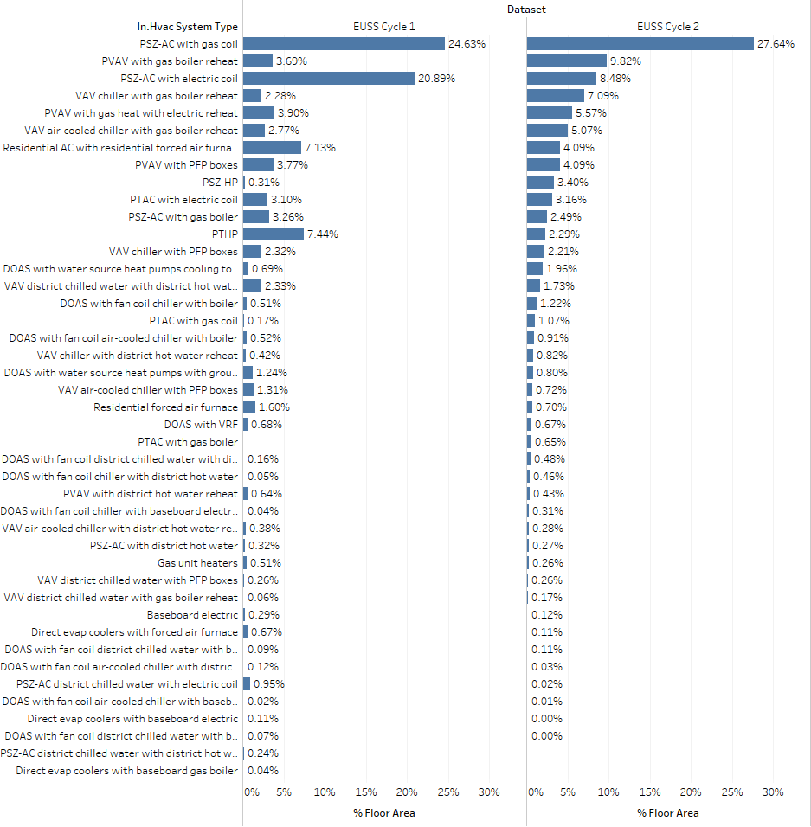
Figure 2: HVAC system type prevalence by floor area between EUSS Cycle 1 and Cycle 2. Cycle 2 represents the new distribution.

Table 2: HVAC system type floor area comparison between EUSS cycle 1 and 2.
HVAC System Type | % Area Cycle 1 | % Area Cycle 2 | Cycle 2 - Cycle 1
PSZ-AC with electric coil | 20.9 | 8.5 | -12.4
PTHP | 7.4 | 2.3 | -5.1
Residential AC with residential forced air furnace | 7.1 | 4.1 | -3.0
PSZ-AC district chilled water with electric coil | 0.9 | 0.0 | -0.9
Residential forced air furnace | 1.6 | 0.7 | -0.9
PSZ-AC with gas boiler | 3.3 | 2.5 | -0.8
VAV district chilled water with district hot water reheat | 2.3 | 1.7 | -0.6
VAV air-cooled chiller with PFP boxes | 1.3 | 0.7 | -0.6
Direct evap coolers with forced air furnace | 0.7 | 0.1 | -0.6
DOAS with water source heat pumps with ground source heat pump | 1.2 | 0.8 | -0.4
Gas unit heaters | 0.5 | 0.3 | -0.3
PVAV with district hot water reheat | 0.6 | 0.4 | -0.2
Baseboard electric | 0.3 | 0.1 | -0.2
VAV chiller with PFP boxes | 2.3 | 2.2 | -0.1
Direct evap coolers with baseboard electric | 0.1 | 0.0 | -0.1
VAV air-cooled chiller with district hot water reheat | 0.4 | 0.3 | -0.1
DOAS with fan coil air-cooled chiller with district hot water | 0.1 | 0.0 | -0.1
DOAS with fan coil district chilled water with boiler | 0.1 | 0.0 | -0.1
PSZ-AC with district hot water | 0.3 | 0.3 | 0.0
DOAS with fan coil air-cooled chiller with baseboard electric | 0.0 | 0.0 | 0.0
DOAS with VRF | 0.7 | 0.7 | 0.0
VAV district chilled water with PFP boxes | 0.3 | 0.3 | 0.0
DOAS with fan coil district chilled water with baseboard electric | 0.1 | 0.1 | 0.0
PTAC with electric coil | 3.1 | 3.2 | 0.1
VAV district chilled water with gas boiler reheat | 0.1 | 0.2 | 0.1
DOAS with fan coil chiller with baseboard electric | 0.0 | 0.3 | 0.3
PVAV with PFP boxes | 3.8 | 4.1 | 0.3
DOAS with fan coil district chilled water with district hot water | 0.2 | 0.5 | 0.3
DOAS with fan coil air-cooled chiller with boiler | 0.5 | 0.9 | 0.4
VAV chiller with district hot water reheat | 0.4 | 0.8 | 0.4
DOAS with fan coil chiller with district hot water | 0.1 | 0.5 | 0.4
DOAS with fan coil chiller with boiler | 0.5 | 1.2 | 0.7
PTAC with gas coil | 0.2 | 1.1 | 0.9
DOAS with water source heat pumps cooling tower with boiler | 0.7 | 2.0 | 1.3
PVAV with gas heat with electric reheat | 3.9 | 5.6 | 1.7
VAV air-cooled chiller with gas boiler reheat | 2.8 | 5.1 | 2.3
PSZ-AC with gas coil | 24.6 | 27.6 | 3.0
PSZ-HP | 0.3 | 3.4 | 3.1
VAV chiller with gas boiler reheat | 2.3 | 7.1 | 4.8
PVAV with gas boiler reheat | 3.7 | 9.8 | 6.1
Direct evap coolers with baseboard gas boiler | 0.0 | NA | NA
PSZ-AC district chilled water with district hot water | 0.2 | NA | NA
PTAC with gas boiler | NA | 0.7 | NA

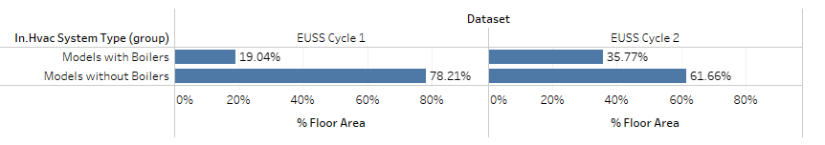
Figure 1: Comparison of area served by boiler systems between the original HVAC distributions used in EUSS cycle 1 and the update distributions used in EUSS cycle 2.

Fuel Type Impacts
This section walks through comparing fuel type distributions by building type. Note, however, that fuel type distributions are set at the county level, so this comparison is less granular than the actual implementation.
Figure 2 compares fuel type prevalence by building type for CBECS 2012 and the updated TSV. Note that the TSVs are implemented at the county level, so this aggregation uses county level areas from a past ComStock run to estimate the building type level aggregation, which is an imperfect estimation. Figure 2 shows little discrepancy between CBECS and the TSV estimation, with the largest differences generally being under 7% (noting that this is absolute difference, not percent difference). Despite these differences, the TSV estimation seems largely adequate.
Figure 3: Comparison of fuel type prevalence of CBECS and the implemented ComStock TSVs. Note that the TSVs are at the county level, so this rollup uses county-level area to estimate the building-type-level aggregations, which may be cause error.
Figure 3 compares fuel type prevalence for the older distributions (used in EUSS Cycle 1) and the new distributions (used in EUSS cycle 2). There are some notable differences, mostly causing reductions in electric heating and increases in gas heating. Since ComStock has historically been low on natural gas heating compared to other data sources, this change is likely beneficial.
Figure 4: Comparison of fuel type prevalence for the older distributions (used in EUSS Cycle 1) and the new distributions (used in EUSS cycle 2).
Figure 4 compares the fuel type distribution between EUSS Cycle 1 and CBECS 2012, where we can see notably large differences across many building types. Much of the discrepancy shows ComStock having too much electric heating and not enough natural gas heating relative to CBECS.
Figure 5: Comparison of fuel type prevalence for the older distributions (used in EUSS Cycle 1) and CBECS 2012.
Figure 5 compares the fuel type prevalence of CBECS 2012 and the updated fuel type distributions used in EUSS cycle 2. These show large improvements over the EUSS cycle 1 comparisons. There is still some deviation from CBECS, however. Part of this is due to randomness in the sampling process. Additionally, error can be introduced through the process of adding county level granularity for fuel type. Each county needs to be assigned a weight, per building type, when calculating a solution for aligning census regions to CBECS 2012. A past ComStock run is used for this, but ComStock samples can be thin by building type at the county level which increases uncertainty in this process. The largest error comes from small and large hotels that show ~10% too much electric heat and ~10% low on gas heat (these are absolute differences in the distribution, not percent change).
Figure 6: Comparison of fuel type prevalence for the updated distributions (used in EUSS cycle 2) and CBECS 2012.

Energy Impacts
Figure 6 compares the annual energy by end use and fuel type for the old (Baseline) and updated (V21) ComStock versions. Note that some end uses show differences due to rerunning sampling, which includes some randomness. For example, lighting energy increased between runs, but no change was made to the lighting. The most notable change is in gas heating, where ComStock increased from 550 TBtu/year to 720 TBtu/year. This change is welcomed since CBECS suggests this value to be over 800 for the building types we model in ComStock, so the new V21 value is much closer. The reduction in electric heating energy from 282 to 224 is also preferred, since ComStock is high on electric heating compared to CBECS. CBECS suggests stock electric heating should be less than 100 TBtu, but it is unclear how accurately this value is disaggregated, and if further reductions in electric heating should be pursued.
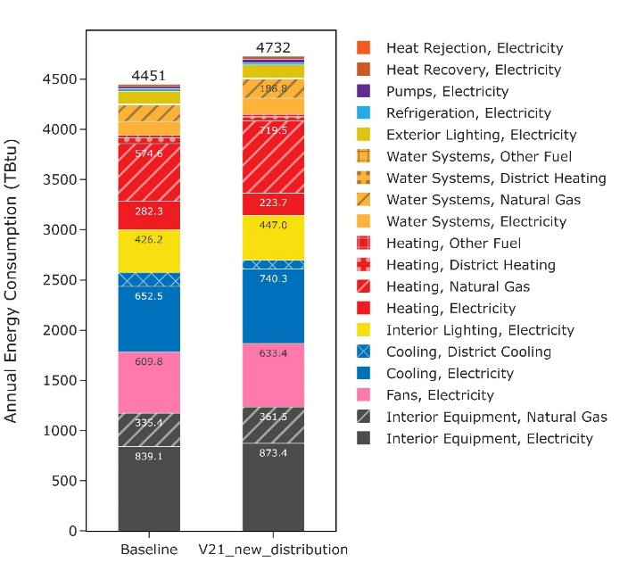
Figure 7: End use comparison of ComStock version V19 "Baseline" and the updated ComStock V21.
Figure 7 compares electricity consumption by building type for V19 vs. V21.Strip malls and primary/secondary schools show notable improvements towards CBECS 2018. Note that the distributions were generated using CBECS 2012, so perfect alignment is not expected. The results vary by building type, but most building types show improved alignment with CBECS 2012 vs. the older V19 run. The biggest improvements are in strip malls and schools. Warehouses show the largest increase in deviation from CBECS, but ComStock aggregate warehouse energy consumption has historically not aligned closely with CBECS, so this is not being considered heavily. Other building types show small changes. Note that both large hotels and secondary schools overestimate electricity consumption by about 10% or more, which may be in part due to the fuel type distributions overestimating electric heating by 10% or more, although other factors are likely at play here too.

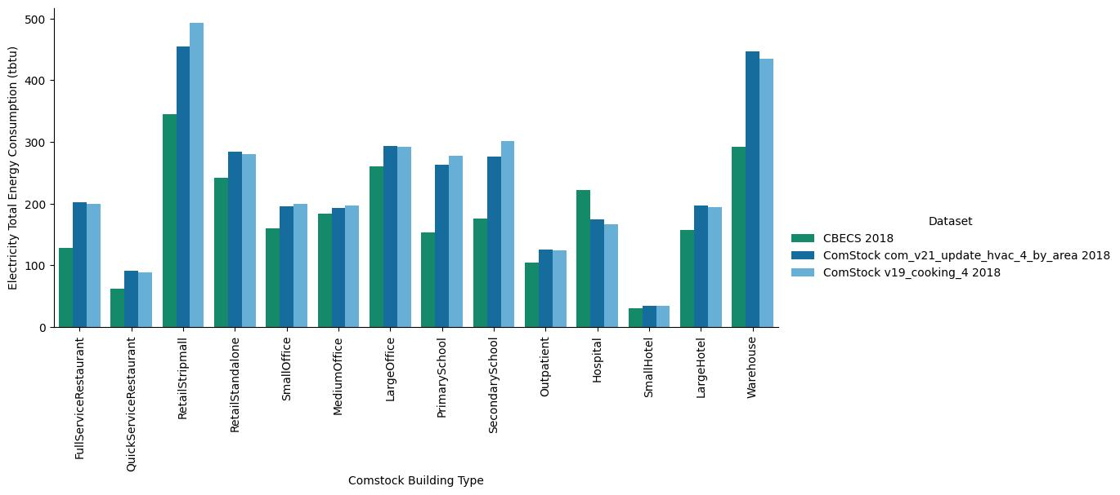
Figure 8: Electricity comparison by building type.

Figure 8 shows the results for a schools-only run that removes the nighttime ventilation functionality. This means school AHU operation is no longer modified to reflect BAS data introduced during EULP calibration. This was tried since schools are showing large overestimation of both gas and electricity consumption compared to CBECS. Overall, electricity consumption is more closely aligned to CBECS than the cooking V4 run, or the original fuel type distribution run shown in Figure 6. However, ComStock is still overestimating electricity consumption compared to CBECS by large margins despite these changes.
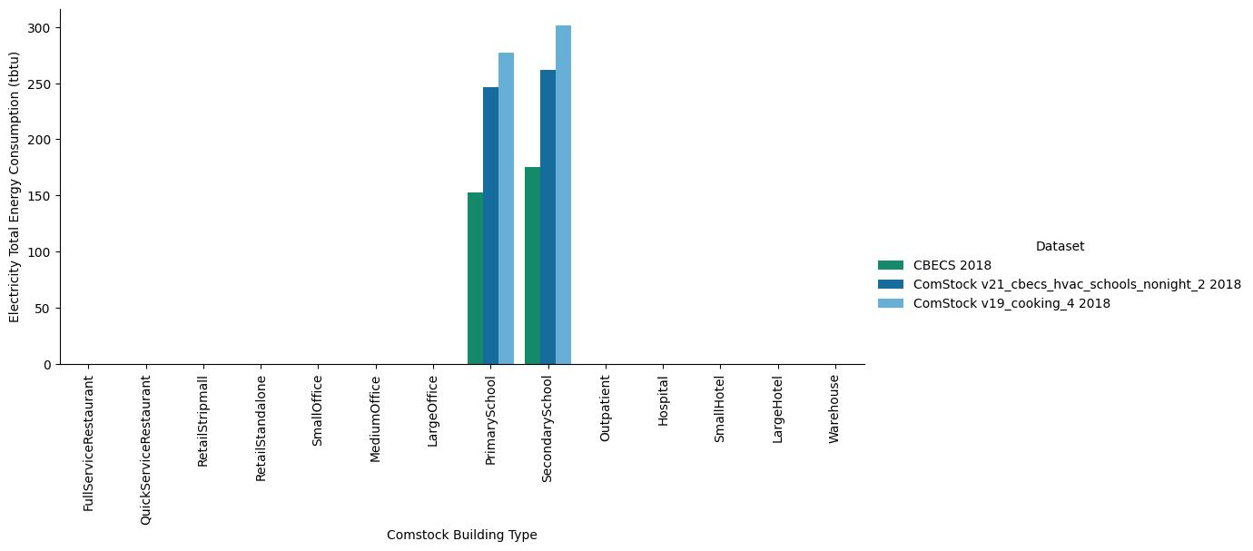
Figure 9: Electricity comparison by building type; schools only, after removing night ventilation functionality.
Figure 9 compares natural gas usage of the V19 and V21 ComStock runs versus CBECS 2018. Some building types show closer alignment to CBECS for the V21 run versus the V19 run. Strip mall, retail, medium office, large office, outpatient and warehouse are some examples of these. Strip malls, retail, large offices, and outpatient have improved to the point that they could be considered calibrated to CBECS 2018 for natural gas at this granularity. Note the shortfalls are large and small hotels could be somewhat attributed to ComStock underestimating natural gas heating for these building types by a magnitude of 10%. However, some building types moved further from CBECS 2018, noting once again that the distributions are from CBECS 2012, not 2018. The primary examples of this are full service restaurant, hospitals (to a small degree), and secondary schools. Secondary schools especially show a large overcorrection as they now exceed CBECS 2018 by over 30%.
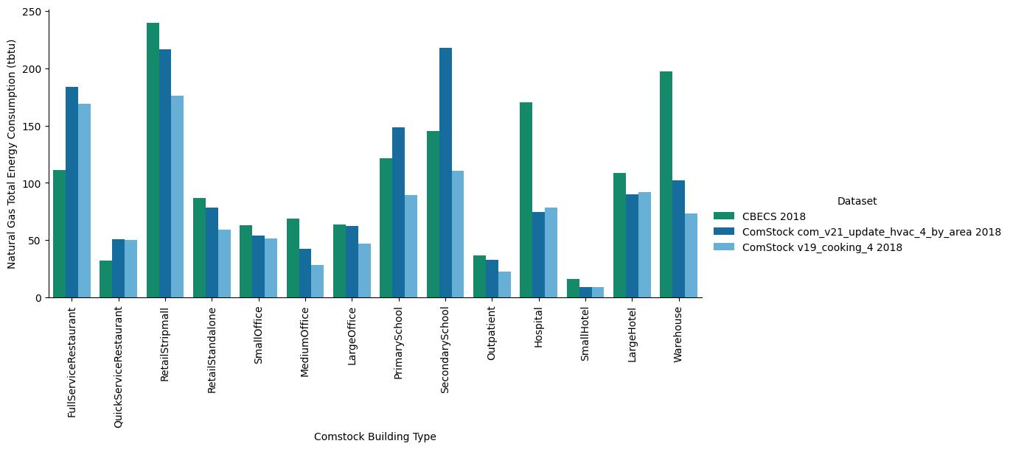
Figure 10: Natural gas comparison by building type.
Figure 10 shows the same “schools only” rerun that eliminates the nighttime AHU operation variability. This was done to address the large gas and electric overestimation of new updated ComStock distributions. Compared to Figure 9, this updated run shows better alignment to CBECS 2018. Primary schools could be considered largely calibrated for natural gas at this granularity. Secondary schools show similar error to the V4 run, except now they overestimate natural gas whereas before they were underestimating. It is unclear if removing the nighttime AHU operation change is appropriate for this improvement. However, schools are large periods of unoccupied times compared to other building types, so they are far more impacted by this measure. My recommendation is to keep this change with the assumption that the end use data used to implement the original nighttime operation behavior may not represent the larger picture of school AHU operation. For example, it is not clear if the end use data covered all spaces in schools, including higher ventilation areas like auditoriums, gymnasiums, and cafeterias.
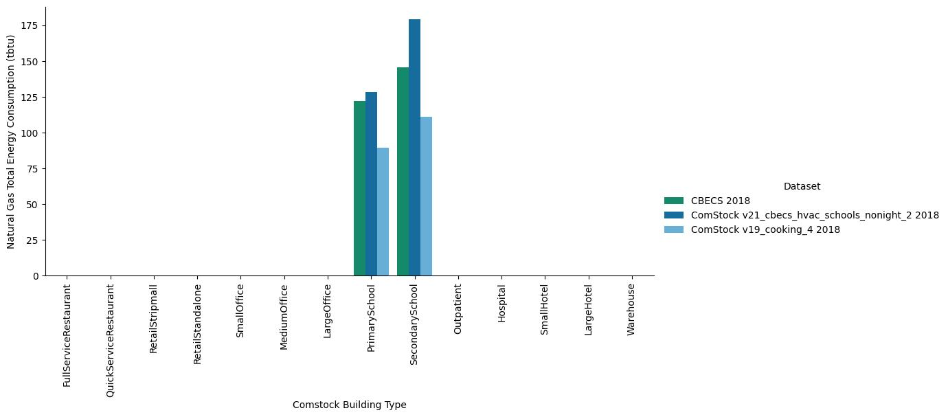
Figure 11: Natural gas comparison by building type; schools only, after removing night ventilation functionality.

