ComStock Change
  - v22 – VRP-based VAV Sizing
  - Implementer: Eric Ringold, Matthew Dahlhausen
Change Document Author: Eric Ringold
Reviewer: Andrew Parker

Description of Change

Summary
This update replaces the SizingSystem input ‘System Outdoor Air Method’ from ‘Standard62.1VentilationRateProcedure’ to ‘ZoneSum’ for sizing VAV/PVAV systems.

Existing Methodology
The Prototype.hvac_systems methods `model_add_vav_reheat` and `model_add_pvav_reheat` included calls to `model_system_outdoor_air_sizing_vrp_method`, which sets the AirLoopHVAC’s SizingSystem object input ‘System Outdoor Air Method’ to ‘Standard62.1VentilationRateProcedure.’ This input specifies the system outdoor airflow used for calculating system loads and airflow. ‘Standard62.1VentilationRateProcedure’ tells EnergyPlus to perform the multi-zone equations defined in Standard 62.1 and use the resulting required ventilation air for system sizing. These equations use zone ventilation effectiveness and zone population diversity to adjust required system ventilation air. Final system design outdoor airflow is selected as the maximum of the design outdoor airflow from the heating and cooling load calculations.
We found that for certain building types, this sizing method would result in the required ventilation air to be the same or near the system total supply air flow due to some zones with very low Zone Ventilation Efficiency. This would manifest by autosizing the air loop’s Controller:OutdoorAir field ‘Minimum Outdoor Air Flow Rate’ to be at or near the air loop’s design supply flow rate. The ComStock workflow would then hardsize that autosized value to that input field, which would then cause the controller to always deliver that minimum outdoor air, effectively turning the air loop into a 100% outdoor air unit. That same workflow step would revert the SizingSystem System Outdoor Air Method to ‘ZoneSum’, obscuring the reason for the high minimum outdoor airflow.
Additionally, this defect primarily impacted models generated with the ‘DOE Ref 1980-2004' and ‘DOE Ref Pre-1980' standards templates. In the code that generates the HVAC systems (calling `model_add_vav_reheat` from openstudio-standards), the method `model_apply_multizone_vav_outdoor_air_sizing` was also called. This method ultimately adjusts VAV minimum damper positions to achieve a minimum system ventilation effectiveness of 0.6, however the method is overloaded for older vintages to do nothing.

New Methodology
The new methodology removed the call to `model_system_outdoor_air_sizing_vrp_method` from the VAV/PVAV system creation. This caused the SizingSystem input ‘System Outdoor Air Method’ to default to ‘ZoneSum’, which uses the uncorrected outdoor air intake (summed from the DesignSpecification:OutdoorAir objects for spaces served by the system) as the design outdoor air rate. This allowed the Controller:OutdoorAir autosized value for Minimum Outdoor Air Flow Rate to remain the same as the total of the DesignSpecification:OutdoorAir flows, and therefore during system operation the outdoor air rate would modulate between that design minimum up to the AirLoopHVAC supply maximum during economizer operation.

Impact of Change

Individual Model Input Change
Review of the model input for a building of type “RetailStripmall|FullServiceRestaurant” built to code “ComStock DOE Ref Pre-1980" with system type “PVAV with gas boiler reheat” (Figure 1), shows that Controller:OutdoorAir Minimum Outdoor Air Flow Rate, previously set to equal Maximum Outdoor Air Flow Rate, after the change is set to the sum of the zone DesignSpecification:OutdoorAir outdoor air requirements.
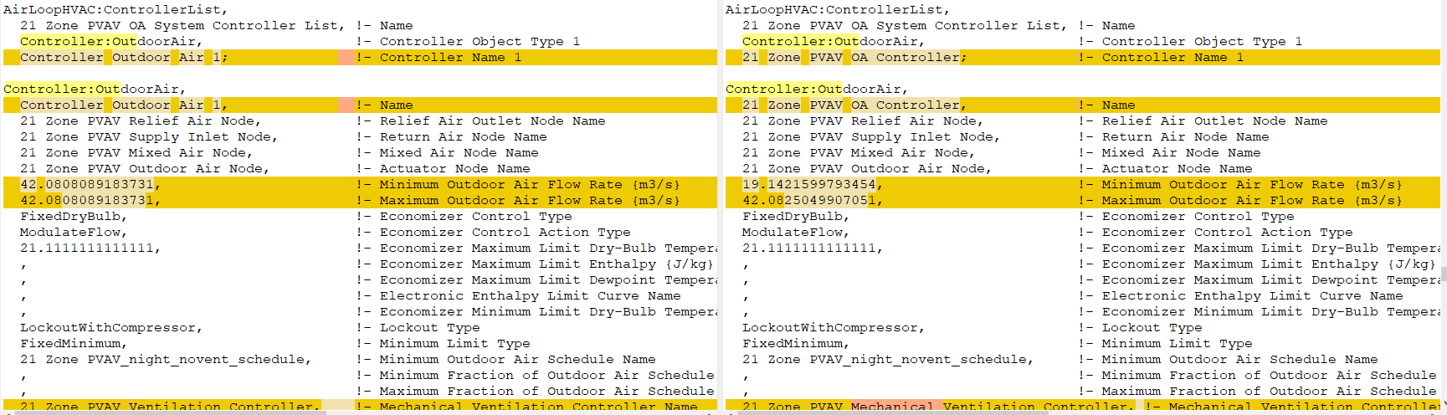
Figure 1: IDF diff before the fix (left) and after (right).
Additionally, inspecting system node flow rate output (Figure 2) shows that prior to the fix, the air loop would deliver 100% outdoor air during occupied hours, well in excess of the zone requirement. After the fix, the outside air volume flow would be limited to the minimum requirement. Note that the supply airflow rate was dramatically higher prior to the fix, which resulted from the system not being able to meet setpoint for those hours, causing the terminals to request more air to meet zone loads.
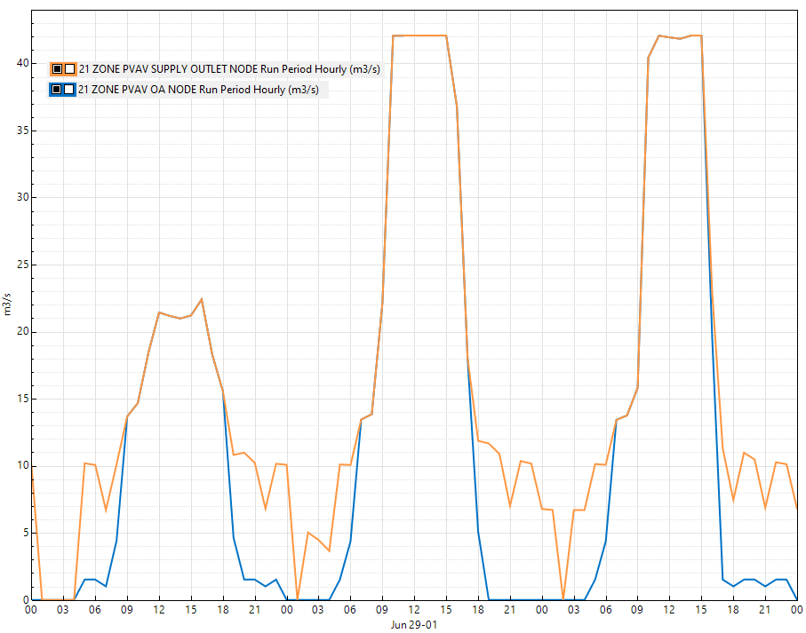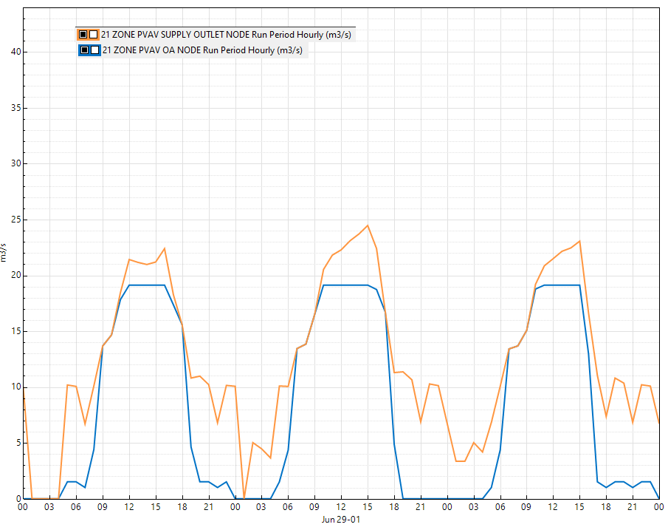
Figure 2: System Node Volume Flow outputs for the Air Loop outdoor air node (blue) and supply air node (orange), before the fix (left) and after (right).

Stock-Level Input Change
Unfortunately, comparing the effect of this change on stock-level inputs proved difficult, because the run including the change also included a change in how the model input parameters are reported for average outdoor air fraction. The previous reporting method used the simulation output variable ‘Air System Outdoor Air Fraction’, averaged over the run period, combined with the run period average of ‘Air System Mixed Air Mass Flow Rate’ to calculate a building-average outdoor air fraction. However, time-averaged values of ‘Air System Outdoor Air Fraction’ would include zero values for timesteps when the system is not operating, thus underestimating the system’s operational outdoor air fraction. The modified calculation uses run period averaged value of ‘Air System Outdoor Air Mass Flow Rate’ (and Mixed Air Mass Flow Rate’) to calculate the outdoor air fraction. This calculation method better approximates the average operational system outdoor air fraction, since the flow averages aren’t affected by system operation. Table 1 below summarizes the effect of this reporting change for the example model examined above: although the fix decreased the average operational outdoor air fraction (Average OA Mass Flow / Average Mixed Air Mass Flow), the reported value appears to increase compared to the calculation using time-averaged Outdoor Air Flow Fraction.
Table 1: Comparison of model output metrics between the base and fix runs
 | Base Case | Fix
Air System Outdoor Air Flow Fraction, RunPeriod | 0.5341 | 0.5314
Air System Outdoor Air Mass Flow Rate, RunPeriod | 8.9385 | 8.7081
Air System Mixed Air Mass Flow Rate, RunPeriod | 12.5267 | 12.361
com_report_average_outdoor_air_fraction (old) | 0.5341 | 0.5314
com_report_average_outdoor_air_fraction (new) | 0.7136 | 0.7045

From the building stock-level output, we can see this increase primarily for building types where systems are expected to operate intermittently (i.e. schools, retail), and an average decrease for types with more continuously-operating systems (i.e. hospitals):
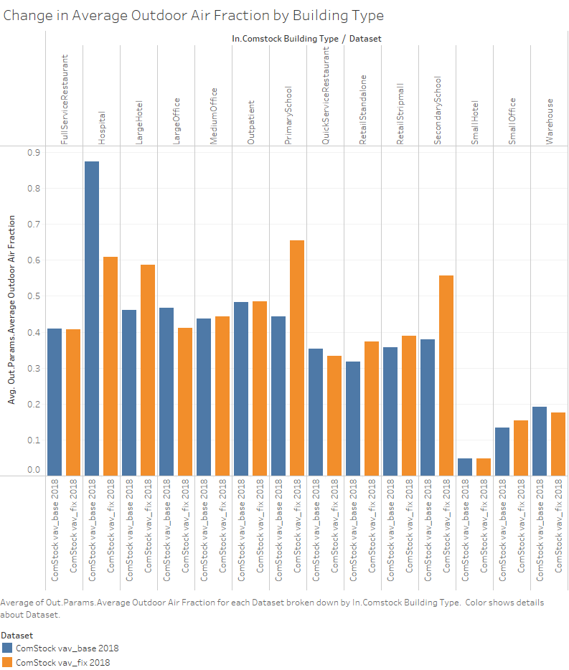

Stock-Level Output Change
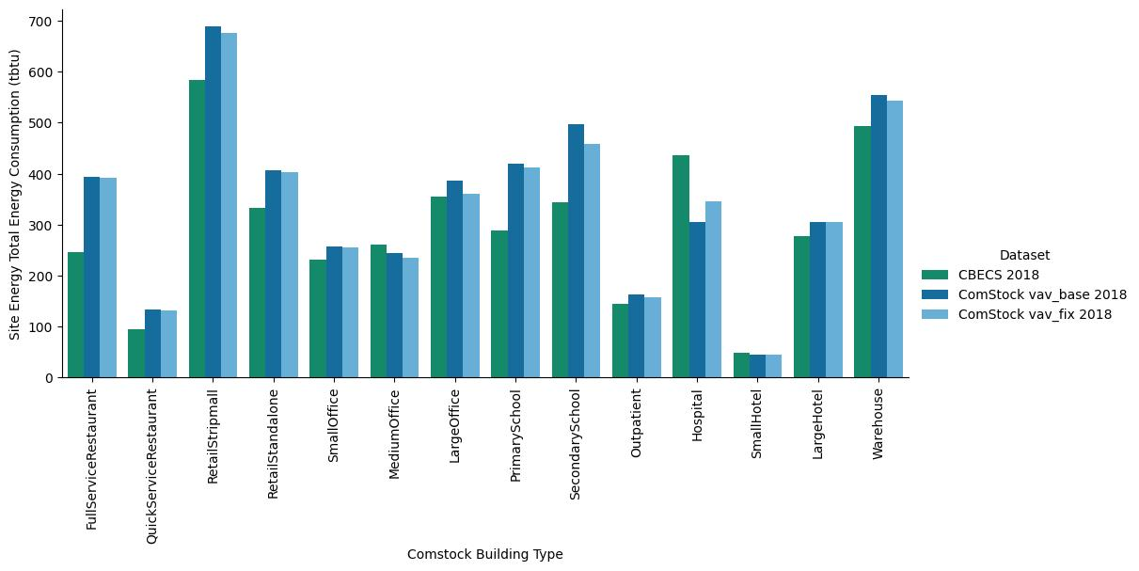
Figure 3: Site Energy Change by Building Type
Figure 3 summarizes the change in site energy for the building stock by building type for the fix compared to CBECs and prior results, and Figure 4 summarizes the change in total electricity and natural gas consumption for the building stock by climate zone. By reducing the amount of outdoor air delivered by PVAV and VAV systems, the expected reduction in electricity, primarily for cooling and fan energy, is expected, with greater savings in warmer climates. Similarly, introducing less outside air during heating season is expected to result in lower natural gas consumption for heating, with more savings in colder climates, which is also reflected in this summary.
Finally, Figure 5 shows that this modification reduced total energy consumption by approximately 5.8%, or 580 GWh. Average energy consumption intensity for the building stock was reduced by approximately 1.3%, from 36.1 KWh/Ft2 to 35.6 KWh/Ft2.
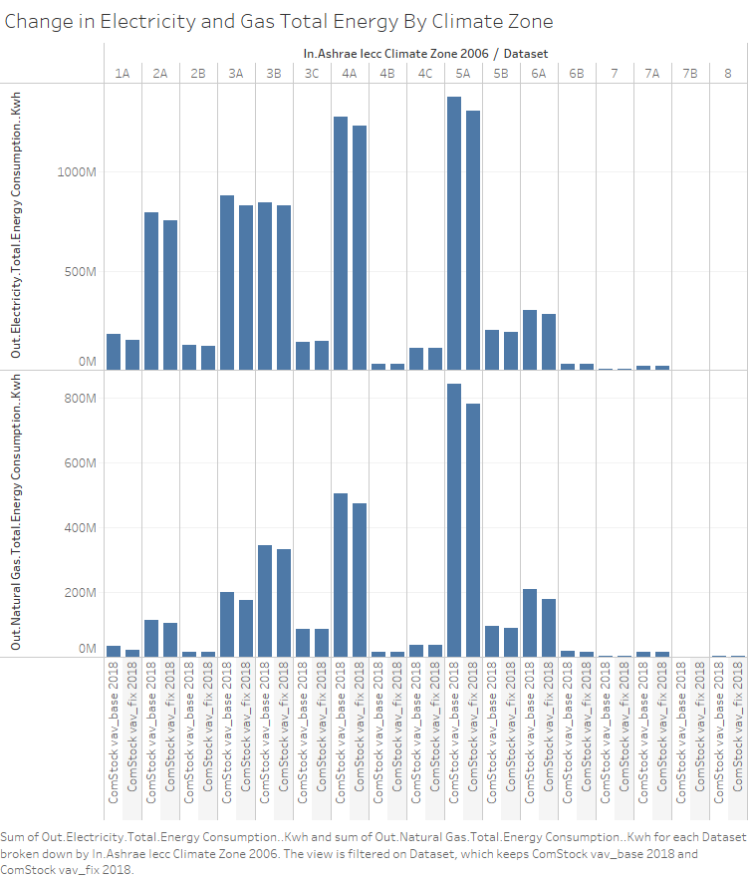
Figure 4: Change in Total Electricity and Gas Energy Consumption by Climate Zone
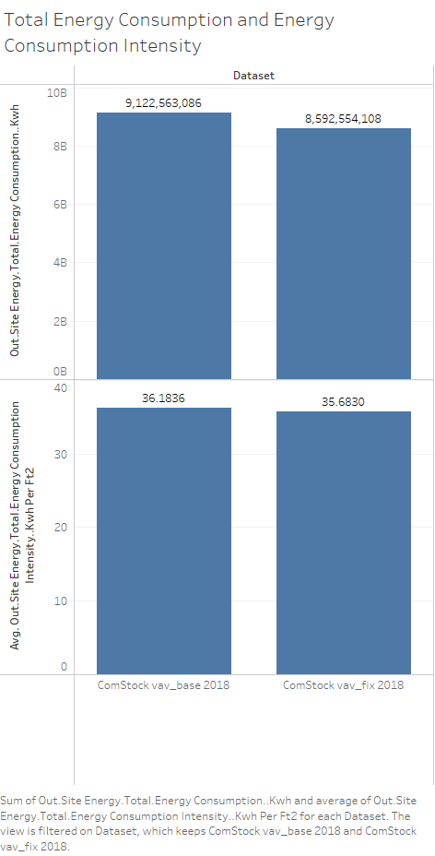
Figure 5: Change in Total Energy Consumption and Energy Consumption Intensity

