ComStock Change
  - OpenStudio 3.6.1 to 3.7.0
Implementer: Marley Praprost
Change Document Author: Marley Praprost
Reviewer: Andrew Parker, Chris CaraDonna

Description of Change

Summary
This updates the version of OpenStudio used by ComStock from 3.6.1 (EnergyPlus 23.1.0, OpenStudio-Standards 0.4.0, released May 2023) to 3.7.0 (EnergyPlus 23.2.0, OpenStudio-Standards 0.5.0, released November 2023). This update includes several new features, performance improvements, and bug fixes, as described in the EnergyPlus release notes. A summary of the changes that were observed in the models is included here.

Dockerfile Approach
The existing approach starts with the OpenStudio 3.6.1 base image. Custom gems are chosen by editing the /resources/.Gemfile in the ComStock repository, which is then loaded and installed via bundler to replace the default set of gems that comes with OpenStudio 3.6.1. When building a Singularity image for HPC, the custom gems are installed directly inside the image. When running locally using Docker, the custom gems are installed into the /.custom_gems directory in the ComStock repository. This latter approach allows developers to quickly test changes to OpenStudio-Standards without having to repeatedly re-clone that repository.
This approach will be maintained, but instead uses the OpenStudio 3.7.0 base image instead of 3.6.1. The only gems required that changed from OpenStudio 3.6.1 to 3.7.0 were the OpenStudio-Standards gem, which updated from 0.4.0 to 0.5.0, and the openstudio-extension gem, which updated from 0.6.0 to 0.7.0.
One error caused by the name changes to the DistrictHeating fuel type was caught and fixed in this OS version update. The changes were made to the set_heating_fuel, set_water_heating_fuel, and TimeseriesCSVExport measures. An example code snippet is shown below; as can be seen, the fuel enumeration changed from “DistrictHeating” to “DistrictHeatingWater” based on this commit.
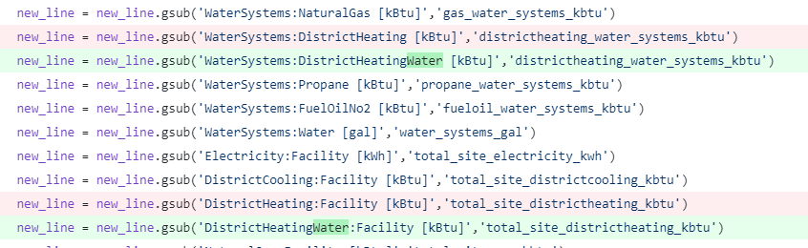

Impact of Change
These changes were tested using two 10k sample runs with identical buildstock.csv files. There was exactly zero impact on the stock when comparing the results to each other. Every plot showed no change to the previous version of ComStock. Several checks were done to ensure that these results were legitimate.
An example OSM from each run was pulled, and it was verified that the previous OSM is OpenStudio 3.6.1 and the new OSM is OpenStudio 3.7.0. The OSMs were diffed in Notepad++ and there was no difference in the files (other than handle names), meaning the new OpenStudio version did not cause any changes to the model. The failed buildings were compared, and the exact same buildings failed in both versions, and there were no new failures in the latest run. A review of the changes between OS 3.6.1 and 3.7.0 was done, and while there are many features and bug fixes, there were not any that would obviously be used in ComStock and impact the results. The OpenStudio-Standards version also changed between releases, but it is possible that none of the changes made affect the systems and objects used in ComStock.
One observation from the latest run is that some of the buildings that failed did not register as “Fail” in the results.csv. Instead, the completed_status column was blank for some buildings. However, the parquet file did show the word “Fail” for these buildings, so it appears that there could have been an issue when the results.csv was generated. This did not cause any errors in the postprocessing. It may have simply been an isolated issue with the Eagle run, but if it persists we may want to investigate buildstockbatch to see if it is causing this error.

