ComStock Change
  - Updating Power and Fraction Values for Kitchen Equipment
Implementer: Marley Praprost
Change Document Author: Marley Praprost
Reviewer: Andrew Parker, Chris CaraDonna

Description of Change

Summary
This change makes minor changes to kitchen equipment design levels and fractions latent, radiant, and lost. Each of the six types of commercial kitchen equipment modeled in ComStock were modified – broilers, fryers, griddles, ovens, ranges, and steamers. Both electric and gas versions of each type equipment can be modeled in ComStock. Previously, the values were taken from several sources from the 1990s, which are over 30 years old and may not represent the current state of commercial kitchen equipment. The new values are primarily driven by assumptions from the ASHRAE Fundamentals 2017 Handbook. Most of the values were similar in magnitude, therefore the change should not have significant impact on the stock level results. However, we decided that making minor changes and using the ASHRAE assumptions provide more credibility in results due to recency and industry reputation of ASHRAE. In addition, no other sources could be found that provide both the design level and internal gains fractions for all six types of appliances modeled, including comparable gas and electric models. Therefore, using the ASHRAE values wherever possible provides consistency in our modeling of these difference appliances and their performance.
The new assumptions were corroborated via additional research and verification of commercially available kitchen equipment with comparable specifications. The details of this investigation are outlined in the Kitchen Equipment Electrification EUSS Measure Documentation. It was important for the kitchen electrification measure to have consistent and credible assumptions in the baseline, and that the upgrade represents a true one-for-one swap out of gas to electric equipment. Therefore, the research and real products used to verify the assumptions ensures that the gas and electric equipment being modeled are comparable. A summary of the old and new design levels for gas and electric equipment is in Table 1 below.

Table 1: Gas and Electric Equipment Design Levels Before and After Change
Equipment Type | Gas Design Level (BTU/h) |  | Gas Design Level (W) |  | Electric Design Level (BTU/h) |  | Electric Design Level (W)
 | Old | New | Old | New | Old | New | Old | New
Broiler | 88030 | 96000 | 25800 | 28136 | 37532 | 36900 | 11000 | 10815
Griddle | 69946 | 90000 | 20500 | 26377 | 40944 | 58400 | 12000 | 17116
Fryer | 164117 | 80000 | 48100 | 23447 | 75064 | 47800 | 22000 | 14009
Oven | 55957 | 44000 | 16400 | 12896 | 51180 | 41300 | 15000 | 12104
Range | 179130 | 145000 | 52500 | 42497 | 40944 | 71700 | 12000 | 21014
Steamer | 209838 | 200000 | 61500 | 58617 | 51180 | 92000 | 15000 | 26964
In addition to the design level, the model also requires inputs for fraction latent, radiant, and lost for any gas or electric equipment object. Previously, the assumptions for every type of equipment were the same. For gas equipment, the fractions latent, radiant, and lost were 0.1, 0.2, and 0.7 respectively, and for electric equipment the fractions were 0.25, 0.3, and 0.3. The new fractions are based off of ASHRAE Fundamentals and modified slightly using engineering judgement. ASHRAE Fundamentals assumes that all of the six types of kitchen equipment modeled in ComStock are hooded, meaning the appliances are located under an exhaust hood which removes airborne grease, combustion products, smoke, heat, steam, etc. from the air. For hooded equipment, ASHRAE assumes that the appliances only emit radiant heat, and that all convective and latent heat is exhausted through the hood. While exhaust hoods are proven to be effective, it seemed unrealistic to assume that exactly 100% of the latent and convective heat is exhausted through the hood. Therefore, we made the assumption that the fraction latent and fraction convective may be closer to 10% in reality, and adjusted the fractions as such. The radiant fractions used in the model were taken from ASHRAE for the gas and electric versions of each appliance. The fraction lost was then calculated as
$F_{lost }= 1 - \left(F_{radiant} +F_{latent}+F_{convected} \right)$
Table 2 below summarizes the fractions used in the model for each appliance.
Table 2: Gas and Electric Equipment Fraction Radiant, Latent, Convective, and Lost
Equipment Type | Fraction Radiant |  | Fraction Latent |  | Fraction Convective |  | Fraction Lost
 | Gas | Electric | Gas | Electric | Gas | Electric | Gas | Electric
Broiler | 0.12 | 0.35 | 0.1 | 0.1 | 0.1 | 0.1 | 0.68 | 0.45
Griddle | 0.18 | 0.39 | 0.1 | 0.1 | 0.1 | 0.1 | 0.62 | 0.41
Fryer | 0.23 | 0.36 | 0.1 | 0.1 | 0.1 | 0.1 | 0.57 | 0.44
Oven | 0.08 | 0.22 | 0.1 | 0.1 | 0.1 | 0.1 | 0.72 | 0.58
Range | 0.11 | 0.1 | 0.1 | 0.1 | 0.1 | 0.1 | 0.69 | 0.7
Steamer | 0.1 | 0.1 | 0.1 | 0.1 | 0.1 | 0.1 | 0.7 | 0.7
Finally, a bug with the baseline kitchen equipment schedules was caught during this process. Previously, the gas and electric appliances were set to different schedules. As shown in the figure below (which is an example from a QuickServiceRestaurant), the gas equipment schedule being used was nearly half the magnitude of the electric equipment schedule. The differences in efficiency between gas and electric equipment are already captured through the rated input power values, therefore we want the equipment to be set to the same operation schedules.
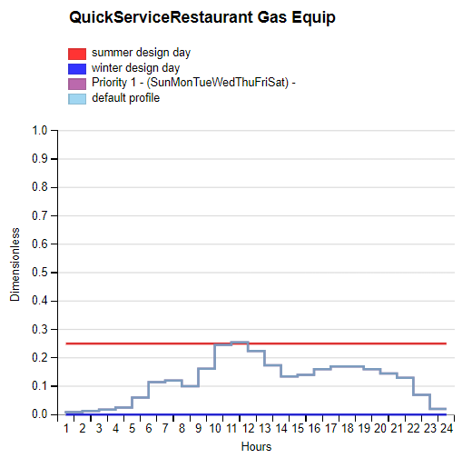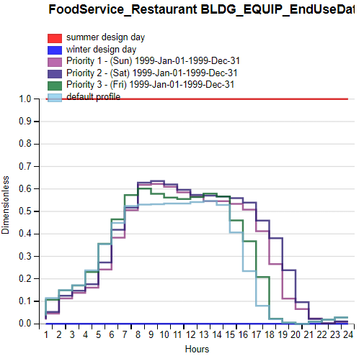
This also caused issues when swapping out gas equipment with electric in the EUSS Electric Equipment measure, because we want to replicate a 1:1 equipment replacement, which assumes that the new equipment operates on the same schedule as the existing equipment. And once again, the efficiency difference when switching to electric is already captured through the design power input.
According to the research that was done for the EUSS Kitchen Equipment measure, the idle operation of both electric and gas kitchen equipment is often a small fraction of the rated input power. This means that while the equipment may be rated for 60,000 BTU/h, for example, the power draw during idle conditions (maintaining or holding at a stabilized operating condition or temperature) may only be 10,000-20,000 BTU/h. Therefore, we felt that the gas equipment schedule, which maxed out around 25% of the rated design level, was more reflective of the actual operation of the kitchen equipment. As a result, the decision was made to reset the electric equipment in the baseline to the gas equipment schedule. This will result in a decrease in electric equipment energy in the annual results due to the decreased schedule magnitude. The miscellaneous electric equipment object, which represents miscellaneous smaller kitchen appliances, was not changed and maintained the existing electric equipment schedule.
Impact of Change
These changes were tested using two 10k sample runs with identical buildstock.csv files. There was minimal impact on the stock when comparing the results to each other. The end uses that had changes were interior equipment, fans, cooling, and heating. Both electric and gas interior equipment saw a decrease in total annual energy due to the changes in equipment power and the change to the electric equipment schedules. The changes to equipment also had residual effects on some HVAC end uses, such as fans, cooling, and heating. This is due to the change in internal gains caused by the modified equipment power, schedules, and fractions of heat gain to the space. The resulting simulation showed a decrease in cooling and fan energy and a small increase to heating energy, which makes sense given that the equipment loads decreased (therefore less cooling was required in summer and more heating was required in winter).
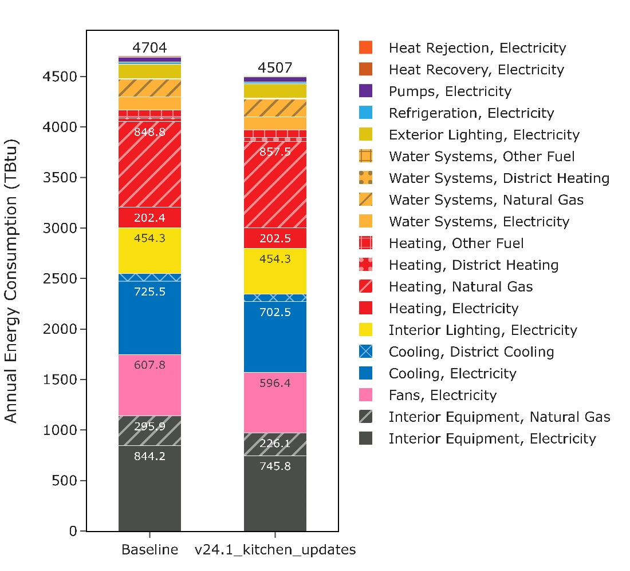
Building types without kitchens (Retail Standalone, Small Office, Medium Office, Large Office, Outpatient, Small Hotel, and Warehouse) were not affected by the changes to kitchen equipment and hence had very minimal change in annual site energy. However, this run did include one unrelated baseline change to the “PVAV with gas heat with electric reheat” HVAC system (changed from gas boiler to gas furnace), which affects about 5% of the stock square footage. Therefore, there are some very minimal changes to the building types that do not contain kitchens.
Some building types that have kitchens showed minimal change in total energy because kitchens make up a very small portion of their total square footage; this includes Primary School, Secondary School, Hospital, and Large Hotel. The remaining three building types showed a non-trivial change in annual energy consumption – Full Service Restaurant, Quick Service Restaurant, and Retail Strip Mall. All building types with kitchens showed a decrease in total site energy, which is primarily driven by the electric equipment schedule being reduced by a factor of 2, but is also affected by the minor changes to equipment rated power. In almost all cases where there was a change in total site energy, the change closed the gap between ComStock and CBECS.
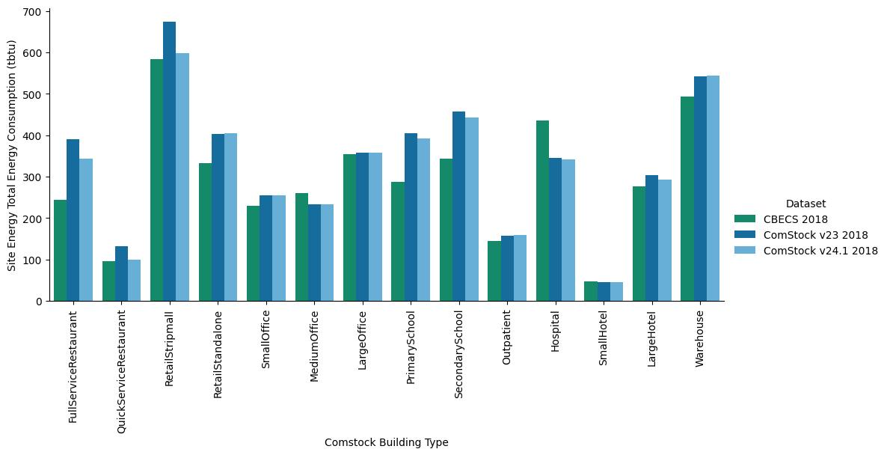
When looking at electricity and natural gas CBECS comparisons, we also see an improvement across the board. The reduction in electric kitchen equipment schedules resulted in Restaurants and Strip Malls getting much closer to CBECS in the electricity comparison. The other building types with kitchens had minimal change due to the small square footage percentage of kitchens in other building types.
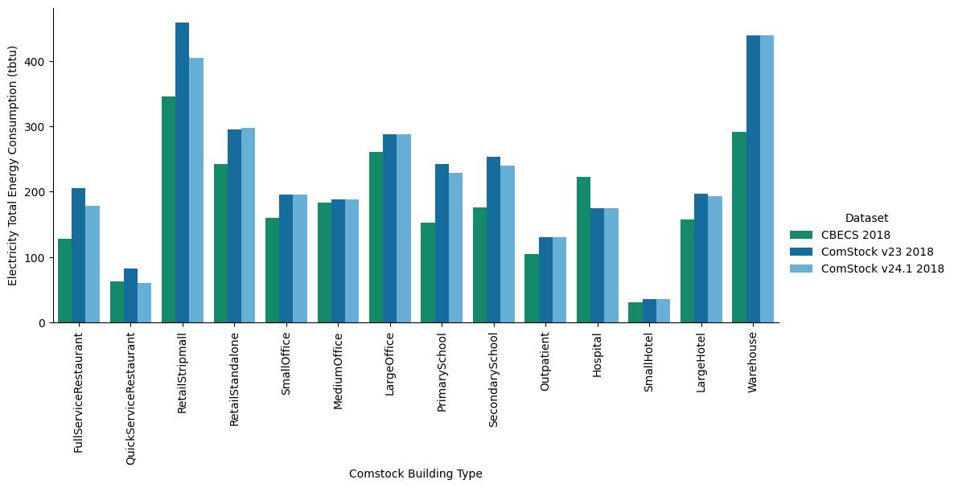
In terms of natural gas, the change once again helped in calibration of restaurants. The gap between CBECS and ComStock for Strip Malls got worse. This could be an indication that we may need to be modeling a higher percentage of kitchens in strip malls, but could also be related to gas heating or water heating. The changes in natural gas consumption in this run are mainly driven by the changes to gas equipment power, but there could also be minor changes caused by the PVAV change.
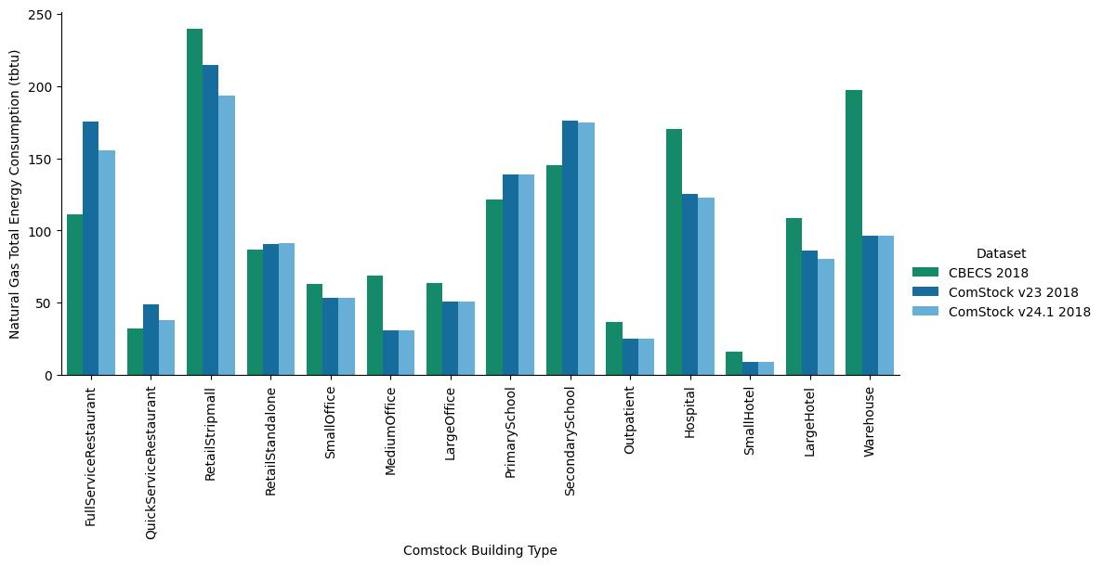
Overall, the changes made in v24 were a simple implementation (just changing numerical values in the measure and resetting one schedule) and resulted in positive change in the stock level results when compared to CBECS. Retail strip mall and restaurants saw the most significant change, which is to be expected because of their high density of kitchen spaces compared to the total square footage. These changes were made to set up the baseline for the electric kitchen equipment measure, in order to ensure consistency in sources being used for the gas and electric equipment specifications.

