ComStock Change
  - V25 – Adding Utility Rates
Implementer: Andrew Parker
Change Document Author: Andrew Parker
Reviewer: Matt Dahlhausen, Eric Ringold

Description of Change

Summary
This update adds utility bill calculations to ComStock.

Existing Methodology

Utility bills (existing)
ComStock does not estimate utility bills at all.

New Methodology

Electric bills (new)
The primary resource for the electric utility rates is the Utility Rate Database (URDB), hosted on OpenEI. This database contains machine-readable descriptions of electric rate structures which have been compiled by manually processing utility rate documentation published by utilities.

Rate Selection
URDB contains electric rates that span all sectors (residential, commercial, industrial, etc.), so we limited the rates to those applicable to commercial buildings. First, we filtered down to rates identified as serving the “Commercial” sector and not supplied at “Transmission” voltage. Second, we processed the utility rate names to eliminate rates serving non-building loads based on certain keywords. The list of keywords included Agriculture, Irrigation, Farming, Pump, Snow, Vehicle, Oil, Cotton Gin, Outdoor Light, Security Light, Street, Wholesale, Recreation, Heating (typically found in names of heating-only rates), Substation, and Electric Motor Standby. We downloaded the detailed rate structure data in JSON format for the selected 13,923 rates.
Next, we fed each utility rate and an 8,760-hour electric consumption profile from a Small Hotel building energy model to the NREL PySAM SDK to calculate an annual electric bill. We eliminated rates with an annual average blended price below $0.01/kWh. Upon reading the names and comments included with these rates, we found that they were mostly fixed rates for individual pieces of equipment such as cable or internet infrastructure that are not metered. We also eliminated rates with an annual average blended price above $0.45/kWh, except in the case of AK or HI, which legitimately have high rates. Some of the high rates appeared to be data entry errors. We also removed rates where PySam could not calculate an annual bill based on the rate data. Overall, this process resulted in 10,623 remaining rates spread across 2,658 utilities. 90% of the utilities have 8 or fewer rates. The remainder have more rates, with the most (~200) belonging to Southern California Edison. These rates cover 85% of the buildings and 85% of the floor area in ComStock. Rates are stored in machine-readable JSON format and organized by EIA Utility Identifier.
Figure 1 shows a histogram of annual average blended prices from evaluating all the rates using the small hotel 8,760-hour electric load profile. This profile is not applicable to all the rates because it sometimes does not fall within kWh or kW minimums or maximums. However, it gives a point of comparison for sanity checking the rates. The median blended price in the URDB rates was about $0.08/kWh

Figure 1. Annual average blended price for URDB Rates Used in ComStock
Figure 2 shows a histogram of the 2022 commercial sector annual average blended prices from all the utilities reporting to EIA on Form EIA-861. A quick comparison between this histogram and Figure 1 shows that the median blended price in the URDB rates was about $0.08/kWh, while the median blended price reported to EIA in 2022 was $0.12/kWh, which is about 50% higher than URDB.

Figure 2. 2022 EIA Blended Commercial Prices by Utility

Figure 3 shows a histogram of the “Start Date” field for the rates selected from URDB. The rates before 1995 did not list a start date. The figure shows that the median start year is 2013. Thus most of the URDB rates are more than 10 years old at the time of writing.

Figure 3. Start Dates for Commercial Building Rates in URDB
In order to understand the change in rates between 2013 and 2022, a pairwise analysis of the utilities reporting to EIA on Form EIA-861 in both years was performed, and a state-wide average annual change was calculated. Figure 4 shows that the median increase was 1-3% per year. Thus in many cases the rates have increased by (2%/yr * (2022-2013)) = 18% or more between 2013 and 2022.

Figure 4. Average Annual Per-State Commercial Electric Price Increase from 2013-2022

Electric Utility Assignment
To assign an electric rate to a building in ComStock, we need to know which electric utility serves it. We joined the U.S. DOE U.S. Electric Utility Companies and Rates: Look-up by Zipcode (2021) with the U.S. HUD HUD USPS ZIP Code Crosswalk Files to create a mapping between census tracts and utilities. This was done using both 2010 and 2020 census tracts, because ComStock uses a mix of both.
As previously described, rates are assigned to 85% of the buildings in ComStock, and cover 85% of the weighted floor area. There are approximately 37,734 ZIP Codes in the United States. The dataset does not have an electric utility assignment for 738 of these ZIP Codes, which are spread across many states. There are 3,946 census tracts covered by these ZIP Codes which therefore do not have an electric utility assigned. Manually filling these missing mappings could be done in future work.

Bill Calculation
At runtime, an 8,670-hour electric load profile is extracted from the building energy model. The annual min and max demand (kW) and annual energy consumption (kWh) are calculated. Based on the census tract, the electric utility EIA identifier is looked up. If rates are found for this utility, the rates are down selected based on the observed load profile any min/max demand or energy consumption qualifiers the rate may have. For example, some rates only apply to buildings with a minimum annual peak demand of 500 kW.
For each of the remaining applicable rates, the annual bill is calculated using the 8,760 load profile and the PySAM utility rate calculation engine. This engine accounts for complex rate structures with demand charges, lookback periods, time-of-use rates, etc. To adjust for the lag in the rates on the URDB, the start date for rate is collected and the number of years between the start date and 2022 is calculated. The average annual price increase for the state where the building is located, which was calculated from Form EIA-861 data as previously described, is looked up. The annual bill is multiplied by this increase to estimate an adjustment to current 2022 rates.

A median bill is calculated from all applicable rates. Any bill that is lower than 25% of the median or higher than 200% of the median is eliminated to avoid extreme bills. Although uncommon, in testing these extreme bills were found to be associated with rates whose names indicate they are likely not applicable to the building. For example, a “large secondary general” rate which has a high minimum demand charge is not likely applicable to a small retail customer. This step typically only affects the mean bill for a building +/- 10%, so the other applicability criteria appear to be down selecting appropriate rates effectively. For each applicable rate, the name of the rate and the adjusted annual bill are reported. The minimum, maximum, mean, median, and count of all applicable bills is also reported.
For buildings with no electric utility assigned, or for buildings where none of the stored rates are applicable, the annual bill is estimated using the 2022 EIA Form-861 average prices based on the state the building is located in. While this method does not reflect the detailed rate structures and demand charges, it is a fallback for the 15% of buildings in ComStock with no utility assigned.

Natural gas bills (new)
For natural gas rates, no detailed database of rates was found. Therefore, instead of using detailed rates, natural gas pricing is assumed to be volumetric. 2022 U.S. EIA Natural Gas Prices – Commercial Price and U.S. EIA Heat Content of Natural Gas Delivered to Consumers were used to create an energy price in dollars per kBtu. State-level prices range from $0.007/kBtu in ID to $0.048/kBtu in HI, with a mean of $0.012/kBtu nationally.

Propane and fuel oil bills (new)
For propane and fuel oil, no detailed database of rates was found. Therefore, instead of using detailed rates, pricing for these fuels is assumed to be volumetric. These fuels are typically delivered in batches, so in any given year the number of deliveries could vary. Minimum charges per delivery are assumed to be included in the volumetric price. 2022 U.S. EIA residential No. 2 Distillate Prices by Sales Type and U.S. EIA residential Weekly Heating Oil and Propane Prices (October - March) were downloaded, along with the EIA assumed heat content for these fuels. Residential prices were used because commercial prices are only available at the national scale. Additionally, most commercial buildings using these fuels are assumed to be smaller buildings where a residential rate is likely realistic. These data were used to create an energy price in dollars per kBtu for both fuels.
For states where state-level pricing was available, these prices are used directly. For other states, Petroleum Administration for Defense District (PADD)-average pricing was used. For states where PADD-level pricing was not available, national average pricing was used. For propane, prices ranged from $0.022/kBtu in ND to $0.052 in FL, with a mean of $0.032/kBtu nationally. For fuel oil, prices ranged from $0.027/kBtu in NE to $0.036 in DE, with a mean of $0.033/kBtu nationally. The mean national price for both fuels is roughly 3X the mean national price of natural gas.

District heating and cooling (not covered)
No resources with utility rates for district heating and cooling were identified. Because there are several hundred district systems across the US, many of which are university or healthcare campuses, gathering individual rates manually was deemed impractical. Therefore, utility bills for these fuels are not calculated.

Impact of Change
The utility bill calculations are done as a postprocessing step outside of the building energy simulations. Therefore, they do not influence the individual building energy model inputs in any way. A 10k model run was performed and the resulting bills were compared to other data sources to check if they are reasonable.

Individual Model Output

Electricity Bills
The electricity bills were calculated using complex rates from URDB. Although these rates were screened, it is useful to evaluate the resulting bills. Figure 5 below shows a distribution of the electric bills per floor area, grouped by building type. Most of the bills fall into the expected range of $1-$3/sqft that is common for commercial buildings. The high outlier building were evaluated and found to almost entirely be 1,000 or 3,000 sqft restaurants with full electric cooking located in CA (which has high electricity rates). Any unreasonableness in the bills appears to be associated with the amount of cooking energy per floor area in these models, not with the utility rates or bills calculations. The very low buildings were found to primarily be natural-gas-heated warehouses located in mild climates, or with no cooling.
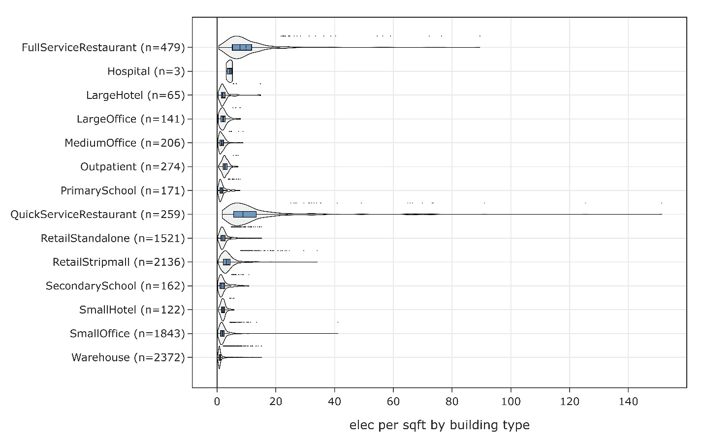
Figure 5. Distribution of Electricity Bills per Floor Area ($/sqft)

Stock-Level Output

Electricity Bills
To understand the stock-wide reasonableness of the electricity rates and associated bills, a per-energy blended rate was calculated for each building in ComStock. This was compared to the per-energy blended rate from CBECS 2018 data. The distributions are plotted in Figure 6. In general, the mean in ComStock is higher than the mean in CBECS. Because CBECS represents 2018 rates and ComStock represents 2022 rates, a blended rate was calculated using Form EIA 861 data from these years. As shown in Table 1, the average increases varied between 6% and 26%. These increases include the entire commercial sector as defined by utilities, not just the buildings represented in ComStock, so they aren’t a perfect comparison, but they do give a general magnitude of increase.
In the context of the 2018 to 2022 rate increases changes, the 2022 ComStock rates in Figure 6 show a reasonable overlap with the 2018 CBECS data. ComStock is likely somewhat low in New England, Middle Atlantic, and East North Central, and somewhat high in East South Central, West South Central, and Pacific.
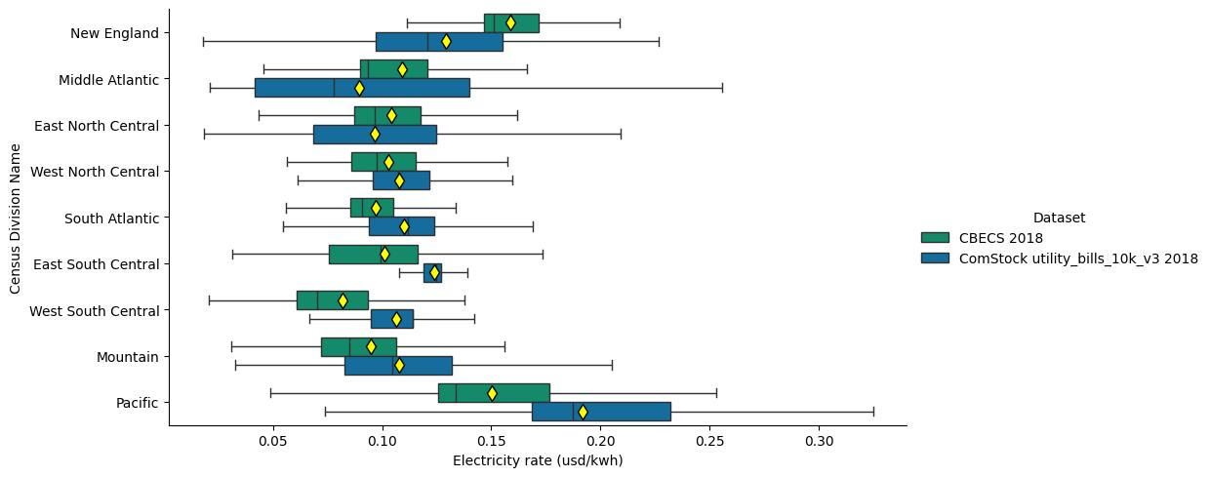

Figure 6. Distribution of Blended Electricity Rates by Census Division
Table 1. Average increase in blended electricity rates from 2018 to 2022 by census division
Census Division | Average total increase in blended electricity rates, 2018 to 2022
New England | 16%
Middle Atlantic | 26%
East North Central | 16%
West North Central | 6%
South Atlantic | 16%
East South Central | 13%
West South Central | 21%
Mountain | 8%
Pacific | 20%

Natural Gas Bills
To understand the stock-wide reasonableness of the natural gas rates and associated bills, a per-energy blended rate was calculated for each building in ComStock. This was compared to the per-energy blended rate from CBECS 2018 data. The distributions are plotted in Figure 7. In general, the mean in ComStock is higher than the mean in CBECS. Because CBECS represents 2018 rates and ComStock represents 2022 rates, a blended rate was calculated using EIA natural gas data from these years. As shown in Table 2, the average increases varied between 27% and 63%. These increases include the entire commercial sector as defined by utilities, not just the buildings represented in ComStock, so they aren’t a perfect comparison, but they do give a general magnitude of increase.
In the context of the 2018 to 2022 rate increases changes, the 2022 ComStock rates in Figure 7 show a reasonable overlap with the 2018 CBECS data. ComStock may be a bit low in some census divisions, particularly Pacific.
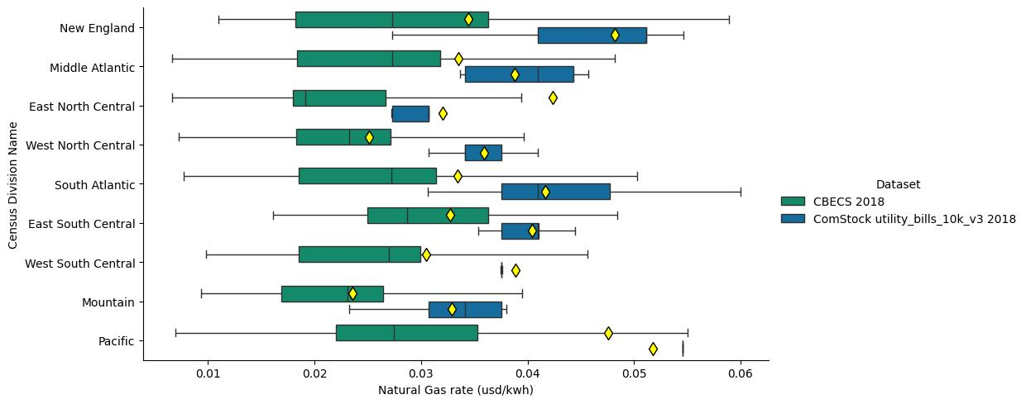
Figure 7. Distribution of Blended Natural Gas Rates by Census Division
Table 2. Average increase in natural gas rates from 2018 to 2022 by census division
Census Division | Average total increase in natural gas rates, 2018 to 2022
New England | 27%
Middle Atlantic | 39%
East North Central | 46%
West North Central | 54%
South Atlantic | 35%
East South Central | 35%
West South Central | 63%
Mountain | 47%
Pacific | 38%

Validity of Volumetric Rate Assumption
As previously described, the natural gas rates used in ComStock are simply volumetric prices by state from 2022 EIA data. CBECS does not include the state level location of each building, so an exact comparison is not possible. However, looking at the CBECS data by building type Figure 8 below, we can see that the distribution shifts lower between small, medium, and large offices. This indicates that for smaller buildings, either the fixed charge is a more significant portion of the bills, or that there is a lower volumetric price for larger buildings. The same shift is seen between small and large hotels. If better data on natural gas rates becomes available, one improvement to the current methodology would be to better represent this trend.
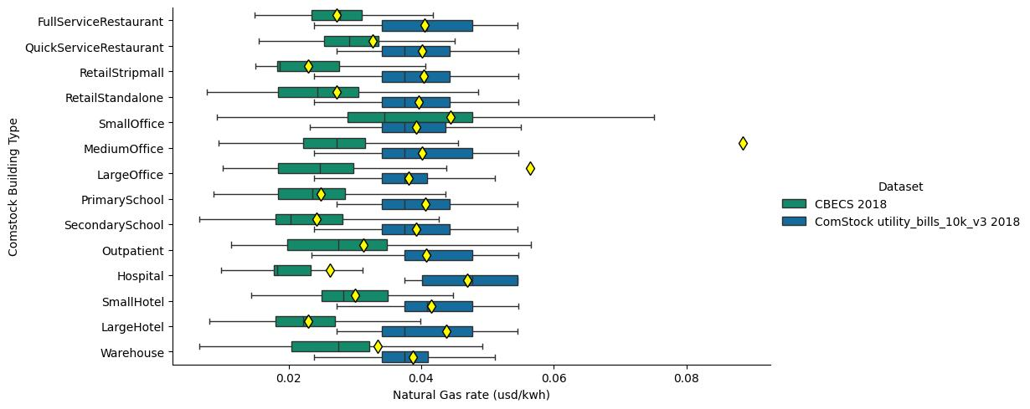
Figure 8. Distribution of Blended Natural Gas Rates by ComStock Building Type

Fuel Oil and Propane Bills
Unfortunately, ComStock currently reports energy consumption for propane and fuel oil combined into one “other fuel” category, and CBECS only reports bills for fuel oil and not propane. Therefore, a comparison of energy rates for these fuels was not performed. Although these fuels account for a significant portion of the energy consumption in some parts of the country, this is not true on a national scale.

