ComStock Change
  - v26 – Update total operational occupancy in ComStock models
Implementer: Eric Ringold
Change Document Author: Eric Ringold
Reviewer: Andrew Parker, Matthew Dahlhausen

Description of Change

Summary
This update improves the total operational occupancy of all the buildings in ComStock. The goal of this change is to better represent the occupant-driven loads and energy consumption of the building stock (particularly in heating fuel) by estimating the actual number of people occupying the modeled commercial building stock.

Existing Methodology
ComStock currently uses space occupant densities and schedules by building space type as defined in openstudio-standards. Occupant densities are based on DOE Prototype building inputs, ASHRAE 62.1 design assumptions or a combination of the two. Occupant schedules defining the hourly occupancy adjustments are obtained directly from openstudio-standards. The start time and occupied hours of ComStock models are adjusted based on input distributions derived from analysis of building AMI utility meter data depending on the building type. These adjustments do not change schedule peak values, just when they occur. These schedules were derived from ASHRAE 90.1 User’s Guide and the DOE and DEER Prototype Buildings.
To determine the maximum total daily occupancy in all ComStock buildings, the following metadata was extracted for each building from a full run of 350,000 buildings:
- In.Comstock Building Type
- In.Energy Code Followed During Original Building Construction
- In.Building Subtype
- Avg. Out.Params.Occupant Density Ppl Per M 2..People Per M2
- Calc.Weighted Sqft

The first three inputs were used to determine the space types comprising each building, and the fraction of the total area represented by each type. With this information, the openstudio-standards data could be queried for the design occupancy level by space type, as well as the occupancy schedule assigned to each space type’s People load. The maximum daily value of the occupancy schedules was then multiplied by the space type occupant density, space type fraction and weighted total building area to determine the maximum daily occupancy in all buildings. The total non-schedule-adjusted ComStock building occupancy totals approximately 638M people, and with schedule adjustments this was reduced to 498M, which is still well in excess of to 2018 US population of 327M. Put another way: ComStock was assuming that the ~66% of the commercial floor area represented contained more occupants than the entire US population, which is clearly incorrect.

New Methodology
This change maintains the prior method for modelling occupants in ComStock buildings, except the occupancy schedules are modified so that the peak total occupancy in all ComStock buildings reflects the peak total occupancy of modeled commercial buildings derived from the American Time Use Survey (ATUS) conducted by the US Bureau of Labor Statistics. Part of the American Time Use Survey asks respondents to list the activities they engaged in during a particular day of the week, the start/end times during which they were engaged in that activity, and the location of that activity. Each response is given a weight representing the total people-hours represented by that respondent.
The Activity data from ATUS was analyzed to determine the total population engaged in activities at the various location codes, binned by intervals of time in an average day. Not all activities in the survey are location-coded, such as sleeping and grooming, which are in large part expected to occur in the respondent’s residence and thus not of concern for this analysis. Responses with location codes of -2 (‘don’t know’) and -1 (‘blank’) were not included in the analysis. Location codes representing non-commercial buildings (e.g. ‘outdoors’, ‘taxi’, ‘walking’), or which represent building types not currently included in ComStock (e.g. ‘gym’, ‘library’, ‘worship’) were also excluded from the total count.Figure 1 shows the resulting plot of total population at various commercial building locations for every 15 minute interval in an average day. The locations shown in dark green correspond to the ‘work’ location, which contains no specificity regarding commercial building types occupied. Potential future work might involve analyzing the ATUS-CPS file, which combines information collected in the Current Population Survey about persons selected to participate in the ATUS, their occupancy and the corresponding Industry Classification System code, and mapping industries to commercial building types. Other location codes included in Figure 1 are Other_retail, Restaurant, and School types. Since ATUS respondents includes the population over age 15, the Schools occupancy is expected to undercount the actual daily school attendance. This was corrected in the data by adding an estimate of the population of school-aged children ages 5 – 14 of approximately 41M, of which it is estimated that roughly 80% attended schools modeled in ComStock. This yields a total additional population of 32M, which agrees well with data from the US Department of Education.
From this data, the peak occupancy for all average day time intervals was determined to be approximately 115M, which is used as the target total maximum daily population of ComStock buildings.
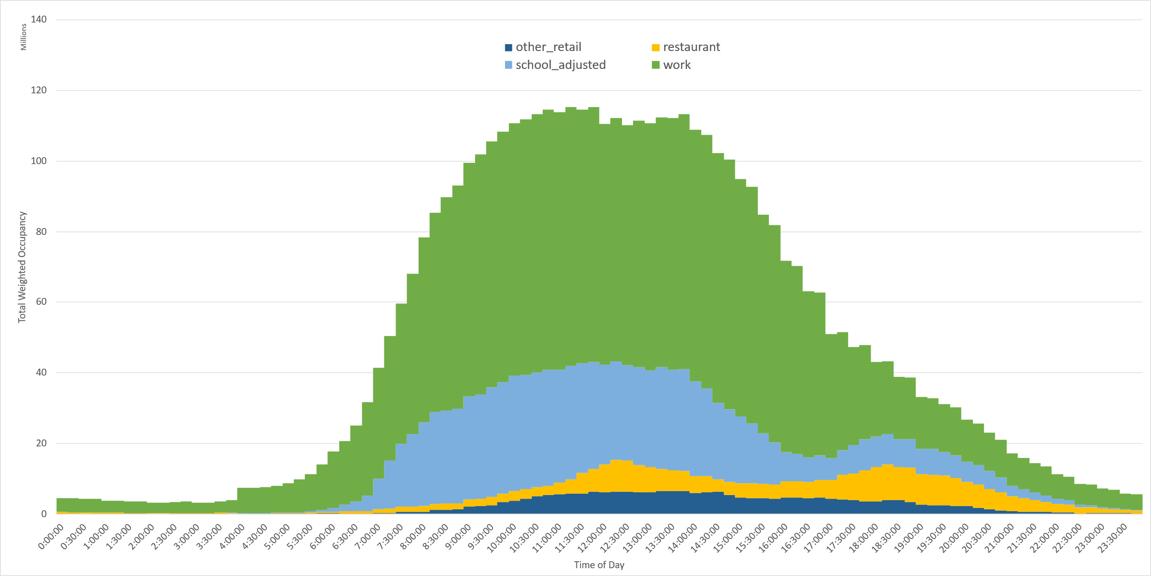
Figure 1: Total occupancy in Commercial Buildings for average day in 15min intervals from ATUS
An OpenStudio measure ‘adjust_occupancy_schedule’ was created which gathers all ‘number of people’ schedules applied to People objects in the model. These schedules are then modified in-place by multiplying each schedule value by a user-entered fraction. The occupancy fraction was calculated using the total daily occupancy from ATUS divided by the current total ComStock occupancy of 498M, yielding an input occupancy adjustment of 0.231. The measure does not modify design day schedules, reflecting buildings that were designed and sized based on an assumed occupant density, but experience fewer people during typical operation. The measure was applied as an upgrade affecting all models in the stock.

Impact of Change

Individual Model Input Change
A sample of ComStock building occupancy schedules was examined before and after the measure, and summarized in Table 1. The peak values of the schedules after the change reflect the result of the prior peak value multiplied by the input occupancy fraction of 0.231, with all intermediate values scaled accordingly.
Table 1: Occupancy Schedules of selected buildings before/after adjustment
Building Type – Occupancy Schedule | Current Default Schedule | Changed Default Schedule
Small Office – Small Office Bldg Occ | 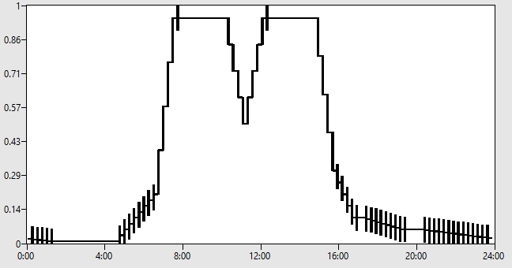  Max = 0.95 | 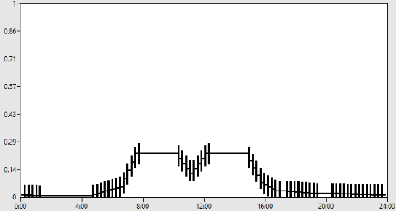Max = 0.21945
Primary School – PrimarySchool Bldg Occ | 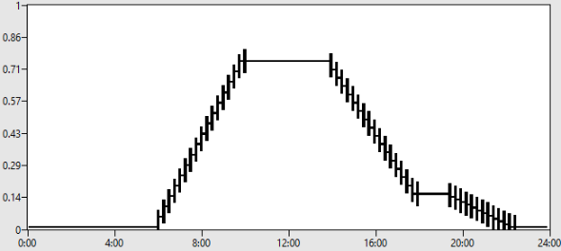Max = 0.75 | 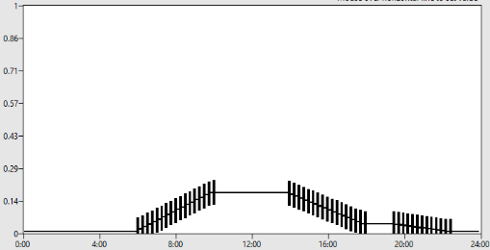Max = 0.17325
StripMall – StripMall Bldg Occ | 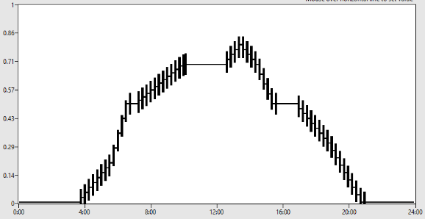Max = 0.8 | 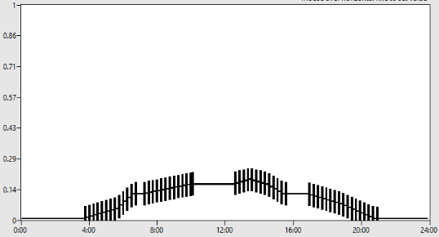Max = 0.1848
FullServiceRestaurant – FullServiceRestaurant Bldg Occ | 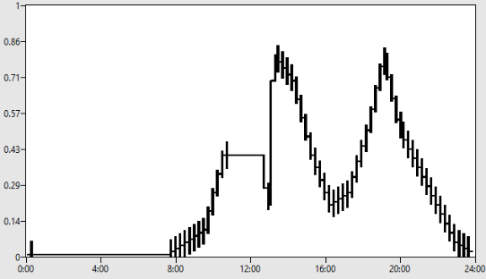Max = 0.775 | 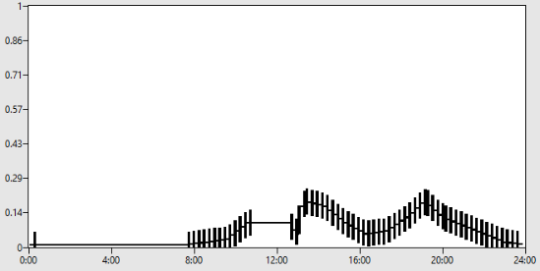  Max = 0.179

Stock-Level Input Change
To view the stock-level input change, the output parameter ‘Occupant EFLH’ was used to compare the average occupancy equivalent full-load hours before and after the modification, as shown in Figure 2.
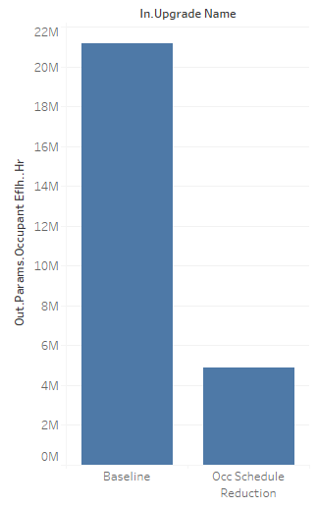
Figure 2: Stock-Level Occupant EFLH change from measure

Stock-Level Output Change
Reducing the total occupancy in ComStock models to 23% of the baseline value resulted in an overall increase in stock-level total energy consumption of approximately 50 TBtu, or about 1% of the total (Figure 3). The total natural gas consumption for HVAC increased by approximately 9.37%, and total Electricity HVAC consumption dropped by 2.1% (Figure 4).
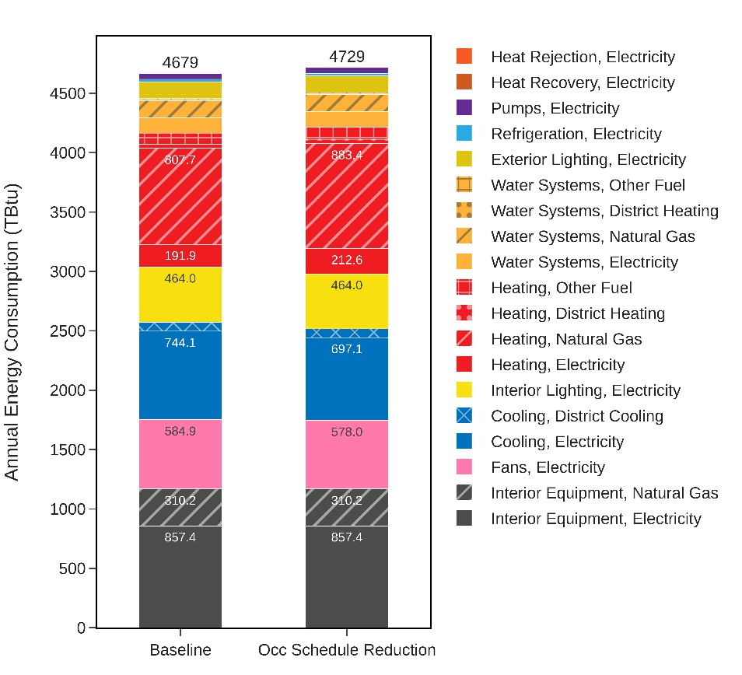
Figure 3: Total Stock End-Use Energy Consumption by End-Use

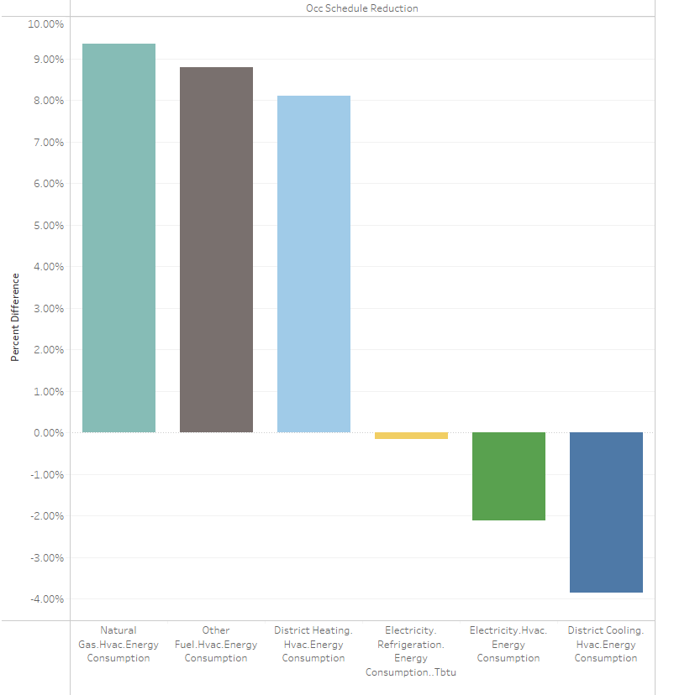
Figure 4: Major End-Use Group Relative Energy Differences

The occupancy schedule reduction measure moves the total natural gas consumption in ComStock closer to the CBECS totals for most census divisions (Figure 5) and building types (Figure 6), with a few notable exceptions. The large differences in Pacific division and FullServiceRestaurant type indicate that further investigation is needed in the gas use profiles for those slices of the building stock. Additionally, comparing the gas use by vintage shows significant differences in both the very old and more recent vintages, with good agreement in the middle vintages. Although these results are based on a small 10k building test run, and thus may be impacted by anomalies due to the small sample size, these results are nevertheless helpful in deducing other areas to improve for the larger gas calibration effort.
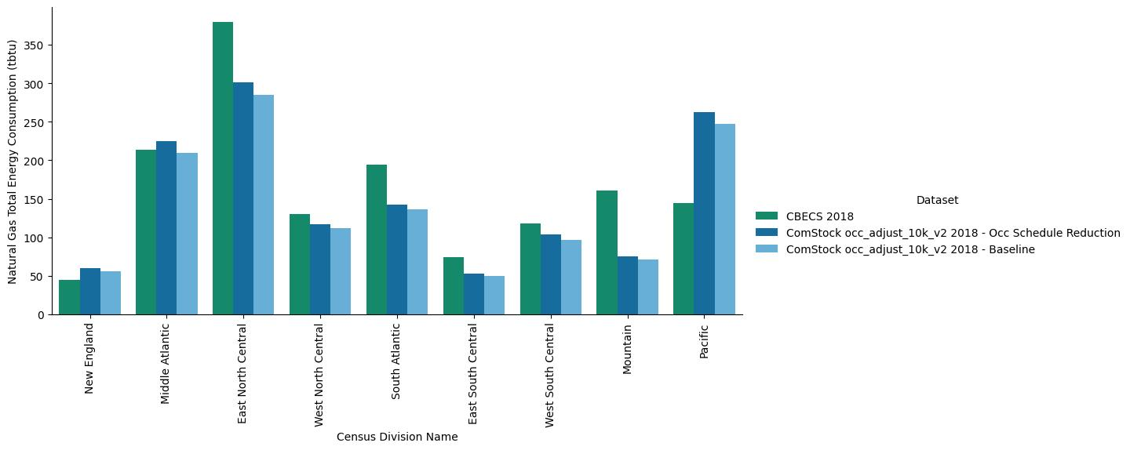
Figure 5: Natural Gas Consumption for Baseline and Occupancy Reduction measure compared to CBECS by Census Division

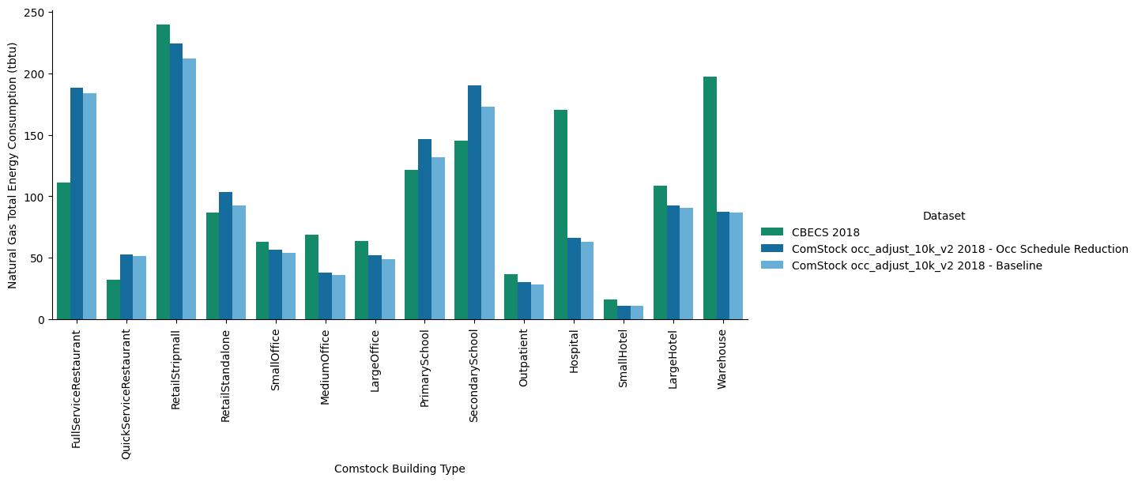
Figure 6: Natural Gas Consumption for Baseline and Occupancy Reduction measure compared to CBECS by Building Type
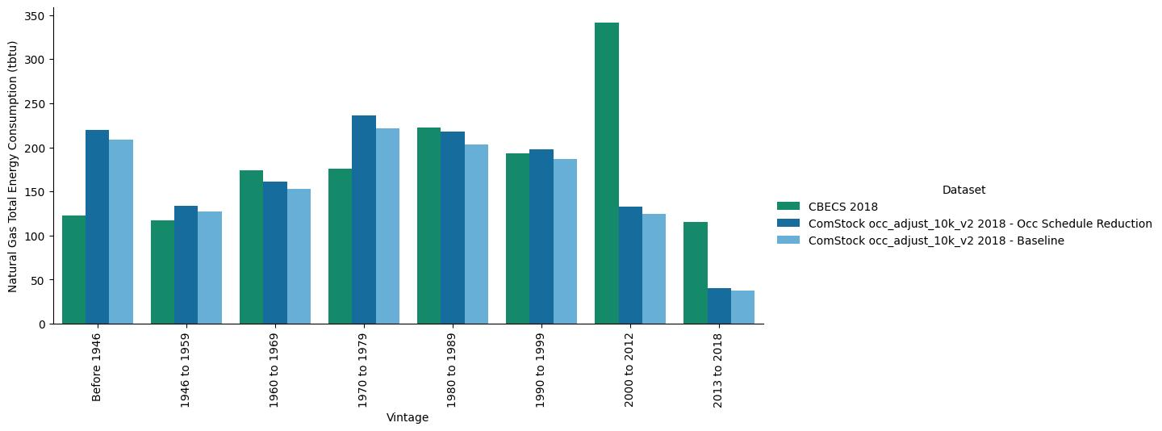
Figure 7: Natural Gas Consumption for Baseline and Occupancy Schedule measure compared to CBECS by Vintage

https://www.census.gov/library/visualizations/interactive/population-increase-2018.html
Representing the civilian noninstitutional population age 15 or over.
The ATUS asks different respondents to answer for a specific day during the week prior to the interview. The survey day may be a weekday or weekend, and the responses are weighted accordingly. Thus an ‘average day’ includes the impact of both weekday and weekend activities proportioned by the fraction of days of a particular type, e.g. 5/7 for weekdays and 2/7 for weekends. Potential future refinement of this analysis would be to analyze locations by day of the week.
US Census Bureau, Current Population Survey, Annual Social and Economic Supplement, 2018
Approximately 35M total Elementary School enrollment, from U.S. Department of Education, National Center for Education Statistics, Common Core of Data (CCD), "State Nonfiscal Survey of Public Elementary/Secondary Education," 2016-17. https://nces.ed.gov/programs/digest/d18/tables/dt18_203.40.asp

