ComStock Reduce Design Days
  - V27 – Reduce Design Days
Implementer: Matthew Dahlhausen
Change Document Author: Matthew Dahlhausen
Reviewer: Eric Ringold, Andrew Parker

Description of Change

Summary
This update reduces the amount of design days and subsequent sizing runs. Previous, many annual and all 12 monthly cooling design days were included in the models. This update reduces it to 3 annual conditions and 3 monthly cooling conditions. Given the majority of run time is spent in sizing runs, this update should significantly reduce ComStock runtime.

Existing Methodology
Design Days are added in the ChangeBuildingLocation measure. Here is a list of the current regex list. Any design days that match are added.
ddy_list = [
/Htg 99.6. Condns DB/, # Annual heating 99.6%
/Htg 99. Condns DB/, # Annual heating 99%
/Htg Wind 99. Condns WS=>MCDB/, # Annual heating wind
/Clg 1. Condns DB=>MWB/, # Annual cooling 1%
/Clg 2. Condns DP=>MDB/, # Annual cooling 2%
/Clg .4. Condns WB=>MDB/, # Annual cooling
/Clg .4. Condns DB=>MWB/, # Annual humidity (for cooling towers and evap coolers)
/January .4. Condns DB=>MCWB/, # Monthly cooling DB=>MCWB (to handle solar-gain-driven cooling)
/February .4. Condns DB=>MCWB/,
/March .4. Condns DB=>MCWB/,
/April .4. Condns DB=>MCWB/,
/May .4. Condns DB=>MCWB/,
/June .4. Condns DB=>MCWB/,
/July .4. Condns DB=>MCWB/,
/August .4. Condns DB=>MCWB/,
/September .4. Condns DB=>MCWB/,
/October .4. Condns DB=>MCWB/,
/November .4. Condns DB=>MCWB/,
/December .4. Condns DB=>MCWB/,
/January .4. Condns WB=>MCDB/, # Monthly cooling WB=>MCDB (to handle solar-gain-driven cooling)
/February .4. Condns WB=>MCDB/,
/March .4. Condns WB=>MCDB/,
/April .4. Condns WB=>MCDB/,
/May .4. Condns WB=>MCDB/,
/June .4. Condns WB=>MCDB/,
/July .4. Condns WB=>MCDB/,
/August .4. Condns WB=>MCDB/,
/September .4. Condns WB=>MCDB/,
/October .4. Condns WB=>MCDB/,
/November .4. Condns WB=>MCDB/,
/December .4. Condns WB=>MCDB/
]
For a typical model, this adds the following design days:
- Ann Clg .4% Condns DB=>MWB
- Ann Clg .4% Condns WB=>MDB
- Ann Clg 1% Condns DB=>MWB
- Ann Clg 2% Condns DP=>MDB
- Ann Htg 99% Condns DB
- Ann Htg 99.6% Condns DB
- Ann Htg Wind 99% Condns WS=>MCDB
- January .4% Condns DB=>MCWB
- February .4% Condns DB=>MCWB
- March .4% Condns DB=>MCWB
- April .4% Condns DB=>MCWB
- May .4% Condns DB=>MCWB
- June .4% Condns DB=>MCWB
- July .4% Condns DB=>MCWB
- August .4% Condns DB=>MCWB
- September .4% Condns DB=>MCWB
- October .4% Condns DB=>MCWB
- November .4% Condns DB=>MCWB
- December .4% Condns DB=>MCWB
- January .4% Condns WB=>MCDB
- February .4% Condns WB=>MCDB
- March .4% Condns WB=>MCDB
- April .4% Condns WB=>MCDB
- May .4% Condns WB=>MCDB
- June .4% Condns WB=>MCDB
- July .4% Condns WB=>MCDB
- August .4% Condns WB=>MCDB
- September .4% Condns WB=>MCDB
- October .4% Condns WB=>MCDB
- November .4% Condns WB=>MCDB
- December .4% Condns WB=>MCDB
Eric graciously provided this analysis of a small sample of models from a recent 10k run in the baseline condition. These show which design days determined the zone peak sensible loads. The monthly July condition determined the cooling size in most models, while other monthly design conditions determined cooling size in some models. The annual heating design day determined the heating size in most models, while the wind condition determined the heating size in some models.
Type | Division | Baseline Zone Clg | Baseline Zone Htg
FullServiceRestaurant | Mountain | 8x July .4% DB  1x Sept .4% DB | 9x Ann Htg 99.6%
PrimarySchool | East North Central | 22x July .4% DB  10x Sept .4% DB  6x Aug .4% DB  1x Oct .4% DB | 39x Ann Htg 99.6%
SmallOffice | Pacific | 2x July .4% DB | 2x Ann Wind 99%
StripMall | Mountain | 10x July .4% DB  10x Sept .4% DB  6x June .4% DB  1x Aug .4% DB | 22x Ann Htg 99.6%  5x nil
StripMall | Pacific | 19x July .4% DB  2x Aug .4% DB  2x Sept .4% DB  1x Oct .4% DB | 24% Ann Htg 99.6%
StripMall | South Atlantic | 11x August .4% DB  10x July .4% DB | 21 Ann Htg 99.6%
StripMall | West South Central | 12x June .4% DB  7x Sept .4% DB  4x Aug .4% DB  1x July .4% DB | 20x Ann Htg 99.6%  4x nil

New Methodology
The change reduces the design day list to the following:
ddy_list = [
/Htg 99.6. Condns DB/, # Annual heating 99.6%
/Clg .4. Condns WB=>MDB/, # Annual humidity (for cooling towers and evap coolers)
/Clg .4. Condns DB=>MWB/, # Annual cooling
/August .4. Condns DB=>MCWB/, # Monthly cooling DB=>MCWB (to handle solar-gain-driven cooling)
/September .4. Condns DB=>MCWB/,
/October .4. Condns DB=>MCWB/
]
For a typical model, this adds the following design days:
- Ann Clg .4% Condns DB=>MWB
- Ann Clg .4% Condns WB=>MDB
- Ann Htg 99.6% Condns DB
- August .4% Condns DB=>MCWB
- September .4% Condns DB=>MCWB
- October .4% Condns DB=>MCWB

Impact of Change

Individual Model Input Change
Model | SizingPeriod:DesignDay objects in the model
 | Before | After
Example Model | - Ann Clg .4% Condns DB=>MWB  - Ann Clg .4% Condns WB=>MDB  - Ann Clg 1% Condns DB=>MWB  - Ann Clg 2% Condns DP=>MDB  - Ann Htg 99% Condns DB  - Ann Htg 99.6% Condns DB  - Ann Htg Wind 99% Condns WS=>MCDB  - January .4% Condns DB=>MCWB  - February .4% Condns DB=>MCWB  - March .4% Condns DB=>MCWB  - April .4% Condns DB=>MCWB  - May .4% Condns DB=>MCWB  - June .4% Condns DB=>MCWB  - July .4% Condns DB=>MCWB  - August .4% Condns DB=>MCWB  - September .4% Condns DB=>MCWB  - October .4% Condns DB=>MCWB  - November .4% Condns DB=>MCWB  - December .4% Condns DB=>MCWB  - January .4% Condns WB=>MCDB  - February .4% Condns WB=>MCDB  - March .4% Condns WB=>MCDB  - April .4% Condns WB=>MCDB  - May .4% Condns WB=>MCDB  - June .4% Condns WB=>MCDB  - July .4% Condns WB=>MCDB  - August .4% Condns WB=>MCDB  - September .4% Condns WB=>MCDB  - October .4% Condns WB=>MCDB  - November .4% Condns WB=>MCDB  - December .4% Condns WB=>MCDB | - Ann Clg .4% Condns DB=>MWB  - Ann Clg .4% Condns WB=>MDB  - Ann Htg 99.6% Condns DB  - August .4% Condns DB=>MCWB  - September .4% Condns DB=>MCWB  - October .4% Condns DB=>MCWB

Sizing Changes
The following two graphs show a modest decrease in the design size of the average DX system capacity and average furnace capacity. These reductions are consistent with the less restrictive design day criteria.
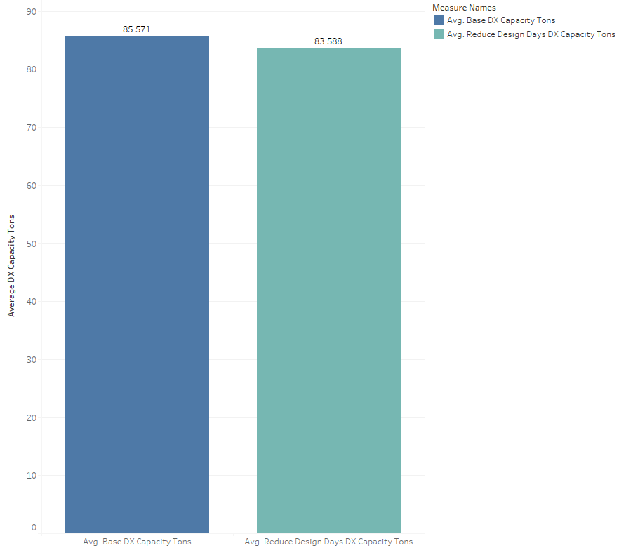
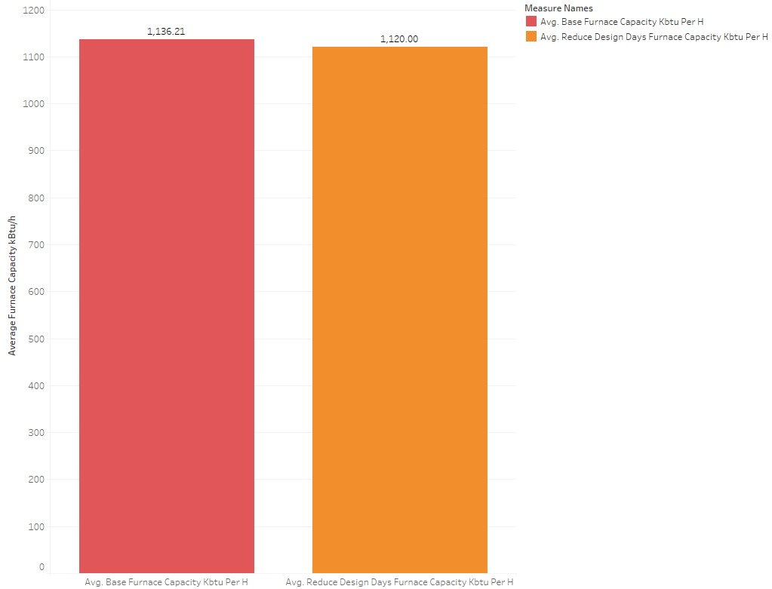

Stock-Level Output Change
The intend effect is there is for there to be a negligible difference between the two models. The first figure shows the average electricity heating and cooling and gas heating intensity. The values are within 1% or less, with the most variation in cooling energy use. This difference comes from a difference in sizing, particularly cooling where the 0.4% July condition was usually the determinitive design day in the baseline condition. The annual 0.4% condition is more appropriate for typical practice, so this change is expected and intended.
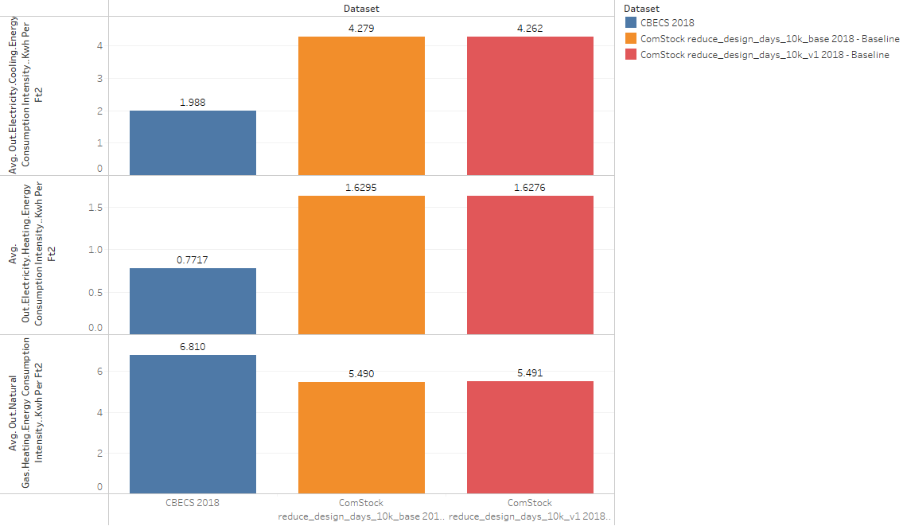

The following graphs show changes in total stock electricity and natural gas in total, and by building type, region, and vintage. The values between the base and v1 (reduce design days) run are very similar. There are differences in Hospitals, and in the West South Central and Pacific regions. This is because of the differences from the less extreme monthly 0.4% cooling design day in summer, and the instances of the annual heating wind condition being the deciding design day in some models.
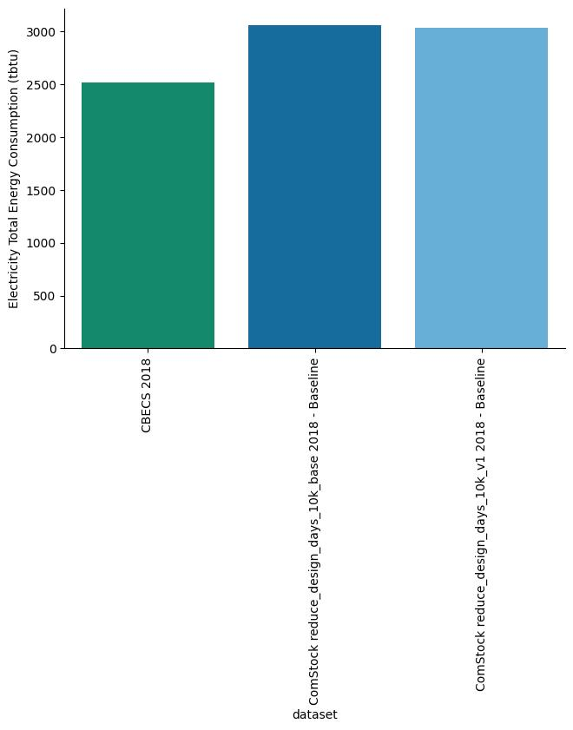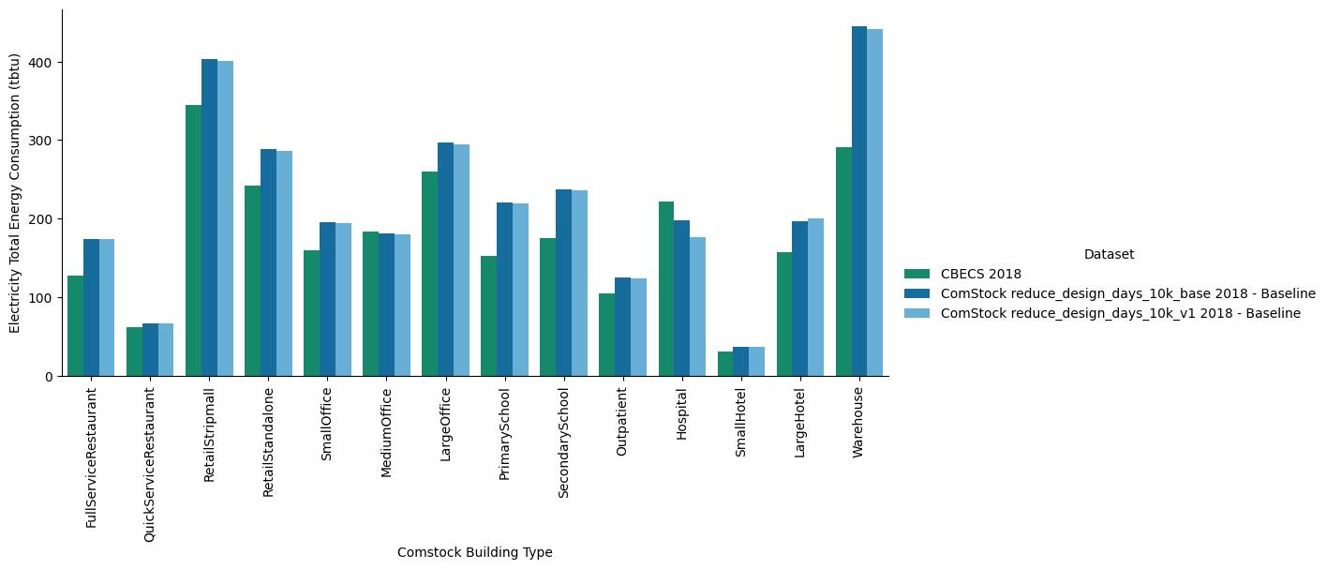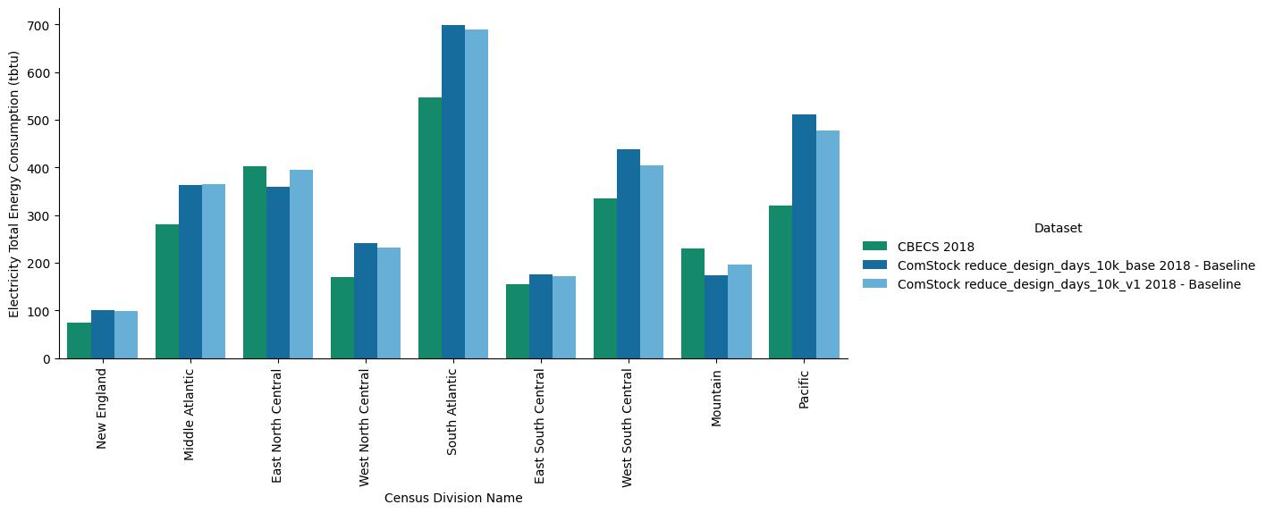
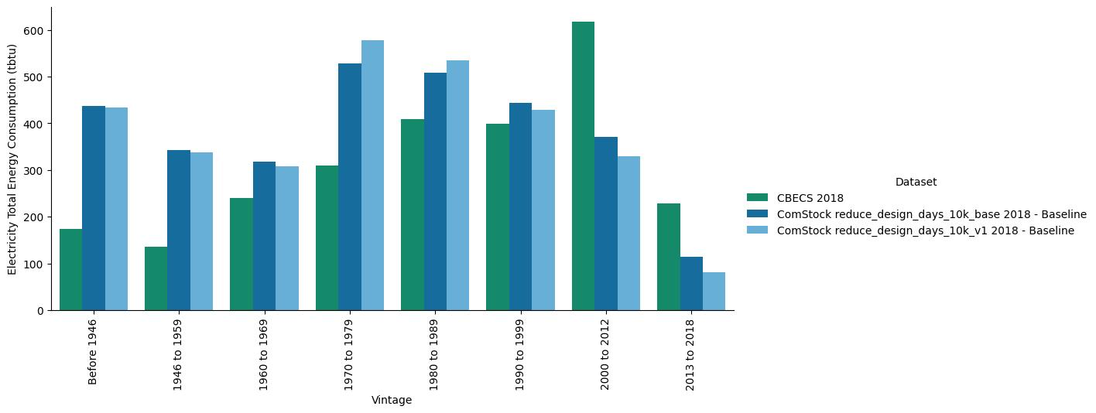
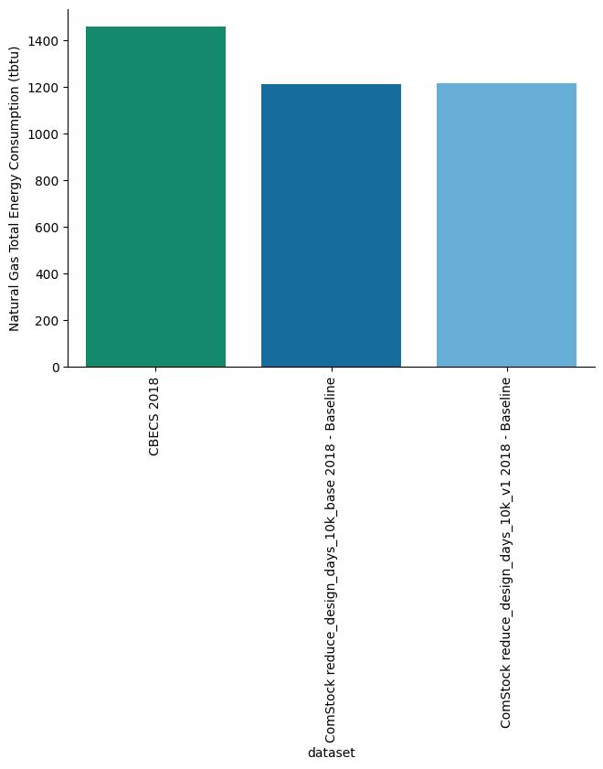

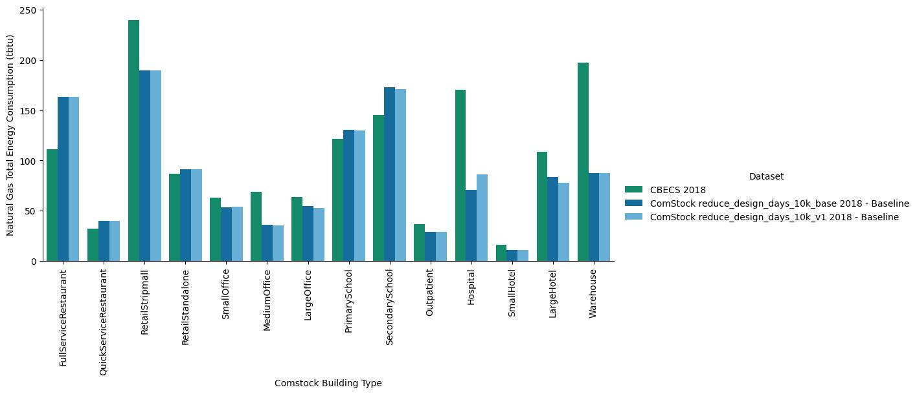
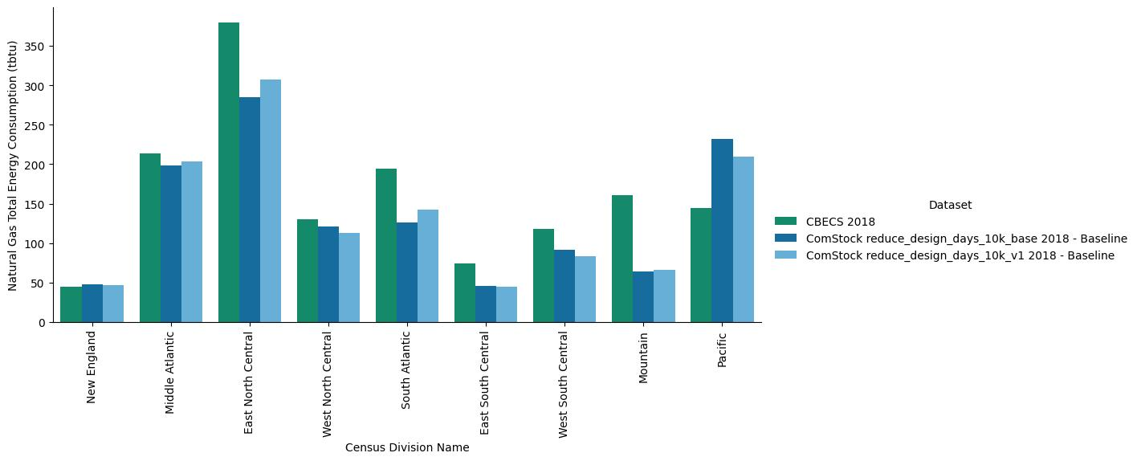
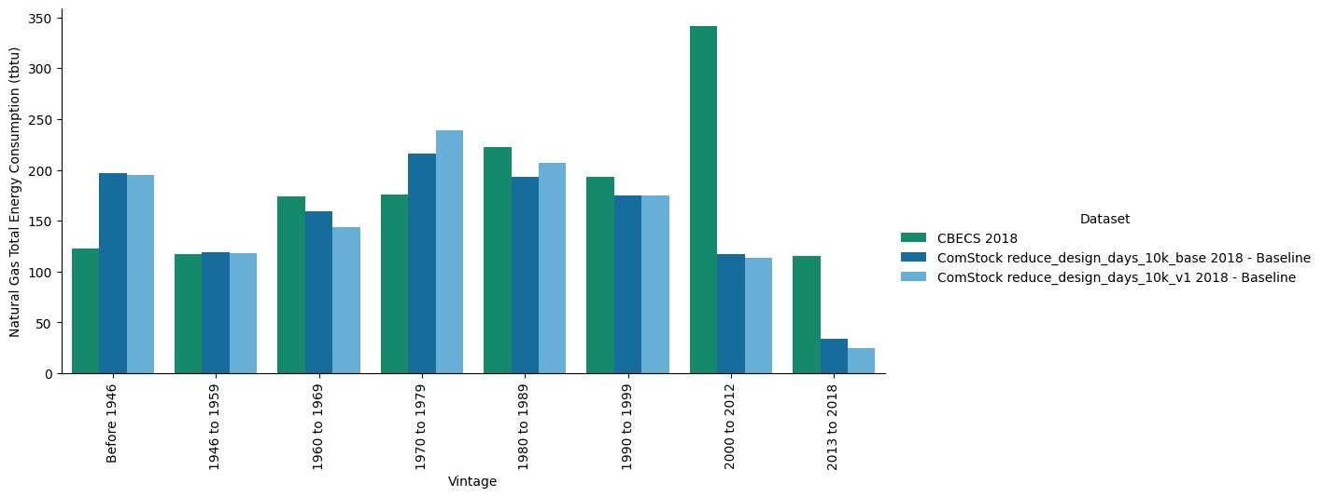

The main difference is that fewer design days means much faster run times. The average simulation time reduced by about 40%.
