ComStock Change
  - v28 – Warehouse Thermostats and System Types
Implementer: Eric Ringold
Change Document Author: Eric Ringold
Reviewer: Andrew Parker, Chris CaraDonna, Matt Dahlhausen

Description of Change

Summary
This update improves the overall energy consumption of Warehouse buildings represented in ComStock. The goal of this change is to better alight warehouse prototype space conditioning assumptions with the building stock characteristics and to better represent the warehouse type’s electricity and natural gas use compared to CBECS.

Existing Methodology
In the investigation of causes of energy consumption disparities between ComStock and the CBECS truth data set, it is observed that warehouse buildings were among the worst represented types in the dataset, estimating total electricity usage approximately 50% higher than CBECS (Figure 1), and natural gas usage approximately 50% lower than CBECS (Figure 2).
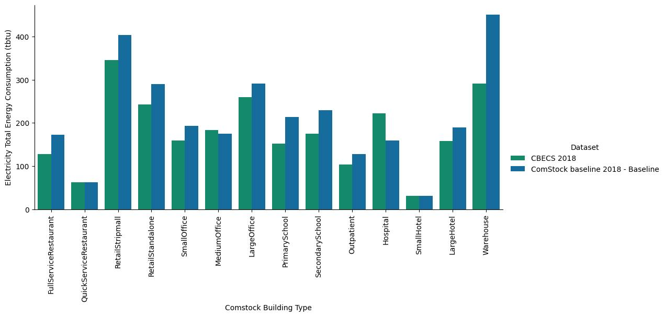
Figure 1: Electricity Total Energy Consumption by Building Type, ComStock vs CBECS 2018
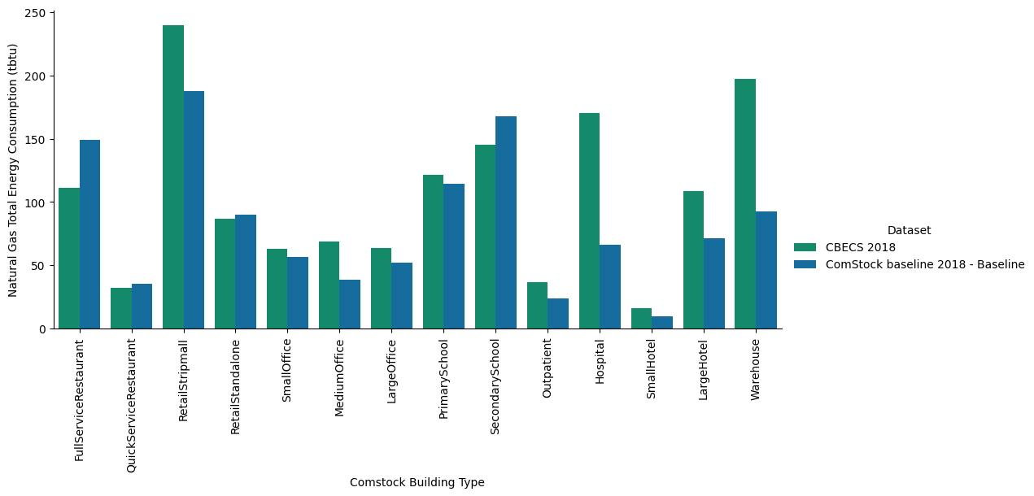
Figure 2: Natural Gas Total Energy Consumption by Building Type, ComStock vs CBECS 2018
Figure 3 shows large over-estimations in electricity consumption for warehouse buildings particularly in the Pacific region, as well as East North Central and Atlantic. In contrast, warehouse natural gas consumption shows very large under-estimations for almost all census divisions, with the notable exception of Pacific, which drastically over-estimates total gas consumption (Figure 4). These observations indicate some issues with fundamental assumptions in the ComStock warehouse models.
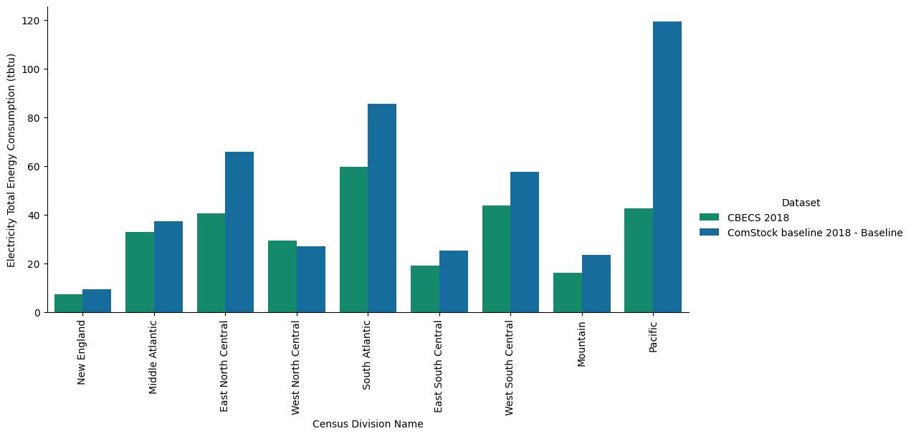
Figure 3: Electricity Consumption for Warehouse Buildings by Census Division, ComStock vs CBECS
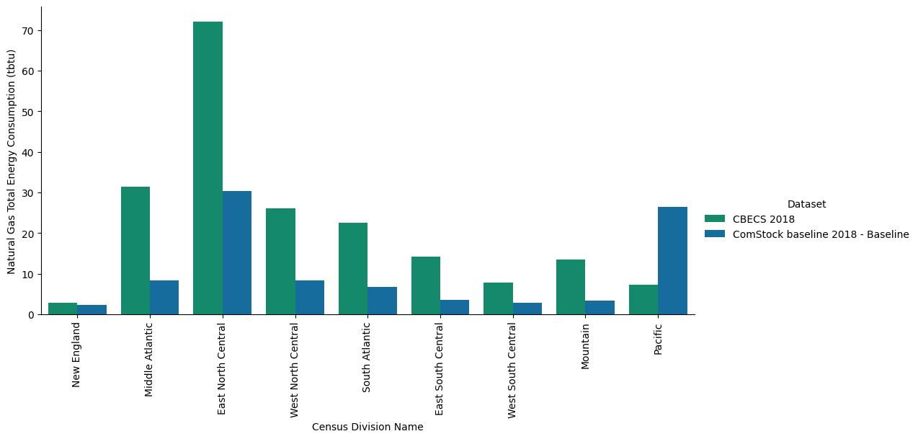
Figure 4: Natural Gas Consumption for Warehouse Buildings by Census Division, ComStock vs CBECS
This Warehouse building space conditioning characteristics in ComStock are largely derived from inputs from the DOE and DEER prototype buildings. The DOE warehouse buildings are separated into three space types, with area fractions and default setpoints summarized in Table 1.
Space Type Name | Percent of Building Area | Heating Thermostat Setpoint | Cooling Thermostat Setpoint
Bulk | 66.2% | 10C (50F)  7.2C (45F) - ComStock DOE Ref 1980-2004 and ComStock DOE Ref Pre-1980 | 50C (122F)
Fine | 28.8% | 15.56C (60F) | 26.7C (80F)
Office | 4.9% | 21.1C (70F) - 15.6C (60F) | 23.9C (75F) - 29.4C (85F)  24C (75F) - 30C (85F) - ComStock DOE Ref 1980-2004 and ComStock DOE Ref Pre-1980
Table 1: DOE Warehouse Space Type Conditions
The percentage of total warehouse square footage by vintage is show in Figure 5. Around 90% of the warehouse floor area in the building stock was built before 2004, thus approximately 60% (0.662 * 0.9) of that floor area is currently modeled with a heating setpoint of 45F. CBECS 2018 included a question asking what percentage of the area in the building is heated to at least 50 degrees Fahrenheit. The responses to this question are shown in the bar coloring of Figure 6 for percent of respondent total warehouse square footage by vintage, indicating that older (pre-2004) warehouse vintages show larger amounts of their total area heated to above 50F than ComStock currently represents.
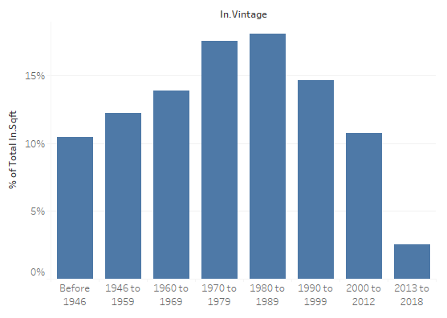
Figure 5: ComStock Percent of Warehouse Total Area by Vintage
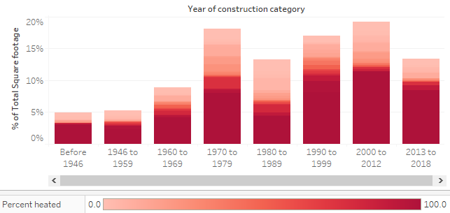
Figure 6: CBECS 2018 Percent of Warehouse Total Area by Vintage, colored by Percent Heated
For DOE warehouse buildings in ComStock, the HVAC system assignments determined by the hvac_system_type distribution are for the most part assigned to all zones in the model, according to the logic in the method add_cbecs_hvac_system. In the current method, for some HVAC system types, zones categorized as ‘heating only’ (i.e., that have a zone cooling thermostat setpoint above 91F) are assigned to a ‘secondary’ heated-only system type. This secondary system was not added for all primary HVAC systems, and the main heating fuel for some of the secondary systems did not always match the primary system type main heating fuel. The majority (65%) of non-California warehouse buildings in ComStock are assigned the system ‘PSZ-AC with gas coil’, for which the secondary system type is being set as Electric Baseboards, which serve most of the floor area of these warehouse buildings, albeit at a much lower zone heating setpoint. This heating fuel imbalance is a key contributor to the energy consumption discrepancy seen in the ComStock results compared to CBECS.
In contrast to the DOE prototypes, ComStock models California warehouses using the DEER SCn (conditioned warehouse) prototype buildings only contain one space type, with one thermostat with a zone heating setpoint of 21.1C (70F) and zone cooling setpoint of 24.4C (76F). For these buildings, the primary HVAC system type as determined by ComStock is assigned to the entire floor area, and in many cases runs constantly. In effect, all California warehouse buildings in ComStock are 100% conditioned almost as much as offices. In contrast, from CBECS 2018 we can see that Warehouses in the Pacific census division (the majority of which are assumed to be in California), a sizeable majority of the floor area is under 40% cooled (Figure 7) and under 30% heated (Figure 8). Additionally, a longstanding bug in openstudio-standards for the California Title 24 code ventilation requirements was assigning ventilation as the sum of the CFM/area and CFM/person requirements, when the actual code specifies the maximum of the two. Therefore, ComStock is currently overrepresenting the amount of conditioned floor area in California warehouses, as well as the amount of ventilation the warehouses (and California buildings in general) are receiving.
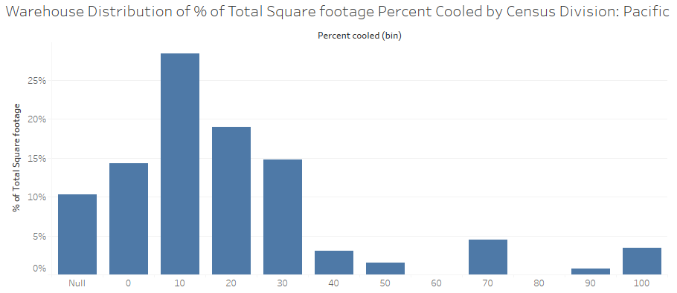
Figure 7: Percent of total Pacific Census Division Warehouse Square Footage by bin of Percent Cooled
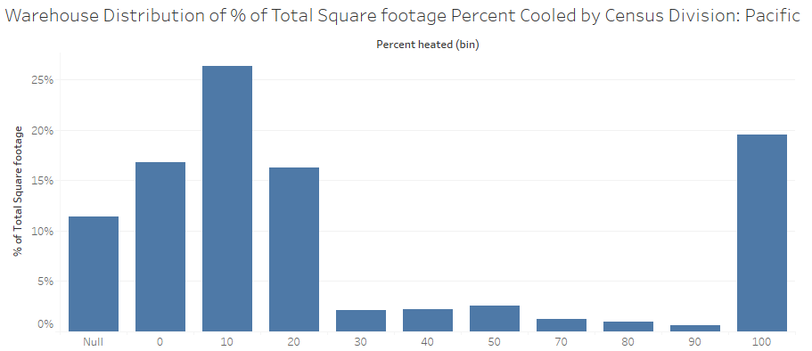
Figure 8: Percent of total Pacific Census Division Warehouse Square Footage by bin of Percent Heated

New Methodology
This change includes the following components:
First, to address the widespread underheating in all DOE (i.e., non-California) warehouses buildings in ComStock, the warehouse heating thermostat setpoint distribution was updated to increase setpoints for all warehouse spaces to 61F. Since data on actual warehouse building thermostat setpoints was unavailable when this change was made, 61F was chosen because it was the minimum temperature in the existing heating thermostat setpoint distribution, and this change would minimize changes in the sampling distributions, while also appearing to the ComStock team as a reasonable first approximation. The thermostat variability measure was significantly refactored, unit tested, and modified so that setpoint reductions would not apply to DOE warehouse office spaces, thus leaving those heating setpoints unchanged.
Next, to address the over-conditioning in DEER (i.e. California) warehouses, the DEER warehouse model was changed to the Unconditioned Warehouse prototype, and the corresponding heating and cooling thermostat schedules (which were previously identical to those for the Conditioned warehouse) in openstudio-standards to reflect actual unconditioned, or at least heating-only, setpoints, i.e. 55F for heating and 122F for cooling. The heating setpoints would then be adjusted by the thermostat adjustment measure to increase to 61F along with the DEER warehouses. Additionally, openstudio-standards was changed so that the ComStock DEER templates would set the ventilation method in the DesignSpecification:OutdoorAir objects to ‘Maximum’ rather than ‘Sum’, fixing the ventilation bug by setting ventilation to the maximum of CFM/area and CFM/person per Title 24 code.
Finally, to address the HVAC system type heating energy discrepancy and assign a proper system type for heated-only warehouse spaces, add_cbecs_hvac_system was updated to add ‘secondary systems’ (electric baseboards or gas unit heaters, depending on primary system main heating fuel) to all primary systems assigned to California warehouse buildings (Table 2).

Hvac System Type | # CA warehouses in 10k run
Direct evap coolers with forced air furnace | 4
DOAS with VRF | 15
PSZ-AC with electric coil | 102
PSZ-AC with gas coil | 148
PSZ-HP | 29
PTAC with electric coil | 14
PTAC with gas coil | 3
PTHP | 6
PVAV with gas boiler reheat | 29
PVAV with gas heat with electric reheat | 8
PVAV with PFP boxes | 23
Residential AC with residential forced air furnace | 3
Residential forced air furnace | 10
Table 2: ComStock California Warehouse Primary HVAC System Types

Impact of Change

Individual Model Input Change
Building 14 was described in the test 10k buildstock CSV with building_type = warehouse, heating_fuel = NaturalGas, and hvac_system_type = PSZ-AC with gas coil, and located in Dekalb County, AL. In the baseline run, zone ‘Zone Warehouse Bulk - Story Ground’ was assigned an electric baseboard system (Figure 9) and a heating thermostat schedule set to 45F (Figure 10). The nominal heating capacity of the baseboard system was sized to about 10.5 kW.
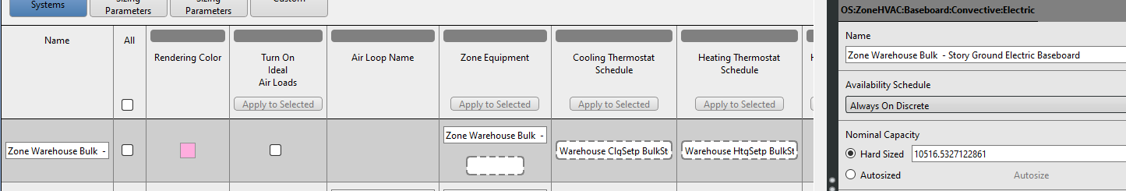
Figure 9: Bldg14 Baseline Bulk Zone HVAC Assignment
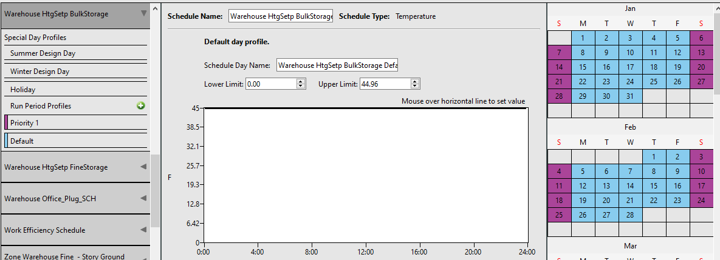
Figure 10: Bldg14 Baseline Warehouse HtgSetp BulkStorage Schedule
After the changes described above, ‘Zone Warehouse Bulk - Story Ground’ of Building 14 was assigned a natural gas unit heater, with gas coil nominal capacity sized to 21 kW (Figure 11). The heating setpoint schedule for the zone is now set to the 61F per the code changes (Figure 12). The heating setpoint assigned to the zone ‘Zone Warehouse Office - Story Ground’ remained unchanged, since the modification would have reduced that setpoint from the baseline 70F.
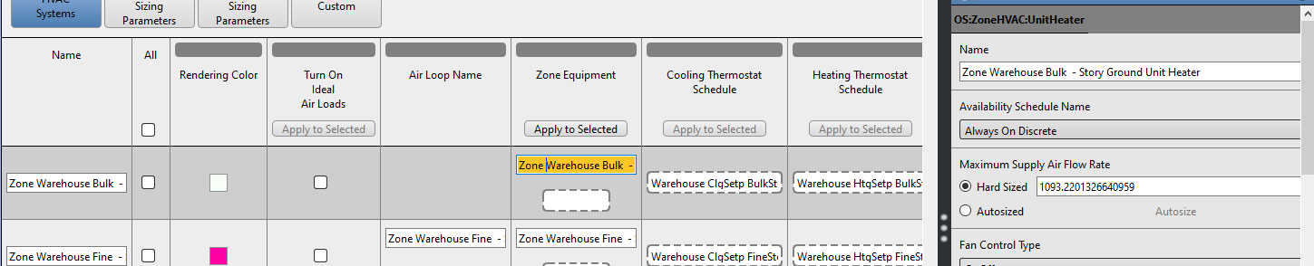
Figure 11: Bldg14 modified Bulk Zone HVAC System assignment
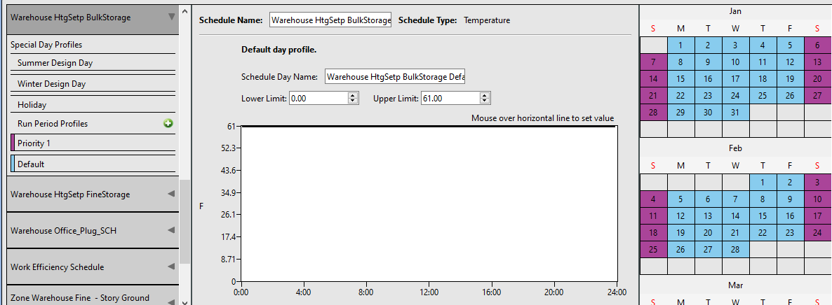
Figure 12: Bldg14 modified Warehouse HtgSetp BulkStorage Schedule

Building 743 was described in the 10k buildstock CSV as a warehouse with electric heating and a DOAS with VRF system type, located in Solano County, CA. In the baseline run, all nine thermal zones totaling 75,000 SF were assigned to the constant-volume DOAS air system, with zone-level VRF terminals and heating thermostat setpoint schedules of a constant 70F.
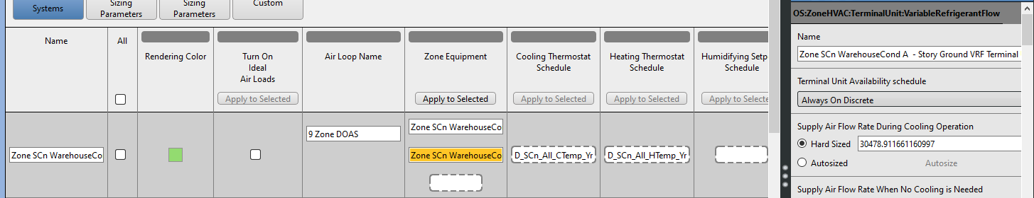Figure 13: Bldg743 Baseline Heating Temperature Schedule
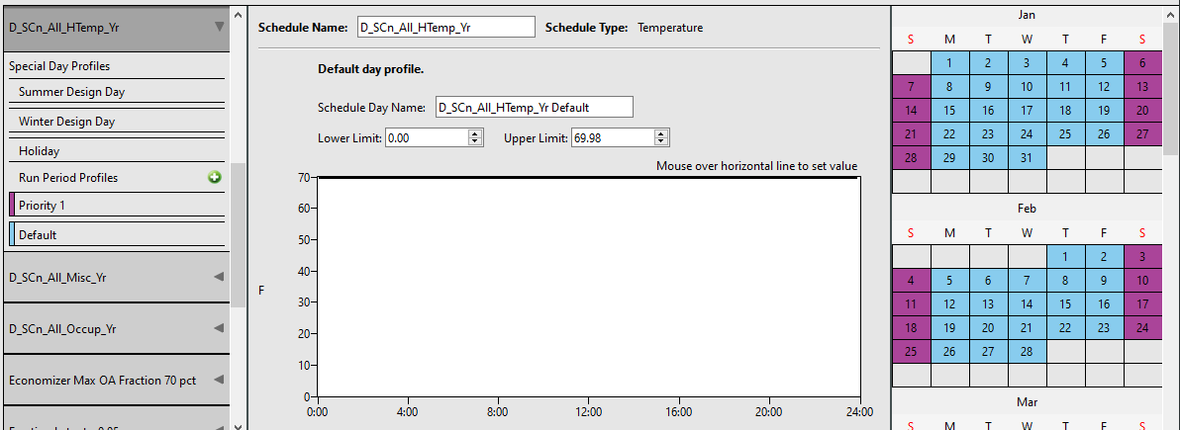
Figure 14: Bldg743 Baseline Conditioned Warehouse heating thermostat schedule
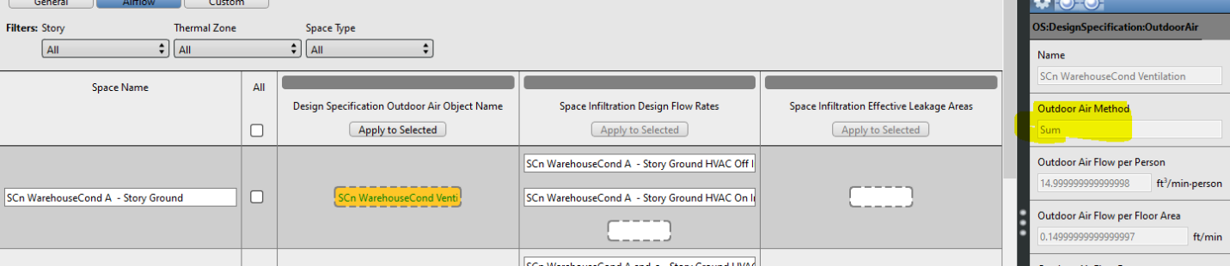
Figure 15: Bldg743 DEER Ventilation Erroneous Outdoor Air Method
After the changes, Building 743 is now designated with the ‘SUn’ DEER prototype code for unconditioned warehouses, but all inputs remain the same with the exception of those affected by the changes described above. Namely, the HVAC system assigned to all zones changed to electric baseboards, and the zone heating thermostat schedule reduced to a constant 61F. Additionally, the Outdoor Air Method was changed from the erroneous ‘Sum’ to the correct (for California code) ‘Maximum’. The impact of both changes reduced the heating system capacity for ‘Zone SCn WarehouseCond A - Story Ground’ from 245 kW to 54 kW.

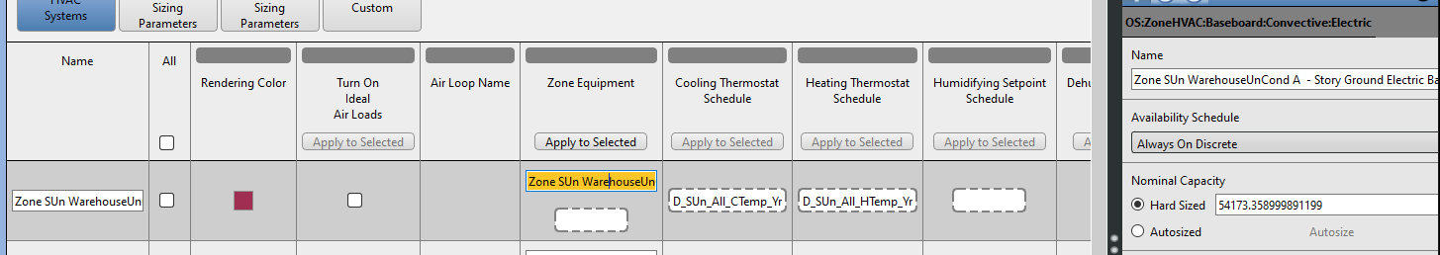
Figure 16: Bldg743 modified Zone HVAC Assignment
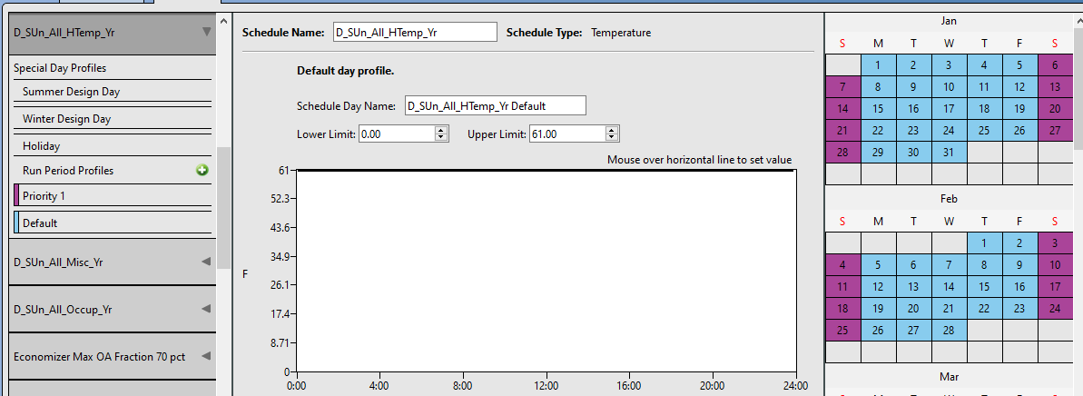
Figure 17: Bldg743 modified Heating Thermostat Schedule
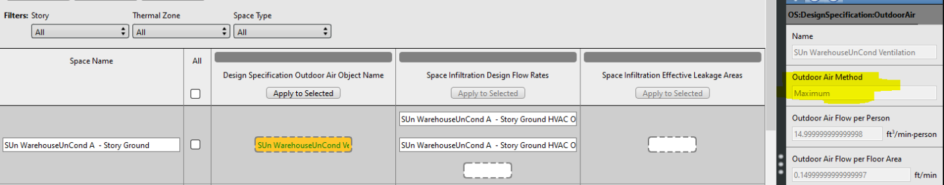
Figure 18: Bldg743 modified DEER Ventilation Outdoor Air Method

Stock-Level Input Change
The major stock-level change is the assignment of all warehouse space heating setpoints (except for DOE Warehouse Offices) from ‘no change’ (999) to 61F.
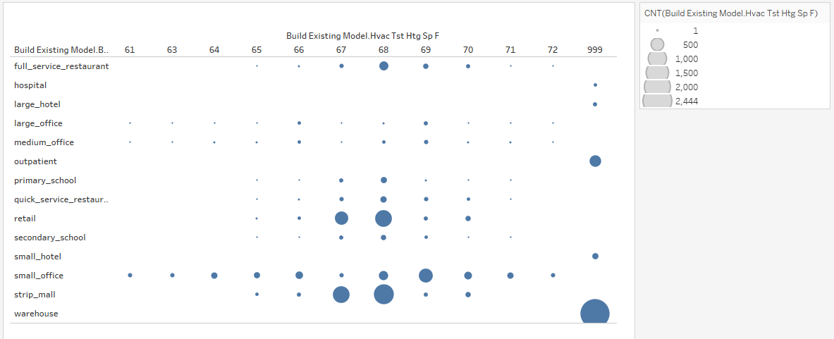
Figure 19: Distribution of Heating Thermostat Temperatures by Building Type before change
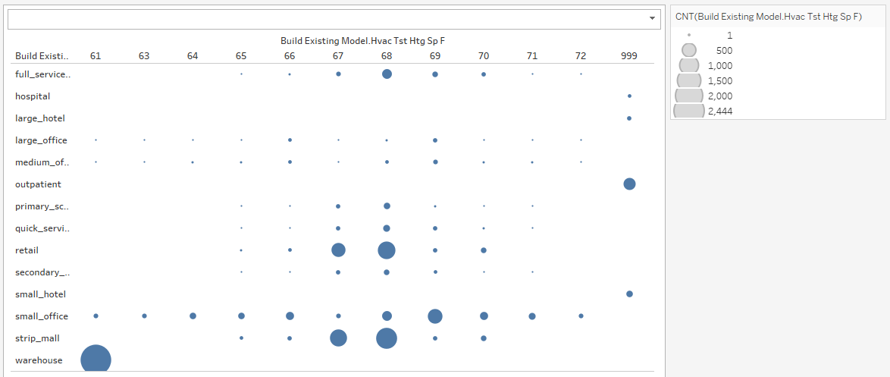
Figure 20: Distribution of Heating Thermostat Temperatures by Building Type after change

Stock-Level Output Change
Overall, the changes described above reduced the overall building stock electricity overestimation compared to CBECS 2018 from 18.8% to 13.8%, thus more accurately representing electricity consumption by 126.9 TBtu. Figure 21 and Figure 22 shows the electric consumption compared to CBECS and the baseline condition, broken down by census division and ComStock building type, respectively, showing that the majority of electricity use reduction occurred among warehouses in the Pacific region (i.e., California). Electricity reductions in other building types and census divisions can be attributed to the secondary system change for DOE warehouse Bulk storage areas from electric baseboards to Unit Heaters.
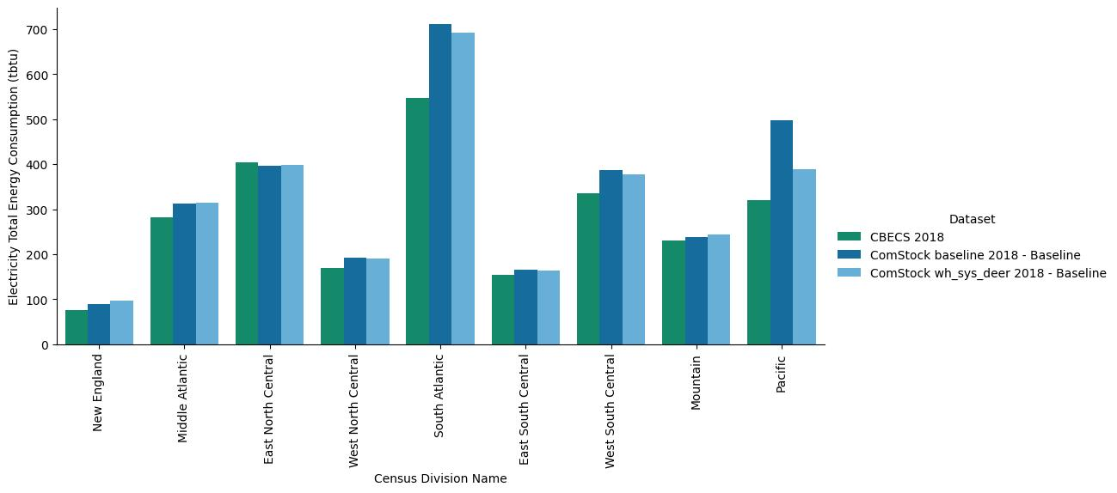
Figure 21: ComStock vs CBECS Total Electricity Consumption by Census Division
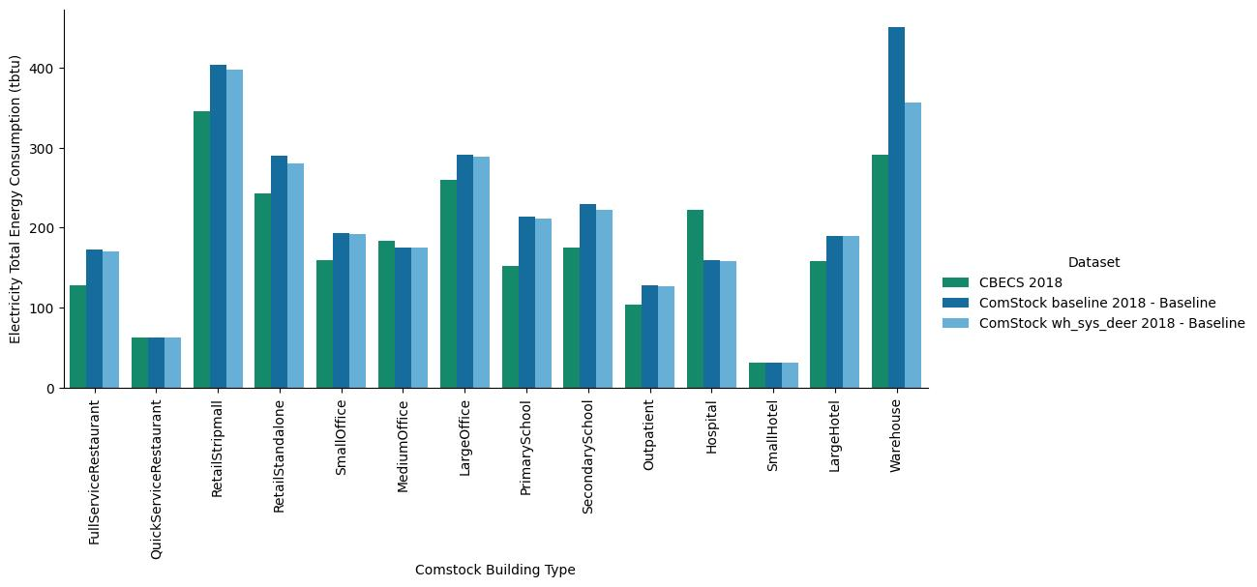
Figure 22: ComStock vs CBECS Total Electricity Consumption by ComStock Building Type
For the overall stock, the changes reduced the natural gas underestimation compared to CBECS from 21% to 20%, thus more accurately representing natural gas use by 14.4 TBtu. However, breaking down gas consumption by census division (Figure 23) shows that the relatively modest overall change hides some major shifts in gas use geographically, where all regions saw consumption move closer to the CBECS estimates, sometimes dramatically. By building type (Figure 24), these changes are seen again most dramatically in warehouses, as increased heating setpoints resulted in more gas use for heating. Gas use reductions in other building types were fairly small, but could primarily be the result of the California ventilation method change, which reduced the amount of outside air that California buildings would need to heat.
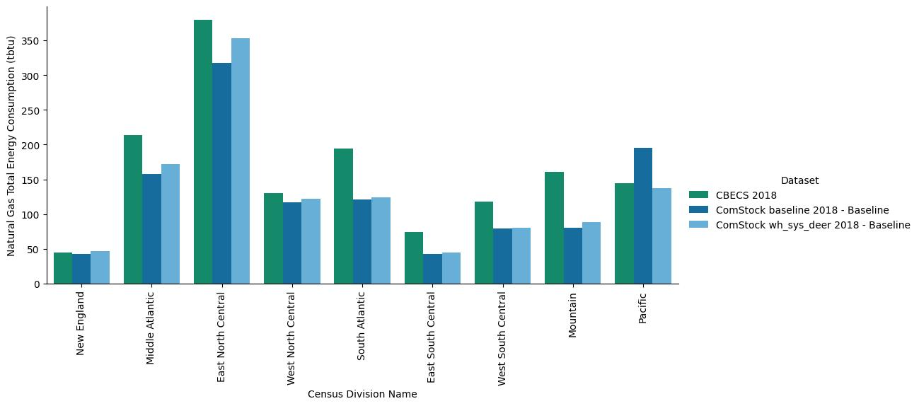
Figure 23: ComStock vs CBECS Total Natural Gas Consumption by Census Division
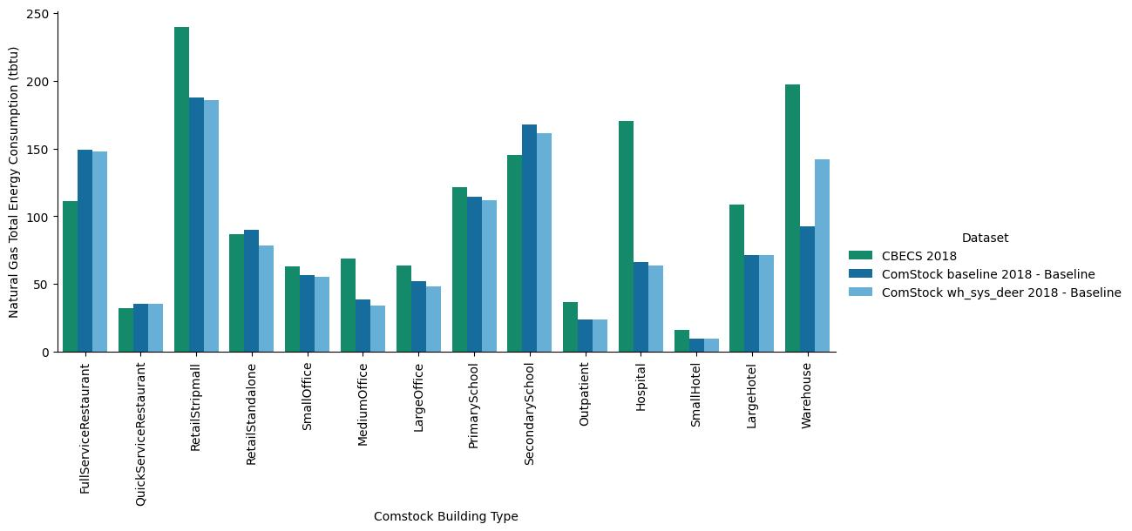
Figure 24: ComStock vs CBECS Total Natural Gas Consumption by ComStock Building Type
Looking at specifically warehouse energy, Figure 25 shows that the largest reduction occurred in the Pacific division, as a result of switching from fully-conditioned warehouses in California to heated-only, thus eliminating electricity for cooling and fans. The electricity reduction does show some over-shoot relative to CBECS, indicating that eliminating cooling from California warehouses entirely is not entirely accurate; indeed Figure 7 indicates that some percent of California warehouses should contain at least some cooling. It is hoped that this will be addressed in future refinements to the ComStock modeling approach that relies less on the existing DEER Prototype space uses.
The changes shows the most impact in warehouse natural gas consumption by census division (Figure 26), where almost all geographic regions moved much closer to the CBECS 2018 estimates, most dramatically in East North Central, Middle Atlantic and Pacific, due to the large warehouse square footage in these areas, and the impact of thermal zone increases in the heating-dominated climates (and decrease in the less-heating-dominated Pacific).
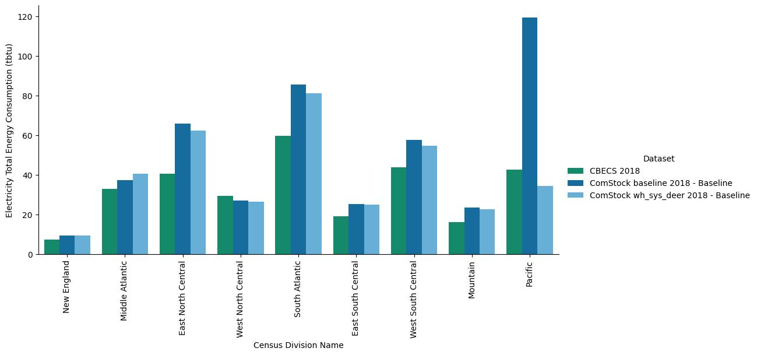
Figure 25: ComStock vs CBECS Warehouse Electricity Consumption by Census Division
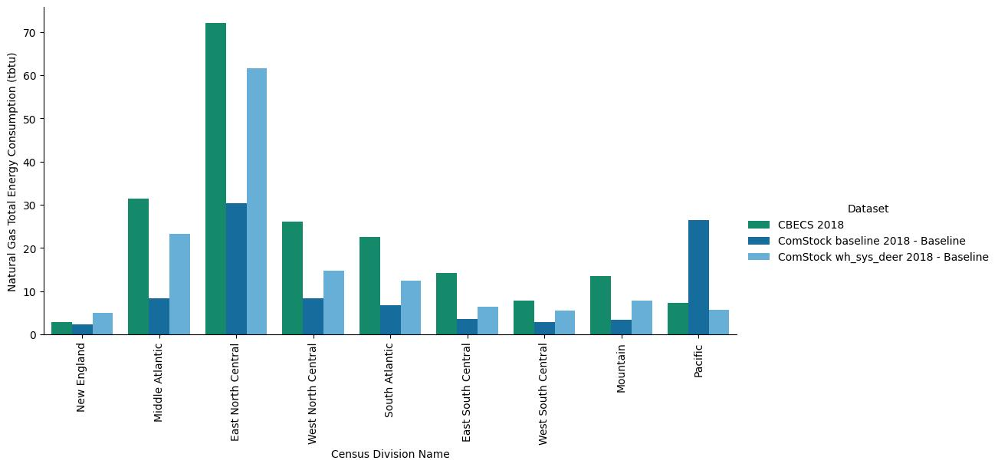
Figure 26: ComStock vs CBECS Warehouse Natural Gas Consumption by Census Division

Question D20 ‘Percent Heated' https://www.eia.gov/consumption/commercial/data/2018/pdf/eia871aij_2018.pdf
https://github.com/NREL/ComStock/blob/main/resources/measures/create_typical_building_from_model/resources/Model.hvac.rb
https://energycodeace.com/site/custom/public/reference-ace-2016/index.html#!Documents/section1201requirementsforventilation.htm

