ComStock Change
  - OpenStudio 3.7.0 to 3.8.0
Implementer: Marley Praprost
Change Document Author: Marley Praprost
Reviewer: Andrew Parker, Chris CaraDonna

Description of Change

Summary
This updates the version of OpenStudio used by ComStock from 3.7.0 ((EnergyPlus 24.1.0, OpenStudio-Standards 0.5.0, released November 2023) to 3.8.0 (EnergyPlus 23.2.0, OpenStudio-Standards 40f794b0401cbbb500b70b76ea04c523084c02c7, released May 2024). This update includes several new features, performance improvements, and bug fixes, as described in the release notes. A summary of the changes that were observed in the models is included here.

Dockerfile Approach
The existing approach starts with the OpenStudio 3.7.0 base image. Custom gems are chosen by editing the /resources/.Gemfile in the ComStock repository, which is then loaded and installed via bundler to replace the default set of gems that comes with OpenStudio 3.7.0. When building a Singularity image for HPC, the custom gems are installed directly inside the image. When running locally using Docker, the custom gems are installed into the /.custom_gems directory in the ComStock repository. This latter approach allows developers to quickly test changes to OpenStudio-Standards without having to repeatedly re-clone that repository.
This approach will be maintained, but instead uses the OpenStudio 3.8.0 base image instead of 3.7.0. The required gems that changed from OpenStudio 3.7.0 to 3.8.0 include:
- openstudio-extension: 0.7.0 to 0.8.0
- openstudio-workflow: 2.3.1 to 2.4.0
- openstudio-standards: 0.5.0 to 40f794b0401cbbb500b70b76ea04c523084c02c7
- tbd: 3.2.3 to 3.4.1
- openstudio_measure_tester: 0.3.2 to 0.4.0
In addition, a new gem called “openstudio-geb” (version 0.4.0) developed by LBNL was added to the Gemfile in this update, which will enable ComStock to run GEB-related measures in the next release of EUSS.
The minimum ruby version required for this release was updated from 2.7.0 to 3.2.0.

Impact of Change
These changes were tested using two 10k sample runs with identical buildstock.csv files. There was close to zero impact on the stock when comparing the results to each other. Very small changes were observed in the results plots, which will be discussed briefly in this section.
The number of errors in the 10k run increased from 112 to 114 in the new run. There were 3 additional model failures in the new run, while 1 error from the previous run was resolved. All 4 of these errors were this same EnergyPlus fatal error related to coil bypass fractions: Coil:Cooling:DX:SingleSpeed "ZONE STRIPMALL STRIP MALL - TYPE 2 C - STORY MID2 PSZ-AC 1SPD DX AC CLG COIL" -- negative coil bypass factor calculated.
Upon further investigation, this error was present 2 times out of 10k in the previous run and 6 times out of 10k in the new run, indicating that it is not a new error caused by this update. There do not appear to be any obvious trends by HVAC system or building type where this error is occurring. The number of times this error occurred increase slightly in the new run, however it does not have a large enough prevalence to warrant investigating and fixing it before this merge. It has been noted to the ComStock core team for investigation when time permits.
The plots below show the very minimal changes to the baseline stock as a result of upgrading to OS 3.8.0. Natural gas heating showed the largest change at the stock level, but this was still a fraction of a percent overall. Schools and retail buildings had the largest changes in gas, electricity, and site energy, but once again these were very minimal at the stock level. None of the changes seemed substantial enough to warrant further investigation.
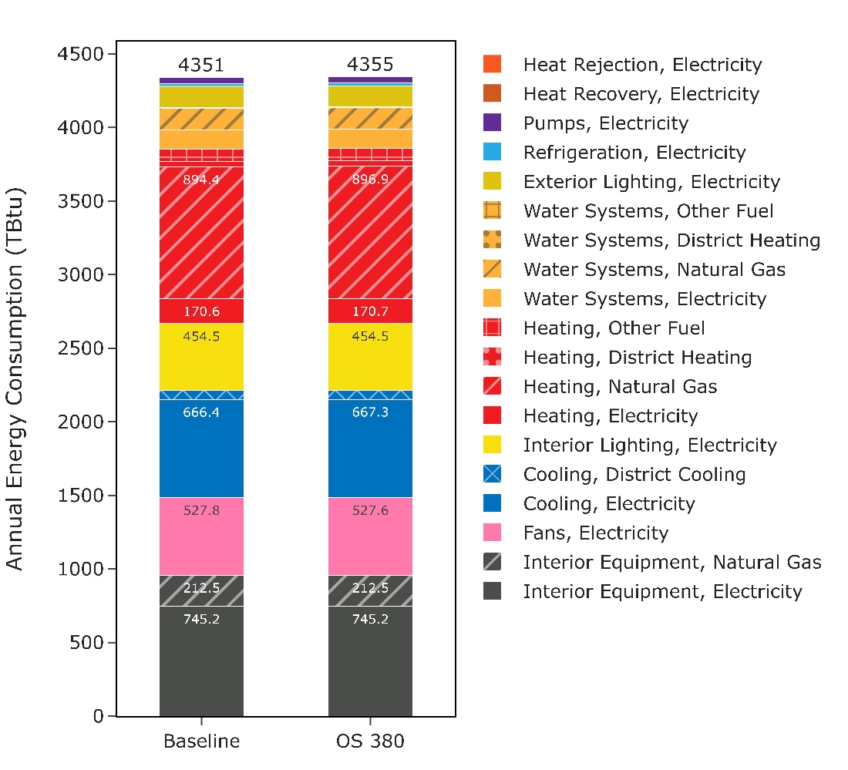
Figure 1: Stacked end use plot before and after update. The new run shows a 4 TBtu (0.09%) increase in total energy, which is mostly due to the natural gas heating end use.
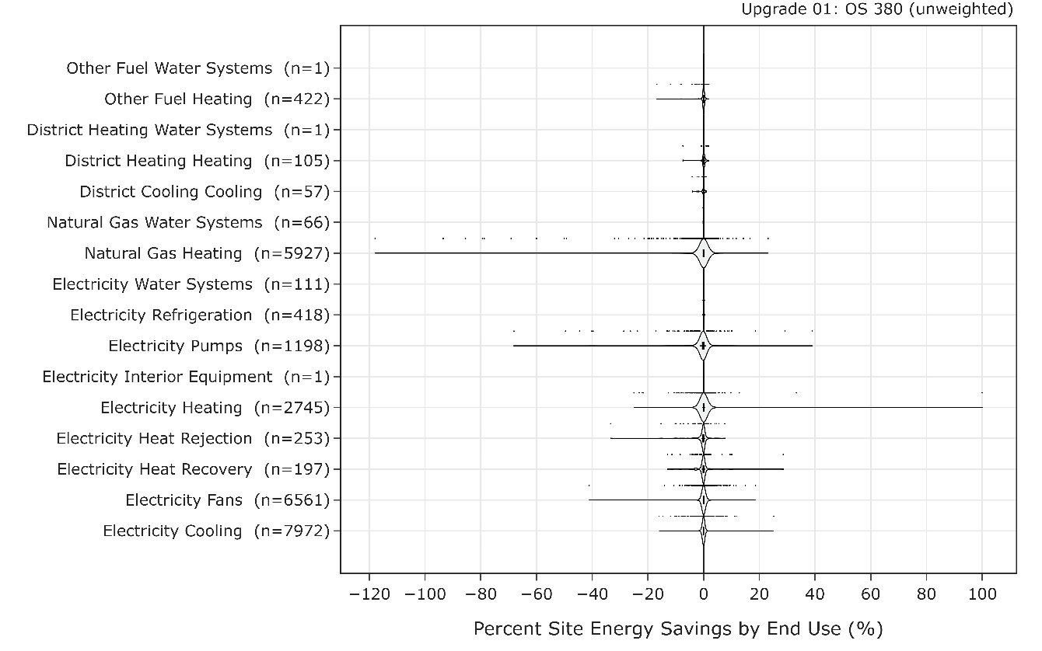
Figure 2: Savings distributions by end use before and after the update. Natural gas heating, pumps, and electric heating had a few outliers with substantial percent changes, but the median change for all end uses was very close to 0%.
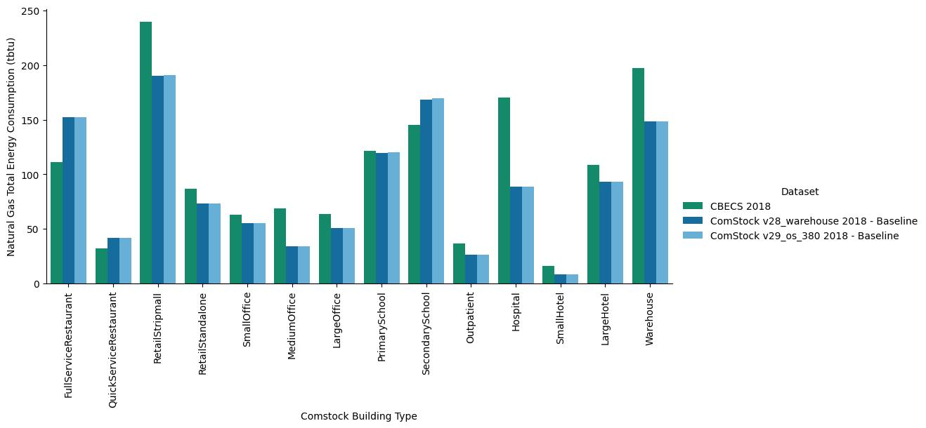
Figure 3: Natural use by building type. Most buildings show no change, while schools and retail show a very slight increase compared to the previous run.

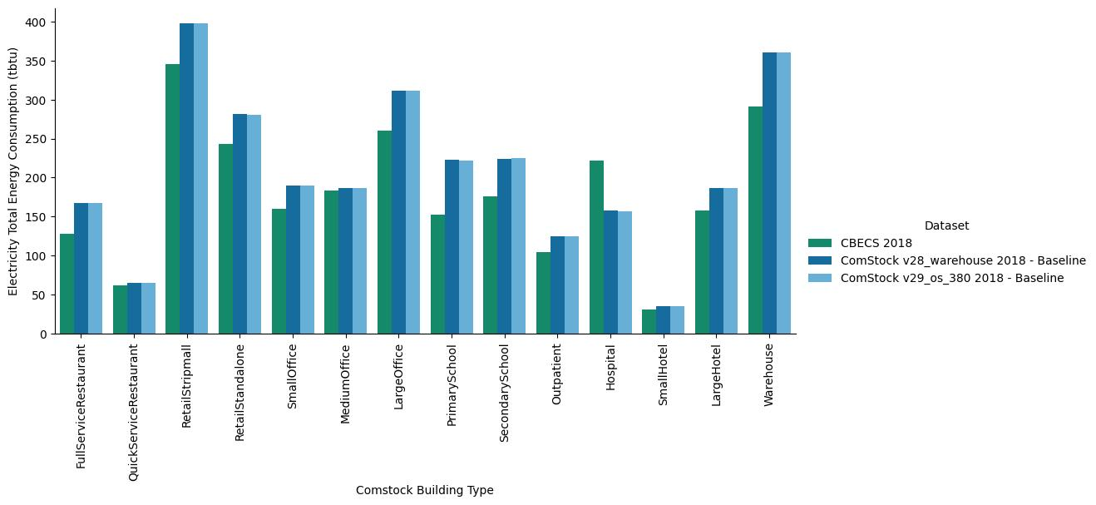
Figure 4: Electricity use by building type. Most buildings show no change, while schools and retail show a very slight change compared to the previous run.
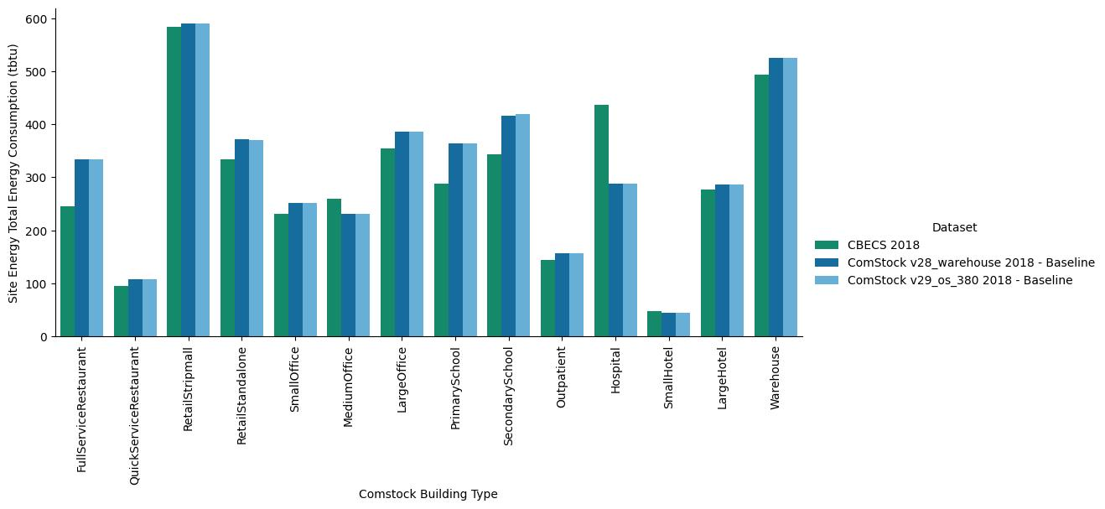
Figure 5: Site energy use by building type. Most buildings show no change, while schools and retail show a very slight change compared to the previous run.

