ComStock Change
  - V30 – Thermal Bridging
Implementer: Matthew Dahlhausen
Change Document Author: Matthew Dahlhausen
Reviewer: Eric Ringold

Description of Change

Summary
This update to the workflow derates the thermal resistance of opaque constructions to account for thermal bridging. The intent of this change is to increase conduction losses, which should increase overall gas use, and therefore reduce the overall gas underestimation in ComStock.

Existing Methodology
ComStock does not include the impact of thermal bridging. Opaque construction thermal resistance is assumed to match the thermal resistance specified as the prescriptive minimum requirement in 90.1 (or T24) for the building vintage.

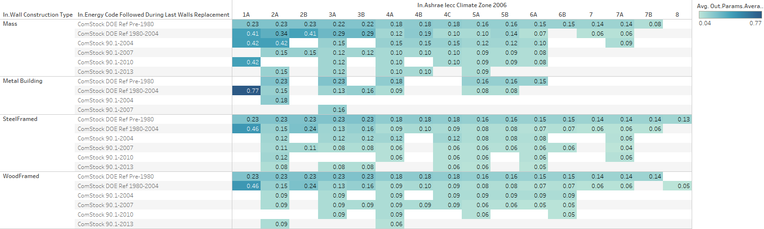
Figure 1 Existing Wall Average U-values, which depend on vintage and climate zone
More detail on wall construction type and thermal performance is included in the change documentation for the wall construction type change.

New Methodology

Thermal Bridging Background
Thermal bridging includes the impact of uninsulated structural elements that undermine the overall thermal resistance of an opaque assembly. These include linear thermal bridges, such as along corners, roof parapets, and fenestration, and point thermal bridges, such as protruding steel beams. These are formalized by psi factors multiplied by the length of a thermal bridge, and chi factors multiplied by the number of a thermal bridge. ASHRAE research publishes psi and chi factors for common major thermal bridges.
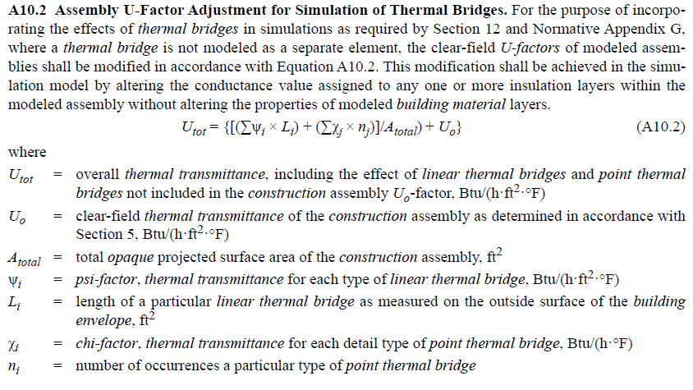
Figure 2 Thermal Bridging Methodology as specified in 90.1-2022 Appendix A10
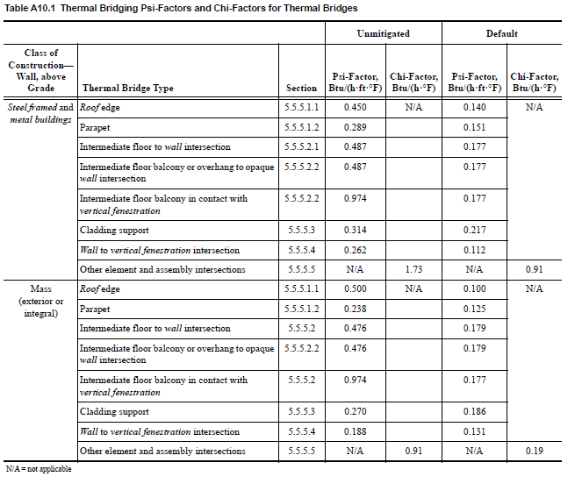
Figure 3 90.1-2022 Thermal Bridging Requirements

TBD gem
TBD in this context means “thermal bridging and derating”, not “to-be-determined”. The TBD gem (https://github.com/rd2/tbd) was developed by Denis Bourgeois for the Canadian government. The gem detects the presence of common major thermal bridges in the model (corners, parapets, etc.), and derates the adjacent opaque surface construction (walls and roofs) to account for the thermal bridging.
TBD gem version 3.4.1 includes default ASHRAE 90.1-2022 psi and chi factors for different kinds of thermal bridges. These vary by wall construction type (steel frame, mass, wood) and whether thermal bridges are considered mitigated or unmitigated. Default values are shown in Appendix A - Default thermal bridging options in the TBD gem.

Implementation
Implementation is relatively simple using the TBD gem. A new “thermal_bridging_derating” measure in the ComStock workflow selects a default psi/chi factor set available in the TBD gem and uses the TBD gem to apply it to a model. This is as simple as passing an option for a default psi/chi factor set to the TBD “process” method. ComStock assumes the “unmitigated” condition for all existing buildings using the 90.1-2022 defaults by wall construction type; meaning there is no distribution. The commercial stock is somewhat similar to the residential stock here, in that the vast majority of the buildings didn’t take special precautions during construction to mitigate thermal bridges. Rather than attempt to estimate the low single digit percent of buildings that mitigated thermal bridges, it is simpler to assume all buildings have unmitigated thermal bridges. Distributions could be in added in the future for upgrade measure or to capture buildings built to 90.1-2022 in the stock

Impact of Change

Individual Model Input Change
An example outpatient model shows how the measure changes material properties. The original wall construction is “Typical Insulated Exterior Mass Wall R-4.4”, a composition of 1 in stucco, 8 in concrete, typical simulation R-2.06, and ½ in gypsum board.
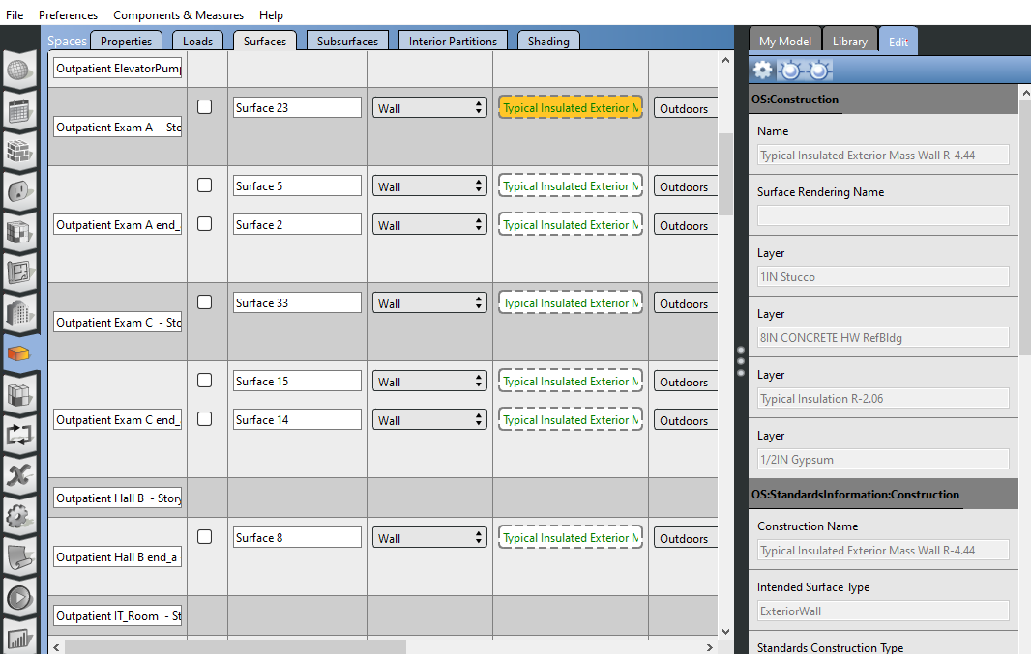

This construction is replaced by unique constructions for each wall surface:
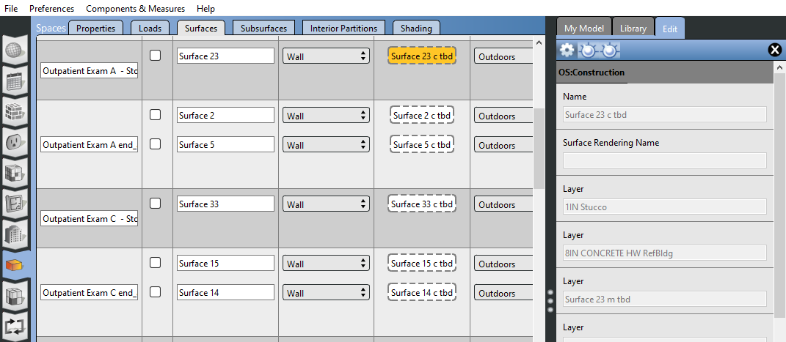
The custom construction identifies and changes the insulation layer, in this case derating it from R-2.06 to R-1.85.

Stock-Level Input Change
At a stock level, adding the TBD measure to the model increases wall and roof U-values, shown in the following figures. In addition to vintage, these changes vary by climate zone and wall construction type for walls. There were not enough samples in the 10k to fully show the changes broken out by all three variables. Vintage is the most significant. DEER models have similar changes, though those were excluded here for space.
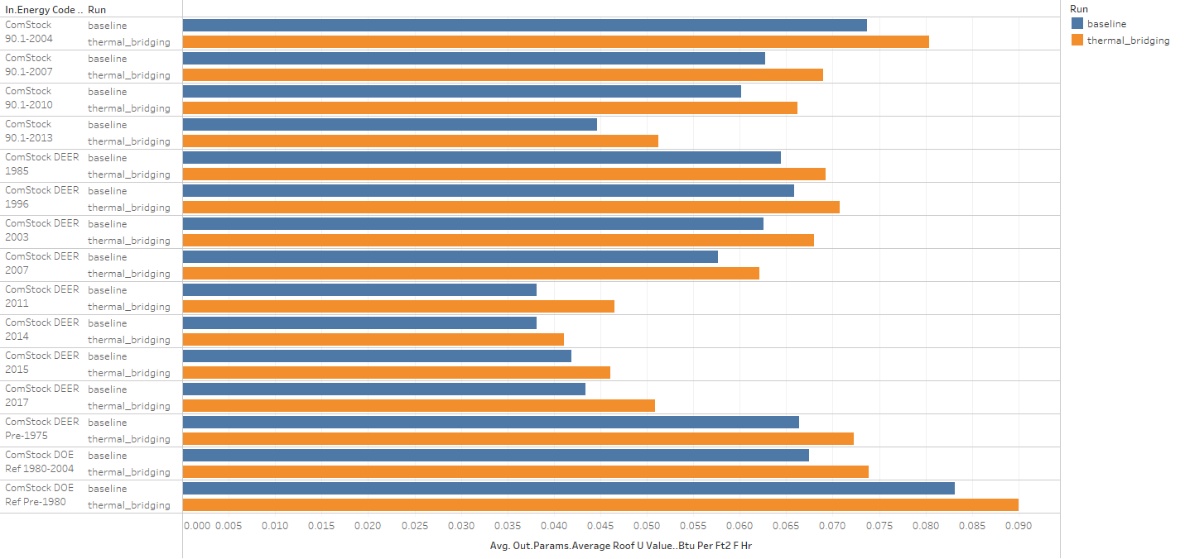
Figure 4 Roof U-values before and after applying thermal bridging

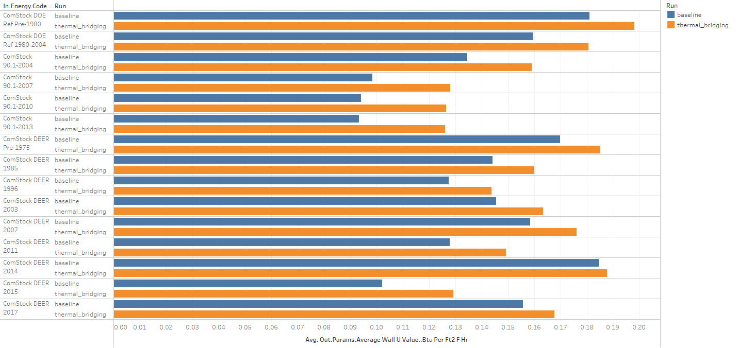
Figure 5 Wall U-values before and after applying thermal bridging
Energy Code Followed During Last Walls Replacement | Run | Average Wall U-Value (Btu Per Ft2 F Hr) | Average Wall R-Value (Ft2 F Hr Per Btu) | Reduction
ComStock DOE Ref Pre-1980 | baseline | 0.181 | 5.52
ComStock DOE Ref Pre-1980 | thermal_bridging | 0.198 | 5.05 | 8.5%
ComStock DOE Ref 1980-2004 | baseline | 0.160 | 6.26
ComStock DOE Ref 1980-2004 | thermal_bridging | 0.181 | 5.54 | 11.6%
ComStock 90.1-2004 | baseline | 0.135 | 7.43
ComStock 90.1-2004 | thermal_bridging | 0.159 | 6.28 | 15.4%
ComStock 90.1-2007 | baseline | 0.098 | 10.16
ComStock 90.1-2007 | thermal_bridging | 0.128 | 7.80 | 23.2%
ComStock 90.1-2010 | baseline | 0.094 | 10.62
ComStock 90.1-2010 | thermal_bridging | 0.127 | 7.90 | 25.6%
ComStock 90.1-2013 | baseline | 0.093 | 10.70
ComStock 90.1-2013 | thermal_bridging | 0.126 | 7.93 | 25.9%

Energy Code Followed During Last Roof Replacement | Run | Average Roof U-Value (Btu Per Ft2 F Hr) | Average Roof R-Value (Ft2 F Hr Per Btu) | Reduction
ComStock DOE Ref Pre-1980 | baseline | 0.083 | 12.03
ComStock DOE Ref Pre-1980 | thermal_bridging | 0.090 | 11.11 | 7.6%
ComStock DOE Ref 1980-2004 | baseline | 0.068 | 14.81
ComStock DOE Ref 1980-2004 | thermal_bridging | 0.074 | 13.53 | 8.7%
ComStock 90.1-2004 | baseline | 0.074 | 13.57
ComStock 90.1-2004 | thermal_bridging | 0.080 | 12.44 | 8.3%
ComStock 90.1-2007 | baseline | 0.063 | 15.94
ComStock 90.1-2007 | thermal_bridging | 0.069 | 14.49 | 9.1%
ComStock 90.1-2010 | baseline | 0.060 | 16.63
ComStock 90.1-2010 | thermal_bridging | 0.066 | 15.10 | 9.2%
ComStock 90.1-2013 | baseline | 0.045 | 22.39
ComStock 90.1-2013 | thermal_bridging | 0.051 | 19.51 | 12.8%

Applying thermal bridging and derating to the stock reduces wall R-values by 8-26% and roof R-values by 7-13%, depending on vintage. As most of the stock was built before 2010, the impact of this measure overall is roughly a 10% reduction in opaque envelope R-values.

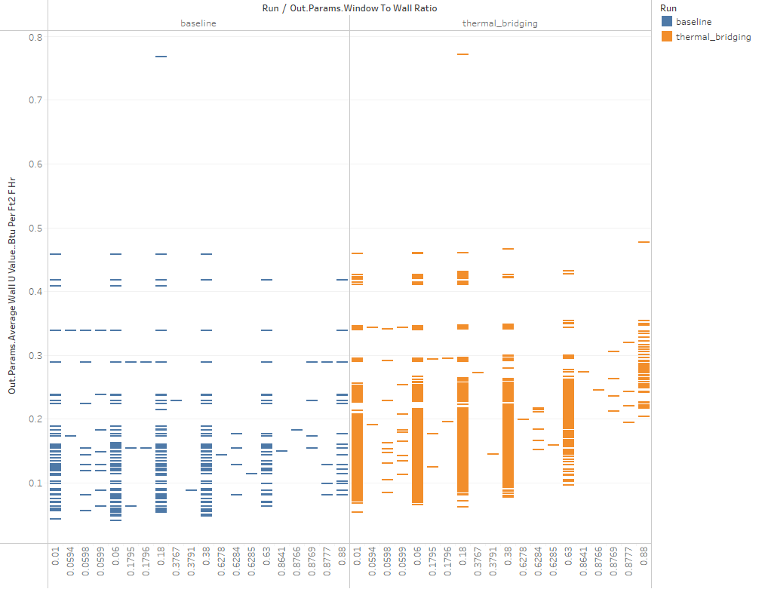
Figure 6 Variation in U-value based on the window to wall ratio. In the thermal bridging case, higher window to wall ratio means more thermal bridging, as expected.

Stock-Level Output Change
Adding the thermal bridging and derating measure to the baseline workflow causes a 2% increase in natural gas use, and a negligible increase in electric use. The increase in gas use is from natural gas heating energy use. Heating equipment average size increases by a similar amount.
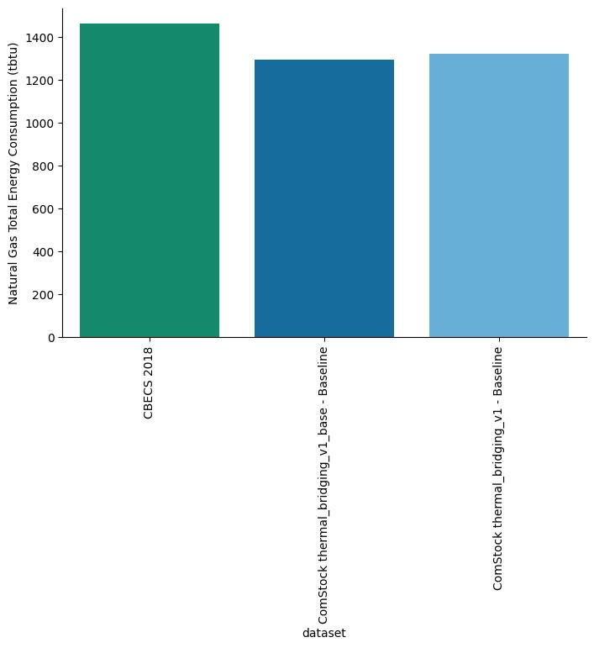

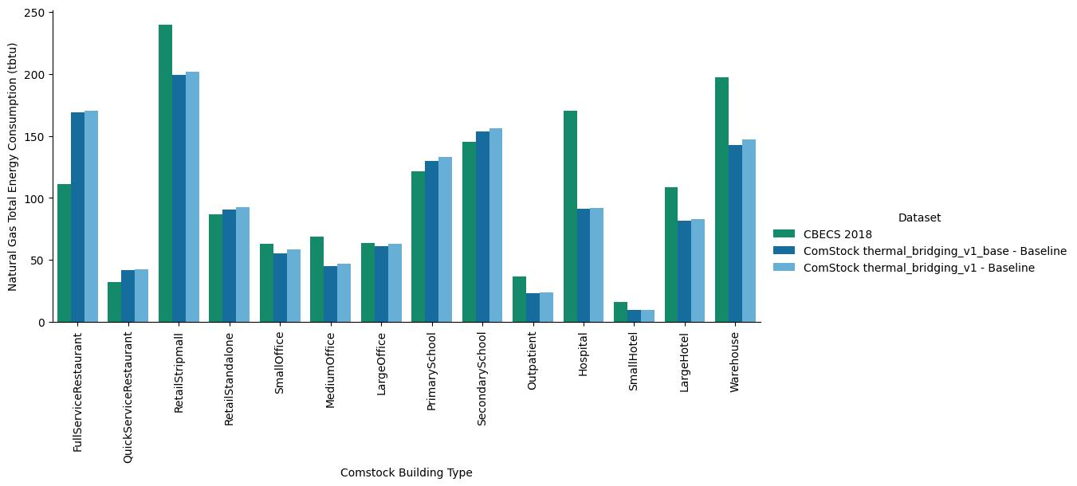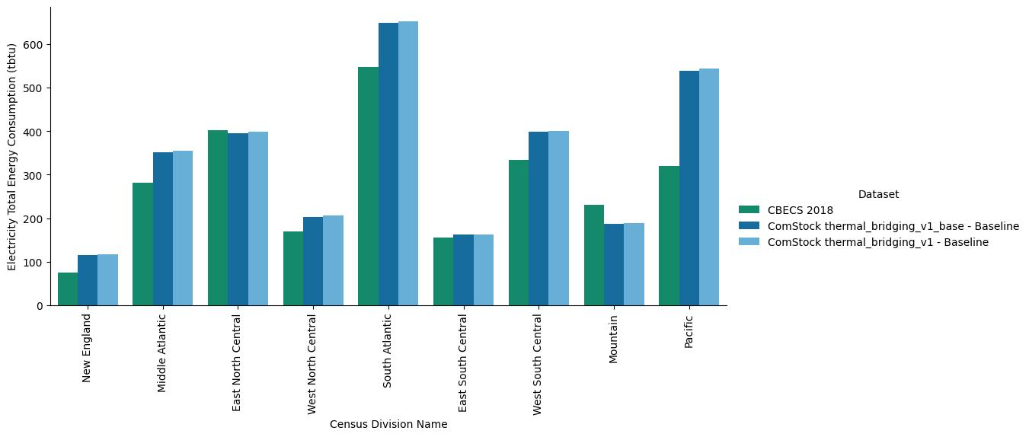
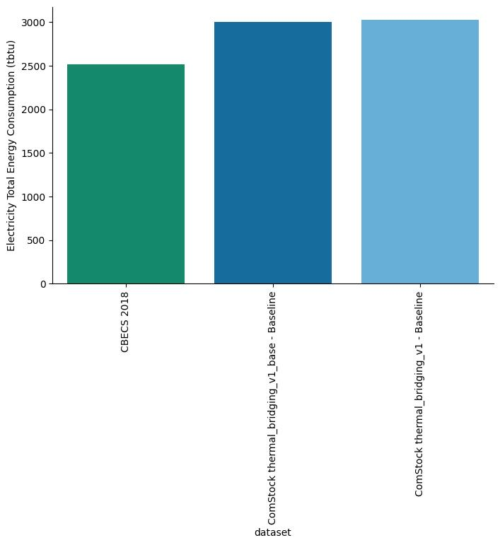
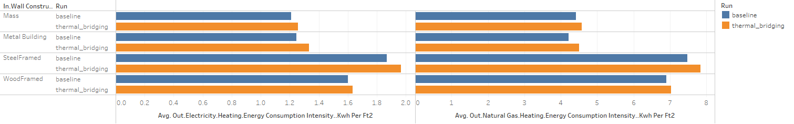
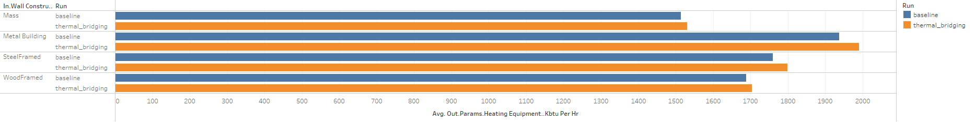

Impact on EUSS measures
Two EUSS measures are impacted by this change, upgrade_env_exterior_wall_insulation and upgrade_env_roof_insul_aedg. These measures are used in package 1 as well.
upgrade_env_exterior_wall_insulation
This measure loops through all exterior walls and collects their constructions. It then determines the existing wall insulation level and determines the thickness of XPS board required to bring the wall up to the target insulation level. If the increased thickness is less than 0.5 inches, it does not add the XPS. If more than 0.5 inches is required, it adds this as an additional insulation layer under the existing cladding layer.
The thermal bridging and derating measure influences this measure by reducing the overall wall insulation level, which will increase the number of buildings that surpass the 0.5 thickness of insulation added to meet the target insulation level, thus increasing the measure applicability. As is, it will show greater savings from this measure. It is not clear what the intended behavior for the measure should be.
The upgrade_env_exterior_wall_insulation has been adjusted to apply thermal bridging after the addition of exterior wall insulation.

upgrade_env_roof_insul_aedg
This measure works in a similar way to exterior walls. It loops through all exterior roofs and collects their constructions. It then determines the existing wall insulation level and determines the thickness of XPS board required to bring the roof up to the target insulation level. Unlike the walls, there is no minimum thickness of insulation material below which none is added.
The thermal bridging and derating measure influences this measure by reducing the overall roof insulation level. As is, it will increase the cost and savings of the It is not clear what the intended behavior for the measure should be.
Unlike the wall insulation measure, which changes the wall constructions individually for each surface, the roof measure makes the new roof construction the default roof construction in the default construction set. This will be ignored, as some of the surfaces in the model with thermal bridging have individually assigned constructions. This measure will need to be refactored to follow the method in wall construction to apply insulation. As with the wall insulation measure, this measure will need to reapply roof surface derating to account for remaining thermal bridges.

EUSS impacts
The measures run with no additional failures from the baseline case in a 100 run test.

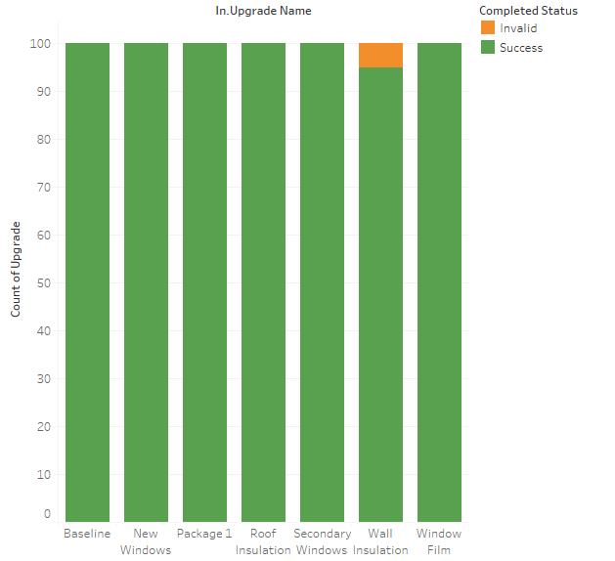
The measures produce results, with expected impacts from adding roof and wall insulation. The windows and window film measures are increasing heating gas use. That is expected for window film (which reduces heat gain), and cooling is also lowered.
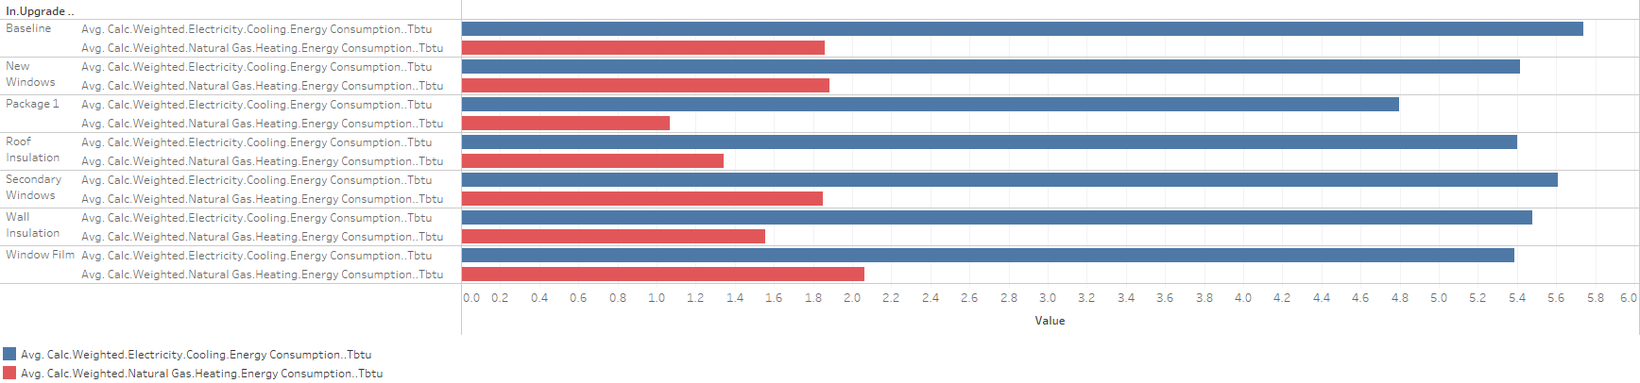

Appendix A – Default thermal bridging options in the TBD gem
This a copy of the default psi and chi factors in the TBD gem. View on github for code formatting: https://github.com/rd2/tbd/blob/develop/lib/tbd/psi.rb
# ASHRAE 90.1 2022 (A10) "default" steel-framed and metal buildings.
@set["90.1.22|steel.m|default"] =
{
rimjoist: 0.307000, # "intermediate floor to wall intersection"
parapet: 0.260000, # "parapet" edge
roof: 0.020000, # (non-parapet) "roof" edge
ceiling: 0.000000, # e.g. suspended ceiling tiles
fenestration: 0.194000, # "wall to vertical fenestration intersection"
door: 0.000000, # (unspecified, defaults to 0)
skylight: 0.000000, # (unspecified, defaults to 0)
spandrel: 0.000001, # (unspecified, defaults to 0)
corner: 0.000002, # (unspecified, defaults to 0)
balcony: 0.307000, # "intermediate floor balcony/overhang" edge
balconysill: 0.307000, # "intermediate floor balcony" edge (when sill)
balconydoorsill: 0.307000, # same as balcony
party: 0.000001, # (unspecified, defaults to 0)
grade: 0.000001, # (unspecified, defaults to 0)
joint: 0.376000, # placeholder for "cladding support"
transition: 0.000000 # defaults to 0
}.freeze

# ASHRAE 90.1 2022 (A10) "unmitigated" steel-framed and metal buildings.
@set["90.1.22|steel.m|unmitigated"] =
{
rimjoist: 0.842000, # "intermediate floor to wall intersection"
parapet: 0.500000, # "parapet" edge
roof: 0.650000, # (non-parapet) "roof" edge
ceiling: 0.000000, # e.g. suspended ceiling tiles
fenestration: 0.505000, # "wall to vertical fenestration intersection"
door: 0.000000, # (unspecified, defaults to 0)
skylight: 0.000000, # (unspecified, defaults to 0)
spandrel: 0.000001, # (unspecified, defaults to 0)
corner: 0.000002, # (unspecified, defaults to 0)
balcony: 0.842000, # "intermediate floor balcony/overhang" edge
balconysill: 1.686000, # "intermediate floor balcony" edge (when sill)
balconydoorsill: 0.842000, # same as balcony
party: 0.000001, # (unspecified, defaults to 0)
grade: 0.000001, # (unspecified, defaults to 0)
joint: 0.554000, # placeholder for "cladding support"
transition: 0.000000 # defaults to 0
}.freeze

# ASHRAE 90.1 2022 (A10) "default" exterior/integral mass walls.
@set["90.1.22|mass.ex|default"] =
{
rimjoist: 0.205000, # "intermediate floor to wall intersection"
parapet: 0.217000, # "parapet" edge
roof: 0.150000, # (non-parapet) "roof" edge
ceiling: 0.000000, # e.g. suspended ceiling tiles
fenestration: 0.226000, # "wall to vertical fenestration intersection"
door: 0.000000, # (unspecified, defaults to 0)
skylight: 0.000000, # (unspecified, defaults to 0)
spandrel: 0.000001, # (unspecified, defaults to 0)
corner: 0.000002, # (unspecified, defaults to 0)
balcony: 0.205000, # "intermediate floor balcony/overhang" edge
balconysill: 0.307000, # "intermediate floor balcony" edge (when sill)
balconydoorsill: 0.205000, # same as balcony
party: 0.000001, # (unspecified, defaults to 0)
grade: 0.000001, # (unspecified, defaults to 0)
joint: 0.322000, # placeholder for "cladding support"
transition: 0.000000 # defaults to 0
}.freeze

# ASHRAE 90.1 2022 (A10) "unmitigated" exterior/integral mass walls.
@set["90.1.22|mass.ex|unmitigated"] =
{
rimjoist: 0.824000, # "intermediate floor to wall intersection"
parapet: 0.412000, # "parapet" edge
roof: 0.750000, # (non-parapet) "roof" edge
ceiling: 0.000000, # e.g. suspended ceiling tiles
fenestration: 0.325000, # "wall to vertical fenestration intersection"
door: 0.000000, # (unspecified, defaults to 0)
skylight: 0.000000, # (unspecified, defaults to 0)
spandrel: 0.000001, # (unspecified, defaults to 0)
corner: 0.000002, # (unspecified, defaults to 0)
balcony: 0.824000, # "intermediate floor balcony/overhang" edge
balconysill: 1.686000, # "intermediate floor balcony" edge (when sill)
balconydoorsill: 0.824000, # same as balcony
party: 0.000001, # (unspecified, defaults to 0)
grade: 0.000001, # (unspecified, defaults to 0)
joint: 0.476000, # placeholder for "cladding support"
transition: 0.000000 # defaults to 0
}.freeze

# ASHRAE 90.1 2022 (A10) "default" interior mass walls.
@set["90.1.22|mass.in|default"] =
{
rimjoist: 0.495000, # "intermediate floor to wall intersection"
parapet: 0.393000, # "parapet" edge
roof: 0.150000, # (non-parapet) "roof" edge
ceiling: 0.000000, # e.g. suspended ceiling tiles
fenestration: 0.143000, # "wall to vertical fenestration intersection"
door: 0.000000, # (unspecified, defaults to 0)
skylight: 0.000000, # (unspecified, defaults to 0)
spandrel: 0.000000, # (unspecified, defaults to 0)
corner: 0.000001, # (unspecified, defaults to 0)
balcony: 0.495000, # "intermediate floor balcony/overhang" edge
balconysill: 0.307000, # "intermediate floor balcony" edge (when sill)
balconydoorsill: 0.495000, # same as balcony
party: 0.000001, # (unspecified, defaults to 0)
grade: 0.000001, # (unspecified, defaults to 0)
joint: 0.322000, # placeholder for "cladding support"
transition: 0.000000 # defaults to 0
}.freeze

# ASHRAE 90.1 2022 (A10) "unmitigated" interior mass walls.
@set["90.1.22|mass.in|unmitigated"] =
{
rimjoist: 0.824000, # "intermediate floor to wall intersection"
parapet: 0.884000, # "parapet" edge
roof: 0.750000, # (non-parapet) "roof" edge
ceiling: 0.000000, # e.g. suspended ceiling tiles
fenestration: 0.543000, # "wall to vertical fenestration intersection"
door: 0.000000, # (unspecified, defaults to 0)
skylight: 0.000000, # (unspecified, defaults to 0)
spandrel: 0.000000, # (unspecified, defaults to 0)
corner: 0.000001, # (unspecified, defaults to 0)
balcony: 0.824000, # "intermediate floor balcony/overhang" edge
balconysill: 1.686000, # "intermediate floor balcony" edge (when sill)
balconydoorsill: 0.824000, # same as balcony
party: 0.000001, # (unspecified, defaults to 0)
grade: 0.000001, # (unspecified, defaults to 0)
joint: 0.476000, # placeholder for "cladding support"
transition: 0.000000 # defaults to 0
}.freeze

# ASHRAE 90.1 2022 (A10) "default" wood-framed (and other) walls.
@set["90.1.22|wood.fr|default"] =
{
rimjoist: 0.084000, # "intermediate floor to wall intersection"
parapet: 0.056000, # "parapet" edge
roof: 0.020000, # (non-parapet) "roof" edge
ceiling: 0.000000, # e.g. suspended ceiling tiles
fenestration: 0.171000, # "wall to vertical fenestration intersection"
door: 0.000000, # (unspecified, defaults to 0)
skylight: 0.000000, # (unspecified, defaults to 0)
spandrel: 0.000000, # (unspecified, defaults to 0)
corner: 0.000001, # (unspecified, defaults to 0)
balcony: 0.084000, # "intermediate floor balcony/overhang" edge
balconysill: 0.171001, # same as :fenestration
balconydoorsill: 0.084000, # same as balcony
party: 0.000001, # (unspecified, defaults to 0)
grade: 0.000001, # (unspecified, defaults to 0)
joint: 0.074000, # placeholder for "cladding support"
transition: 0.000000 # defaults to 0
}.freeze

# ASHRAE 90.1 2022 (A10) "unmitigated" wood-framed (and other) walls.
@set["90.1.22|wood.fr|unmitigated"] =
{
rimjoist: 0.582000, # "intermediate floor to wall intersection"
parapet: 0.056000, # "parapet" edge
roof: 0.150000, # (non-parapet) "roof" edge
ceiling: 0.000000, # e.g. suspended ceiling tiles
fenestration: 0.260000, # "wall to vertical fenestration intersection"
door: 0.000000, # (unspecified, defaults to 0)
skylight: 0.000000, # (unspecified, defaults to 0)
spandrel: 0.000000, # (unspecified, defaults to 0)
corner: 0.000001, # (unspecified, defaults to 0)
balcony: 0.582000, # same as :rimjoist
balconysill: 0.582000, # same as :rimjoist
balconydoorsill: 0.582000, # same as balcony
party: 0.000001, # (unspecified, defaults to 0)
grade: 0.000001, # (unspecified, defaults to 0)
joint: 0.322000, # placeholder for "cladding support"
transition: 0.000000 # defaults to 0
}.freeze

