ComStock Change
  - v31 – OpenStudio Standards Update
Implementer: Matthew Dahlhausen
Change Document Author: Matthew Dahlhausen, Eric Ringold
Reviewer: Chris CaraDonna, Landan Taylor

Description of Change

Summary
This updates ComStock to the latest openstudio-standards release (v0.6.3). This includes changes to basic workflow measures to use the create geometry and create typical workflow methods that are now in openstudio-standards.

Existing Methodology
ComStock currently uses OpenStudio v3.8 with an older version of openstudio-standards, v0.5.0.

New Methodology
This measure updates ComStock to the latest version, openstudio-standards (v0.6.3).
Most important, it replaces the resources directories in resources/measures/create_bar_from_building_type_ratio and resources/measures/create_typical_building_from_model to call create typical geometry and model methods directly in openstudio-standards. Several other measures are updated to use the new standards as well.

Impact of Change

Individual Model Input Change

Stock-Level Input Change
Not applicable; no changes to sampling

Warehouse Changes
This update incorporates the warehouse changes that were tested on OS 3.7, but were not included in the most recent OS 3.8 image. These changed HVAC and thermostat characteristics for warehouses. See the v28 Warehouses for more detail: (https://nrel.sharepoint.com/:w:/r/sites/comstock/Shared%20Documents/ComStock%20Filing%20Cabinet/ComStock%20Core/Change%20Documentation/Changes/v28%20warehouses/v28%20Warehouses.docx?d=w24e6076bf9e944e79f5c74f6ae32851f&csf=1&web=1&e=3Dh5pk)

Space Type Ratio Changes
California RTL buildings changed to remove the Kitchen space type.
Space Type | Old | New
OfficeGeneral | 0.0359 | 0.0363
Work | 0.04 | 0.0405
StockRoom | 0.091 | 0.092
RetailSales | 0.8219 | 0.8312
Kitchen | 0.0113 | 0

Space and Zone Multipliers
The large office models with multiple stories now use zone multipliers for the middle floors. The comstock sensitivity reports measure is updated to adjust counts, floor area, and surface areas to account for space and zone multipliers.

(Fixed) Geometry Differences
Initially in this update, warehouse and secondary school geometry changed. Previously, warehouse offices had a lower custom space height than the rest of the building and were separated into their own box. This meant the general lighting assignment would be T5s in some lighting generations. The new geometry is part of the main building, with a higher space height, and is therefore getting high bay general lighting instead. This shows up as a difference of higher lighting power densities in warehouse office spaces. Likewise, previously, secondary school gyms had a higher custom space height than the rest of the building and were separated into their own box. This meant the general lighting assignment would be T5s instead of high bay in some lighting generations. The new geometry is part of the main building, with a lower space height, and is therefore getting T5 general lighting instead. This shows up as a difference of lower lighting power densities in secondary school gym spaces.
Both geometry changes are from custom heights not getting applied in the create bar method.
This was traced to a typo in the create bar method in standards that wasn’t checking for defaulted floor heights. It has been fixed and there are no changes to geometry in this update. https://github.com/NREL/openstudio-standards/pull/1792

PTAC and PTHP Supply Fan Operating Schedule
In the baseline, the schedule was set to “Always Off” which means cycling operation whenever there is heating or cooling. The new schedule uses the zone occupancy schedule, which supplies ventilation air. This means a lot more fan energy use, and some extra heating and cooling energy use.
This comes from a bug fix that now sets the zone occupancy schedule to make sure ventilation air is provided if the zone has ventilation. (https://github.com/NREL/openstudio-standards/commit/1b19fd9a1074e4d8a8155958ebe6868ef13fc14f)
After consulting with Chris CaraDonna, the preferred solution is to not have any ventilation in PTAC or PTHP systems, and to include any intended ventilation through a DOAS. This update changes those system to have no ventilation. Subsequent updates may add DOAS ventilation to large hotels that have PTACs/PTHPs.

Parametric Schedules Changes
As far as can be determined, the remainder of the model differences come from parametric schedule updates which changed equipment, lighting, occupancy, thermostat, and hot water schedules.
Updates to parametric schedule methods in openstudio-standards involved moving schedule-related methods to a new OpenstudioStandards::Schedules module, and refactoring certain methods to address an issue identified in ComStock models where certain schedules were not being modified based on the weekday/weekend start time and duration inputs. The primary changes in the refactor were made to ensure that schedule “profiles” (i.e. ScheduleRules defining which ScheduleDay were applied for a particular ScheduleRuleset) matched the generated ‘Hours of Operation’ schedule, so that changes to the hours of operation could be properly applied in the parametric formulas for each ScheduleDay. Interpreting this formula with the new hours of operation serves to ‘stretch’ or ‘squish’ the profiles to match the modified hours of operation to properly function. This change most widely impacted the thermostat schedules, allowing the setback and setup times to match the input building hours of operation as shown in the following figures, reflecting expected operation in actual buildings.
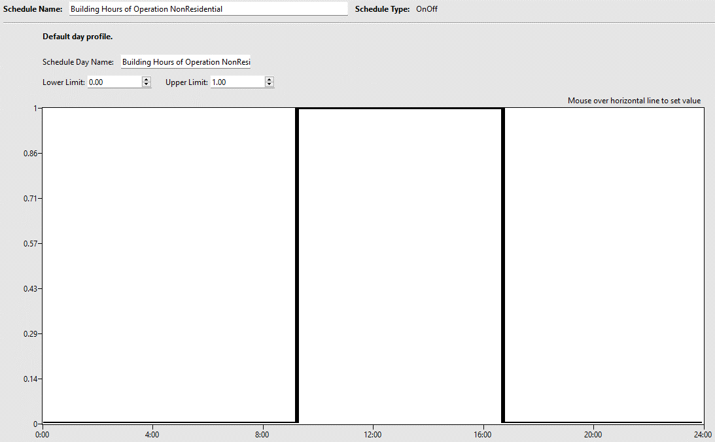
Figure 1: Bldg2267 Input Weekday Hours of Occupancy
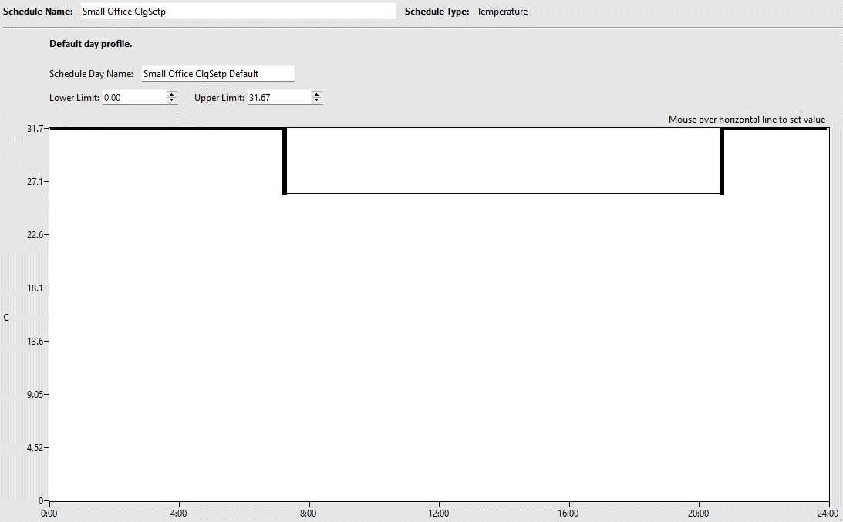
Figure 2: Bldg2267 Baseline Small Office Cooling Setpoint Schedule - not aligned with inputs
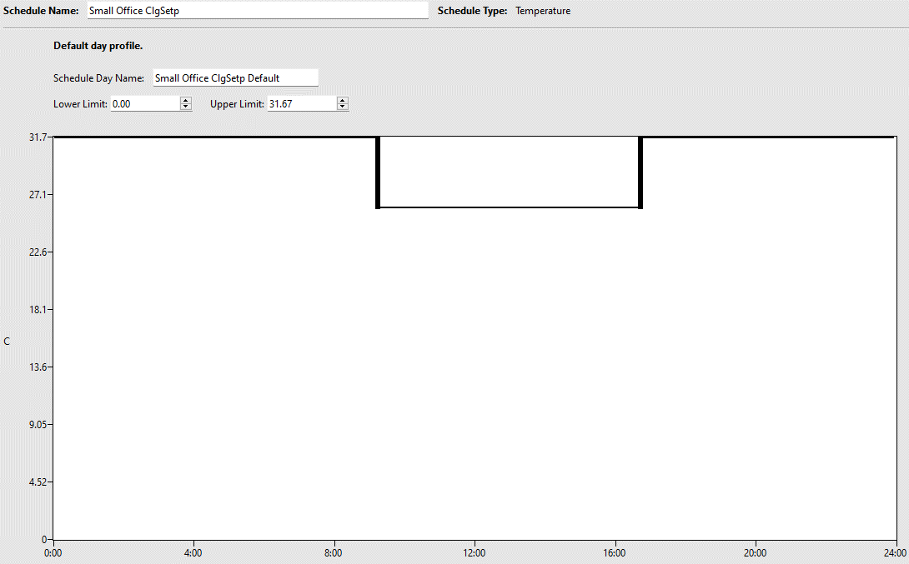
Figure 3: Bldg2267 This change Small Office Cooling Setpoint Schedule - aligned with inputs

(Fixed) DEER building type enumerations
There was a bug in the enumerations for DEER to DOE building type dictionary that would return the same building type or nil, because the dictionary was cast as an array instead of hash. https://github.com/NREL/openstudio-standards/pull/1785

(Fixed) FC Factor error
Some area and perimeter combinations would result a thermal resistance below the minimum allowed by EnergyPlus (0.001), resulting in a failed simulation. Corrected the check to specify a minimum of R-1. https://github.com/NREL/openstudio-standards/pull/1785, https://github.com/NREL/openstudio-standards/pull/1798.

(Fixed) Geometry error with party walls
There was an error where party walls were not getting cast as symbols for the create bar arguments resulting in some mismatched areas. https://github.com/NREL/openstudio-standards/pull/1793

(Fixed) Align CBES HVAC system arguments
CBES HVAC systems were edited in the ComStock version to match the secondary system fuel type with the main system fuel type. These changes were carried over into openstudio-standards. https://github.com/NREL/openstudio-standards/pull/1798

(Fixed) Error where equipment latent, radiant, and lost fractions sum to greater than 1
Setting heat loss fractions on equipment throws an error if at any point the sum of latent, radiant, and lost is greater than 1. This is a perennial issue that was fixed again. https://github.com/NREL/openstudio-standards/pull/1798

(Fixed) Update DOE reference and DEER efficiencies for boilers, furnaces, chillers, heat rejection, and hot water heaters to match PNNL database schema.
PNNL created a Building Energy Standards database and adopted new fields and deprecated some fields for equipment efficiency. Two PRs update the DOE reference building and DEER versions to match this new schema. https://github.com/NREL/openstudio-standards/pull/1798 and https://github.com/NREL/openstudio-standards/pull/1799.

(Fixed) Add missing DEER construction properties
Added missing construction properties for Metal Buildings Pre-1975 CEC3 roof and Metal Building exterior wall. https://github.com/NREL/openstudio-standards/pull/1798

(Fixed) Chiller EIR function of PLR curve
ASHRAE 90.1-2007 and 90.1-2010 chillers were incorrectly getting the EIR as a function of temperature instead of EIR as a function of PLR default curve. https://github.com/NREL/openstudio-standards/pull/1799

(Fixed) Default boiler efficiency curve
Default the boiler efficiency curve for DOE reference building vintages. https://github.com/NREL/openstudio-standards/pull/1799

(Fixed) Add lookup checks for paired DX coils
Heating equipment efficiency for DX equipment depends on the capacity of the paired cooling equipment. The check to determine the type of heating coil, and therefore which efficiency rule to apply, didn’t exhaustively all DX equipment types encountered in ComStock. https://github.com/NREL/openstudio-standards/pull/1799

Stock-Level Output Change
This change went through several iterations of 10k runs comparing the openstudio-standards update with the current ComStock baseline. Initial changes check to make sure there were no differences in interior equipment, lighting, and occupant load densities. Multiple fixes to the parametric schedules methods changed equivalent full load hours in most models for equipment, lighting, occupancy, and thermostat schedules. Therefore, most models had changes to equipment and lighting energy use, and therefore cooling and fan energy use. Large differences in heating and cooling use were investigated, often resulting in fixes to openstudio-standards. These differences were due to changes in secondary HVAC system assignments, missing efficiencies, or missing curves. Similar results are not expected in packaged terminal systems because of changes to outdoor air requirements, and warehouses because the current baseline on the main branch doesn’t include previous warehouse changes. Remaining differences are mostly due to schedule changes, though we can’t guarantee they are only from schedule changes.
Total fuel uses – electricity and natural gas – are similar, which is expected. There is a minor improvement in electricity use accuracy compared ot CBECS.
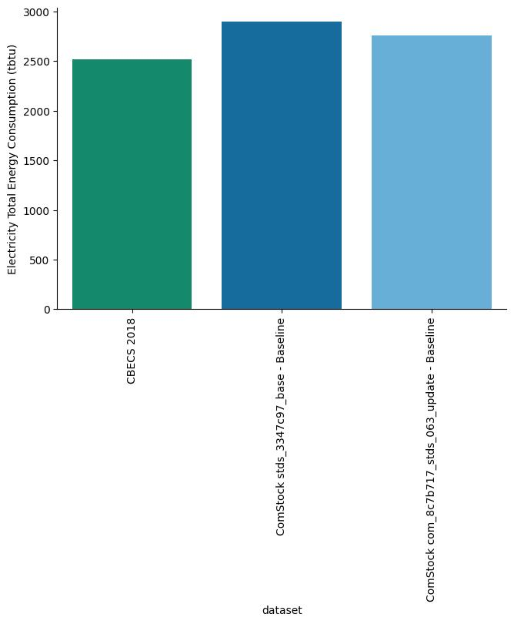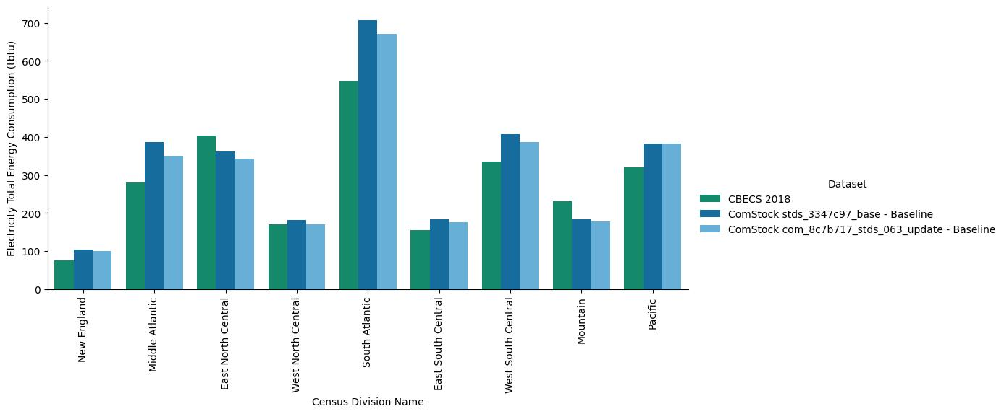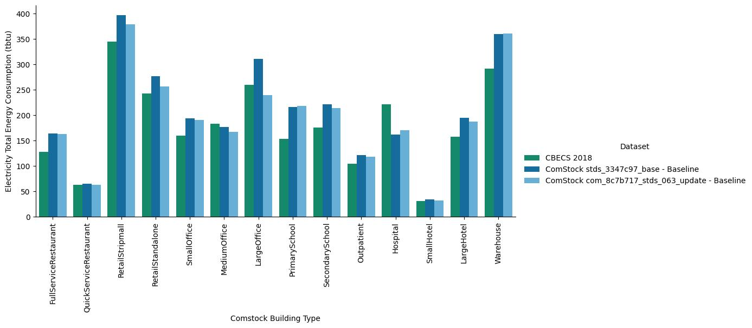
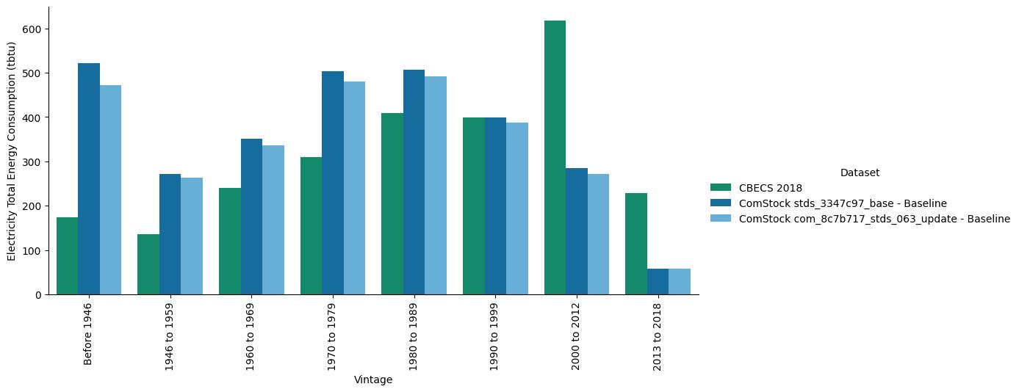
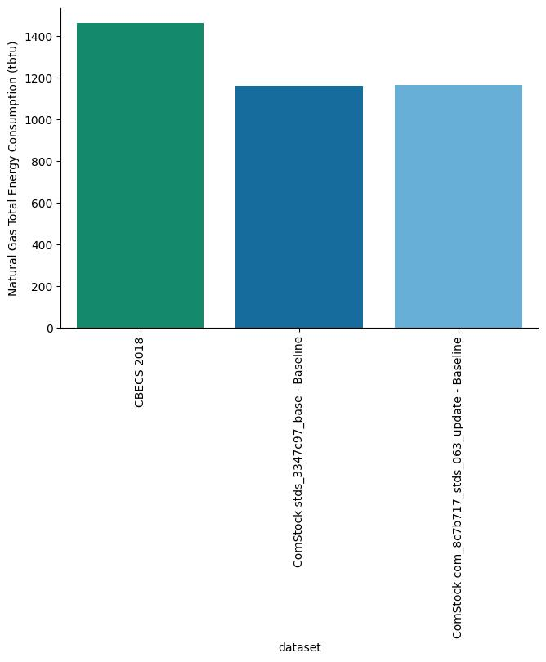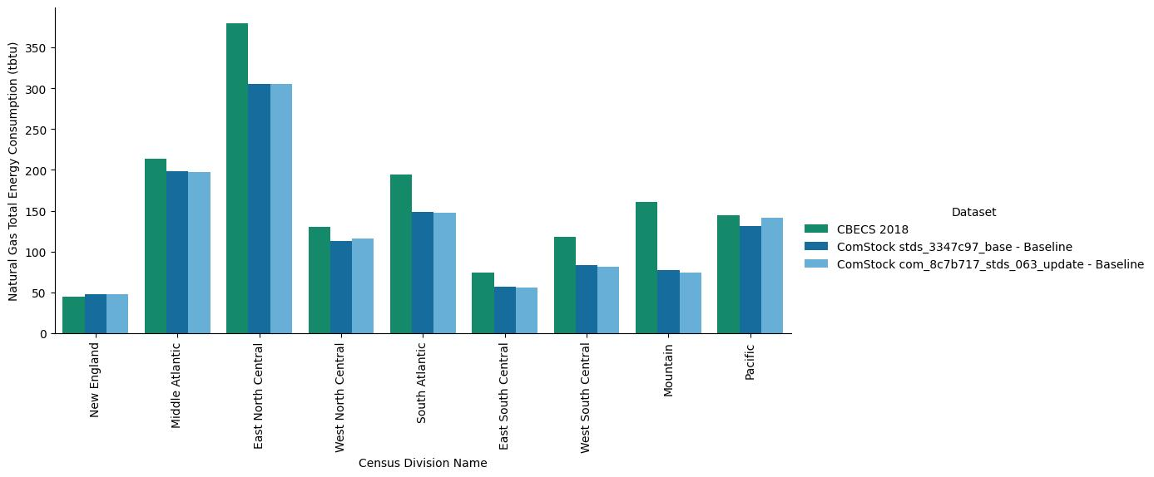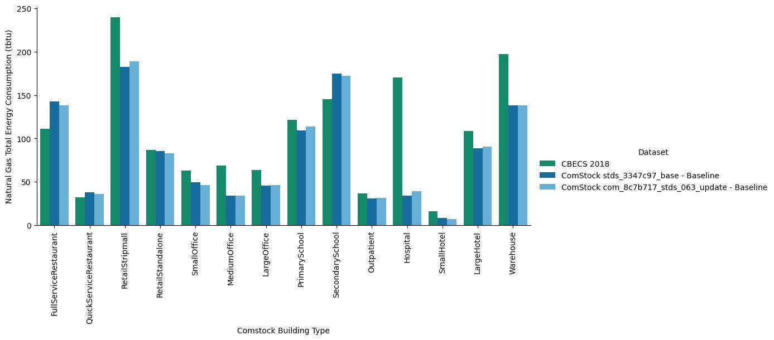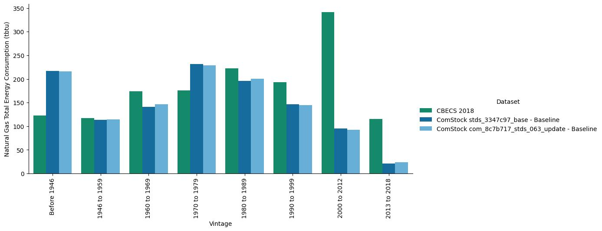

EUSS Upgrade Measure Impacts
There are no intended changes to EUSS measures. All EUSS measures were run with an earlier branch of the openstudio-standards update, compared to a baseline of the current branch. There were no total measure failures. And the proportion of failure rate was the same. It’s recommended that EUSS look at each measure individually to see if the update changed specific measure results substantially.

https://github.com/NREL/openstudio-standards/pull/1708
https://github.com/NREL/openstudio-standards/pull/1718, https://github.com/NREL/openstudio-standards/pull/1726, https://github.com/NREL/openstudio-standards/pull/1775, https://github.com/NREL/openstudio-standards/pull/1785, https://github.com/NREL/openstudio-standards/pull/1788

