ComStock Change
  - v32 – OpenStudio Standards 0.7.0 Update.
Implementer: Matthew Dahlhausen
Change Document Author: Matthew Dahlhausen
Reviewer: Chris CaraDonna, Eric Ringold

Description of Change

Summary
This updates ComStock to the latest openstudio-standards release (v0.7.0). There are few changes from 0.6.3, namely some bug fixes when equipment sizes were too large for the lookups in some building types.

Existing Methodology
ComStock currently uses OpenStudio v3.8 with an older version of openstudio-standards, v0.6.3.

New Methodology
This measure updates ComStock to the latest version, openstudio-standards (v0.7.0). There were no major changes to workflow or measures, only bug fixes.

Impact of Change

Individual Model Input Change

Stock-Level Input Change
Not applicable; no changes to sampling.

Model Changes
These PRs impact ComStock models:
- #1804 fixed PTHP capacity and VAV minimum damper calculation issues
- #1805 fixed refrigerated case and walkin defrost and dripdown schedule values
- #1834 fixed a UA calculation error in FFactor constructions
- #1838 default WSHP efficiency if capacity too large
- #1839 add lookup for larger DEER motors
All of these are bug fixes. The last three deal directly with issues that caused simulation failures in ComStock runs.

Stock-Level Output Change
The comparison plots show (4) separate run conditions:
- CBECS 2018 baseline
- Current ComStock baseline used in the most recent EUSS runs, using OpenStudio v3.8.0 and openstudio-standards v0.6.3
- ComStock main as of Nov/Dec 2024, using OpenStudio v3.8.0 and updating to openstudio-standards v0.7.0
- ComStock main as of Nov/Dec 2024, updating to OpenStudio v3.9.0 and openstudio-standards v0.7.0
The failure rates are shown in the following table:
run | Building Count | Success | Failed | Fraction of Total Failed
os_380_com_4d7baa7_stds_063 | 11078 | 10699 | 379 | 0.034
os_380_com_01cc36b_stds_070 | 11078 | 10731 | 347 | 0.031
os_390_com_32b3f6f_stds_070 | 11078 | 10433 | 645 | 0.058

There are few differences in failure rates. There was an uptick in models failing in OpenStudio v3.9.0 because of a pump heat buildup simulation error in models with ‘DOAS with water source heat pumps cooling tower with boiler’ HVAC systems. All water source heat pumps systems are affected.
Total fuel uses – electricity and natural gas – are identical are extremely similar across building types, census regions, and vintages. There are slight changes in the OS v3.9.0 update with buildings that are more likely to use WSHPS (large hotels) because of the higher failure rate.
There remain large errors in the Pacific region, warehouses, full-service restaurants, hospitals, and schools.

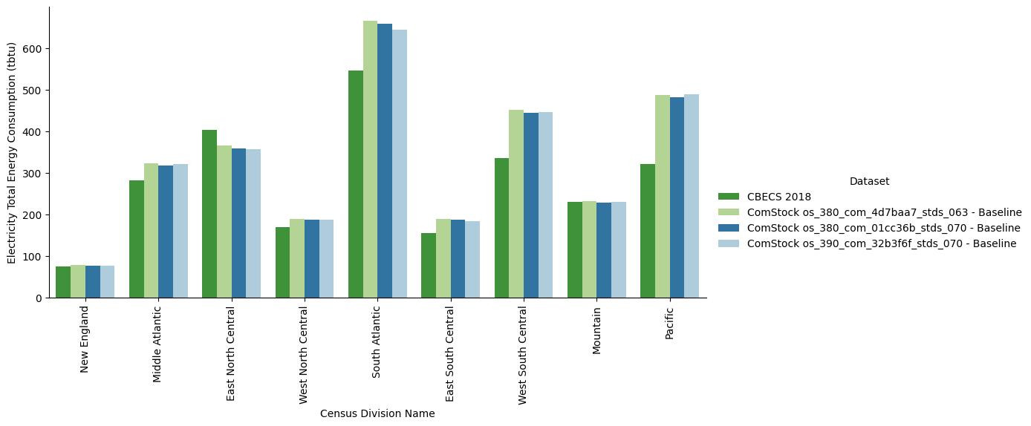
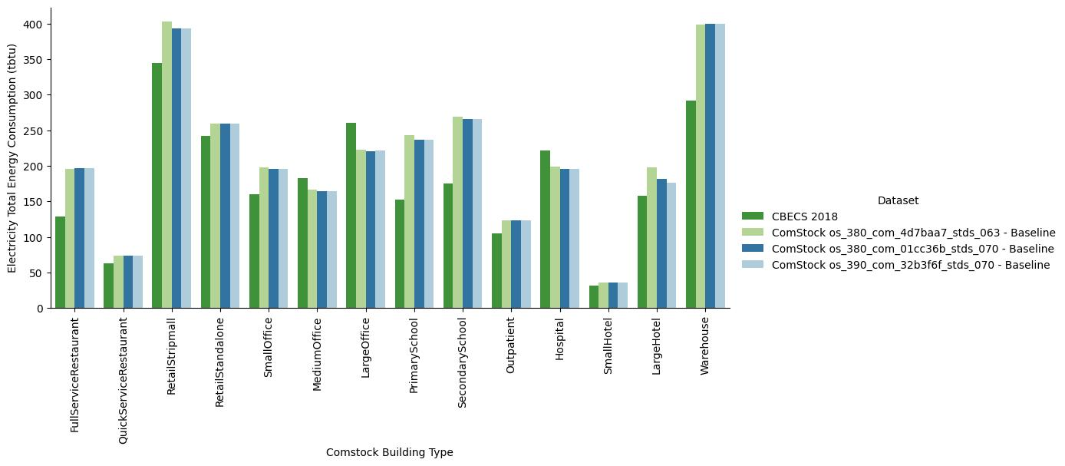
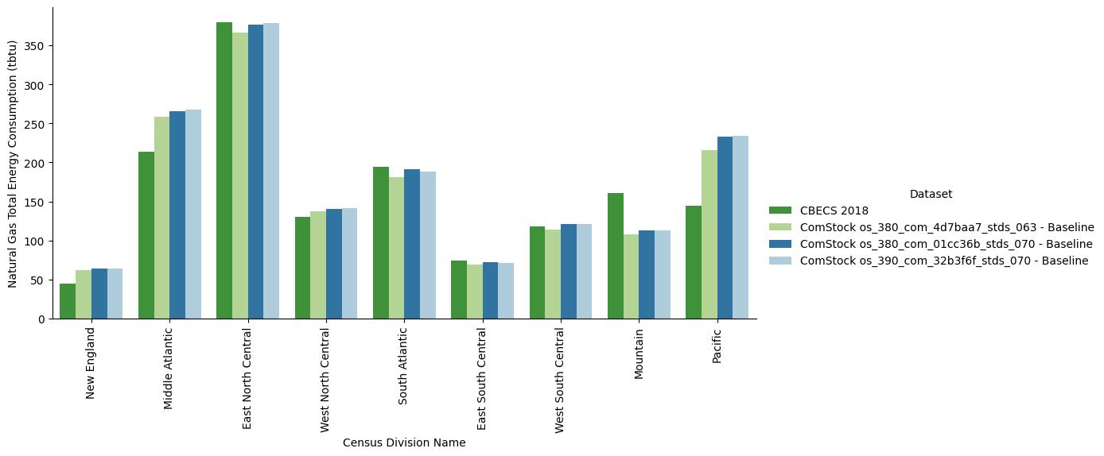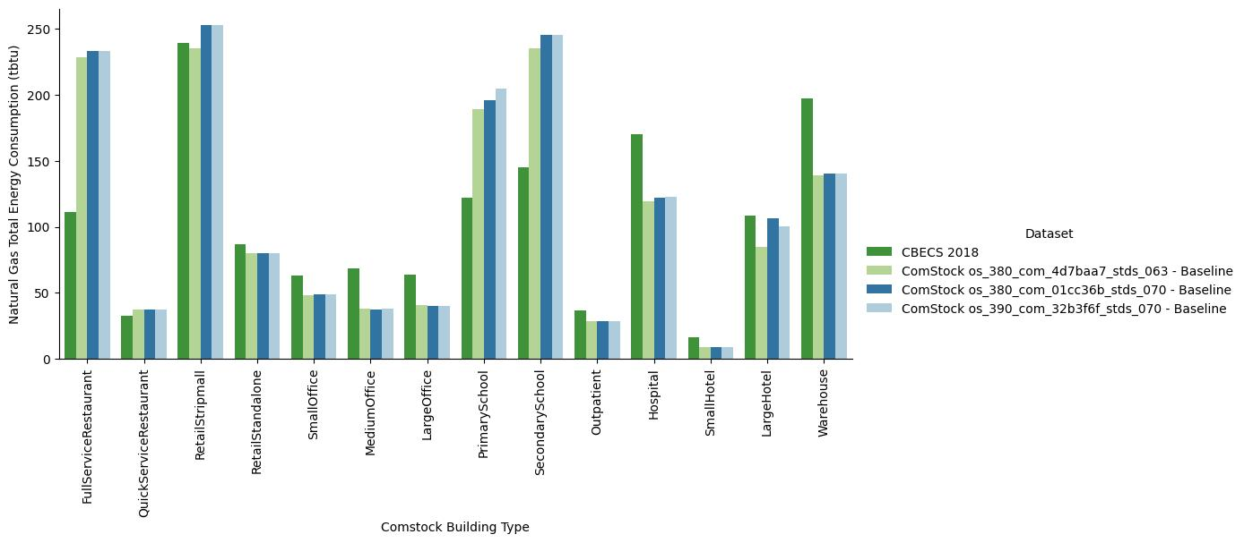

Close inspection of end use intensities shows most of the change from fan and refrigeration energy use. In particular, refrigeration energy use is now present in strip malls from the restaurant component.
OS version | 3.8.0 | 3.8.0 | 3.8.0 | 3.8.0 | 3.8.0 | 3.8.0
os stds version | 0.7.0 | 0.8.2 | 0.7.0 | 0.8.2 | 0.7.0 | 0.8.2
end use | fan | fan | refrigeration | refrigeration | ext lighting | ext lighting
unit | kwh_per_ft2 | kwh_per_ft2 | kwh_per_ft2 | kwh_per_ft2 | kwh_per_ft2 | kwh_per_ft2
building_type
strip_mall | 4.639 | 5.956 | 0.000 | 1.276 | 1.571 | 1.440
retail | 3.711 | 4.754 | 0.000 | 0.000 | 1.438 | 0.839
warehouse | 0.550 | 0.860 | 0.000 | 0.000 | 1.160 | 0.604
small_office | 2.844 | 4.570 | 0.000 | 0.000 | 1.061 | 0.767
full_service_restaurant | 11.775 | 12.240 | 2.258 | 2.618 | 1.443 | 1.208
quick_service_restaurant | 12.990 | 15.471 | 5.323 | 5.931 | 2.535 | 2.179
grocery | #DIV/0! | 6.213 | #DIV/0! | 18.486 | #DIV/0! | 0.643
large_hotel | 2.688 | 1.622 | 0.641 | 0.710 | 0.637 | 0.459
small_hotel | 1.932 | 1.336 | 0.000 | 0.000 | 1.681 | 1.229
medium_office | 2.892 | 3.087 | 0.000 | 0.000 | 0.624 | 0.506
primary_school | 4.132 | 4.209 | 2.122 | 1.274 | 1.157 | 0.664
large_office | 2.549 | 1.999 | 0.000 | 0.000 | 0.368 | 0.310
secondary_school | 3.691 | 4.326 | 1.815 | 0.963 | 1.021 | 0.622
outpatient | 4.366 | 6.610 | 0.000 | 0.000 | 0.814 | 0.771
hospital | 3.957 | 4.754 | 0.463 | 0.259 | 0.491 | 0.364

Gas end use intensities changed slightly, trending lower with water heating. This is from changes in the service water heating module.
OS version | 3.8.0 | 3.8.0 | 3.8.0 | 3.8.0
os stds version | 0.7.0 | 0.8.2 | 0.7.0 | 0.8.2
end use | gas_equip | gas_equip | water_heating | water_heating
unit | therm_per_ft2 | therm_per_ft2 | therm_per_ft2 | therm_per_ft2
building_type
strip_mall | 0.094 | 0.101 | 0.132 | 0.095
retail | 0.000 | 0.000 | 0.000 | 0.000
warehouse | 0.000 | 0.000 | 0.000 | 0.000
small_office | 0.000 | 0.000 | 0.006 | 0.004
full_service_restaurant | 0.874 | 1.046 | 0.377 | 0.220
quick_service_restaurant | 1.034 | 1.094 | 0.135 | 0.124
grocery | #DIV/0! | 0.018 | #DIV/0! | 0.001
large_hotel | 0.148 | 0.153 | 0.126 | 0.130
small_hotel | 0.070 | 0.067 | 0.086 | 0.043
medium_office | 0.000 | 0.000 | 0.006 | 0.007
primary_school | 0.012 | 0.013 | 0.031 | 0.016
large_office | 0.000 | 0.000 | 0.003 | 0.006
secondary_school | 0.015 | 0.012 | 0.034 | 0.013
outpatient | 0.034 | 0.035 | 0.010 | 0.011
hospital | 0.158 | 0.217 | 0.071 | 0.038

EUSS Upgrade Measure Impacts
There are no expected changes to EUSS measures.

