ComStock Change
  - v33 – Utility Rate Precalculation
Implementer: Eric Ringold
Change Document Author: Eric Ringold
Reviewer: Andrew Parker
The purpose of this document is to make sure that the changes we are making to ComStock are working as intended and clearly documented. Going through this process while working on a change enables us to find and fix issues before they get into the code. Although it requires more work up front, it will ultimately be cheaper than making mistakes and having to go back and fix things a month or year later when an issue is identified. Additionally, much of the content of this document will be repurposed to update the ComStock documentation. This document does not need to be publication-quality, but should stand alone such that someone familiar with building simulation and a general concept of ComStock can evaluate the change from both a qualitative and quantitative standpoint.
The person who is implementing the change is responsible for writing this template. The reviewer of the change is responsible for ensuring that the document is filled out thoroughly.

Description of Change

Summary
Quick 1-2 sentence summary of what we are changing and why.
This update changes how utility bills are calculated to accommodate the new sampling methodology. All potential utility bills for a given sampling region are now pre-calculated and the results parsed in postprocessing after the tract is assigned.

Existing Methodology
A few paragraphs, figures, tables, etc. showing the current assumptions and describing the limitations of the current approach. If the assumptions were taken from another source, include a brief description of how the assumptions were developed and a reference link. Ideally, the existing documentation will be sufficiently detailed that most of the content can be copy/pasted from there. If there are important related assumptions that are not changing, those should be described here too for context.

Utility rate calculation (existing)
The new sampling methodology (REF) allocates simulations to geographical locations in post-processing, after the simulation has been run. Since utilities and bills are geographically-dependent, this created an issue for calculating utility bills during the simulation workflow, as the final location of the building is not available at that time. In the utility_bills measure, the tract information assigned from the buildstock csv is obtained from the model additional properties and the electric utility determined from a pre-defined mapping of census tract to electric utility EIA ID. The applicable rates for that utility are then found by applying criteria from the Utility Rate Database (URDB) and the electric bill calculated by passing the rate definition and the modeled hourly electricity profile to the PySAM program (see original change document). The resulting electric utility cost is then adjusted for inflation per state-level average annual inflation rates. If no rate is applicable to the building, the state average flat electricity rate from EIA is used to calculate the bill. Each applicable rate is reported out of the measure, as well as descriptive statistics (minimum, maximum, mean, median, and number applicable) of all applicable rates. Fuel costs are calculated from state average rates and are reported individually.

New Methodology

Utility rate pre-calculation (changing)
When the measure is run in the simulation the final apportioned tract is not known, but the sampling region is. The sampling region contains all tracts that the simulation results may be assigned to with the final weight in postprocessing. Thus, the measure is changed to determine all possible electric utilities and corresponding utility rates, and calculate all potential utility bills from the building’s electricity consumption. This is done by introducing a new mapping of sampling region to census tract, generated from the StockE data and called ‘sampling_region_to_tracts.json’. The sampling region is read from the Building additional properties, and the list of unique tracts retrieved from the lookup. Since sampling regions may span multiple states, the state FIPS code is extracted from the list of tract codes, and the state abbreviation found from a second lookup file ‘state_abbrev_to_fips.json’. The measure then loops through the state abbreviations and the potential tracts for each state, and performs the applicable utility/rate lookup and calculations as before for each one. The only change is that the state-average electricity cost is calculated for every building, not just the ones for which no applicable detailed rate is found. Additionally, since the number of possible rates can be in the hundreds, each bill cannot be reported to its own column (Figure 1). Instead, for each potential Utility ID, the descriptive statistics (min, max, mean, median, number) are appended to a string, which is then registered by the measure. In postprocessing, after geographic apportionment is complete and the final tract known, the Utility ID can again be found, and the electricity rate string parsed, and the bill statistics written to their final columns.

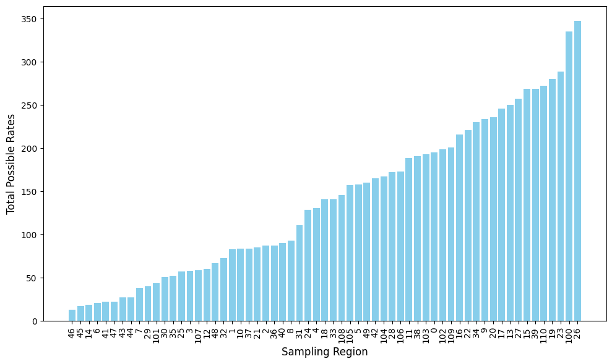
Figure 1: Number of all possible utility rates by Sampling Region

Impact of Change

Individual Model Input Change
No input changes are expected from the measure refactor.

Stock-Level Input Change
No input changes are expected from the measure refactor.

Stock-Level Output Change
Describe the changes quantitatively using tables and graphics. Be sure to include a comparison at an end-use level wherever applicable because oftentimes a large change in a small end-use doesn’t show up in annual, total fuel, national-scale results.
The stock level energy outputs will remain unchanged; the stock-level utility rate outputs will be more accurate compared to before, since they will reflect the actual post-allocation location and electric utility. The measure will have some additional runtime overhead due to calculating all applicable rates for all possible utilities, rather than just the applicable rates for one utility. Testing based on a small 10-model run shows that the total time for the utility bills measure more than doubled, both in absolute time and as a percentage of total run time (Figure 2). However, after the refactor this still only represents about 5% of the total run time.
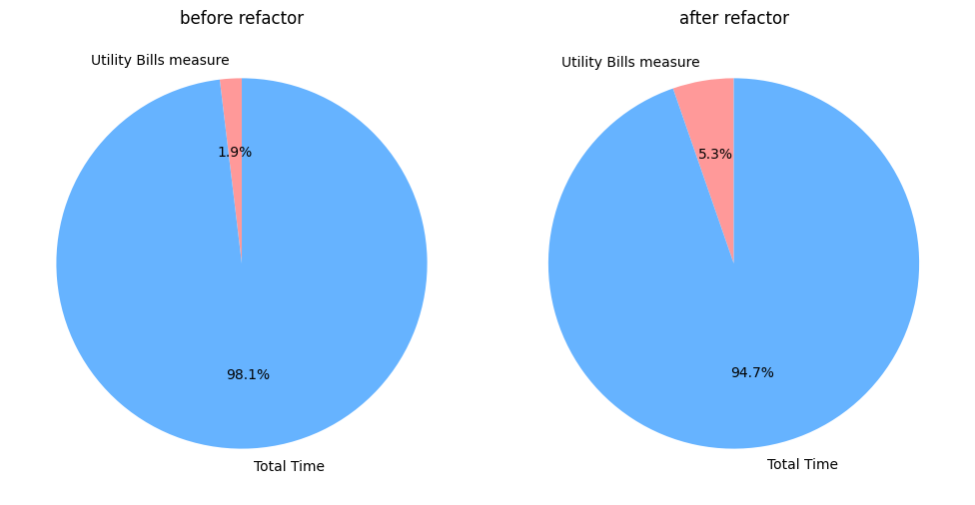
Figure 2: Impact of measure refactor as a percentage of total test run time

EUSS Upgrade Measure Impacts
Include this section if the change will impact EUSS measure or require changes to EUSS measures. Describe what changes will be necessary. If the changes are small, make them and include them in the pull request.

