ComStock Change
  - v34 – CBECS 2018 Update
Implementer: Landan Taylor
Change Document Author: Landan Taylor
Reviewer: Chris CaraDonna

Description of Change

Summary
This update modifies the existing framework for generating probability distributions for HVAC system types using CBECS 2018 microdata. The methodology builds upon the previous approach while incorporating additional fields from the CBECS 2018 survey to improve HVAC system type categorization. The key modifications include:
- Improved classification of HVAC systems using additional fields from CBECS 2018.
- Weighted combination of CBECS 2012 and CBECS 2018 distributions to increase sample counts.
- Enhanced sampling methodology to better match HVAC system types with appropriate building types and sizes.
- Implementation of size bins rules to prevent incorrect system assignments, special case handling for schools was removed as a result.

Existing Methodology
The previous approach used CBECS 2012 microdata to determine HVAC system type distributions. The system type classifications were derived hierarchically based on building type, census division, and heating fuel type. The sampling methodology involved checking system categories in a prioritized order to assign the most dominant system.

New Methodology
The updated methodology refines the HVAC distribution approach by incorporating new fields from CBECS 2018, which provides more granularity in system categorization. The primary changes include:
- Expanded Classification Fields: New fields from CBECS 2018 allow for improved HVAC categorization, reducing misclassification errors.
- Weighted Distribution Between CBECS 2012 and 2018: A weighted average, based on the number of samples from each survey year, of the HVAC distributions from both datasets is used to improve statistical confidence, considering that system types have not drastically changed in the six-years between surveys.
- Refined Sampling Methodology: The improved distributions allow for more precise sampling of system types based on building size and type.
- Size Bin Assignments: New size bins have been added to prevent system assignments that do not align with typical building configurations based on building type and size. Special case handling for schools was removed as a result.
Outside of these major changes, the HVAC system and fuel type assignment methodology does not change from the previous implementation.

Impact of Change

Individual Model Input Change

Stock-Level Input Change
This change is reflected in the hvac.tsv that is used in sampling as a result the distribution of HVAC systems has changed. Figure 1 below shows the % of floor area by HVAC system type and CBECs implementation. CBECS 2012 is based on the 2024 SDR R2 release. It should be noted that the 20224 SDR R2 release includes the sampling changes aside from the size bin assignment change noted above. CBECS 2018 utilizes the same SDR branch for its run but with the updated TSV and sampling implementation. PSZ AC with Gas Coil remains the most common system type as expected as this represents packaged rooftop equipment that is seen on many commercial buildings. Many other systems have shifted slightly with the addition of CBECs 2018 data but generally are within 1% of where they were in current Comstock implementation. Of note, for the less common systems we see on average a decrease in the % of floor area with the new implementation. This is due to the fact that the new implementation has a greater number of samples to develop these distributions so a single sample will not be as overrepresented in the final distribution.
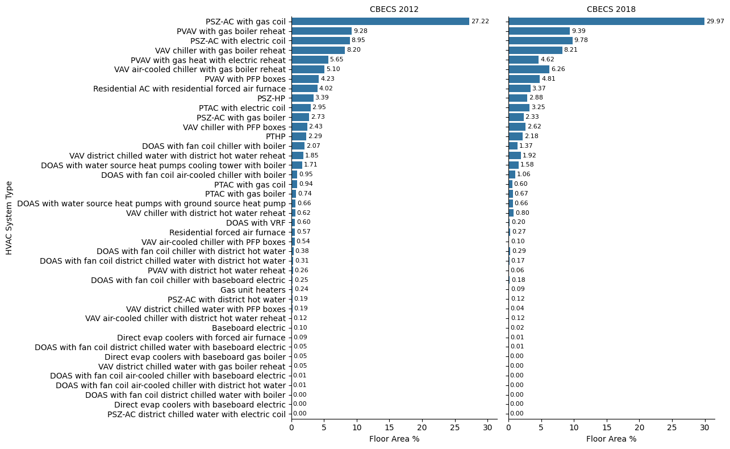
Figure 1: Percent Floor Area by Comstock System Type and CBECs distribution implementation
Table 1 below shows the tabulated data CBECS 2012 and 2018 data and the difference in floor area from the different CBECs implementation.
HVAC System Type | % Floor Area CBECS 2012 | % Floor Area CBECS 2018 | Difference (2018 - 2012)
PVAV with gas boiler reheat | 9.28 | 9.39 | 0.11
PSZ-AC with electric coil | 8.95 | 9.78 | 0.83
VAV chiller with gas boiler reheat | 8.2 | 8.21 | 0.01
PVAV with gas heat with electric reheat | 5.65 | 4.62 | -1.03
VAV air-cooled chiller with gas boiler reheat | 5.1 | 6.26 | 1.16
PVAV with PFP boxes | 4.23 | 4.81 | 0.58
Residential AC with residential forced air furnace | 4.02 | 3.37 | -0.65
PSZ-HP | 3.39 | 2.88 | -0.51
PSZ-AC with gas coil | 27.22 | 29.97 | 2.75
PTAC with electric coil | 2.95 | 3.25 | 0.3
PSZ-AC with gas boiler | 2.73 | 2.33 | -0.4
VAV chiller with PFP boxes | 2.43 | 2.62 | 0.19
PTHP | 2.29 | 2.18 | -0.11
DOAS with fan coil chiller with boiler | 2.07 | 1.37 | -0.7
VAV district chilled water with district hot water reheat | 1.85 | 1.92 | 0.06
DOAS with water source heat pumps cooling tower with boiler | 1.71 | 1.58 | -0.13
DOAS with fan coil air-cooled chiller with boiler | 0.95 | 1.06 | 0.11
PTAC with gas coil | 0.94 | 0.6 | -0.34
PTAC with gas boiler | 0.74 | 0.67 | -0.08
DOAS with water source heat pumps with ground source heat pump | 0.66 | 0.66 | 0
VAV chiller with district hot water reheat | 0.62 | 0.8 | 0.18
DOAS with VRF | 0.6 | 0.2 | -0.39
Residential forced air furnace | 0.57 | 0.27 | -0.31
VAV air-cooled chiller with PFP boxes | 0.54 | 0.1 | -0.44
DOAS with fan coil chiller with district hot water | 0.38 | 0.29 | -0.09
DOAS with fan coil district chilled water with district hot water | 0.31 | 0.17 | -0.15
PVAV with district hot water reheat | 0.26 | 0.06 | -0.21
DOAS with fan coil chiller with baseboard electric | 0.25 | 0.18 | -0.07
Gas unit heaters | 0.24 | 0.09 | -0.15
PSZ-AC with district hot water | 0.19 | 0.12 | -0.08
VAV district chilled water with PFP boxes | 0.19 | 0.04 | -0.15
VAV air-cooled chiller with district hot water reheat | 0.12 | 0.12 | 0.01
Baseboard electric | 0.1 | 0.02 | -0.08
Direct evap coolers with forced air furnace | 0.09 | 0.01 | -0.08
Direct evap coolers with baseboard gas boiler | 0.05 | 0 | -0.05
DOAS with fan coil district chilled water with baseboard electric | 0.05 | 0.01 | -0.05
VAV district chilled water with gas boiler reheat | 0.05 | 0 | -0.05
DOAS with fan coil air-cooled chiller with district hot water | 0.01 | 0 | -0.01
DOAS with fan coil air-cooled chiller with baseboard electric | 0.01 | 0 | -0.01
Table 1: Percent of floor area by HVAC System Type and CBECS implementation

A common heating system in the commercial building stock are boilers. It is not anticipated that there would be much change for this system type between 2012 and 2018 and due to its high provenance serves as a system type to help investigate the impact of this update. Figure 2 below shows the total floor area for all systems that include a boiler. This graphic shows that there is not major changes in the distributions of boilers by floor area in the stock while there might be some shifts in the cooling or other HVAC systems. Pre and post implementation boiler systems make up approximately 30.8% of the total floor area.
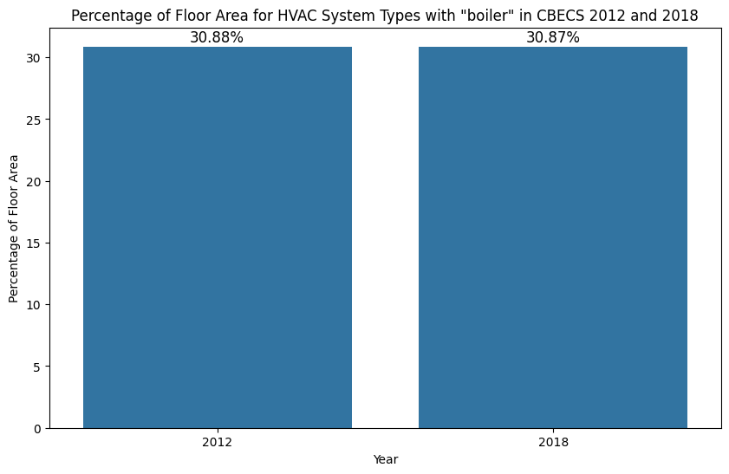
Figure 2: Percent of floor area for boiler system types pre and post CBECs 2018 implementation

Stock-Level Output Change
This change was tested on a full ComStock run utilizing the most recent 2024 SDR R2 branch. There were no major failures in the run as result of this change. Total fuel uses – electricity and natural gas – are similar, which is expected. There is a minor improvement in electricity alignment with CBECs 2018 and a minor decrease in Natural gas alignment with CBECs 2018. Overall, this change does not result in major impacts to stock level energy. There are minor changes in energy when you slice the energy consumption deeper into building, census division, and vintage categories. The biggest changes being seen on the building level is to be expected as this is one of the primary factors that determines the HVAC system assignment. The largest changes are seen in schools due to the size bin change that removed the school type rules that were originally in place resulting in some of larger shifts in HVAC system type assignment.
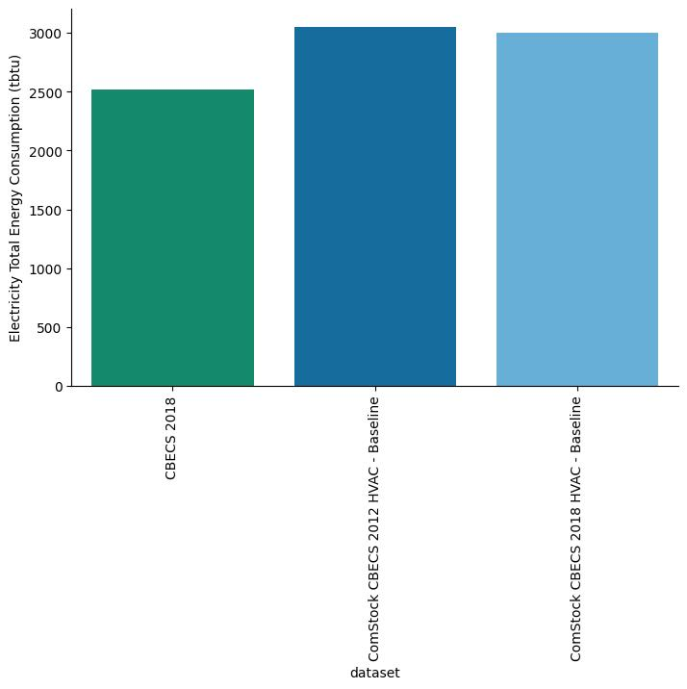
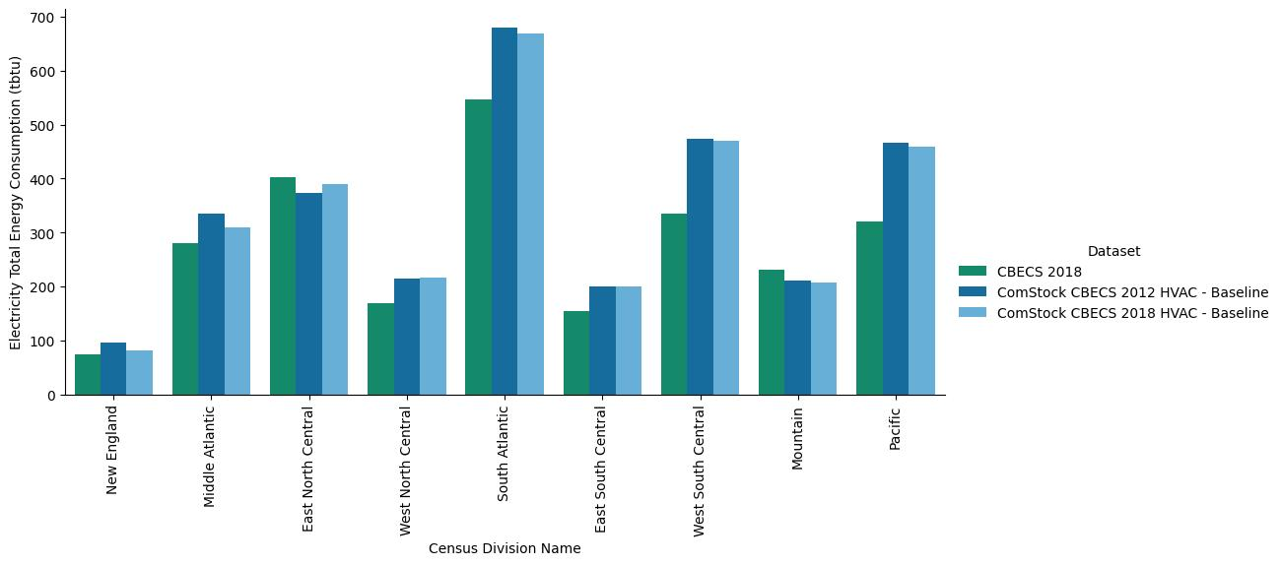
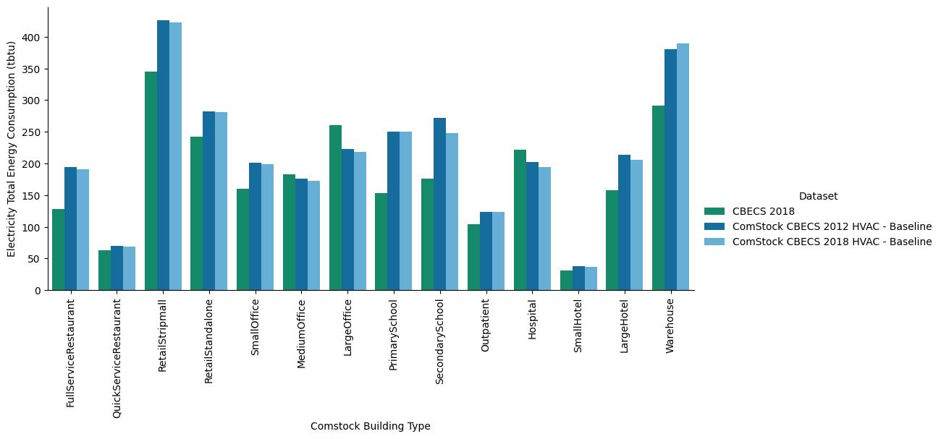

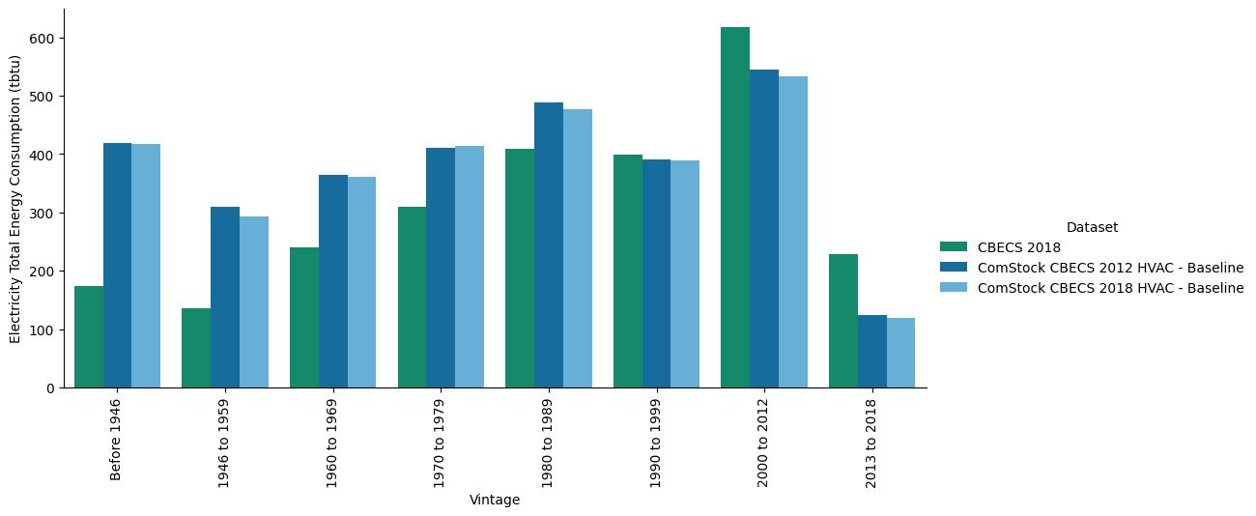

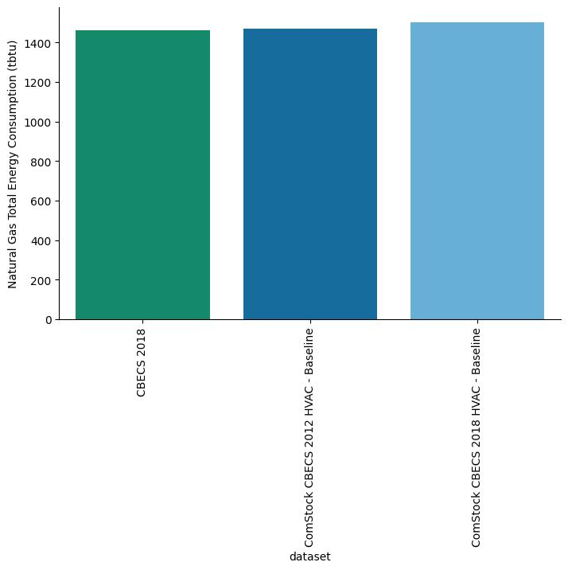
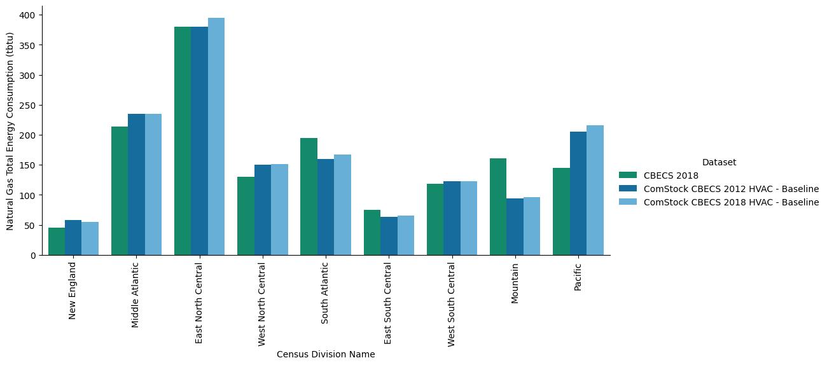
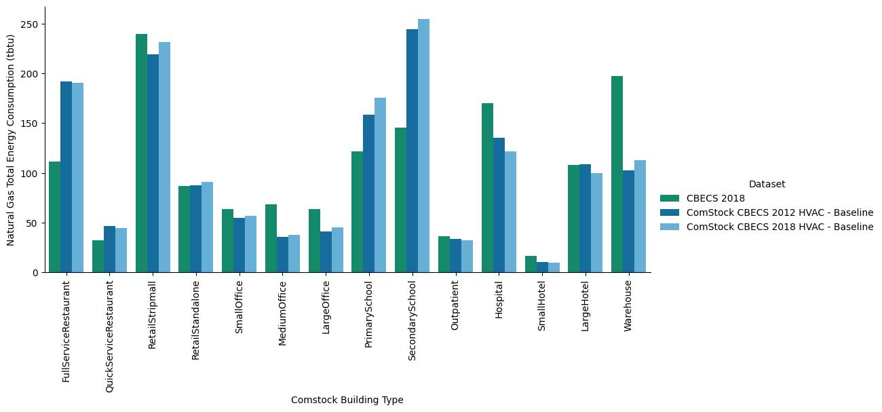
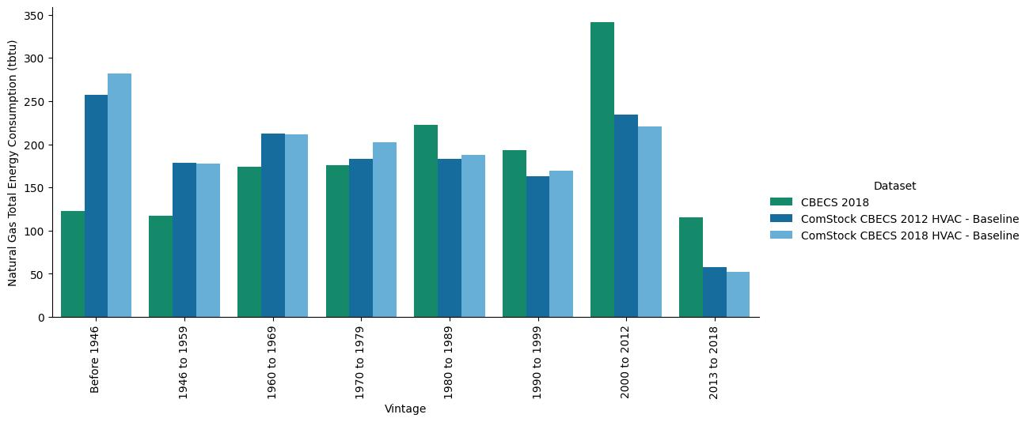

EUSS Upgrade Measure Impacts
This change results in an updated TSV and essentially updates the distributions of assigned HVAC system types for each building. The update to CBECS 2018 does not directly modify EUSS measures or their underlying methodologies. However, it does affect the number of buildings each measure applies to, as the revised dataset reflects a more current distribution of commercial building stock characteristics. This shift in applicability will influence the total estimated savings across the building stock for each measure.
It is recommended that EUSS reviews individual measures to assess any significant changes in impact due to shifts in building stock representation.

