ComStock Change
  - V35 – Changing CA Warehouse Space Type Ratio
Implementer: Landan Taylor
Change Document Author: Landan Taylor
Reviewer: Matt Dahlhausen

Description of Change

Summary
This update add space type ratios for CA DEER warehouses to include office space types similar to 90.1 warehouses used for the rest of the US. This was done as currently warehouses in CA were modelled as only being unconditioned. This resulted in warehouses that should be assigned cooling systems to not have a space type that these systems would be assigned too resulting in decrepencies with the build stock system type counts and the what actually shows up in the model. This change is reflected Openstudio Standards changes that will be implemented in the August 2025 release. This fixes issue #129

Existing Methodology

DEER Warehouse Model Space Types (Existing)
In the current implementation of OpenStudio Standards, the DEER warehouse prototype includes a space type labeled as “Unconditioned Warehouse,” which accounts for 100% of the building’s floor area. This modeling approach assumes the entire warehouse is unconditioned, with no provisions for office or conditioned space. As a result, the typical systems applied to this prototype do not include cooling equipment or setpoint schedules commonly associated with conditioned spaces.
ComStock California warehouse models have historically followed this DEER-based methodology. Consequently, when warehouses are classified as “unconditioned” in ComStock for California, they are modeled without any cooling systems. This decision is enforced through space-type mapping logic and system assignment routines, which rely on the designated space type to determine HVAC applicability. Because there is no conditioned or office space in the assigned space type, the warehouse is excluded from receiving cooling systems—even in cases where real-world buildings may include conditioned areas, such as offices or packaging zones.
This differs significantly from the ASHRAE 90.1 warehouse prototype, which includes approximately 4.9% office space by floor area. That small share of conditioned space prompts the assignment of appropriate HVAC systems, including cooling, which better reflects typical commercial warehouse configurations. The ASHRAE 90.1 prototype thus serves as a more representative baseline for energy modeling in regions where mixed-use warehouse configurations are prevalent.
The lack of conditioned space types in the DEER-based California warehouse models has resulted in an underrepresentation of cooling energy use and potentially misrepresents the HVAC system stock in the state. To address this, a revision to the space-type assignment or prototype selection may be necessary to better align modeled results with observed building characteristics and code-based expectations for California warehouses.
Comparison of Space Type Ratios
The table below compares the space-type distributions for a representative ASHRAE 90.1 warehouse (warehouse_bulk80) against the DEER-conditioned (SCn) and unconditioned (SUn) warehouse prototypes:
OS Building Prototype | Space Type | Ratio | Notes
ASHRAE 90.1 (Bulk 80) | Bulk | 0.800 | Primary storage space
 | Fine | 0.151 | Higher-load warehouse zone
 | Office | 0.049 | Includes glazing (WWR: 0.71), conditioned zone
DEER – Conditioned (SCn) | WarehouseCond | 0.951 | General warehouse area, conditioned
 | OfficeGeneral | 0.049 | Conditioned office area
DEER – Unconditioned (SUn) | WarehouseUnCond | 1.000 | Entire building unconditioned

This side-by-side comparison highlights how DEER-unconditioned models eliminate the possibility of assigning cooling HVAC systems.

New Methodology

DEER Unconditioned Warehouse Office Space Type Ratio additon (changing)
To improve the representativeness of unconditioned warehouse models in ComStock for California, the methodology for assigning space types has been updated. Previously, DEER-based “Unconditioned Warehouse” prototypes allocated 100% of the building area to an unconditioned warehouse space type. This approach prevented the assignment of HVAC systems, including cooling equipment, even in buildings where small conditioned spaces—such as offices or administrative areas—are common in real-world warehouse configurations.
The updated methodology introduces a fixed 4.9% office space allocation to all unconditioned warehouse models, with the remaining 95.1% of the floor area retaining the unconditioned warehouse designation. This aligns with the space type ratios used in both DEER-conditioned warehouses and ASHRAE 90.1 prototypes, which include a small proportion of conditioned office area. The office space is assigned appropriate thermal zones, internal loads, and HVAC systems to reflect realistic occupancy and energy use, while the remainder of the building remains unconditioned.
This change improves the accuracy of HVAC system representation and better captures the mixed-use nature of many warehouses in California. By modeling even small conditioned spaces, ComStock can now account for cooling and heating system stock where it previously showed none, resulting in more accurate system prevalence metrics and energy use estimates for warehouse buildings. This update also ensures greater consistency with national warehouse prototypes and provides a more realistic baseline for evaluating retrofit measures, policy impacts, and decarbonization scenarios.
Revised DEER Unconditioned Warehouse Space Type Ratios
Space Type | Ratio | Conditioned | Notes
WarehouseUnCond | 0.951 | No | Represents the bulk of the warehouse area
OfficeGeneral | 0.049 | Yes | Small office zone with standard internal loads
These updated ratios ensure that unconditioned warehouses in ComStock reflect typical real-world usage patterns while preserving the intent of the DEER definition.

Impact of Change

Individual Model Input Change
Model | Modeled System Type
 | Before | After
1911 – Warehouse CA – PSZ-AC with electric coil | Heating Only Equipment | PSZ-AC with electric coil
2319 – Warehouse CA –  Residential forced air furnace | Residential forced air furnace | Residential forced air furnace

Stock-Level Input Change
This change does not result in any input level changes but rather changes the way the CA Unconditioned Warehoues are modelled by adjusting the ratio of space types to include offices in those building types. This change does not impact sampling or other input parameters.

Stock-Level Output Change
This update to the DEER unconditioned warehouse space type methodology results in notable changes to modeled outputs for California warehouses in ComStock. By introducing 4.9% conditioned office space with representative internal loads, and reducing the unconditioned warehouse floor area accordingly, the models now more accurately reflect real-world mixed-use warehouse configurations.
As a result of this change:
- HVAC System Assignment: Cooling HVAC system types are now assigned to the office space zones, where appropriate, based on OpenStudio Standards logic. Previously, unconditioned warehouse models included no cooling systems due to the absence of conditioned space.
- Internal Load Adjustments: The introduction of office space types brings typical office-level internal gains (e.g., lighting, plug loads, occupancy), increasing energy use in those zones compared to the previous unconditioned-only configuration.
- Floor Area Reallocation: The overall reduction in unconditioned warehouse floor area (from 100% to 95.1%) slightly reduces the total modeled load associated with large, typically low-energy-use warehouse spaces.
These changes collectively influence the modeled end-use energy consumption of warehouse buildings. The charts below illustrate these impacts on total and end-use energy consumption across the warehouse stock in Comstock.
Note: The energy charts presented also reflect additional updates to OpenStudio Standards that will be included in the August ComStock release. These updates include revisions to lighting power densities and control assumptions that affect all space types, not just warehouses.
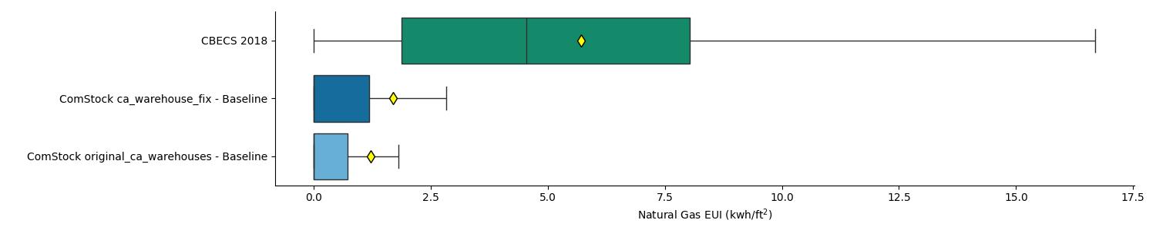
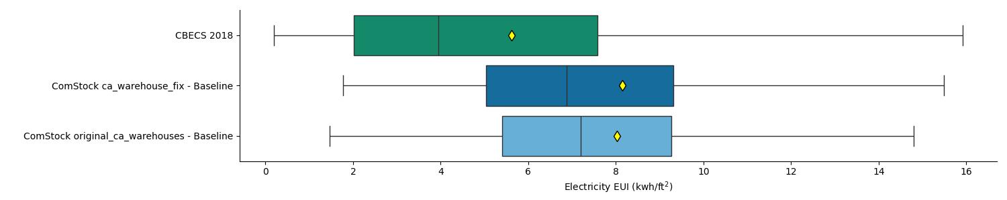
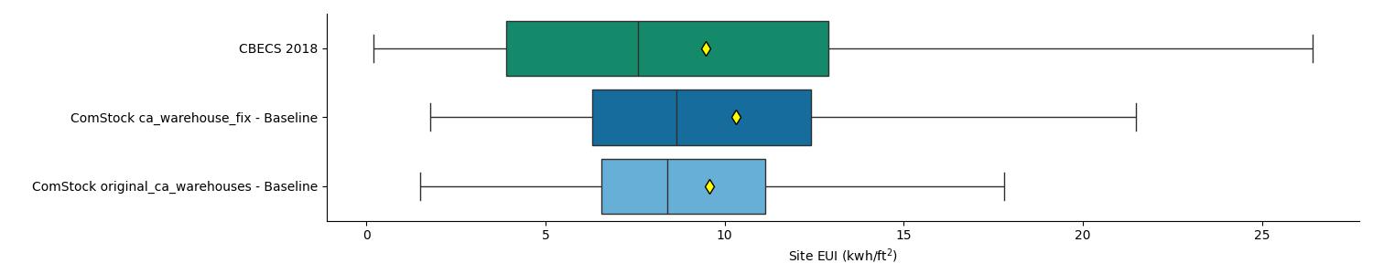
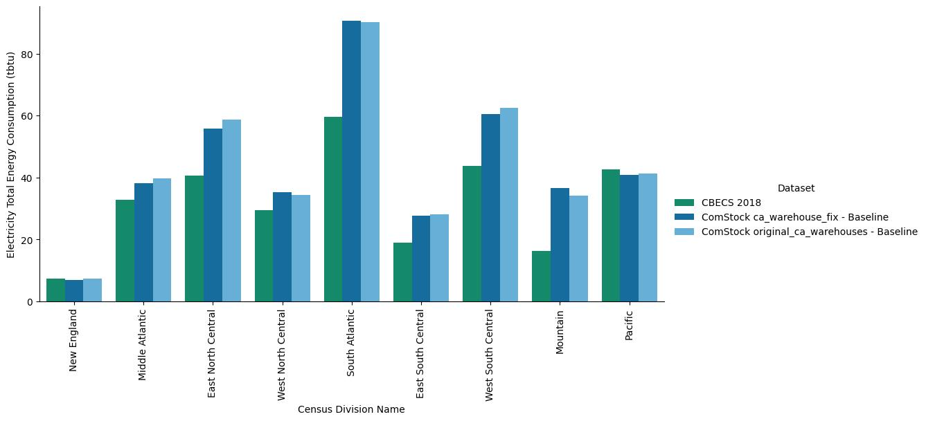
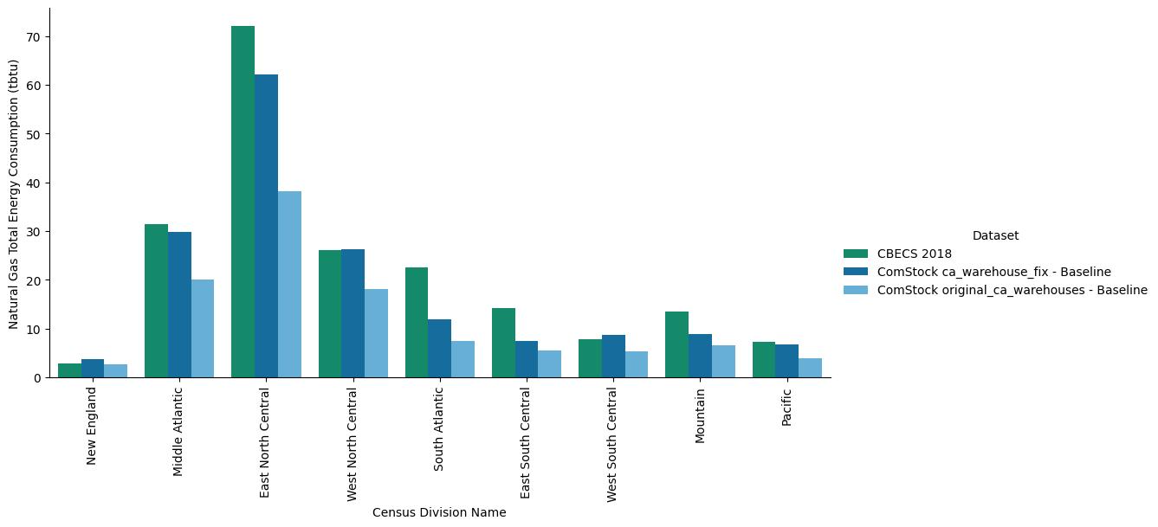
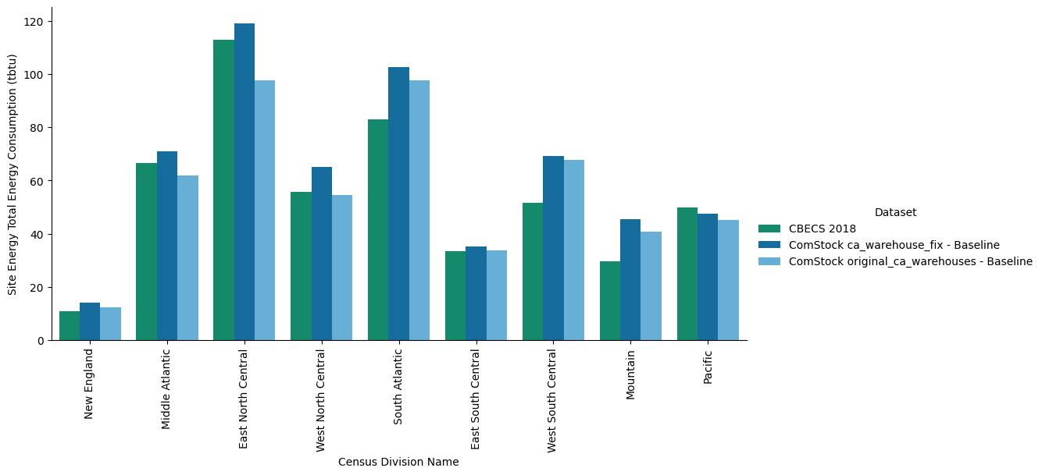

EUSS Upgrade Measure Impacts
Include this section if the change will impact EUSS measure or require changes to EUSS measures. Describe what changes will be necessary. If the changes are small, make them and include them in the pull request.
This update to the DEER unconditioned warehouse modeling—introducing 4.9% conditioned office space—will affect how energy savings from certain EUSS measures are realized in ComStock warehouse models. Specifically, measures that apply to HVAC systems, internal loads, or controls associated with conditioned spaces (such as offices) may now show non-zero energy impacts where previously no applicable conditioned space existed.
Measures that fall into this category may include:
- HVAC equipment efficiency upgrades
- Advanced thermostat controls
- Lighting retrofits in office areas
- Plug load reductions
- Envelope improvements with HVAC-interactive effects
While the energy impact of these measures may now appear in California warehouse models due to the presence of office zones, this change does not alter the logic or applicability of any EUSS measure. All measure applicability filters, building stock targeting, and interaction mechanisms remain unchanged. The update simply enables these measures to interact with a more realistic representation of warehouse building space types.
This enhancement improves the accuracy and completeness of energy savings estimates without requiring any changes to measure definitions or application strategies.

