ComStock Change
  - v36 – OpenStudio 3.10.0 and openstudio-standards 0.8.3 update.
Implementer: Matthew Dahlhausen
Change Document Author: Matthew Dahlhausen
Reviewer: Landan Taylor and Chris CaraDonna

Description of Change

Summary
This updates ComStock to the latest OpenStudio (3.10.0) and openstudio-standards (v0.8.3). The major changes are to add modules in openstudio-standards, and refactoring refrigeration to accommodate grocery stores using ORNL refrigeration data. create_typical now uses methods wholly within openstudio-standards.
The module conversion has changes to:
- infiltration
- service water heating
- exhaust fans
- refrigeration
- exterior lighting

Existing Methodology
ComStock currently uses OpenStudio 3.8.0 with openstudio-standards 0.7.0.

New Methodology
This measure updates ComStock to OpenStudio 3.10.0 and openstudio-standards 0.8.3.

Impact of Change

Individual Model Input Change
There are several individual model changes from the module conversion.

Infiltration
The infiltration method in create_typical now uses the nist infiltration method. The NIST infiltration method is still in the workflow, so there is no change in infiltration in the final models. The are two extra schedule artifacts in the new version.

Service Water Heating
The service water heating assumptions are the same, however in the new service water heating module, all service water use equipment is assigned to an individual zone and not aggregated. This causes slight variations in zone loads. Also, the whole building gets a shared water loop, rather than splitting one off separately for the kitchen.
In initial testing of the openstudio-standards v0.8.2 udpate, there were significant differences in equipment sizing and subsequent hot water use. The draw profile schedules, water use gpm totals, and target setpoint temperatures are the same. The issue was that some models weren't reaching the target temperature, because the mixed water temperature target at the use is the same as the loop and water heater temperature (140F / 180F), and there is non-adiabatic pipe that makes achieving it impossible. The sizing routine has issues with the combined loops when it can't meet the target temperature at the use. The fix is changing hot water use equipment temperatures to the to the lower mixed water temperature target of 110F and 120F in kitchens from 140F and setting minimum loop temperatures. The openstudio-standards v0.8.3 version has similar service water heating results.

Exhaust Fans
Exhaust fan assumptions for location and pressure rises are the same, but the calculations for fan efficiency are different. Efficiency assignment now assumes more efficient fans. Schedules are defaulted to always on in openstudio-standards pending schedule integration. A new section was added to the add_hvac_nighttime_operation_variability measure to re-add the exhaust fan schedules based on building type.

Refrigeration
Refrigeration changed significantly in the update. Openstudio-standards v0.8.3 adopts ORNL’s refrigeration database. The data uses most of the same values for older vintages, but adds an entirely new refrigeration vintage. create_typical now uses a toggle for refrigeration equipment vintage rather than base it on the 90.1 standard.
One significant change is that strip malls with restaurants in the baseline should have had refrigeration but did not. This is because refrigeration system lookups were keyed to the top level building type, so sub types did not get refrigeration. Refrigeration is now handled at the space type level, and the update now adds refrigeration (both low temperature and medium temperature) to strip mall restaurants models.
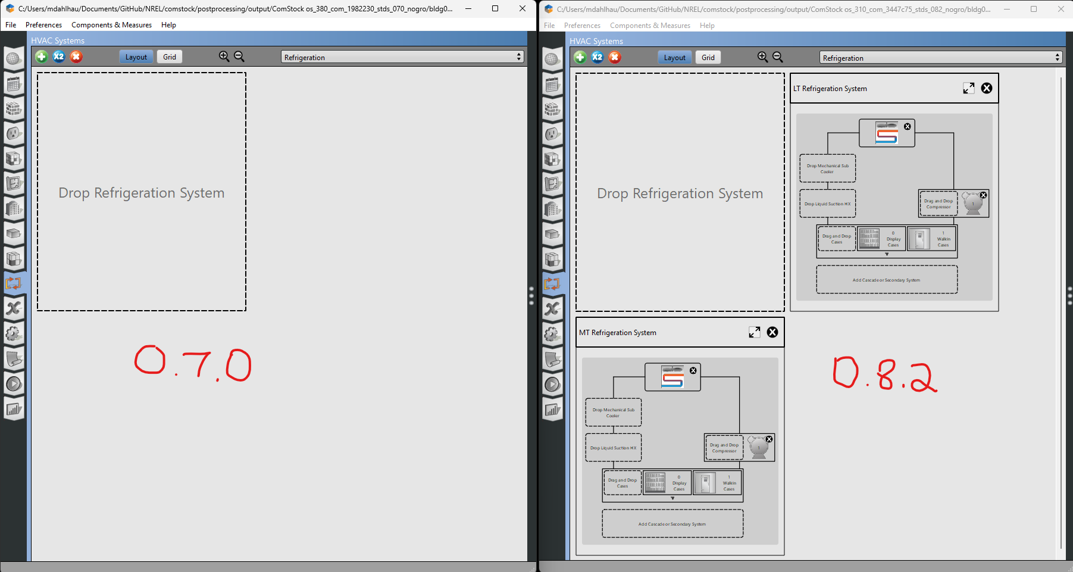
Baseline vs. new kitchen refrigeration in the restaurant portion of a strip mall

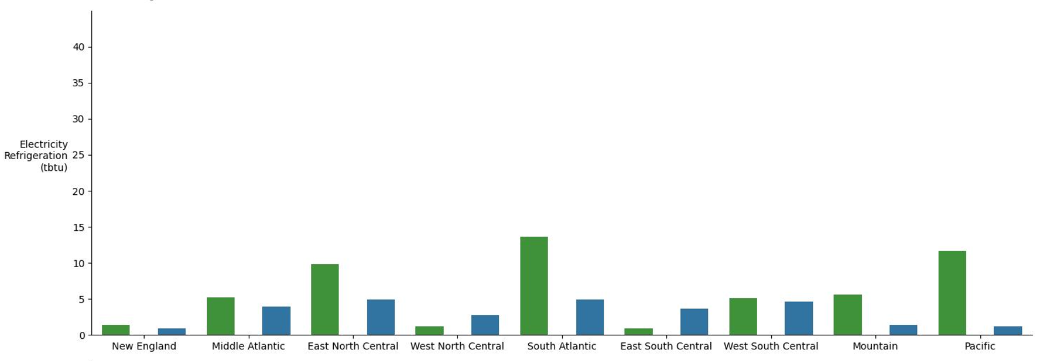
RetailStripMall refrigeration – dark green is CBECS, blue is the OS 3.10.0 / stds 0.8.2 update, the middle is OS 3.8.0 / stds 0.7.0 which blank because there was no refrigeration applied. This is the only building type affected with no refrigeration in the baseline.

Exterior Lighting
Exterior lighting has a few changes:
- The values for lighting are slightly different, use defaults instead of changing by 90.1 vintage. That causes changes particularly to non-parking exterior lighting.
- Most façade and landscape lighting now have a schedule setback that turns off lighting during the early morning hours.
- The area values now consider the whole model rather than being by building type, which may include some extra façade area for models with mixed building types (currently only strip mall with restaurant).
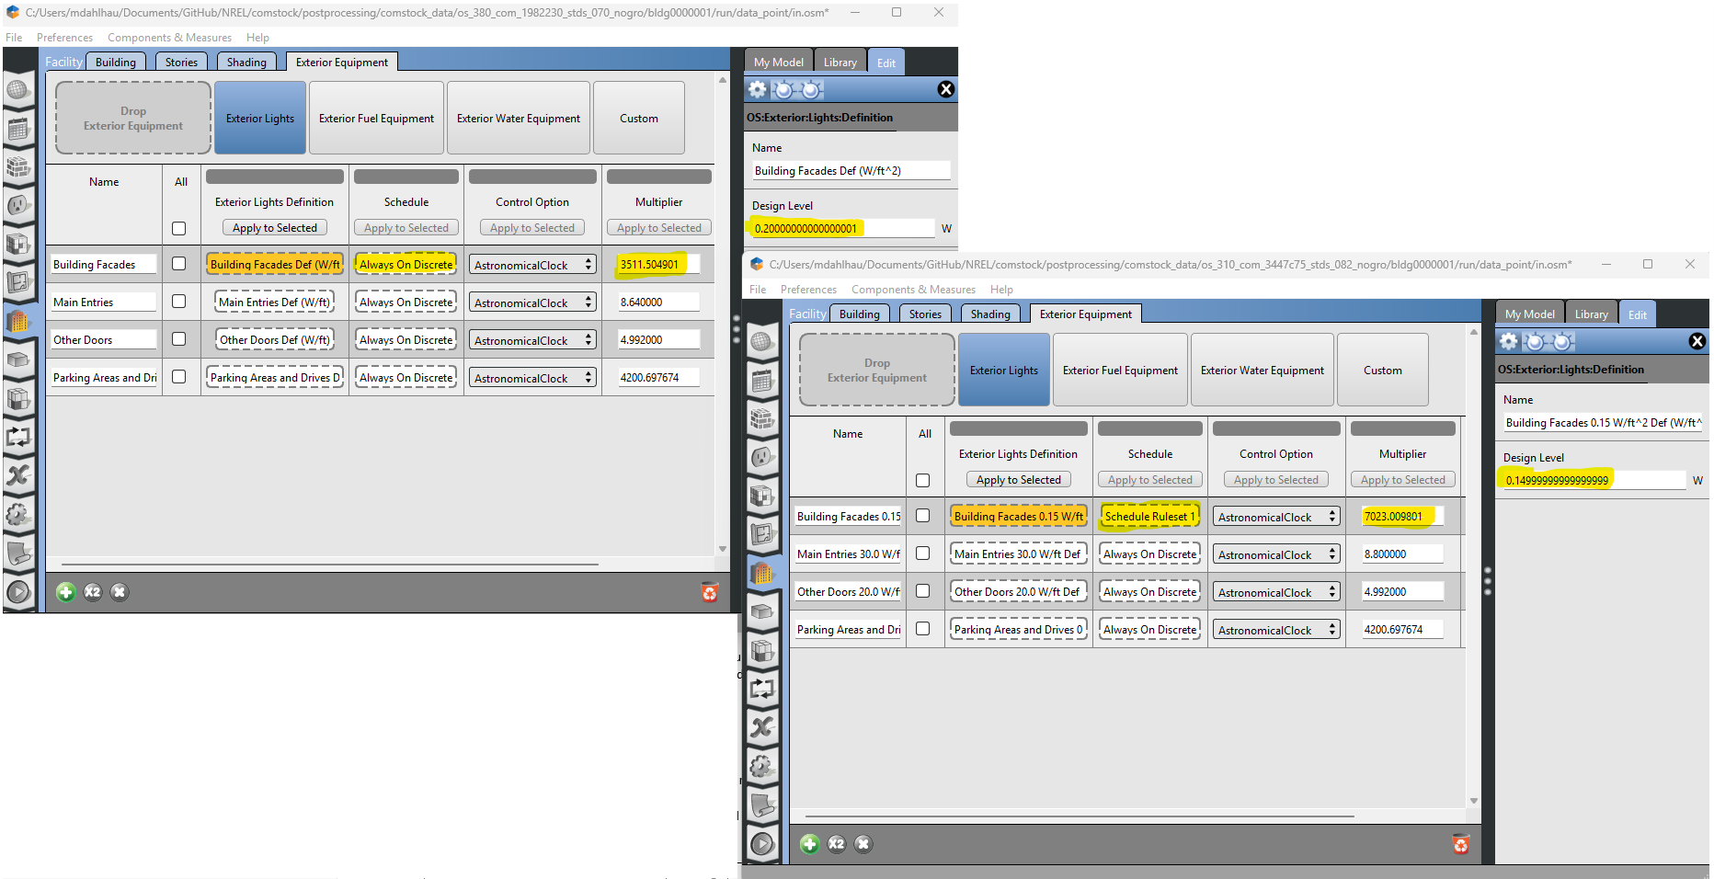
Exterior lighting changes in a stripmall with restaurant model.

Stock-Level Input Change
This PR uses the new HVAC sampling implement in Spring 2025. Those changes are covered in the CBECS 2018 HVAC Distribution update change documentation. Those sampling changes are included in the baseline run comparisons for this change.

Model Changes
The main changes are from implementation of new modules in openstudio-standards covering infiltration, water heating, exhaust fans, refrigeration, and exterior lighting.

Stock-Level Output Change
The comparison plots show (3) datasets:
- CBECS 2018 baseline
- ComStock baseline used in the most recent EUSS runs, using OpenStudio v3.8.0 and openstudio-standards v0.7.0
- A final version with OpenStudio v3.10.0 and openstudio-standards v0.8.3

The failure rates are shown in the following table:
run | Building Count | Success | Failed | Failure Percentage | Average Total Runtime (seconds)
os_380_com_1982230_stds_070 | 9189 | 8991 | 198 | 2.2% | 241.5
os_380_com_af68e4b_stds_070 | 9189 | 8991 | 198 | 2.2% | (kestrel down)
os_310_com_3447c75_stds_082 | 9189 | 8863 | 326 | 3.5% | 255.8
os_310_com_acfab95_stds_ca6ec44 | 9189 | 8775 | 414 | 4.5% | 245.0
os_310_com_44638d9_stds_ff3674f | 9189 | 8808 | 381 | 4.1% | 240.2
os_310_com_112a7aa_stds_083 | 9189 | 8986 | 203 | 2.2% | 238.3
os_310_com_1302af9_stds_083 | 9189 | 8986 | 203 | 2.2% | (kestrel down)
os_310_com_c2f62a5_stds_083 | 9189 | 8988 | 201 | 2.2% | 237.4
Also shown here are various openstudio-standards iterations. See run log for details.
Several iterations had an increase in failure rates. These were from changes to coil efficiency data from PNNL standards data update, and from a missing key for SUn offices (warehouse) buildings in the prototype_space_type_assignment measure. Both these issues are addressed, and the failure rate is similar to the baseline.
Several iterations of os_310 lacked the terrain field set to “City” as in the baseline. This caused wind speeds to be higher with the OpenStudio default, and subsequently increased infiltration considerably. Thus the models were showing an average 15% heating energy increase. This field has since been set in the change_building_location measure, and will in the future be an input from sampling.

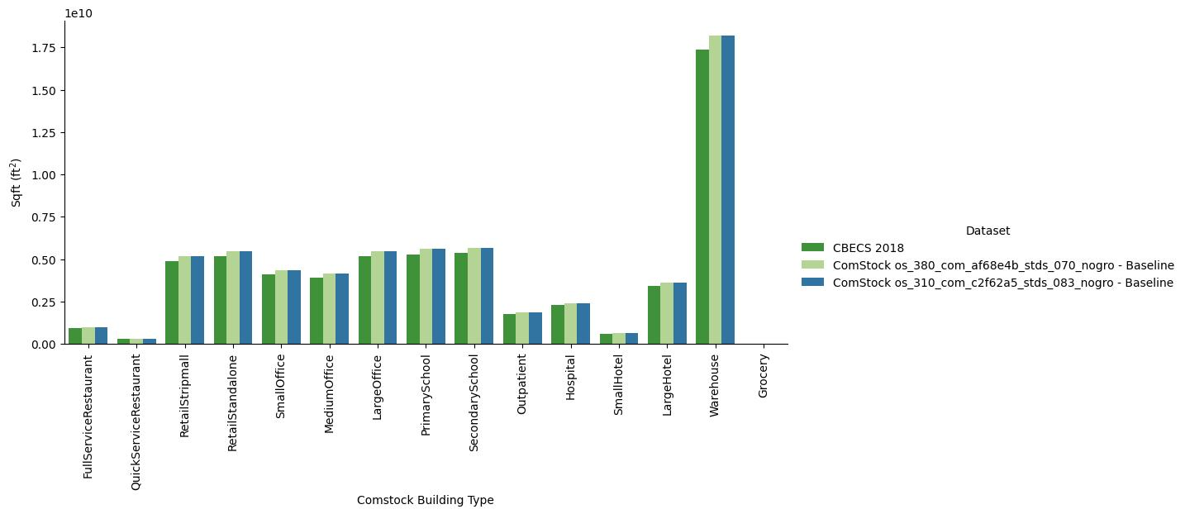
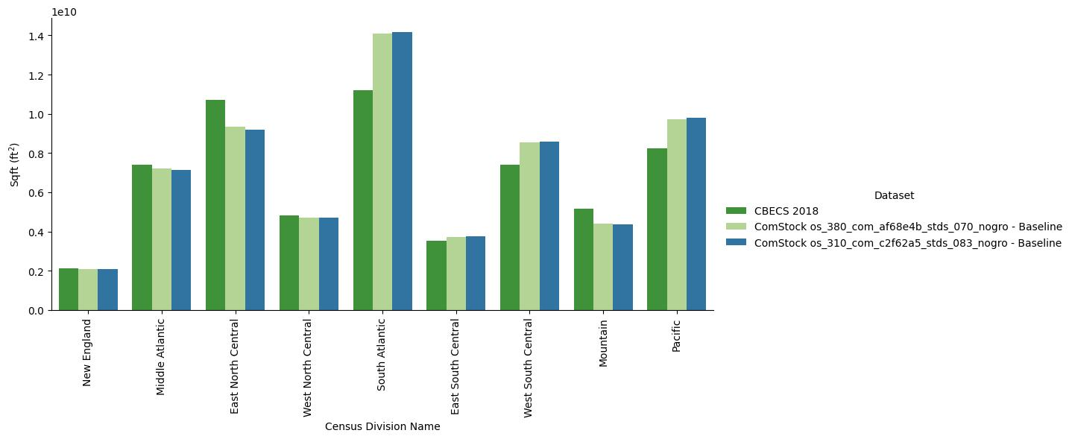
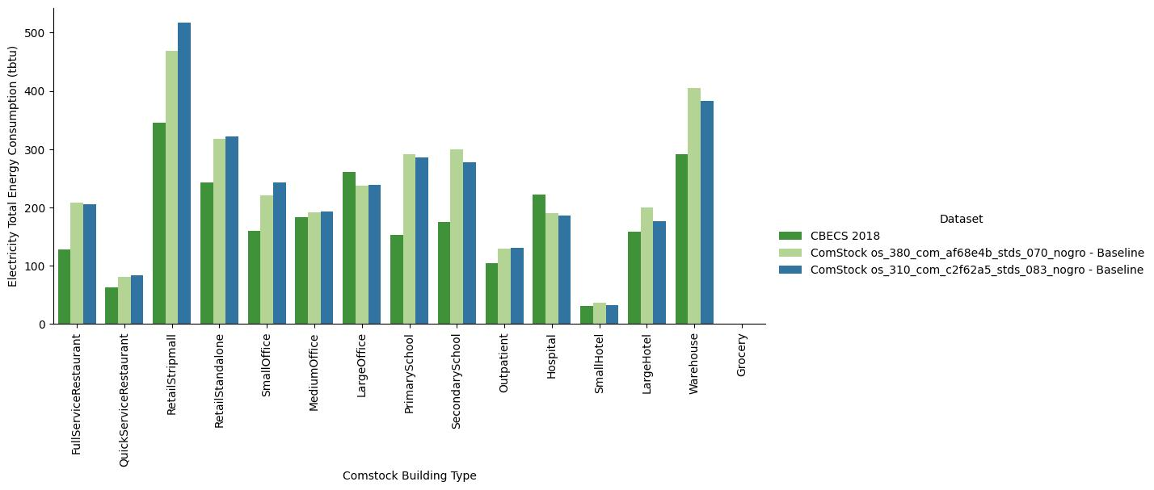
The electricity increase in strip malls is mostly from now including refrigeration in restaurants.
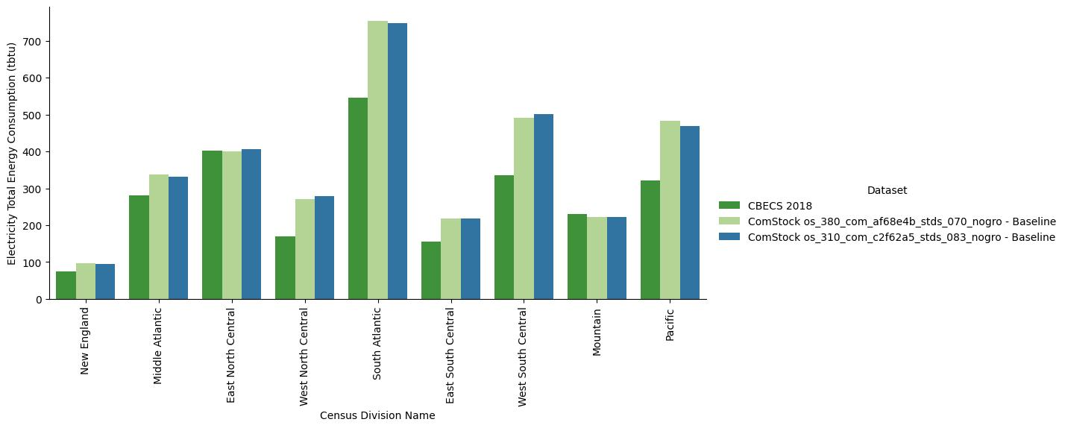

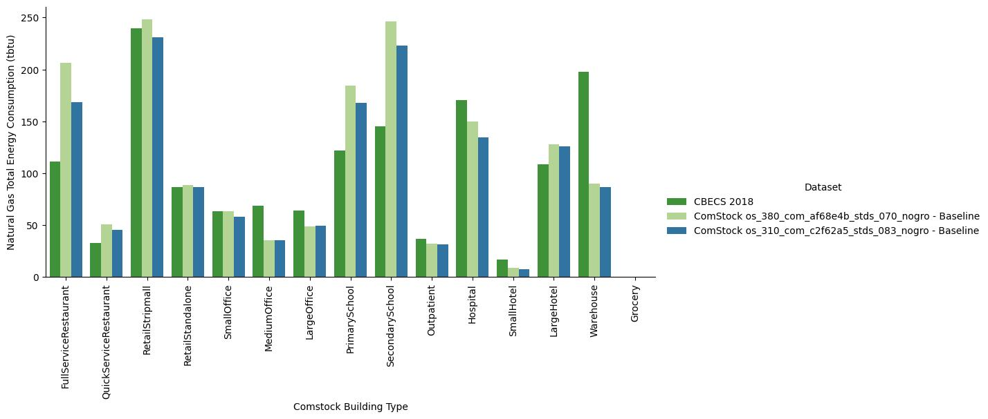
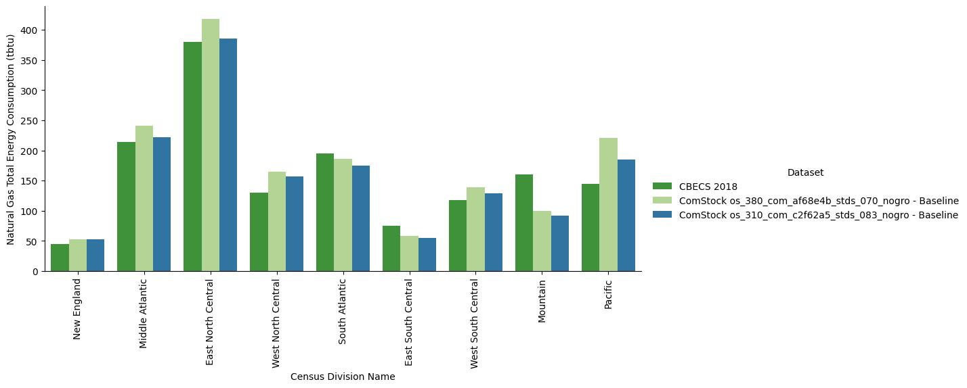

Energy End Use Changes
Water heating drops because of the switch in water use mixed temperature targets. Exterior lighting drops slightly because there is now shutoff of façade lighting during some nighttime hours.

EUSS Upgrade Measure Impacts
No EUSS upgrade measure impacts expected. We currently do not have any infiltration, water heating, exhaust fans, refrigeration, or exterior lighting measures.

