ComStock Change
  - V39 – Re-enable total operational occupancy in ComStock models
Implementer: Landan Taylor
Change Document Author: Landan Taylor
Reviewer: Chris Caradonna

Description of Change

Summary
This update re-enables the total occupancy fix that was implemented as part of the original V26 change. This issue was the result of an accidental update to the option_lookup.tsv that removed the occupancy adjustment measure from the baseline workflow.

Existing Methodology
Change doc v26 discussed the existing methodology that was utilized review that change doc for details on what was changed, this change doc will focus on why and how the issue was resolved. The issue was a result of the options_lookup.tsv showing this line (Figure 1) for occupancy measure. The screenshot below shows that the occupancy schedule adjust option in the options lookup tsv the buildstock does not include this option as part of our workflow so it does not result in the adjust occupancy measure being applied.
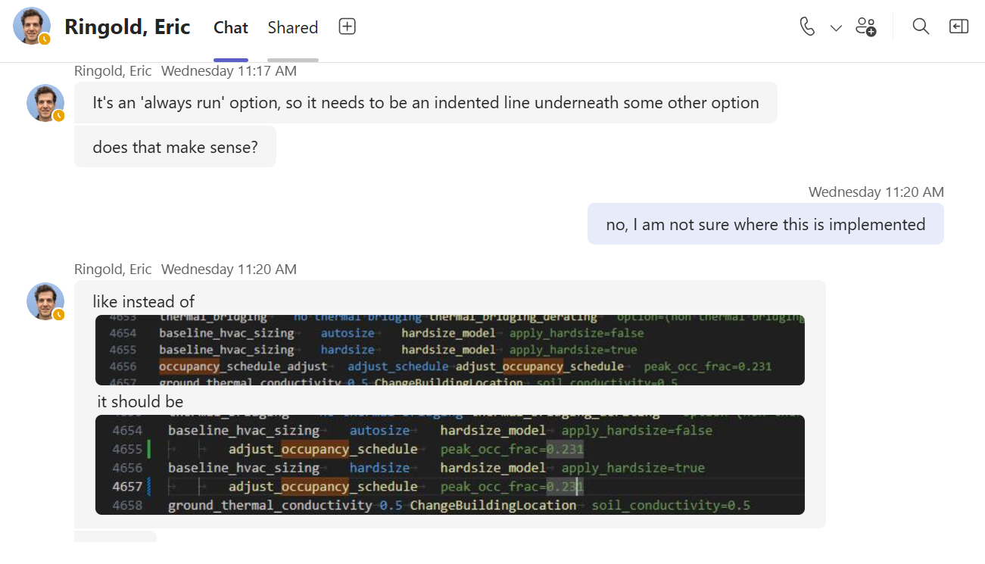
Figure 1: Options Lookup tsv with incorrect measure call

New Methodology
Change doc v26 discusses the new methodology that was utilized - please review that change doc for details on the implementation methodology - this change doc focuses on why and how the issue was resolved to re-enable that change. The screenshot below (Figure 2) shows the fix which makes the adjust_occupancy_schedule to be a sub option of the baseline hvac sizing measure in options lookup. This makes this occupancy schedule run in the baseline.


Figure 2: Options Lookup tsv with fixed measure call

Figure 1: Total occupancy in Commercial Buildings for average day in 15min intervals from ATUS
An OpenStudio measure ‘adjust_occupancy_schedule’ was created which gathers all ‘number of people’ schedules applied to People objects in the model. These schedules are then modified in-place by multiplying each schedule value by a user-entered fraction. The occupancy fraction was calculated using the total daily occupancy from ATUS divided by the current total ComStock occupancy of 498M, yielding an input occupancy adjustment of 0.231. The measure does not modify design day schedules, reflecting buildings that were designed and sized based on an assumed occupant density, but experience fewer people during typical operation. The measure was applied as an upgrade affecting all models in the stock.

Impact of Change

Stock-Level Input Change
See change doc V26 for additional breakdown of input changes. In general the peak occupancy of Comstock models is reduced.

Stock-Level Output Change
This change results in marginal reduction in electric energy as a result of reducing cooling need from fewer people. The change results in marginal increase in natural gas energy as a result of reduced internal heat load from people requiring more heating energy. For deeper breakdowns of energy impacts see change doc v26. Upon review the energy impacts in v26 are similar to what we are seeing in this change but with a different baseline due to additional changes that have occurred since v26
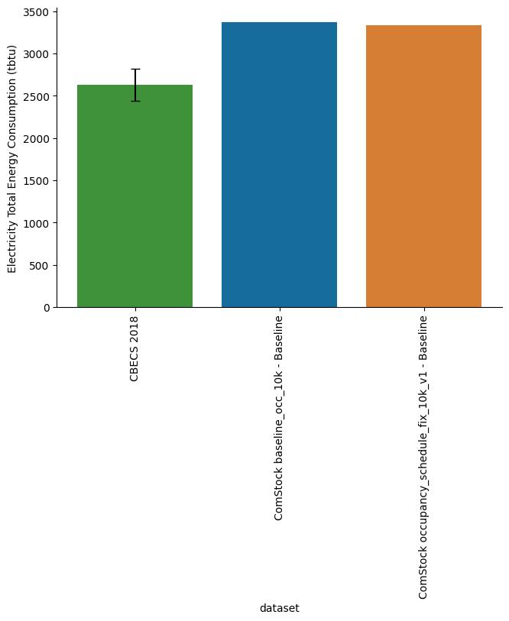
Figure 3: Total Electricity Energy Consumption Compared to CBECs
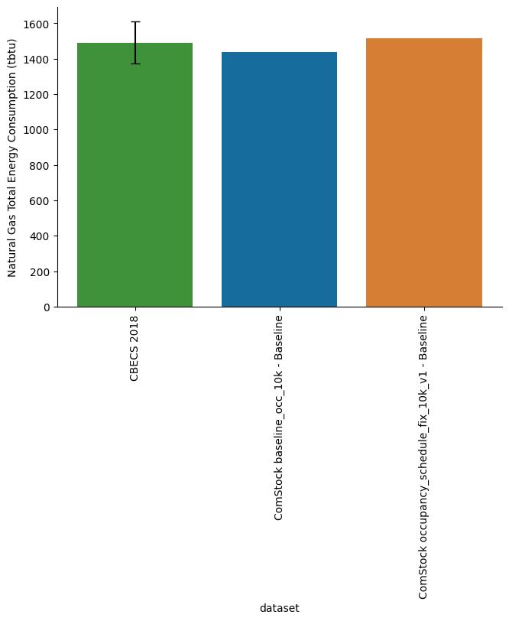
Figure 4: Total Natural Gas Compared to CBECs

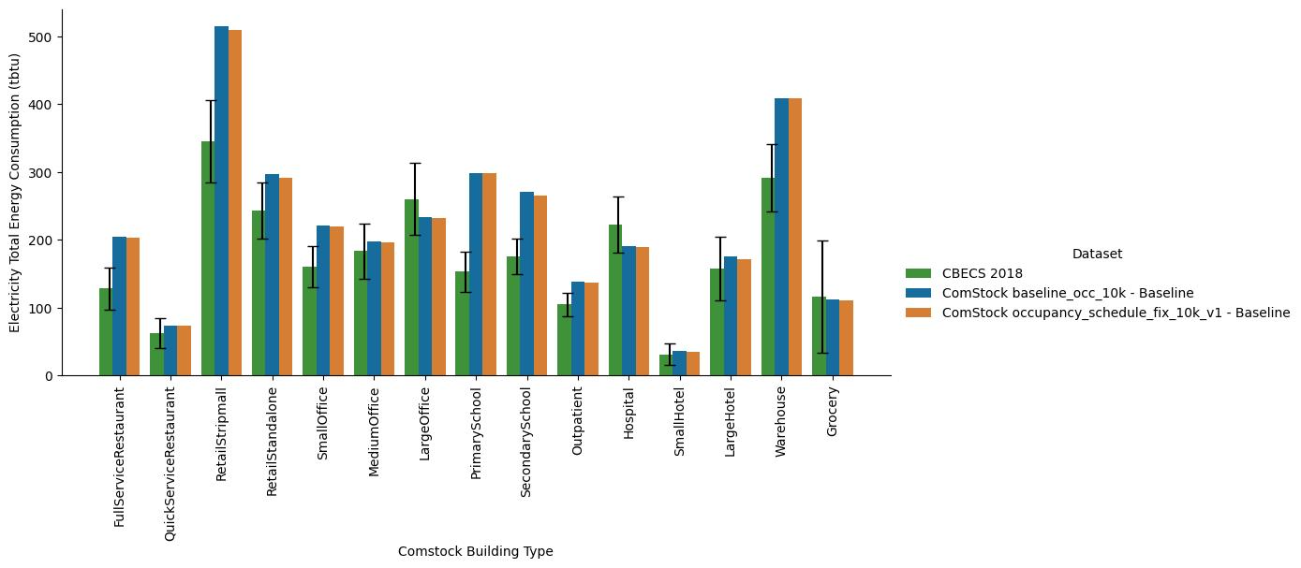 Figure 5: Electricity by Building Type
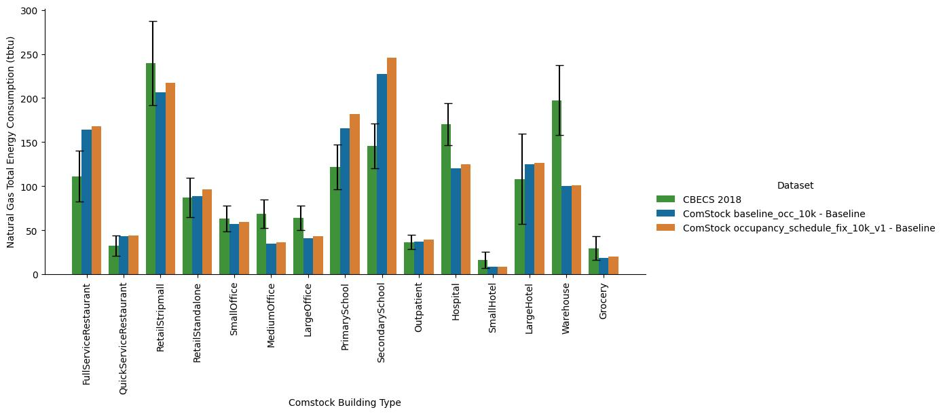
Figure 6: Natural Gas by Building Type

