ComStock Change
  - V40 – Re-fix minimum warehouse thermostat setpoint
Implementer: Chris CaraDonna
Change Document Author: Chris CaraDonna
Reviewer: Landan Taylor and Eric Ringold

Description of Change

Summary
This update re-enables the minimum 61F warehouse heating setpoint that was previously implemented. The issue appears to be that the beforementioned implementation – setting warehouses to 61F instead of the previous ‘NA’ option’ in the ‘hvac_tst_htg_sp_f.tsv’ tsv file - was mistakenly dropped between V24 and V25. This has substantial impact on the gas usage in warehouses. Based on the previous change document (change document),without the minimum 61F, ComStock warehouses underestimate gas usage by about half, whereas with the 61F minimum, ComStock is within the expected confidence of CBECS.

Existing Methodology
The V28 change document describes assigning the heating thermostat setpoint for warehouses to 61F in the hvac_tst_htg_sp_f TSV. This appears to be the case in TSV zip 24, but not the case in V25. At time of writing, the existing methodology assigns all warehouses to option ‘999’ which essentially skips any thermoset setpoint assignment, leaving the default OS Standards values (Figure 1). For many warehouses spaces, this assumes a heating setpoint of 45F. Based on engineering judgement and model comparison to CBECS, this assumption was originally determined to be too cold, and likely a key culprit for why ComStock was severely underestimating gas usage compared to CBECS. Figure 2 shows an example from the latest dataset release of a 45F heating setpoint for bulk storage (should be 61F).

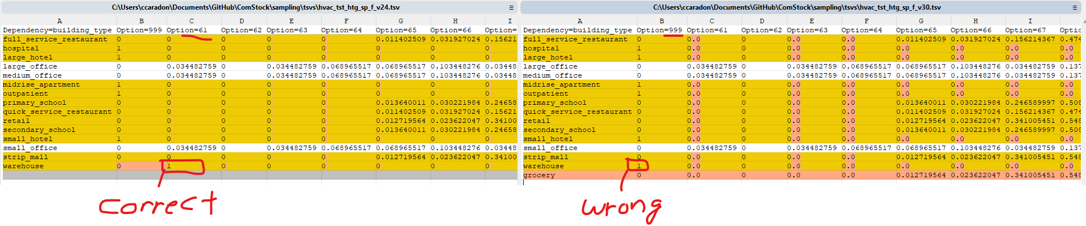
Figure 1. TSV comparison of warehouse heating thermostat setpoints where the left is the correct implementation in V24 and the right is the incorrect implementation in V30.
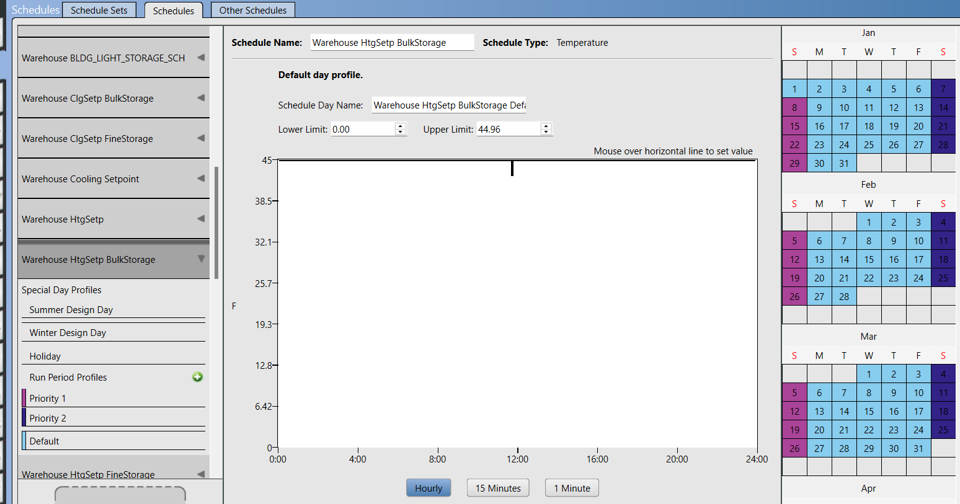
Figure 2. Example heating schedule for warehouse ‘Bulk Storage’ space type.

New Methodology
The new methodology simply returns the TSV implementation to setting all warehouses to 61F in the hvac_tst_htg_sp_f TSV, as shown in Figure 1 (left side). This is now reflected in the new tsvs-v31.zip.

Impact of Change

Stock-Level Input Change
The only input change is to the heating setpoint TSV, where all warehouses are not set to 61F (previously all were incorrectly set to ‘999’). The PR includes this, which would be used to create future sample files. However, using the buildstock files on Kestrel from this change (buildstock_20250916-1309_v30_2018_ltaylor2_8602_hardsize_wh_fixed.csv) are where users would practically see these changes in future runs when they are not generating a new sample.

Stock-Level Output Change
These changes impact both gas and electricity consumption in warehouses.
Gas usage shows a large improvement, bringing our severe underestimation well within the confidence interval of CBECS estimation for warehouses (and in line with the original change documentation for this implementation, Figure 3). Taken with a grain of salt, Figure 4 shows great comparison of ComStock gas heating usage in warehouses compared to CBECS’ estimated disaggregation.
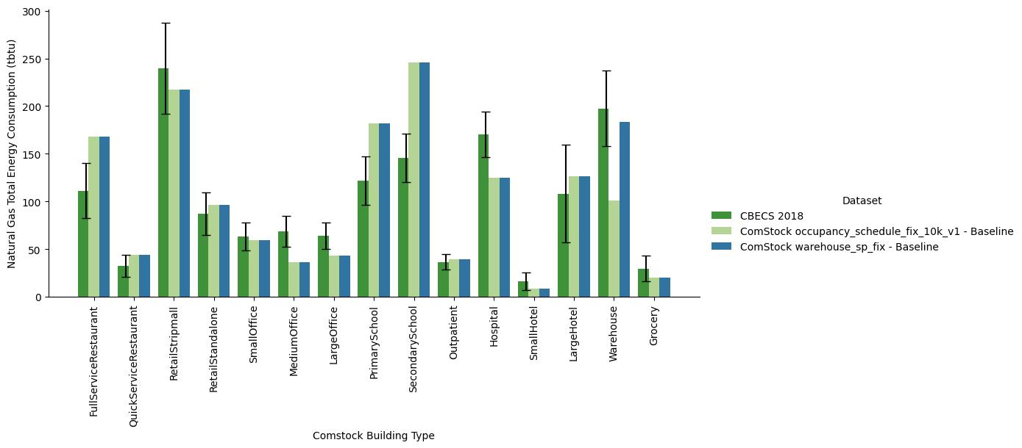
Figure 3. Gas usage by building type (blue is new, light green is old).
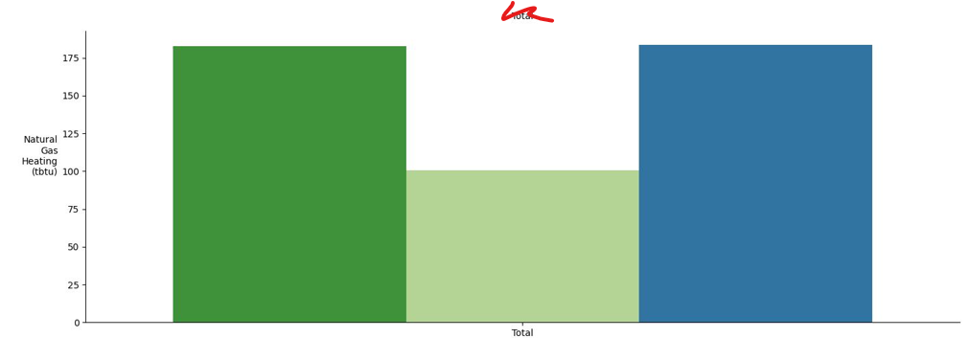
Figure 4. Gas heating usage for warehouses (green=CBECS, light green=current, blue=new)
Electricity usage increases with this change, as electric heating also experiences the increased heating setpoint. Unfortunately, this makes warehouse electricity calibration marginally worse (Figure 5). CBECS (green) is ~290 tBtus, while the current model (light green) is about 410 tBtus, and the new change (blue) is about 450 tBtus).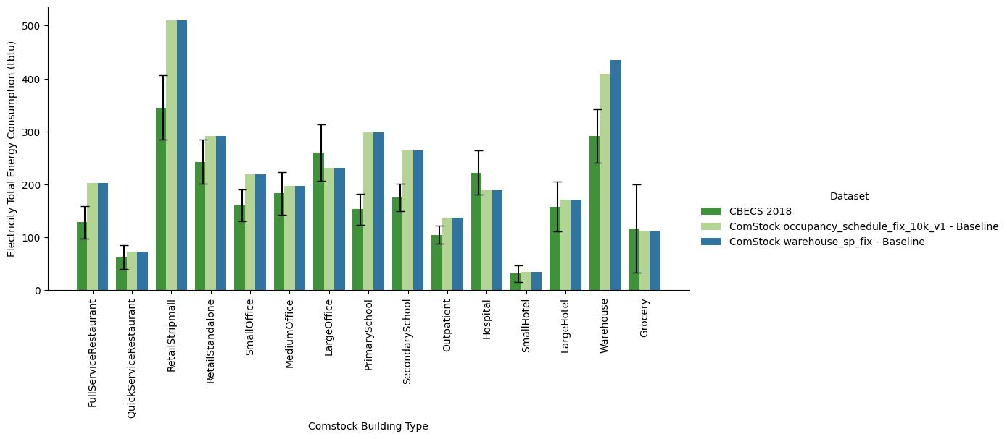
Figure 5. Electricity usage by building type (blue is new, light green is old).

Figure 6 compares ComStock warehouse electricity to CBECS disaggregated estimates. Cooling and interior lighting are notable end uses that are not included here, as they are very well aligned to CBECS estimates. Of the overestimated 120 tBtus comparing ComStock to CBECS, ~25 tBtu come from exterior lighting (not included in CBECS, not maybe not an issue), ~25 tBtu come from fans, ~30 tBtu from electric heating (increased with this change), and ~40 tBtu from interior equipment. This could suggest too much electric heating, but that is likely only a fraction of the issue (25% according to CBECS), and may not be caused by thermostat setpoints. And again, these end use breakdowns from CBECS are just rough estimates. But we can likely trust that we are overestimating total electricity in warehouses, which can be resolved in a future effort.

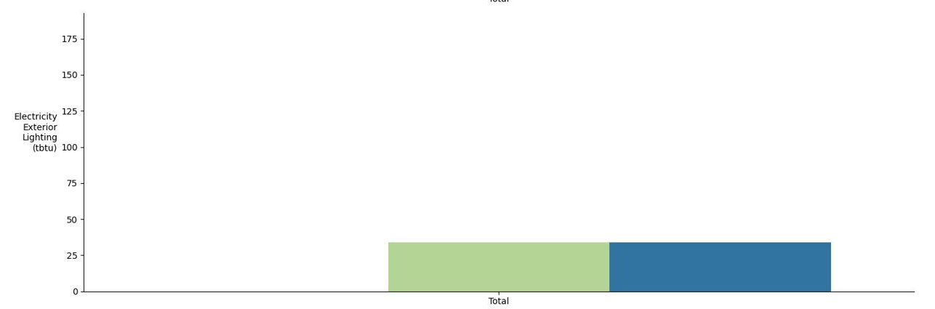
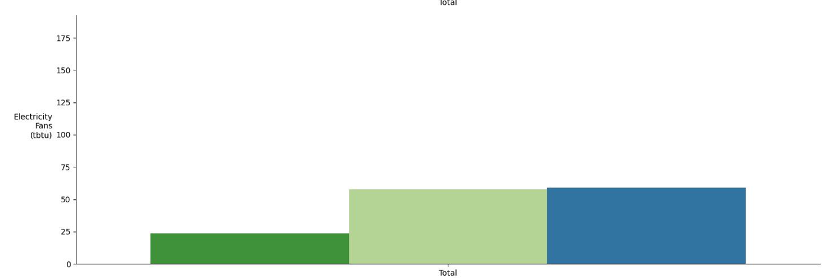
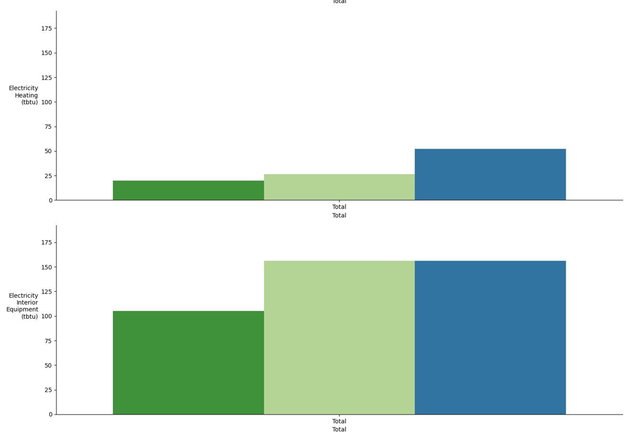
Figure 6. Electricity by end use for warehouses compared to CBECS disaggregated (green=CBECS, light green=current, blue=new). Only problematic end uses included.

