ComStock Change
  - V38 – Adjustment to Retail HVAC System Type Assignment – Prioritizing Packaged Single Zone (RTU) over VAV in Mixed Cases
Implementer: Landan Taylor
Change Document Author: Landan Taylor (primary)
Reviewer: Chris CaraDonna

Description of Change

Summary

This change updates ComStock’s interpretation of CBECS HVAC system type responses for retail buildings. Previously, if a retail building was reported to have both variable air volume (VAV) and single-zone packaged systems, the ComStock methodology defaulted to assigning VAV. We believe this overrepresented multi-zone VAV systems in retail, based on observed industry practices, particularly in California models. The updated methodology now prioritizes packaged single-zone rooftop units (RTUs) in tie-break situations, only assigning VAV when it is the sole reported system. This aligns with observed industry practice and existing ComStock treatment of grocery buildings.

Existing Methodology
- HVAC system type assignment in ComStock is based on CBECS responses, where multiple system types can be reported.
- For most building types, tie-break prioritization rules determine which system is assigned.
- In retail buildings, the legacy ComStock implementation prioritized VAV in cases where both VAV and packaged single-zone were reported.
- This resulted in an overrepresentation of VAV systems in retail, diverging from the typical real-world stock mix where single-zone packaged rooftop units are dominant.
Limitation
The legacy methodology misrepresents retail building system stock, impacting stock-level HVAC distribution and energy use profiles, particularly in regions like California where retail building distributions are critical for policy and utility planning.

New Methodology

- Retail buildings will now only be assigned VAV when it is the only reported HVAC system in CBECS.
- In cases where both VAV and packaged single-zone are reported, packaged single-zone (RTUs) will be prioritized.
- This change makes retail HVAC assignments consistent with grocery store treatment, where RTUs are also prioritized.
- Implementation required modifying the HVAC sampling logic in the retail system type assignment module.
- A new hvac_system_type.tsv (v30) was created to reflect this change, and sampling input files were updated to align with the revised logic.

Impact of Change

Individual Model Input Change
- Review of affected retail building OSM/IDF inputs shows VAV assignments are replaced with packaged single-zone systems (PSZ-AC).
  - Example:
    - Before: Retail strip mall with VAV system assignment.
    - After: Retail strip mall assigned packaged single-zone RTU.

Stock-Level Input Change
- System type prevalence in retail shifts significantly: VAV share decreases, packaged single-zone share increases.
- Aligns retail distributions more closely with CBECS intent and observed industry practice.
- See attached distribution chart (Figure A – System Type Prevalence in Retail, pre vs post change).

Stock-Level Output Change
- Before Change (Legacy Methodology): Retail buildings with CBECS responses that included both VAV and PSZ were assigned VAV. Resulted in inflated prevalence of VAV in retail.
- After Change (TSV v30): Retail buildings are only assigned VAV if it is the only reported system type. Mixed cases are assigned PSZ (RTUs).

Observed results:
  - System Distribution: Significant decrease in retail VAV share; increase in PSZ share. Note that differences in the sample counts come from changes in the number of buildings that no longer get assigned a building types with this new methodology.
    - Pre Change
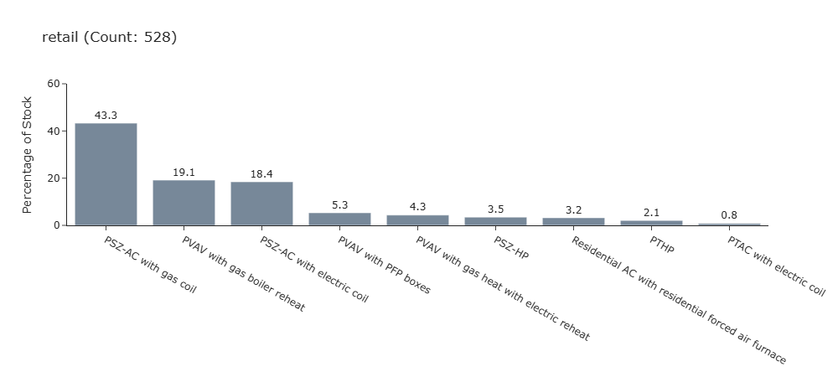
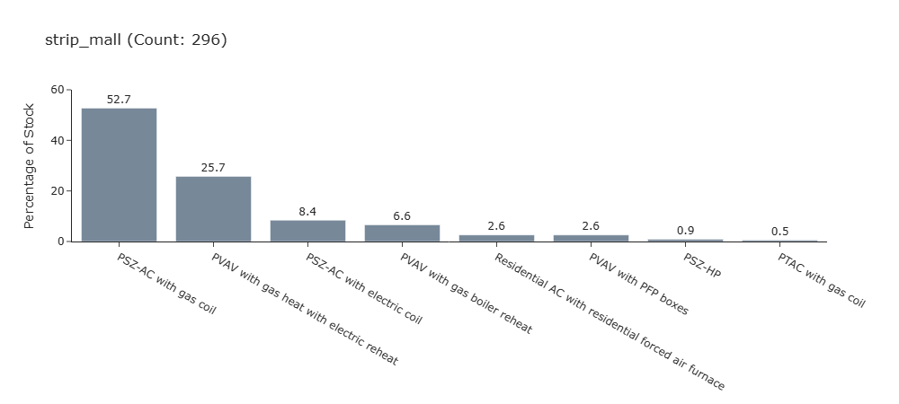
    - Post Change
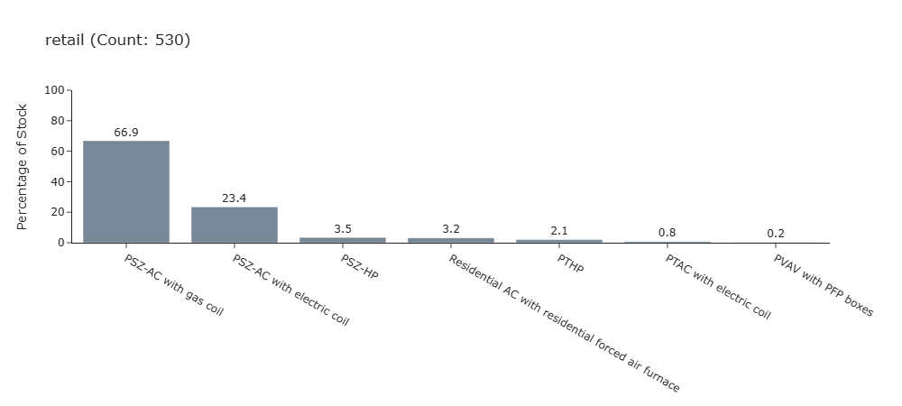
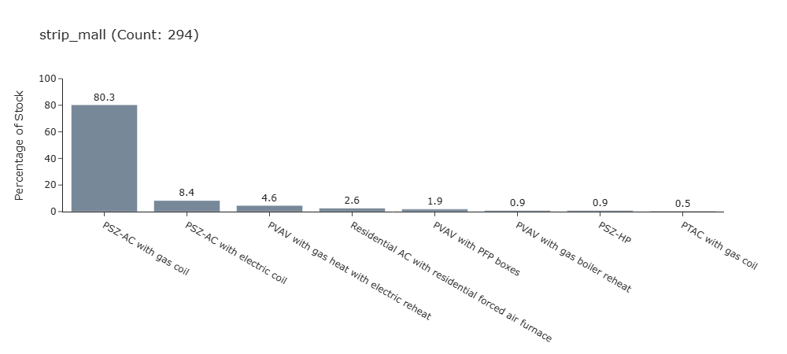
  - Energy Impacts:
    - All charts below are retail building types only. Since the runs use different samples for the runs, energy comparisons between should be taken with caution due to normal variance in the random samples that are generated. However shifts in energy are minor across the building stock. Blue bars below represents the new methodology. Orange bars represents the old methodology. Both of these are baseline runs.
    - Electricity Use
      - Retail Standalone
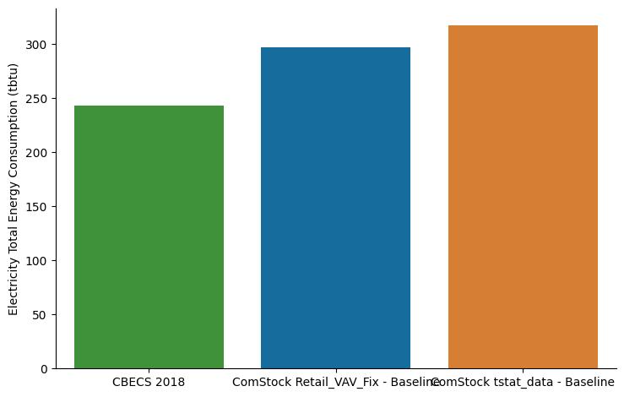
      - Retail Stripmall
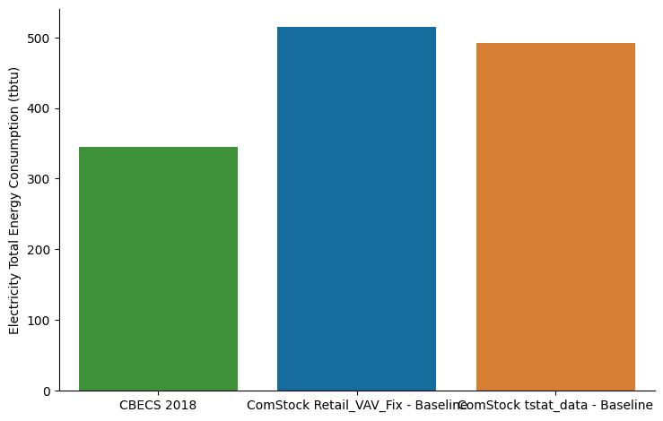

    - Natural Gas Use
      - Retail Standalone

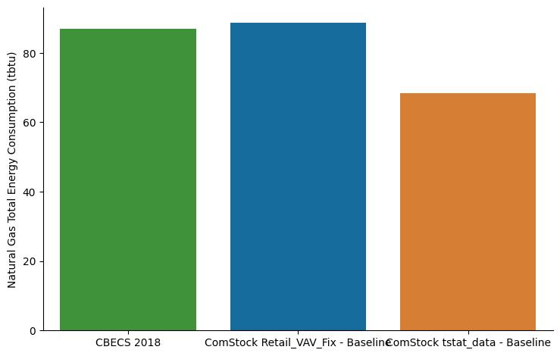
      - Retail Stripmall
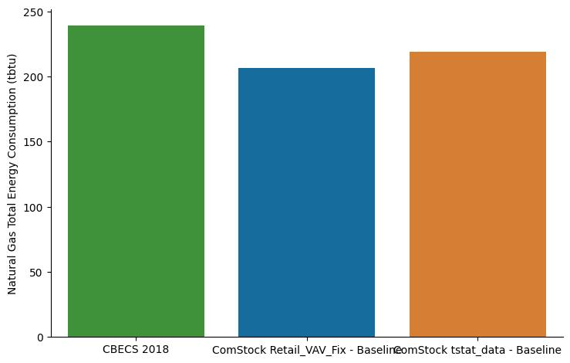

    - Total Site Energy
      - Retail Standalone
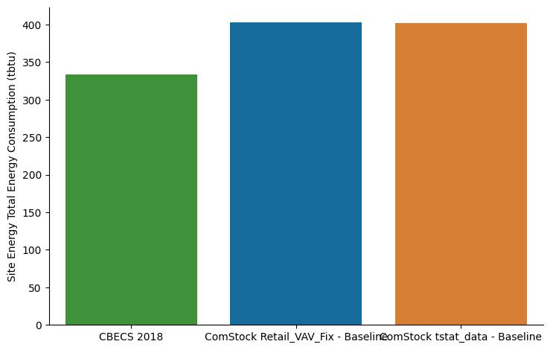
      - Retail Stripmall
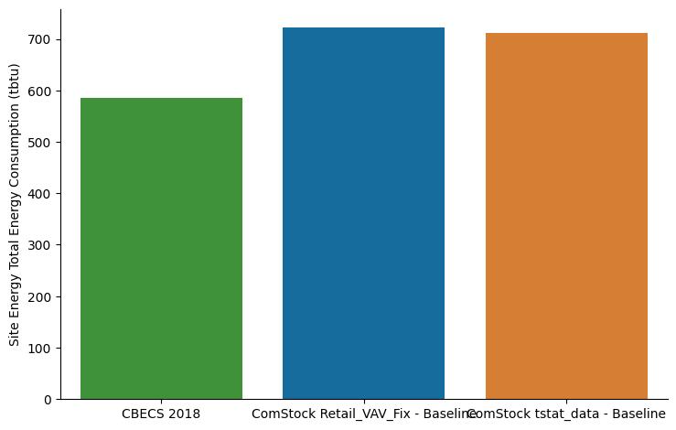
    - Regional Breakdown
      - Retail Standalone
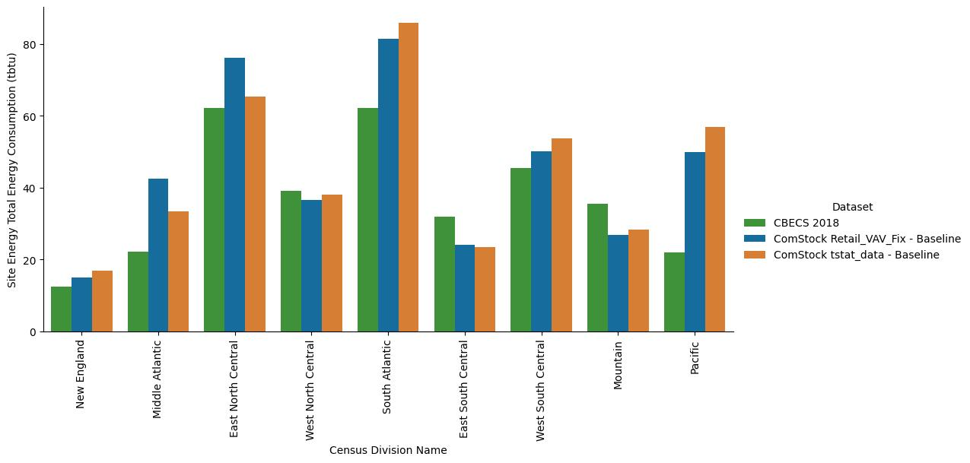
      - Retail Stripmall
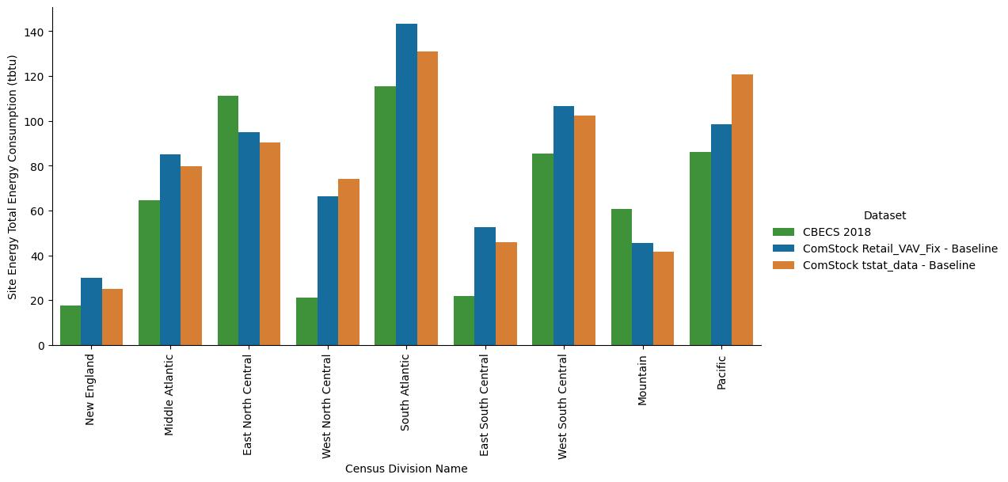
Note on Interpretation: Because a new buildstock was generated (with updated sampling files and TSV v30), results reflect both the HVAC assignment change and stochastic variation inherent in the ComStock sampling process.

Validation
- Stock-level HVAC distribution for retail now resembles expected practice: RTUs dominate, VAV systems are present only when exclusively reported.
- Energy results are consistent with expectations and directionally correct, with caveats due to new buildstock sampling variability.
- Change aligns retail methodology with grocery store logic.
- Updated inputs: hvac_system_type.tsv advanced to v30; corresponding sampling files regenerated.

EUSS Upgrade Measure Impacts
This change impacts the baseline HVAC system mix for retail, which directly affects downstream EUSS runs:
- Affected Measures: All HVAC-related measures applied to retail buildings (e.g., advanced RTU measures, economizer retrofits, RTU efficiency upgrades, VAV fan power reductions).
- Impact Mechanism:
  - The applicability of measures will be impacted that relate to RTUs and VAV systems retail now has a greater number of RTUs and a lower number of vav systems.
  - Under the old methodology, many retail buildings were misclassified as VAV, so EUSS results overstated savings potential from VAV-targeted measures and understated savings potential from RTU-targeted measures.
  - With the updated methodology, retail is predominantly modeled with RTUs, leading to:
    - Increased baseline applicability of RTU measures (greater coverage across the retail stock).
    - Reduced applicability of VAV measures in retail (VAV only remains in buildings where it is the sole reported system).
- Expected Energy Impact in EUSS Runs:
  - Fan Energy Savings Shapes: Lower baseline VAV fan energy reduces savings potential from fan power measures, but improves representativeness.
  - Cooling/Heating Measures: Minor shifts in applicability, depending on whether the measure is tied to VAV or RTU system archetypes.
  - Non-HVAC Measures: Unaffected (lighting, plug/process, envelope, refrigeration).
- Stock-Wide Effect on EUSS Outputs:
  - Changes isolated to retail; other building types unaffected.
  - Retail EUSS outputs will now better represent RTU-dominated savings shapes, aligning with observed market data.
Note: Because this change required regenerating the buildstock and advancing hvac_system_type.tsv to v30, downstream EUSS runs will need to be re-executed to ensure measure coverage and savings shapes align with the corrected baseline.

