EnergyPlus  
Engineering Reference

The Reference to EnergyPlus Calculations  
(in case you want or need to know)

### DX Coil Sizing

<<Snip>>

Add new sizing section at the end of Indirect Evaporative Cooler Sizing section:

### Secondary DX Coils Sizing

The secondary DX coils model does not have a standalone object and it is models as add–on feature to the DX Coils. When the secondary DX coil is added to a primary DX cooling coil, the heat rejected to secondary zone is sensible only and is treated as tnternal gain, hence secondary air flow rate is not required in the model. Where as when the secondary DX coil is added to a primary DX heating coil, then the heat removed from secondary zone may have sensible and latent components and is treated as tnternal gain. The sensible/latent component split among other parameters requires secondary coil air flow rate. Hence secondary coil air flow rate sizing is added based on the primary DX cooling coil only.



Where,

 = the secondary coil design air flow rate (m3/s)

 = the primary heating DX coil design air flow rate, (kg/s)

 = secondary DX coil air flow rarte scaling factor (-)

## Zone Outdoor Air Design Data

<<Snip>>

## Coils

<<Snip>>

#### Coil:Cooling:WaterToAirHeatPump:VariableSpeedEquationFit

<<Snipp>>

#### New section: insert it at the end of “Coil:Cooling:WaterToAirHeatPump:VariableSpeedEquationFit” section.

#### Secondary Coils of DX Systems and Heat Pumps

**Overview**

Secondary coils reject to or remove heat from a secondary zone. Secondary coil refers to a condenser of a DX system or a heat pump in cooling operating mode or an evaporator of a heat pump in heating mode. The secondary coil (e.g. condenser) of DX system or heat pumps is commonly installed outdoor but when installed indoor either heat is dumped to or extracted from the secondary zone. A secondary zone is a conditioned or unconditioned zone where the secondary coil is installed. Secondary coils are not standalone DX coil objects but they are add-on features on existing DX coil objects. A secondary DX coil is modelled by specifying additional inputs in single speed and multi speed DX coil objects: The additional inputs allow us to model the heat rejected or extracted by the secondary coil while the primary coil serves another controlled zone as shown in Figure 1. A secondary coil is not controlled directly but responds to the requirements of the primary DX coil. The operating mode of a secondary DX coil is determined by the primary DX coil serving the conditioned zone. If the primary DX coil is in cooling mode, then the secondary coil is rejecting heat (heating mode) to the secondary zone, or else if the primary DX coil is in heating mode, then the secondary coil is extracting heat (cooling mode) from the secondary zone. Heat rejected to a secondary zone by a condenser of a DX system or a heat pump is considered as sensible only. Whereas energy extracted from a secondary zone may contain sensible and latent components. The condenser type of the primary DX coils should be *AirCooled*. There is no need to specify the condenser air inlet node. The model uses zone air node as the secondary coil air inlet node. Air drawn by the secondary coil fan passes through the secondary coil and dumped back into the secondary zone. The previous time step zone condition is used as an inlet condition to the current time for the secondary DX coil model.

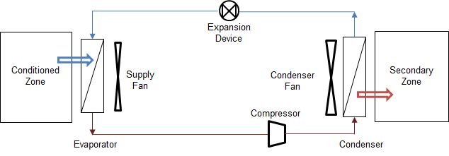

**Figure 1 Schematic of DX System in cooling operating mode**

The heat rejected or extracted by the secondary DX coil is estimated from the delivered capacity and electric power input of the primary DX coils. And the rejected or extracted heat is treated as internal gain of the secondary zone. Currently secondary DX coil are allowed in single speed, two speed and multi speed DX coil objects: *Coil:Cooling:DX:SingleSpeed*, Coil:Heating:DX:SingleSpeed, *Coil:Cooling:DX:TwoSpeed*, *Coil:Cooling:DX:MultiSpeed*, and *Coil:Heating:DX:MultiSpeed*.

**Model Description**:

The secondary coil performance calculation is invoked using inputs in the DX coil objects. The input required for cooling and heating operation of the primary DX coils are different. In the DX cooling coils the only required input is the zone name where the secondary coil is installed. In heating DX coils six inputs are required for single speed coils and a minimum of 11 input fields are required for multispeed DX heating coils. And five more inputs are required for every additional compressor speed. The extensible five input fields are used for splitting the total heat extraction rate into sensible and latent components. These five input fields are: rated sensible heat ratio, secondary air flow rates, scaling factor for auto-sizing secondary air flow rates, sensible heat ratio modifier curves as a function of temperature and sensible heat ratio modifier curves as a function of secondary air flow fraction. The secondary coil model assumes that liquid water from defrosting operation is drained to the outdoor and has no impact on the zone air heat balance.

**Cooling Operating Mode**: the primary DX cooling coil of a DX system serving a primary zone is on and heat is rejected by the secondary coil (condenser) into a secondary zone. The secondary zone name is specified in DX cooling coil objects. This operating mode applies to a DX cooling system and cooling operating mode of air-to-air single and multi-speed heat pumps. The heat rejected by the secondary coil (condenser) of a DX system or heat pump operating in cooling mode is given by:



Where,

 = cooling load delivered by the primary DX cooling coil system, W

 = compressor and condenser fan electric power input of a DX system or heat

pump in cooling mode, W

 = heat rejected by the secondary coil (condenser) of a DX system or heat

pump, W

Heat rejected by a secondary coil (condenser) calculated at each time step becomes internal gain of the secondary zone as shown in Figure 2. Whenever a secondary zone name is specified in DX cooling coil objects, the secondary DX coil model calculation is invoked. New input field required as add-on to the DX cooling coil objects is “*Zone Name for Secondary Coil (condenser) Placement*”.

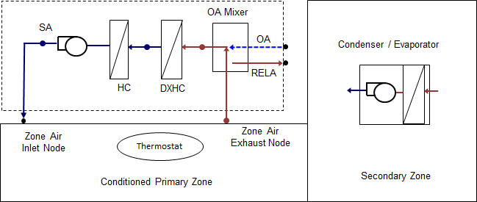

**Figure 2 Schematic of DX system and secondary coil (condenser)**

**Heating Operating Mode**: When a heat pump operates in heating mode then energy is extracted from the secondary zone. The total energy extracted is estimated by rearranging the equation above as follows:



Where,

 = heat delivered by the primary heating DX coil to the primary zone, W

 = compressor and evaporator fan electric power input of a heat pump in

heating mode, W

 = energy extracted by secondary coil (evaporator) from the secondary zone, W.

The total energy extracted from a secondary zone may contain sensible and latent components. The secondary coil model checks for the coil inlet and full load outlet air condition to determine whether dehumidification will occur. The sensible and latent split of the energy extracted is done using a user specified rated sensible heat ratio (SHR) and SHR modifier curves for temperature and the secondary air flow fraction. If the secondary coil operation is dry, then the SHR is set to 1.0. In addition, the model assumes that defrosting operation is on, then the defrosting melts the frost and the liquid water from the collecting pan is drained to outside. Thus defrosting energy is not included in the zone energy balance. The heat extracted from the secondary zone may contain sensible and latent components and the secondary coil model does the sensible/latent heat split calculation.

***Sensible Heat Ratio Calculation***

The SHR calculation method uses user specified *SHR* modifying curves for temperature and flow fraction. The modifying curves correct the rated *SHR* value for a given secondary DX coil (evaporator) entering air temperatures and air mass flow fraction for a given speed. If these *SHR* modifying curves are not specified a constant SHR will be assumed. These two curves are a biquadratic *SHR* modifier curve for temperature (*SHRFT*), and a quadratic *SHR* correction curve for flow fraction (*SHRFFF*). The SHR is given by:



Where

 = sensible heat ratio modifier normalized biquadratic curve as a function of secondary DX coil entering air wet-bulb and primary DX coil entering air dry-bulb temperatures, (-). The secondary DX coil (evaporator) entering air wet-bulb temperature is the secondary zone air wet-bulb temperature.

= sensible heat ratio modifier normalized quadratic curve as a function of air mass flow fraction. Flow fraction is the ratio of actual to rated mass flow rate of air through the secondary DX coil, (-).

 = sensible heat ratio at rated condition, (-).

For multispeed secondary DX coils when the system is cycling between two speeds of *n* and *n-1* the operating SHR is weighted using *SpeedRatio* as follows:



Where

 = sensible heat ratio at speed *n* determined from user specified rated SHR, and *SHR* modifier curves at speed *n*.

 = sensible heat ratio at speed *n-1* determined from user specified rated SHR,

and *SHR* modifier curves at speed *n-1*.

 = a parameter that relates performance between successive compressor

speeds.

***Sensible and Latent Split***

The air enthalpy difference across the secondary DX coil (evaporator) at full load is given by:



The coil outlet enthalpy is calculated as follows:



Using the SHR calculated above and secondary DX coil outlet temperature is given by:



Calculate the saturated outlet temperature at the outlet enthalpy and check the secondary outlet air condition if super-saturation has occurred:



IF () Then



ELSE



The coil outlet humidity ratio is determined using psychrometric functions as follows.



ENDIF

Where

 = enthalpy of air entering the passive coil, (J/kg)

 = enthalpy of air leaving the passive coil, (J/kg)

 = secondary DX coil mass flow rate, (kg/s)

 = primary DX cooling coil compressor part-load ratio, (-)

 = total pressure at the inlet of secondary DX coil, (Pa)

 = secondary coil outlet air temperature, (°C)

 = secondary coil saturated air temperature at the outlet enthalpy, (°C)

 = secondary coil inlet node air humidity ratio, (kgH2O/kgDryair)

 = secondary coil outlet node air humidity ratio, (kgH2O/kgDryair)

## HVAC Controllers